Midweek of Lent 4
March 22, 2023
12 Noon and 6:30 PM

Salem Lutheran Church
1-715-537-3011
http://www.salembarron.com
rev.mike.nielsen@gmail.com

Bread of Life

The bread we bake in our homes or buy from the store is good for today. But by tomorrow, it may be gone. The gifts we receive in this world satisfy us for a moment; however, the gifts we receive in the promised treasures of God’s Word are gifts that are eternal. When Jesus describes Himself in John 6 as the bread of life, we know that He highlights for us His mission of salvation. As our bread of life, Jesus comes to forgive us, renew us, and lead us toward a meaningful life in relationship with Him. Let us taste and experience that life together this day as the Holy Spirit calls us to walk with Jesus and be satisfied by His presence among us.

Hymn: O Christ, You Walked the Road LSB 424
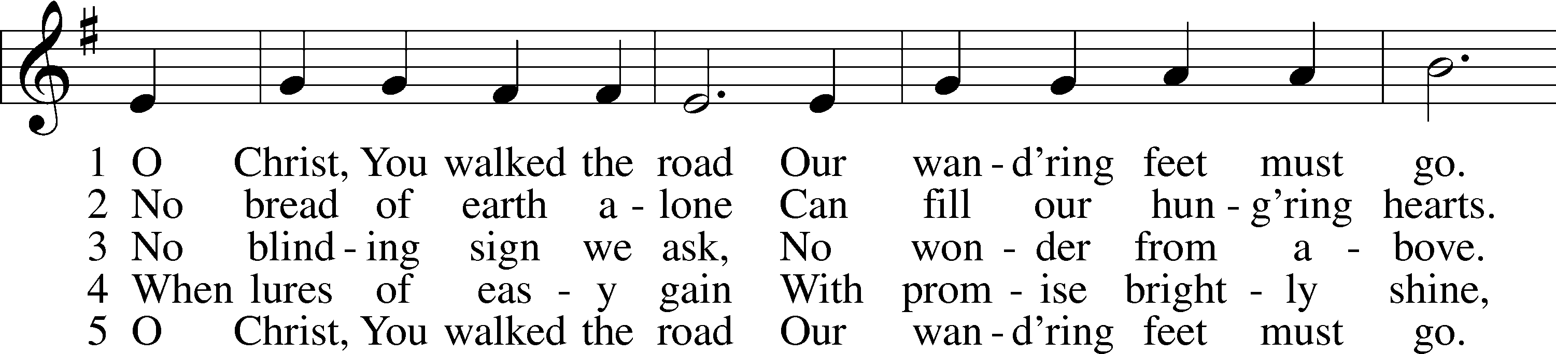
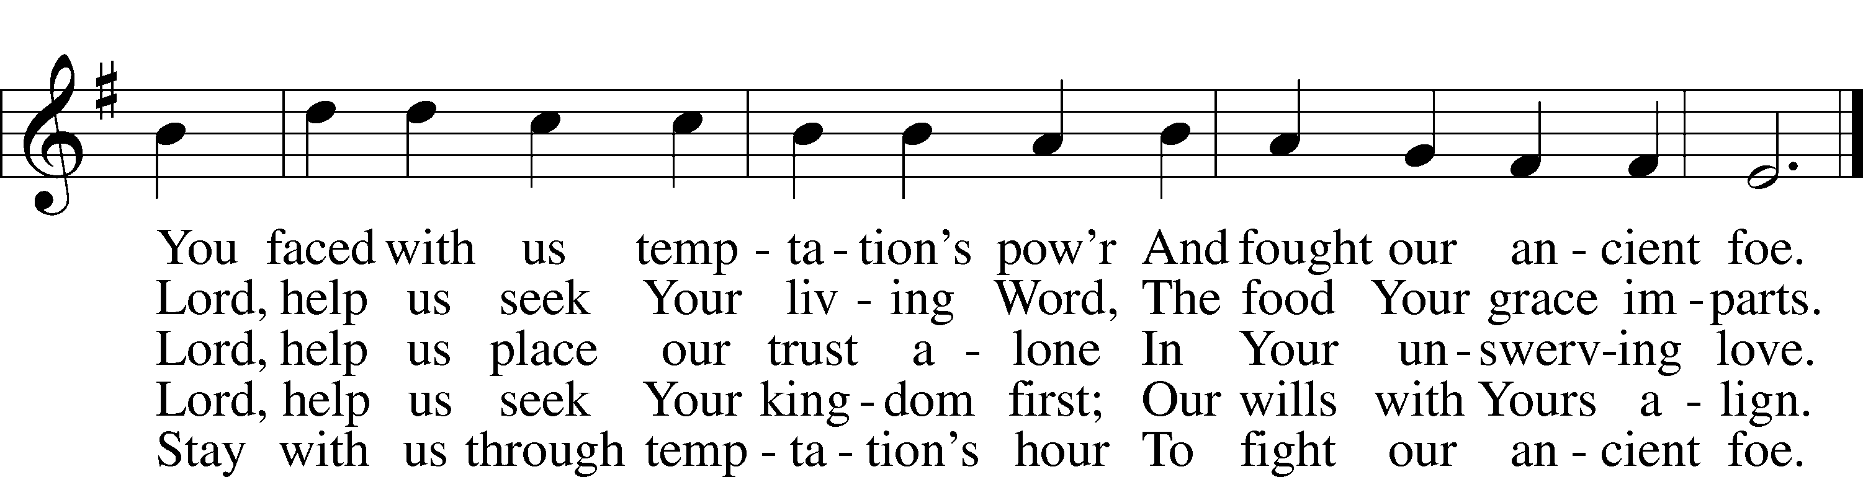
Text: Herman G. Stuempfle, Jr., 1923–2007
Tune: William Daman, c. 1540–1591
Text: © 1997 GIA Publications, Inc. Used by permission: LSB Hymn License no. 110005504
Tune: Public domain

Opening Sentences
L O Lord, open my lips,

L Make haste, O God, to deliver me;

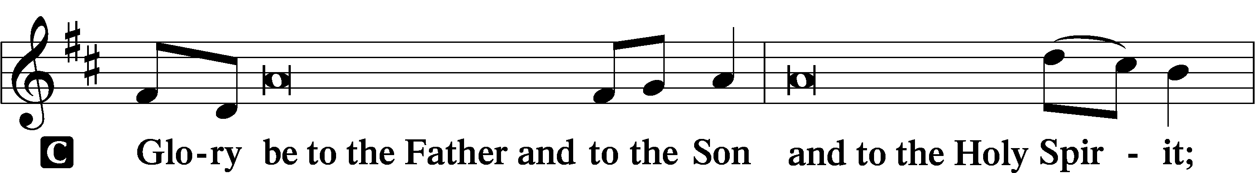
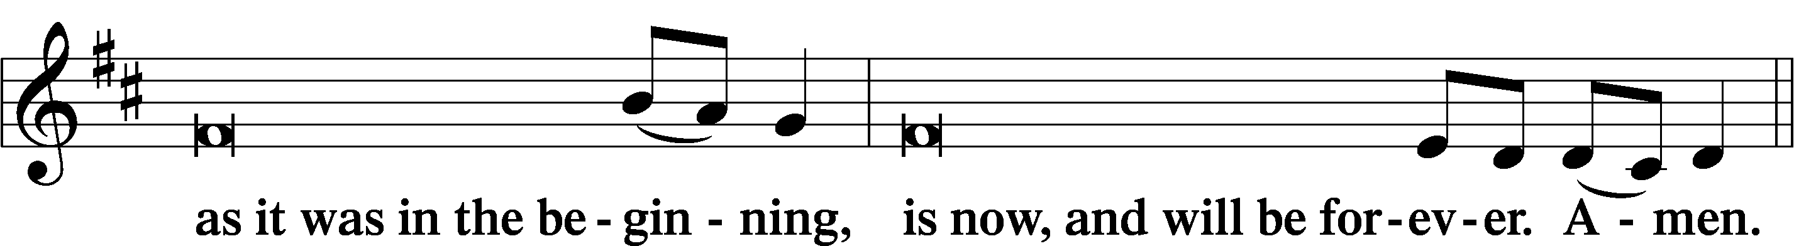
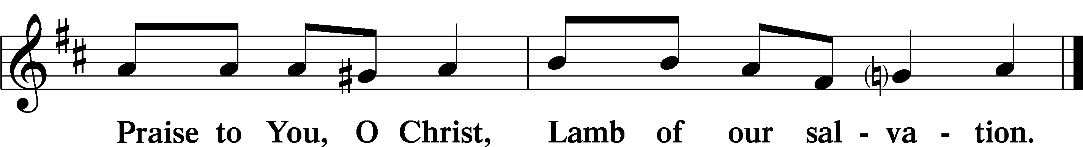

PSALMODY

Psalm Psalm 19:7–10, 14
P The law of the Lord is perfect,
C reviving the soul;
P the testimony of the Lord is sure,
C making wise the simple;
P the precepts of the Lord are right,
C rejoicing the heart;
P the commandment of the Lord is pure,
C enlightening the eyes;
P the fear of the Lord is clean,
C enduring forever;
P the just decrees of the Lord are true,
C and righteous altogether.
P More to be desired are they than gold, even much fine gold;
C sweeter also than honey and drippings of the honeycomb.
P Let the words of my mouth and the meditation of my heart
C be acceptable in Your sight, O Lord, my rock and my redeemer.
Glory be to the Father and to the Son and to the Holy Spirit;
as it was in the beginning, is now, and will be forever. Amen.

Hymn: One House Abides Unending See Insert

READINGS

Reading Exodus 16:2–5, 11–18
P A reading from Exodus, the sixteenth chapter.

2And the whole congregation of the people of Israel grumbled against Moses and Aaron in the wilderness, 3and the people of Israel said to them, “Would that we had died by the hand of the Lord in the land of Egypt, when we sat by the meat pots and ate bread to the full, for you have brought us out into this wilderness to kill this whole assembly with hunger.”
4Then the Lord said to Moses, “Behold, I am about to rain bread from heaven for you, and the people shall go out and gather a day’s portion every day, that I may test them, whether they will walk in my law or not. 5On the sixth day, when they prepare what they bring in, it will be twice as much as they gather daily.”
11And the Lord said to Moses, 12“I have heard the grumbling of the people of Israel. Say to them, ‘At twilight you shall eat meat, and in the morning you shall be filled with bread. Then you shall know that I am the Lord your God.’”
13In the evening quail came up and covered the camp, and in the morning dew lay around the camp. 14And when the dew had gone up, there was on the face of the wilderness a fine, flake-like thing, fine as frost on the ground. 15When the people of Israel saw it, they said to one another, “What is it?” For they did not know what it was. And Moses said to them, “It is the bread that the Lord has given you to eat. 16This is what the Lord has commanded: ‘Gather of it, each one of you, as much as he can eat. You shall each take an omer, according to the number of the persons that each of you has in his tent.’” 17And the people of Israel did so. They gathered, some more, some less. 18But when they measured it with an omer, whoever gathered much had nothing left over, and whoever gathered little had no lack. Each of them gathered as much as he could eat.

P O Lord, have mercy on us.
C Thanks be to God.
Reading 1 Corinthians 10:1–4, 15–17
P A reading from First Corinthians, the tenth chapter.

Warning Against Idolatry
1I want you to know, brothers, that our fathers were all under the cloud, and all passed through the sea, 2and all were baptized into Moses in the cloud and in the sea, 3and all ate the same spiritual food, 4and all drank the same spiritual drink. For they drank from the spiritual Rock that followed them, and the Rock was Christ.
15I speak as to sensible people; judge for yourselves what I say. 16The cup of blessing that we bless, is it not a participation in the blood of Christ? The bread that we break, is it not a participation in the body of Christ? 17Because there is one bread, we who are many are one body, for we all partake of the one bread.

P O Lord, have mercy on us.
C Thanks be to God.

Reading John 6:32–37
P A reading from St. John, the sixth chapter.

32Jesus then said to them, “Truly, truly, I say to you, it was not Moses who gave you the bread from heaven, but my Father gives you the true bread from heaven. 33For the bread of God is he who comes down from heaven and gives life to the world.” 34They said to him, “Sir, give us this bread always.”
35Jesus said to them, “I am the bread of life; whoever comes to me shall not hunger, and whoever believes in me shall never thirst. 36But I said to you that you have seen me and yet do not believe. 37All that the Father gives me will come to me, and whoever comes to me I will never cast out.

P O Lord, have mercy on us.
C Thanks be to God.

Lent Responsory LSB, p. 231
L Deliver me, O Lord, my God, for You are the God of my salvation.
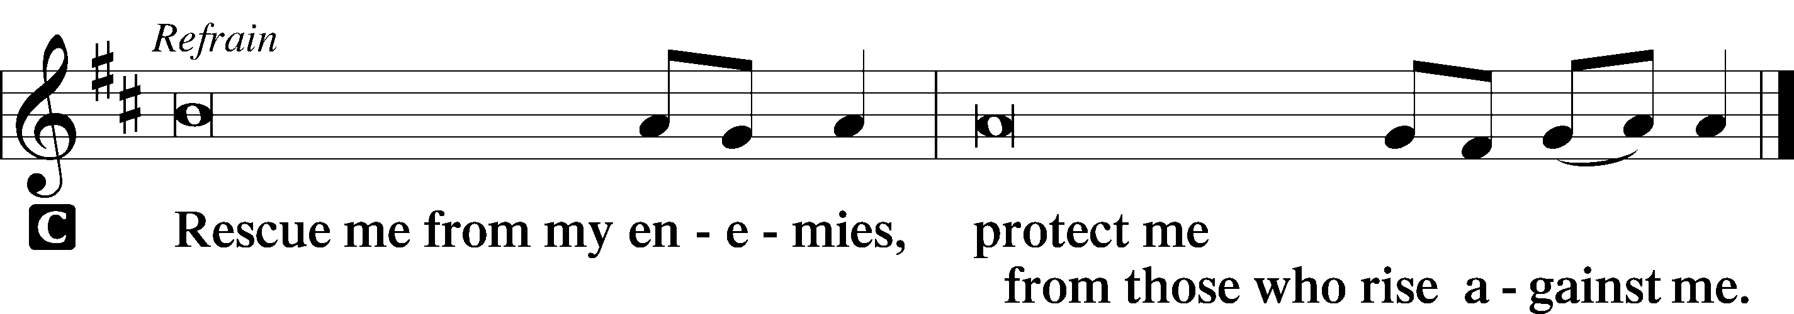

L In You, O Lord, do I put my trust, leave me not, O Lord, my God.

L Deliver me, O Lord, my God, for You are the God of my salvation.
Sermon

CANTICLE

Antiphon
L Let my prayer rise before You as incense,
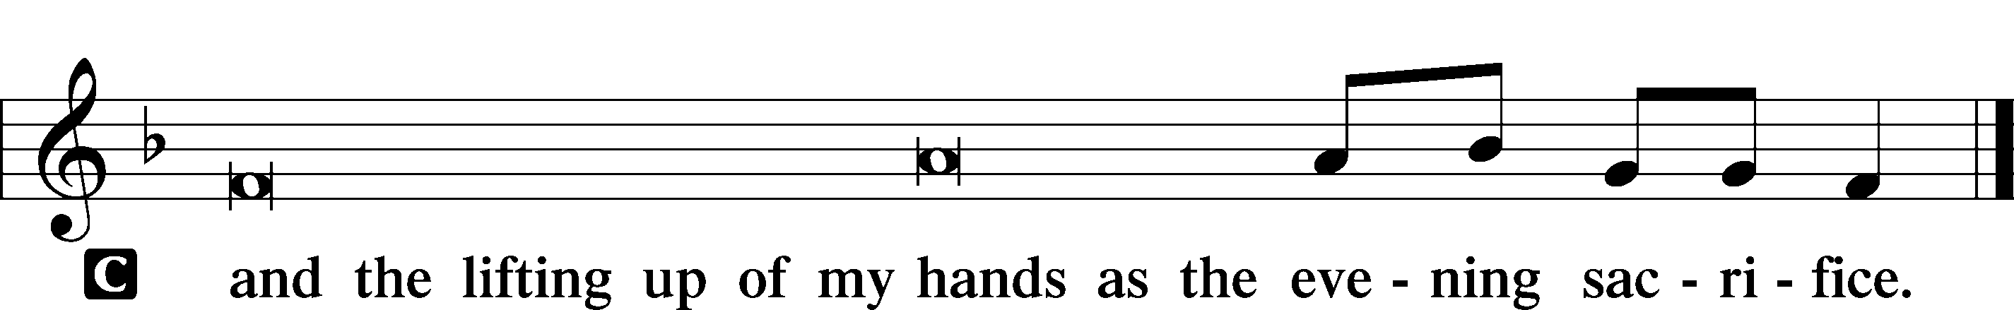

Magnificat LSB 231
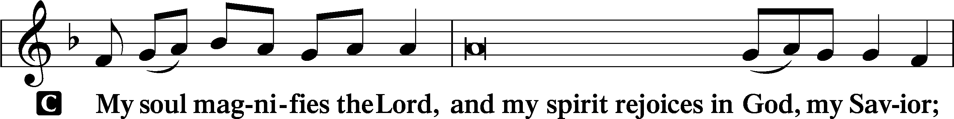
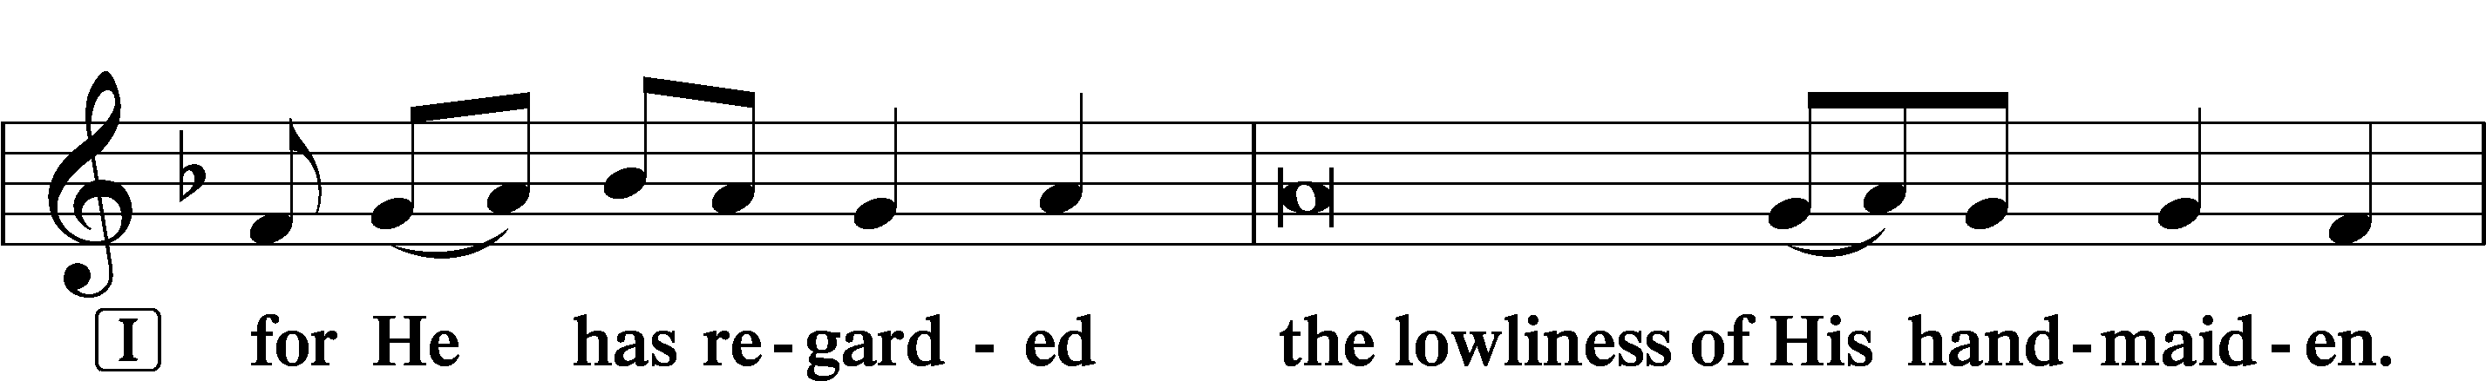
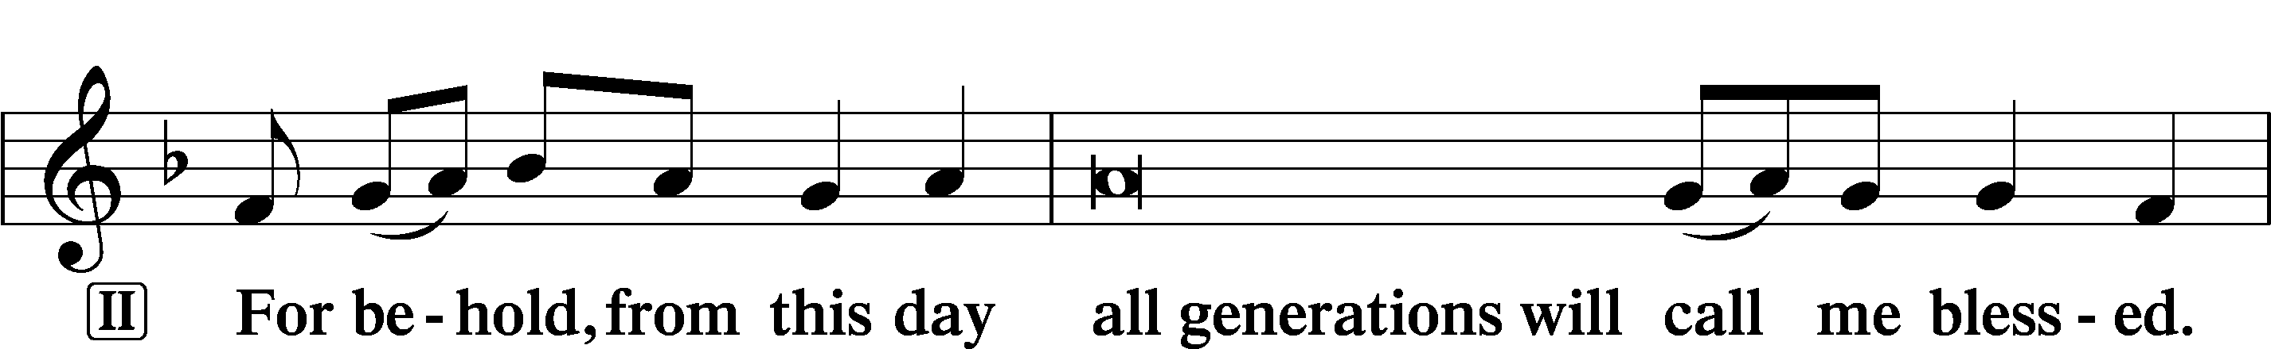
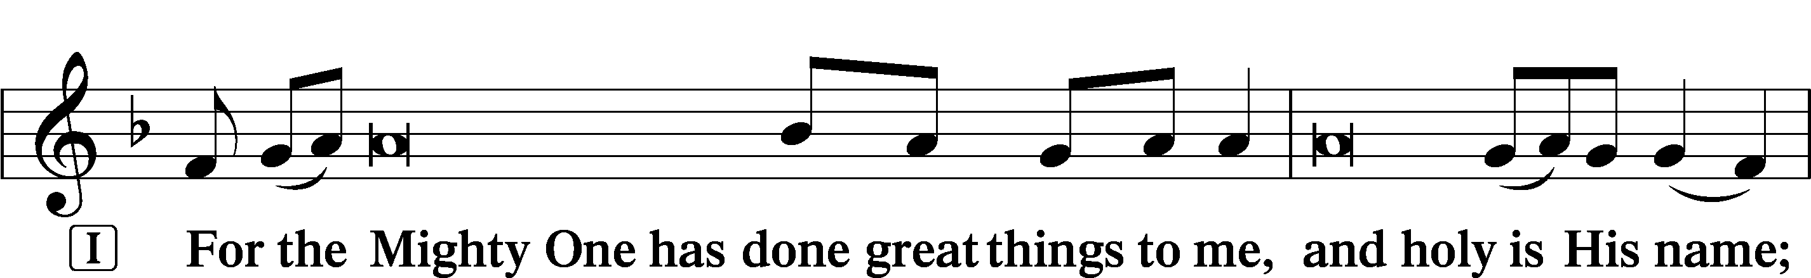
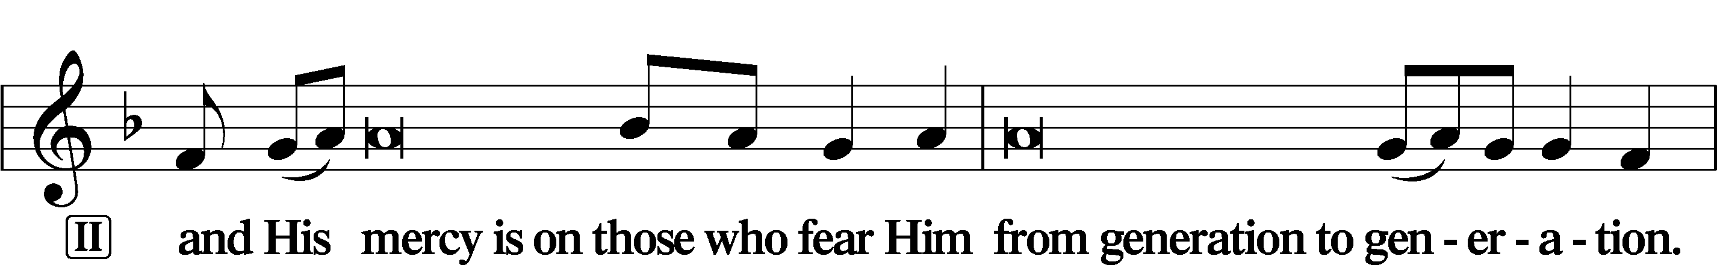
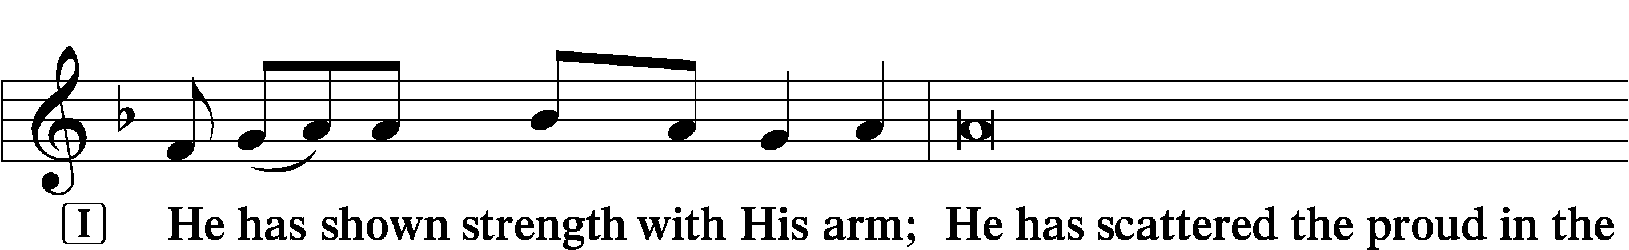
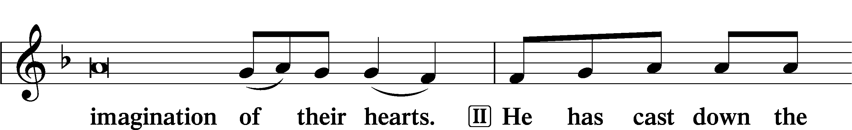
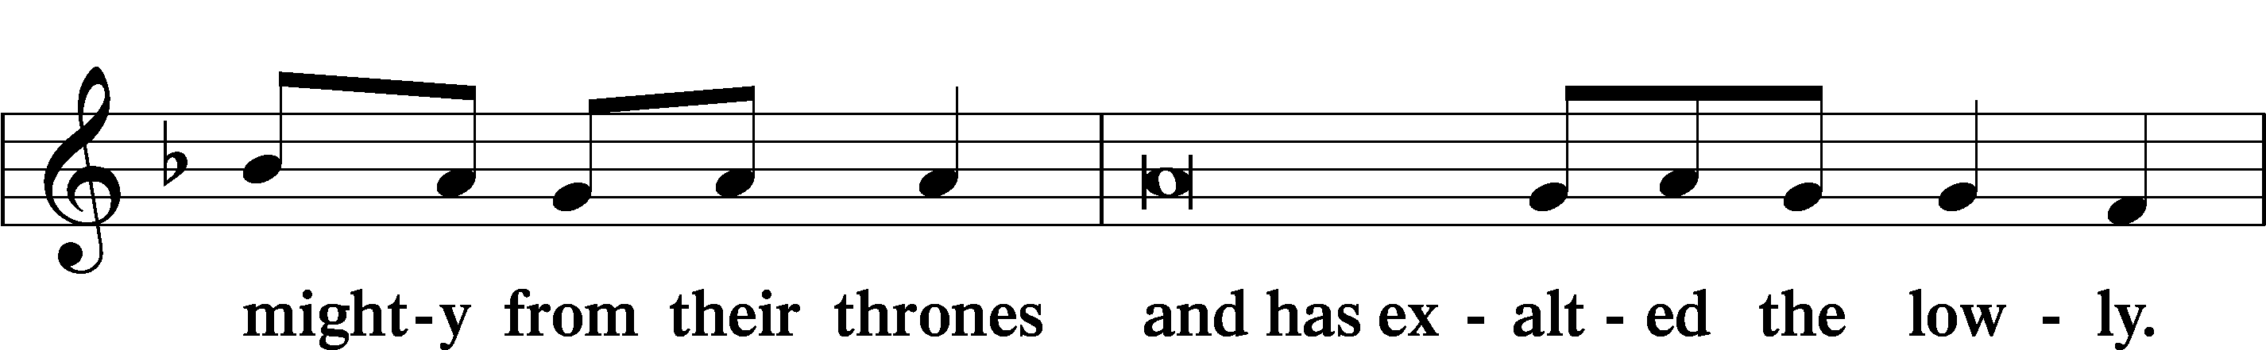
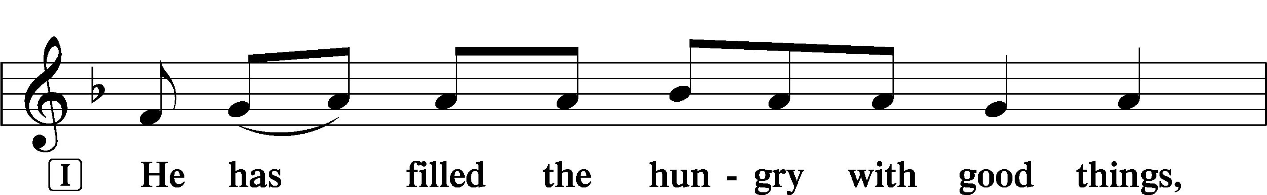
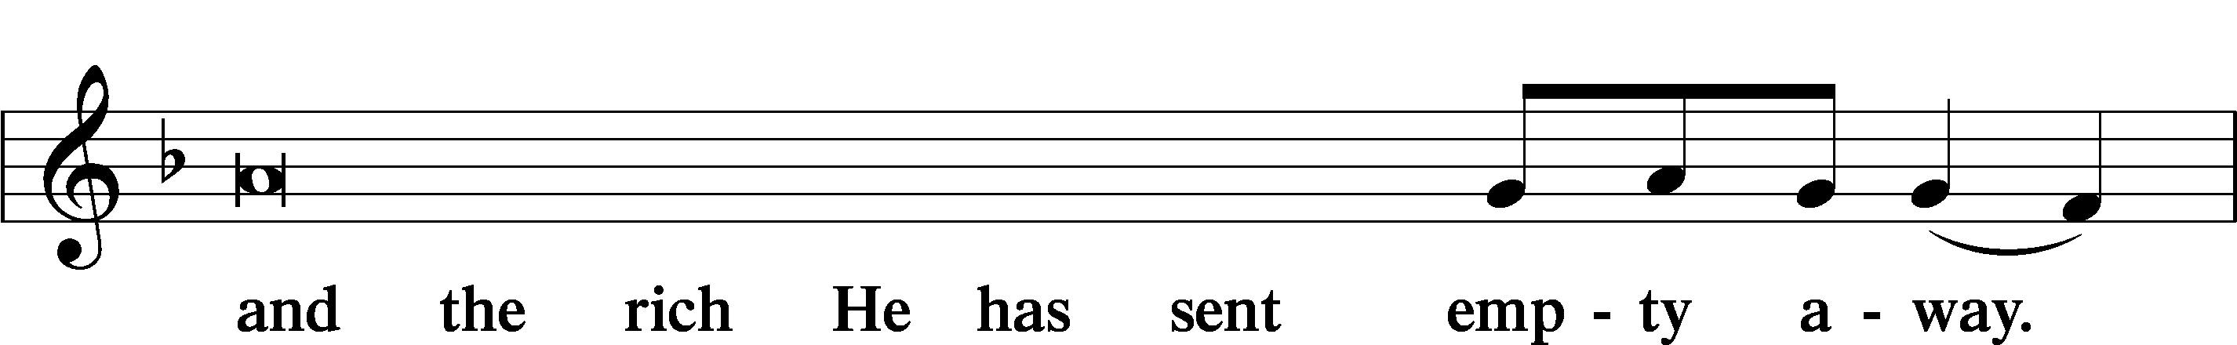
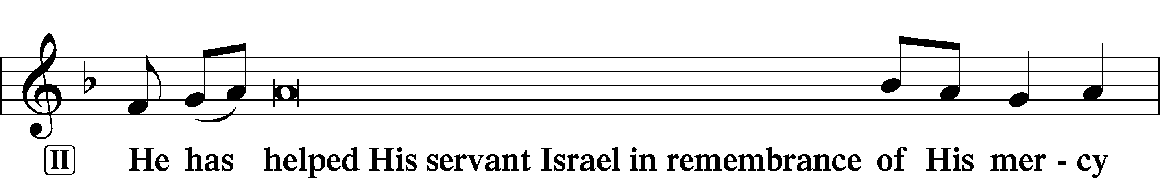
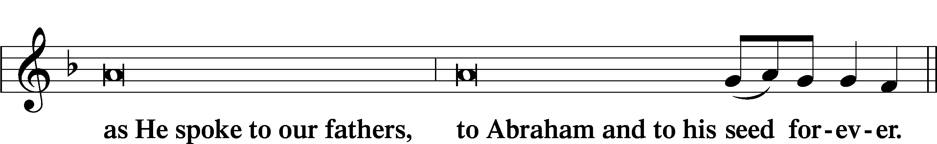
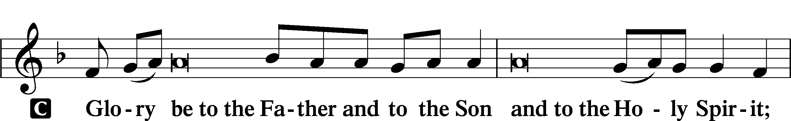
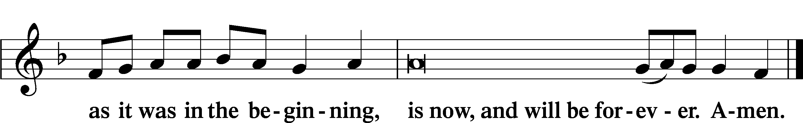

PRAYER

Kyrie
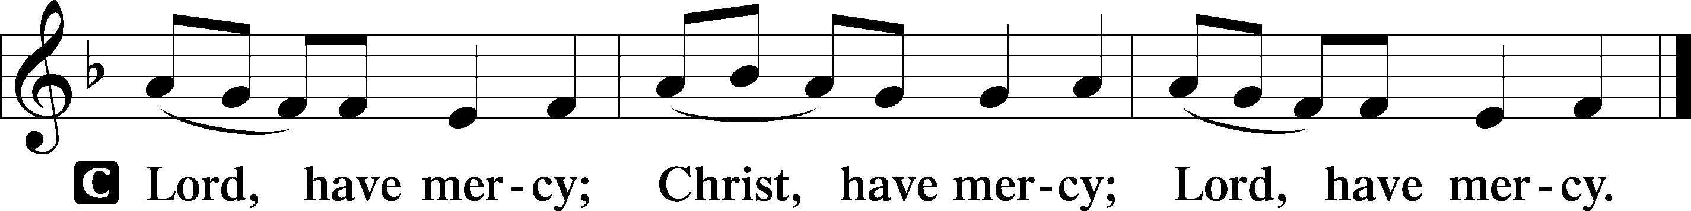

Lord’s Prayer
C Our Father who art in heaven,
hallowed be Thy name,
Thy kingdom come,
Thy will be done on earth
as it is in heaven;
give us this day our daily bread;
and forgive us our trespasses
as we forgive those
who trespass against us;
and lead us not into temptation,
but deliver us from evil.
For Thine is the kingdom
and the power and the glory
forever and ever. Amen.

Collects
P O Lord, hear my prayer.
C And let my cry come to You. (sung)

P Lord Jesus Christ, You reveal Yourself as the bread of life who satisfies all the hungry souls that return to You in repentance and faith. Renew our hearts and minds during this Lenten season as we receive the promised treasures of Your Word; for You live and reign with the Father and the Holy Spirit, one God, now and forever.
C Amen.

P Gracious God, Father of our Lord Jesus Christ, we thank You for blessing us with the opportunity to meditate again on the cross of Christ and receive Your promised treasures.
C Grant that the message of the Lamb of God slain for our salvation bring us the riches of Your pardon and peace.

P Lead us to see that our sins caused Jesus’ great agony in the garden, that our sins nailed Him to the cross of Calvary,
C that He was forsaken by His Father so that we might never be forsaken, and that He died so that we may live.

P Lord Jesus, grant that especially during this sacred season the treasured story of Your wondrous love for us would draw us closer to You.
C Enable us to savor You as the true bread of life, trusting that You forgive us, renew us, satisfy us, and give our lives meaning.

P Holy Spirit, lift up troubled souls everywhere. Grant wholeness to those hurting in heart, body, and mind. Work Your healing power in the lives of those in need, [especially . . .], and in the lives of all we name before You in our hearts.
C All glory, honor, and praise be to You, with the Father and the Son, one God, now and forever. Amen.

P O God, from whom come all holy desires, all good counsels, and all just works, give to us, Your servants, that peace which the world cannot give, that our hearts may be set to obey Your commandments and also that we, being defended from the fear of our enemies, may live in peace and quietness; through Jesus Christ, Your Son, our Lord, who lives and reigns with You and the Holy Spirit, one God, now and forever.
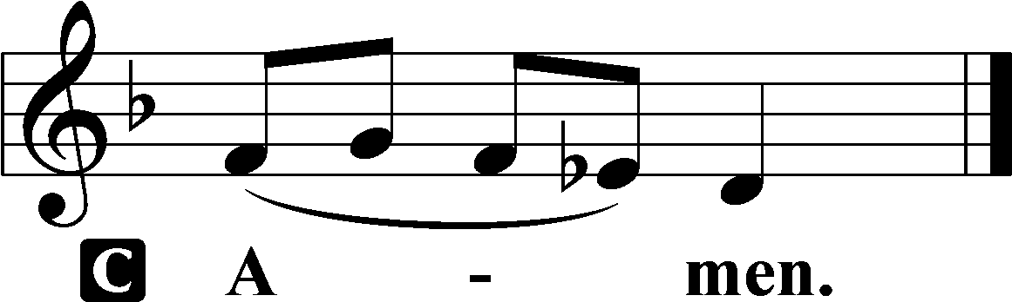

Benedicamus LSB 234
L Let us bless the Lord.
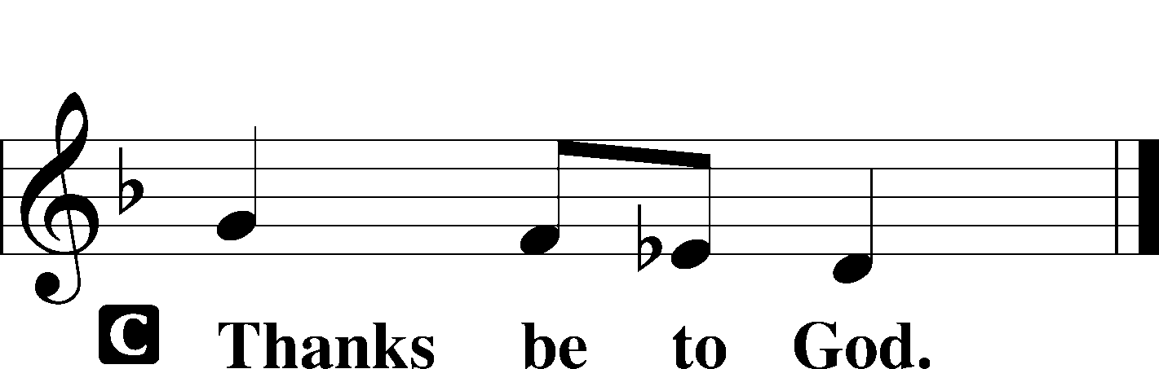

Benediction LSB 234
P The grace of our Lord T Jesus Christ and the love of God and the communion of the Holy Spirit be with you all.

Hymn: Lord Jesus Christ, Life Giving Bread LSB 625
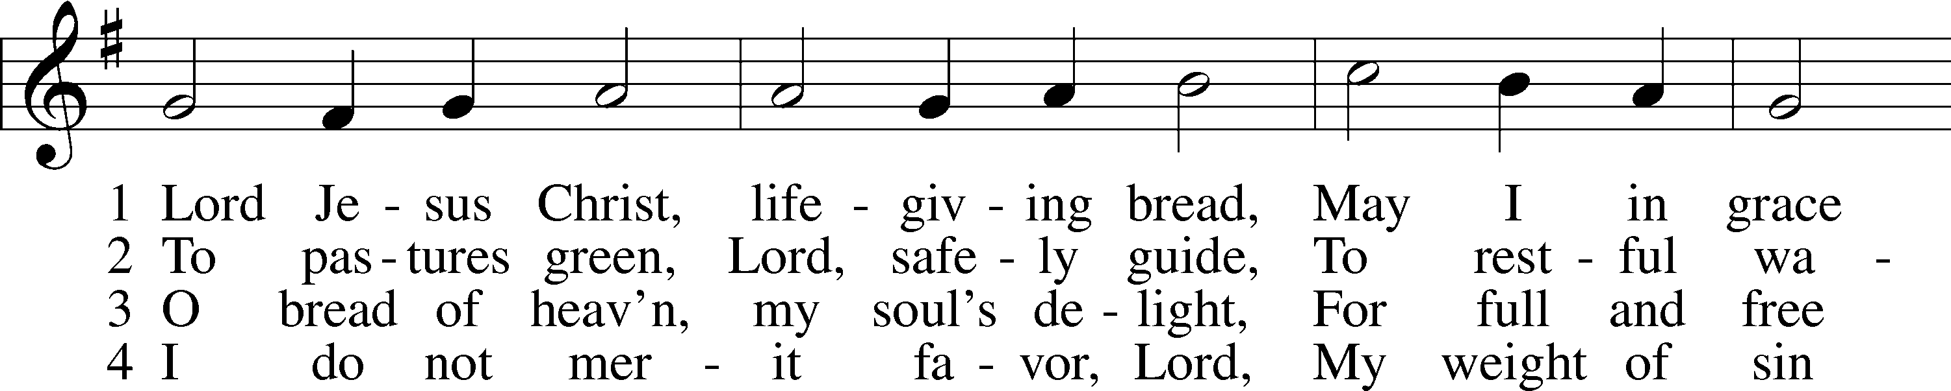
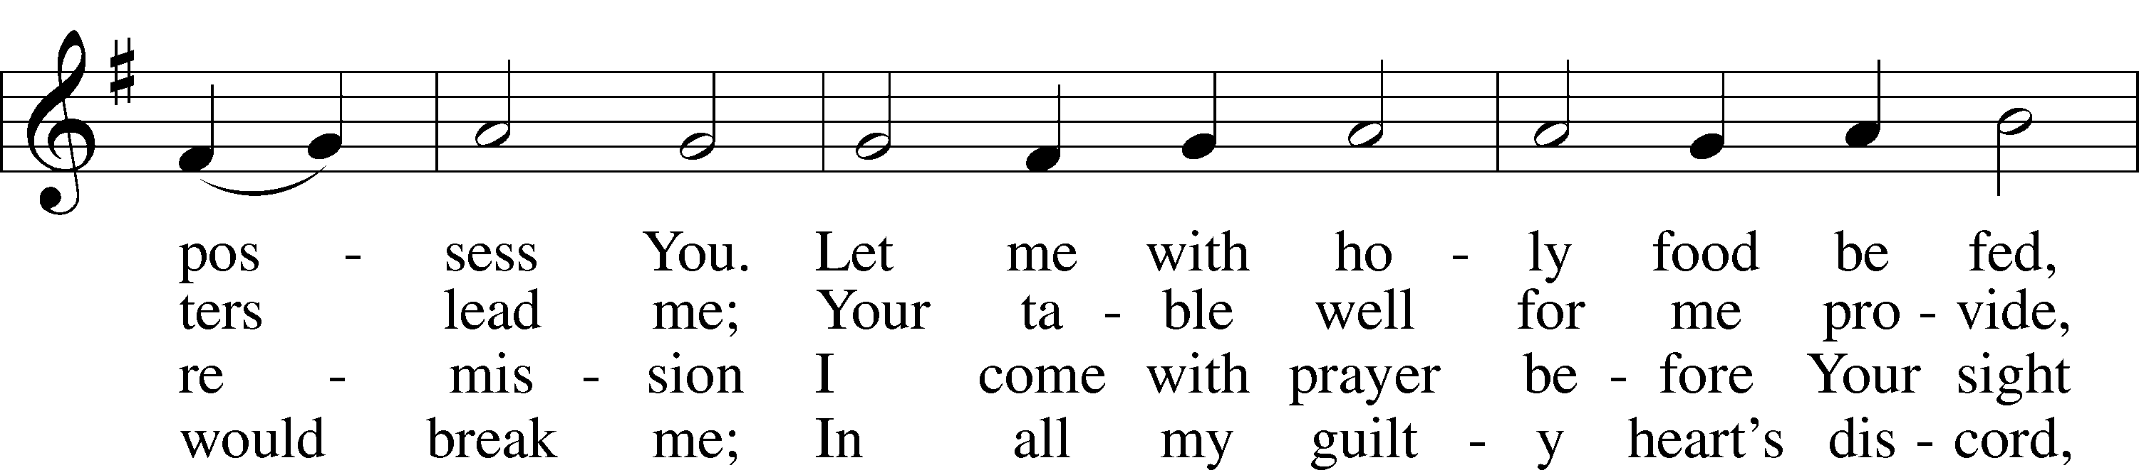
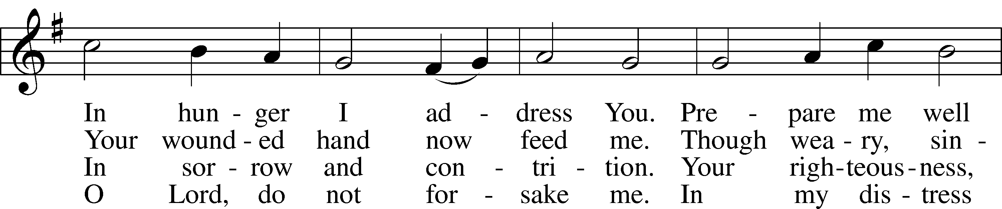
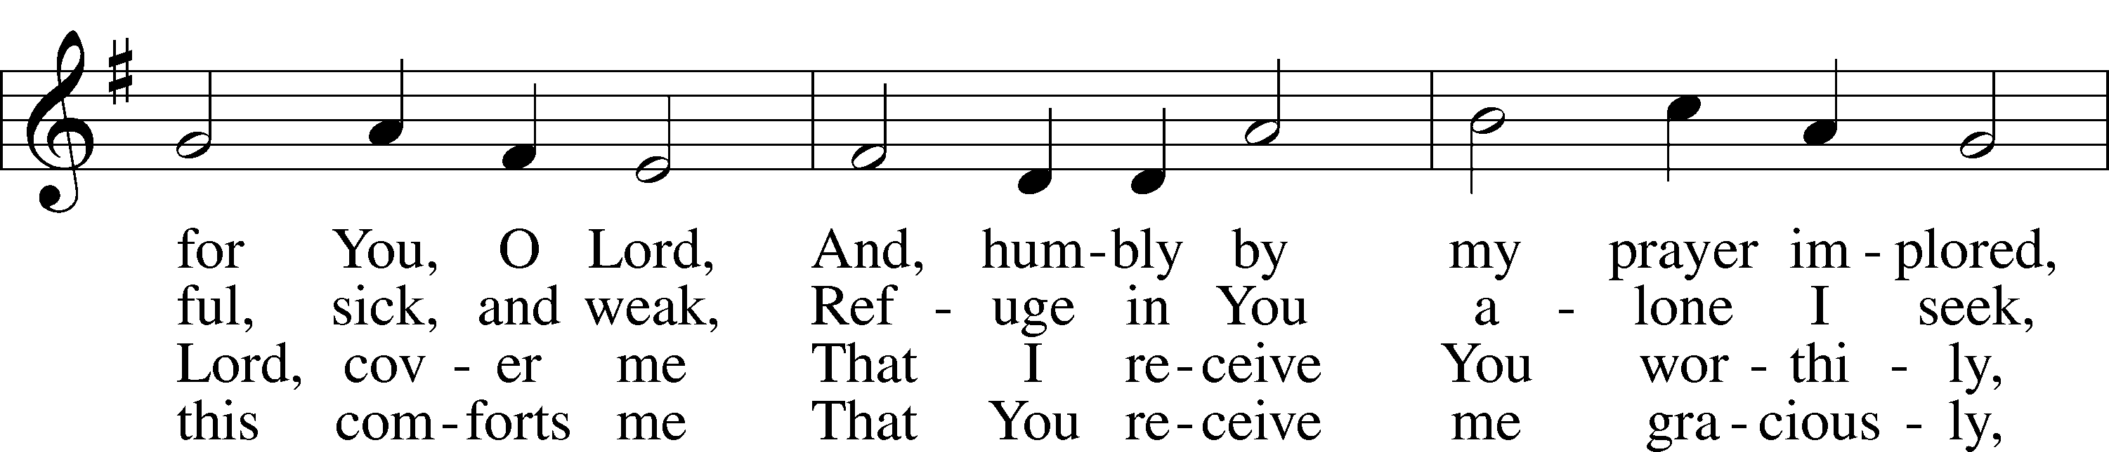
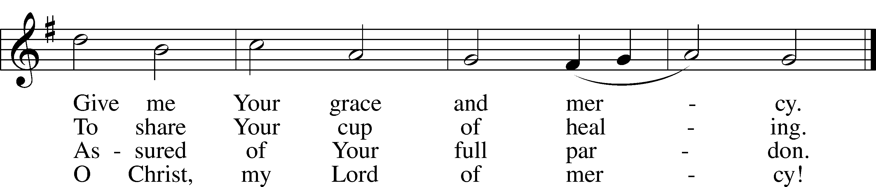
Text: Johann Rist, 1607–67; tr. Arthur T. Russell, 1806–74, alt.
Tune: Theütsch kirchen ampt, 1525, Strassburg
Text and tune: Public domain

Acknowledgments
Unless otherwise indicated, Scripture quotations are from the ESV® Bible (The Holy Bible, English Standard Version®), copyright © 2001 by Crossway, a publishing ministry of Good News Publishers. Used by permission. All rights reserved.
Created by Lutheran Service Builder © 2023 Concordia Publishing House.

