Midweek of Lent 1
March 1, 2023
12 Noon and 6:30 PM

Salem Lutheran Church
1-715-537-3011
http://www.salembarron.com
rev.mike.nielsen@gmail.com

Salt That Sweetens and Preserves

We are blessed to be God’s children—cleansed of sin, renewed by the Spirit, and salted in Christ Jesus. The promised treasures in God’s Word remind us of the importance of salt, which both sweetens and preserves things for our enjoyment. When Paul reminds us to let our conversations be “seasoned with salt” (Colossians 4:6), and when Jesus tells us that we are “the salt of the earth” (Matthew 5:13), the image is rich, for it is not only visual, but it also engages the sense of taste. We are reminded today that we are blessed to sweeten this world with the presence of Christ in us, even as Jesus Himself preserves our lives through His Word and Spirit.

Hymn: O Lord, Throughout These Forty Days LSB 418
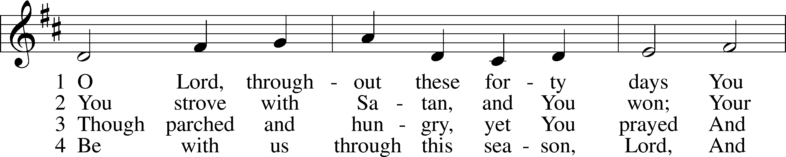
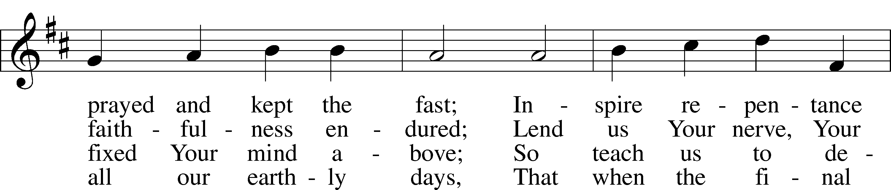
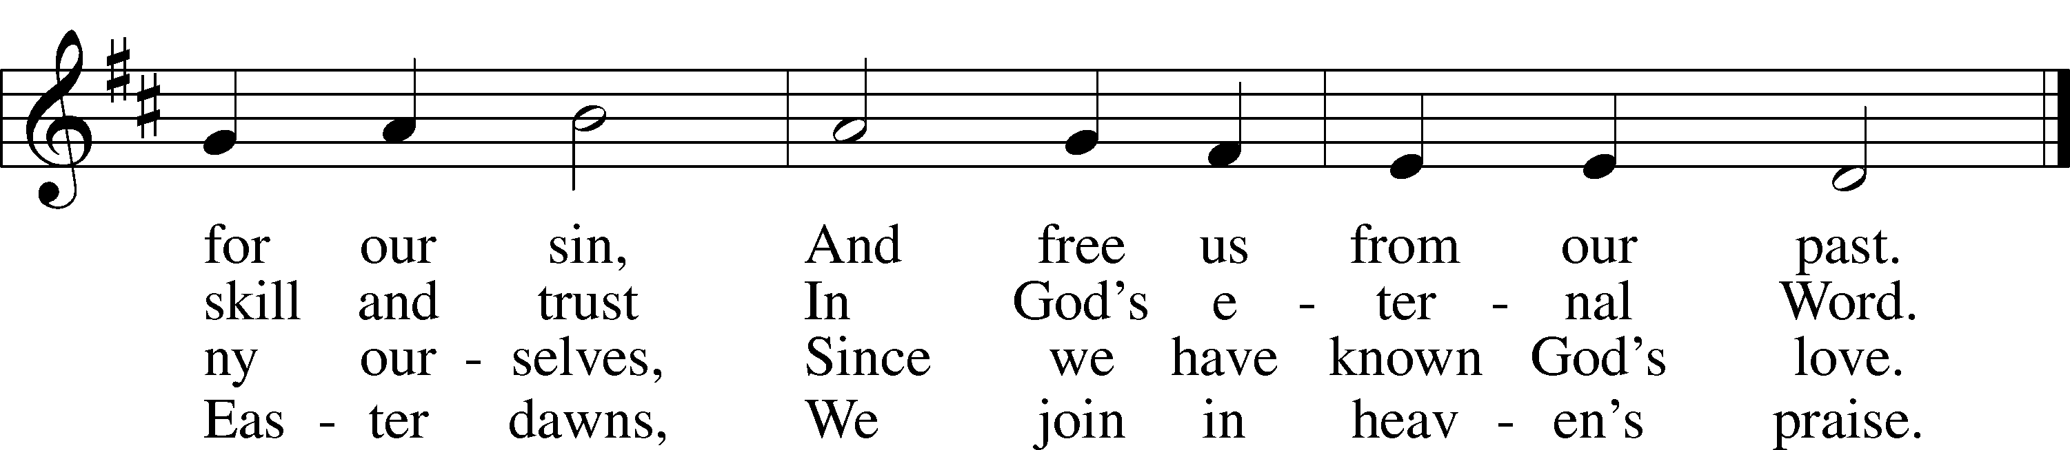
Text: based on Claudia F. Hernaman, 1838–98; para. Gilbert E. Doan, 1930
Tune: The Psalmes of David in Prose and Meeter, 1635, Edinburgh
Text: © 1978 Lutheran Book of Worship. Used by permission: LSB Hymn License no. 110005504
Tune: Public domain

Opening Sentences
L O Lord, open my lips,

L Make haste, O God, to deliver me;

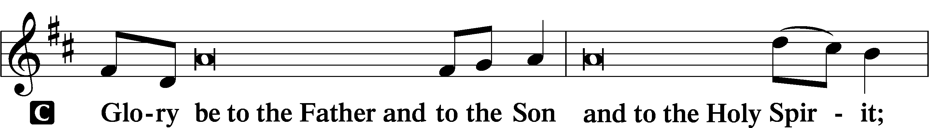
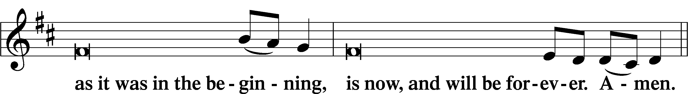
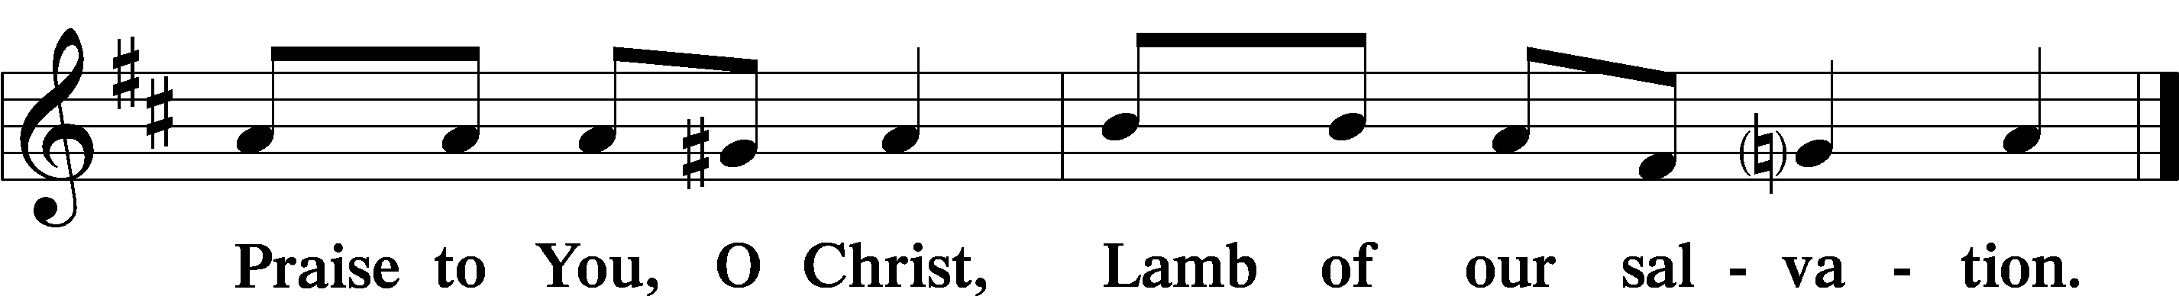

PSALMODY

Psalm Psalm 107:28–36
P Then they cried to the Lord in their trouble,
C and He delivered them from their distress.
P He made the storm be still,
C and the waves of the sea were hushed.
P Then they were glad that the waters were quiet,
C and He brought them to their desired haven.
P Let them thank the Lord for His steadfast love,
C for His wondrous works to the children of men!
P Let them extol Him in the congregation of the people,
C and praise Him in the assembly of the elders.
P He turns rivers into a desert, springs of water into thirsty ground,
C a fruitful land into a salty waste, because of the evil of its inhabitants.
P He turns a desert into pools of water, a parched land into springs of water.
C And there He lets the hungry dwell, and they establish a city to live in.
Glory be to the Father and to the Son and to the Holy Spirit;
as it was in the beginning, is now, and will be forever. Amen.

Series Hymn: One House Abides Unending See Insert

READINGS

Reading 2 Kings 2:19–22
P A reading from Second Kings, the second chapter.

19Now the men of the city said to Elisha, “Behold, the situation of this city is pleasant, as my lord sees, but the water is bad, and the land is unfruitful.” 20He said, “Bring me a new bowl, and put salt in it.” So they brought it to him. 21Then he went to the spring of water and threw salt in it and said, “Thus says the Lord, I have healed this water; from now on neither death nor miscarriage shall come from it.” 22So the water has been healed to this day, according to the word that Elisha spoke.

P O Lord, have mercy on us.
C Thanks be to God.

Reading Colossians 4:2–6
P A reading from Colossians, the fourth chapter.

Further Instructions
2Continue steadfastly in prayer, being watchful in it with thanksgiving. 3At the same time, pray also for us, that God may open to us a door for the word, to declare the mystery of Christ, on account of which I am in prison— 4that I may make it clear, which is how I ought to speak.
5Conduct yourselves wisely toward outsiders, making the best use of the time. 6Let your speech always be gracious, seasoned with salt, so that you may know how you ought to answer each person.

P O Lord, have mercy on us.
C Thanks be to God.

Reading Matthew 5:13–16
P A reading from St. Matthew, the fifth chapter.

Salt and Light
13“You are the salt of the earth, but if salt has lost its taste, how shall its saltiness be restored? It is no longer good for anything except to be thrown out and trampled under people’s feet.
14“You are the light of the world. A city set on a hill cannot be hidden. 15Nor do people light a lamp and put it under a basket, but on a stand, and it gives light to all in the house. 16In the same way, let your light shine before others, so that they may see your good works and give glory to your Father who is in heaven.

P O Lord, have mercy on us.
C Thanks be to God.

Lent Responsory LSB, p. 231
L Deliver me, O Lord, my God, for You are the God of my salvation.
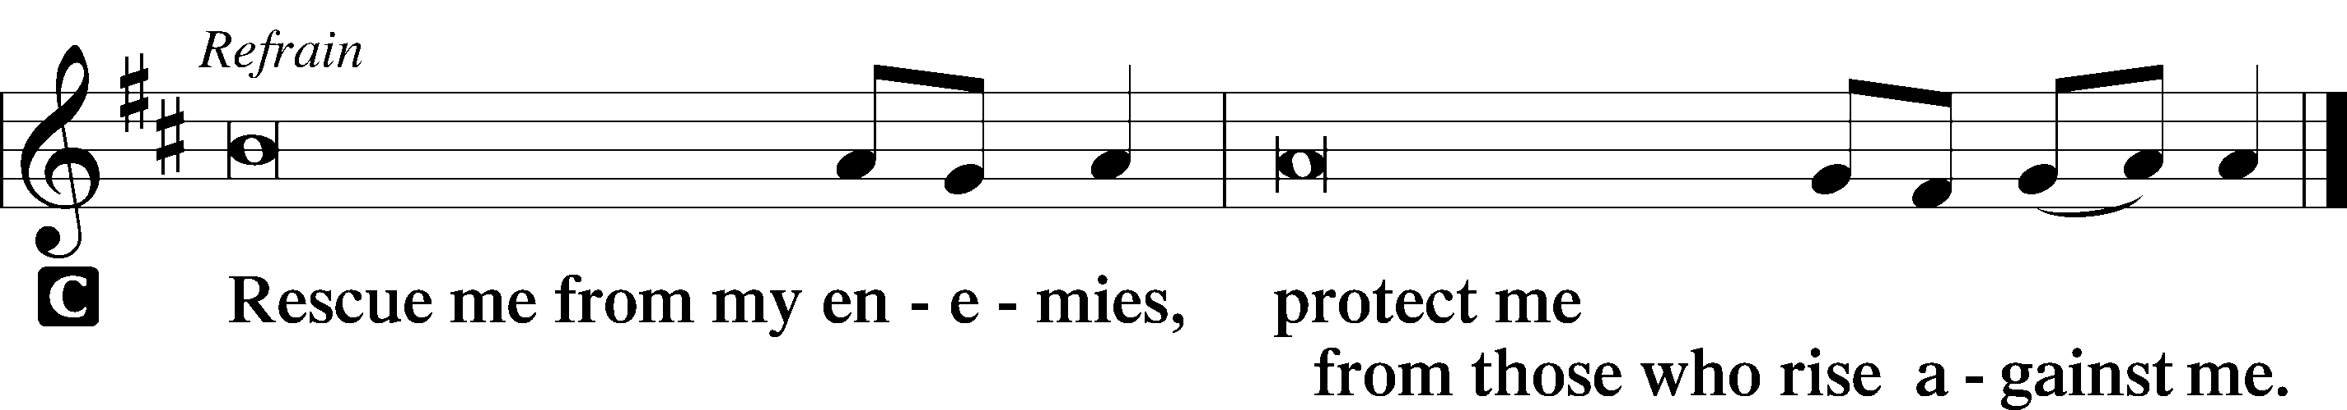

L In You, O Lord, do I put my trust, leave me not, O Lord, my God.

L Deliver me, O Lord, my God, for You are the God of my salvation.

Sermon

CANTICLE

Antiphon
L Let my prayer rise before You as incense,
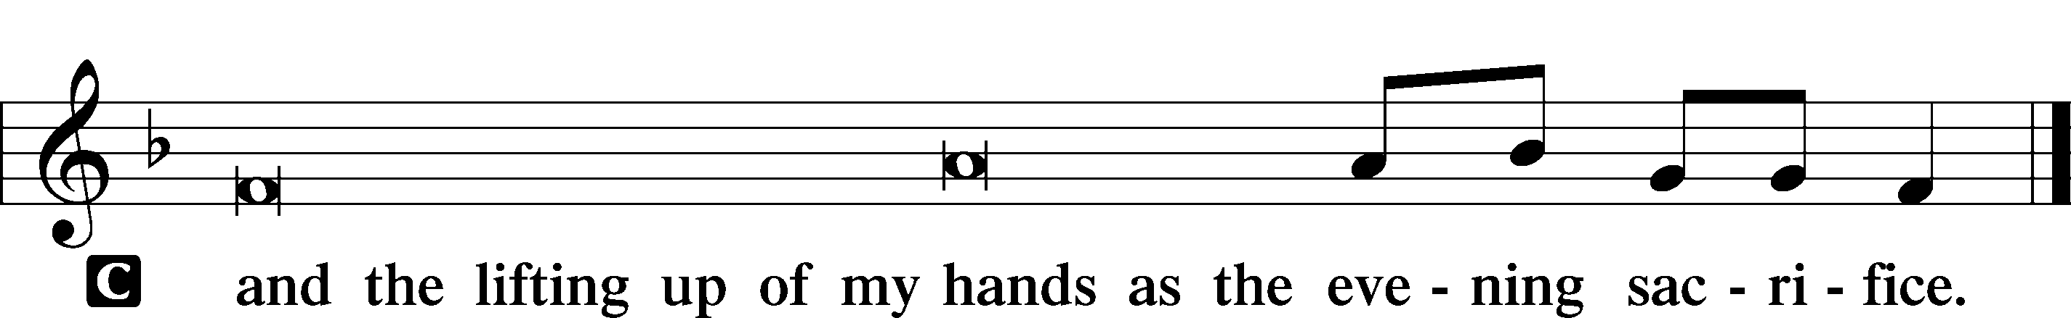

Magnificat LSB 231
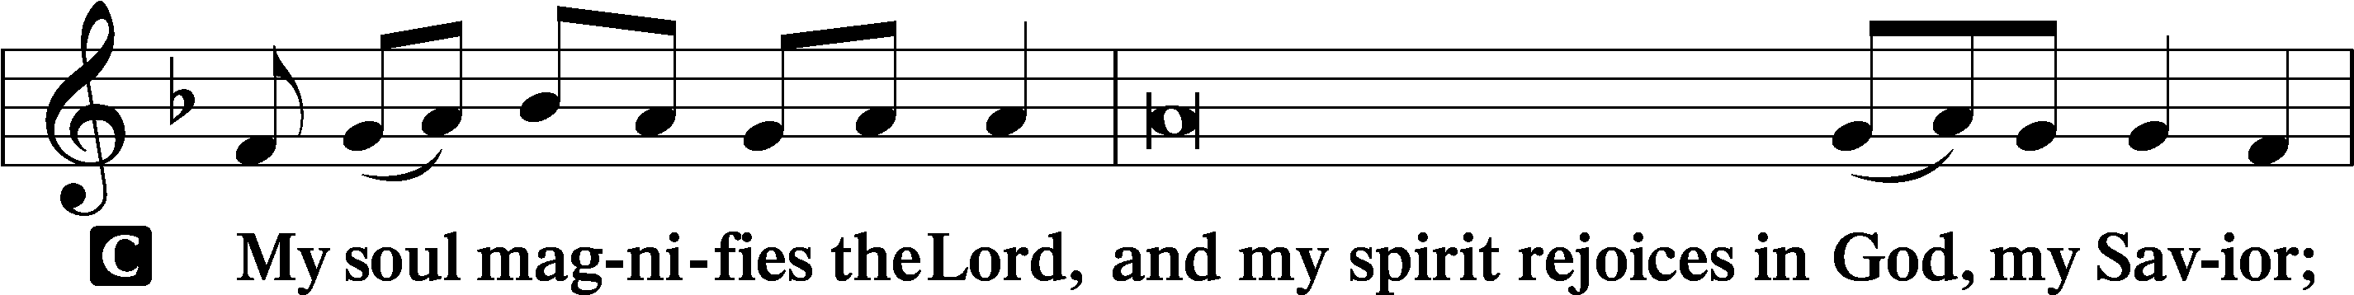
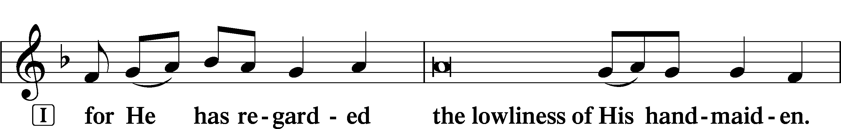
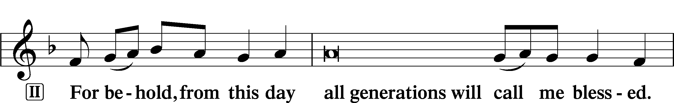
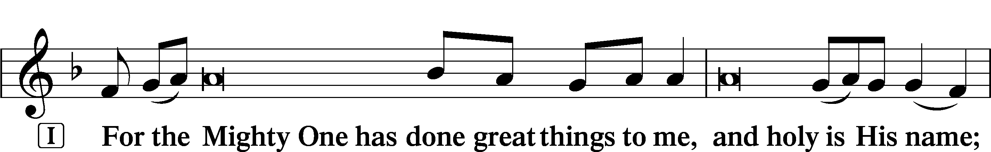
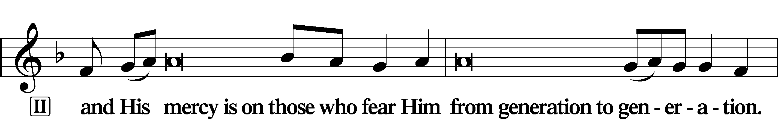
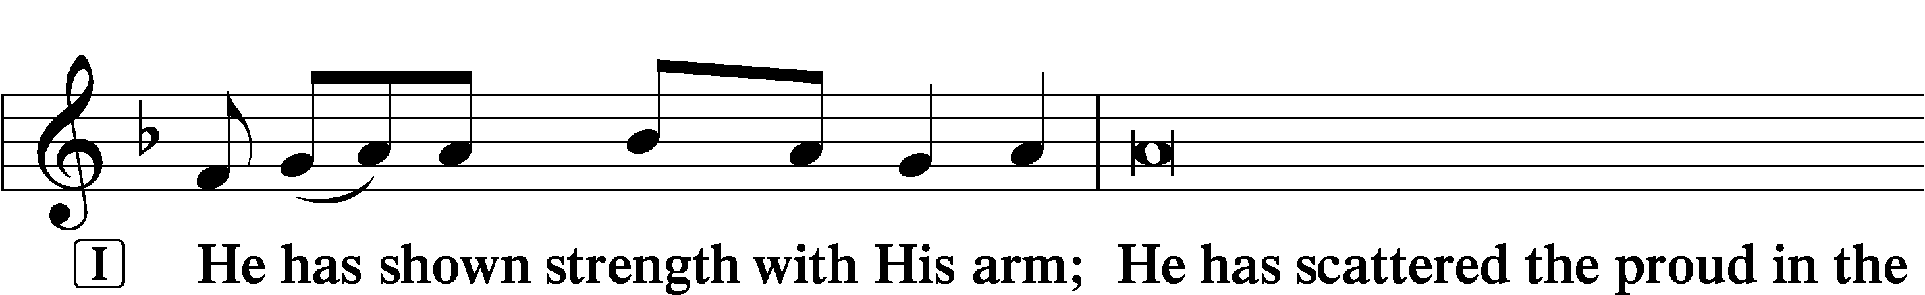
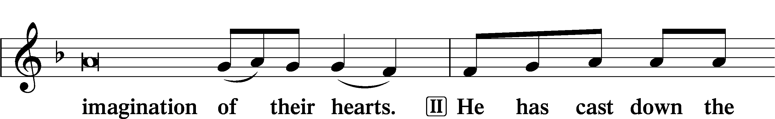
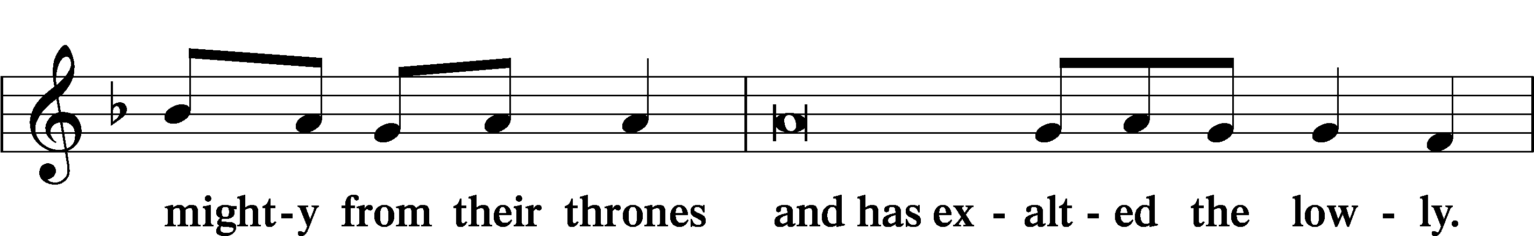
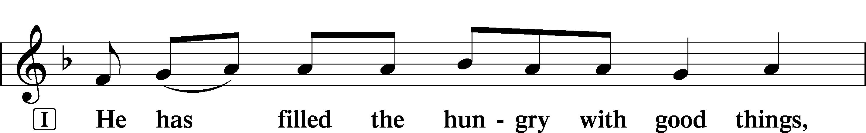
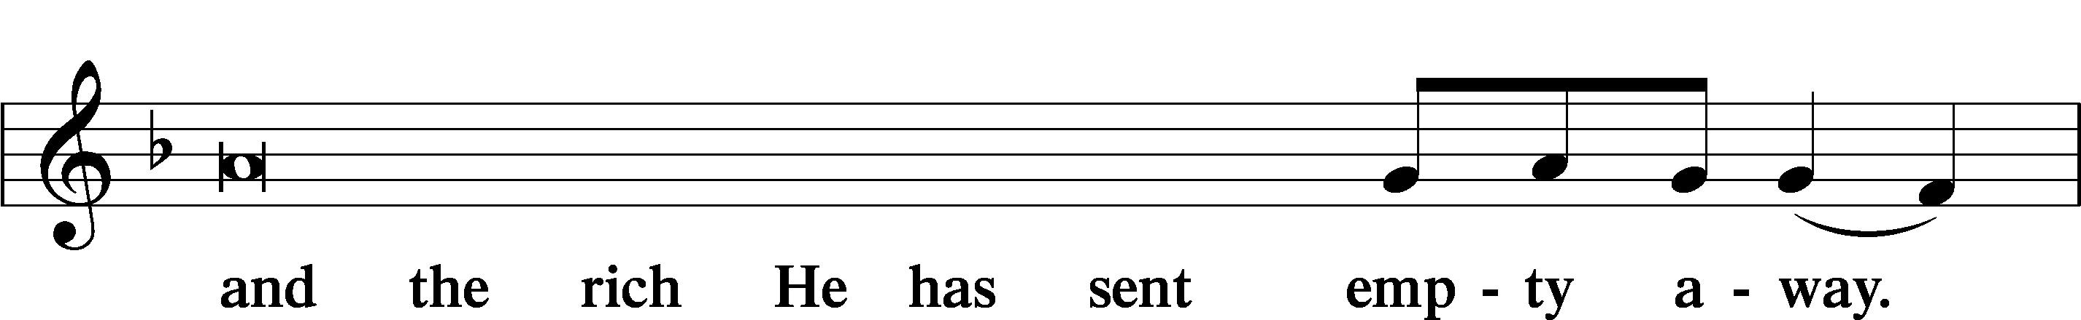
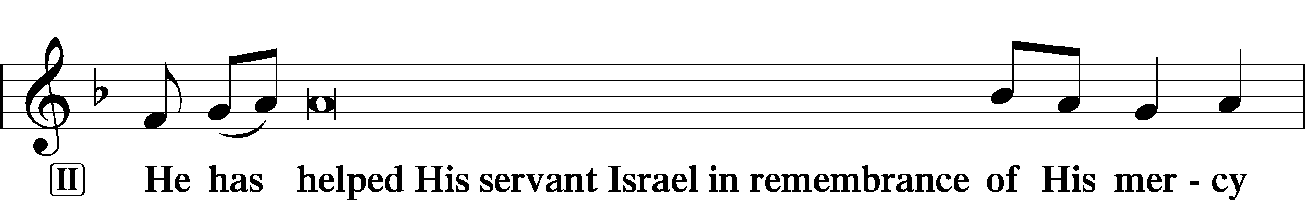
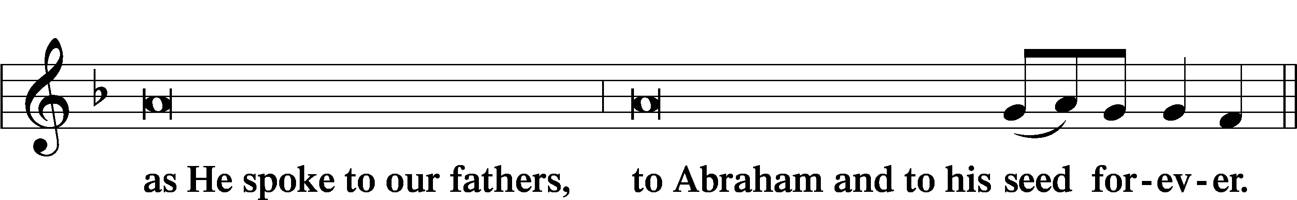
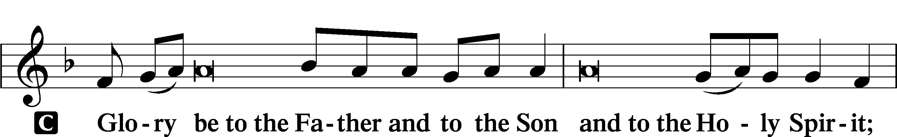
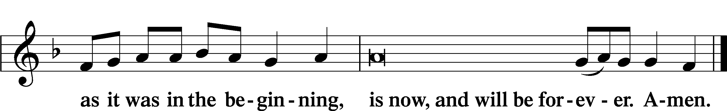

Offering

PRAYER

Kyrie
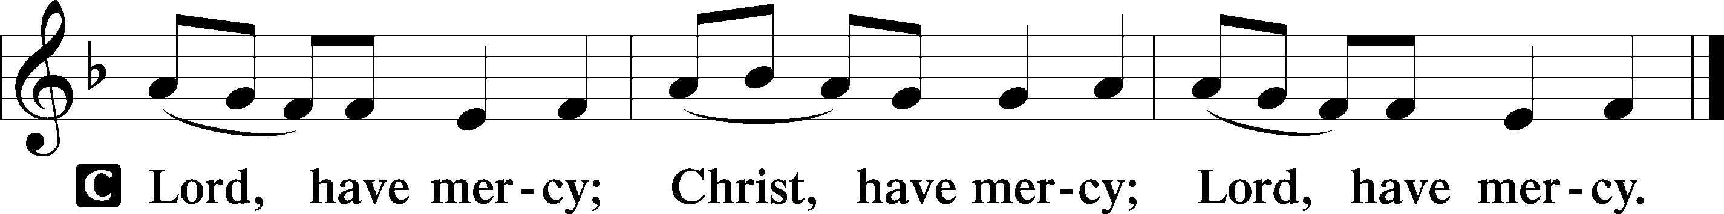

Lord’s Prayer
C Our Father who art in heaven,
hallowed be Thy name,
Thy kingdom come,
Thy will be done on earth
as it is in heaven;
give us this day our daily bread;
and forgive us our trespasses
as we forgive those
who trespass against us;
and lead us not into temptation,
but deliver us from evil.
For Thine is the kingdom
and the power and the glory
forever and ever. Amen.

Collects
P O Lord, hear my prayer.
C And let my cry come to You.

P Lord Jesus Christ, You call Your people to be the salt of the earth, to sweeten and preserve this world even as You have sweetened our lives with Your forgiveness and have preserved us by Your Spirit. Renew our hearts and minds during this Lenten season as we receive the promised treasures of Your Word; for You live and reign with the Father and the Holy Spirit, one God, now and forever.
C Amen.

P Gracious God, Father of our Lord Jesus Christ, we thank You for blessing us with the opportunity to meditate again on the cross of Christ and receive Your promised treasures.
C Grant that the message of the Lamb of God slain for our salvation bring us the riches of Your pardon and peace.

P Lead us to see that our sins caused Jesus’ great agony in the garden, that our sins nailed Him to the cross of Calvary,
C that He was forsaken by His Father so that we might never be forsaken, and that He died so that we may live.

P Lord Jesus, grant that especially during this sacred season the treasured story of Your wondrous love for us would draw us closer to You.
C Enable us to see that we are the salt of the earth, preserved by Your grace and sweetened by Your forgiveness.

P Holy Spirit, lift up troubled souls everywhere. Grant wholeness to those hurting in heart, body, and mind. Work Your healing power in the lives of those in need, [especially . . .], and in the lives of all we name before You in our hearts.
C All glory, honor, and praise be to You, with the Father and the Son, one God, now and forever. Amen.

P O God, from whom come all holy desires, all good counsels, and all just works, give to us, Your servants, that peace which the world cannot give, that our hearts may be set to obey Your commandments and also that we, being defended from the fear of our enemies, may live in peace and quietness; through Jesus Christ, Your Son, our Lord, who lives and reigns with You and the Holy Spirit, one God, now and forever.

Benedicamus LSB 234
L Let us bless the Lord.
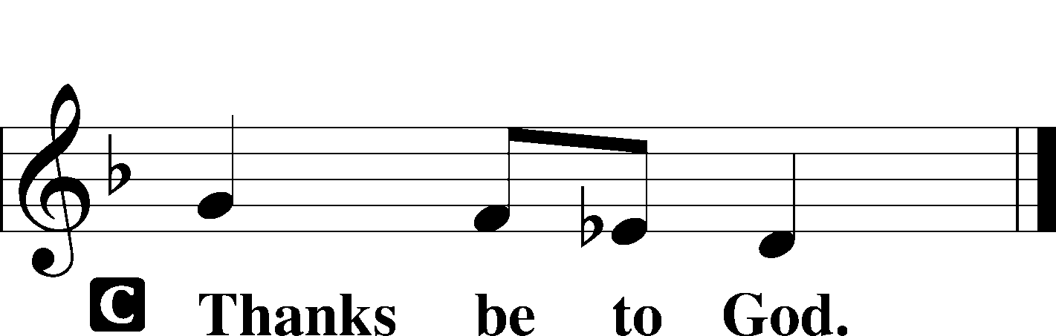

Benediction LSB 234
P The grace of our Lord T Jesus Christ and the love of God and the communion of the Holy Spirit be with you all.

Hymn: When I Survey the Wondrous Cross LSB 425
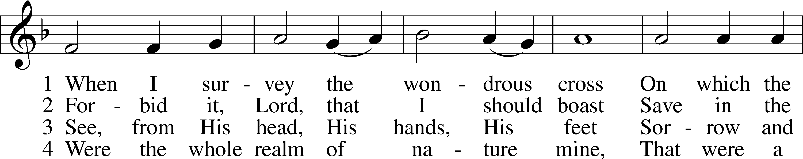
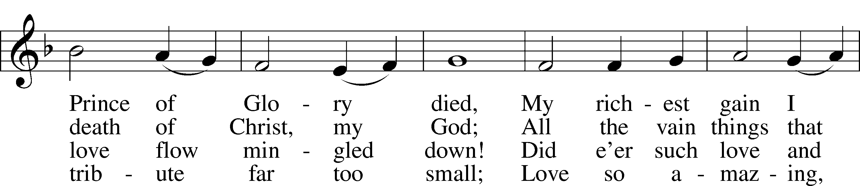
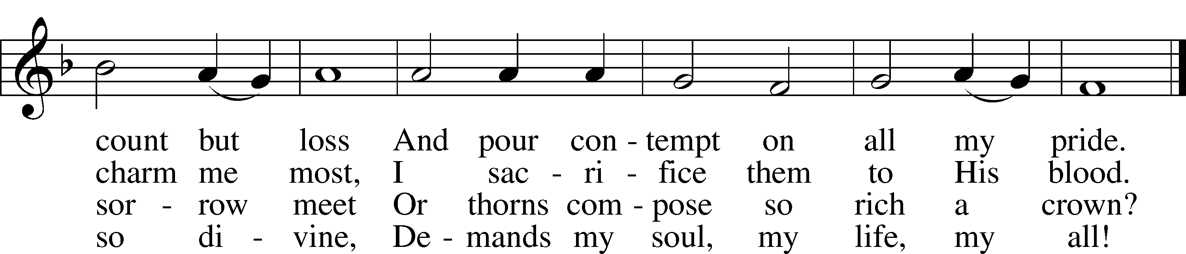
Text: Isaac Watts, 1674–1748
Tune: Lowell Mason, 1792–1872
Text and tune: Public domain

Acknowledgments
Unless otherwise indicated, Scripture quotations are from the ESV® Bible (The Holy Bible, English Standard Version®), copyright © 2001 by Crossway, a publishing ministry of Good News Publishers. Used by permission. All rights reserved.
Created by Lutheran Service Builder © 2023 Concordia Publishing House.

