Fourth Sunday in Lent
March 19, 2023
9:00 AM

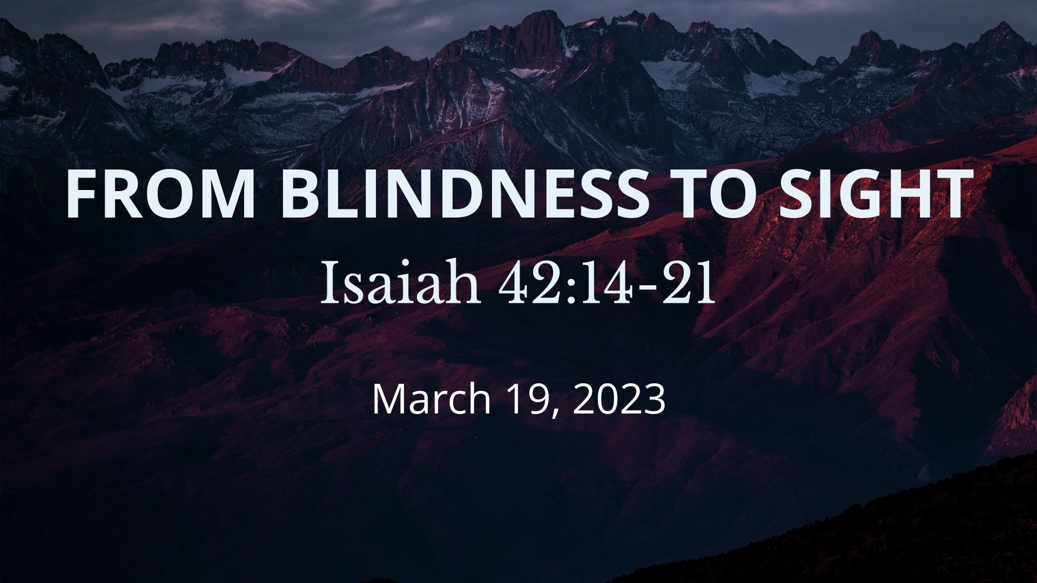

Salem Lutheran Church
1-715-537-3011
http://www.salembarron.com
rev.mike.nielsen@gmail.com
By His Word of the Gospel, Jesus Calls Us Out of the Darkness into His Marvelous Light

The Lord is grieved by the spiritual blindness of His people, yet in mercy He does not forsake them. He restrains His anger and keeps His peace, until He opens their ears and eyes to hear and see Him. “For his righteousness’ sake,” He magnifies His Word and makes it glorious in the coming of Christ Jesus (Is. 42:21). Jesus turns “the darkness before them into light” (Is. 42:16) because He is “the light of the world” (John 9:5). The incarnate Son of God does the works of His Father and displays the divine glory in His own flesh “while it is day,” until that night “when no one can work” (John 9:4). By the washing of water with His Word, He opens the eyes of the blind and grants rest to the weary. Therefore, though “at one time you were darkness,” now “you are light in the Lord” (Eph. 5:8). By our Baptism into Christ, we live in the eternal day of His resurrection, wherein He shines upon us. As often as we fall back into the darkness of sin, He calls us by the Gospel to “awake, O sleeper, and arise from the dead” (Eph. 5:14).
Confession and Absolution

Hymn of Invocation: Word of God, Come Down to Earth LSB 545
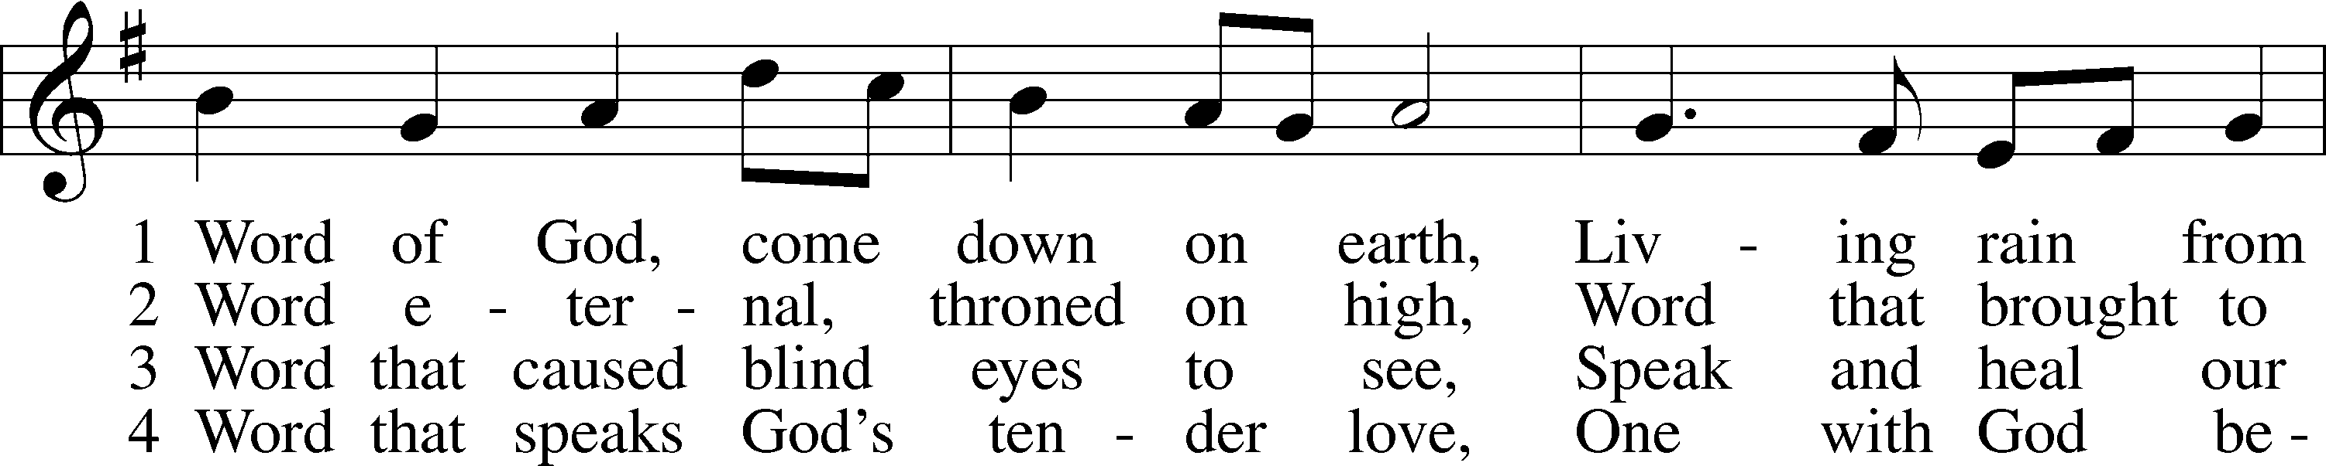
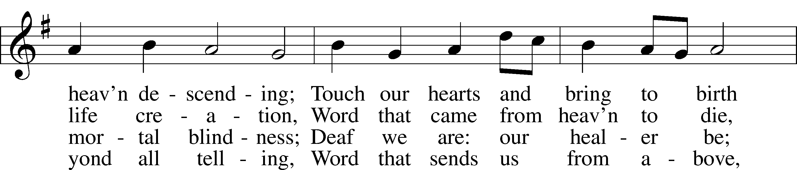
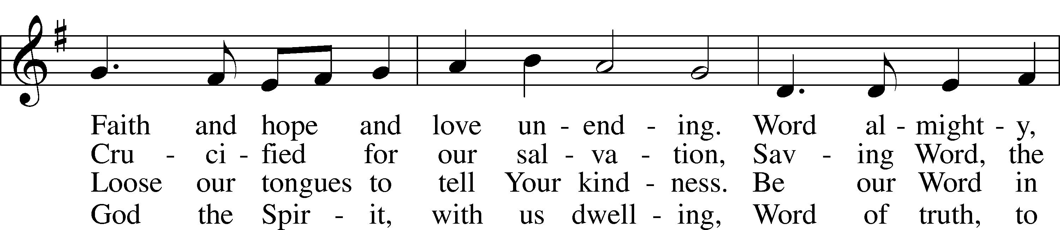
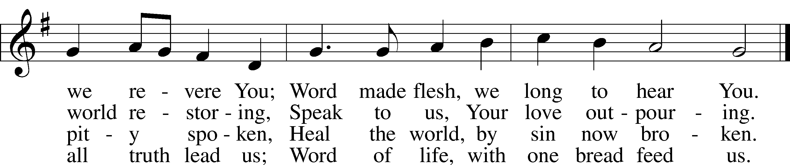
Text: James Quinn, 1919–2010
Tune: Johann Rudolph Ahle, 1625–73, alt.
Text: © 1969 OCP Publications. Used by permission: LSB Hymn License no. 110005504
Tune: Public domain

Stand

The sign of the cross may be made by all in remembrance of their Baptism.

Invocation
P In the name of the Father and of the T Son and of the Holy Spirit.
C Amen.

Exhortation LSB 203
P Our help is in the name of the Lord,
C who made heaven and earth.

P If You, O Lord, kept a record of sins, O Lord, who could stand?
C But with You there is forgiveness; therefore You are feared.

P Since we are gathered to hear God’s Word, call upon Him in prayer and praise, and receive the body and blood of our Lord Jesus Christ in the fellowship of this altar, let us first consider our unworthiness and confess before God and one another that we have sinned in thought, word, and deed, and that we cannot free ourselves from our sinful condition. Together as His people let us take refuge in the infinite mercy of God, our heavenly Father, seeking His grace for the sake of Christ, and saying: God, be merciful to me, a sinner.

Kneel/Stand

Confession of Sins LSB 203
C Almighty God, have mercy upon us, forgive us our sins, and lead us to everlasting life. Amen.

Absolution LSB 203
P Almighty God in His mercy has given His Son to die for you and for His sake forgives you all your sins. As a called and ordained servant of Christ, and by His authority, I therefore forgive you all your sins in the name of the Father and of the T Son and of the Holy Spirit.
C Amen.

Stand

Service of the Word

Introit Psalm 27:4–6; antiphon: Psalm 25:15
My eyes are ever toward the Lord,
for he will pluck my feet out of the net.
One thing have I asked of the Lord, that will I seek after:
that I may dwell in the house of the Lord all the days of my life, to gaze upon the beauty of the Lord and to inquire in his temple.
For he will hide me in his shelter in the day of trouble;
he will conceal me under the cover of his tent; he will lift me high upon a rock.
And now my head shall be lifted up above my enemies all around me, and I will offer in his tent sacrifices with shouts of joy;
I will sing and make melody to the Lord.
Glory be to the Father and to the Son
and to the Holy Spirit;
as it was in the beginning,
is now, and will be forever. Amen.
My eyes are ever toward the Lord,
for he will pluck my feet out of the net.

Kyrie LSB 204
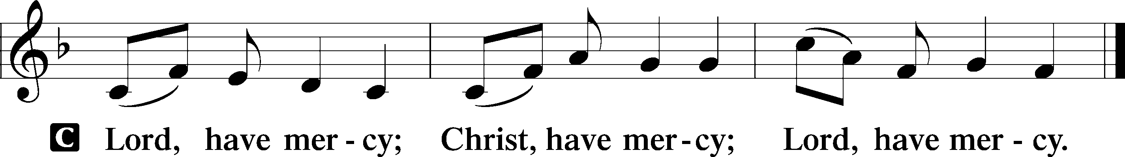

Salutation and Collect of the Day
P The Lord be with you.
C And also with you.

P Let us pray.
Almighty God, our heavenly Father, Your mercies are new every morning; and though we deserve only punishment, You receive us as Your children and provide for all our needs of body and soul. Grant that we may heartily acknowledge Your merciful goodness, give thanks for all Your benefits, and serve You in willing obedience; through Jesus Christ, Your Son, our Lord, who lives and reigns with You and the Holy Spirit, one God, now and forever.

C Amen.

Sit

Old Testament Reading Isaiah 42:14–21
14For a long time I have held my peace;
I have kept still and restrained myself;
now I will cry out like a woman in labor;
I will gasp and pant.
15I will lay waste mountains and hills,
and dry up all their vegetation;
I will turn the rivers into islands,
and dry up the pools.
16And I will lead the blind
in a way that they do not know,
in paths that they have not known
I will guide them.
I will turn the darkness before them into light,
the rough places into level ground.
These are the things I do,
and I do not forsake them.
17They are turned back and utterly put to shame,
who trust in carved idols,
who say to metal images,
“You are our gods.”
Israel’s Failure to Hear and See
18Hear, you deaf,
and look, you blind, that you may see!
19Who is blind but my servant,
or deaf as my messenger whom I send?
Who is blind as my dedicated one,
or blind as the servant of the Lord?
20He sees many things, but does not observe them;
his ears are open, but he does not hear.
21The Lord was pleased, for his righteousness’ sake,
to magnify his law and make it glorious.

A This is the Word of the Lord.
C Thanks be to God.

Epistle Ephesians 5:8–14
8For at one time you were darkness, but now you are light in the Lord. Walk as children of light 9(for the fruit of light is found in all that is good and right and true), 10and try to discern what is pleasing to the Lord. 11Take no part in the unfruitful works of darkness, but instead expose them. 12For it is shameful even to speak of the things that they do in secret. 13But when anything is exposed by the light, it becomes visible, 14for anything that becomes visible is light. Therefore it says,
“Awake, O sleeper,
and arise from the dead,
and Christ will shine on you.”

A This is the Word of the Lord.
C Thanks be to God.

Stand

Alleluia and Verse

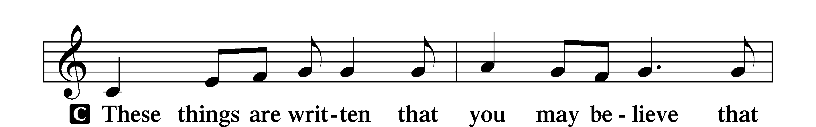
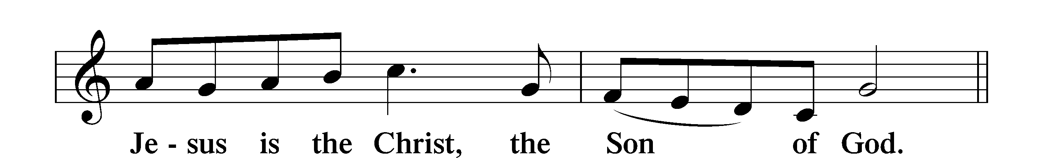

Holy Gospel John 9:1–41
P The Holy Gospel according to St. John, the ninth chapter.
C Glory to You, O Lord.

Jesus Heals a Man Born Blind
1As [Jesus] passed by, he saw a man blind from birth. 2And his disciples asked him, “Rabbi, who sinned, this man or his parents, that he was born blind?” 3Jesus answered, “It was not that this man sinned, or his parents, but that the works of God might be displayed in him. 4We must work the works of him who sent me while it is day; night is coming, when no one can work. 5As long as I am in the world, I am the light of the world.” 6Having said these things, he spat on the ground and made mud with the saliva. Then he anointed the man’s eyes with the mud 7and said to him, “Go, wash in the pool of Siloam” (which means Sent). So he went and washed and came back seeing.
8The neighbors and those who had seen him before as a beggar were saying, “Is this not the man who used to sit and beg?” 9Some said, “It is he.” Others said, “No, but he is like him.” He kept saying, “I am the man.” 10So they said to him, “Then how were your eyes opened?” 11He answered, “The man called Jesus made mud and anointed my eyes and said to me, ‘Go to Siloam and wash.’ So I went and washed and received my sight.” 12They said to him, “Where is he?” He said, “I do not know.”
13They brought to the Pharisees the man who had formerly been blind. 14Now it was a Sabbath day when Jesus made the mud and opened his eyes. 15So the Pharisees again asked him how he had received his sight. And he said to them, “He put mud on my eyes, and I washed, and I see.” 16Some of the Pharisees said, “This man is not from God, for he does not keep the Sabbath.” But others said, “How can a man who is a sinner do such signs?” And there was a division among them. 17So they said again to the blind man, “What do you say about him, since he has opened your eyes?” He said, “He is a prophet.”
18The Jews did not believe that he had been blind and had received his sight, until they called the parents of the man who had received his sight 19and asked them, “Is this your son, who you say was born blind? How then does he now see?” 20His parents answered, “We know that this is our son and that he was born blind. 21But how he now sees we do not know, nor do we know who opened his eyes. Ask him; he is of age. He will speak for himself.” 22(His parents said these things because they feared the Jews, for the Jews had already agreed that if anyone should confess Jesus to be Christ, he was to be put out of the synagogue.) 23Therefore his parents said, “He is of age; ask him.”
24So for the second time they called the man who had been blind and said to him, “Give glory to God. We know that this man is a sinner.” 25He answered, “Whether he is a sinner I do not know. One thing I do know, that though I was blind, now I see.” 26They said to him, “What did he do to you? How did he open your eyes?” 27He answered them, “I have told you already, and you would not listen. Why do you want to hear it again? Do you also want to become his disciples?” 28And they reviled him, saying, “You are his disciple, but we are disciples of Moses. 29We know that God has spoken to Moses, but as for this man, we do not know where he comes from.” 30The man answered, “Why, this is an amazing thing! You do not know where he comes from, and yet he opened my eyes. 31We know that God does not listen to sinners, but if anyone is a worshiper of God and does his will, God listens to him. 32Never since the world began has it been heard that anyone opened the eyes of a man born blind. 33If this man were not from God, he could do nothing.” 34They answered him, “You were born in utter sin, and would you teach us?” And they cast him out.
35Jesus heard that they had cast him out, and having found him he said, “Do you believe in the Son of Man?” 36He answered, “And who is he, sir, that I may believe in him?” 37Jesus said to him, “You have seen him, and it is he who is speaking to you.” 38He said, “Lord, I believe,” and he worshiped him. 39Jesus said, “For judgment I came into this world, that those who do not see may see, and those who see may become blind.” 40Some of the Pharisees near him heard these things, and said to him, “Are we also blind?” 41Jesus said to them, “If you were blind, you would have no guilt; but now that you say, ‘We see,’ your guilt remains.”

P This is the Gospel of the Lord.
C Praise to You, O Christ.

Nicene Creed
C I believe in one God,
the Father Almighty,
maker of heaven and earth
and of all things visible and invisible.

And in one Lord Jesus Christ,
the only-begotten Son of God,
begotten of His Father before all worlds,
God of God, Light of Light,
very God of very God,
begotten, not made,
being of one substance with the Father,
by whom all things were made;
who for us men and for our salvation came down from heaven
and was incarnate by the Holy Spirit of the virgin Mary
and was made man;
and was crucified also for us under Pontius Pilate.
He suffered and was buried.
And the third day He rose again according to the Scriptures
and ascended into heaven
and sits at the right hand of the Father.
And He will come again with glory to judge both the living and the dead,
whose kingdom will have no end.

And I believe in the Holy Spirit,
the Lord and giver of life,
who proceeds from the Father and the Son,
who with the Father and the Son together is worshiped and glorified,
who spoke by the prophets.
And I believe in one holy Christian and apostolic Church,
I acknowledge one Baptism for the remission of sins,
and I look for the resurrection of the dead
and the life T of the world to come. Amen.

Sit

Hymn of the Day: God Loved the World so That He Gave LSB 571
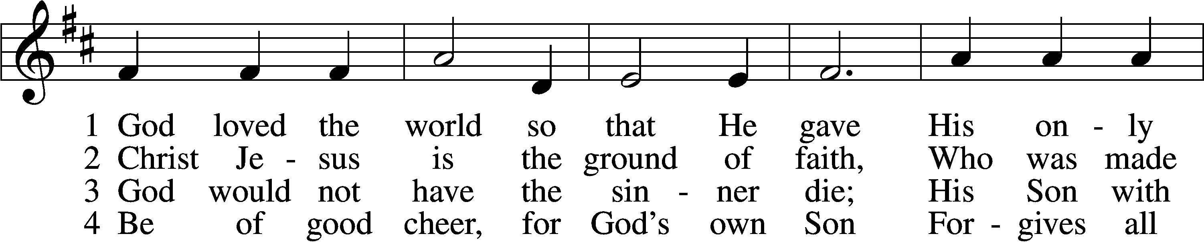
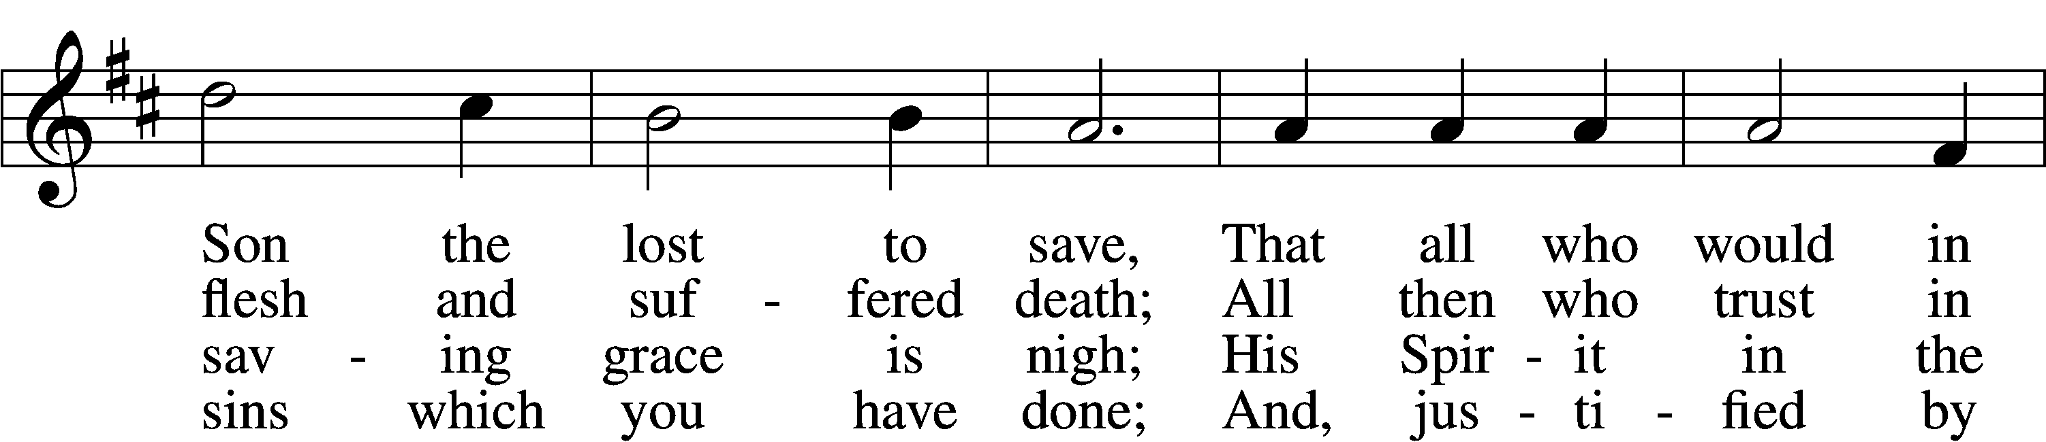
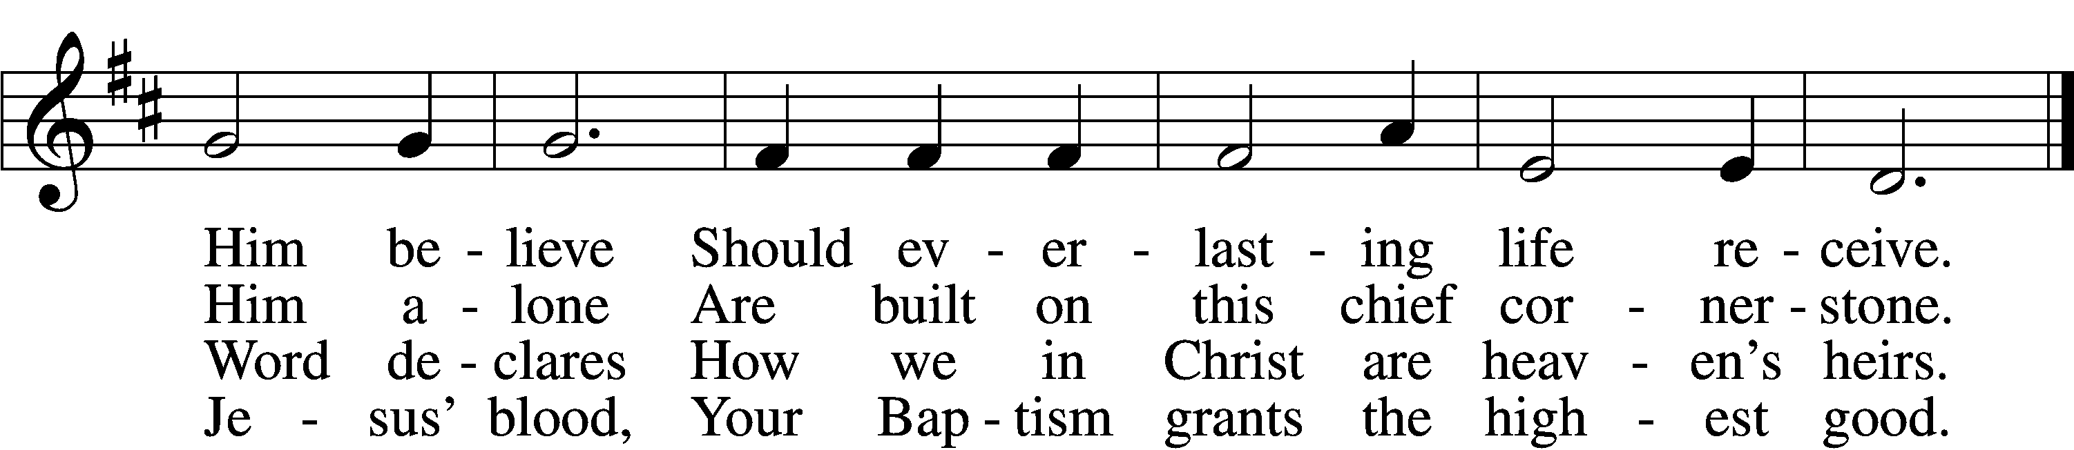

5 If you are sick, if death is near,
This truth your troubled heart can cheer:
Christ Jesus saves your soul from death;
That is the firmest ground of faith.

D 6 Glory to God the Father, Son,
And Holy Spirit, Three in One!
To You, O blessèd Trinity,
Be praise now and eternally!
Text: Heiliges Lippen- und Hertzens-Opffer, c. 1778, Stettin; tr. August Crull, 1845–1923, alt.
Tune: George J. Elvey, 1816–93
Text and tune: Public domain

Sermon

Stand

Prayer of the Church

Sit

Offering and Hymn
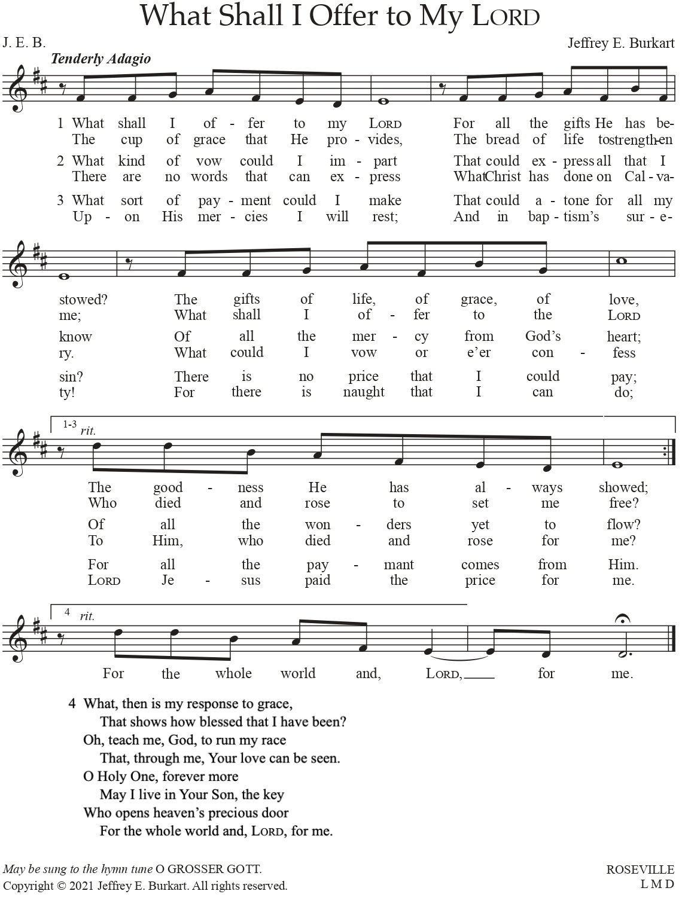
Used by permission of the Author: Dr. Jeffrey E. Burkhart

Service of the Sacrament

Stand

Preface LSB 208
P The Lord be with you.
C And also with you.

P Lift up your hearts.
C We lift them to the Lord.

P Let us give thanks to the Lord our God.
C It is right to give Him thanks and praise.

P It is truly good, right, and salutary that we should at all times and in all places give thanks to You, O Lord, holy Father, almighty and everlasting God, for the countless blessings You so freely bestow on us and all creation. Above all, we give thanks for Your boundless love shown to us when You sent Your only-begotten Son, Jesus Christ, into our flesh and laid on Him our sin, giving Him into death that we might not die eternally. Because He is now risen from the dead and lives and reigns to all eternity, all who believe in Him will overcome sin and death and will rise again to new life. Therefore with angels and archangels and with all the company of heaven we laud and magnify Your glorious name, evermore praising You and saying:

Sanctus LSB 208
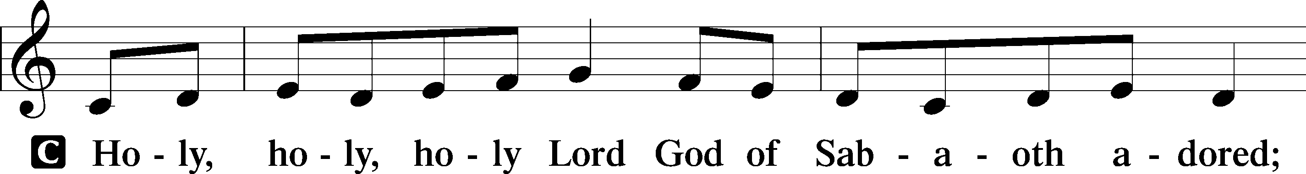
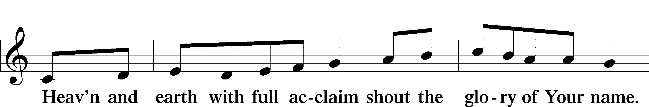
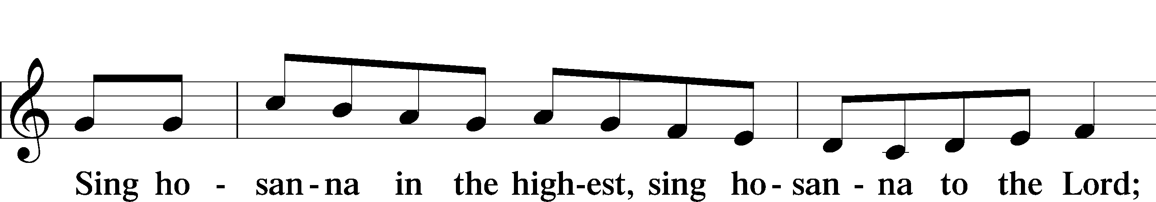
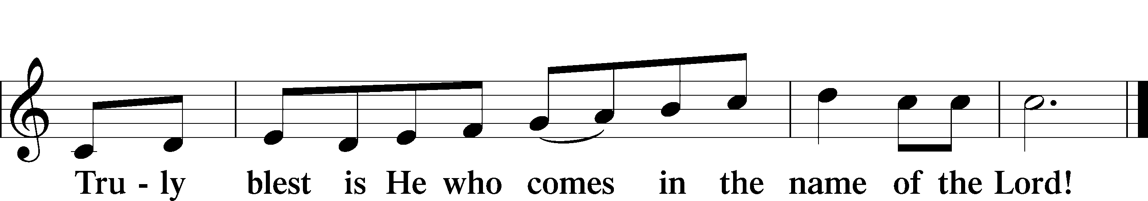
Text: Stephen P. Starke

Prayer of Thanksgiving
P Blessed are You, O Lord our God, king of all creation, for You have had mercy on us and given Your only-begotten Son that whoever believes in Him should not perish but have eternal life.

At Your command, Abraham prepared to offer his son Isaac as a sacrifice on the mountain; yet, in mercy You provided a ram as a substitute. We give You thanks that on Calvary You spared not Your only Son but sent Him to offer His life as a ransom for many.

As we eat and drink His body and blood, grant us, like Abraham our father, to trust in Your promise now fulfilled in Christ, the Lamb of God, who takes away the sin of the world.

Hear us as we pray in His name and as He has taught us:

Lord’s Prayer
C Our Father who art in heaven,
hallowed be Thy name,
Thy kingdom come,
Thy will be done on earth
as it is in heaven;
give us this day our daily bread;
and forgive us our trespasses
as we forgive those
who trespass against us;
and lead us not into temptation,
but deliver us from evil.
For Thine is the kingdom
and the power and the glory
forever and ever. Amen.

The Words of Our Lord
P Our Lord Jesus Christ, on the night when He was betrayed, took bread, and when He had given thanks, He broke it and gave it to the disciples and said: “Take, eat; this is My T body, which is given for you. This do in remembrance of Me.”

In the same way also He took the cup after supper, and when He had given thanks, He gave it to them, saying: “Drink of it, all of you; this cup is the new testament in My T blood, which is shed for you for the forgiveness of sins. This do, as often as you drink it, in remembrance of Me.”

Pax Domini
P The peace of the Lord be with you always.
C Amen.

Agnus Dei LSB 210
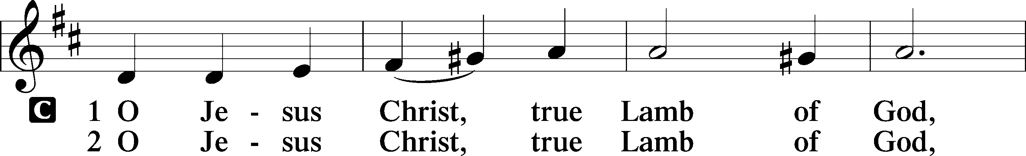
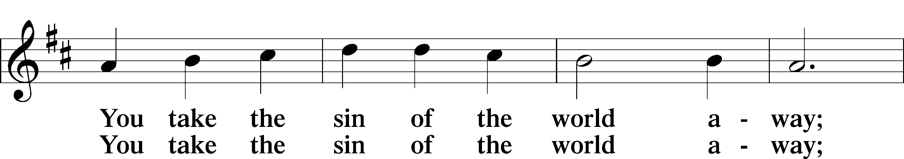
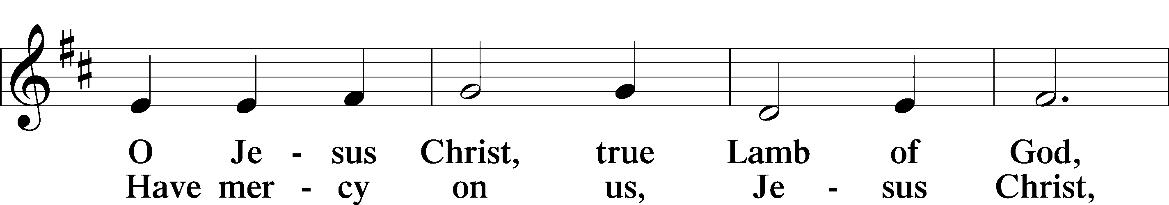
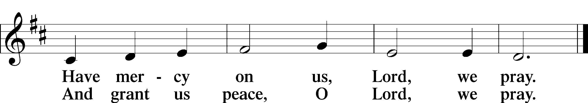
Text: Stephen P. Starke

Sit

Distribution

Distribution Hymn: Not All the Blood of Beasts LSB 431
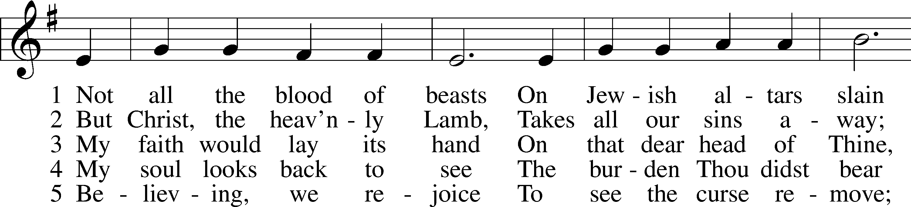
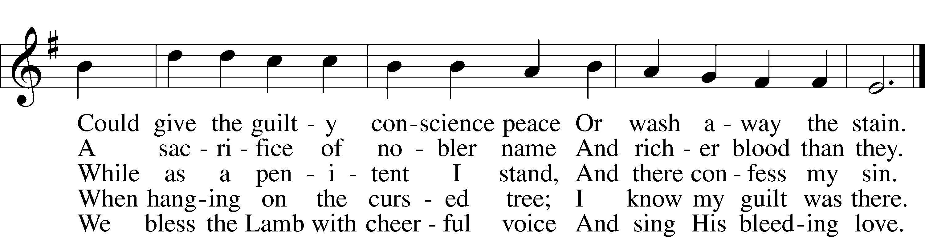
Text: Isaac Watts, 1674–1748, alt.
Tune: William Daman, c. 1540–1591
Text and tune: Public domain

Distribution Hymn: Amazing Grace LSB 744 sts. 1–5
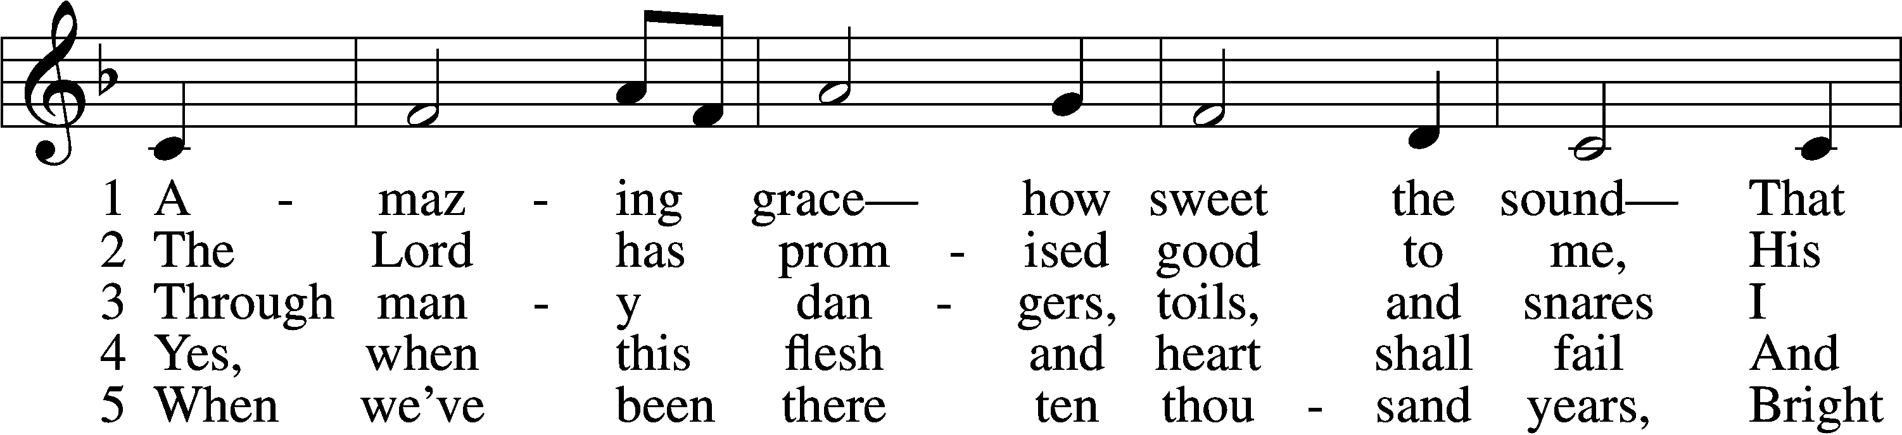
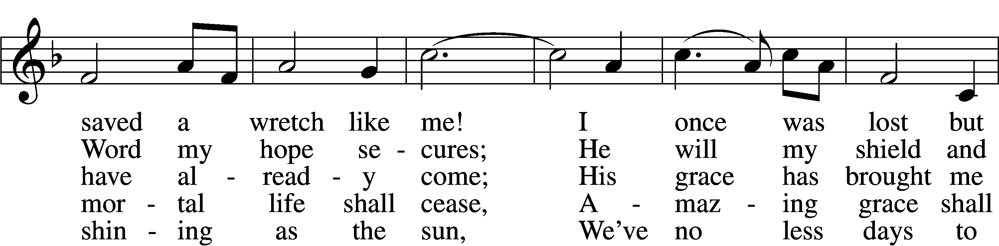
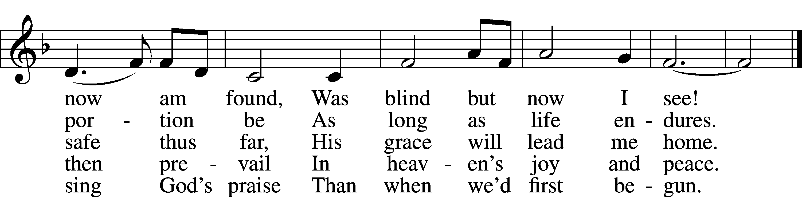
Text (sts. 1–4): John Newton, 1725–1807, alt.; (st. 5): A Collection of Sacred Ballads, 1790, Richmond
Tune: Columbian Harmony, 1829, Cincinnati
Text and tune: Public domain

Stand

Nunc Dimittis LSB 211
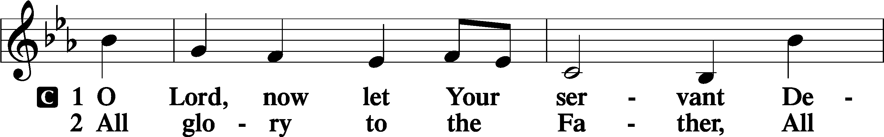
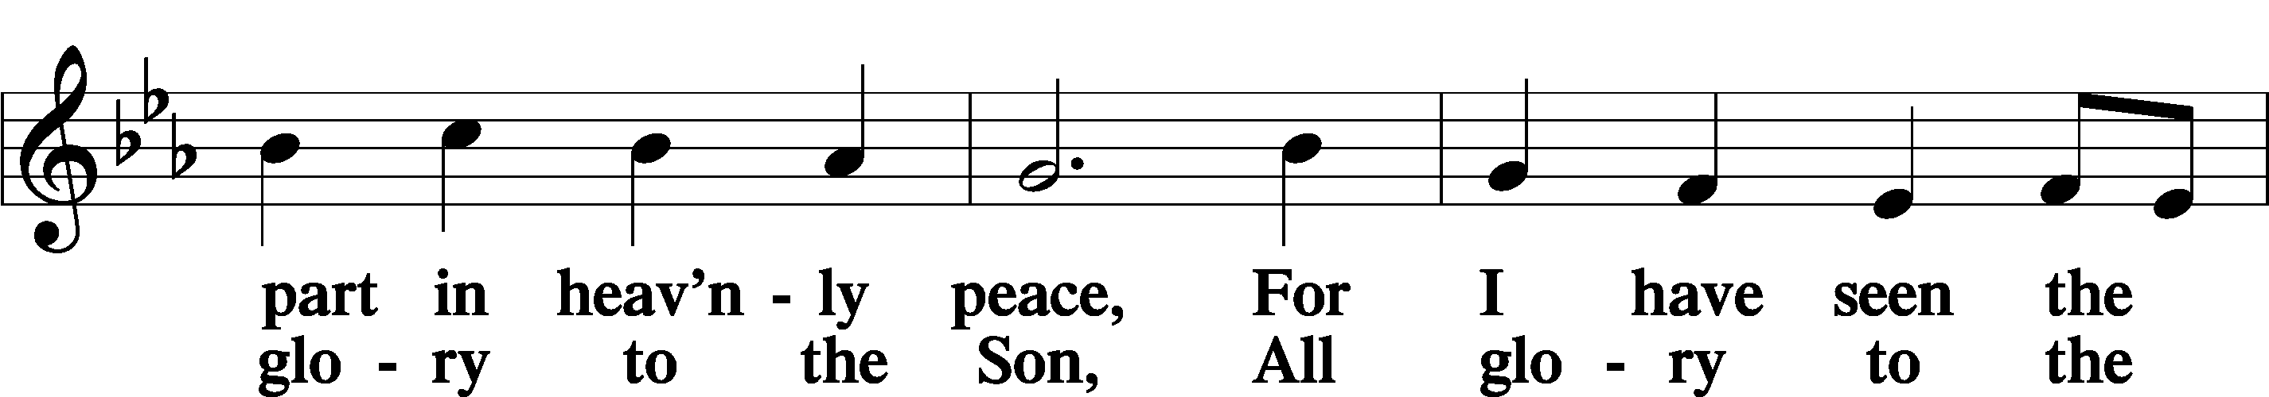
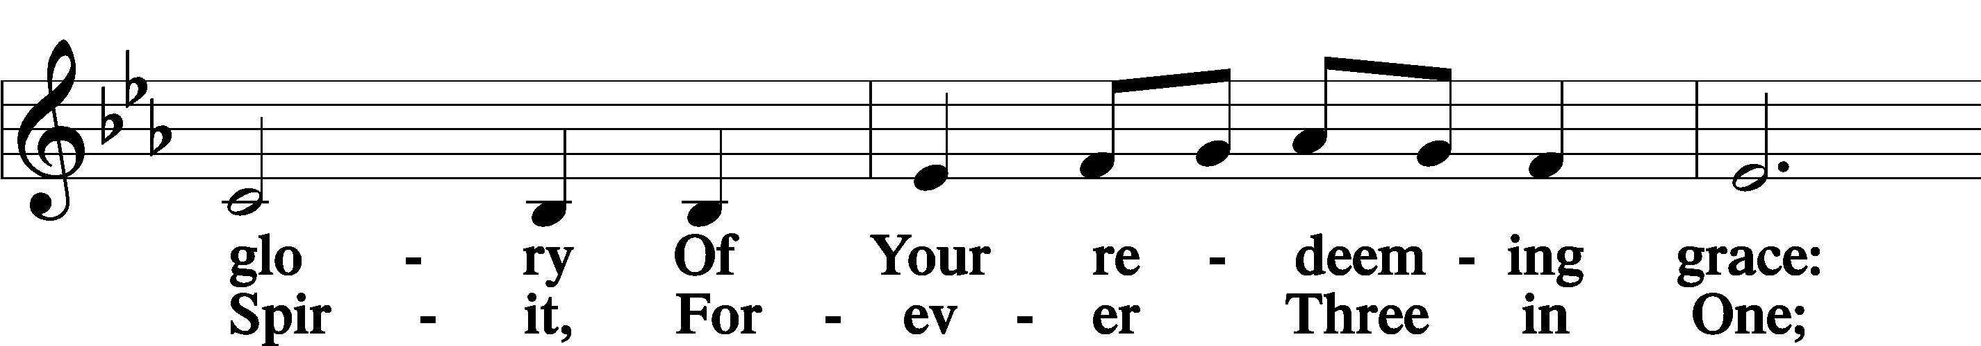
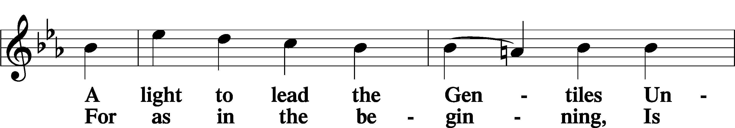
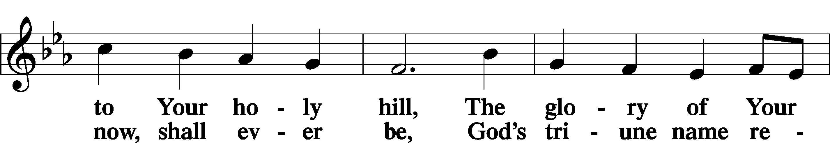
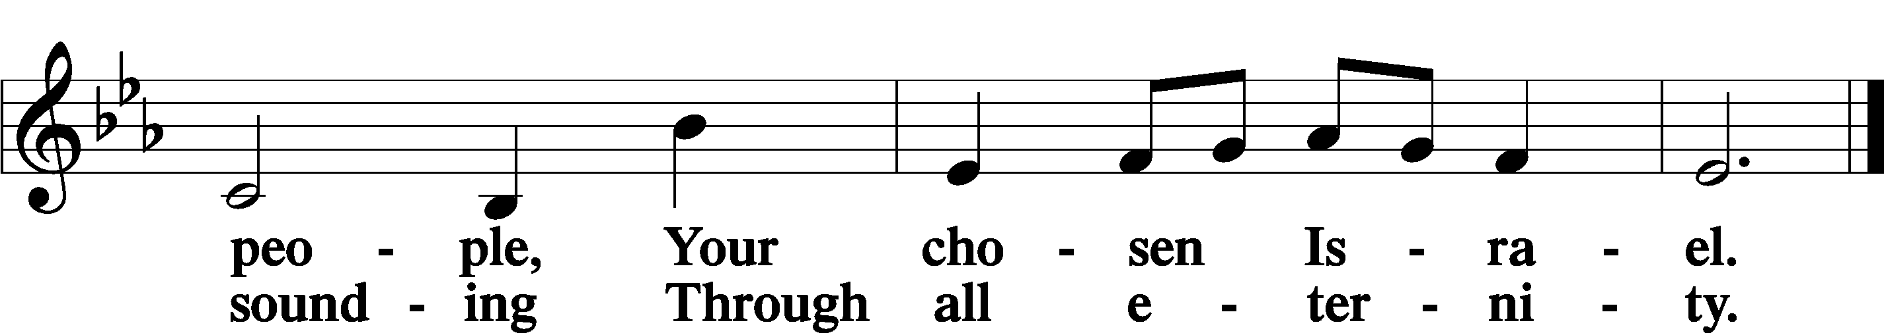

Post-Communion Collect
A Let us pray.
We give thanks to You, almighty God, that You have refreshed us through this salutary gift, and we implore You that of Your mercy You would strengthen us through the same in faith toward You and in fervent love toward one another; through Jesus Christ, Your Son, our Lord, who lives and reigns with You and the Holy Spirit, one God, now and forever.
C Amen.

Benedicamus LSB 212
A Let us bless the Lord.
C Thanks be to God.

Benediction
P The Lord bless you and keep you.
The Lord make His face shine on you and be gracious to you.
The Lord look upon you with favor and T give you peace.
C Amen.

Hymn to Depart: Praise the One Who Breaks the Darkness LSB 849
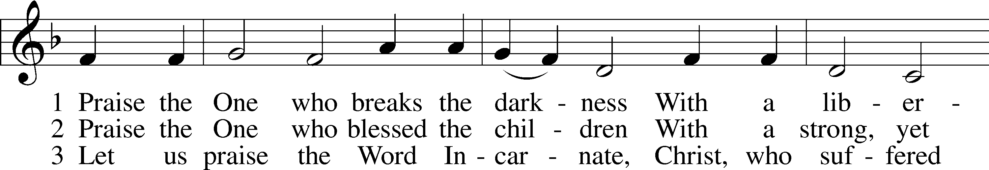
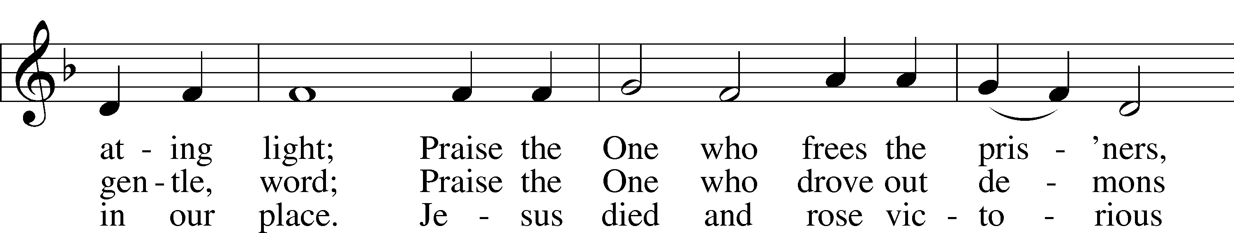
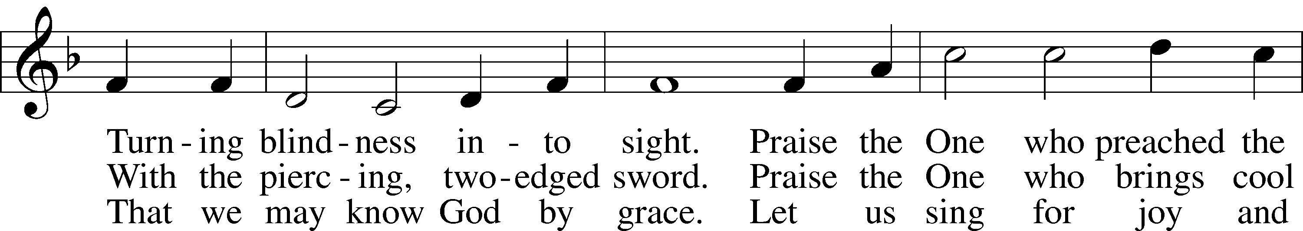
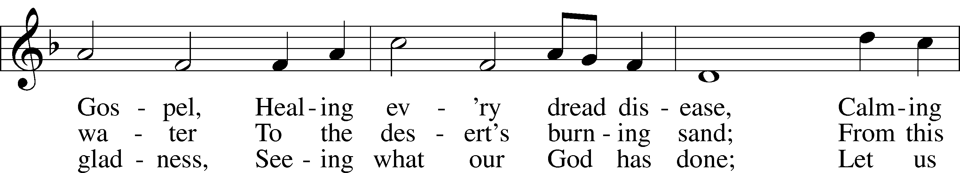
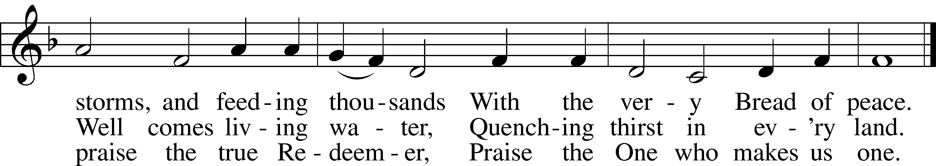
Text: Rusty Edwards, 1955
Tune: The Sacred Harp, 1844, Philadelphia
Text: © 1987 Hope Publishing Co. Used by permission: LSB Hymn License no. 110005504
Tune: Public domain

Acknowledgments
Divine Service, Setting Four from Lutheran Service Book
Unless otherwise indicated, Scripture quotations are from the ESV® Bible (The Holy Bible, English Standard Version®), copyright © 2001 by Crossway, a publishing ministry of Good News Publishers. Used by permission. All rights reserved.
Created by Lutheran Service Builder © 2023 Concordia Publishing House.

Announcements:
Church Service Phone: 888-505-1870/715-438-4200
(Stay on the line for recorded service to start)
Live Stream audio services: http://salem.listentochurch.com
Salem’s Web Page: https://www.salembarron.com/

Pastor Michael Nielsen: Cell phone: 218-280-0999
Email: rev.mike.nielsen@gmail.com
Pastor’s Office Hours: Monday-Wednesday 9-12
Attendance:
Call-in line:3/8 – 1, 3/12 – 5 In-person: 3/8 – 13/20, 3/12 - 68

Weekly Needs: $2823.92

3/5/23 – General: $2475 Missions: $127 Bldg: $56 Childcare: $65 SS: $8.50 AC: $100 VBS: $51 Childcare: $46

Coffee and Snacks:
Elder Today: Paul Millerman
Altar Guild: MaryAnn Thompson and Kari Longmire

Link to Salem’s Facebook page is:
https://www.facebook.com/SalemEvangelicalLutheranChurchAndPreschool/

Schedule for the upcoming week:
Tuesday: 7:30 AM Men‘s Bible Study
Wednesday: 12:00 PM Lent Service
4:00 PM Catechism Class
5:30 Lenten Supper
6:30 PM Lent Service
Thursday: 11:00 AM Bible Class

Save the date: March 22, April, May – 10% nights at DQ for Salem’s Childcare from 4-9 PM

Save the date: March 26, 2023 – Soup Sunday
Save the date: April 8, 2023 – Easter Egg Hunt
Save the date: April 13-15, 2023 – Church Garage Sale. There will be guys to help on Tuesday mornings and Sunday mornings after church.
Save the date: April 19, 2023 – 5-7:30 PM Parents Seminar – Mental Health and Screens
Save the Date: April 30, 2023 – Confirmation Questioning
Save the Date: May 7, 2023 – Confirmation Sunday

Prayer requests:

Those in the nursing home: Caroly, Wilma, Loretta, Diane

Those Shut-in at home: Char, Gail and Roxanne, Joan, Joyce

Those recovering from surgery: Randy Church, Mona Duncan, Carol Shearer
Those recovering from accident: Rusty Weise
Those with ongoing health issues: Harrison, Jeanne, Wyatt, Owen, Joyce, Kathy N, Jeff, Daria, Bob, Pastor Jody Walter, Janee, Larry, Jessica, Darcy

Those who lead our nation:
Joe Biden, Kamala Harris, Tony Evers, Rod Nordby

Those who serve in our military:
Ryan Graf and Ethan Kobernick, Chaplain Pon Chanthaphon (Our Adopt-a-Chaplain)

Our Childcare Staff: Melissa Weinert, Jasmine Ferguson, Denise Stabenow, Katelyn Hendren, Holly Wilhelmi, Janica Skjerly

Families of the Week: Austin and Kaitlyn Klimek (Riley and Brooks), Diane Knoepke, Stan and Nancy Koenig (Owen Metz), Jeff Kolba, Joyce Kolba

Barron Area Businesses: Jennie-O Turkey Store, Mega Co-Op, Nordby Construction, Thrivent Financial

Mission Statement
The Mission of Salem Lutheran Church is to be what God called us to be through faith in Jesus Christ, a body of believers engaged in building the Kingdom of God by discipling the Barron area with His Word and Sacrament ministry.

