Midweek of Lent 2
March 8, 2023
12 Noon and 6:30 PM

Salem Lutheran Church
1-715-537-3011
http://www.salembarron.com
rev.mike.nielsen@gmail.com

Water Gives Me Life

Water is life. Water is everywhere. Not only is this true in the world around us, but it is also true in the Scriptures. Throughout the Bible, we witness our Creator giving us new life—cleansing, reshaping, even re-creating—through the water of the Spirit and through the living and active Word of Jesus. Today our attention is drawn to the promised treasure of the life-giving water that God uses to claim us as His children and unite us to His Son’s death and resurrection. With the Savior, who steps into the water with us, we “daily emerge and arise to live before God in righteousness and purity forever” (Small Catechism, Baptism, Fourth Part).

Opening Hymn: Come to Calvary's Holy Mountain LSB 435
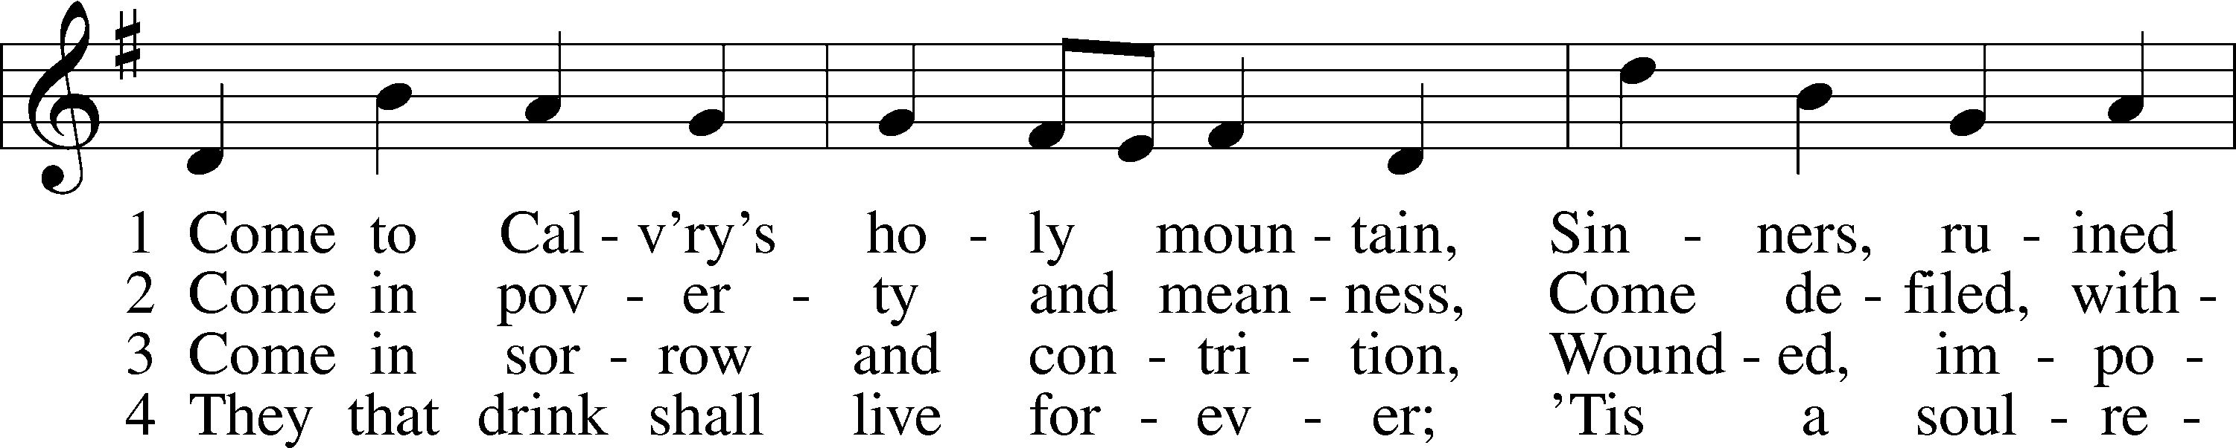
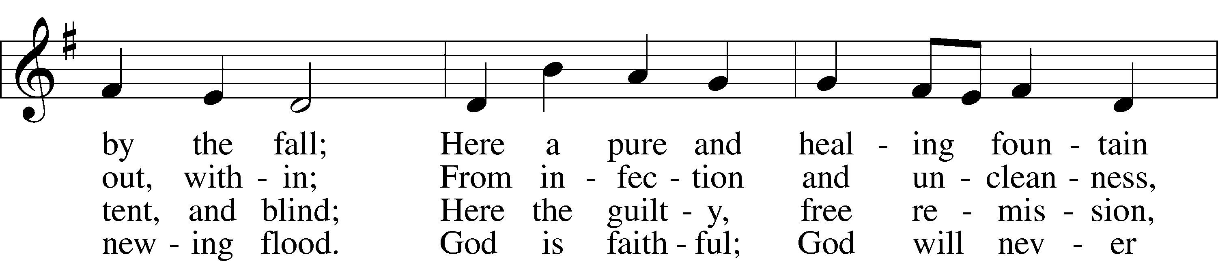
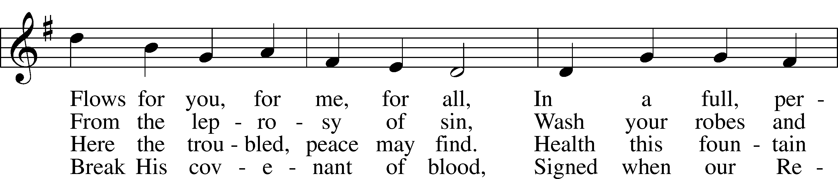
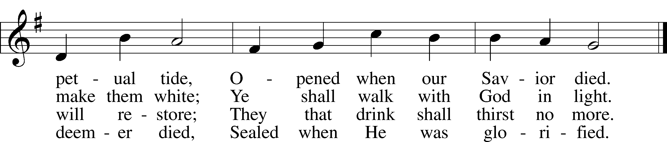
Text: James Montgomery, 1771–1854, alt.
Tune: Ludvig M. Lindeman, 1812–87
Text and tune: Public domain

Opening Sentences
L O Lord, open my lips,

L Make haste, O God, to deliver me;

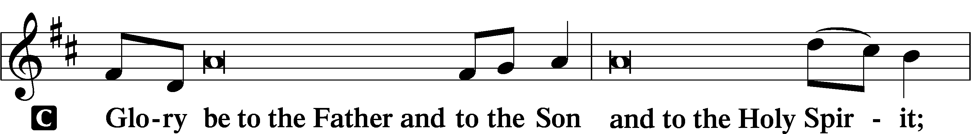
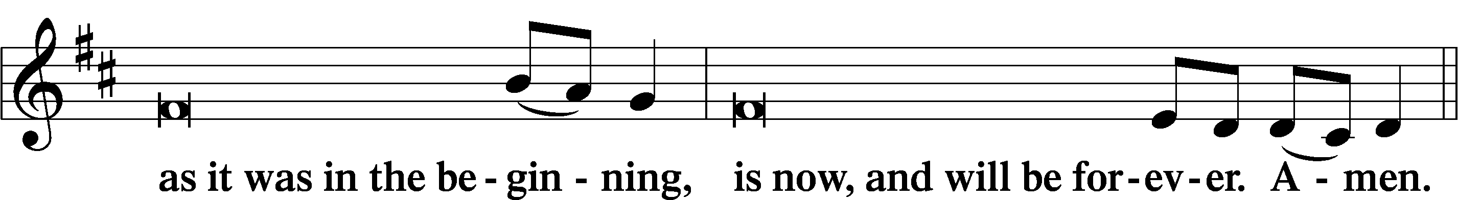
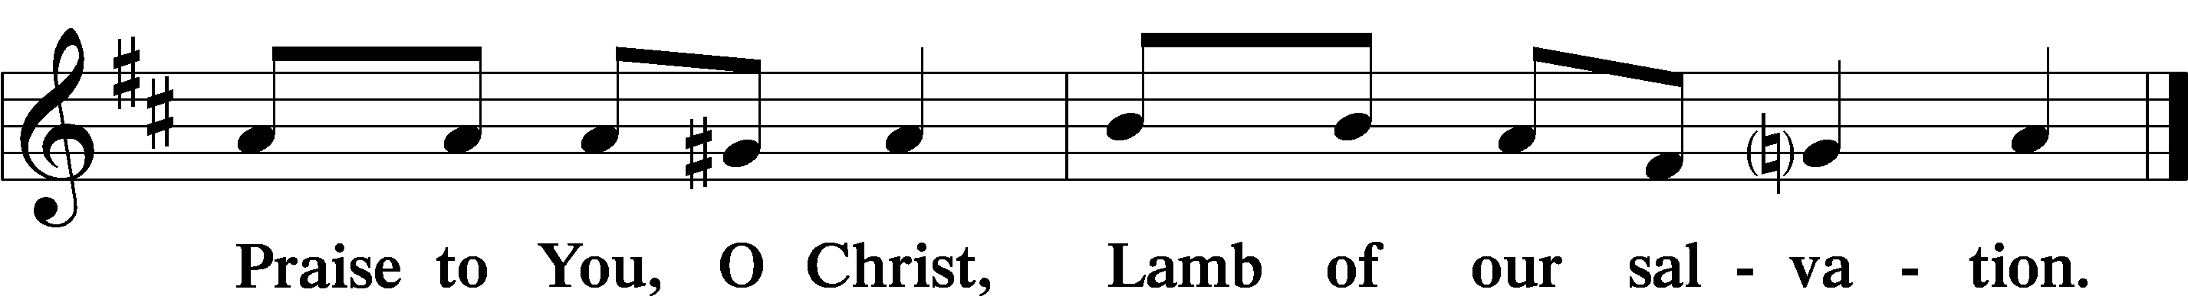

PSALMODY

Psalm Psalm 23
P The Lord is my shepherd; I shall not want.
C He makes me lie down in green pastures. He leads me beside still waters.
P He restores my soul. He leads me in paths of righteousness for His name’s sake.
C Even though I walk through the valley of the shadow of death, I will fear no evil,
P for You are with me;
C Your rod and Your staff, they comfort me.
P You prepare a table before me in the presence of my enemies;
C You anoint my head with oil; my cup overflows.
P Surely goodness and mercy shall follow me all the days of my life,
C and I shall dwell in the house of the Lord forever.
Glory be to the Father and to the Son and to the Holy Spirit;
as it was in the beginning, is now, and will be forever. Amen.

Hymn: One House Abides Unending See Insert

READINGS

Reading Genesis 7:11–23
P A reading from Genesis, the seventh chapter.

11In the six hundredth year of Noah’s life, in the second month, on the seventeenth day of the month, on that day all the fountains of the great deep burst forth, and the windows of the heavens were opened. 12And rain fell upon the earth forty days and forty nights. 13On the very same day Noah and his sons, Shem and Ham and Japheth, and Noah’s wife and the three wives of his sons with them entered the ark, 14they and every beast, according to its kind, and all the livestock according to their kinds, and every creeping thing that creeps on the earth, according to its kind, and every bird, according to its kind, every winged creature. 15They went into the ark with Noah, two and two of all flesh in which there was the breath of life. 16And those that entered, male and female of all flesh, went in as God had commanded him. And the Lord shut him in.
17The flood continued forty days on the earth. The waters increased and bore up the ark, and it rose high above the earth. 18The waters prevailed and increased greatly on the earth, and the ark floated on the face of the waters. 19And the waters prevailed so mightily on the earth that all the high mountains under the whole heaven were covered. 20The waters prevailed above the mountains, covering them fifteen cubits deep. 21And all flesh died that moved on the earth, birds, livestock, beasts, all swarming creatures that swarm on the earth, and all mankind. 22Everything on the dry land in whose nostrils was the breath of life died. 23He blotted out every living thing that was on the face of the ground, man and animals and creeping things and birds of the heavens. They were blotted out from the earth. Only Noah was left, and those who were with him in the ark.

P O Lord, have mercy on us.
C Thanks be to God.

Reading 1 Peter 3:17–22
P A reading from First Peter, the third chapter.

17For it is better to suffer for doing good, if that should be God’s will, than for doing evil.
18For Christ also suffered once for sins, the righteous for the unrighteous, that he might bring us to God, being put to death in the flesh but made alive in the spirit, 19in which he went and proclaimed to the spirits in prison, 20because they formerly did not obey, when God’s patience waited in the days of Noah, while the ark was being prepared, in which a few, that is, eight persons, were brought safely through water. 21Baptism, which corresponds to this, now saves you, not as a removal of dirt from the body but as an appeal to God for a good conscience, through the resurrection of Jesus Christ, 22who has gone into heaven and is at the right hand of God, with angels, authorities, and powers having been subjected to him.

P O Lord, have mercy on us.
C Thanks be to God.

Reading John 3:1–8
P A reading from St. John, the third chapter.

You Must Be Born Again
1Now there was a man of the Pharisees named Nicodemus, a ruler of the Jews. 2This man came to Jesus by night and said to him, “Rabbi, we know that you are a teacher come from God, for no one can do these signs that you do unless God is with him.” 3Jesus answered him, “Truly, truly, I say to you, unless one is born again he cannot see the kingdom of God.” 4Nicodemus said to him, “How can a man be born when he is old? Can he enter a second time into his mother’s womb and be born?” 5Jesus answered, “Truly, truly, I say to you, unless one is born of water and the Spirit, he cannot enter the kingdom of God. 6That which is born of the flesh is flesh, and that which is born of the Spirit is spirit. 7Do not marvel that I said to you, ‘You must be born again.’ 8The wind blows where it wishes, and you hear its sound, but you do not know where it comes from or where it goes. So it is with everyone who is born of the Spirit.”

P O Lord, have mercy on us.
C Thanks be to God.

Lent Responsory LSB, p. 231
L Deliver me, O Lord, my God, for You are the God of my salvation.
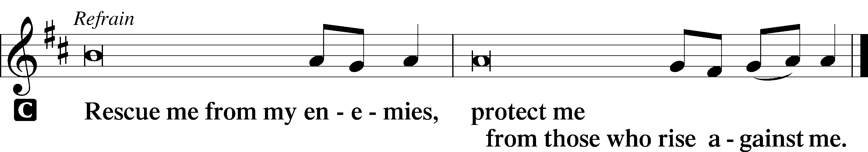

L In You, O Lord, do I put my trust, leave me not, O Lord, my God.

L Deliver me, O Lord, my God, for You are the God of my salvation.

Sermon

CANTICLE

Antiphon
L Let my prayer rise before You as incense,
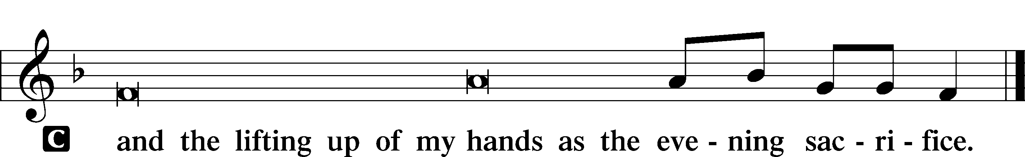

Magnificat LSB 231
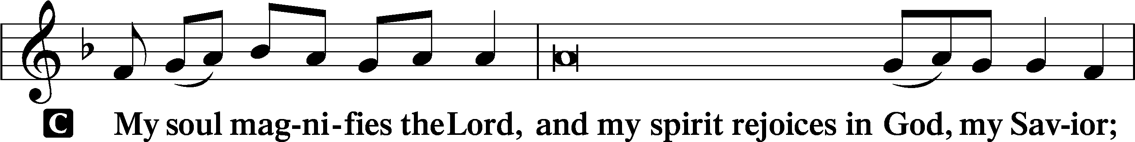
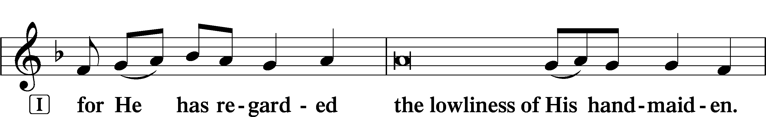
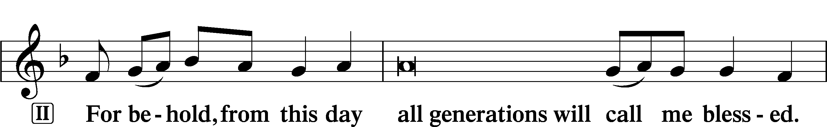
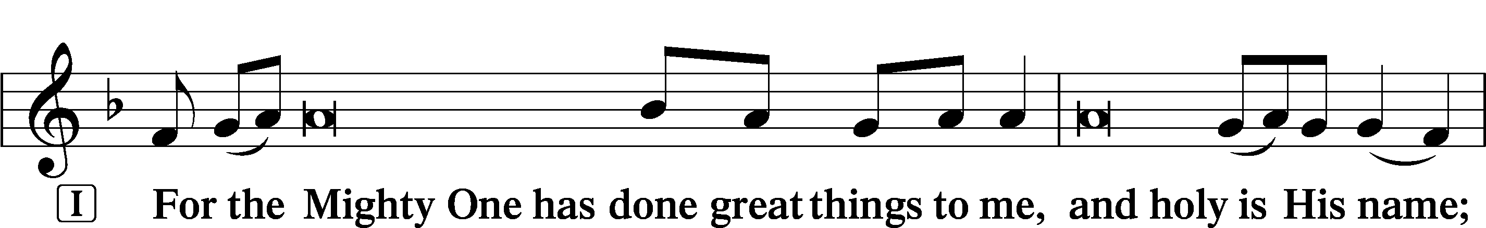
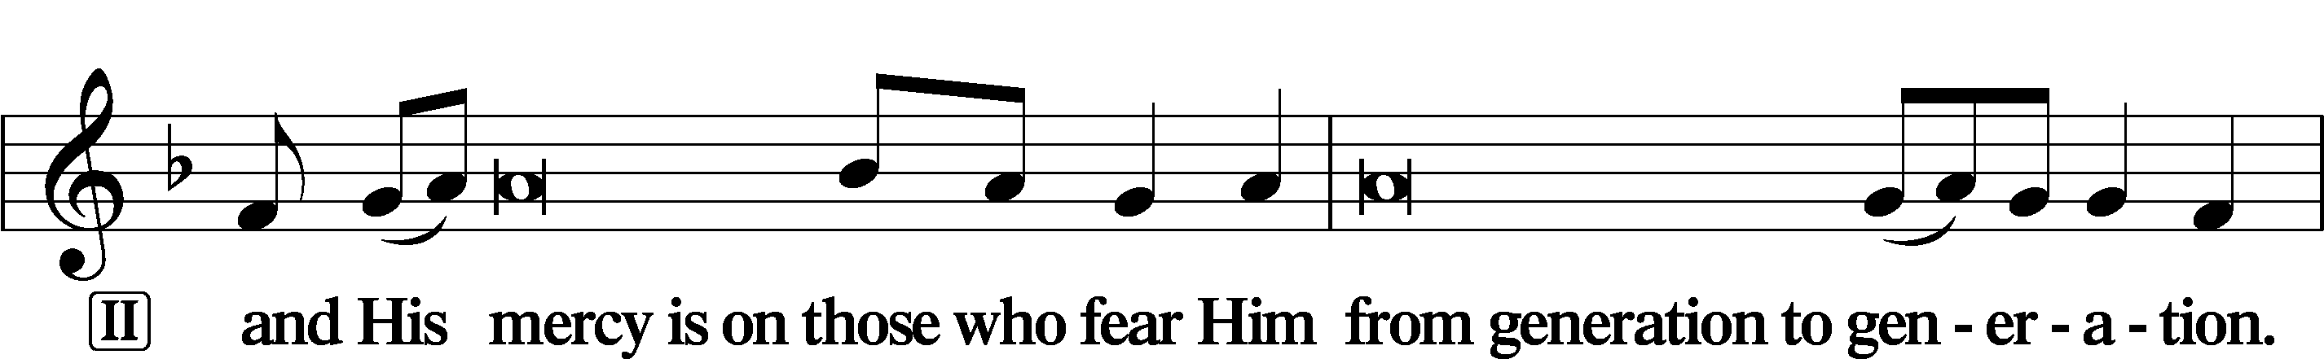
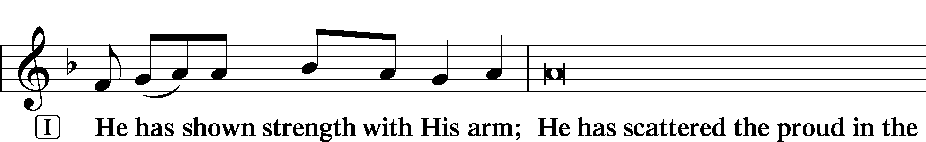
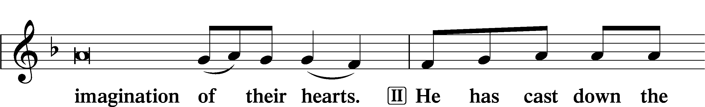
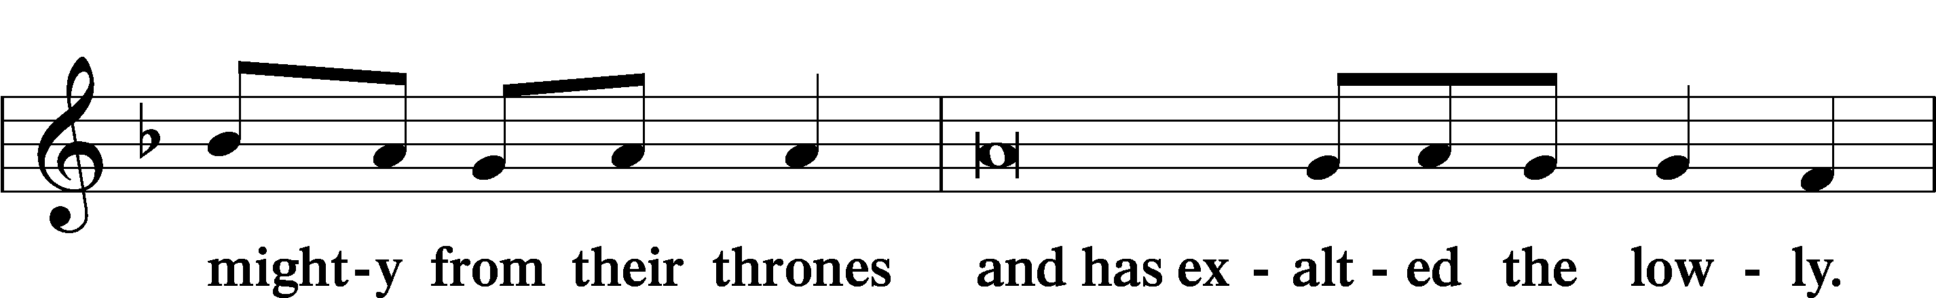
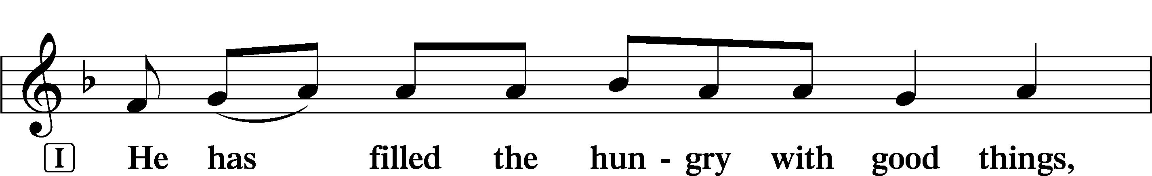
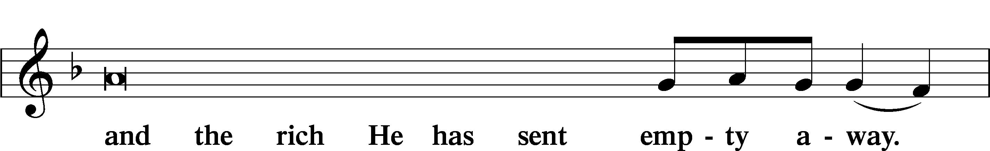
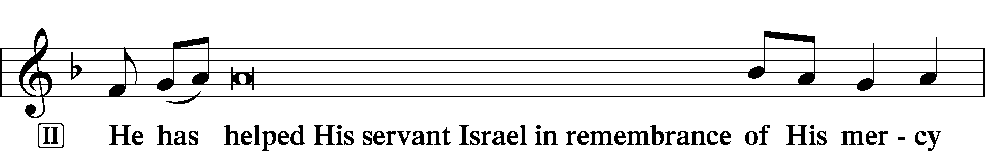
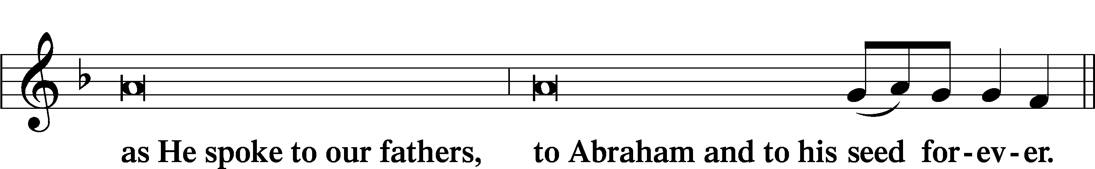
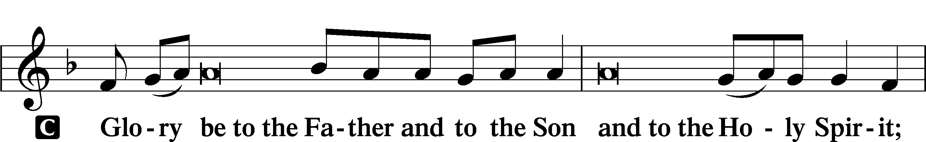
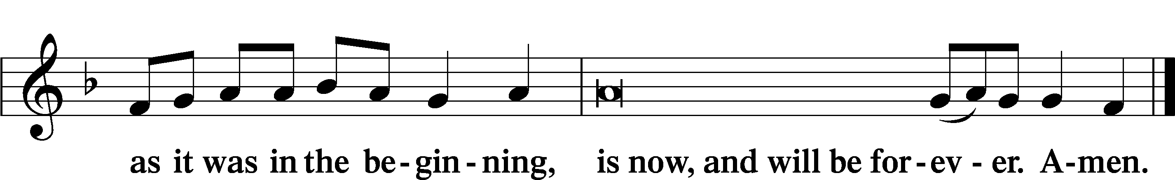

PRAYER
Kyrie
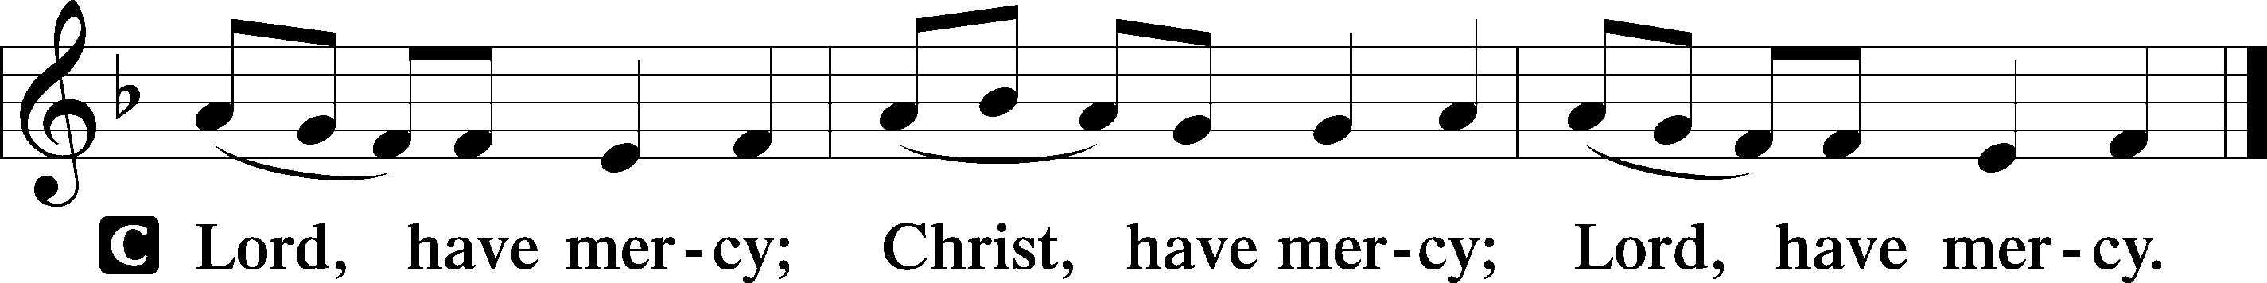

Lord’s Prayer
C Our Father who art in heaven,
hallowed be Thy name,
Thy kingdom come,
Thy will be done on earth
as it is in heaven;
give us this day our daily bread;
and forgive us our trespasses
as we forgive those
who trespass against us;
and lead us not into temptation,
but deliver us from evil.
For Thine is the kingdom
and the power and the glory
forever and ever. Amen.

Collects
P O Lord, hear my prayer.
C And let my cry come to You.

P Lord Jesus Christ, through water You reshape and restore Your fallen creation, entering our lives in Baptism so that we may be cleansed by Your Spirit. Renew our hearts and minds during this Lenten season as we receive the promised treasures of Your Word; for You live and reign with the Father and the Holy Spirit, one God, now and forever.
C Amen.

P Gracious God, Father of our Lord Jesus Christ, we thank You for blessing us with the opportunity to meditate again on the cross of Christ and receive Your promised treasures.
C Grant that the message of the Lamb of God slain for our salvation bring us the riches of Your pardon and peace.

P Lead us to see that our sins caused Jesus’ great agony in the garden, that our sins nailed Him to the cross of Calvary,
C that He was forsaken by His Father so that we might never be forsaken, and that He died so that we may live.

P Lord Jesus, grant that especially during this sacred season the treasured story of Your wondrous love for us would draw us closer to You.
C Enable us to see the blessings You have poured out into our lives through the washing of water with the Word.

P Holy Spirit, lift up troubled souls everywhere. Grant wholeness to those hurting in heart, body, and mind. Work Your healing power in the lives of those in need, [especially . . .], and in the lives of all we name before You in our hearts.
C All glory, honor, and praise be to You, with the Father and the Son, one God, now and forever. Amen.

P O God, from whom come all holy desires, all good counsels, and all just works, give to us, Your servants, that peace which the world cannot give, that our hearts may be set to obey Your commandments and also that we, being defended from the fear of our enemies, may live in peace and quietness; through Jesus Christ, Your Son, our Lord, who lives and reigns with You and the Holy Spirit, one God, now and forever.
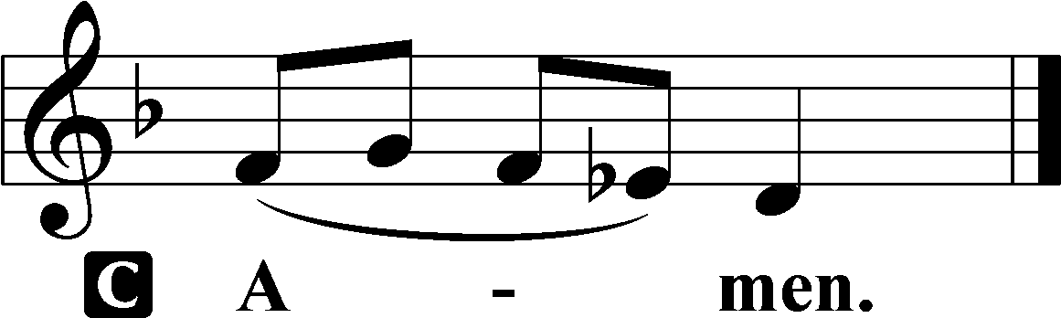

Benedicamus LSB 234
L Let us bless the Lord.
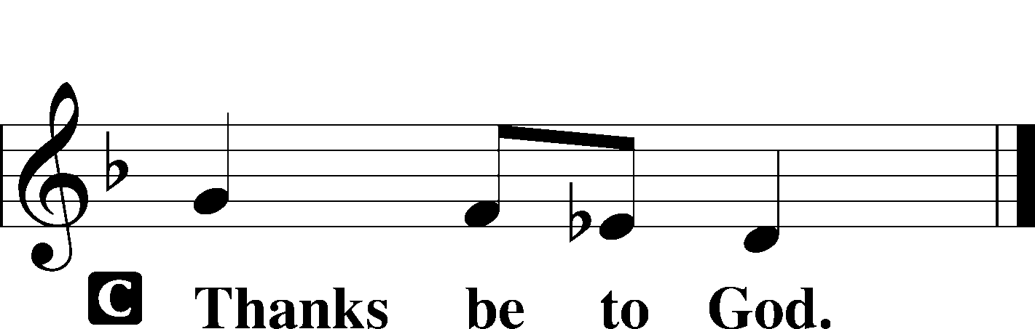

Benediction LSB 234
P The grace of our Lord T Jesus Christ and the love of God and the communion of the Holy Spirit be with you all.

Hymn: Glory Be to Jesus LSB 433
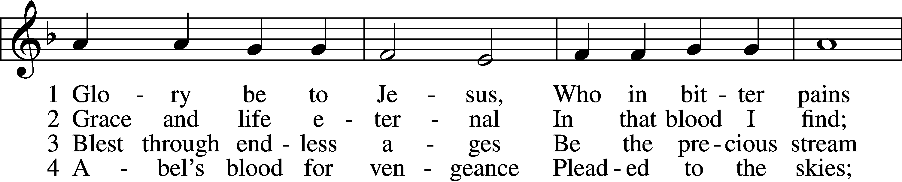
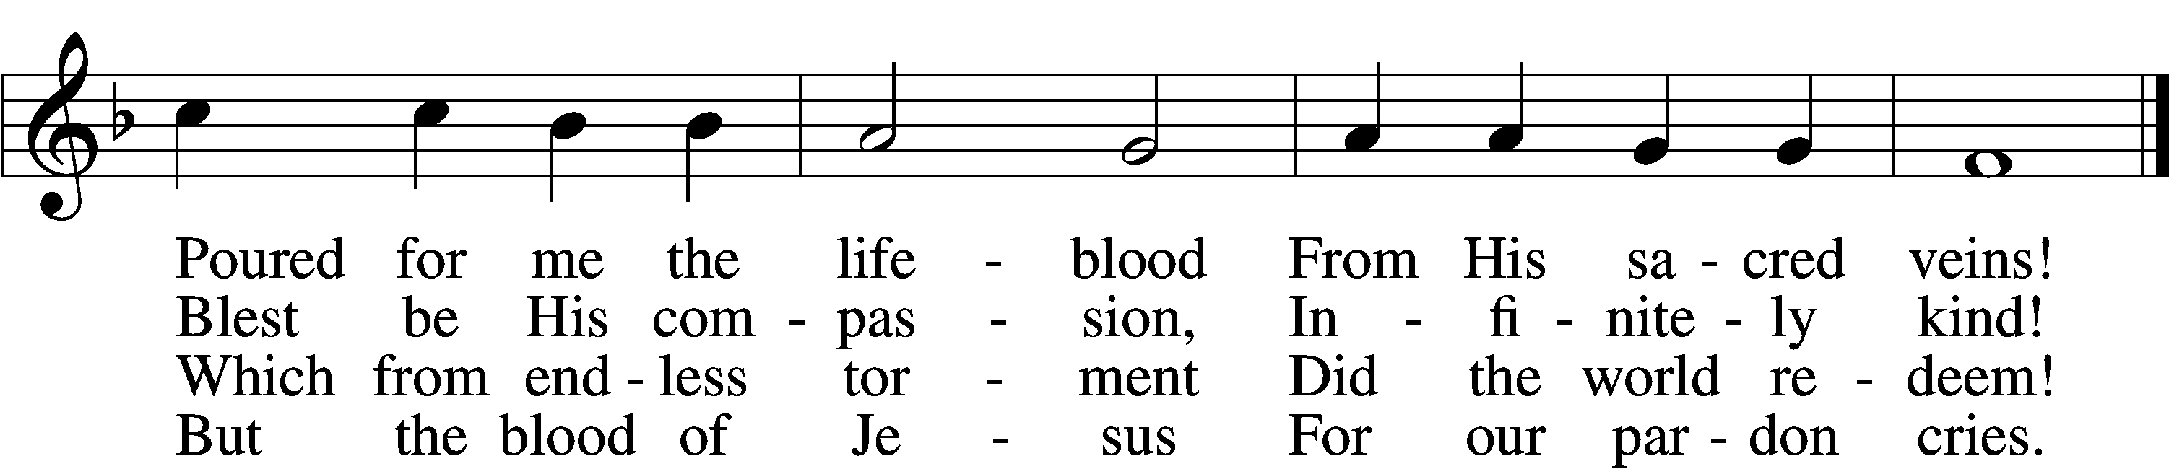

5 Oft as earth exulting
Wafts its praise on high,
Angel hosts rejoicing
Make their glad reply.

6 Lift we, then, our voices,
Swell the mighty flood;
Louder still and louder
Praise the precious blood!
Text: Italian, c. 18th cent.; tr. Edward Caswall, 1814–78, alt.
Tune: Friedrich Filitz, 1804–76
Text and tune: Public domain

Acknowledgments
Unless otherwise indicated, Scripture quotations are from the ESV® Bible (The Holy Bible, English Standard Version®), copyright © 2001 by Crossway, a publishing ministry of Good News Publishers. Used by permission. All rights reserved.
Created by Lutheran Service Builder © 2023 Concordia Publishing House.

