Fourth Sunday of Easter
May 8, 2022
9:00 AM

Salem Lutheran Church
1-715-537-3011
http://www.salembarron.com
rev.mike.nielsen@gmail.com
The Good Shepherd Cares for His Sheep

Jesus Christ, the Son of God, came from the Father and became flesh among us in order to rescue us, His sheep. He laid down His life for us and took it up again in order to give us eternal life. By the preaching of His Gospel, He calls His sheep to Himself and keeps them with Him forever. As they hear His voice and follow Him, “they will never perish” (John 10:28), for “no one is able to snatch them out of the Father’s hand” (John 10:29). In the same way, faithful pastors (literally, “shepherds”) “care for the church of God, which he obtained with his own blood” (Acts 20:28), “testifying both to Jews and to Greeks of repentance toward God and of faith in our Lord Jesus Christ” (Acts 20:21). Therefore, with all the company of heaven, the Good Shepherd gathers His flock in worship, as they cry: “Salvation belongs to our God who sits on the throne, and to the Lamb!” (Rev. 7:10).
Hymn: Savior, Like a Shepherd Lead Us LSB 711
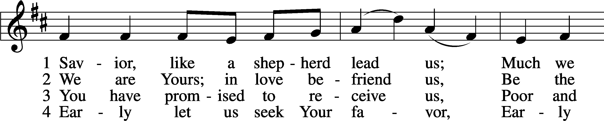
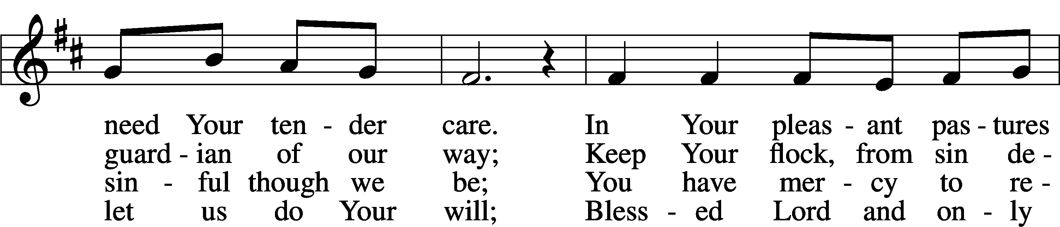
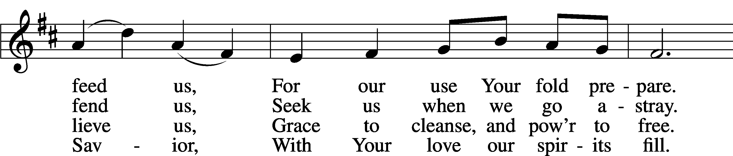
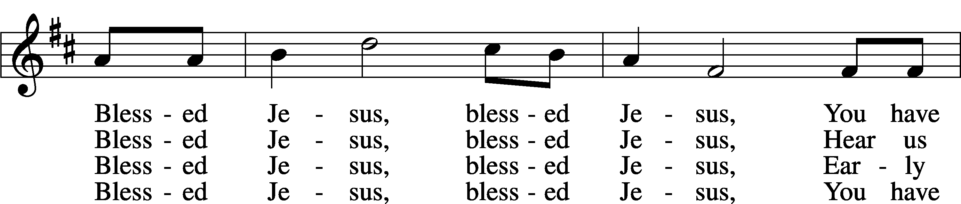
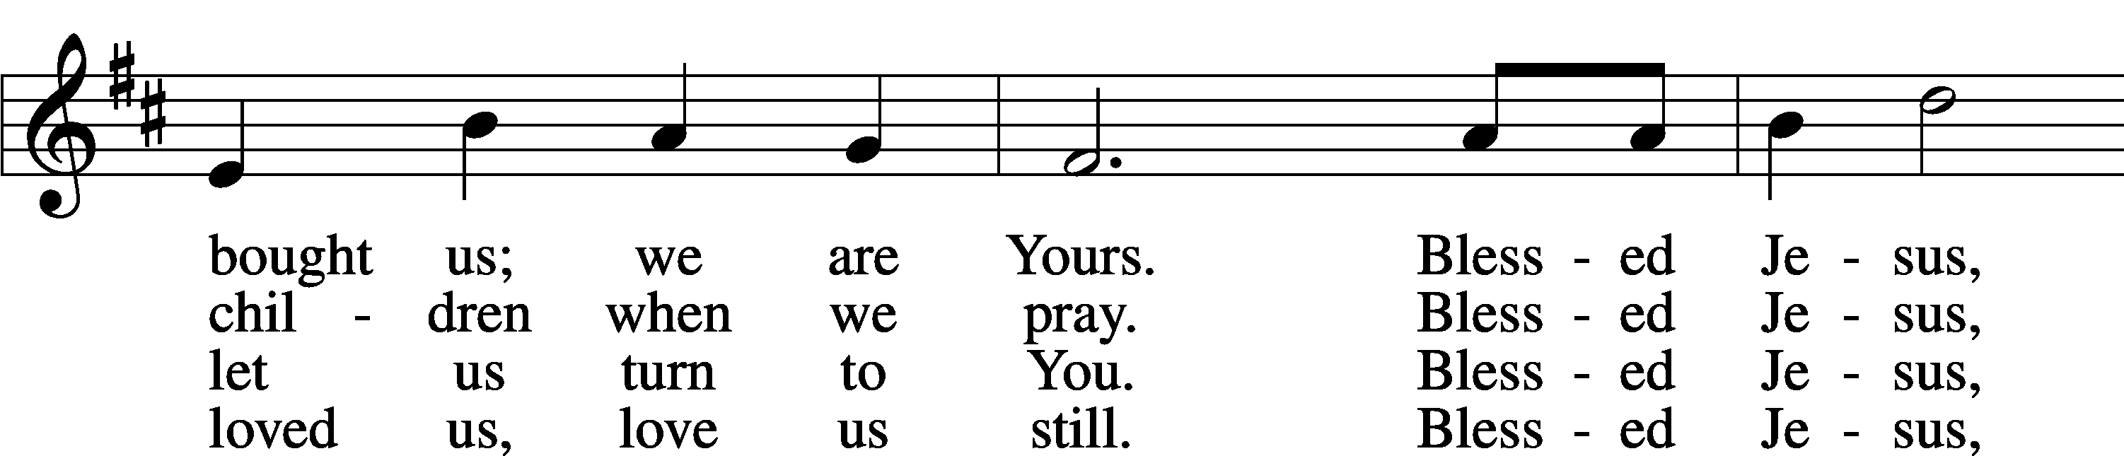
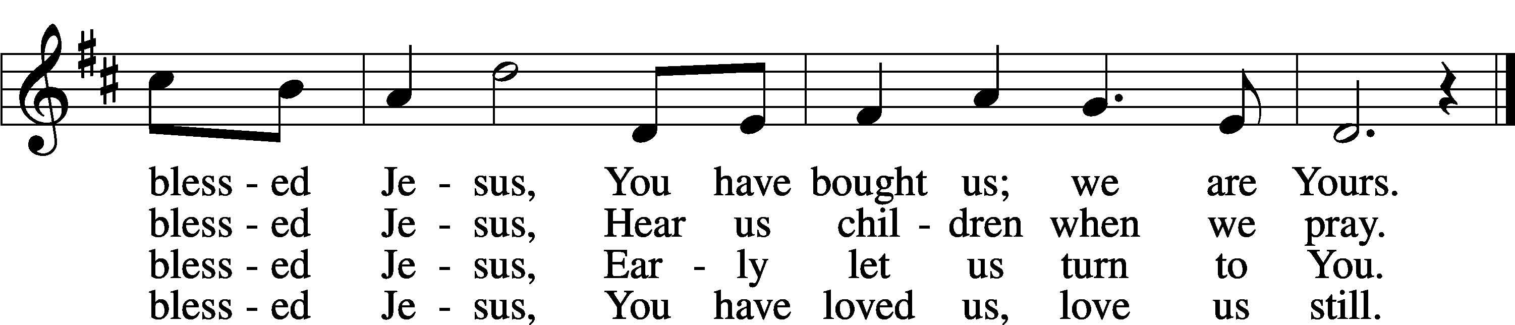
Text: Hymns for the Young, 1836, 4th ed., London, alt.
Tune: William B. Bradbury, 1816–68
Text and tune: Public domain

Stand

Common Versicles LSB 260
L This is the day which the Lord has made;
C let us rejoice and be glad in it.
L From the rising of the sun to its setting,
C the name of the Lord is to be praised.

L Better is one day in Your courts than a thousand elsewhere;
C I would rather be a doorkeeper in the house of my God than dwell in the tents of the wicked.
L Make me to know Your ways, O Lord.
C Teach me Your paths.
L Sanctify us in Your truth.
C Your Word is truth.

L From the rising of the sun to its setting,
C the name of the Lord is to be praised.

C Glory be to the Father and to the Son and to the Holy Spirit;
as it was in the beginning, is now, and will be forever. Amen.

Old Testament Canticle LSB 261
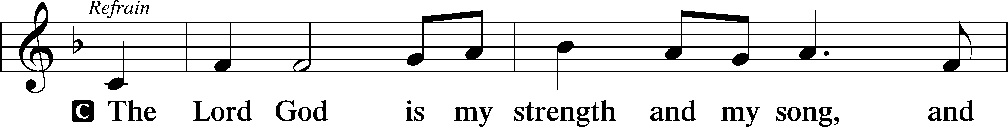
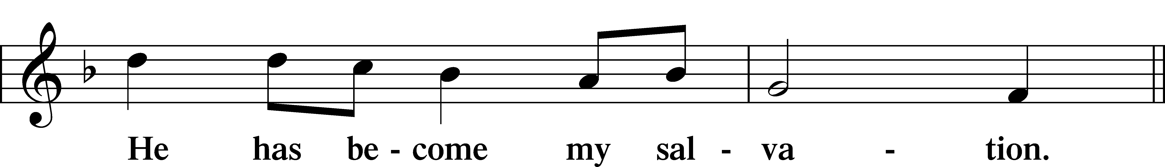
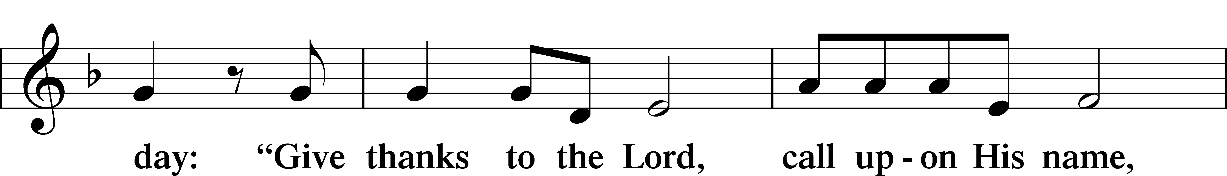
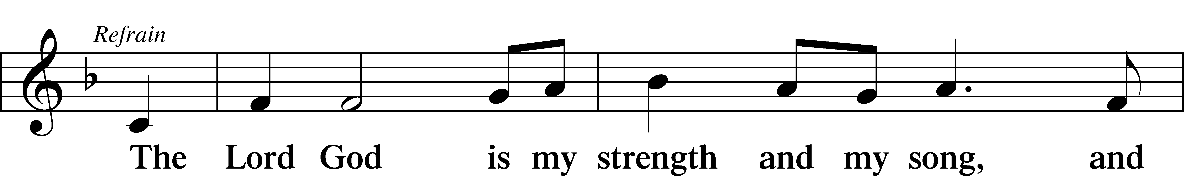
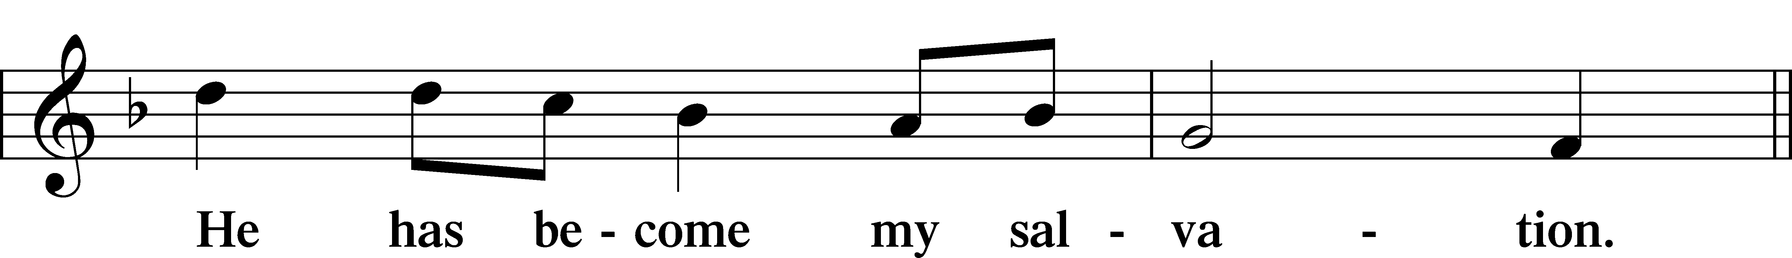
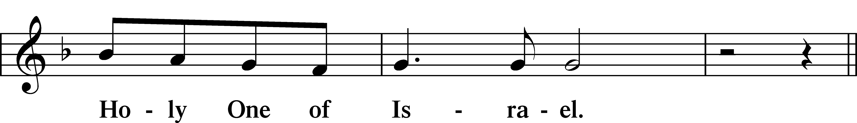
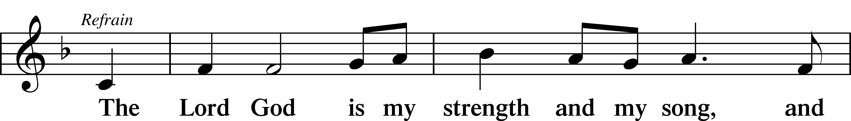
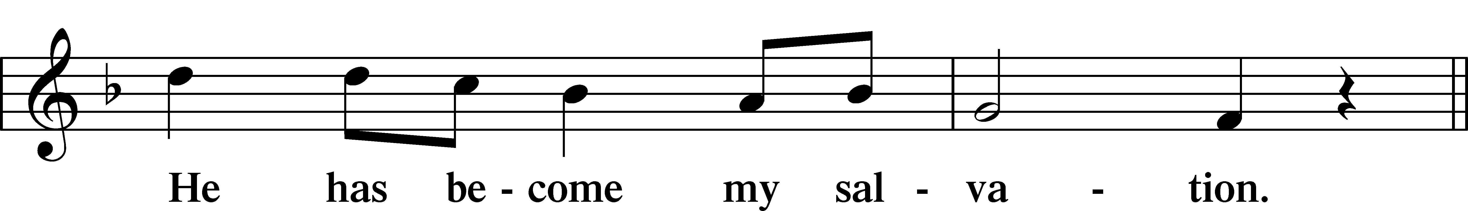
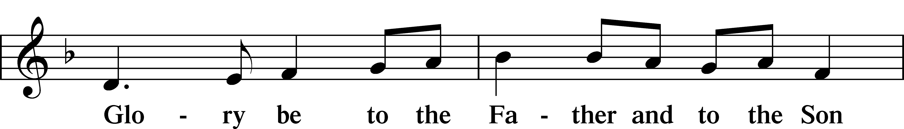
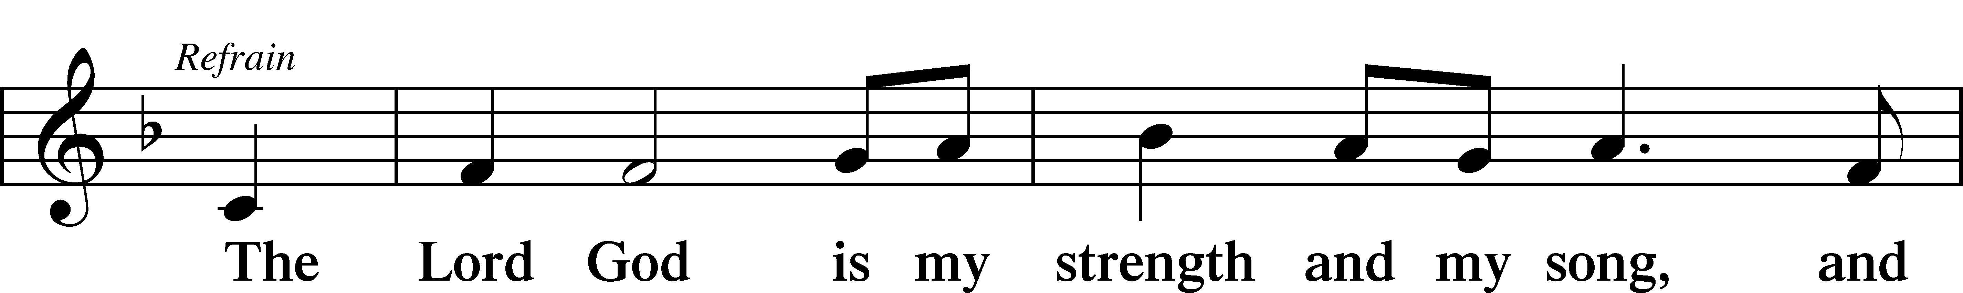
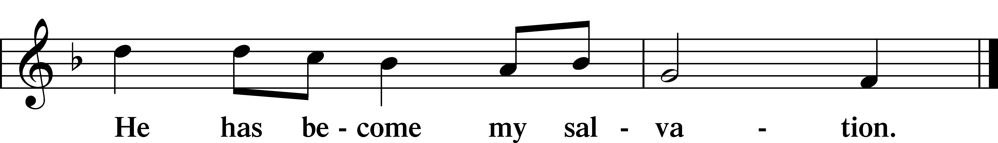

Sit

Reading Acts 20:17–35
L A reading from Acts, the twentieth chapter.

17Now from Miletus [Paul] sent to Ephesus and called the elders of the church to come to him. 18And when they came to him, he said to them:
“You yourselves know how I lived among you the whole time from the first day that I set foot in Asia, 19serving the Lord with all humility and with tears and with trials that happened to me through the plots of the Jews; 20how I did not shrink from declaring to you anything that was profitable, and teaching you in public and from house to house, 21testifying both to Jews and to Greeks of repentance toward God and of faith in our Lord Jesus Christ. 22And now, behold, I am going to Jerusalem, constrained by the Spirit, not knowing what will happen to me there, 23except that the Holy Spirit testifies to me in every city that imprisonment and afflictions await me. 24But I do not account my life of any value nor as precious to myself, if only I may finish my course and the ministry that I received from the Lord Jesus, to testify to the gospel of the grace of God. 25And now, behold, I know that none of you among whom I have gone about proclaiming the kingdom will see my face again. 26Therefore I testify to you this day that I am innocent of the blood of all of you, 27for I did not shrink from declaring to you the whole counsel of God. 28Pay careful attention to yourselves and to all the flock, in which the Holy Spirit has made you overseers, to care for the church of God, which he obtained with his own blood. 29I know that after my departure fierce wolves will come in among you, not sparing the flock; 30and from among your own selves will arise men speaking twisted things, to draw away the disciples after them. 31Therefore be alert, remembering that for three years I did not cease night or day to admonish everyone with tears. 32And now I commend you to God and to the word of his grace, which is able to build you up and to give you the inheritance among all those who are sanctified. 33I coveted no one’s silver or gold or apparel. 34You yourselves know that these hands ministered to my necessities and to those who were with me. 35In all things I have shown you that by working hard in this way we must help the weak and remember the words of the Lord Jesus, how he himself said, ‘It is more blessed to give than to receive.’”

L This is the Word of the Lord.
C Thanks be to God.

Reading Psalm 23
1The Lord is my shepherd;
I shall not want.
2He makes me lie down in green pastures.
He leads me beside still waters.
3He restores my soul.
He leads me in paths of righteousness for his name’s sake.
4Even though I walk through the valley of the shadow of death,
I will fear no evil, for you are with me;
your rod and your staff, they comfort me.
5You prepare a table before me
in the presence of my enemies;
you anoint my head with oil;
my cup overflows.
6Surely goodness and mercy shall follow me
all the days of my life,
and I shall dwell in the house of the Lord forever.

Reading Revelation 7:9–17
9After this I looked, and behold, a great multitude that no one could number, from every nation, from all tribes and peoples and languages, standing before the throne and before the Lamb, clothed in white robes, with palm branches in their hands, 10and crying out with a loud voice, “Salvation belongs to our God who sits on the throne, and to the Lamb!” 11And all the angels were standing around the throne and around the elders and the four living creatures, and they fell on their faces before the throne and worshiped God, 12saying, “Amen! Blessing and glory and wisdom and thanksgiving and honor and power and might be to our God forever and ever! Amen.”
13Then one of the elders addressed me, saying, “Who are these, clothed in white robes, and from where have they come?” 14I said to him, “Sir, you know.” And he said to me, “These are the ones coming out of the great tribulation. They have washed their robes and made them white in the blood of the Lamb.
15“Therefore they are before the throne of God,
and serve him day and night in his temple;
and he who sits on the throne will shelter them with his presence.
16They shall hunger no more, neither thirst anymore;
the sun shall not strike them,
nor any scorching heat.
17For the Lamb in the midst of the throne will be their shepherd,
and he will guide them to springs of living water,
and God will wipe away every tear from their eyes.”

Reading John 10:22–30
22At that time the Feast of Dedication took place at Jerusalem. It was winter, 23and Jesus was walking in the temple, in the colonnade of Solomon. 24So the Jews gathered around him and said to him, “How long will you keep us in suspense? If you are the Christ, tell us plainly.” 25Jesus answered them, “I told you, and you do not believe. The works that I do in my Father’s name bear witness about me, 26but you do not believe because you are not part of my flock. 27My sheep hear my voice, and I know them, and they follow me. 28I give them eternal life, and they will never perish, and no one will snatch them out of my hand. 29My Father, who has given them to me, is greater than all, and no one is able to snatch them out of the Father’s hand. 30I and the Father are one.”

Common Responsory LSB 263
L Forever, O Lord, Your Word is firmly set in the heavens.
C Lord, I love the habitation of Your house and the place where Your glory dwells.
L Blessed are those who hear the Word of God and keep it.
C Lord, I love the habitation of Your house and the place where Your glory dwells.
L Glory be to the Father and to the Son and to the Holy Spirit.
C Lord, I love the habitation of Your house and the place where Your glory dwells.

Stand

Ten Commandments
C You shall have no other gods.
You shall not misuse the name of the Lord your God.
Remember the Sabbath day by keeping it holy.
Honor your father and your mother.
You shall not murder.
You shall not commit adultery.
You shall not steal.
You shall not give false testimony against your neighbor.
You shall not covet your neighbor’s house.
You shall not covet your neighbor’s wife, or his manservant or maidservant, his ox or donkey, or anything that belongs to your neighbor.

Apostles’ Creed
C I believe in God, the Father Almighty,
maker of heaven and earth.

And in Jesus Christ, His only Son, our Lord,
who was conceived by the Holy Spirit,
born of the virgin Mary,
suffered under Pontius Pilate,
was crucified, died and was buried.
He descended into hell.
The third day He rose again from the dead.
He ascended into heaven
and sits at the right hand of God the Father Almighty.
From thence He will come to judge the living and the dead.

I believe in the Holy Spirit,
the holy Christian Church,
the communion of saints,
the forgiveness of sins,
the resurrection of the body,
and the life T everlasting. Amen.

Lord’s Prayer
C Our Father who art in heaven,
hallowed be Thy name,
Thy kingdom come,
Thy will be done on earth
as it is in heaven;
give us this day our daily bread;
and forgive us our trespasses
as we forgive those
who trespass against us;
and lead us not into temptation,
but deliver us from evil.
For Thine is the kingdom
and the power and the glory
forever and ever. Amen.

Sit

Hymn: The King of Love My Shepherd Is LSB 709
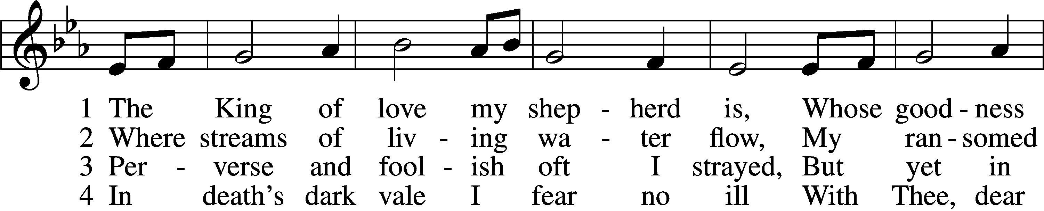
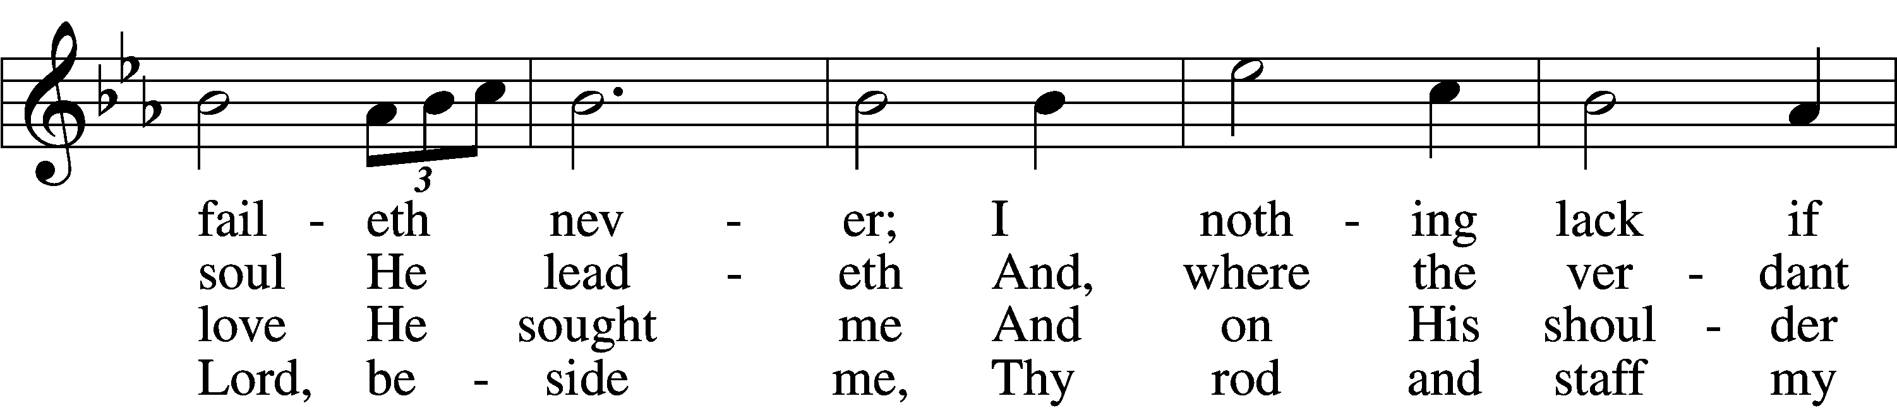
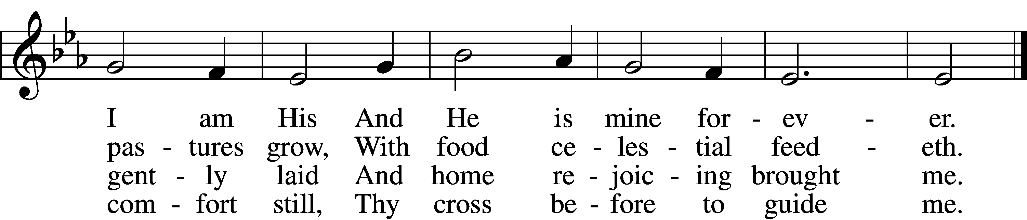

5 Thou spreadst a table in my sight;
Thine unction grace bestoweth;
And, oh, what transport of delight
From Thy pure chalice floweth!

6 And so through all the length of days
Thy goodness faileth never;
Good Shepherd, may I sing Thy praise
Within Thy house forever!
Text: Henry W. Baker, 1821–77
Tune: Irish, c. 18th cent.
Text and tune: Public domain

Sermon

Offering

Stand

Prayer

Collect of the Day
L Almighty God, merciful Father, since You have wakened from death the Shepherd of Your sheep, grant us Your Holy Spirit that when we hear the voice of our Shepherd we may know Him who calls us each by name and follow where He leads; through the same Jesus Christ, Your Son, our Lord, who lives and reigns with You and the Holy Spirit, one God, now and forever.
C Amen.

Collect for the Word
L Blessed Lord, You have caused all Holy Scriptures to be written for our learning. Grant that we may so hear them, read, mark, learn, and take them to heart that, by the patience and comfort of Your holy Word, we may embrace and ever hold fast the blessed hope of everlasting life; through Jesus Christ, Your Son, our Lord, who lives and reigns with You and the Holy Spirit, one God, now and forever.
C Amen.

Morning Prayer
C I thank You, my heavenly Father, through Jesus Christ, Your dear Son, that You have kept me this night from all harm and danger; and I pray that You would keep me this day also from sin and every evil, that all my doings and life may please You. For into Your hands I commend myself, my body and soul, and all things. Let Your holy angel be with me, that the evil foe may have no power over me.

New Testament Canticle LSB 266
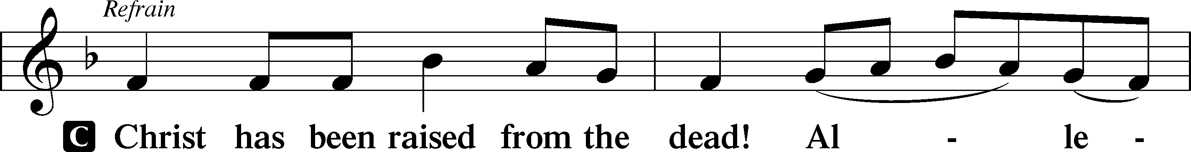
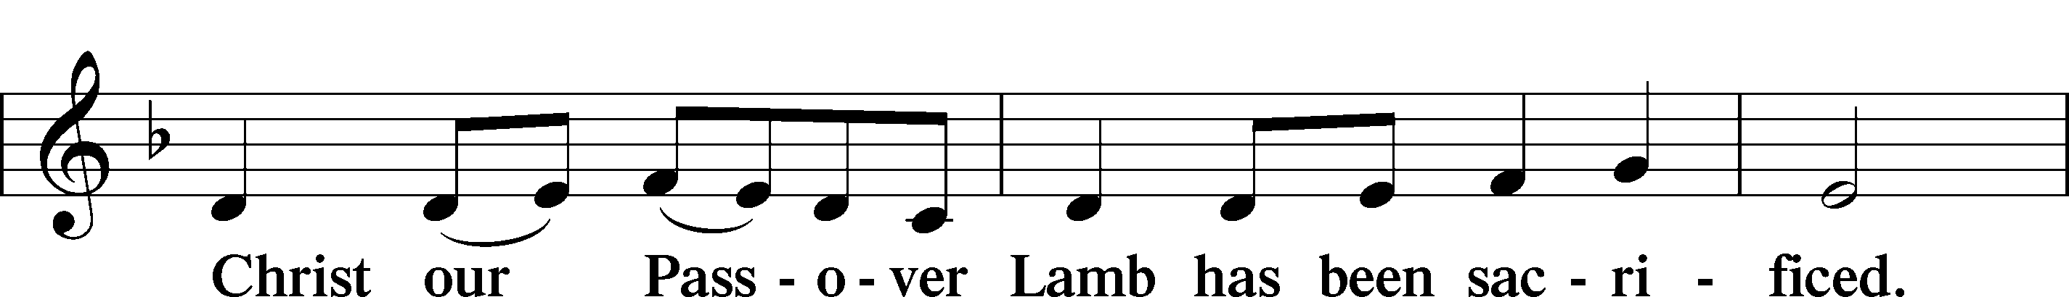
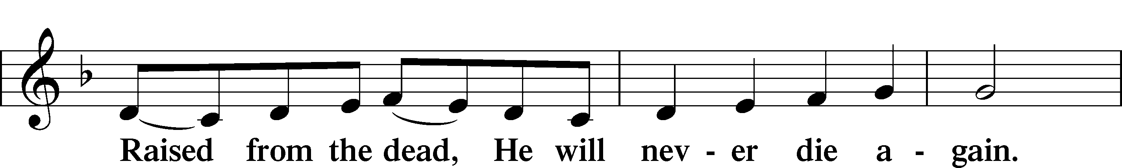
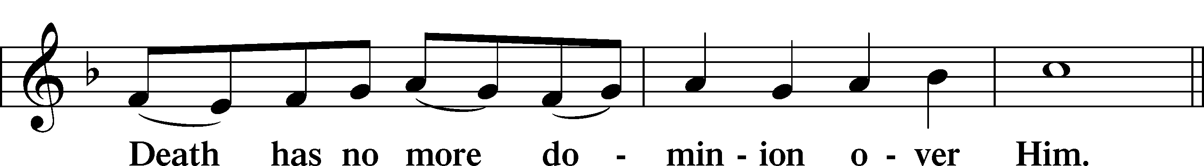
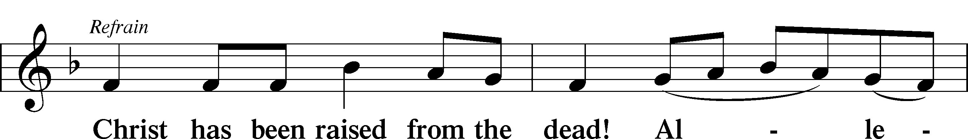
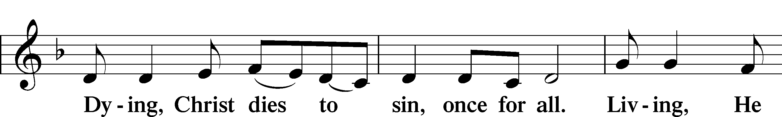
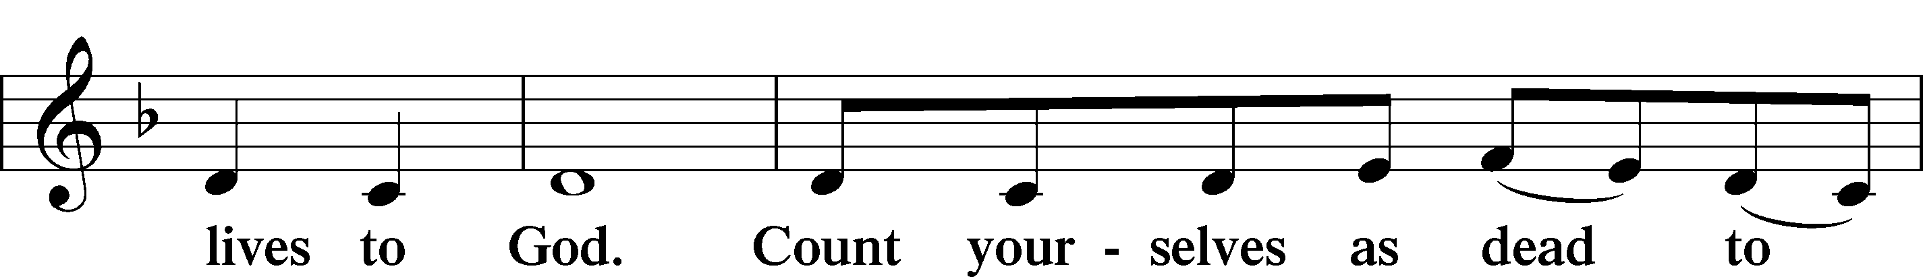
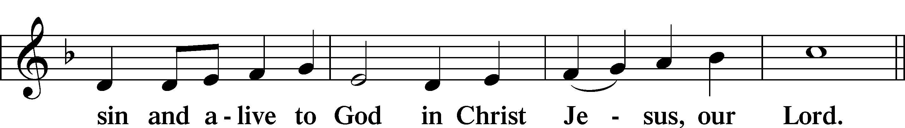
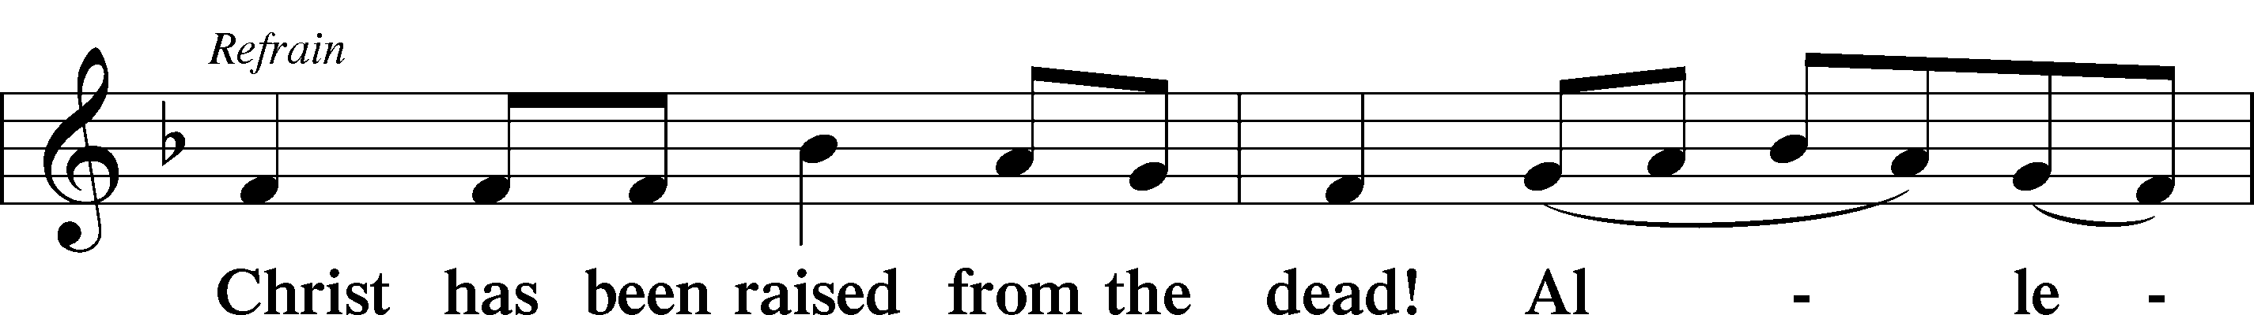
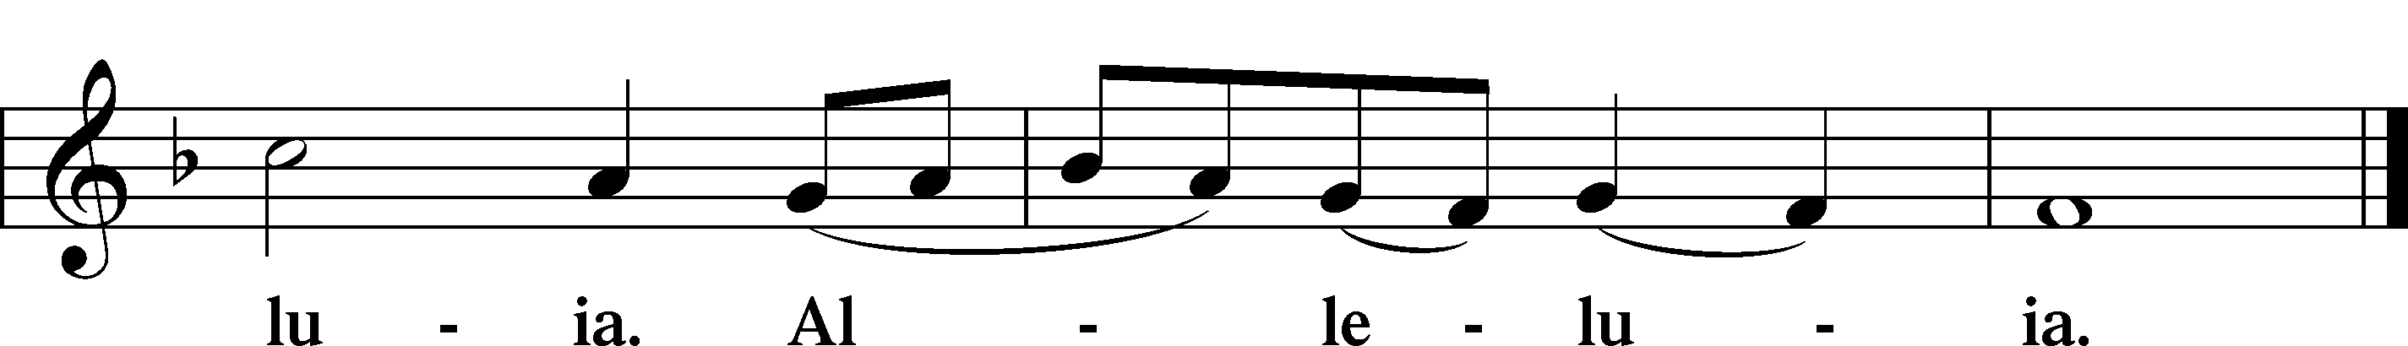

Benedicamus LSB 267
L Let us bless the Lord.
C Thanks be to God.

Benediction LSB 267
L The almighty and merciful Lord, the Father, the T Son, and the Holy Spirit, bless and preserve us.
C Amen.

Hymn: Children of the Heavenly Father LSB 725
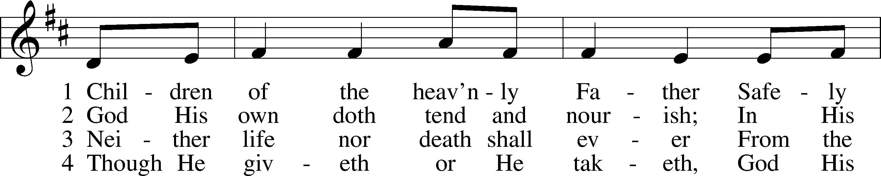
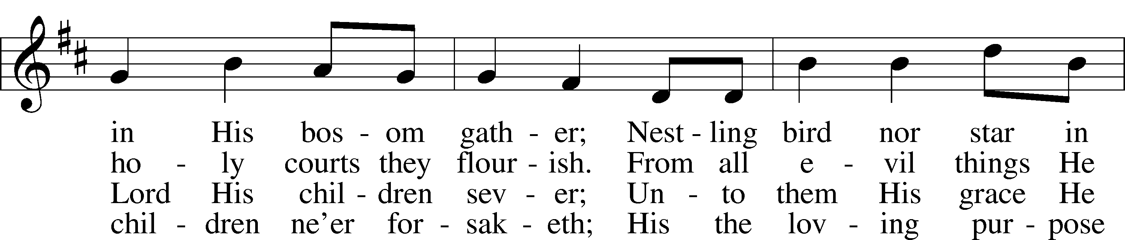
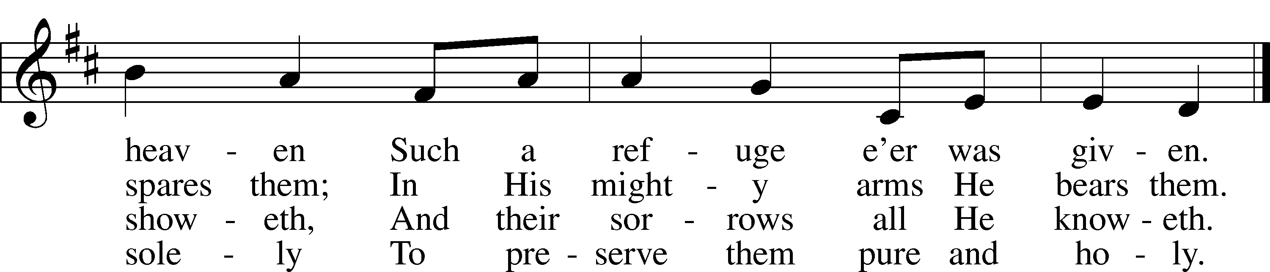
Text: Carolina Sandell Berg, 1832–1903; tr. Ernst W. Olson, 1870–1958
Tune: Lofsånger och andeliga wisor, 1873, Sweden
Text: Public domain
Tune: Public domain

Acknowledgments
Service of Prayer and Preaching from Lutheran Service Book
Unless otherwise indicated, Scripture quotations are from the ESV® Bible (The Holy Bible, English Standard Version®), copyright © 2001 by Crossway, a publishing ministry of Good News Publishers. Used by permission. All rights reserved.
Created by Lutheran Service Builder © 2022 Concordia Publishing House.

Announcements:
Church Service Phone: 888-505-1870/715-438-4200
(Stay on the line for recorded service to start)
Live Stream audio services: http://salem.listentochurch.com
Salem’s Web Page: https://www.salembarron.com/

Pastor Michael Nielsen: Cell phone: 218-280-0999
Email: rev.mike.nielsen@gmail.com
Pastor’s Office Hours: Monday-Wednesday 9-12

Attendance:
Call-in line: 5/1 - 6 Facebook live: 5/1- 7 In-person: 5/1 - 61

Weekly Needs: $2823.92
4/24/22 - General: $1843 Missions: $225 Bldg: $245 Childcare: $10,

Coffee and Snacks: Mark and Amy Dennis, Stan and Nancy Koenig
Elder Today: Trevor Duncan
Altar Guild: MaryAnn Thompson/Mary Hammann

Link to Salem’s Facebook page is:
https://www.facebook.com/SalemEvangelicalLutheranChurchAndPreschool/

Schedule for the upcoming week:
Tuesday: 7:30 AM – Men’s Bible Study
7:00 PM – Church Council
Thursday: 11:00 AM – Basics of Biblical Interpretation

May 15, 2022 – Last Day of Sunday School, Teacher Appreication, High School Graduate Recognition (Church Potluck)

May 18-24 – Pastor will be gone in St. Louis for some family time and for graduation. If you would like to watch graduation on May 20. You can watch on csl.edu/live.

June 19-23 – VBS God’s Wonder Lab. See the newsletter for more details on needs.

Prayer requests:

Those in the nursing home: Caroly, Lois, Wilma

Those Shut-in at home: Char, Gail and Roxanne, Joan, Joyce

Those recovering from accident: Rusty Weise

Those with ongoing health issues: Harrison, Jeanne, Wyatt, Owen, Joyce, Kathy, Jeff, Daria, Bob, Loretta

Those who lead our nation:
Joe Biden, Kamala Harris, Tony Evers, Rod Nordby

Those who serve in our military:
Ryan Graf and Ethan Kobernick, Chaplain Pon Chanthaphon (Our Adopt-a-Chaplain)

Our Childcare Staff: Amanda Ritchie, Mary Zook, Mariah Behnke, Jasmine Thompson

Families of the Week: Daniel and Linda Mullikin, Joyce Myers, Rev. Michael and Emily Nielsen (Hannah, Miriam, Jonah, and Naomi), Wendy (Starck) Noha, Jeff Nyhus

Those who are struggling with Covid and the doctors and nurses caring for their patients.

Mission Statement
The Mission of Salem Lutheran Church is to be what God called us to be through faith in Jesus Christ, a body of believers engaged in building the Kingdom of God by discipling the Barron area with His Word and Sacrament ministry.

The Christ Community Lutheran School Steering Committee will make a presentation at Salem on May 22, 2022, after Church during Bible Class.

