Ash Wednesday
March 2, 2022
12:00 PM and 6:30 PM

Salem Lutheran Church
1-715-537-3011
http://www.salembarron.com
rev.mike.nielsen@gmail.com
John the Baptist

As we begin our Lenten journey, we focus our attention on various witnesses to Christ in John’s Gospel. We begin with John the Baptist, a man on a mission. “There was a man sent from God, whose name was John. He came as a witness, to bear witness about the light, that all might believe through him” (John 1:6–7). John the Baptist’s mission is “to bear witness about the light.” In fact, fourteen times in John’s Gospel, the word witness is connected with John the Baptist. “He was not the light, but came to bear witness about the light. The true light, which enlightens everyone, was coming into the world” (John 1:8–9). John points us to Jesus, who takes away our sin, our guilt, and our shame at the cross.
PREPARATION

Hymn: I Bear the Ashen Cross OAR 195
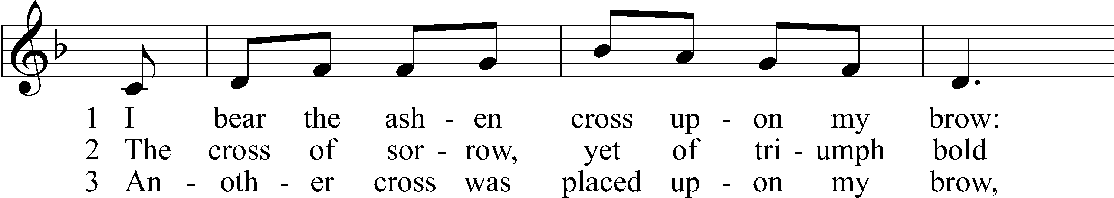
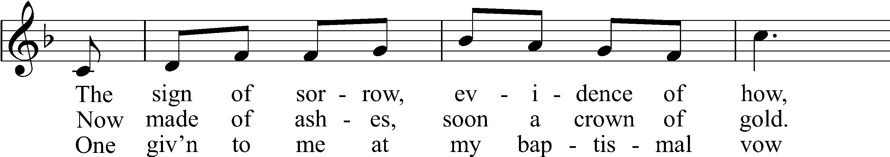
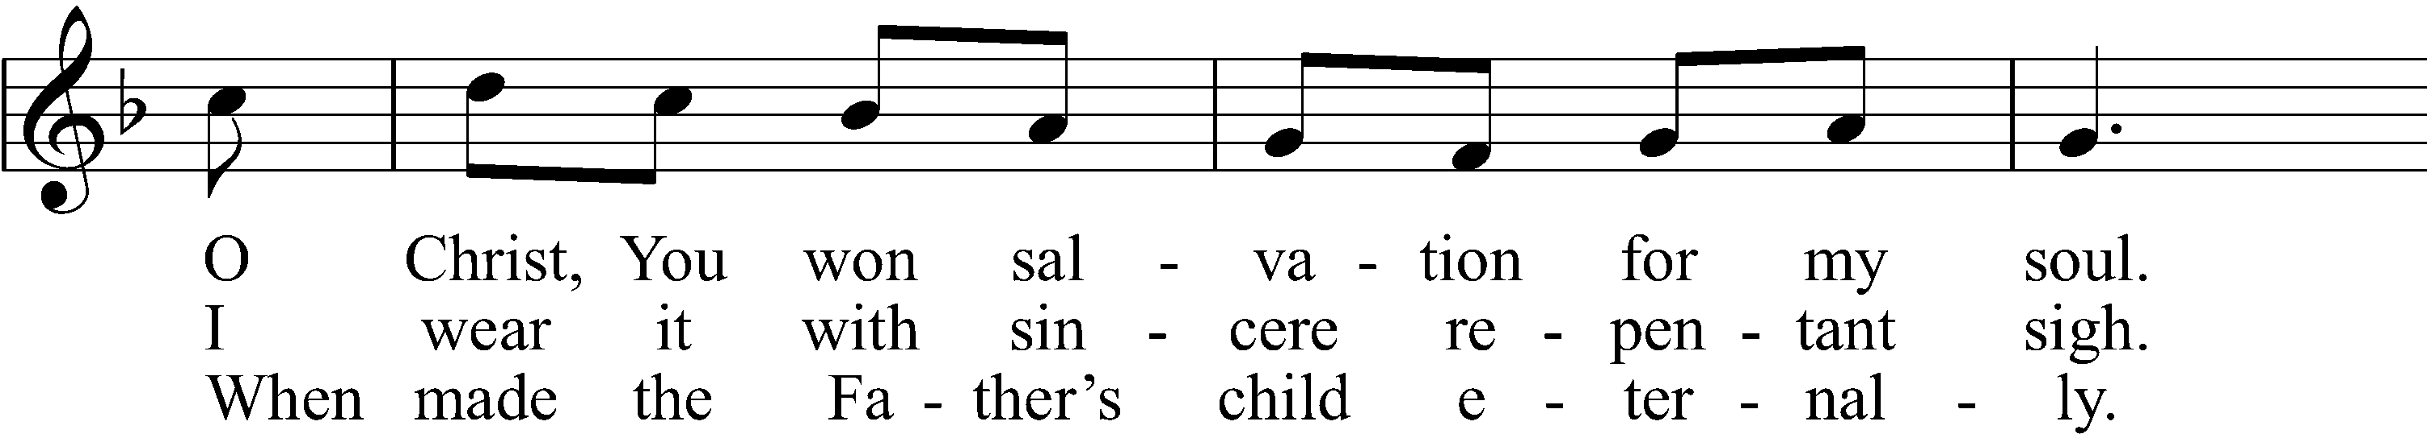
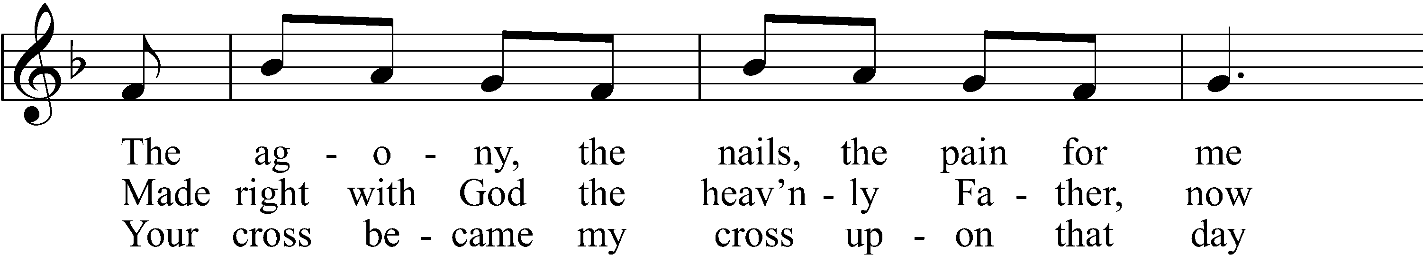
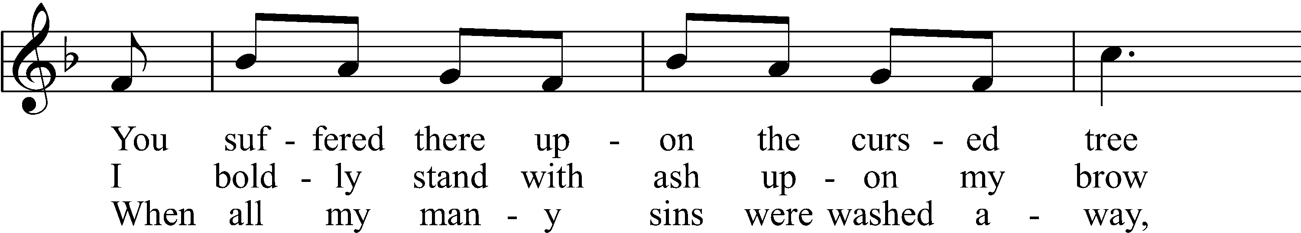
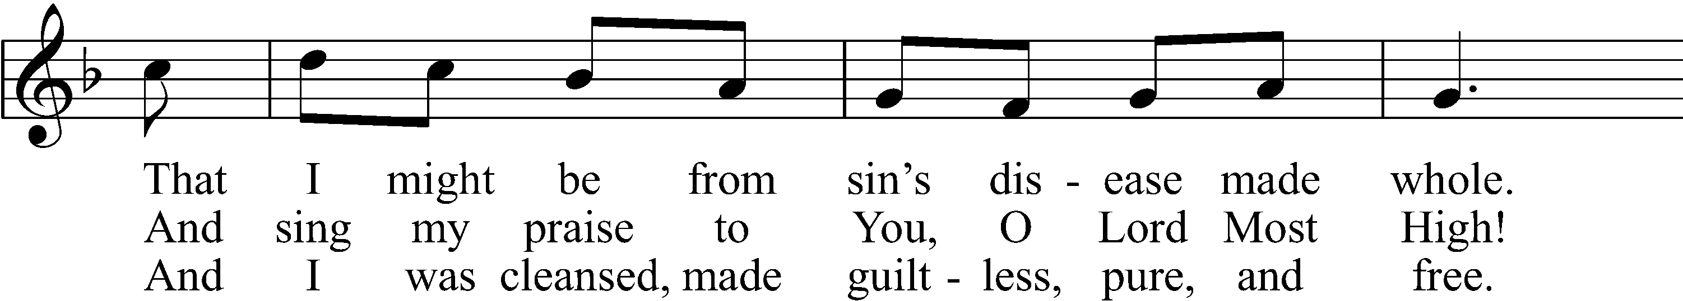
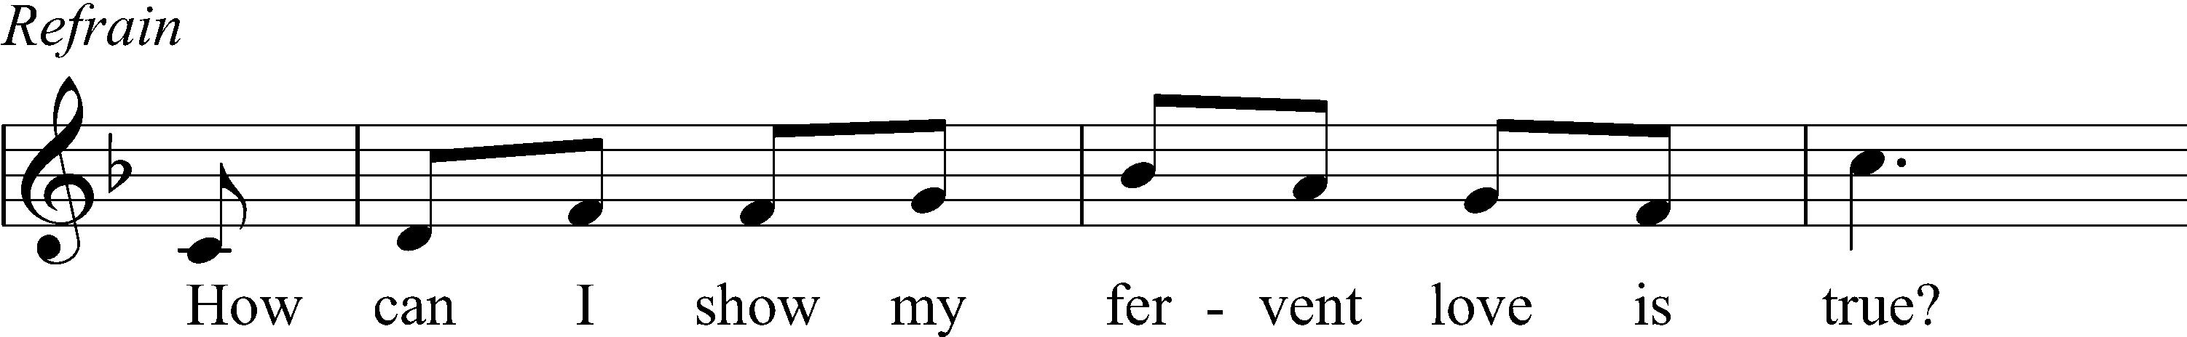
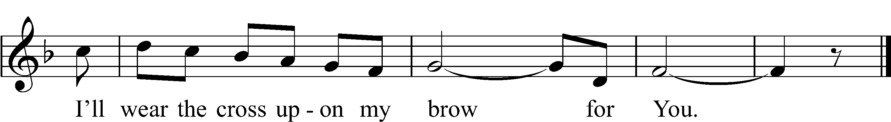
Text: © 2015 Don Petering. Used by permission: OAR Hymn License no. 110005504
Tune: © 2015 Concordia Publishing House. Used by permission: OAR Hymn License no. 110005504

Ash Wednesday Address
P Dear brothers and sisters of our Lord Jesus Christ, on this day the Church begins a holy season of prayerful and penitential reflection. Our attention is especially directed to the holy sufferings and death of our Lord Jesus Christ.
From ancient times the season of Lent has been kept as a time of special devotion, self-denial, and humble repentance born of a faithful heart that dwells confidently on His Word and draws from it life and hope.
Let us pray that our dear Father in heaven, for the sake of His beloved Son and in the power of His Holy Spirit, might richly bless this Lententide for us so that we may come to Easter with glad hearts and keep the feast in sincerity and truth.

Silence for reflection

Litany
P O Lord,
C have mercy.
P O Christ,
C have mercy.
P O Lord,
C have mercy.
P O Christ,
C hear us.
P God the Father in heaven,
C have mercy.
P God the Son, Redeemer of the world,
C have mercy.
P God the Holy Spirit,
C have mercy.
P Be gracious to us.
C Spare us, good Lord.
P Be gracious to us.
C Help us, good Lord.
P By the mystery of Your holy incarnation; by Your holy nativity; by Your baptism, fasting, and temptation; by Your agony and bloody sweat; by Your cross and passion; by Your precious death and burial; by Your glorious resurrection and ascension; and by the coming of the Holy Spirit, the Comforter:
C Help us, good Lord.
P In all time of our tribulation; in all time of our prosperity; in the hour of death; and in the day of judgment:
C Help us, good Lord.
P We poor sinners implore You
C to hear us, O Lord.
P To prosper the preaching of Your Word; to bless our prayer and meditation; to strengthen and preserve us in the true faith; and to give heart to our sorrow and strength to our repentance:
C We implore You to hear us, good Lord.
P To draw all to Yourself; to bless those who are instructed in the faith; to watch over and console the poor, the sick, the distressed, the lonely, the forsaken, the abandoned, and all who stand in need of our prayers; to give abundant blessing to all works of mercy; and to have mercy on us all:
C We implore You to hear us, good Lord.
P To turn our hearts to You; to turn the hearts of our enemies, persecutors, and slanderers; and graciously to hear our prayers:
C We implore You to hear us, good Lord.
P Lord Jesus Christ, Son of God,
C we implore You to hear us.
P Christ, the Lamb of God, who takes away the sin of the world,
C have mercy.
P Christ, the Lamb of God, who takes away the sin of the world,
C have mercy.
P Christ, the Lamb of God, who takes away the sin of the world,
C grant us Your peace.
P O Christ,
C hear us.
P O Lord,
C have mercy.
P O Christ,
C have mercy.
P O Lord,
C have mercy. Amen.

P O God, You desire not the death of sinners, but rather that they turn from their wickedness and live. We implore You to have compassion on the frailty of our mortal nature, for we acknowledge that we are dust and to dust we shall return. Mercifully pardon our sins that we may obtain the promises You have laid up for those who are repentant; through Jesus Christ, Your Son, our Lord, who lives and reigns with You and the Holy Spirit, one God, now and forever.
C Amen.

Imposition of Ashes

The pastor and assistants receive ashes first, followed by the congregation. Using the right thumb, the pastor or an assistant places the ashes on the forehead of each person in the sign of the cross, saying:

P Remember that you are dust, and to dust you shall return.

After receiving the ashes, each person returns to his place in silence.

Confession and Absolution

Hymn: Lord Jesus Think on Me LSB 610
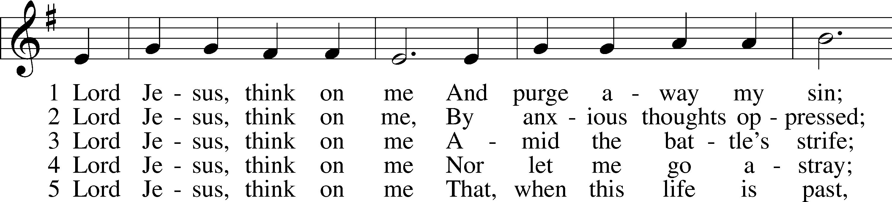
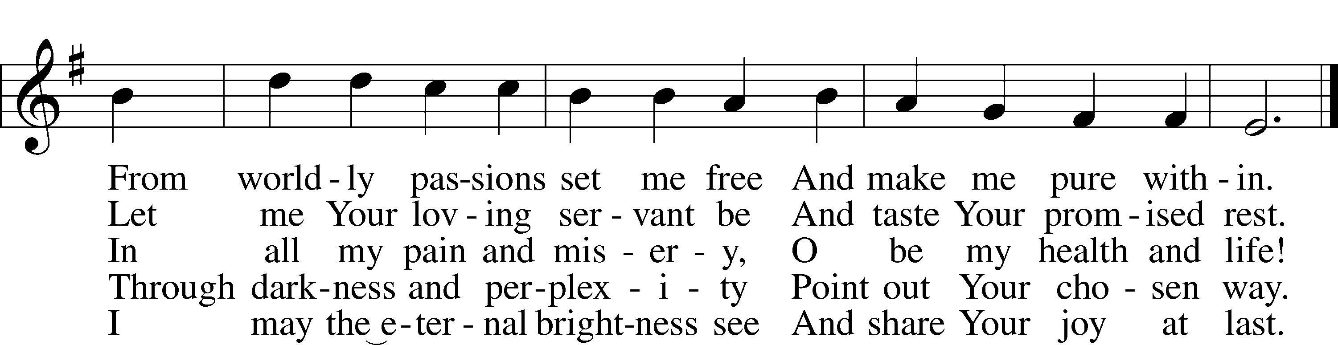
Text and tune: Public domain

The sign of the cross may be made by all in remembrance of their Baptism.

Invocation
P In the name of the Father and of the T Son and of the Holy Spirit.
C Amen.

P If we say we have no sin, we deceive ourselves, and the truth is not in us.
C But if we confess our sins, God, who is faithful and just, will forgive our sins and cleanse us from all unrighteousness.

Silence for reflection on God’s Word and for self-examination.

P Let us then confess our sins to God our Father.
C Most merciful God, we confess that we are by nature sinful and unclean. We have sinned against You in thought, word, and deed, by what we have done and by what we have left undone. We have not loved You with our whole heart; we have not loved our neighbors as ourselves. We justly deserve Your present and eternal punishment. For the sake of Your Son, Jesus Christ, have mercy on us. Forgive us, renew us, and lead us, so that we may delight in Your will and walk in Your ways to the glory of Your holy name. Amen.

P Almighty God in His mercy has given His Son to die for you and for His sake forgives you all your sins. As a called and ordained servant of Christ, and by His authority, I therefore forgive you all your sins in the name of the Father and of the T Son and of the Holy Spirit.
C Amen.
SERVICE OF THE WORD
Introit Psalm 51:1–3, 10–12; antiphon: v. 17
The sacrifices of God are a broken spirit;
a broken and contrite heart, O God, you will not despise.
Have mercy on me, O God, according to your steadfast love;
according to your abundant mercy blot out my transgressions.
Wash me thoroughly from my iniquity,
and cleanse me from my sin!
For I know my transgressions,
and my sin is ever before me.
Create in me a clean heart, O God,
and renew a right spirit within me.
Cast me not away from your presence,
and take not your Holy Spirit from me.
Restore to me the joy of your salvation,
and uphold me with a willing spirit.
Glory be to the Father and to the Son
and to the Holy Spirit;
as it was in the beginning,
is now, and will be forever. Amen.
The sacrifices of God are a broken spirit;
a broken and contrite heart, O God, you will not despise.

Kyrie LSB 152
A In peace let us pray to the Lord.
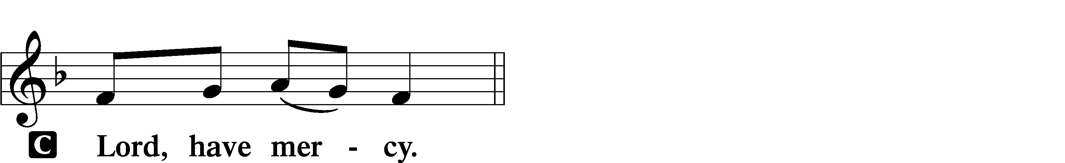

A For the peace from above and for our salvation let us pray to the Lord.
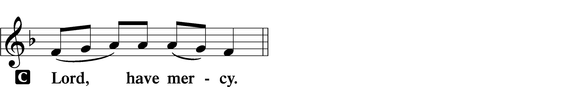

A For the peace of the whole world, for the well-being of the Church of God, and for the unity of all let us pray to the Lord.
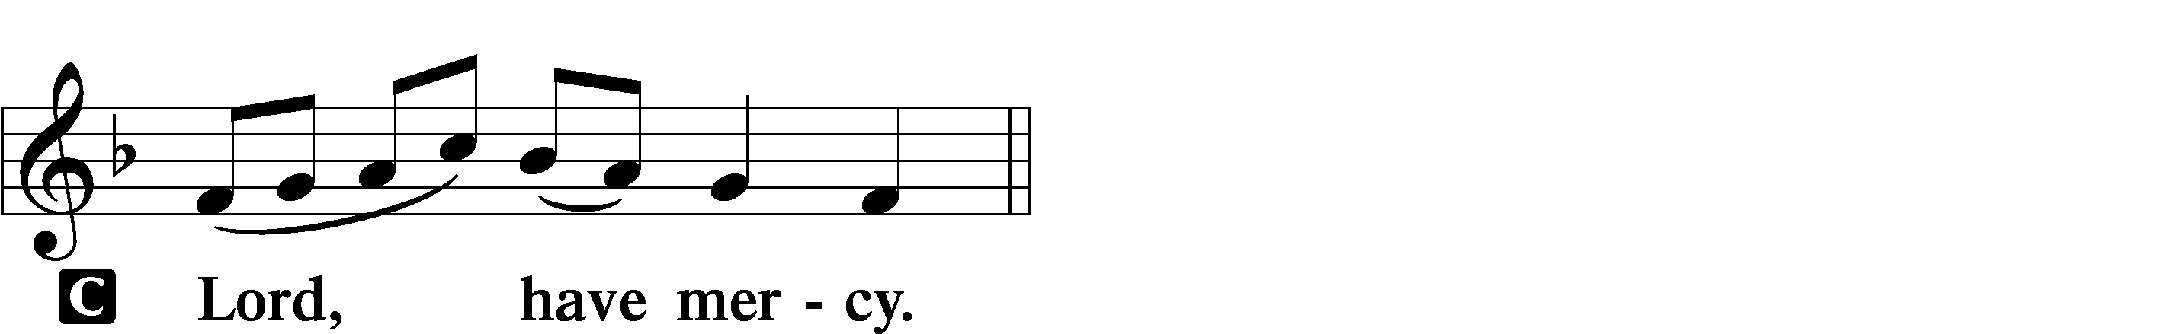

A For this holy house and for all who offer here their worship and praise let us pray to the Lord.
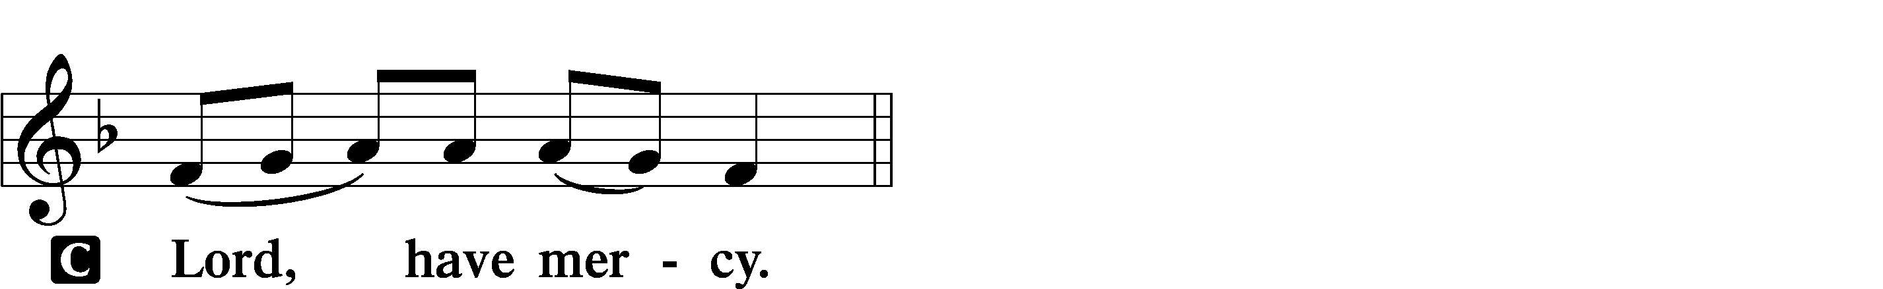

A Help, save, comfort, and defend us, gracious Lord.

Salutation and Collect of the Day
P The Lord be with you.
C And also with you.

P Let us pray.

Almighty and everlasting God, You despise nothing You have made and forgive the sins of all who are penitent. Create in us new and contrite hearts that lamenting our sins and acknowledging our wretchedness we may receive from You full pardon and forgiveness; through Jesus Christ, Your Son, our Lord, who lives and reigns with You and the Holy Spirit, one God, now and forever.
C Amen.

Old Testament Reading Joel 2:12–19
P The Old Testament Reading is from Joel, the second chapter.

Return to the Lord
12“Yet even now,” declares the Lord, “return to me with all your heart,
with fasting, with weeping, and with mourning; 13and rend your hearts and not your garments.” Return to the Lord, your God, for he is gracious and merciful,
slow to anger, and abounding in steadfast love; and he relents over disaster.
14Who knows whether he will not turn and relent, and leave a blessing behind him, a grain offering and a drink offering for the Lord your God? 15Blow the trumpet in Zion; consecrate a fast; call a solemn assembly; 16gather the people. Consecrate the congregation; assemble the elders; gather the children, even nursing infants. Let the bridegroom leave his room, and the bride her chamber.
17Between the vestibule and the altar let the priests, the ministers of the Lord, weep and say, “Spare your people, O Lord, and make not your heritage a reproach, a byword among the nations. Why should they say among the peoples,
‘Where is their God?’”
The Lord Had Pity
18Then the Lord became jealous for his land and had pity on his people.
19The Lord answered and said to his people, “Behold, I am sending to you grain, wine, and oil, and you will be satisfied; and I will no more make you a reproach among the nations.”

P This is the Word of the Lord.
C Thanks be to God.

Hymn LSB 422
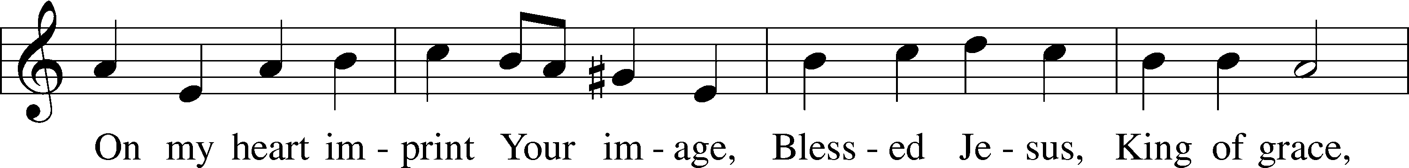
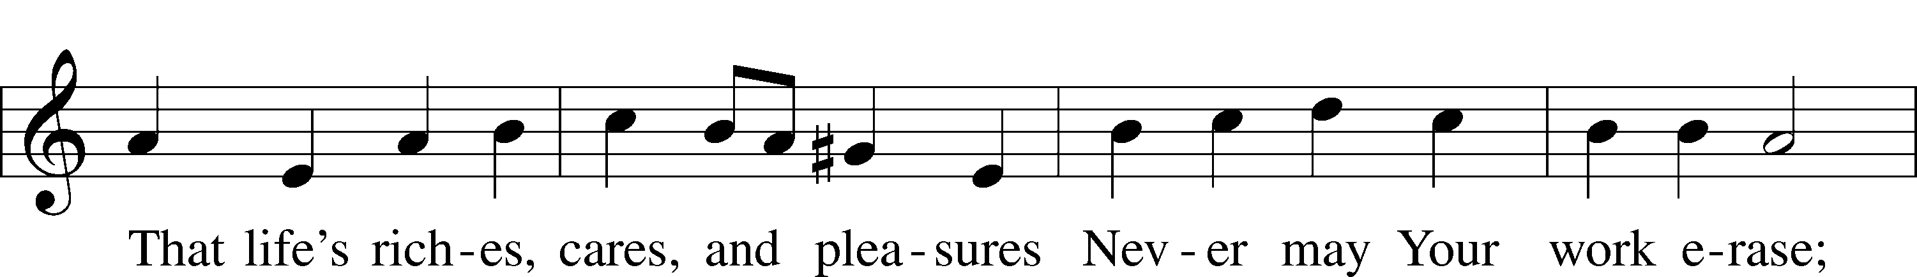
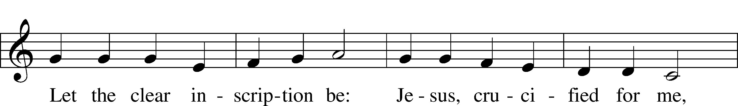
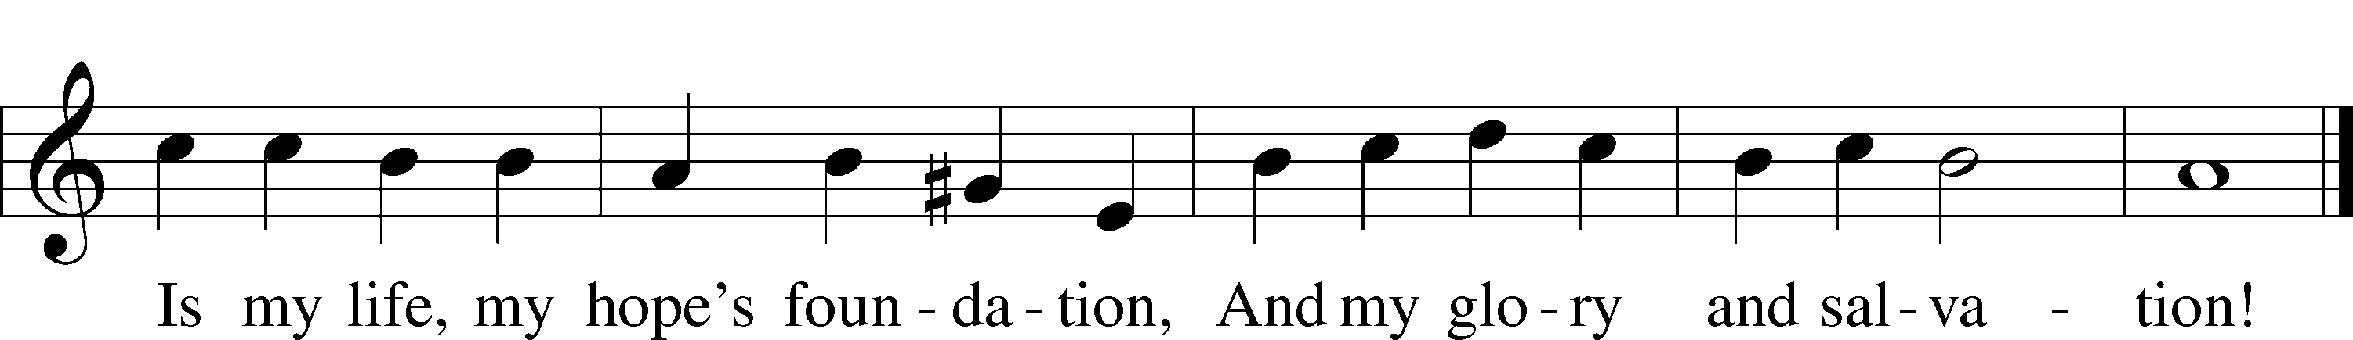
Text and tune: Public domain

Epistle 2 Corinthians 5:20b—6:10
P The Epistle is from Second Corinthians, the fifth and sixth chapters.

We implore you on behalf of Christ, be reconciled to God. 21For our sake he made him to be sin who knew no sin, so that in him we might become the righteousness of God.
1Working together with him, then, we appeal to you not to receive the grace of God in vain. 2For he says,
“In a favorable time I listened to you,
and in a day of salvation I have helped you.”
Behold, now is the favorable time; behold, now is the day of salvation. 3We put no obstacle in anyone’s way, so that no fault may be found with our ministry, 4but as servants of God we commend ourselves in every way: by great endurance, in afflictions, hardships, calamities, 5beatings, imprisonments, riots, labors, sleepless nights, hunger; 6by purity, knowledge, patience, kindness, the Holy Spirit, genuine love; 7by truthful speech, and the power of God; with the weapons of righteousness for the right hand and for the left; 8through honor and dishonor, through slander and praise. We are treated as impostors, and yet are true; 9as unknown, and yet well known; as dying, and behold, we live; as punished, and yet not killed; 10as sorrowful, yet always rejoicing; as poor, yet making many rich; as having nothing, yet possessing everything.

P This is the Word of the Lord.
C Thanks be to God.

Lenten Verse LSB 157
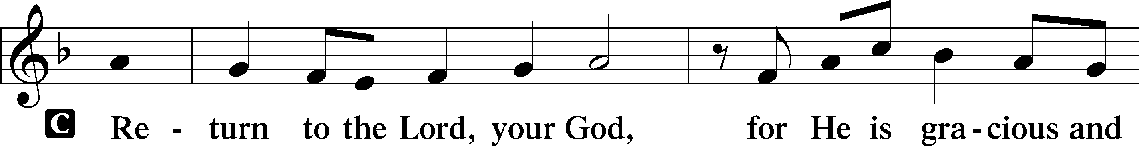
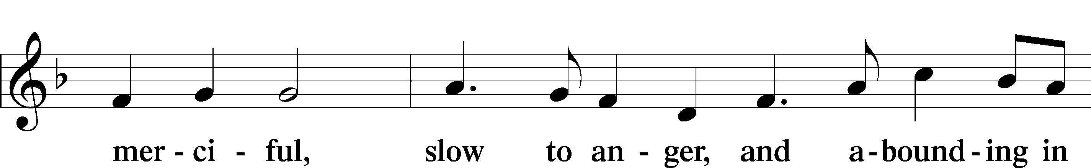
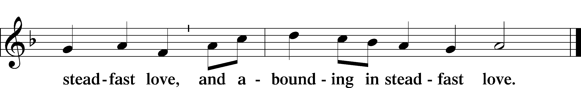

Holy Gospel John 1:29–34
P The Holy Gospel according to St. John, the first chapter.
C Glory to You, O Lord.

Behold, the Lamb of God
29The next day he saw Jesus coming toward him, and said, “Behold, the Lamb of God, who takes away the sin of the world! 30This is he of whom I said, ‘After me comes a man who ranks before me, because he was before me.’ 31I myself did not know him, but for this purpose I came baptizing with water, that he might be revealed to Israel.” 32And John bore witness: “I saw the Spirit descend from heaven like a dove, and it remained on him. 33I myself did not know him, but he who sent me to baptize with water said to me, ‘He on whom you see the Spirit descend and remain, this is he who baptizes with the Holy Spirit.’ 34And I have seen and have borne witness that this is the Son of God.”

P This is the Gospel of the Lord.
C Praise to You, O Christ.

Hymn: “Behold! The Lamb of God,” John Said
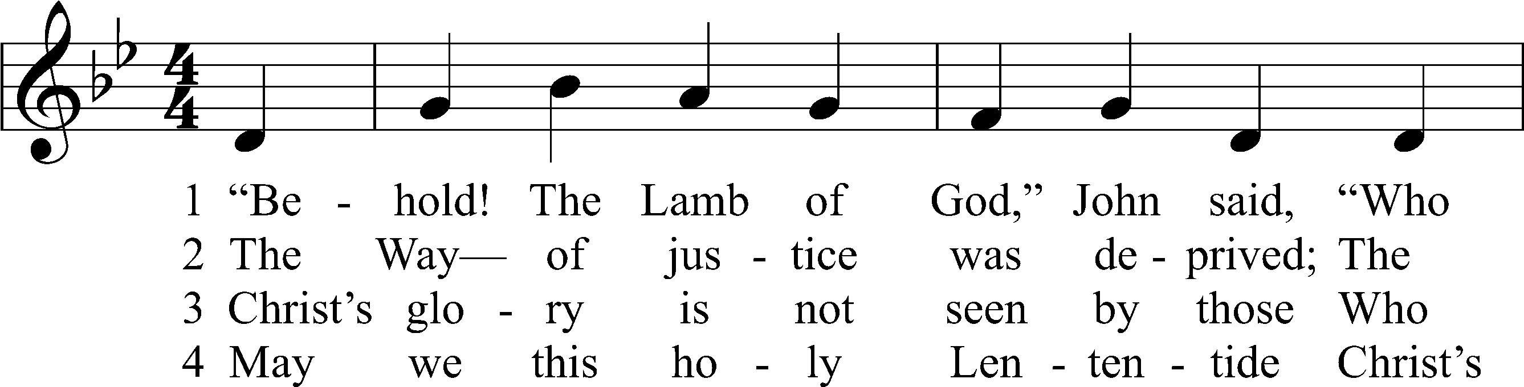
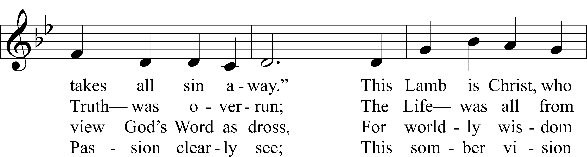
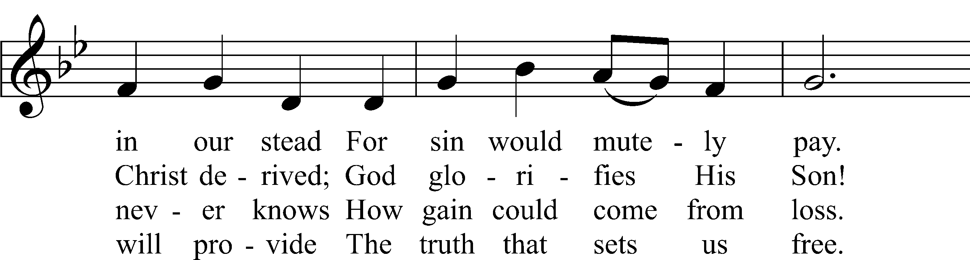
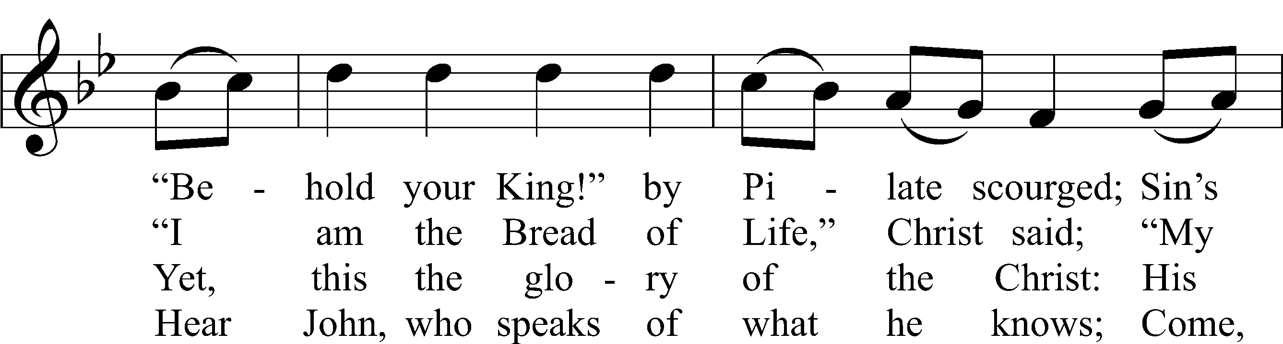
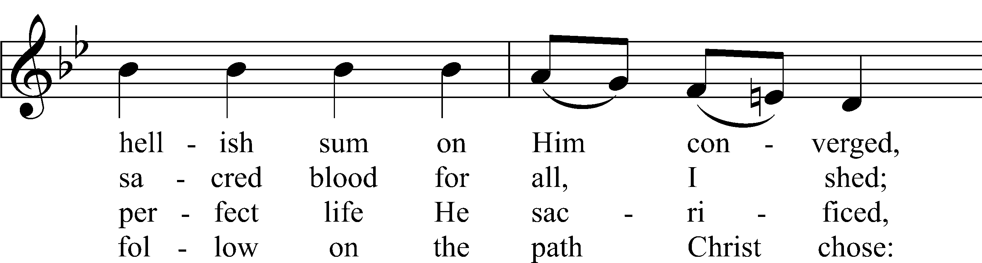
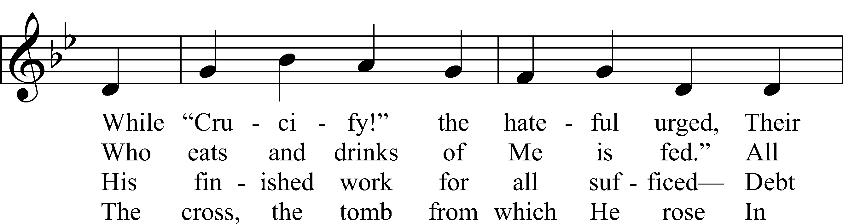
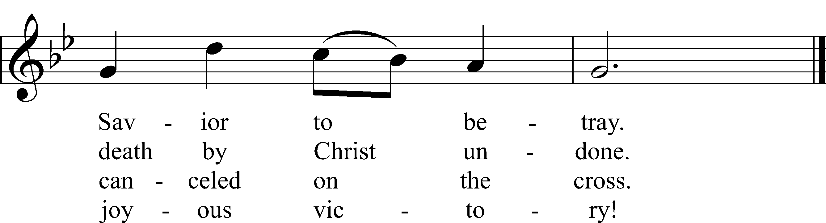
Text: © 2021 Stephen P. Starke, admin. Concordia Publishing House. Used by permission: CPH Lent License no. 110005504
Tune: © 1988, 1997 Wild Goose Resource Group, Iona Community, Scotland, admin. GIA Publications, Inc. Used by permission: CPH Lent License no. 110005504

Sermon

Nicene Creed
C I believe in one God, the Father Almighty, maker of heaven and earth and of all things visible and invisible.

And in one Lord Jesus Christ, the only-begotten Son of God, begotten of His Father before all worlds, God of God, Light of Light, very God of very God, begotten, not made, being of one substance with the Father, by whom all things were made; who for us men and for our salvation came down from heaven and was incarnate by the Holy Spirit of the virgin Mary and was made man; and was crucified also for us under Pontius Pilate. He suffered and was buried. And the third day He rose again according to the Scriptures and ascended into heaven and sits at the right hand of the Father. And He will come again with glory to judge both the living and the dead, whose kingdom will have no end.

And I believe in the Holy Spirit, the Lord and giver of life, who proceeds from the Father and the Son, who with the Father and the Son together is worshiped and glorified, who spoke by the prophets. And I believe in one holy Christian and apostolic Church, I acknowledge one Baptism for the remission of sins, and I look for the resurrection of the dead and the life T of the world to come. Amen.

Prayer of the Church

Offering

Offertory LSB 159
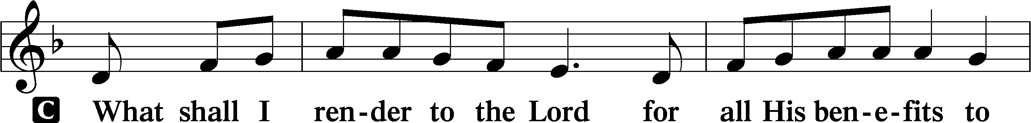
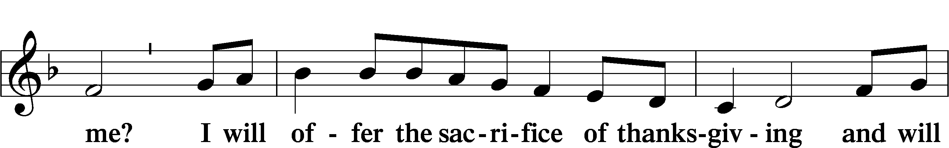
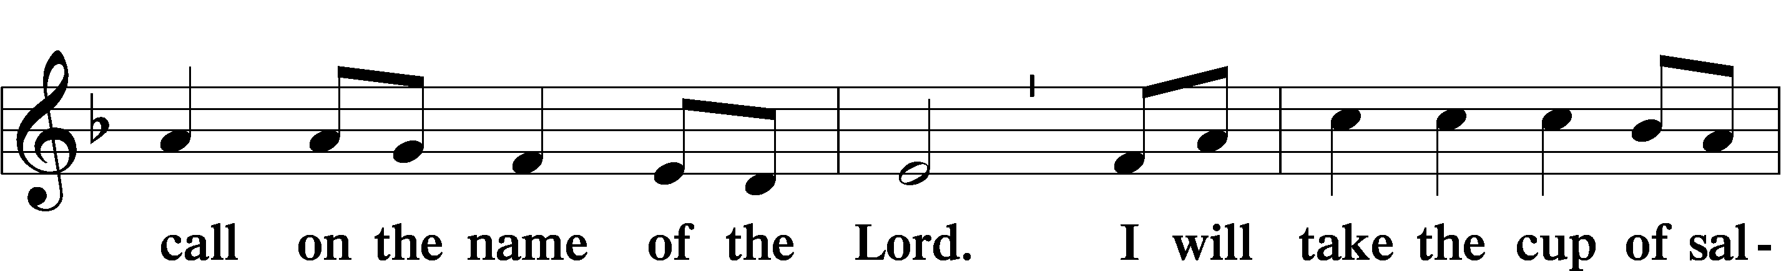
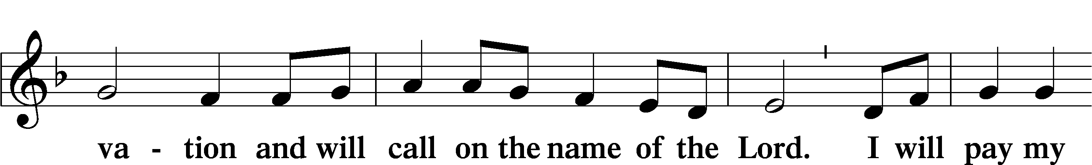
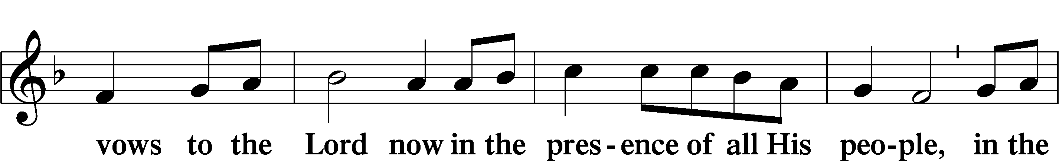
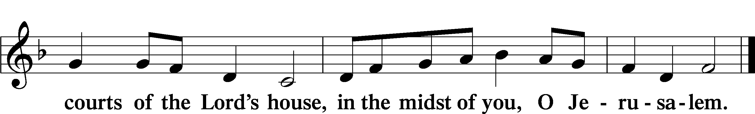

SERVICE OF THE SACRAMENT
Please complete a communion card for our records; they are in the pew in front of you, or request one from an usher. Salem’s communion practice is that of close communion. We invite to our rail those who are members in good standing of sister Missouri Synod parishes. Visitors, please contact the pastor prior to communing. For those who prefer to use the Common Cup, we ask your assistance by holding the cup’s base as you commune.

Preface (Sung)
P The Lord be with you.
C And also with you.

P Lift up your hearts.
C We lift them to the Lord.

P Let us give thanks to the Lord our God.
C It is right to give Him thanks and praise.

Proper Preface
P It is truly good, right, and salutary that we should at all times and in all places give thanks to You, holy Lord, almighty Father, everlasting God, through Jesus Christ, our Lord, who overcame the assaults of the devil and gave His life as a ransom for many that with cleansed hearts we might be prepared joyfully to celebrate the paschal feast in sincerity and truth. Therefore with angels and archangels and with all the company of heaven we laud and magnify Your glorious name, evermore praising You and saying:

Sanctus LSB 161
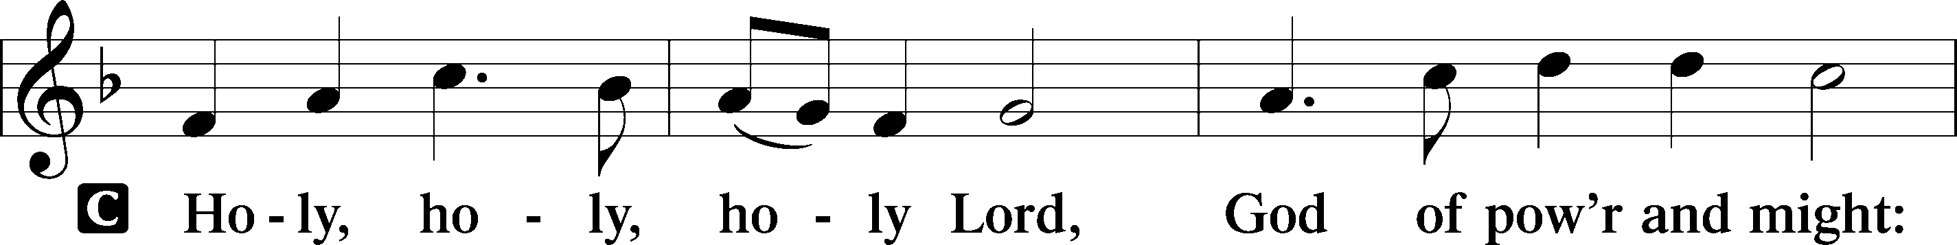
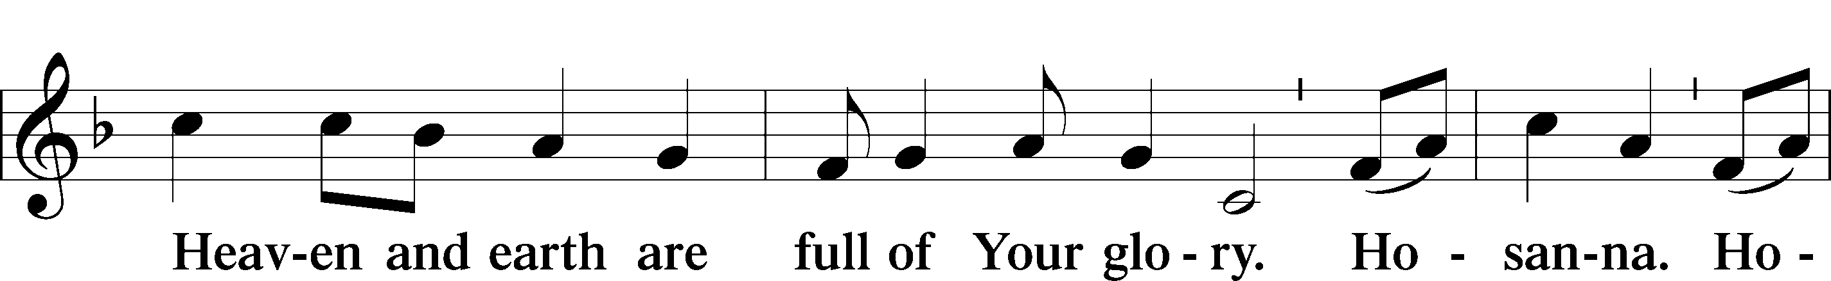
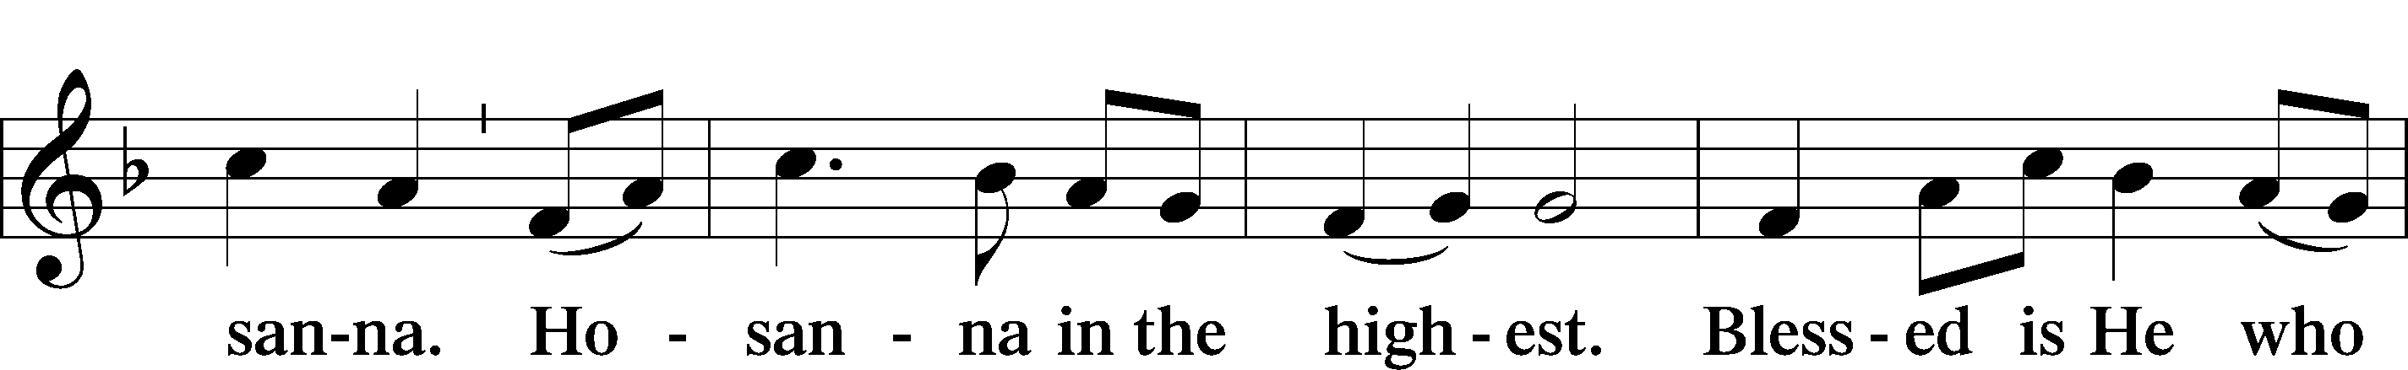
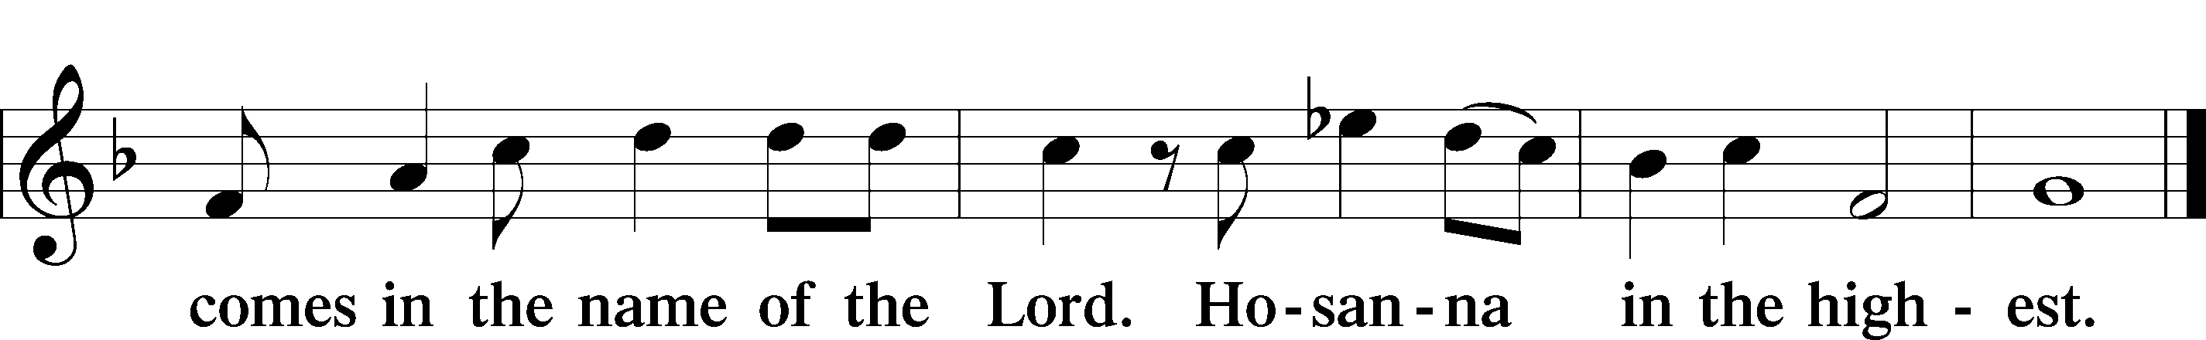

Prayer of Thanksgiving
P Holy are You, O Lord, God of power and might, and great is the majesty of Your glory, for You did so love the world that You gave Your only-begotten Son that whosoever believes in Him should not perish but have everlasting life. Recalling all that He accomplished—His life-giving passion and death, His glorious resurrection from the dead, His ascension to Your right hand, and His promise to bestow His Spirit upon us—we give You thanks and beg Your mercy that we who commune this day may be filled with all heavenly benediction and peace. We rejoice in the gift of forgiveness for our many sins and are renewed by Your grace to serve You in holiness and righteousness all our days. To You, O Father, Son, and Holy Spirit, be all honor and glory, in Your Holy Church, both now and forever.
C Amen.

Lord’s Prayer
P Lord, remember us in Your kingdom and teach us to pray:
C Our Father who art in heaven, hallowed be Thy name, Thy kingdom come, Thy will be done on earth as it is in heaven; give us this day our daily bread; and forgive us our trespasses as we forgive those who trespass against us; and lead us not into temptation, but deliver us from evil. For Thine is the kingdom and the power and the glory forever and ever. Amen.

The Words of Our Lord
P Our Lord Jesus Christ, on the night when He was betrayed, took bread, and when He had given thanks, He broke it and gave it to the disciples and said: “Take, eat; this is My T body, which is given for you. This do in remembrance of Me.”

In the same way also He took the cup after supper, and when He had given thanks, He gave it to them, saying: “Drink of it, all of you; this cup is the new testament in My T blood, which is shed for you for the forgiveness of sins. This do, as often as you drink it, in remembrance of Me.”

Pax Domini
P The peace of the Lord be with you always.
C Amen.

Agnus Dei LSB 163
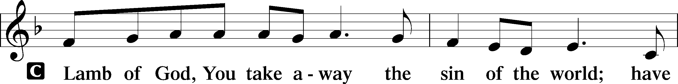
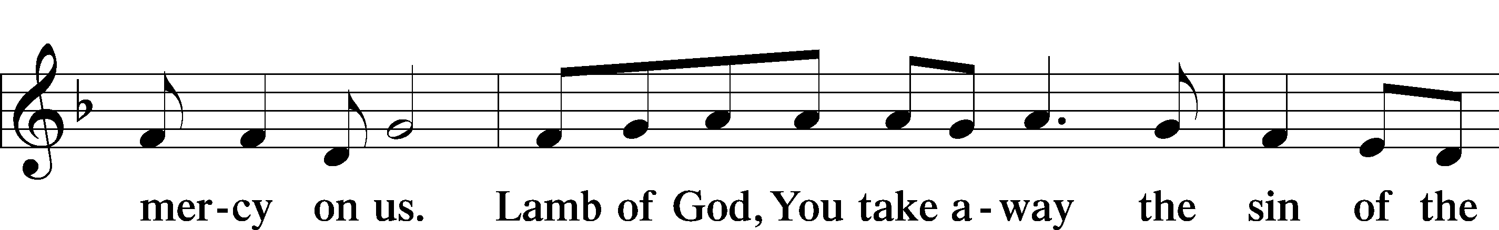
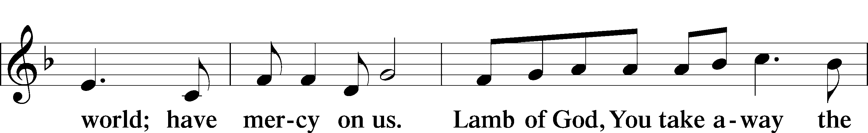
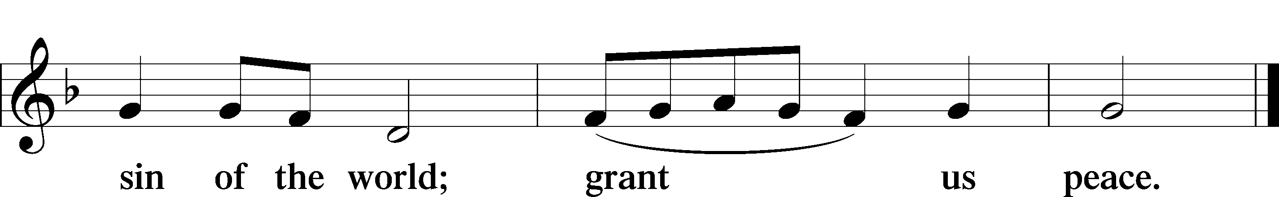

Distribution
Distribution Hymns

Hymn: A Lamb Goes Uncomplaining Forth LSB 438
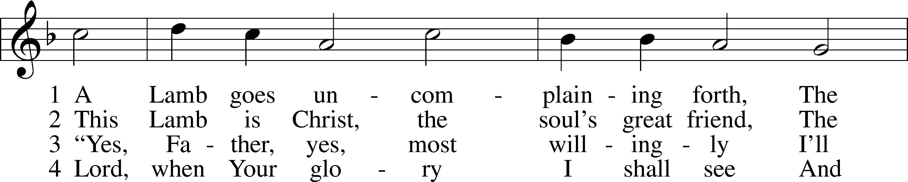
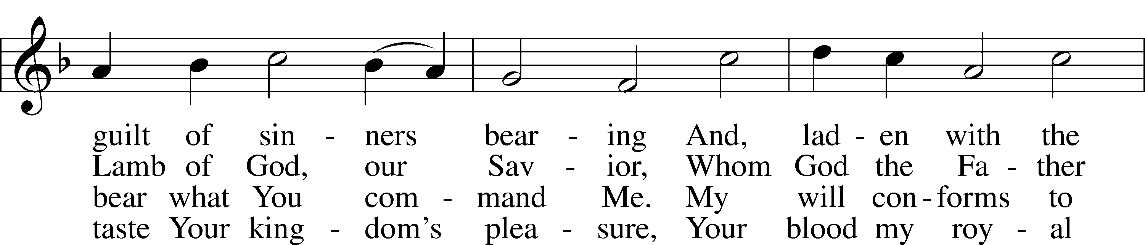
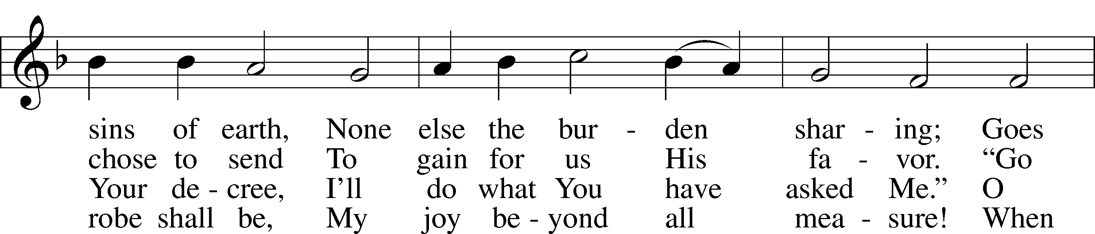
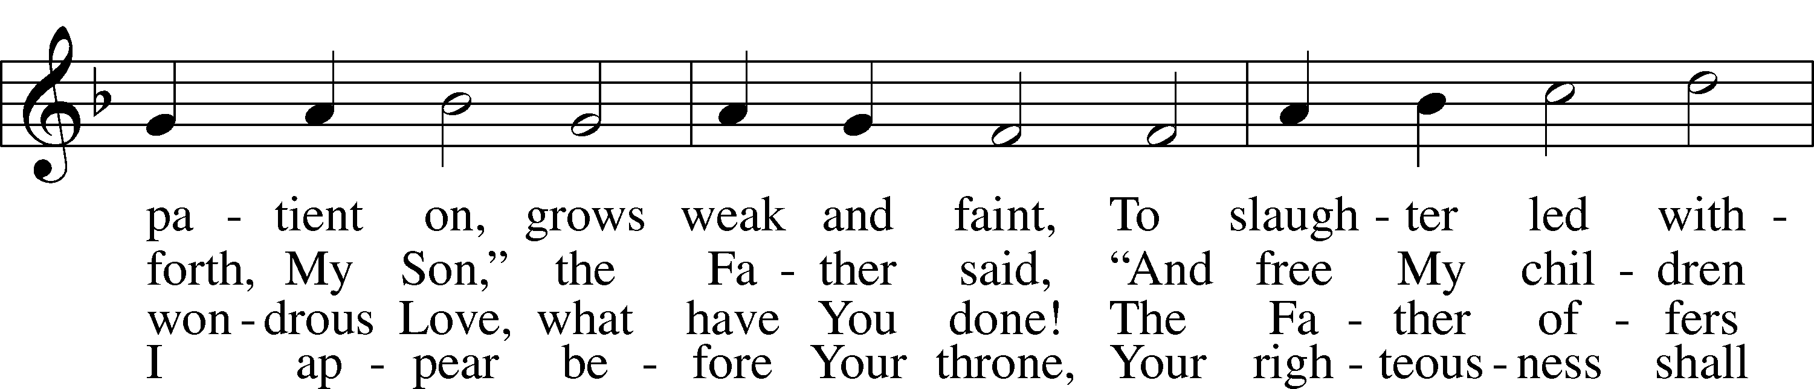
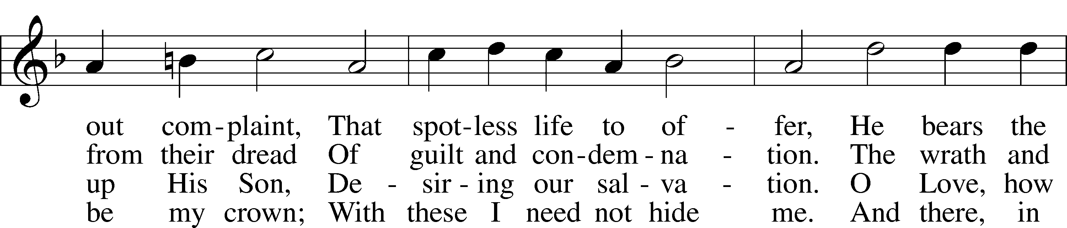
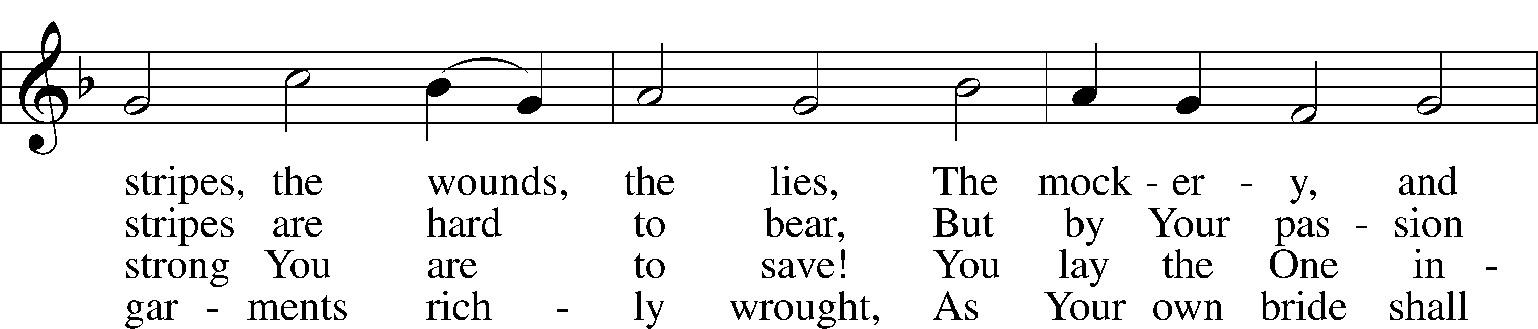
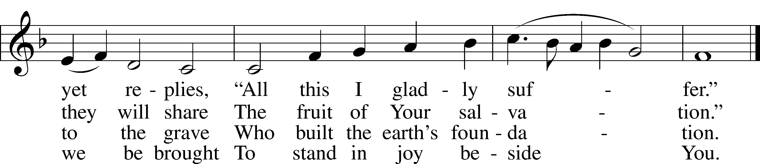
Text: © 1941 Concordia Publishing House. Used by permission: LSB Hymn License no. 110005504
Tune: Public domain

Hymn: Savior, When In Dust to Thee LSB 419
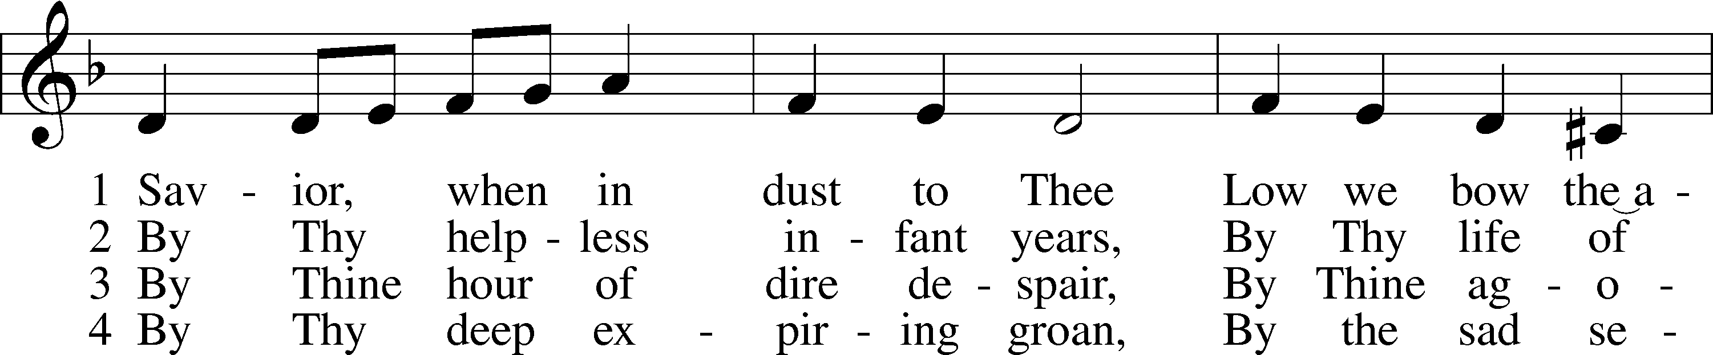
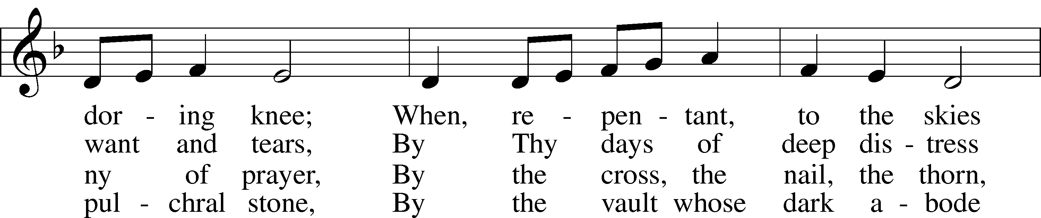
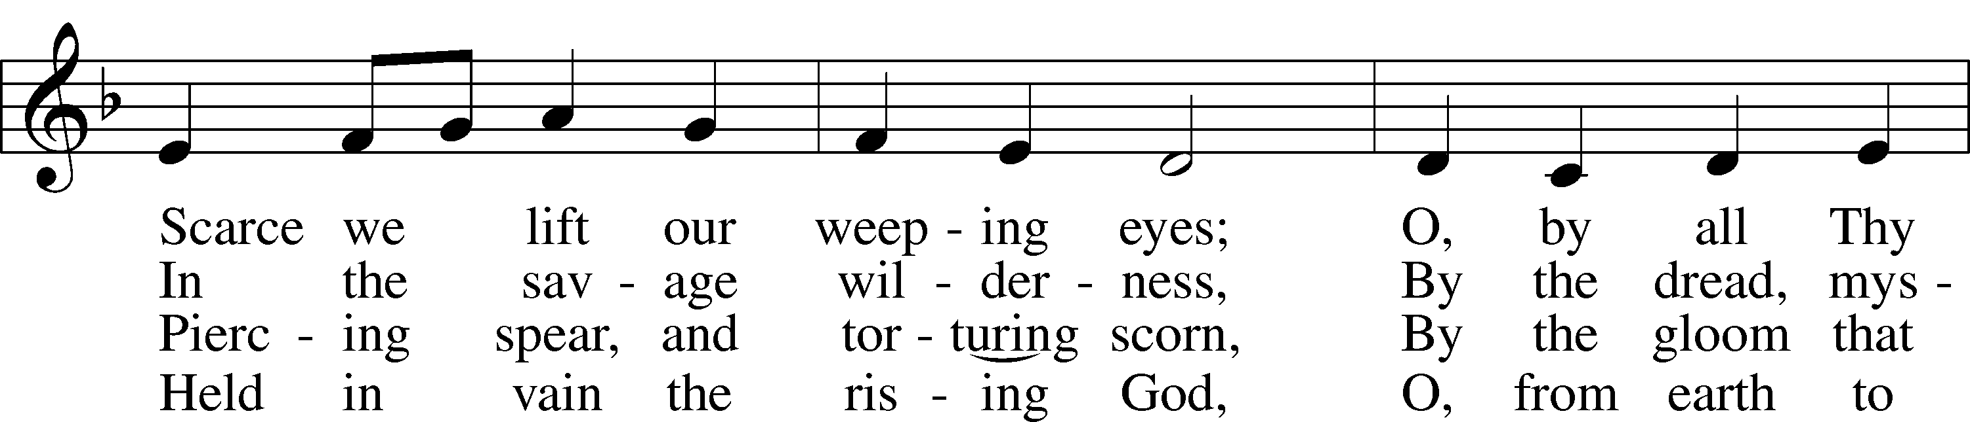
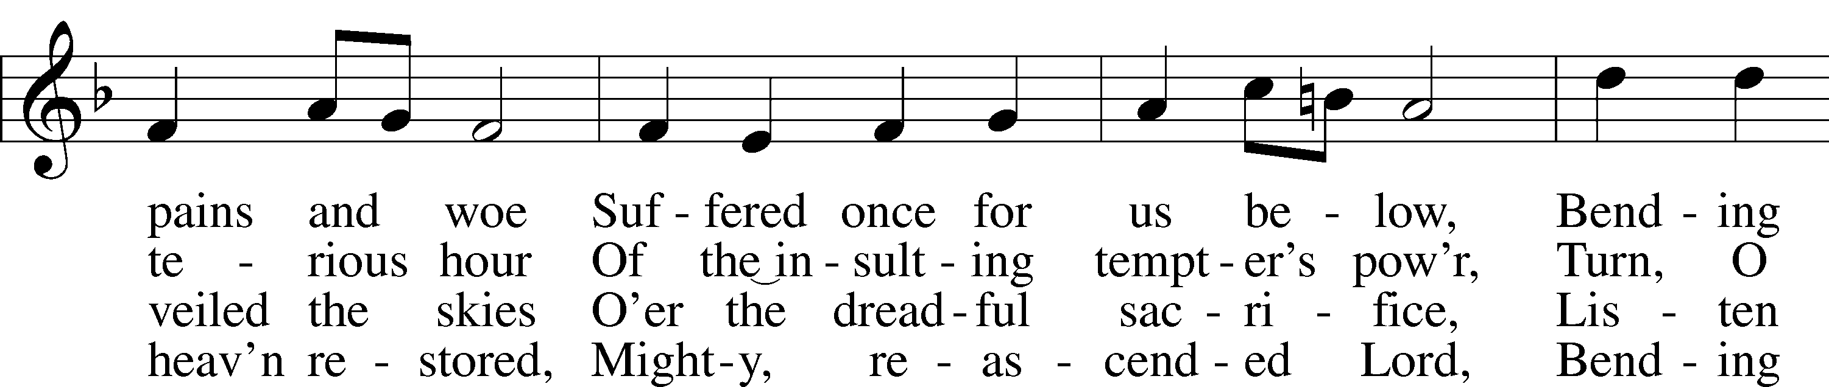
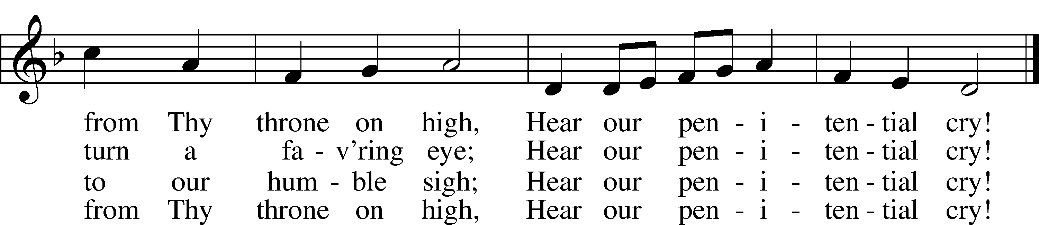
Text and tune: Public domain

Nunc Dimittis LSB 165
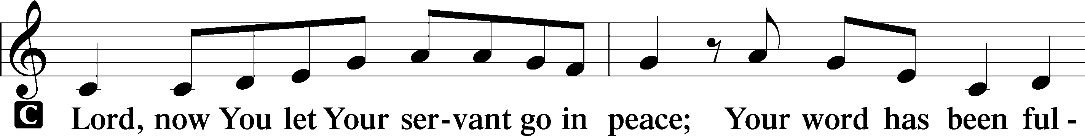
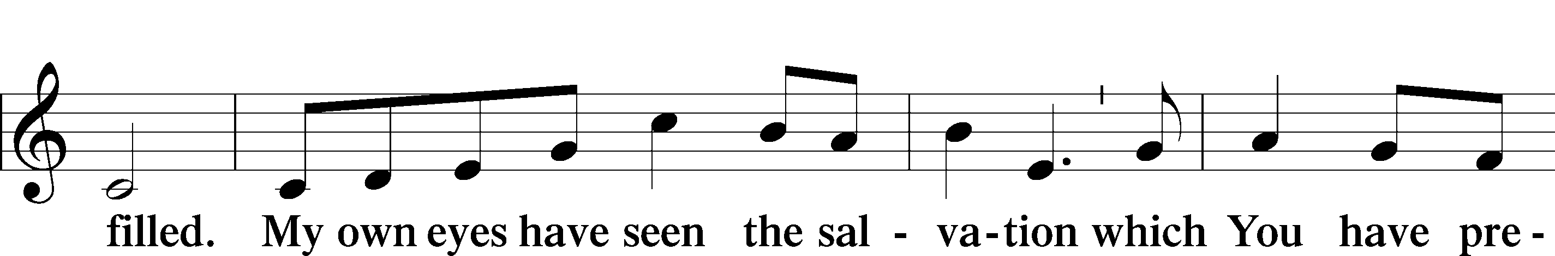
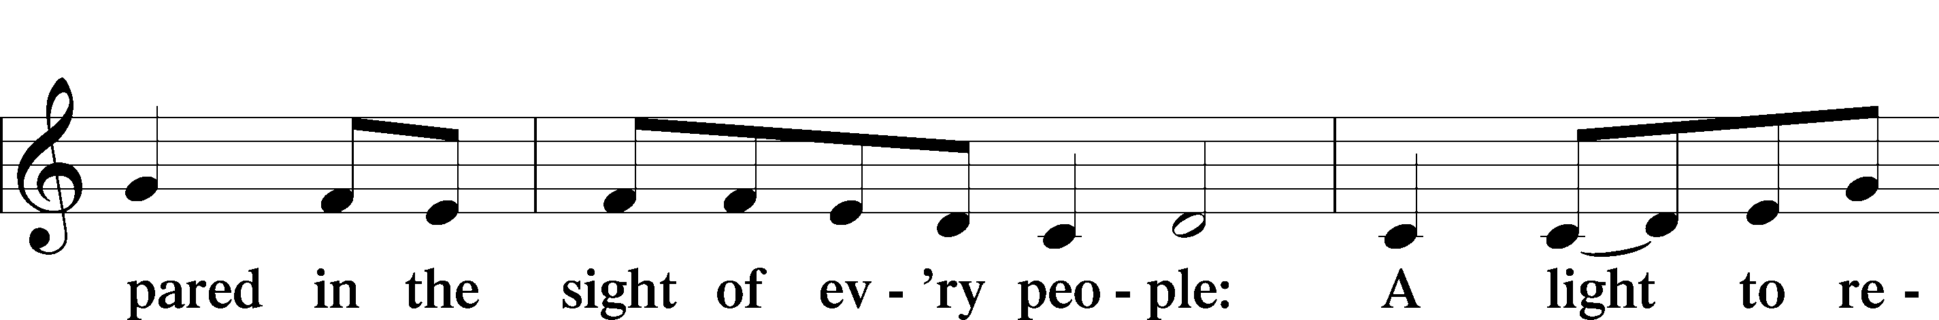
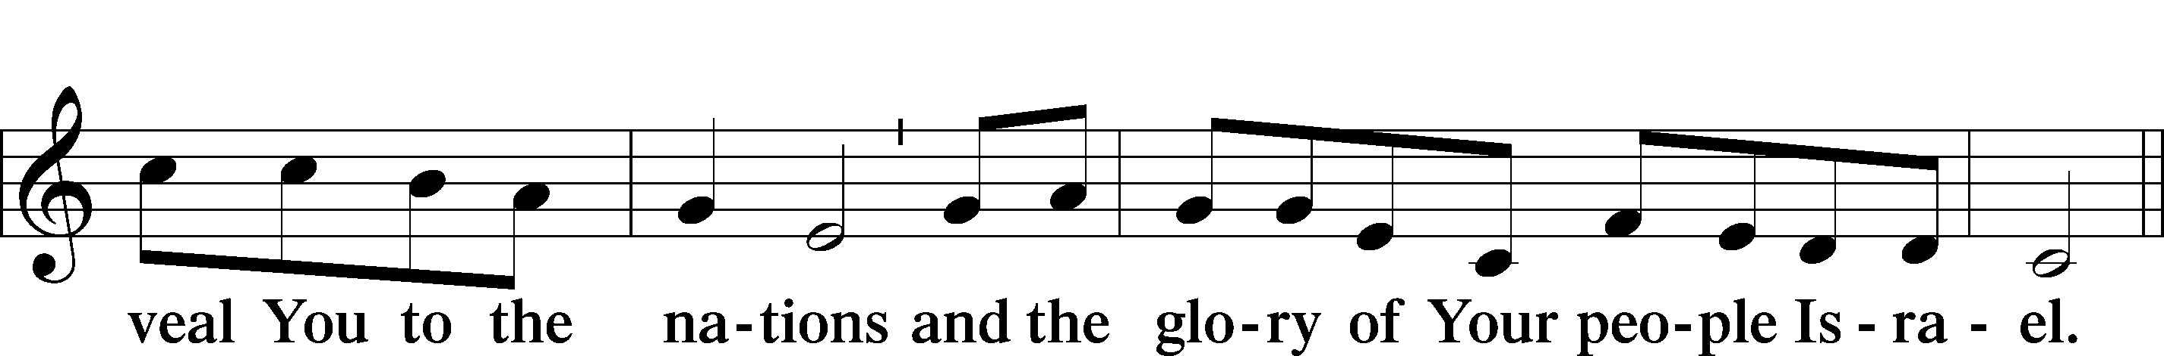
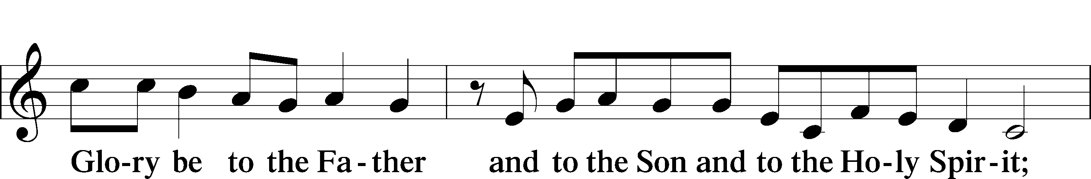
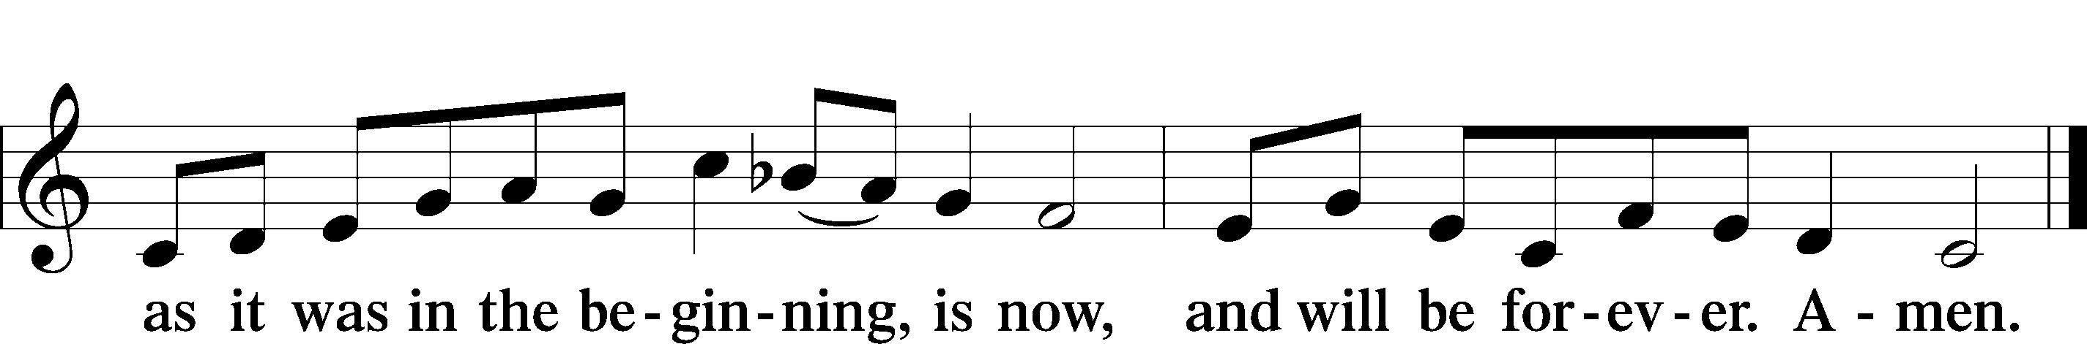

Post-Communion Thanksgiving
P Let us pray.
We give You thanks that You have sent to us Your own Son to be the Passover Lamb who takes away the sin of the world. Grant to us faith like John the Baptist to keep our eyes upon the Lamb and to proclaim Him before the world, that those not yet of Your kingdom may rejoice with us in the love that has forgiven and restored us to be Your people; through Jesus Christ, Your Son and our Lord.
C Amen.

Benediction
P The Lord bless you and keep you.
The Lord make His face shine on you and be gracious to you.
The Lord look upon you with favor and T give you peace.
C Amen.

Hymn: I Lay My Sins on Jesus LSB 606
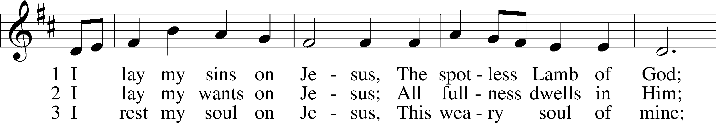
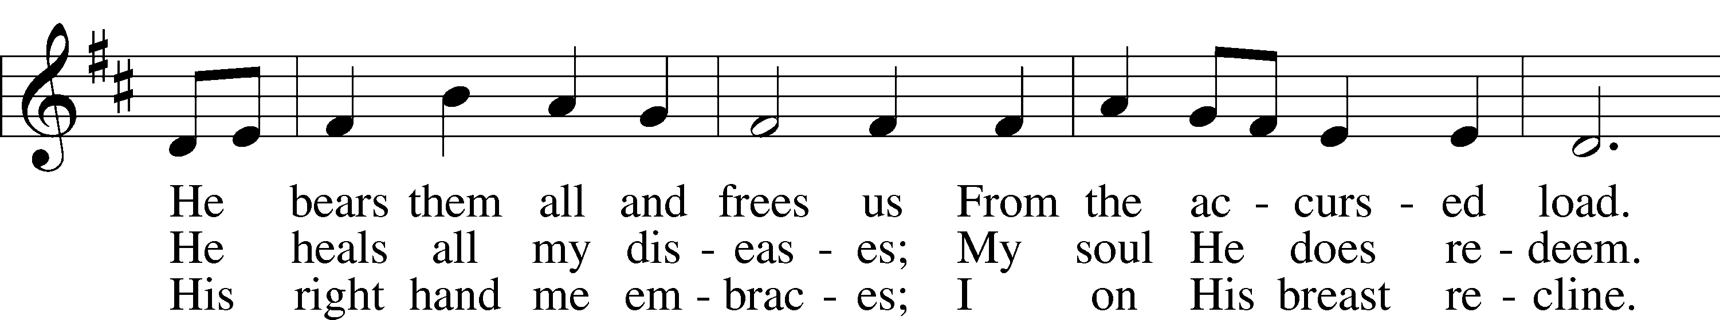
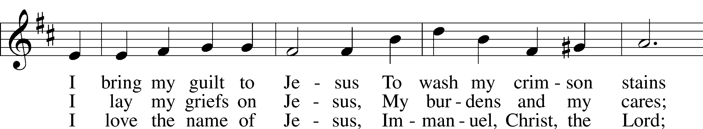
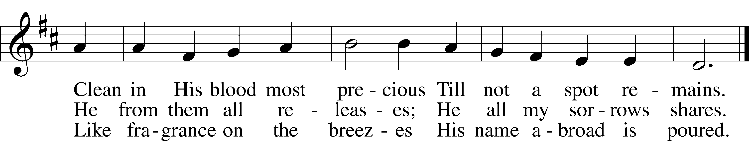
Text and tune: Public domain

Acknowledgments
Unless otherwise indicated, Scripture quotations are from the ESV® Bible (The Holy Bible, English Standard Version®), copyright © 2001 by Crossway, a publishing ministry of Good News Publishers. Used by permission. All rights reserved.
Created by Lutheran Service Builder © 2022 Concordia Publishing House.

