Midweek of Advent 1
November 30, 2022
12:00 Noon and 6:30 PM

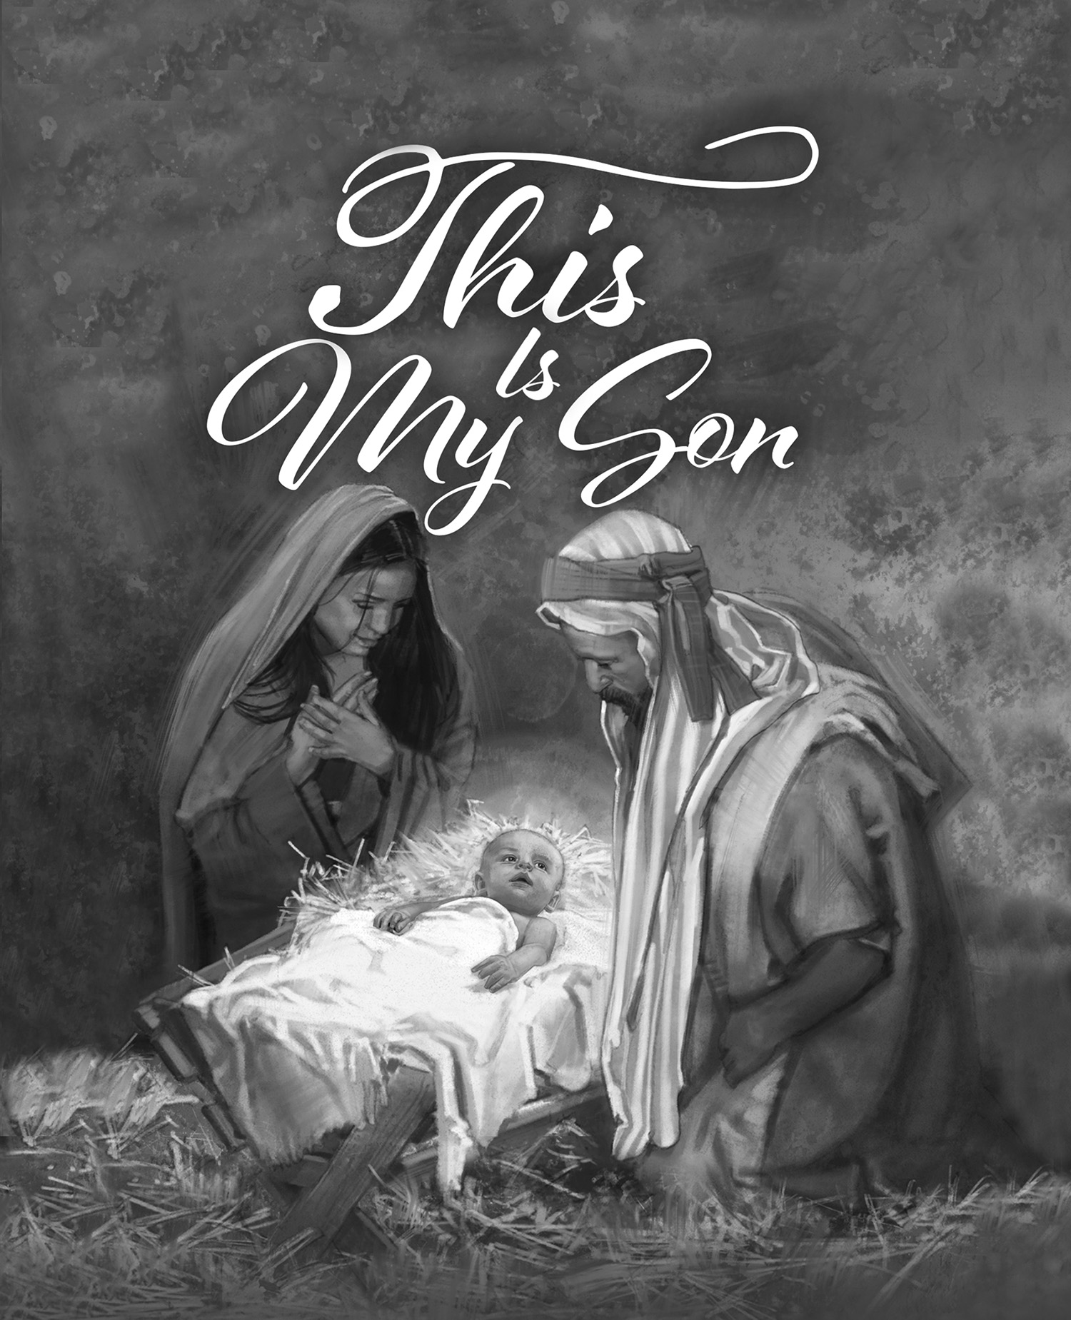

Salem Lutheran Church
1-715-537-3011
http://www.salembarron.com
rev.mike.nielsen@gmail.com

Cain

Just as God’s people of old waited with faith in the coming Messiah, so is our Advent anticipation of Christmas, as we sing of the Savior, “Your people long to greet You, My hope, my heart’s delight!” (LSB 334:1). Our hopes and fears are real. They can distract us from God’s promises. God’s promise was from the beginning spoken to Adam and Eve. Salvation would come through the woman’s offspring (Genesis 3:15). But it would not be Cain, the son of Adam, nor Ishmael, the son of Abraham, nor Absalom, the son of David. The true Son of Adam and Abraham and David is the Son of God. Our attention and faith thus direct our hopes and fears to God’s Son, in whom we receive adoption as sons and daughters in the family of God.
Hymn: O Lord, How Shall I Meet You LSB 334
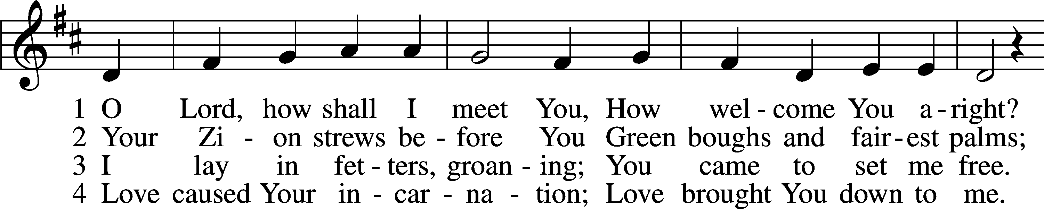
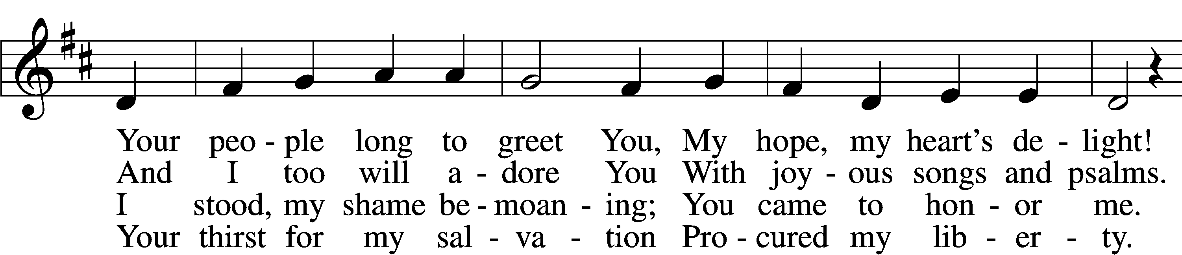
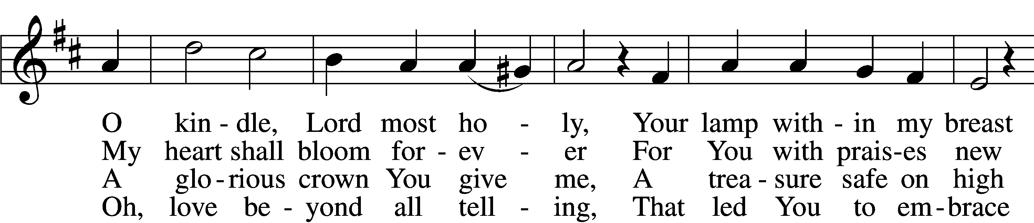
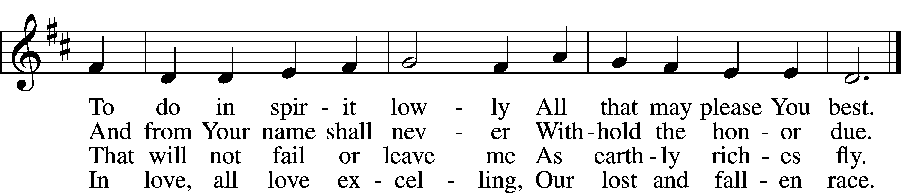

5 Sin’s debt, that fearful burden,
Cannot His love erase;
Your guilt the Lord will pardon
And cover by His grace.
He comes, for you procuring
The peace of sin forgiv’n,
His children thus securing
Eternal life in heav’n.

6 He comes to judge the nations,
A terror to His foes,
A light of consolations
And blessèd hope to those
Who love the Lord’s appearing.
O glorious Sun, now come,
Send forth Your beams so cheering,
And guide us safely home.
Text: Paul Gerhardt, 1607–76; tr. The Lutheran Hymnal, 1941, alt.
Tune: Johann Crüger, 1598–1662
Text and tune: Public domain

Opening Sentences
L O Lord, open my lips,

L Make haste, O God, to deliver me;

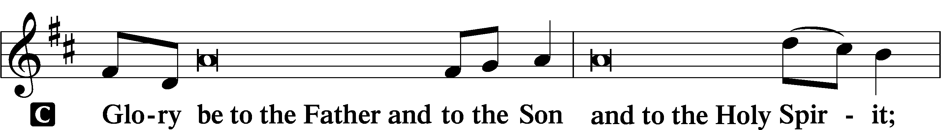
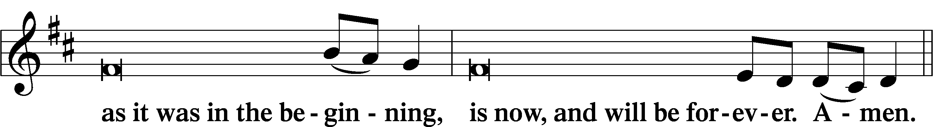
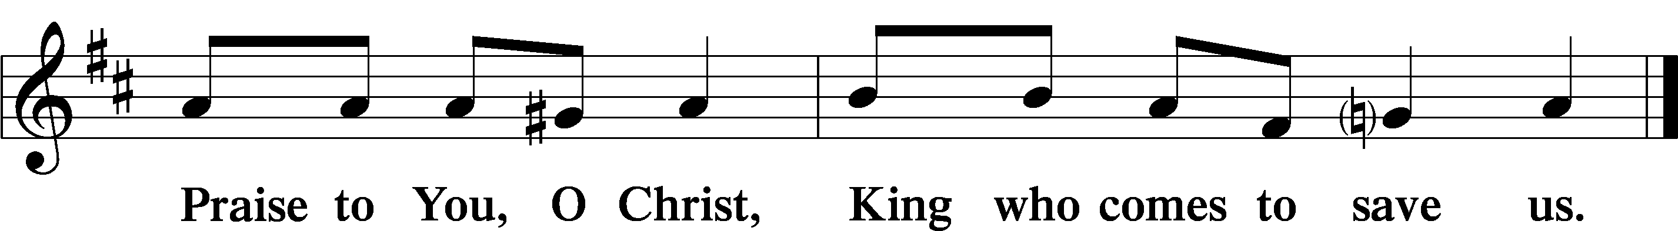

Psalmody

Psalm Psalm 9:1–12; antiphon: Psalm 146:3, 5
Put not your trust in princes,
in a son of man, in whom there is no salvation.
Blessèd is he whose help is the God of Jacob,
whose hope is in the Lord his God.
I will give thanks to the Lord with my whole heart;
I will recount all of Your wonderful deeds.
I will be glad and exult in You;
I will sing praise to Your name, O Most High.
When my enemies turn back,
they stumble and perish before Your presence.
For You have maintained my just cause;
You have sat on the throne, giving righteous judgment.
You have rebuked the nations; You have made the wicked perish;
You have blotted out their name forever and ever.
The enemy came to an end in everlasting ruins;
their cities You rooted out;
the very memory of them has perished.
But the Lord sits enthroned forever;
He has established His throne for justice,
and He judges the world with righteousness;
He judges the peoples with uprightness.
The Lord is a stronghold for the oppressed,
a stronghold in times of trouble.
And those who know Your name put their trust in You,
for You, O Lord, have not forsaken those who seek You.
Sing praises to the Lord, who sits enthroned in Zion!
Tell among the peoples His deeds!
For He who avenges blood is mindful of them;
He does not forget the cry of the afflicted.
Glory be to the Father and to the Son
and to the Holy Spirit;
as it was in the beginning,
is now, and will be forever. Amen.
Put not your trust in princes,
in a son of man, in whom there is no salvation.
Blessèd is he whose help is the God of Jacob,
whose hope is in the Lord his God.

Hymn: In This Precious Baby Boy
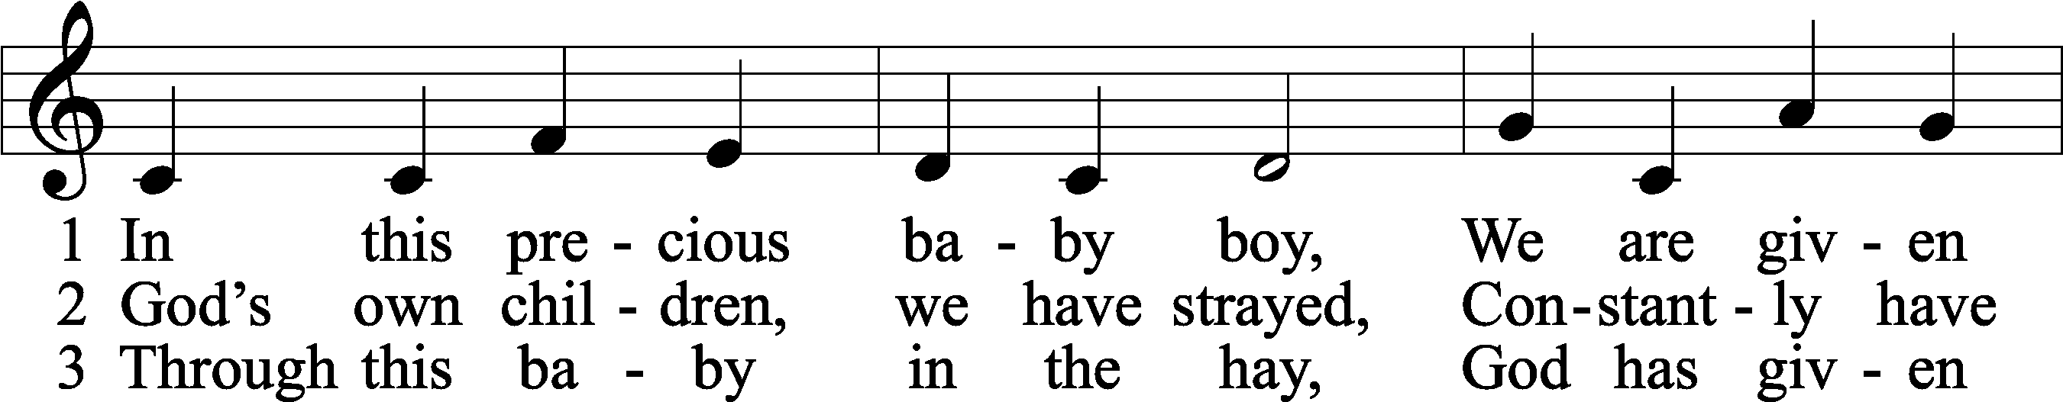
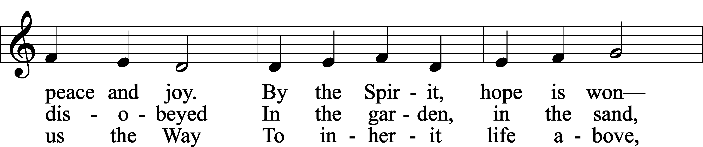
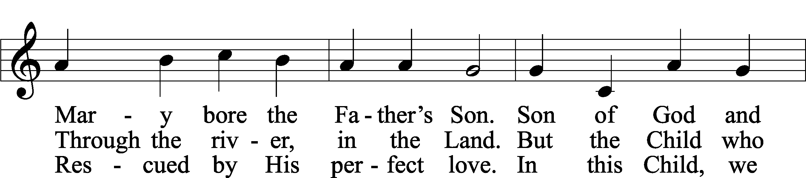
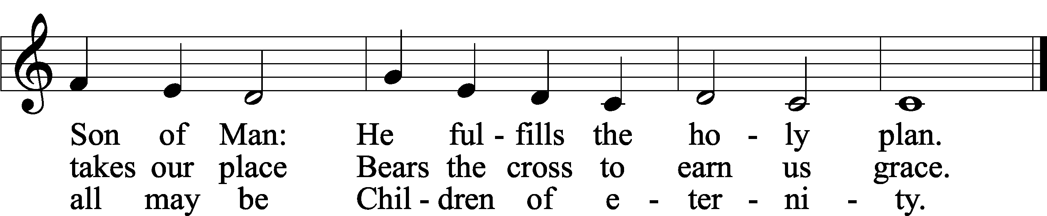
Text: Lisa M. Clark
Tune: Kevin Hildebrand
Text: © 2022 Concordia Publishing House. Used by permission: CPH Advent License no. 110005504
Tune: © 2022 Concordia Publishing House. Used by permission: CPH Advent License no. 110005504

Readings

First Reading Genesis 4:1–16
P A reading from Genesis, the fourth chapter.

Cain and Abel
1Now Adam knew Eve his wife, and she conceived and bore Cain, saying, “I have gotten a man with the help of the Lord.” 2And again, she bore his brother Abel. Now Abel was a keeper of sheep, and Cain a worker of the ground. 3In the course of time Cain brought to the Lord an offering of the fruit of the ground, 4and Abel also brought of the firstborn of his flock and of their fat portions. And the Lord had regard for Abel and his offering, 5but for Cain and his offering he had no regard. So Cain was very angry, and his face fell. 6The Lord said to Cain, “Why are you angry, and why has your face fallen? 7If you do well, will you not be accepted? And if you do not do well, sin is crouching at the door. Its desire is for you, but you must rule over it.”
8Cain spoke to Abel his brother. And when they were in the field, Cain rose up against his brother Abel and killed him. 9Then the Lord said to Cain, “Where is Abel your brother?” He said, “I do not know; am I my brother’s keeper?” 10And the Lord said, “What have you done? The voice of your brother’s blood is crying to me from the ground. 11And now you are cursed from the ground, which has opened its mouth to receive your brother’s blood from your hand. 12When you work the ground, it shall no longer yield to you its strength. You shall be a fugitive and a wanderer on the earth.” 13Cain said to the Lord, “My punishment is greater than I can bear. 14Behold, you have driven me today away from the ground, and from your face I shall be hidden. I shall be a fugitive and a wanderer on the earth, and whoever finds me will kill me.” 15Then the Lord said to him, “Not so! If anyone kills Cain, vengeance shall be taken on him sevenfold.” And the Lord put a mark on Cain, lest any who found him should attack him. 16Then Cain went away from the presence of the Lord and settled in the land of Nod, east of Eden.

P O Lord, have mercy on us.
C Thanks be to God.

Second Reading Romans 5:12–17
P A reading from Romans, the fifth chapter.

Death in Adam, Life in Christ
12Therefore, just as sin came into the world through one man, and death through sin, and so death spread to all men because all sinned— 13for sin indeed was in the world before the law was given, but sin is not counted where there is no law. 14Yet death reigned from Adam to Moses, even over those whose sinning was not like the transgression of Adam, who was a type of the one who was to come.
15But the free gift is not like the trespass. For if many died through one man’s trespass, much more have the grace of God and the free gift by the grace of that one man Jesus Christ abounded for many. 16And the free gift is not like the result of that one man’s sin. For the judgment following one trespass brought condemnation, but the free gift following many trespasses brought justification. 17If, because of one man’s trespass, death reigned through that one man, much more will those who receive the abundance of grace and the free gift of righteousness reign in life through the one man Jesus Christ.

P O Lord, have mercy on us.
C Thanks be to God.

Third Reading Matthew 5:17–26
P A reading from Matthew, the fifth chapter.

Christ Came to Fulfill the Law
17[Jesus said:] “Do not think that I have come to abolish the Law or the Prophets; I have not come to abolish them but to fulfill them. 18For truly, I say to you, until heaven and earth pass away, not an iota, not a dot, will pass from the Law until all is accomplished. 19Therefore whoever relaxes one of the least of these commandments and teaches others to do the same will be called least in the kingdom of heaven, but whoever does them and teaches them will be called great in the kingdom of heaven. 20For I tell you, unless your righteousness exceeds that of the scribes and Pharisees, you will never enter the kingdom of heaven.
Anger
21“You have heard that it was said to those of old, ‘You shall not murder; and whoever murders will be liable to judgment.’ 22But I say to you that everyone who is angry with his brother will be liable to judgment; whoever insults his brother will be liable to the council; and whoever says, ‘You fool!’ will be liable to the hell of fire. 23So if you are offering your gift at the altar and there remember that your brother has something against you, 24leave your gift there before the altar and go. First be reconciled to your brother, and then come and offer your gift. 25Come to terms quickly with your accuser while you are going with him to court, lest your accuser hand you over to the judge, and the judge to the guard, and you be put in prison. 26Truly, I say to you, you will never get out until you have paid the last penny.”

P O Lord, have mercy on us.
C Thanks be to God.

Responsory (Advent) LSB 230
L Behold, the days are coming, says the Lord, when I will raise up for David a righteous Branch.
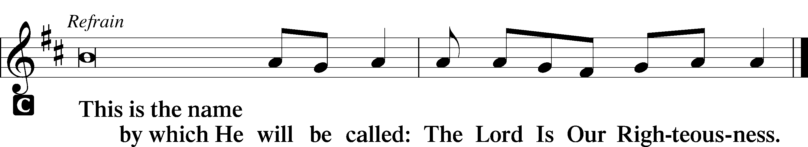

L In His days Judah will be saved, and Israel will dwell securely.

L Glory be to the Father and to the Son and to the Holy Spirit.

Sermon

Canticle

L Let my prayer rise before You as incense,
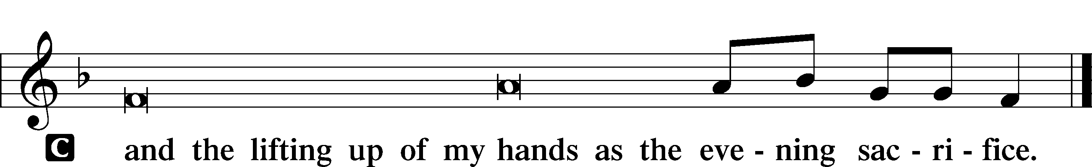

Magnificat LSB 231
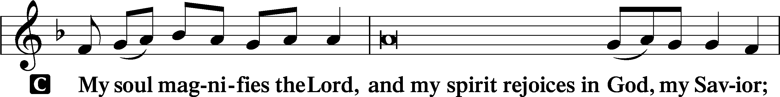
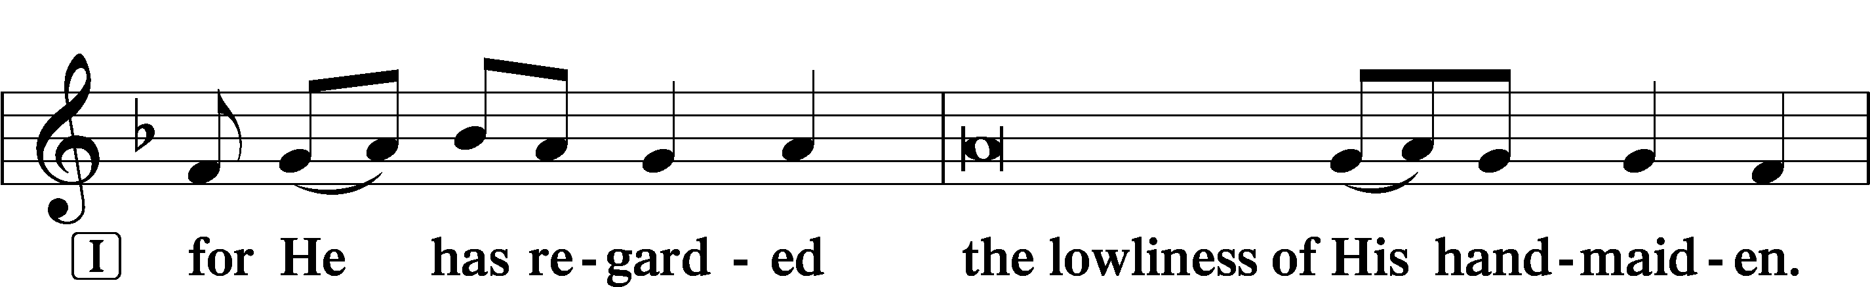
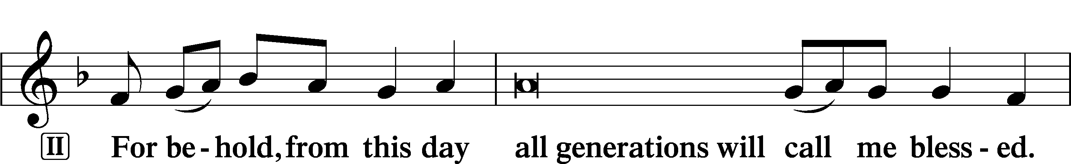
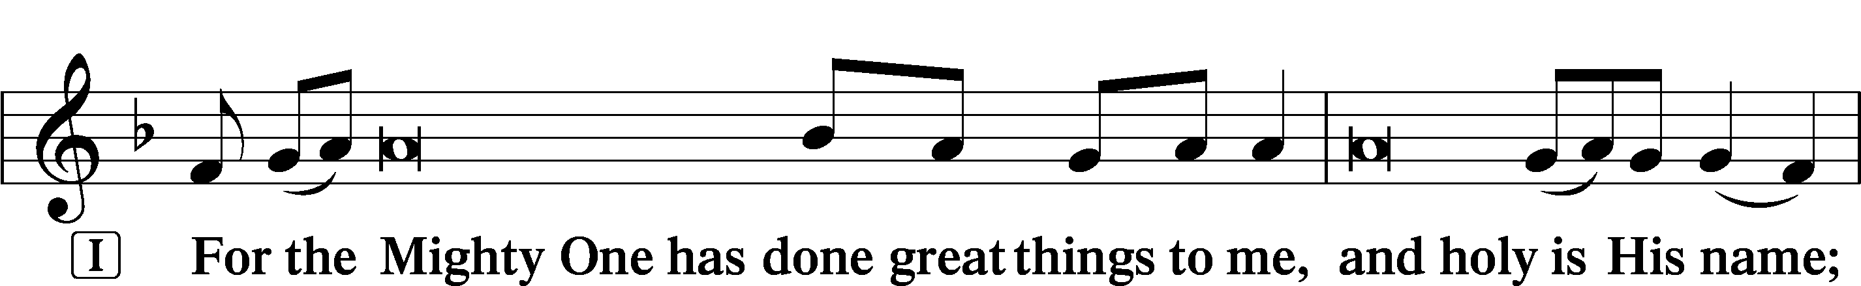
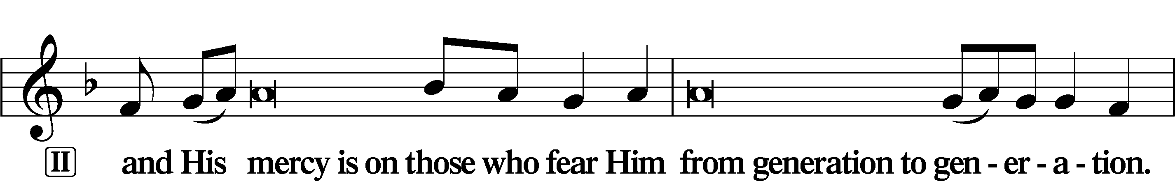
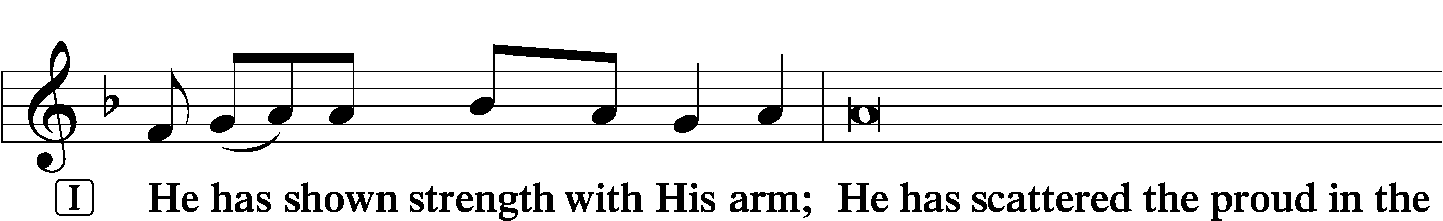
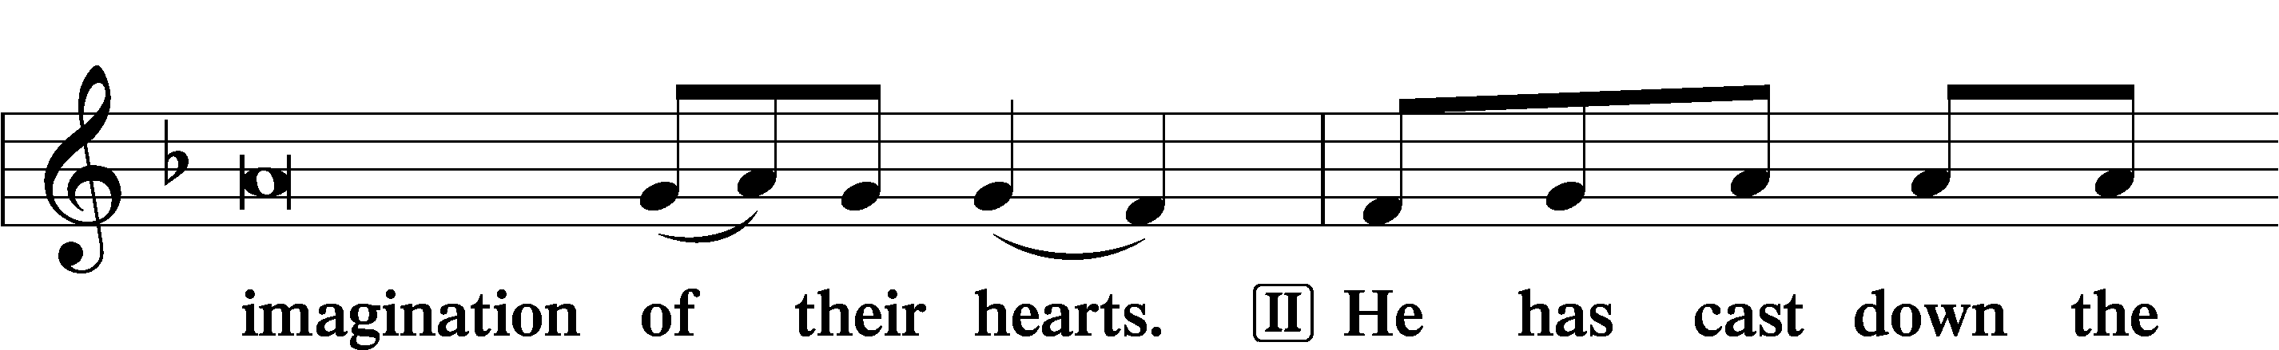
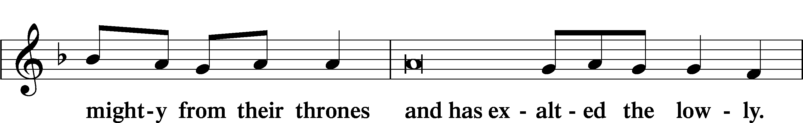
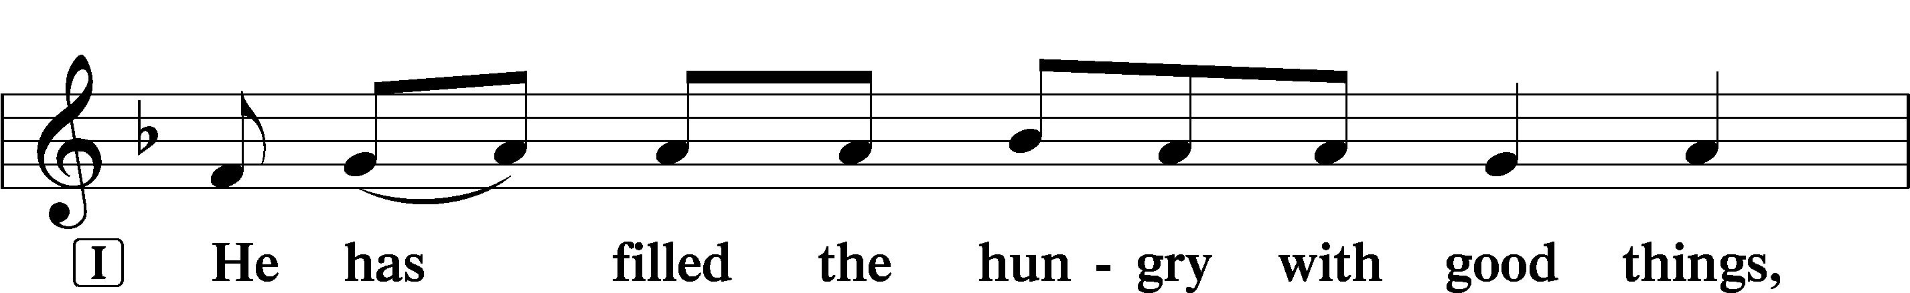
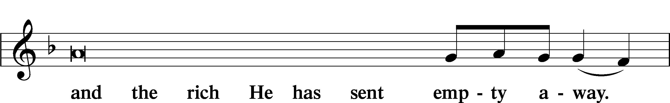
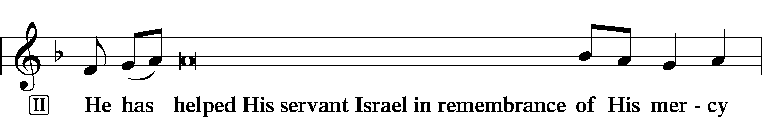
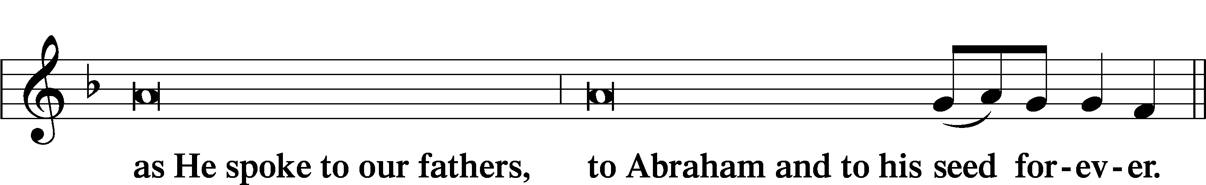
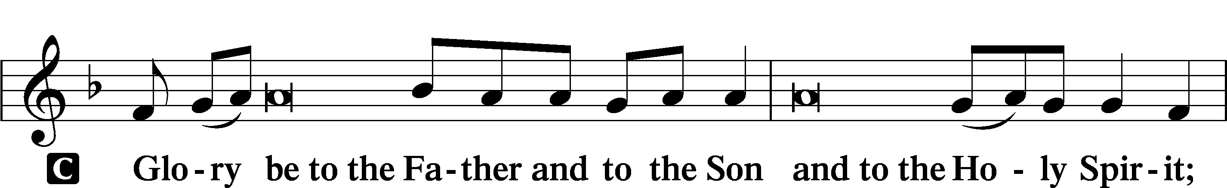
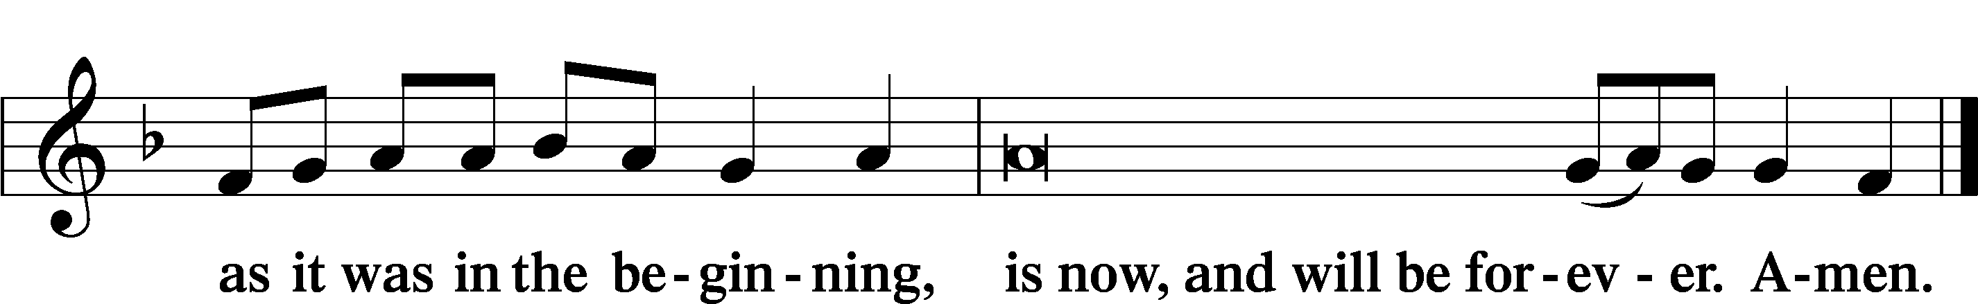

Prayer

Kyrie LSB, p. 233

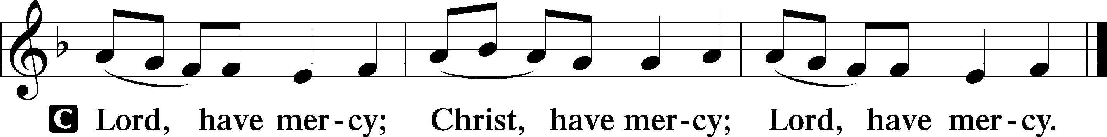

Lord’s Prayer
C Our Father who art in heaven,
hallowed be Thy name,
Thy kingdom come,
Thy will be done on earth
as it is in heaven;
give us this day our daily bread;
and forgive us our trespasses
as we forgive those
who trespass against us;
and lead us not into temptation,
but deliver us from evil.
For Thine is the kingdom
and the power and the glory
forever and ever. Amen.

Collects
L O Lord, hear my prayer.
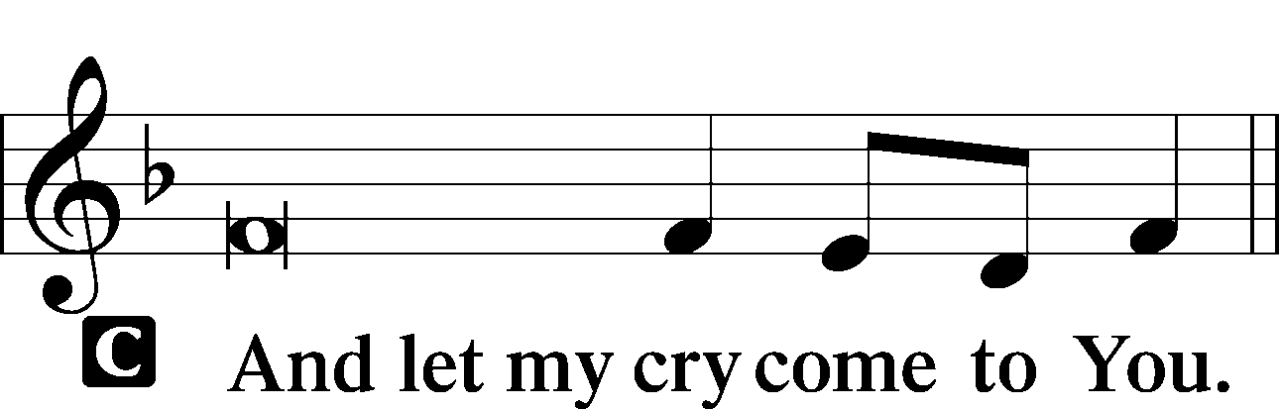

Collect of the Day
P O Lord, by Your own power, You turn sinners from their wicked ways to become Your adopted sons and daughters through repentance of our sins and faith in Your only begotten Son, Jesus Christ, the Savior of the world. Help us to direct all our hope to Your gracious will, which You have revealed in Your Son, the Word made flesh, who lives and reigns with You and the Holy Spirit, one God, now and forever.
C Amen.

Additional Collects of Intercession and Thanksgiving

Collect
P Almighty God, from the very beginning, You promised to send a Savior from sin and death into the world, to redeem us all to be Your true children. Direct the eyes of our faith away from all false hopes and fix them on Your true and only Son, our Savior, Jesus Christ, who lives and reigns with You and the Holy Spirit, one God, now and forever.
C Amen.

Collect for Peace
P O God, from whom come all holy desires, all good counsels, and all just works, give to us, Your servants, that peace which the world cannot give, that our hearts may be set to obey Your commandments and also that we, being defended from the fear of our enemies, may live in peace and quietness; through Jesus Christ, Your Son, our Lord, who lives and reigns with You and the Holy Spirit, one God, now and forever.
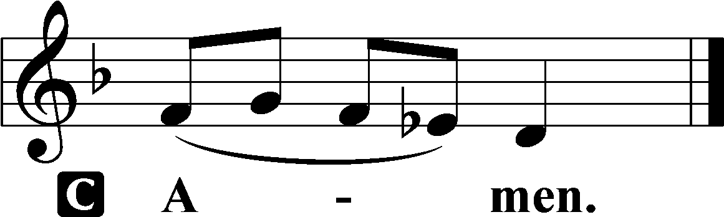

Benedicamus LSB, p. 234
P Let us bless the Lord.
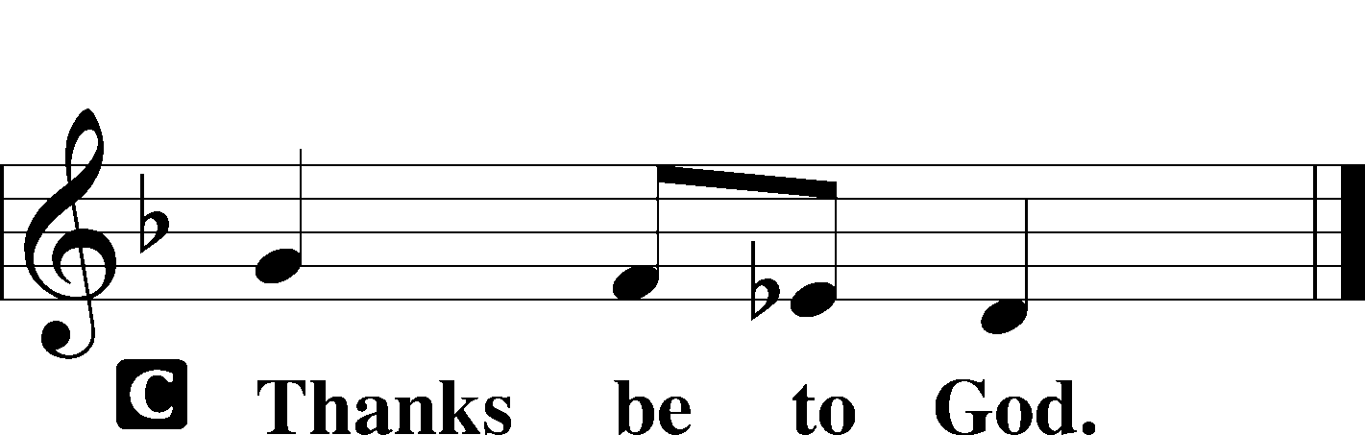

Benediction LSB, p. 234
P The grace of our Lord T Jesus Christ and the love of God and the communion of the Holy Spirit be with you all.

Hymn: In the Shattered Bliss of Eden LSB 572 to the Tune of 531
1 In the shattered bliss of Eden
Dawned the day of sacrifice,
As our primal parents shuddered—
Sin had caused this dreadful price!
Faith embarked with this discernment:
Only God can cover sin,
As He took their leafy garments
And He clothed their shame with skin.

2 Days and months and years unfolding
Clearly showed what sin had wrought:
Fallen Adam’s children learning
Lessons fallen parents taught.
All these sacrificial off’rings
Crested as a crimson flood:
Patriarchs and priests atoning
For their sins with cleansing blood.

3 What these sacrifices promised
From a God who sought to bless,
Came at last—a second Adam—
Priest and King of Righteousness:
Son of God, incarnate Savior,
Son of Man, both Christ and Lord,
Who in naked shame would offer
On the cross His blood outpoured.

4 Lamb of God, once slain for sinners,
Host, who spreads this meal divine,
Here You pledge our sins are covered,
Pledge received in bread and wine:
“Take and eat; this is My body,
Given on the cross for you.
Take and drink; this cup of blessing
Is My blood poured out for you.”

5 Taste and see the bliss of heaven
Known by saints around the throne,
Where the Lamb, in closest union,
Lives to love and feed His own.
From His riven side forever
Flows the purest stream of love,
Love that robes us with the raiment
Worn by all who feast above.

6 Gone the bliss of Eden’s garden,
Gone the age of sacrifice;
Ours the time of grace and favor,
Ours the call to paradise!
Ever, Lord, impress upon us:
Only You can cover sin—
Take our worthless, self-made garments;
Clothe our shame and cleanse within.
Text: Stephen P. Starke, 1955
Text: © 2002 Stephen P. Starke, admin. Concordia Publishing House. Used by permission: LSB Hymn License no. 110005504

Acknowledgments
Unless otherwise indicated, Scripture quotations are from the ESV® Bible (The Holy Bible, English Standard Version®), copyright © 2001 by Crossway, a publishing ministry of Good News Publishers. Used by permission. All rights reserved.
Created by Lutheran Service Builder © 2022 Concordia Publishing House.

