Midweek Lent 3
March 23, 2022
12:00 PM and 6:30 PM

Salem Lutheran Church
1-715-537-3011
http://www.salembarron.com
rev.mike.nielsen@gmail.com

Peter

Simon Peter witnessed much of Christ’s ministry on earth. He is featured in many highlights of the four Gospels, but today we see Peter at his lowest point, as he denies Jesus three times. The result of Peter’s denial is a massive amount of guilt. Each of us can relate to that unwanted flood of self-disgust that comes when we remember past sin. But guilt is not the final word for Peter, and it is not the final word for us. After His resurrection, Jesus restores and forgives Peter. Jesus offered Peter grace. Jesus also gives us grace, forgiveness, and restoration at the cross.

Hymn: Chief of Sinners Thou I Be LSB 611
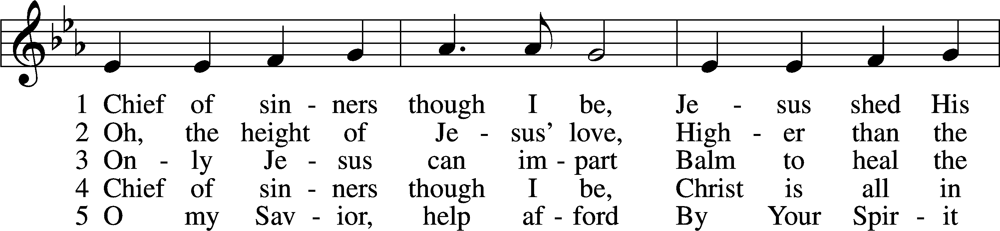
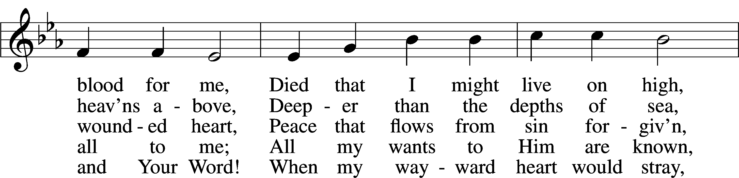
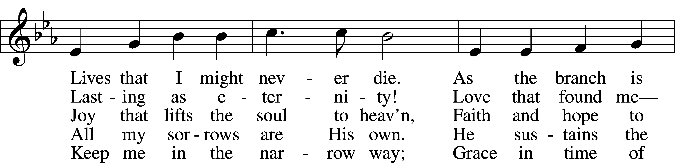
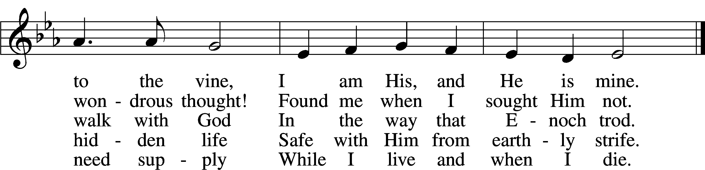
Text: William McComb, 1793–1873, alt.
Tune: Richard Redhead, 1820–1901
Text and tune: Public domain

Lent Versicles
L O Lord, open my lips,

L Make haste, O God, to deliver me;

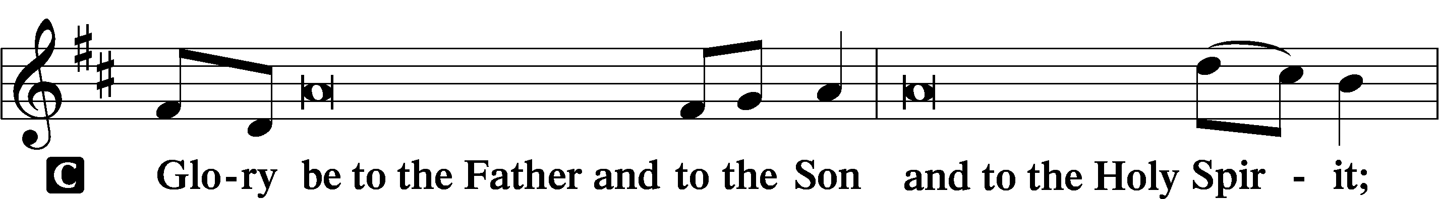
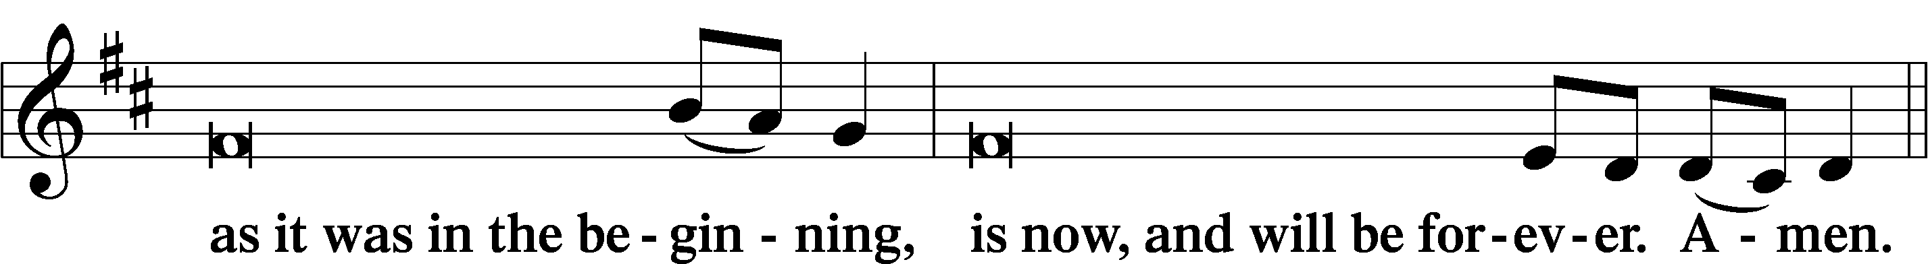
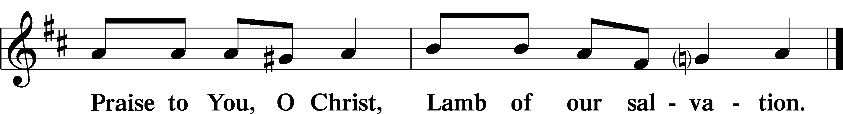

Psalmody

Psalm Psalm 118:19–29; antiphon: v. 26
Blessèd is he who comes in the name | of the Lord!*
We bless you from the house | of the Lord.
Open to me the gates of | righteousness,*
that I may enter through them
and give thanks | to the Lord.
This is the gate | of the Lord;*
the righteous shall enter | through it.
I thank You that you have | answered me*
and have become my sal- | vation.
The stone that the builders re- | jected*
has become the | cornerstone.
This is the Lord’s | doing;*
it is marvelous | in our eyes.
This is the day that the | Lord has made;*
let us rejoice and be | glad in it.
Save us, we pray, | O Lord!*
O Lord, we pray, give | us success!
Blessèd is he who comes in the name | of the Lord!*
We bless you from the house | of the Lord.
The Lord is God,
and He has made His light to shine up- | on us.*
Bind the festal sacrifice with cords,
up to the horns of the | altar!
You are my God, and I will give | thanks to You;*
You are my God; I will ex- | tol You.
Oh give thanks to the Lord, for | He is good;*
for His steadfast love endures for- | ever!
Glory be to the Father and | to the Son*
and to the Holy | Spirit;
as it was in the be- | ginning,*
is now, and will be forever. | Amen.
Blessèd is he who comes in the name | of the Lord!*
We bless you from the house | of the Lord.

Silence for reflection

Psalm Prayer
P Holy God, mighty Lord, endless is Your mercy and eternal Your reign. Your own Son has triumphed over sin and the grave and opened to us the gates of everlasting life. Purify our hearts in Him that we may be granted a share in His glory; through Jesus Christ, Your Son, our Lord.
C Amen.

Series Hymn: “Behold! The Lamb of God,” John Said
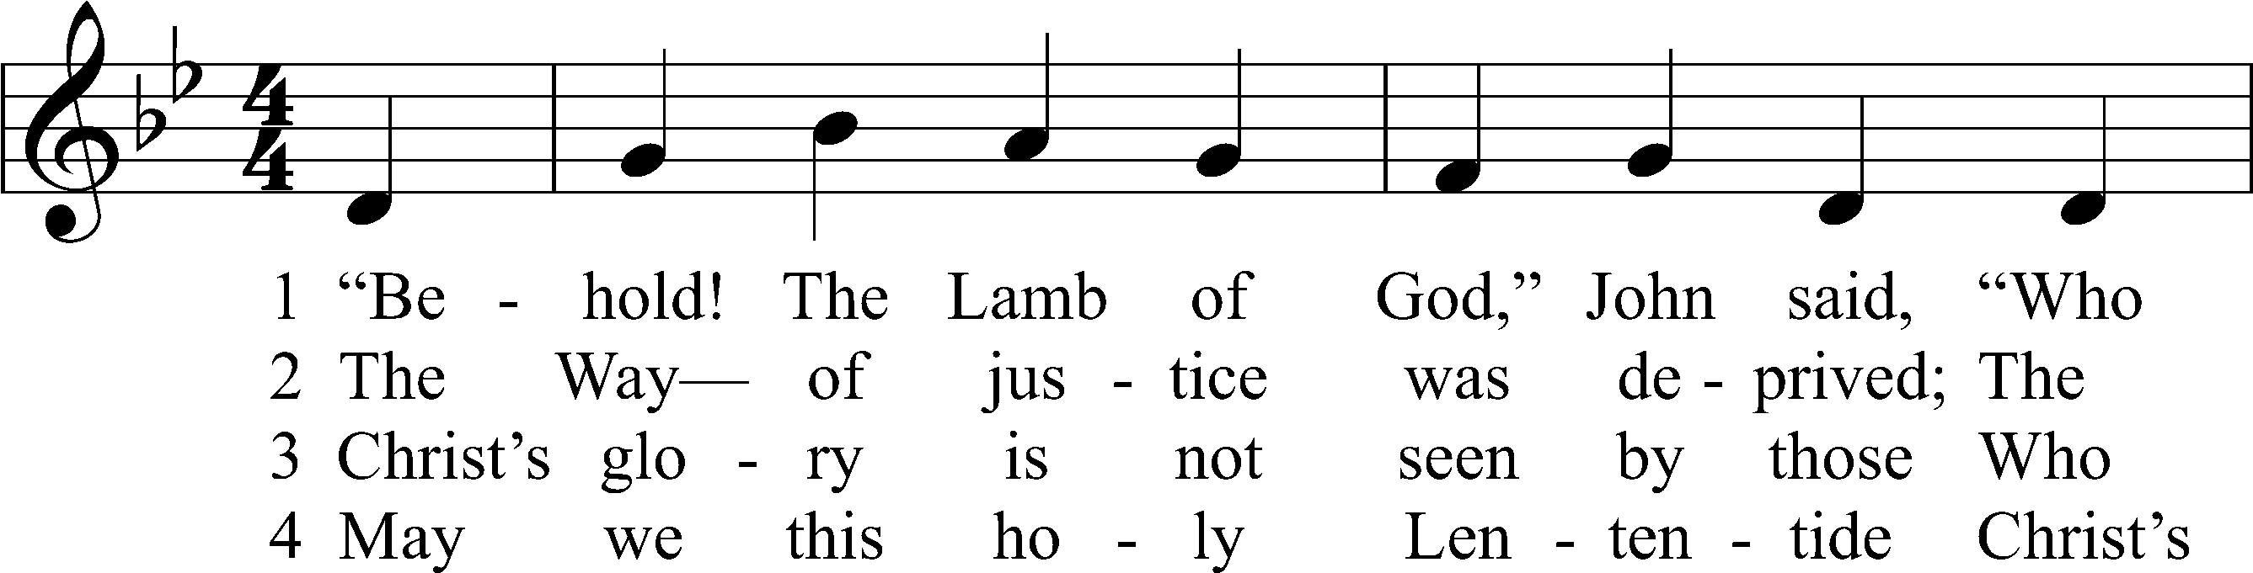
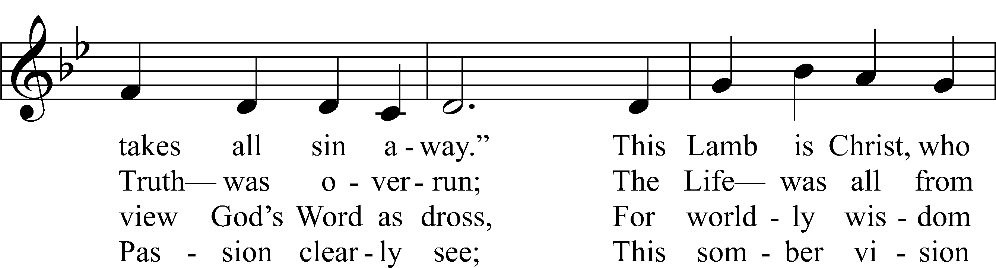
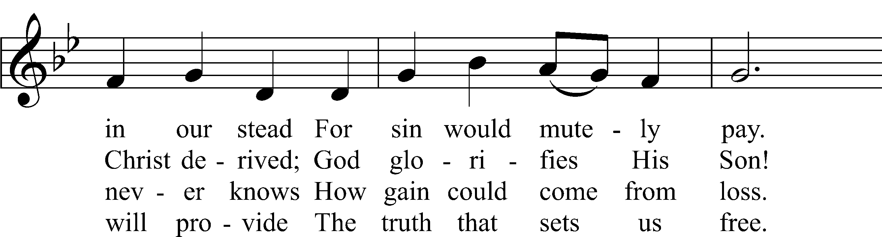
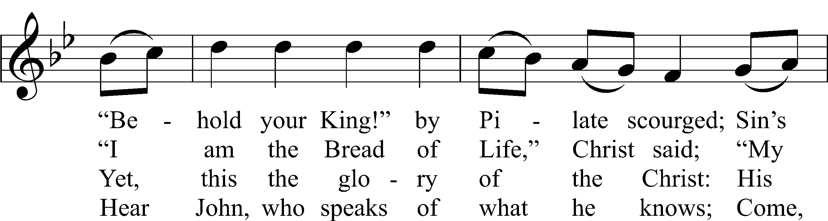
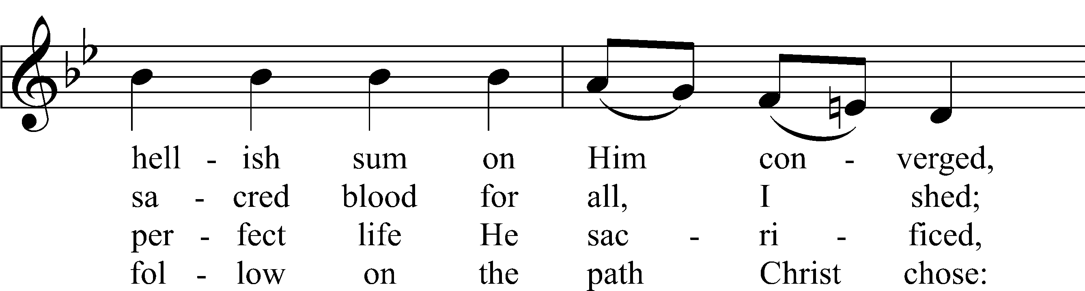
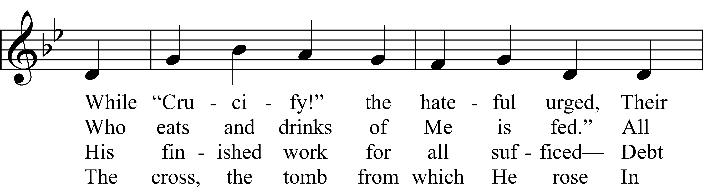
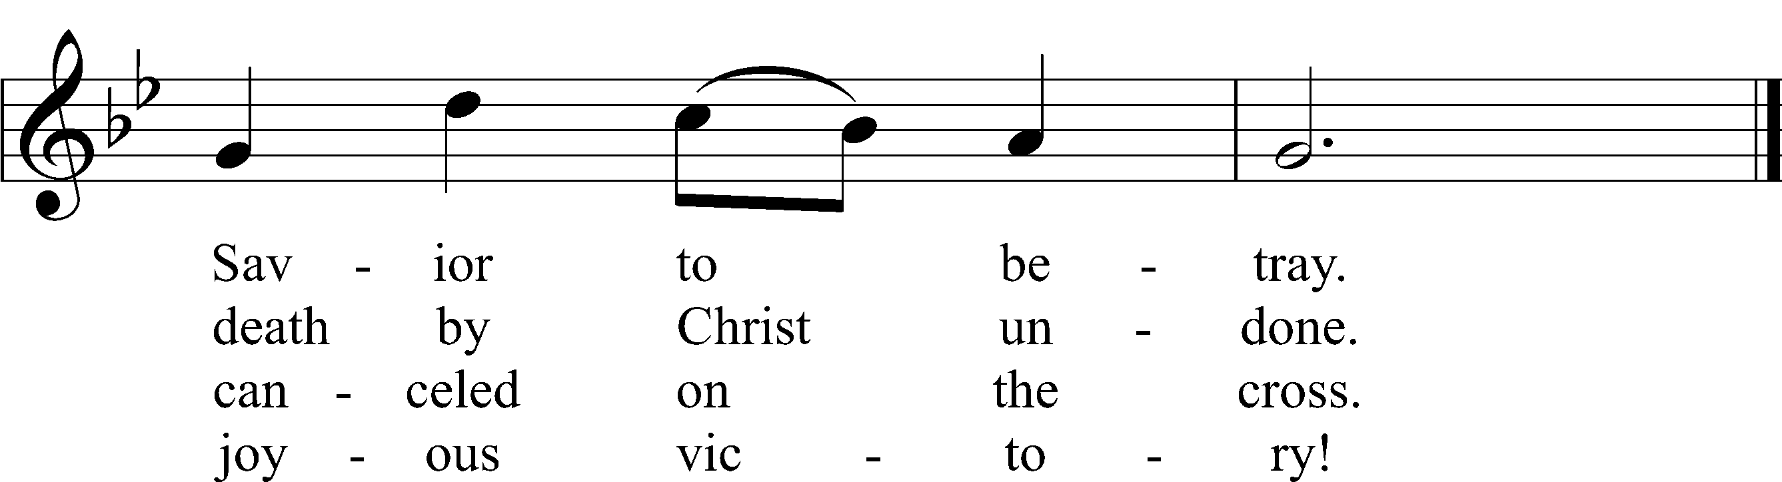
Text and text and text and text and text and text and text and text and text: Stephen P. Starke
Tune and tune and tune and tune and tune and tune and tune and tune and tune: John L. Bell
Text: © 2021 Stephen P. Starke, admin. Concordia Publishing House. Used by permission: CPH Lent License no. 110005504
Tune: © 1988, 1997 Wild Goose Resource Group, Iona Community, Scotland, admin. GIA Publications, Inc. Used by permission: CPH Lent License no. 110005504

Readings

Reading Zechariah 12:10–14
P A reading from Zechariah, the twelfth chapter.

Him Whom They Have Pierced
10“And I will pour out on the house of David and the inhabitants of Jerusalem a spirit of grace and pleas for mercy, so that, when they look on me, on him whom they have pierced, they shall mourn for him, as one mourns for an only child, and weep bitterly over him, as one weeps over a firstborn. 11On that day the mourning in Jerusalem will be as great as the mourning for Hadad-rimmon in the plain of Megiddo. 12The land shall mourn, each family by itself: the family of the house of David by itself, and their wives by themselves; the family of the house of Nathan by itself, and their wives by themselves; 13the family of the house of Levi by itself, and their wives by themselves; the family of the Shimeites by itself, and their wives by themselves; 14and all the families that are left, each by itself, and their wives by themselves.

P O Lord, have mercy on us.
C Thanks be to God.

Reading 2 Corinthians 12:7–10
P A reading from Second Corinthians, the twelfth chapter.

7So to keep me from being too elated by the surpassing greatness of the revelations, a thorn was given me in the flesh, a messenger of Satan to harass me, to keep me from being too elated. 8Three times I pleaded with the Lord about this, that it should leave me. 9But he said to me, “My grace is sufficient for you, for my power is made perfect in weakness.” Therefore I will boast all the more gladly of my weaknesses, so that the power of Christ may rest upon me. 10For the sake of Christ, then, I am content with weaknesses, insults, hardships, persecutions, and calamities. For when I am weak, then I am strong.

P O Lord, have mercy on us.
C Thanks be to God.

Reading John 18:12–27
P A reading from St. John, the eighteenth chapter.

Jesus Before the High Priest
12So the band of soldiers and their captain and the officers of the Jews arrested Jesus and bound him. 13First they led him to Annas, for he was the father-in-law of Caiaphas, who was high priest that year. 14It was Caiaphas who had advised the Jews that it would be expedient that one man should die for the people.
Peter Denies Jesus
15Simon Peter followed Jesus, and so did another disciple. Since that disciple was known to the high priest, he entered with Jesus into the court of the high priest, 16but Peter stood outside at the door. So the other disciple, who was known to the high priest, went out and spoke to the servant girl who kept watch at the door, and brought Peter in. 17The servant girl at the door said to Peter, “You also are not one of this man’s disciples, are you?” He said, “I am not.” 18Now the servants and officers had made a charcoal fire, because it was cold, and they were standing and warming themselves. Peter also was with them, standing and warming himself.
The High Priest Questions Jesus
19The high priest then questioned Jesus about his disciples and his teaching. 20Jesus answered him, “I have spoken openly to the world. I have always taught in synagogues and in the temple, where all Jews come together. I have said nothing in secret. 21Why do you ask me? Ask those who have heard me what I said to them; they know what I said.” 22When he had said these things, one of the officers standing by struck Jesus with his hand, saying, “Is that how you answer the high priest?” 23Jesus answered him, “If what I said is wrong, bear witness about the wrong; but if what I said is right, why do you strike me?” 24Annas then sent him bound to Caiaphas the high priest.
Peter Denies Jesus Again
25Now Simon Peter was standing and warming himself. So they said to him, “You also are not one of his disciples, are you?” He denied it and said, “I am not.” 26One of the servants of the high priest, a relative of the man whose ear Peter had cut off, asked, “Did I not see you in the garden with him?” 27Peter again denied it, and at once a rooster crowed.

P O Lord, have mercy on us.
C Thanks be to God.

Responsory (Lent) LSB 231
L Deliver me, O Lord, my God, for You are the God of my salvation.
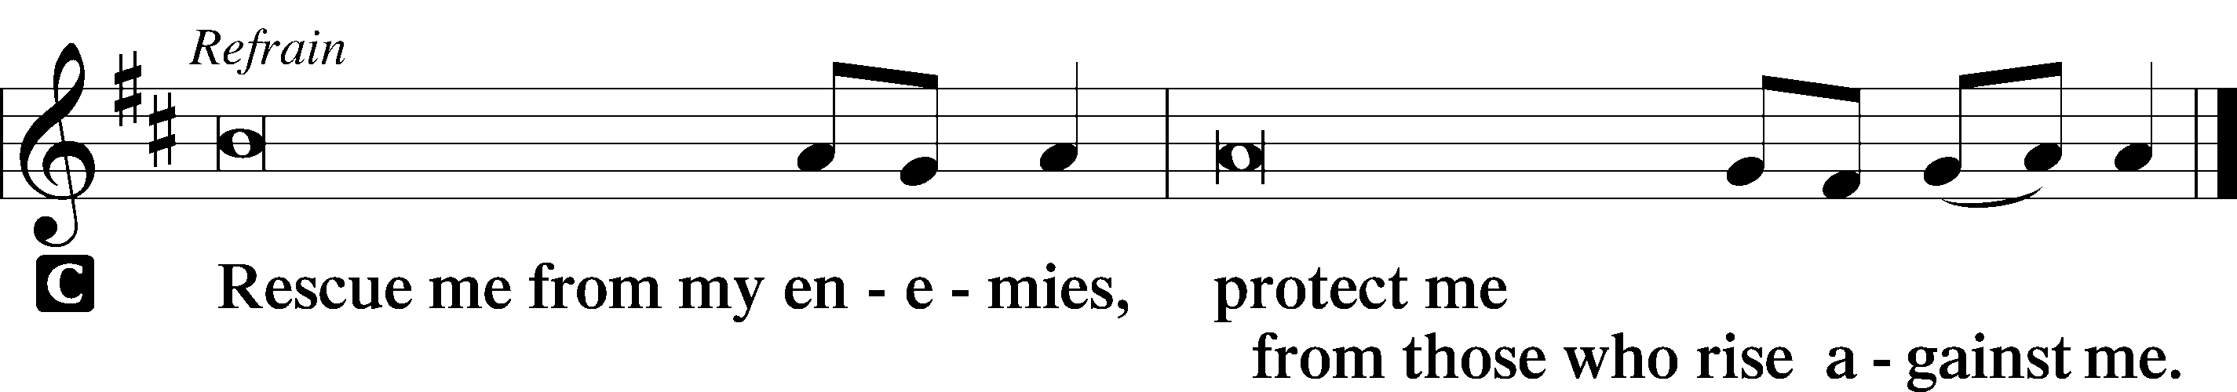

L In You, O Lord, do I put my trust, leave me not, O Lord, my God.

L Deliver me, O Lord, my God, for You are the God of my salvation.

Sermon

Canticle

Antiphon
L Let my prayer rise before You as incense,
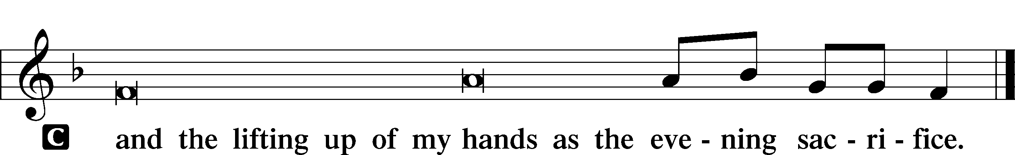

Magnificat LSB 231
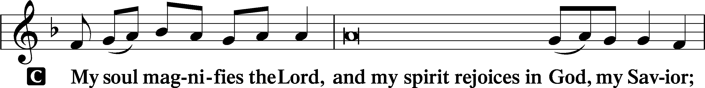
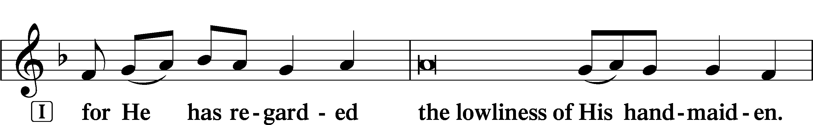
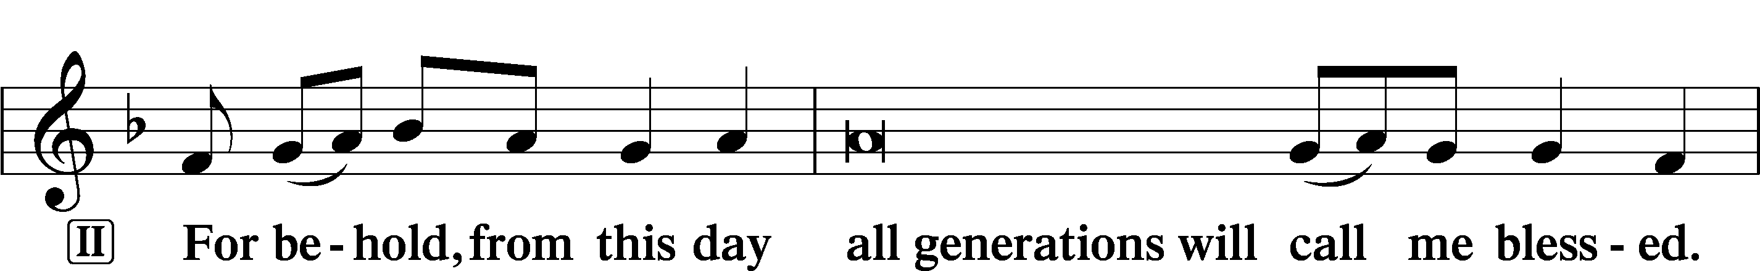
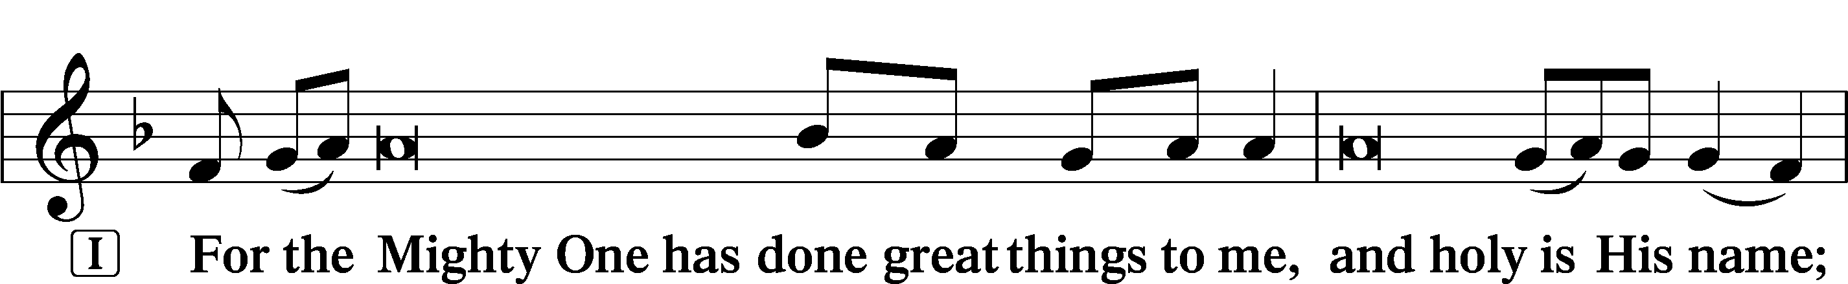
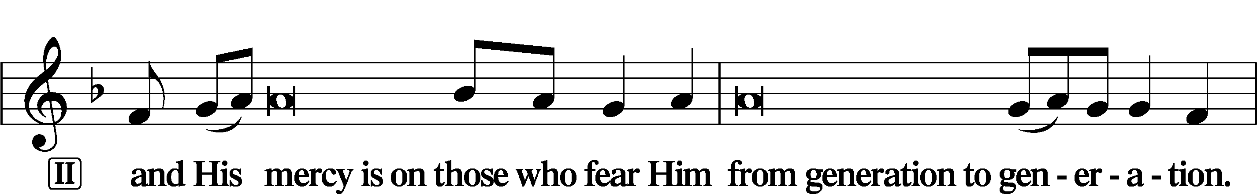
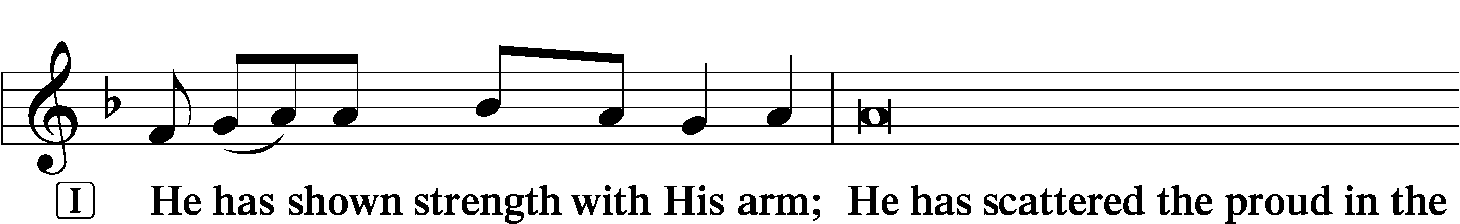
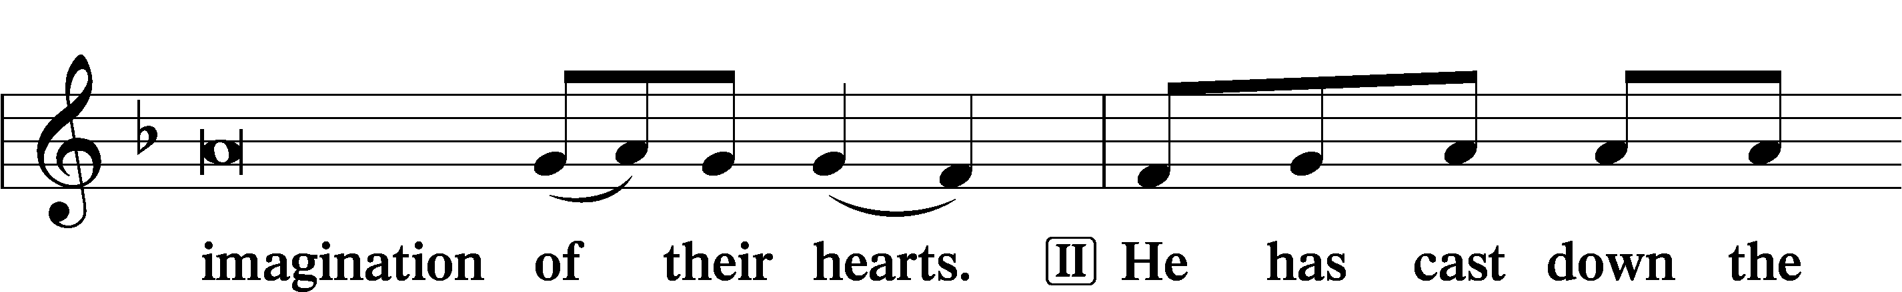
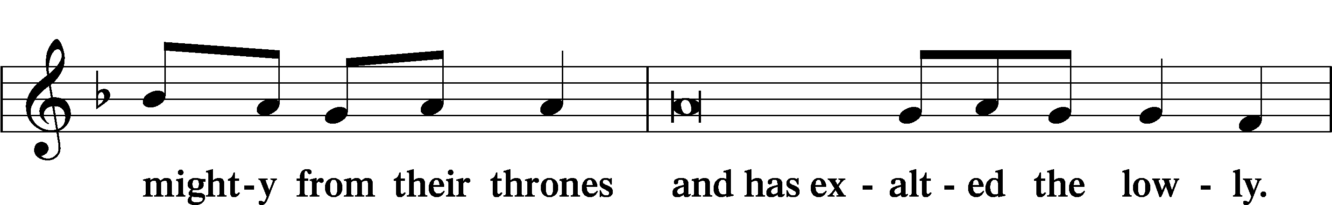
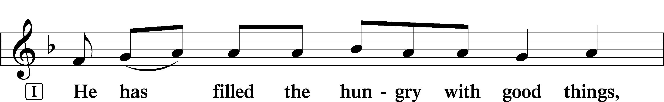
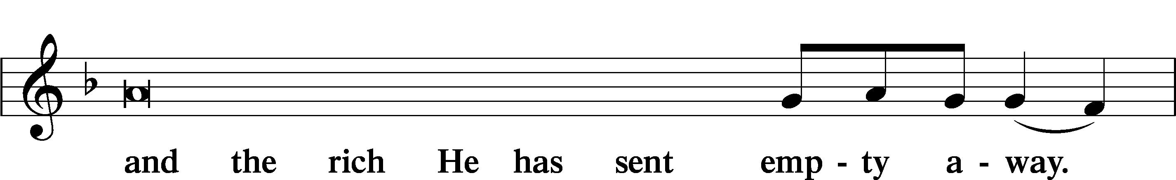
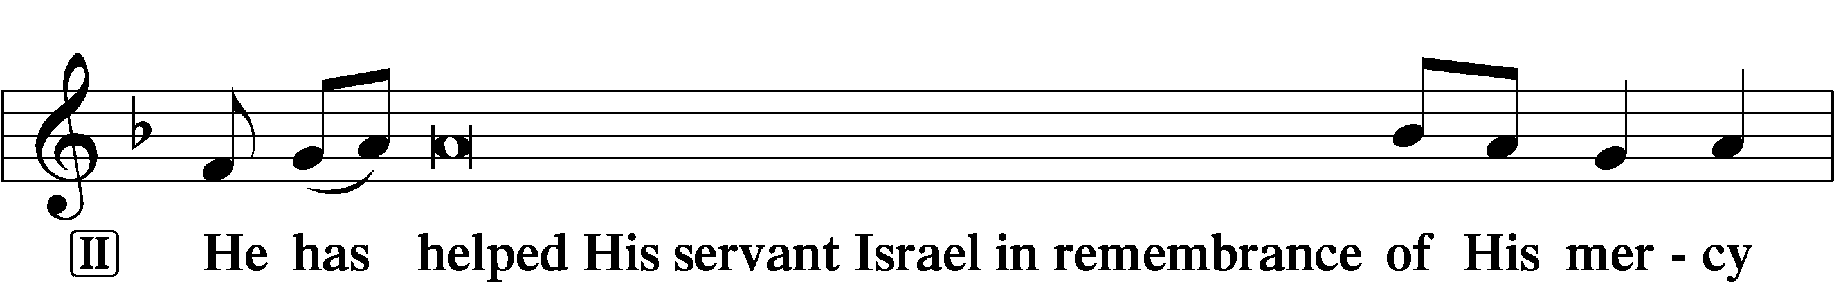
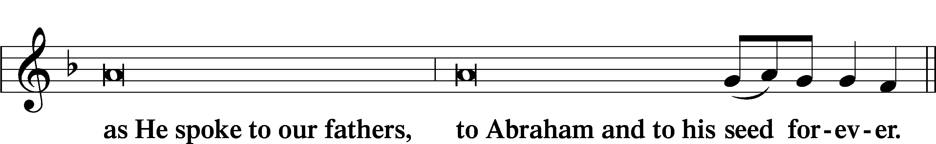
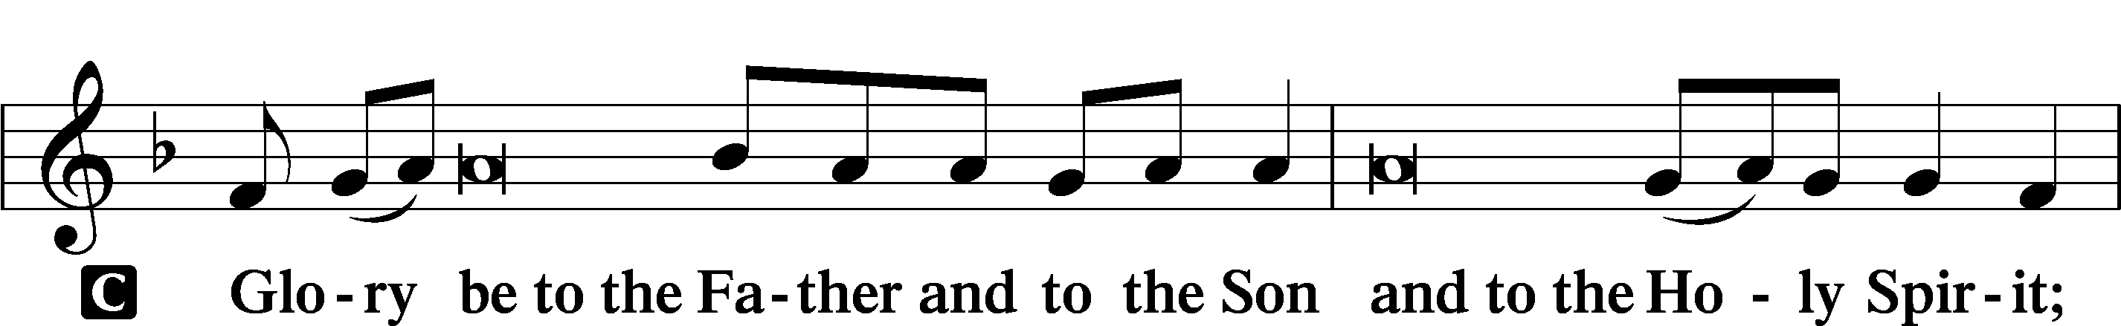
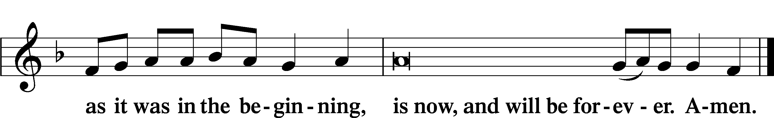

Offering

Prayer

Kyrie LSB 233
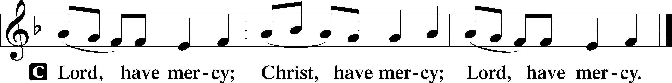

Lord’s Prayer
C Our Father who art in heaven,
hallowed be Thy name,
Thy kingdom come,
Thy will be done on earth
as it is in heaven;
give us this day our daily bread;
and forgive us our trespasses
as we forgive those
who trespass against us;
and lead us not into temptation,
but deliver us from evil.
For Thine is the kingdom
and the power and the glory
forever and ever. Amen.

Collects
L O Lord, hear my prayer.
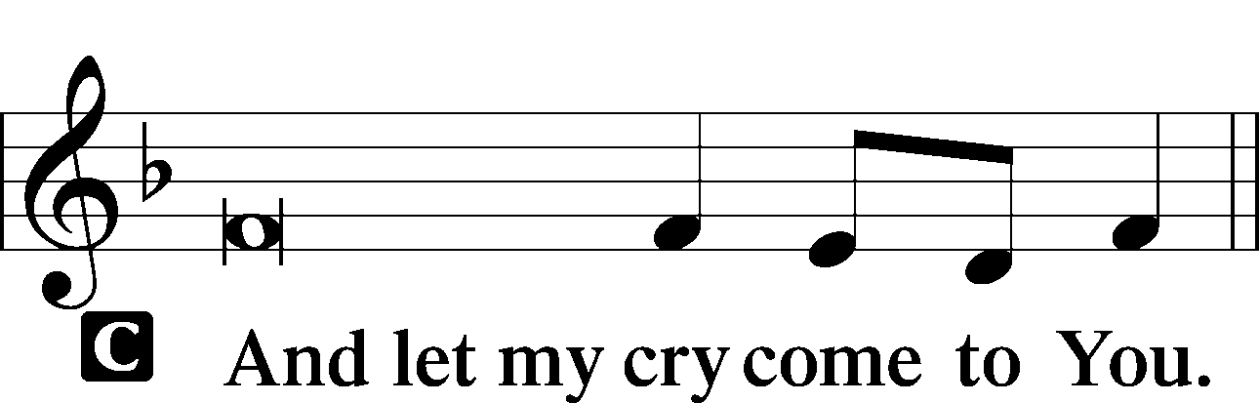

P O God, whose glory it is always to have mercy, be gracious to all who have gone astray from Your ways and bring them again with penitent hearts and steadfast faith to embrace and hold fast the unchangeable truth of Your Word; through Jesus Christ, Your Son, our Lord, who lives and reigns with You and the Holy Spirit, one God, now and forever.
C Amen.

P Lord, Your forgiveness rescues us from ever-failed intention and foolish weakness. Grant to us grace that we may be restored through forgiveness and ever stand before You in the clothing of Your mercy; through Jesus Christ, Your Son, our Lord, who lives and reigns with You and the Holy Spirit, one God, now and forever.
C Amen.

P Merciful God, graciously take into Your fatherly care the sick and needy, the widow and orphan, homeless and homebound, lonely and forgotten, and all who seek Your grace in time of adversity, affliction, or death. Comfort them, O God, with Your Holy Spirit, [especially . . .], that they may patiently endure their afflictions and support them with Your everlasting arms until You grant them a peaceful departure and a joyful entrance into Your eternal kingdom in the resurrection of all flesh; through Jesus Christ, our Lord.
C Amen.

P O God, from whom come all holy desires, all good counsels, and all just works, give to us, Your servants, that peace which the world cannot give, that our hearts may be set to obey Your commandments and also that we, being defended from the fear of our enemies, may live in peace and quietness; through Jesus Christ, Your Son, our Lord, who lives and reigns with You and the Holy Spirit, one God, now and forever.
C Amen.

Benedicamus LSB 234
L Let us bless the Lord.
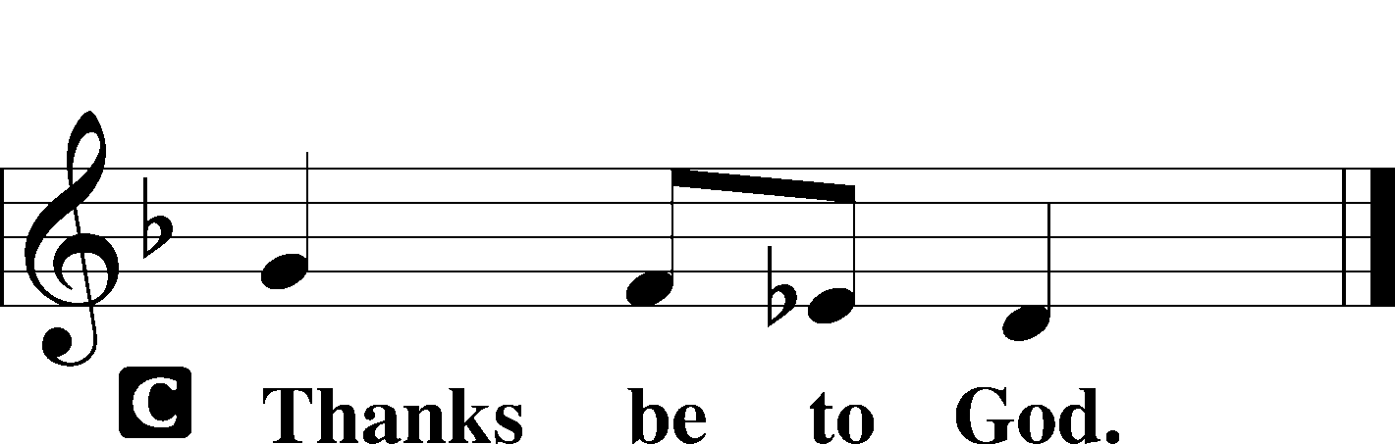

Benediction LSB 234
P The grace of our Lord T Jesus Christ and the love of God and the communion of the Holy Spirit be with you all.

Hymn: In the Cross of Christ I Glory (noon) LSB 427
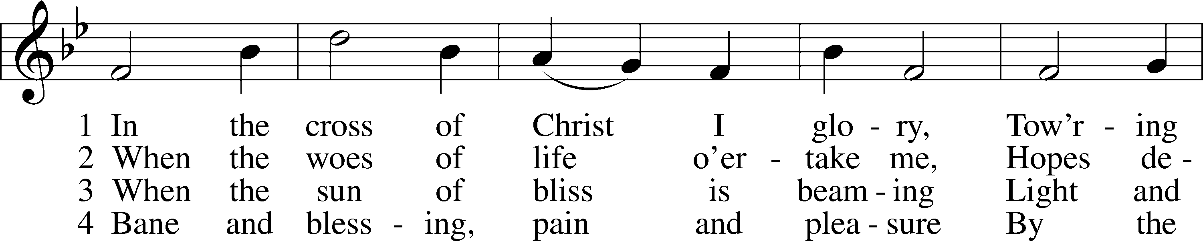
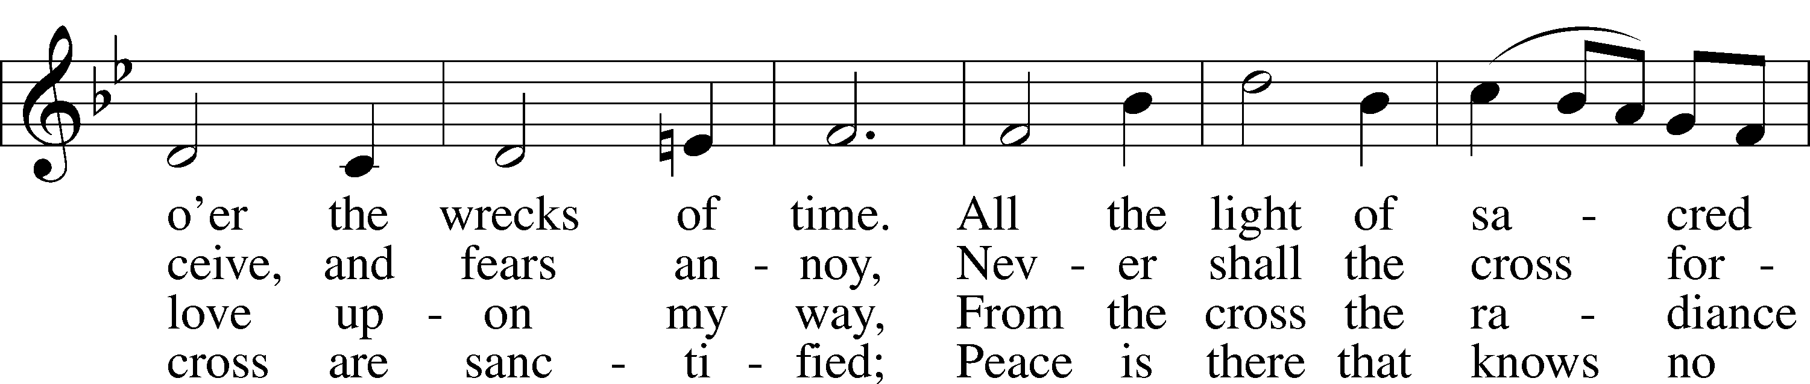
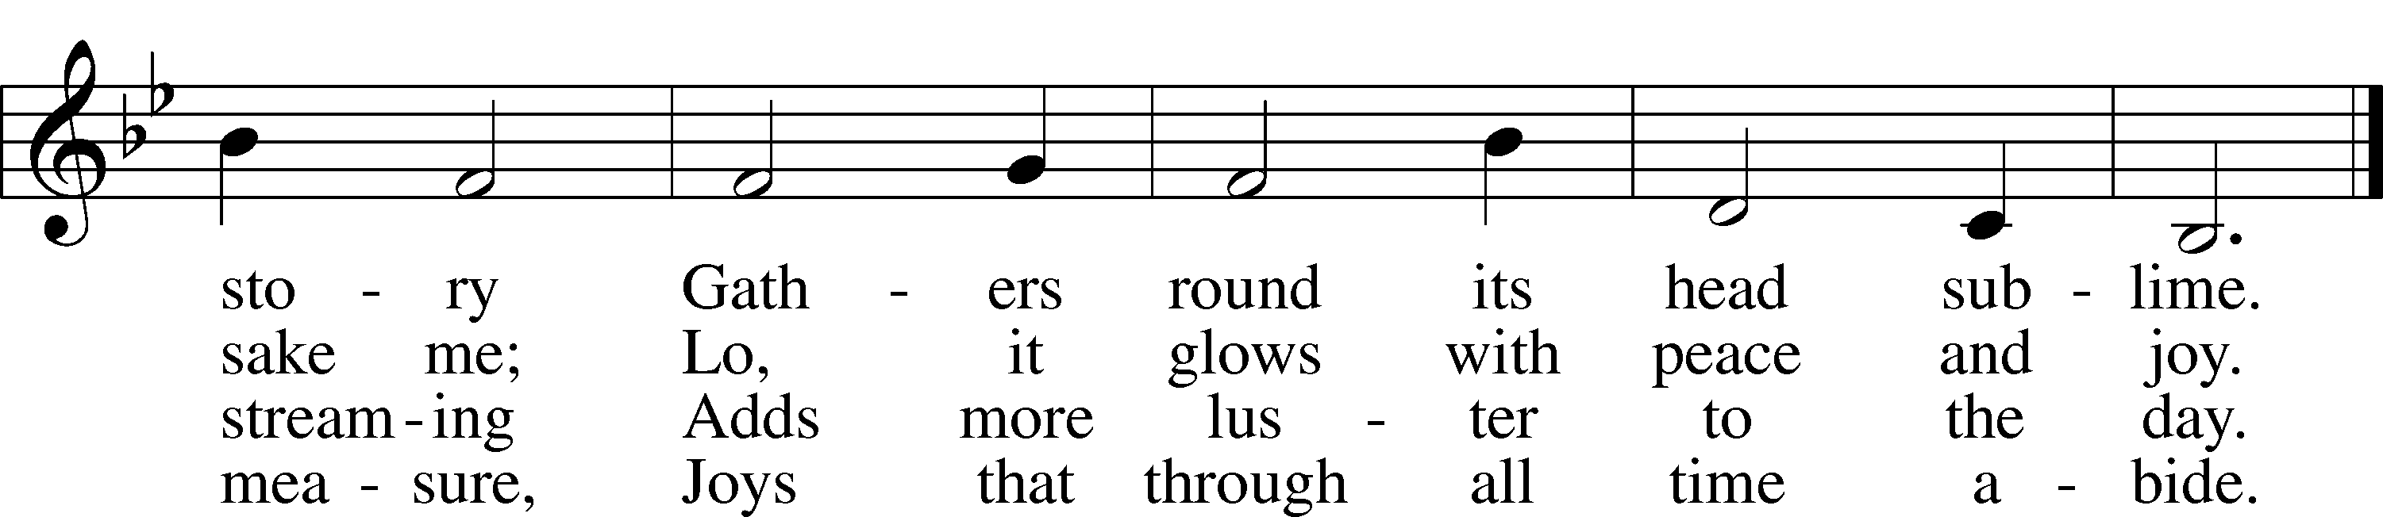
Text: John Bowring, 1792–1872
Tune: Ithamar Conkey, 1815–67
Text and tune: Public domain

Hymn: God, Who Made the Earth and Heaven (630 pm) LSB 877
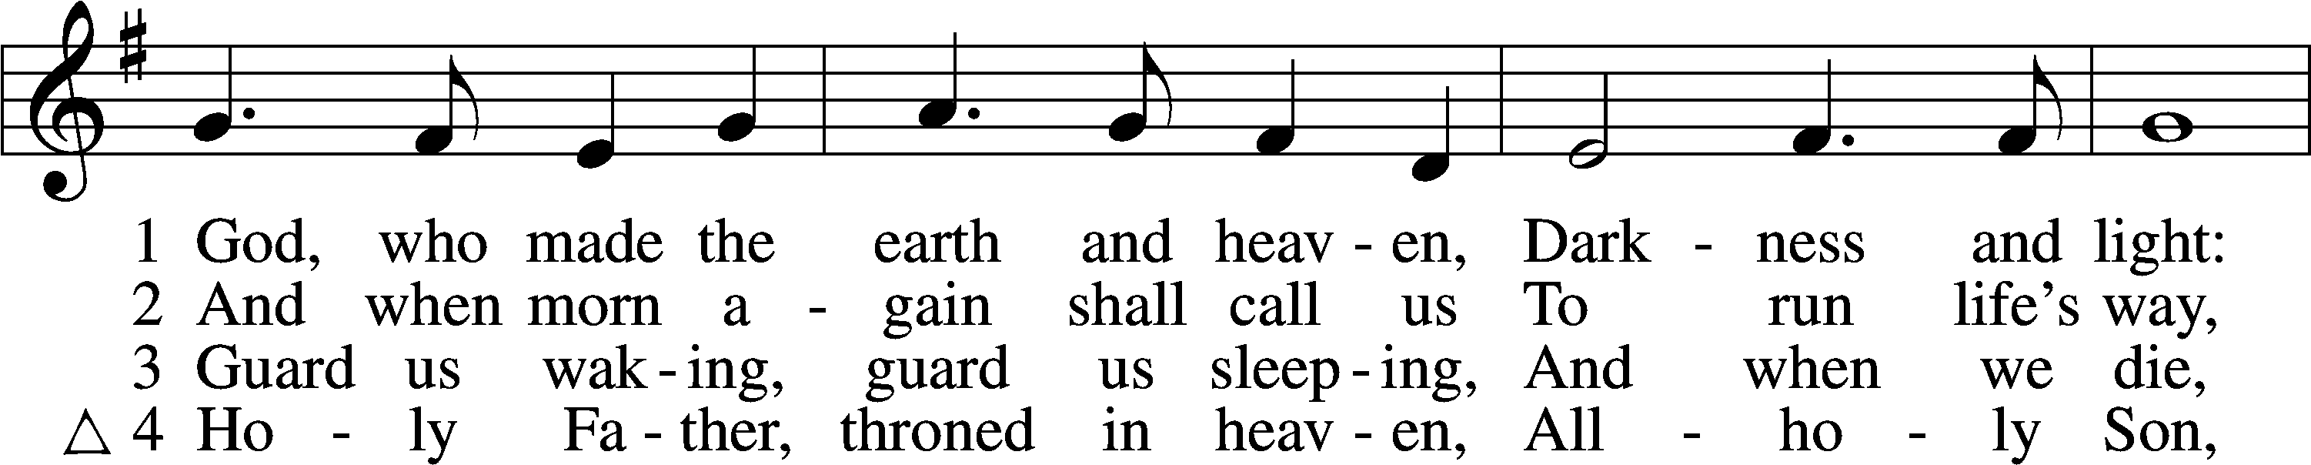
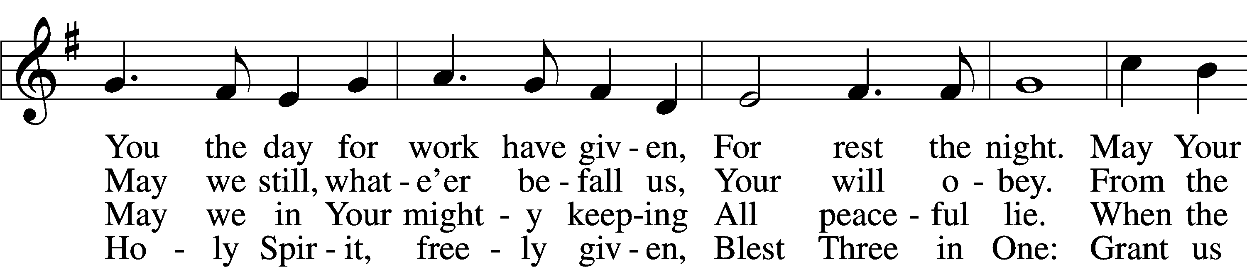
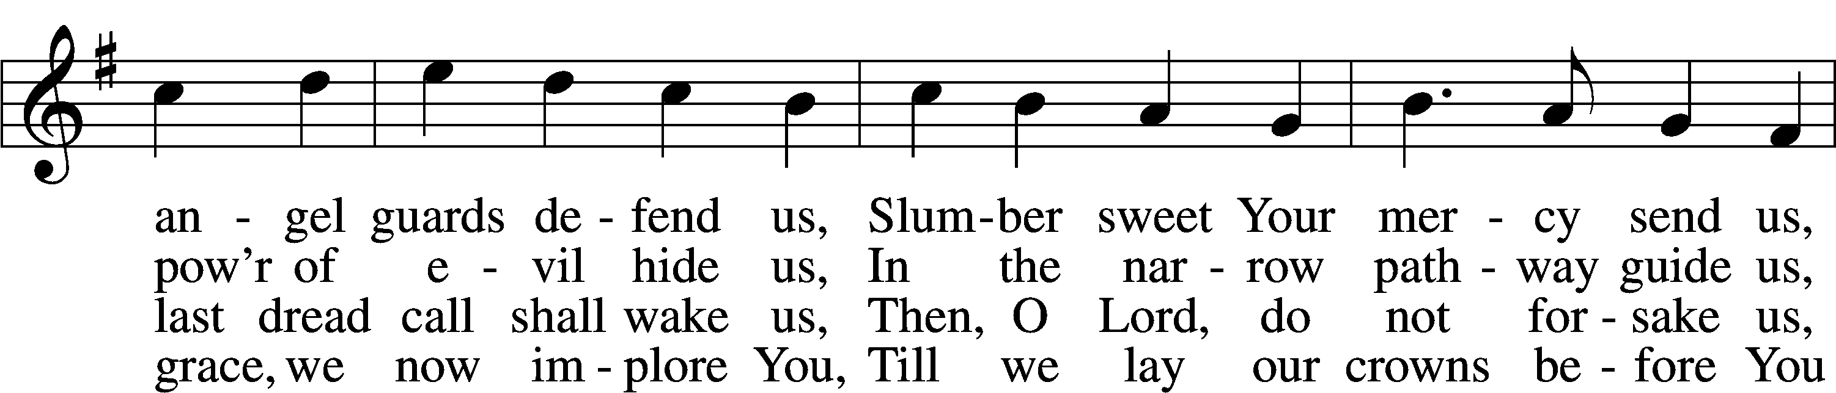
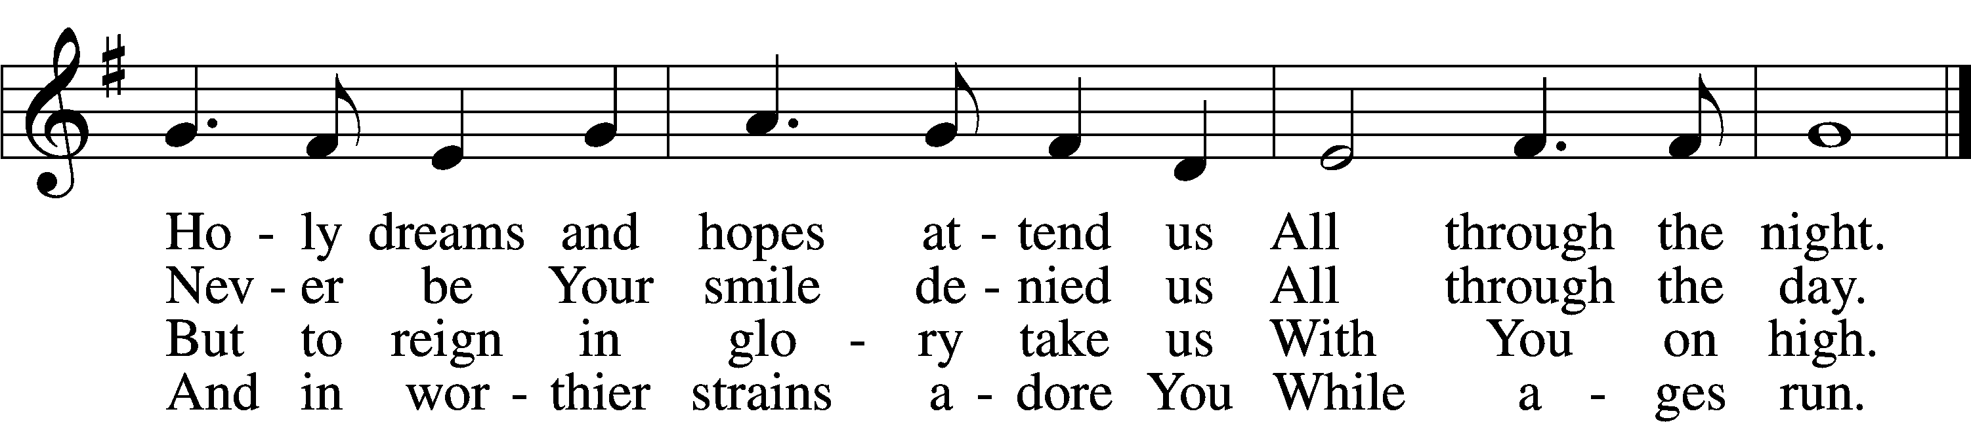
Text (st. 1): Reginald Heber, 1783–1826, alt.; (sts. 2, 4): William Mercer, 1811–73, alt.; (st. 3): Richard Whately, 1787–1863, alt.
Tune: Welsh, 18th cent.
Text and tune: Public domain

Acknowledgments
Unless otherwise indicated, Scripture quotations are from the ESV® Bible (The Holy Bible, English Standard Version®), copyright © 2001 by Crossway, a publishing ministry of Good News Publishers. Used by permission. All rights reserved.
Created by Lutheran Service Builder © 2022 Concordia Publishing House.

