Midweek Lent 5
April 6, 2022
12:00 PM and 6:30 PM

Salem Lutheran Church
1-715-537-3011
http://www.salembarron.com
rev.mike.nielsen@gmail.com

Pontius Pilate

Pontius Pilate, a witness to Christ, consented to order Jesus’ execution. Pilate may wash his hands and proclaim his own innocence in the death of Jesus, but Pilate is guilty. Pilate is caught between a rock and a hard place. Instead of doing what is right, Pilate has Jesus’ flesh ripped, shredded, dressed in purple, and crowned with thorns. His hard heart is complicit in the death of Christ. While it may be an uncomfortable thought, Pilate’s failures make us examine our own complicity in the evil of others. How have we deceived ourselves in proclaiming innocence? How have we been pressured into allowing evil to occur? Thanks be to God that our journey to the cross shows us Jesus’ forgiveness.

Hymn: No Tramp of Soldiers' Marching Feet LSB 444
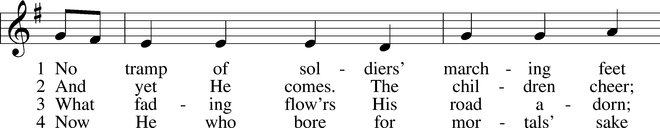
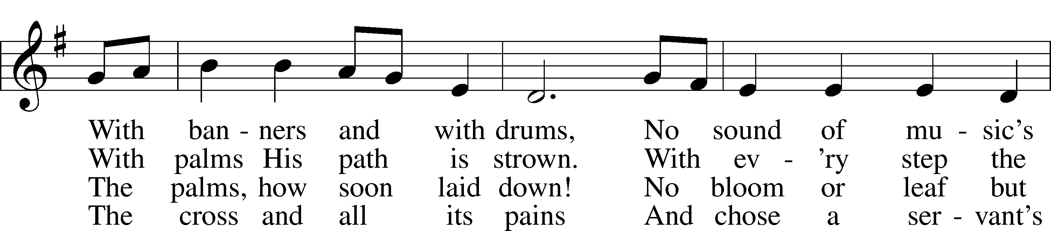
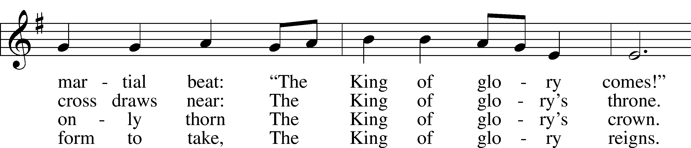
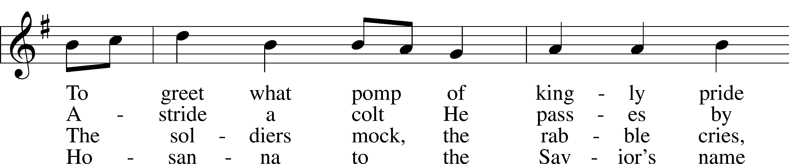
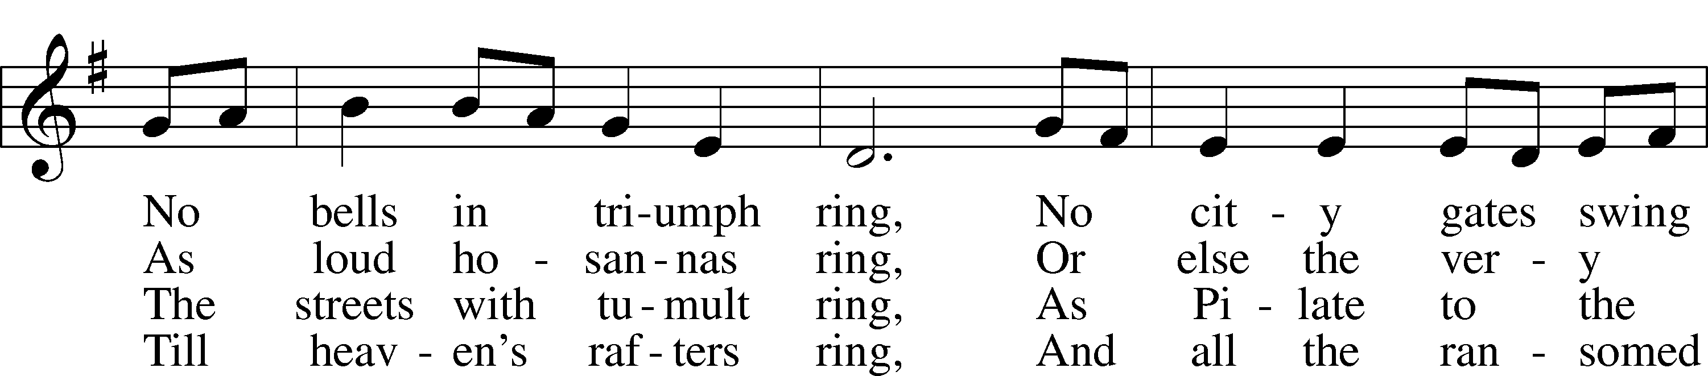
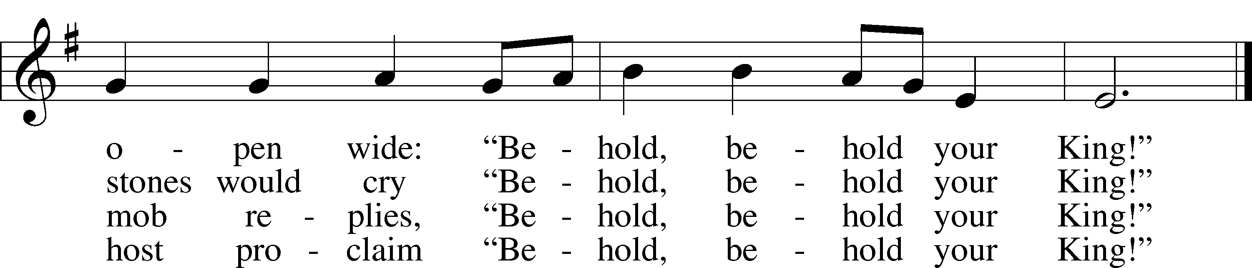
Text: Timothy Dudley-Smith, 1926
Tune: English; adapt. and harm. Ralph Vaughan Williams, 1872–1958, alt.
Text: © 1984 Hope Publishing Co. Used by permission: LSB Hymn License no. 110005504
Tune: Public domain

Lent Versicles
L O Lord, open my lips,

L Make haste, O God, to deliver me;

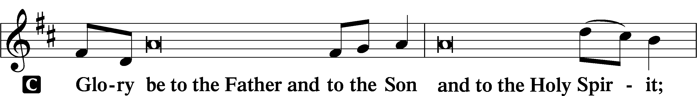
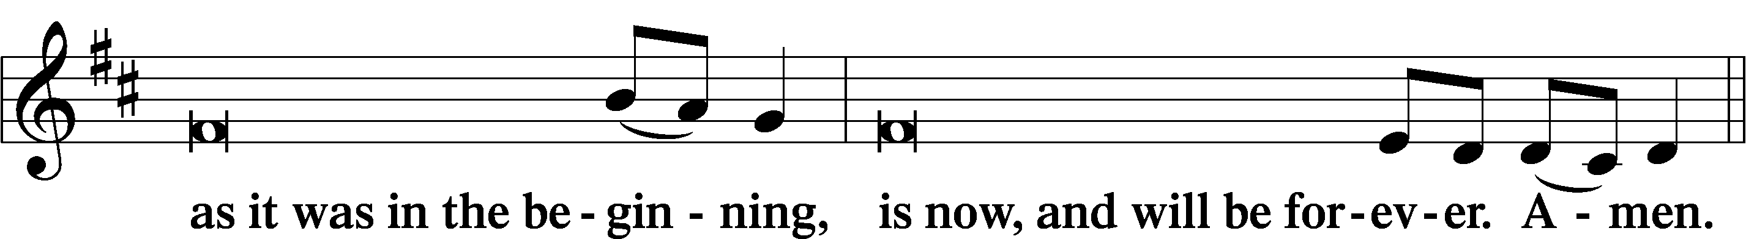
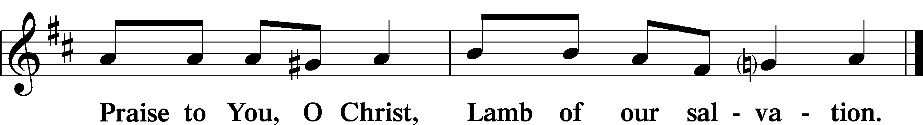

Psalmody

Psalm Psalm 109:1–7, 20–31; antiphon: v. 26
Help me, O | Lord my God!*
Save me according to Your | steadfast love!
Be not silent, O God | of my praise!*
For wicked and deceitful mouths are opened against me,
speaking against me with | lying tongues.
They encircle me with | words of hate,*
and attack me | without cause.
In return for my love they ac- | cuse me,*
but I give my- | self to prayer.
So they reward me e- | vil for good,*
and hatred | for my love.
Appoint a wicked man a- | gainst him;*
let an accuser stand at his | right hand.
When he is tried, let him come forth | guilty;*
let his prayer be count- | ed as sin!
May this be the reward of my accusers | from the Lord,*
of those who speak evil a- | gainst my life!
But You, O God my Lord,
deal on my behalf for Your | name’s sake;*
because Your steadfast love is good, de- | liver me!
For I am poor and | needy,*
and my heart is stricken with- | in me.
I am gone like a shadow at | evening;*
I am shaken off like a | locust.
My knees are weak through | fasting;*
my body has become gaunt, | with no fat.
I am an object of scorn to my ac- | cusers;*
when they see me, they | wag their heads.
Help me, O | Lord my God!*
Save me according to Your | steadfast love!
Let them know that this | is Your hand;*
You, O Lord, have | done it!
Let them curse, but | You will bless!*
They arise and are put to shame, but Your servant | will be glad!
May my accusers be clothed with dis- | honor;*
may they be wrapped in their own shame as | in a cloak!
With my mouth I will give great thanks | to the Lord;*
I will praise Him in the midst | of the throng.
For He stands at the right hand of the | needy,*
to save him from those who condemn his | soul to death.
Glory be to the Father and | to the Son*
and to the Holy | Spirit;
as it was in the be- | ginning,*
is now, and will be forever. | Amen.
Help me, O | Lord my God!*
Save me according to Your | steadfast love!

Silence for reflection

Psalm Prayer
P O God of steadfast love and mercy, on the cross Your Son forgave His enemies. Turn our hearts from hatred and evil that we may forgive the offenses of those who seek our harm and forgive as we have been forgiven. Rescue us in our time of peril and deliver us from bitterness and resentment; through Jesus Christ, our Savior and Lord.
C Amen.

Series Hymn: “Behold! The Lamb of God,” John Said
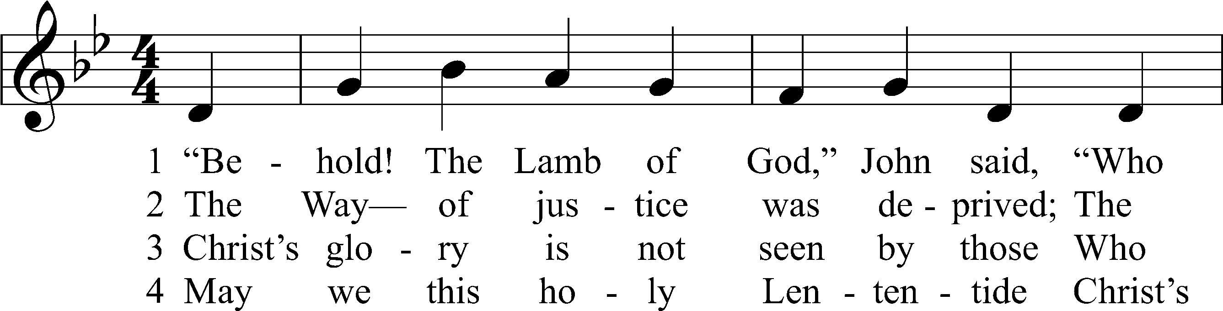
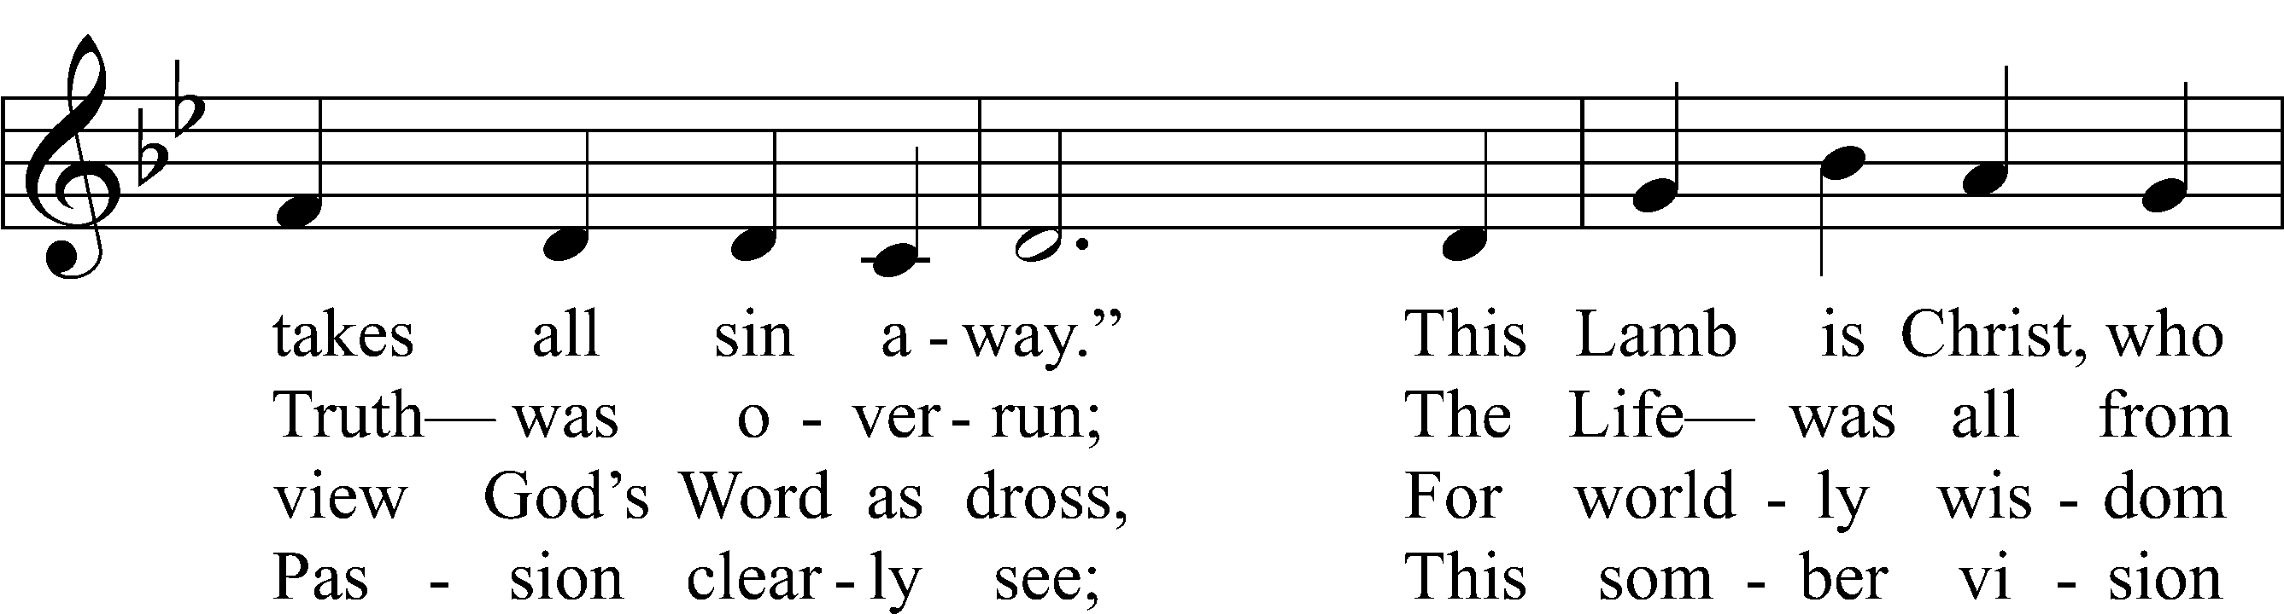
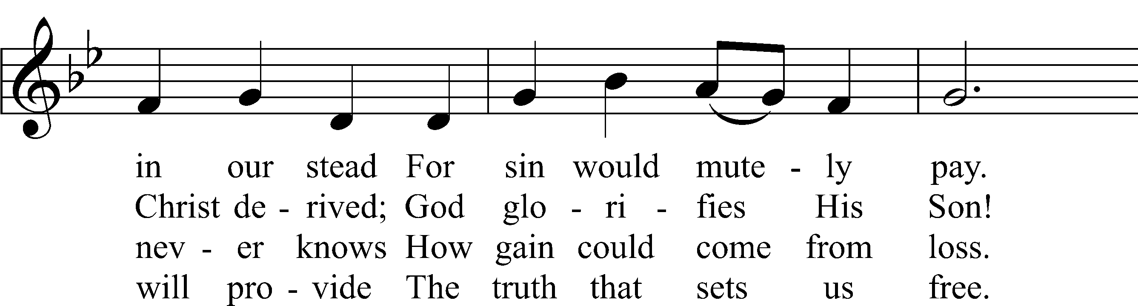
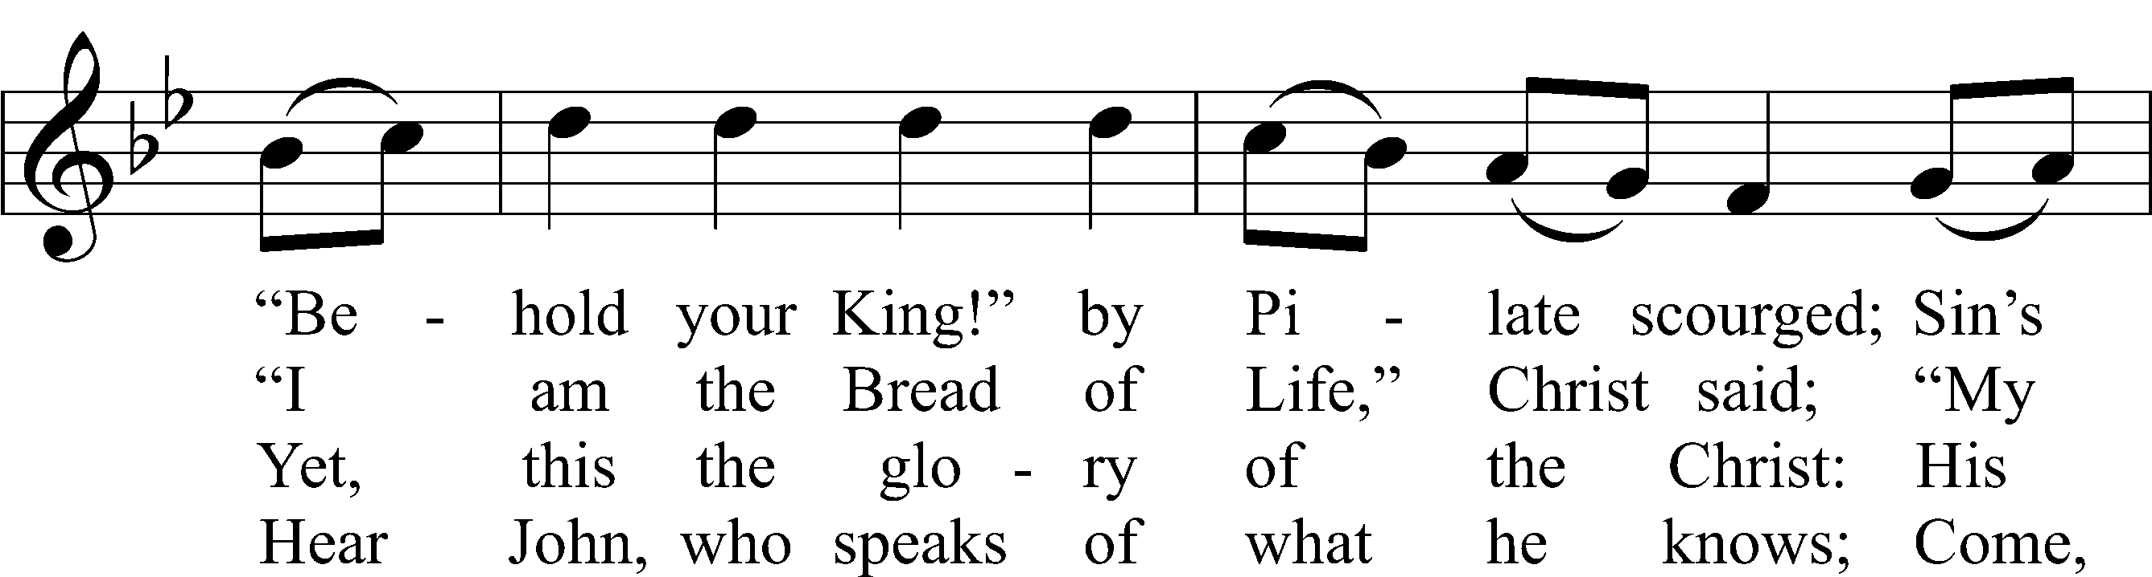
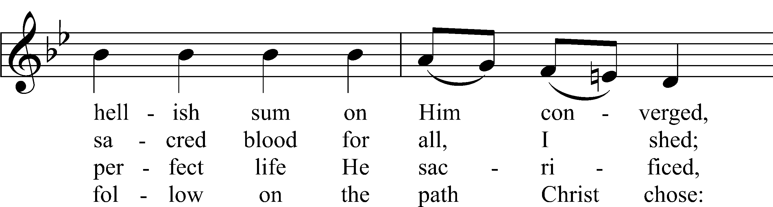
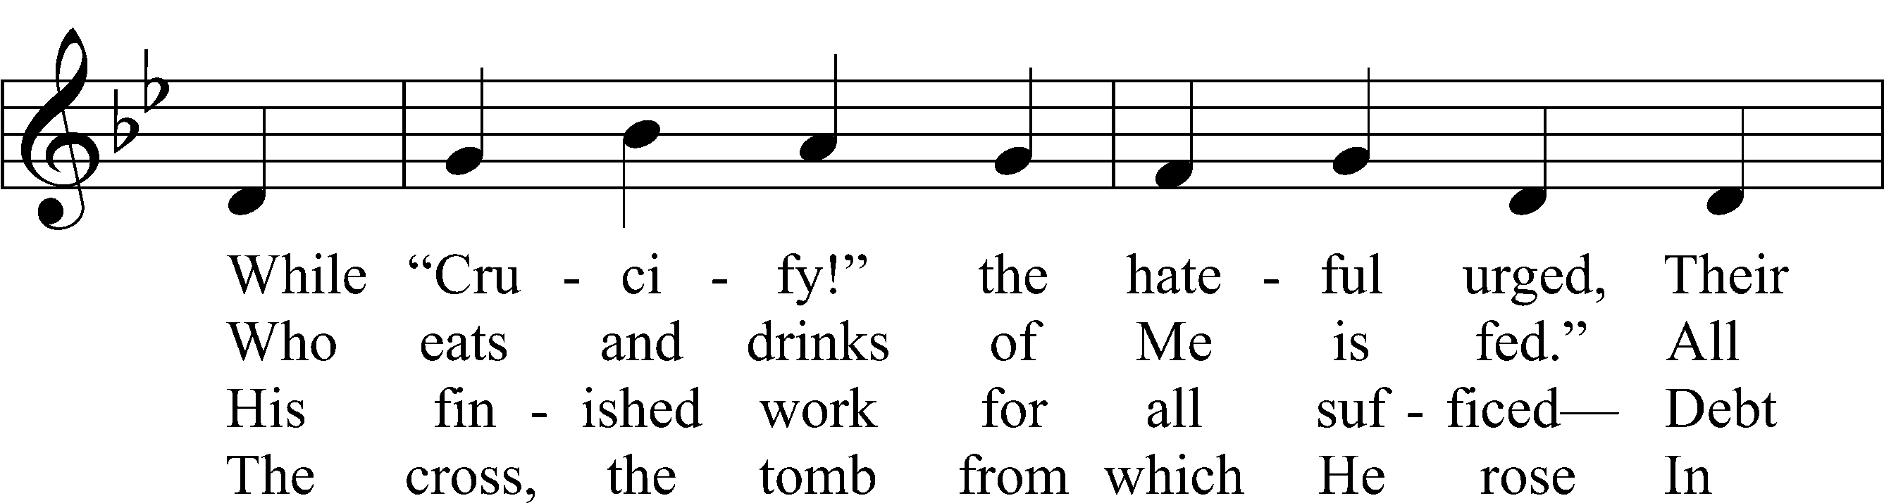
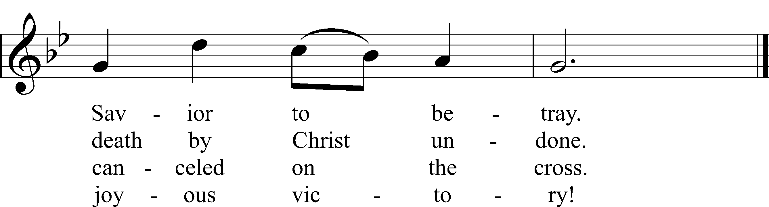
Text and text and text and text and text and text and text and text and text: Stephen P. Starke
Tune and tune and tune and tune and tune and tune and tune and tune and tune: John L. Bell
Text: © 2021 Stephen P. Starke, admin. Concordia Publishing House. Used by permission: CPH Lent License no. 110005504
Tune: © 1988, 1997 Wild Goose Resource Group, Iona Community, Scotland, admin. GIA Publications, Inc. Used by permission: CPH Lent License no. 110005504

Readings

Reading Ezekiel 11:17–21
P A reading from Ezekiel, the eleventh chapter.

17Therefore say, ‘Thus says the Lord God: I will gather you from the peoples and assemble you out of the countries where you have been scattered, and I will give you the land of Israel.’ 18And when they come there, they will remove from it all its detestable things and all its abominations. 19And I will give them one heart, and a new spirit I will put within them. I will remove the heart of stone from their flesh and give them a heart of flesh, 20that they may walk in my statutes and keep my rules and obey them. And they shall be my people, and I will be their God. 21But as for those whose heart goes after their detestable things and their abominations, I will bring their deeds upon their own heads, declares the Lord God.”

P O Lord, have mercy on us.
C Thanks be to God.

Reading 2 Corinthians 4:1–6
P A reading from Second Corinthians, the fourth chapter.

The Light of the Gospel
1Therefore, having this ministry by the mercy of God, we do not lose heart. 2But we have renounced disgraceful, underhanded ways. We refuse to practice cunning or to tamper with God’s word, but by the open statement of the truth we would commend ourselves to everyone’s conscience in the sight of God. 3And even if our gospel is veiled, it is veiled only to those who are perishing. 4In their case the god of this world has blinded the minds of the unbelievers, to keep them from seeing the light of the gospel of the glory of Christ, who is the image of God. 5For what we proclaim is not ourselves, but Jesus Christ as Lord, with ourselves as your servants for Jesus’ sake. 6For God, who said, “Let light shine out of darkness,” has shone in our hearts to give the light of the knowledge of the glory of God in the face of Jesus Christ.

P O Lord, have mercy on us.
C Thanks be to God.

Reading John 19:1–16
P A reading from St. John, the nineteenth chapter.

Jesus Delivered to Be Crucified
1Then Pilate took Jesus and flogged him. 2And the soldiers twisted together a crown of thorns and put it on his head and arrayed him in a purple robe. 3They came up to him, saying, “Hail, King of the Jews!” and struck him with their hands. 4Pilate went out again and said to them, “See, I am bringing him out to you that you may know that I find no guilt in him.” 5So Jesus came out, wearing the crown of thorns and the purple robe. Pilate said to them, “Behold the man!” 6When the chief priests and the officers saw him, they cried out, “Crucify him, crucify him!” Pilate said to them, “Take him yourselves and crucify him, for I find no guilt in him.” 7The Jews answered him, “We have a law, and according to that law he ought to die because he has made himself the Son of God.” 8When Pilate heard this statement, he was even more afraid. 9He entered his headquarters again and said to Jesus, “Where are you from?” But Jesus gave him no answer. 10So Pilate said to him, “You will not speak to me? Do you not know that I have authority to release you and authority to crucify you?” 11Jesus answered him, “You would have no authority over me at all unless it had been given you from above. Therefore he who delivered me over to you has the greater sin.”
12From then on Pilate sought to release him, but the Jews cried out, “If you release this man, you are not Caesar’s friend. Everyone who makes himself a king opposes Caesar.” 13So when Pilate heard these words, he brought Jesus out and sat down on the judgment seat at a place called The Stone Pavement, and in Aramaic Gabbatha. 14Now it was the day of Preparation of the Passover. It was about the sixth hour. He said to the Jews, “Behold your King!” 15They cried out, “Away with him, away with him, crucify him!” Pilate said to them, “Shall I crucify your King?” The chief priests answered, “We have no king but Caesar.” 16So he delivered him over to them to be crucified.
The Crucifixion
So they took Jesus,

P O Lord, have mercy on us.
C Thanks be to God.

Responsory (Lent) LSB 231
L Deliver me, O Lord, my God, for You are the God of my salvation.
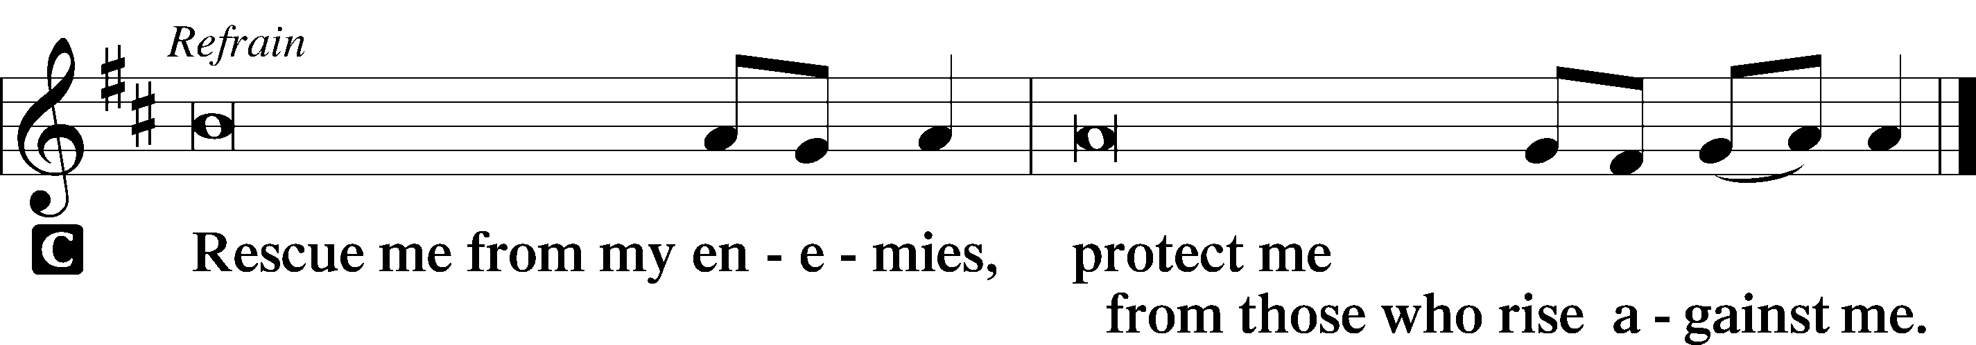

L In You, O Lord, do I put my trust, leave me not, O Lord, my God.

L Deliver me, O Lord, my God, for You are the God of my salvation.

Sermon

Canticle

Antiphon
L Let my prayer rise before You as incense,
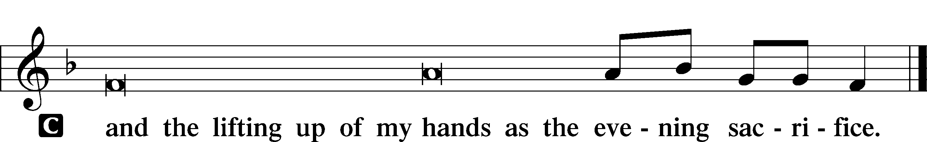

Magnificat LSB 231
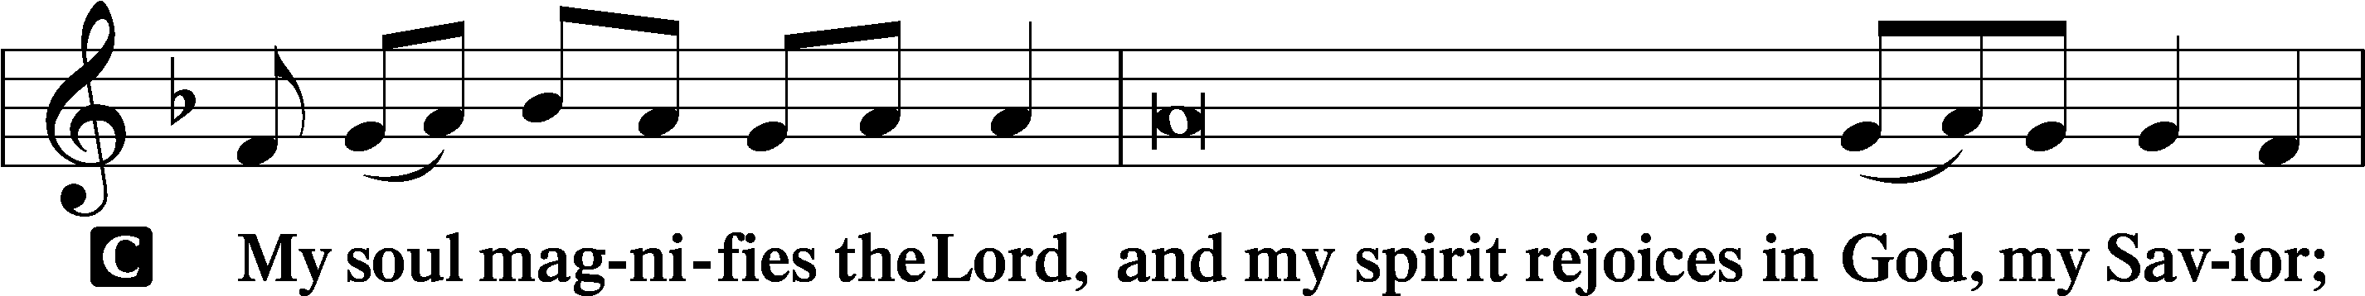
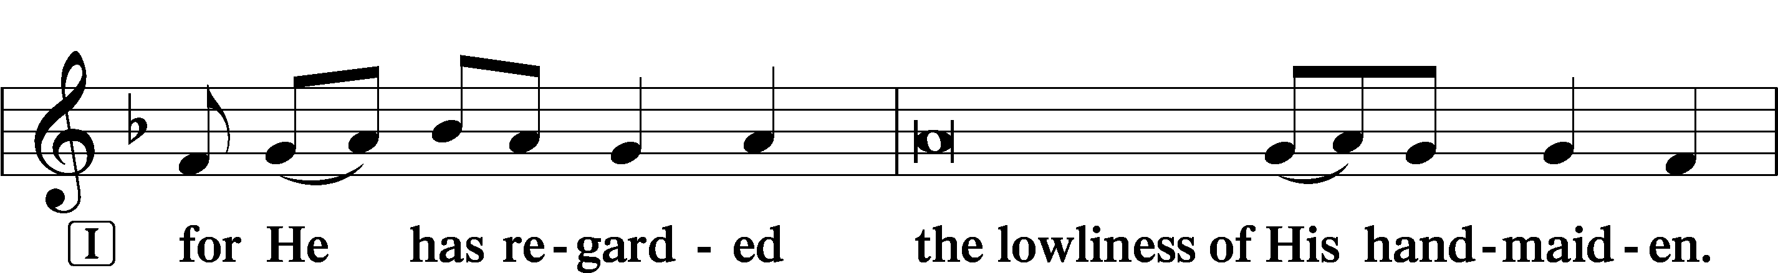
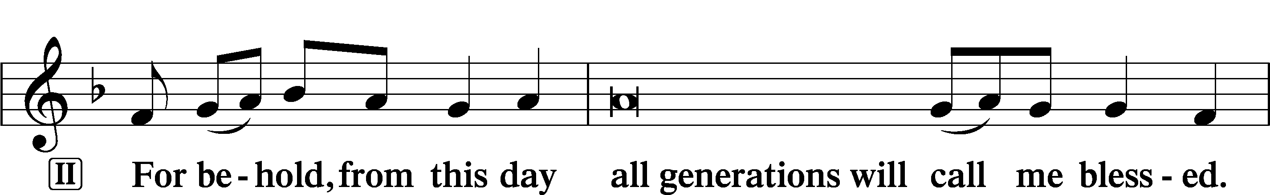
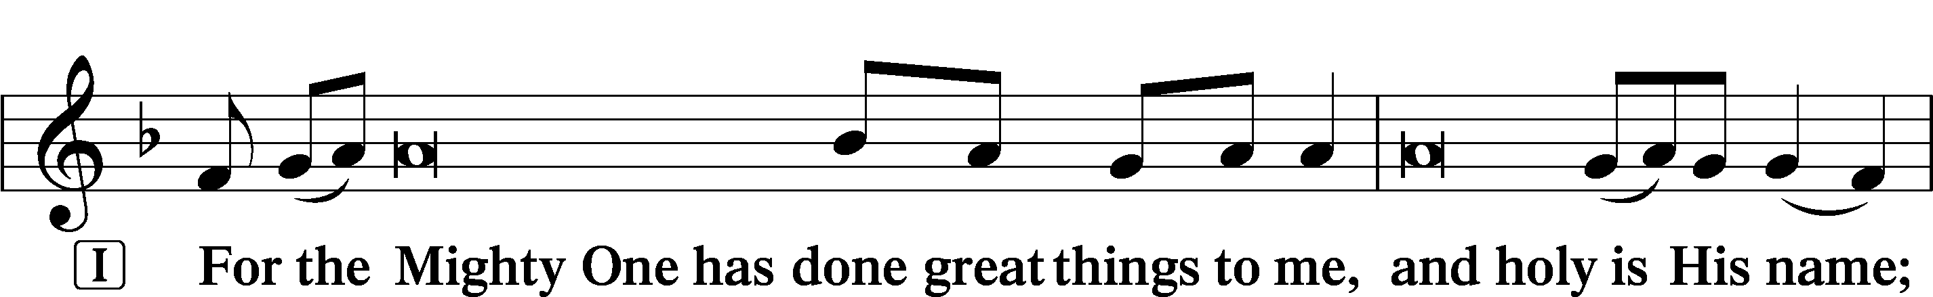
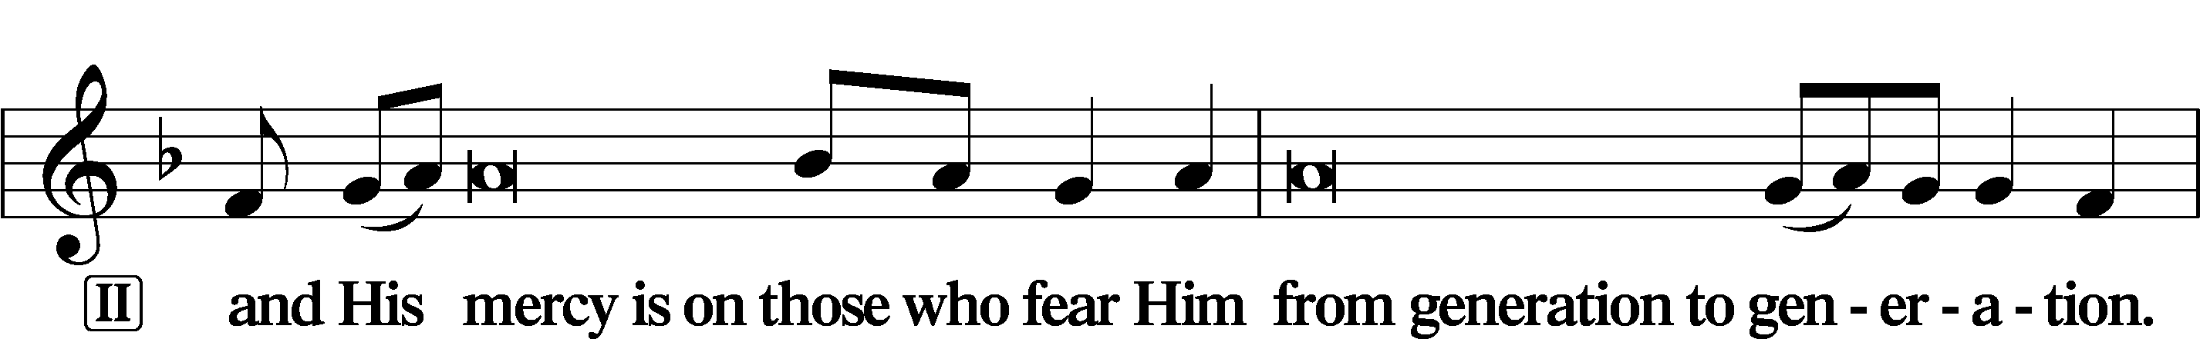
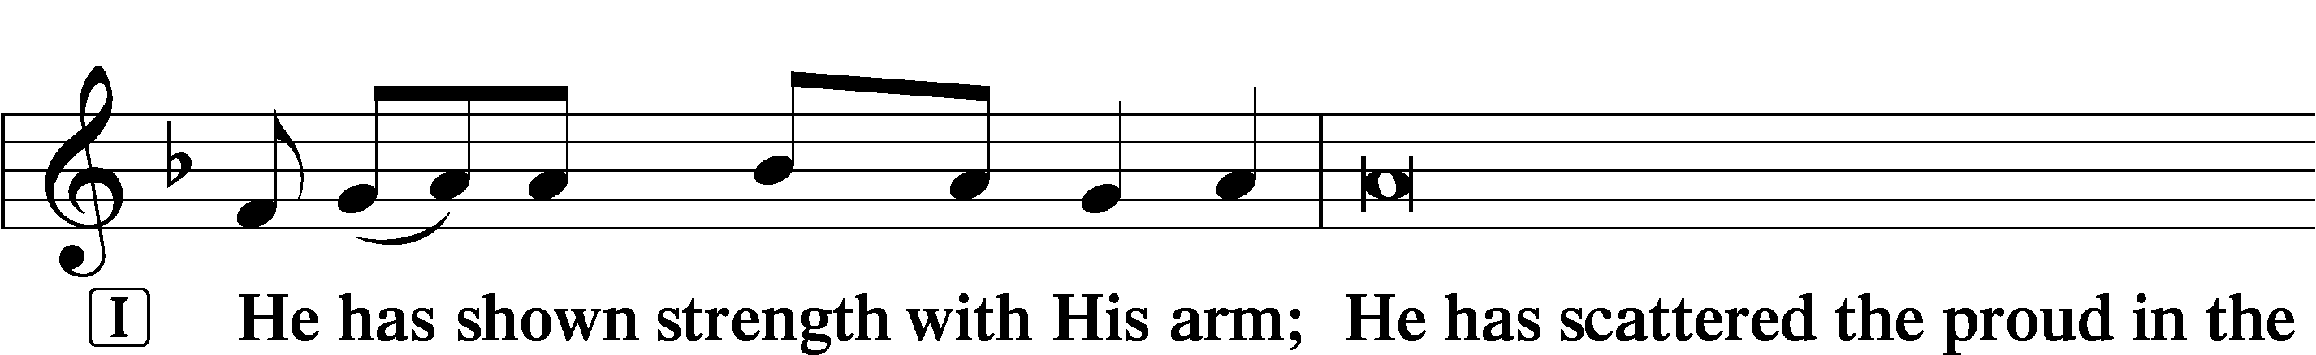
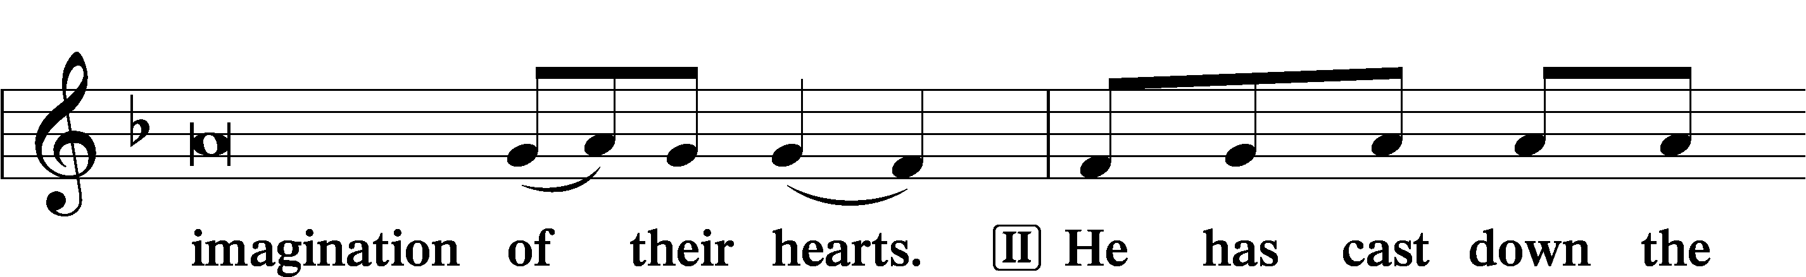
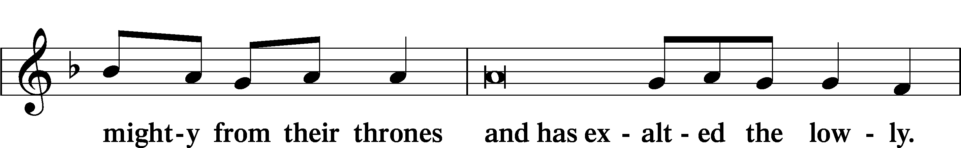
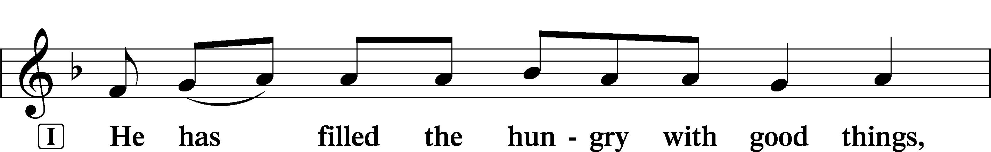
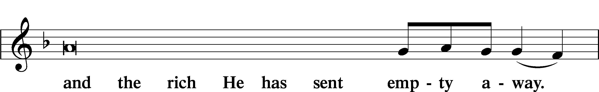
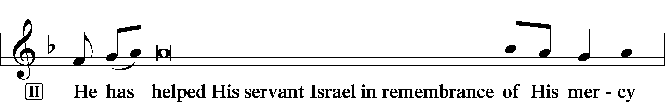
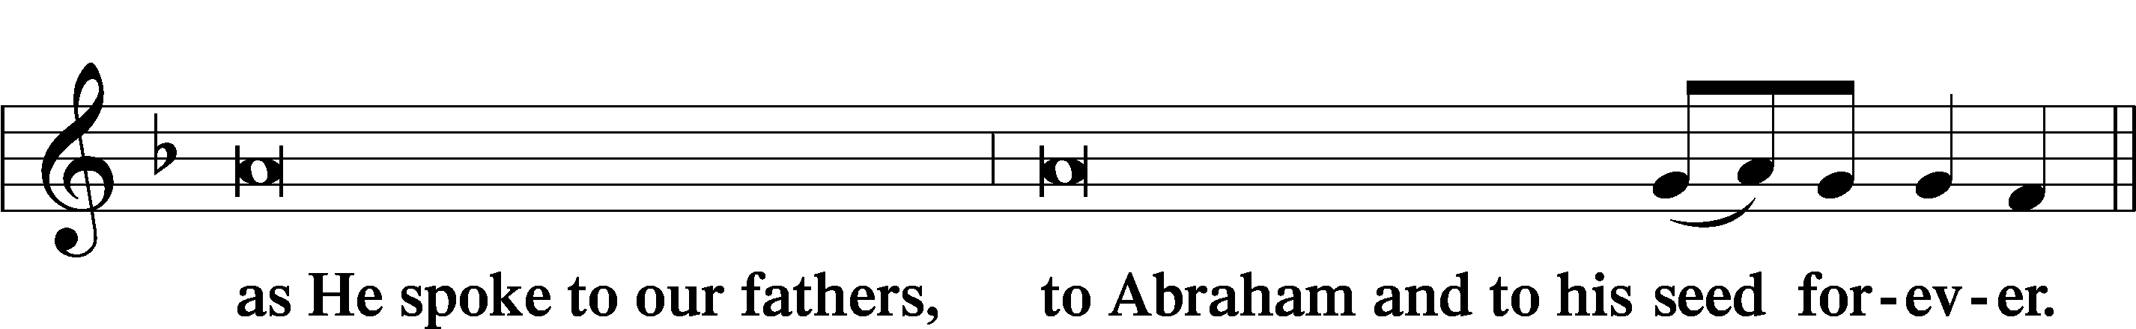
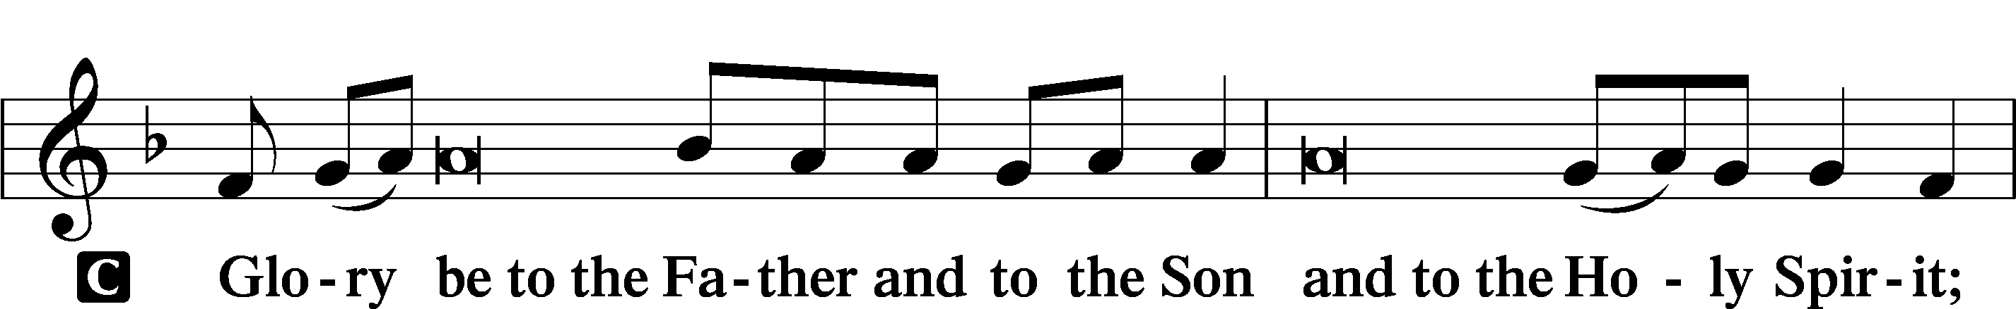
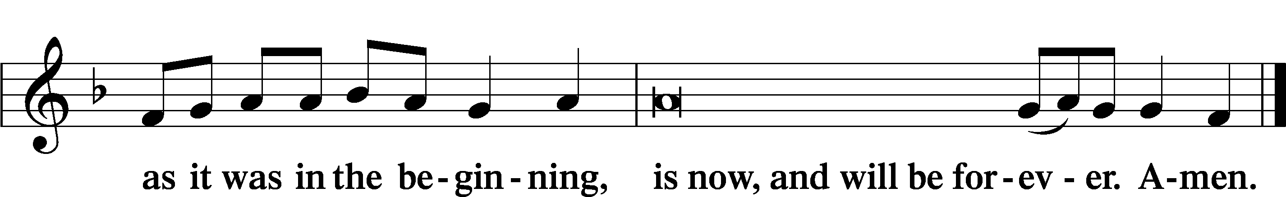

Prayer

Kyrie LSB 233
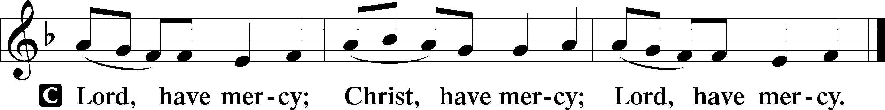

Lord’s Prayer
C Our Father who art in heaven,
hallowed be Thy name,
Thy kingdom come,
Thy will be done on earth
as it is in heaven;
give us this day our daily bread;
and forgive us our trespasses
as we forgive those
who trespass against us;
and lead us not into temptation,
but deliver us from evil.
For Thine is the kingdom
and the power and the glory
forever and ever. Amen.

Collects
L O Lord, hear my prayer.
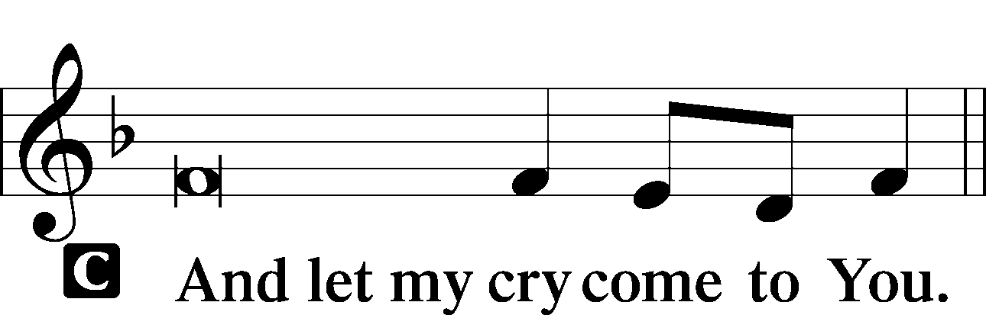

P O Lord God, by the example of Your blessed Son, grant us grace to accept patiently the suffering of this present time. Until we receive the full revelation of Your glory and full relief from all our afflictions, sustain us by Your healing grace through every trial. Hear us [especially for . . . and] for all in need; through Jesus Christ, our Lord, who lives and reigns with You and the Holy Spirit, one God, now and forever.
C Amen.

P Lord Jesus, though ruthless Pontius Pilate declared Your innocence before the crowds, You who knew no sin became sin for us. Grant that the shame You bore for us on the cross give us the greatest honor so that we might always see that only in suffering can we behold who You truly are, our glorious King and Savior; for You live and reign with the Father and the Holy Spirit, one God, now and forever.
C Amen.

P O God, from whom come all holy desires, all good counsels, and all just works, give to us, Your servants, that peace which the world cannot give, that our hearts may be set to obey Your commandments and also that we, being defended from the fear of our enemies, may live in peace and quietness; through Jesus Christ, Your Son, our Lord, who lives and reigns with You and the Holy Spirit, one God, now and forever.
C Amen.

Benedicamus LSB 234
L Let us bless the Lord.
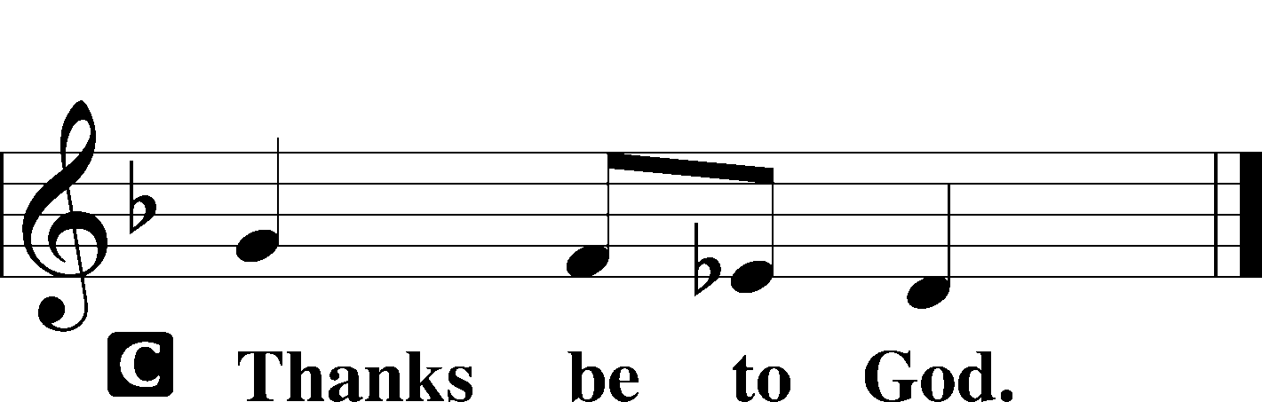

Benediction LSB 234
P The grace of our Lord T Jesus Christ and the love of God and the communion of the Holy Spirit be with you all.

Hymn: Cross of Jesus, Cross of Sorrow (Noon) LSB 428
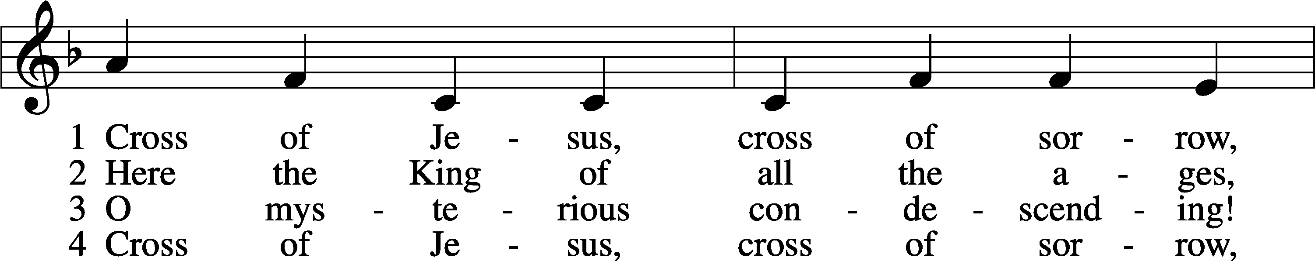
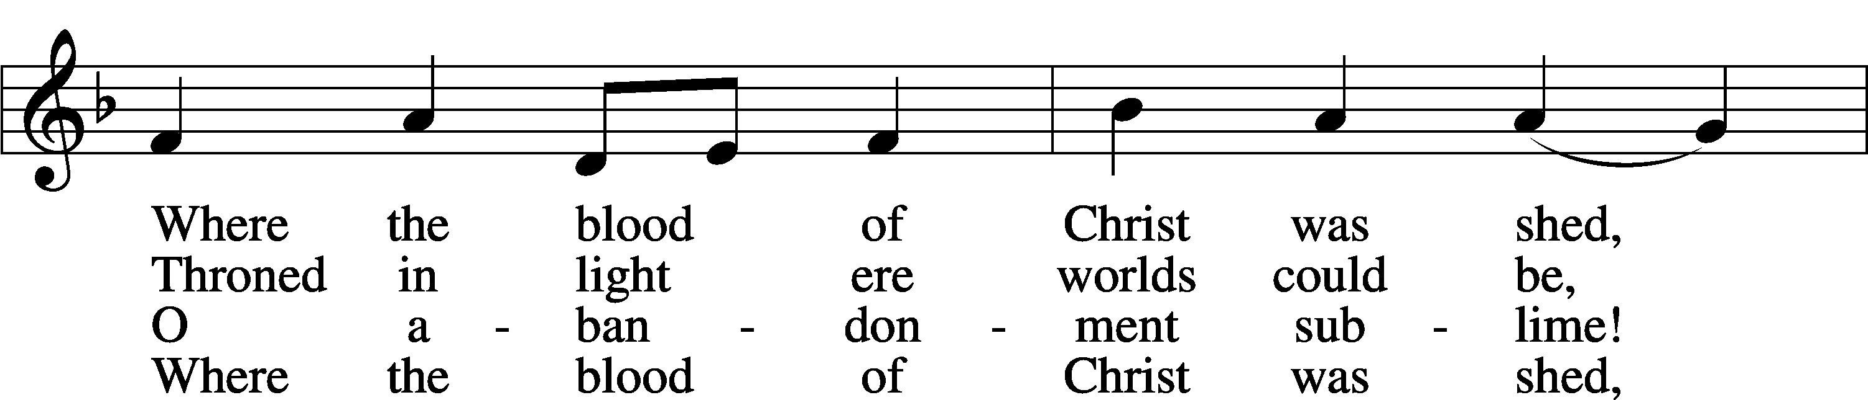
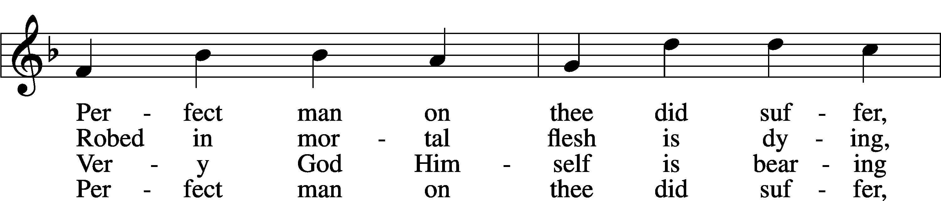
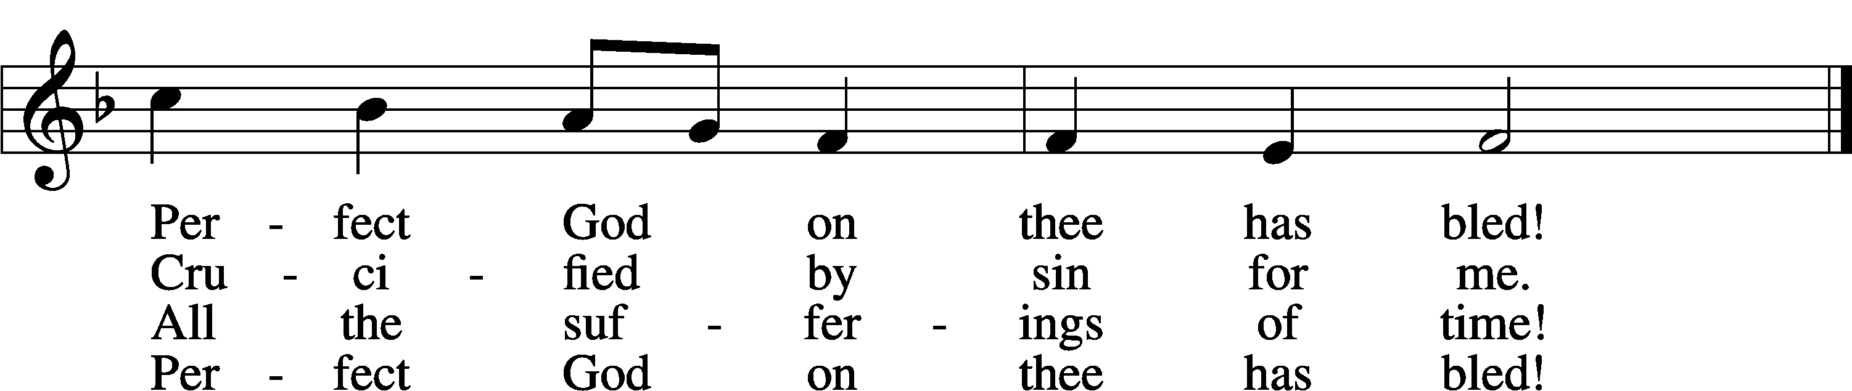
Text: William J. Sparrow Simpson, 1860–1952
Tune: John Stainer, 1840–1901
Text and tune: Public domain

Hymn: Abide With Me (630 PM) LSB 878
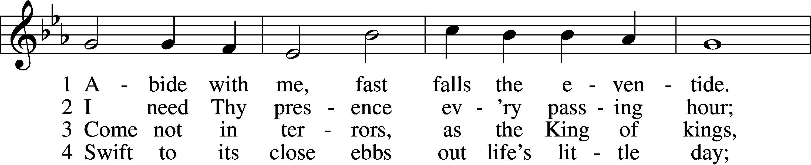
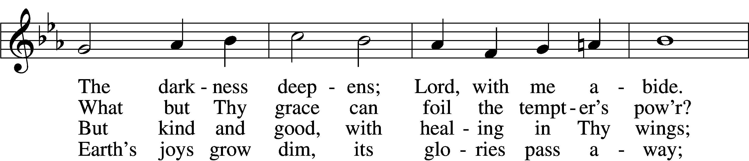
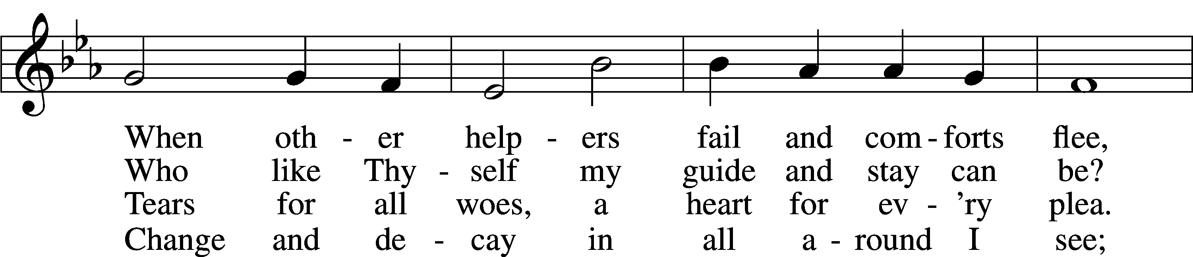
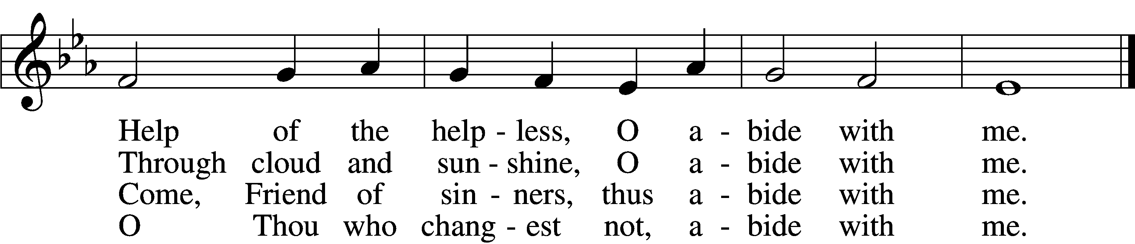

5 I fear no foe with Thee at hand to bless;
Ills have no weight and tears no bitterness.
Where is death’s sting? Where, grave, thy victory?
I triumph still if Thou abide with me!

6 Hold Thou Thy cross before my closing eyes;
Shine through the gloom, and point me to the skies.
Heav’n’s morning breaks, and earth’s vain shadows flee;
In life, in death, O Lord, abide with me.
Text: Henry F. Lyte, 1793–1847, alt.
Tune: William H. Monk, 1823–89
Text and tune: Public domain

Acknowledgments
Unless otherwise indicated, Scripture quotations are from the ESV® Bible (The Holy Bible, English Standard Version®), copyright © 2001 by Crossway, a publishing ministry of Good News Publishers. Used by permission. All rights reserved.
Created by Lutheran Service Builder © 2022 Concordia Publishing House.

