Ash Wednesday
February 22, 2023
12 Noon and 6:30 PM

Salem Lutheran Church
1-715-537-3011
http://www.salembarron.com
rev.mike.nielsen@gmail.com

Sitting in Dust and Ashes

Lent begins with ashes. The wearing of ashes on our forehead may seem like an unusual tradition, but it is rich with meaning. From the earliest days, God’s children have repented before Him in sackcloth and ashes, a visual reflection of their hearts turning to Him for forgiveness and restoration. Fixing our eyes on Jesus during the forty-day season of Lent, we journey with Him to Calvary’s cross where, enduring the “ashes” of our sins and the penalty they deserve, He grants to us the beauty of His forgiveness, full and free. Let us be renewed in our hearts and minds this day as we gather in the Lord’s house. His Word will show us our great need for His saving love and deliver to us the treasures He has promised.

PREPARATION

Ash Wednesday Address
P Dear brothers and sisters of our Lord Jesus Christ, on this day the Church begins a holy season of prayerful and penitential reflection. Our attention is especially directed to the holy sufferings and death of our Lord Jesus Christ.
From ancient times the season of Lent has been kept as a time of special devotion, self-denial, and humble repentance born of a faithful heart that dwells confidently on His Word and draws from it life and hope.
Let us pray that our dear Father in heaven, for the sake of His beloved Son and in the power of His Holy Spirit, might richly bless this Lententide for us so that we may come to Easter with glad hearts and keep the feast in sincerity and truth.

Silence for reflection

The Litany
P O Lord,
C have mercy.
P O Christ,
C have mercy.
P O Lord,
C have mercy.
P O Christ,
C hear us.
P God the Father in heaven,
C have mercy.
P God the Son, Redeemer of the world,
C have mercy.
P God the Holy Spirit,
C have mercy.
P Be gracious to us.
C Spare us, good Lord.
P Be gracious to us.
C Help us, good Lord.
P By the mystery of Your holy incarnation; by Your holy nativity; by Your baptism, fasting, and temptation; by Your agony and bloody sweat; by Your cross and passion; by Your precious death and burial; by Your glorious resurrection and ascension; and by the coming of the Holy Spirit, the Comforter:
C Help us, good Lord.
P In all time of our tribulation; in all time of our prosperity; in the hour of death; and in the day of judgment:
C Help us, good Lord.
P We poor sinners implore You
C to hear us, O Lord.
P To prosper the preaching of Your Word; to bless our prayer and meditation; to strengthen and preserve us in the true faith; and to give heart to our sorrow and strength to our repentance:
C We implore You to hear us, good Lord.
P To draw all to Yourself; to bless those who are instructed in the faith; to watch over and console the poor, the sick, the distressed, the lonely, the forsaken, the abandoned, and all who stand in need of our prayers; to give abundant blessing to all works of mercy; and to have mercy on us all:
C We implore You to hear us, good Lord.
P To turn our hearts to You; to turn the hearts of our enemies, persecutors, and slanderers; and graciously to hear our prayers:
C We implore You to hear us, good Lord.
P Lord Jesus Christ, Son of God,
C we implore You to hear us.
P Christ, the Lamb of God, who takes away the sin of the world,
C have mercy.
P Christ, the Lamb of God, who takes away the sin of the world,
C have mercy.
P Christ, the Lamb of God, who takes away the sin of the world,
C grant us Your peace.
P O Christ,
C hear us.
P O Lord,
C have mercy.
P O Christ,
C have mercy.
P O Lord,
C have mercy. Amen.

P O God, You desire not the death of sinners, but rather that they turn from their wickedness and live. We implore You to have compassion on the frailty of our mortal nature, for we acknowledge that we are dust and to dust we shall return. Mercifully pardon our sins that we may obtain the promises You have laid up for those who are repentant; through Jesus Christ, Your Son, our Lord, who lives and reigns with You and the Holy Spirit, one God, now and forever.
C Amen.

THE IMPOSITION OF ASHES

The pastor and assistants receive ashes first, followed by the congregation. Using the right thumb, the pastor or an assistant places the ashes on the forehead of each person in the sign of the cross, saying:

P Remember that you are dust, and to dust you shall return.

After receiving the ashes, each person returns to his or her place in silence.

CONFESSION AND ABSOLUTION

Hymn: Savior, When in Dust to Thee LSB 419
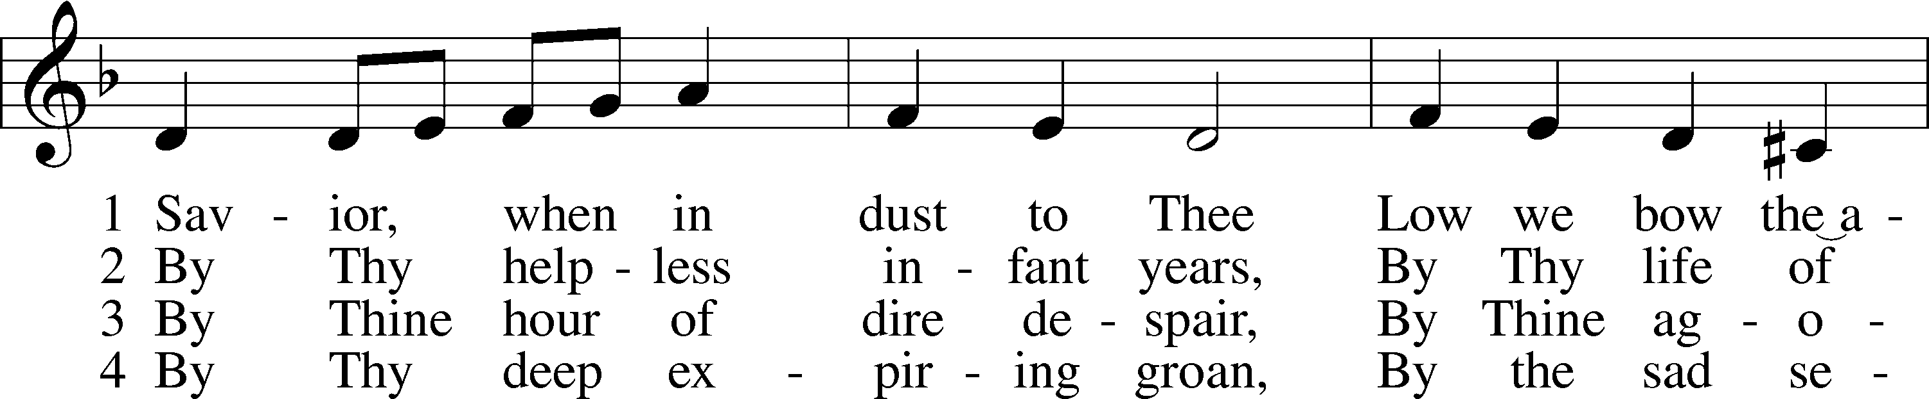
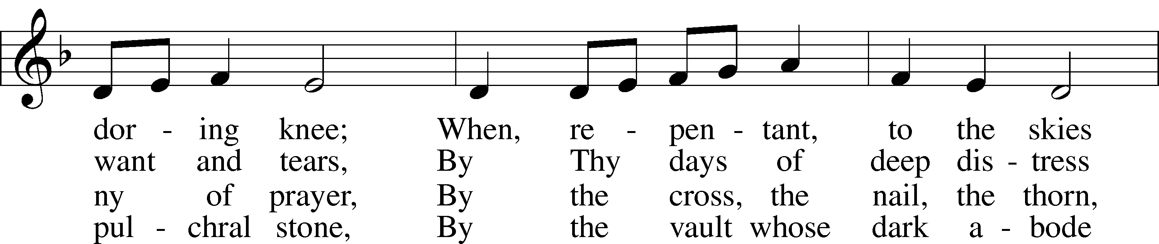
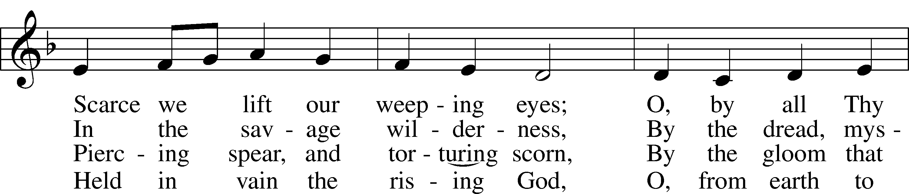
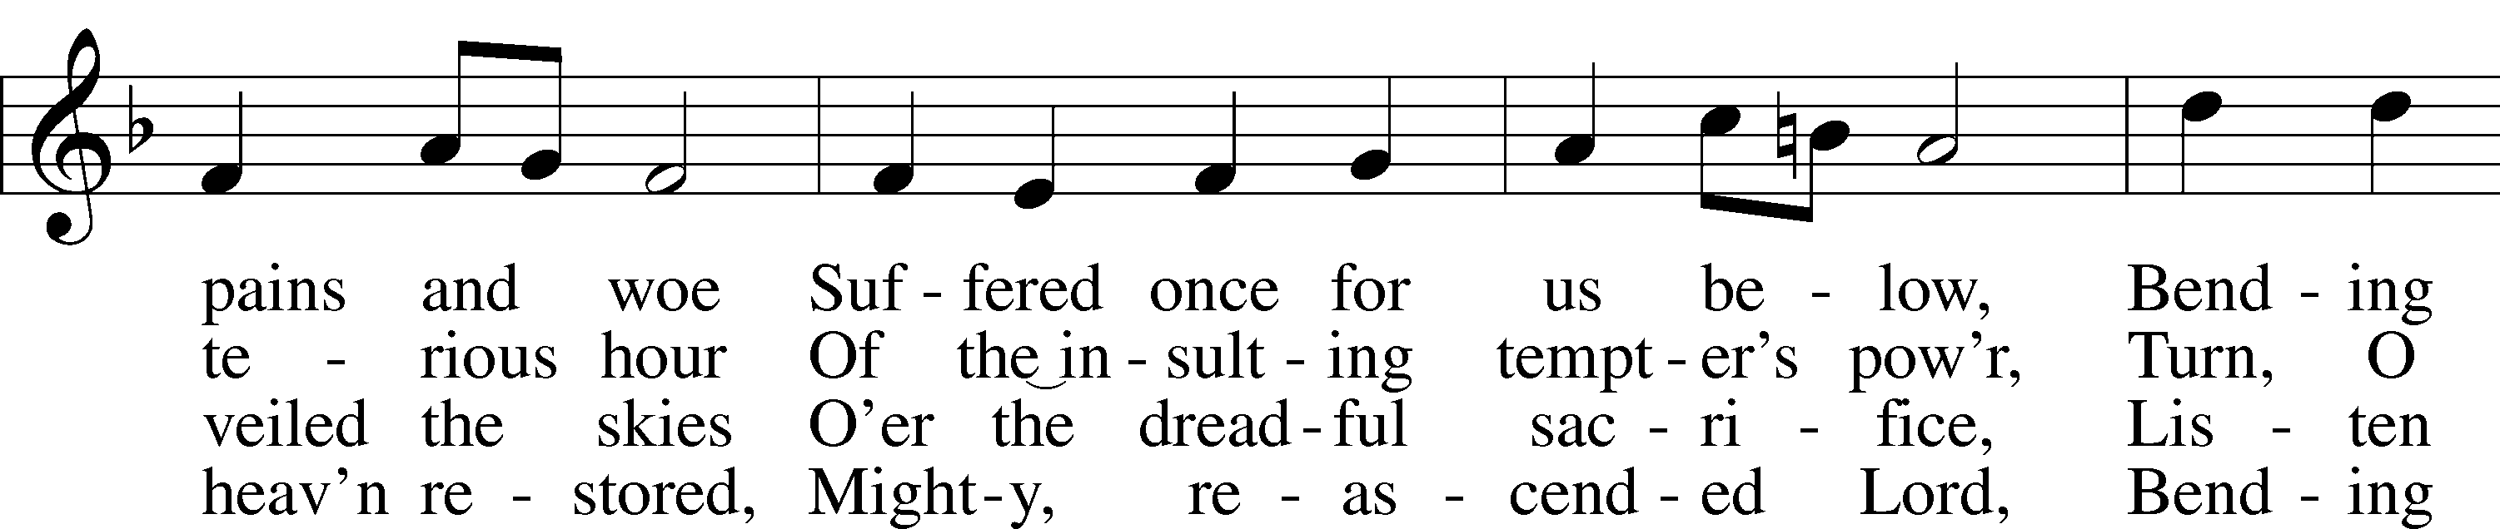
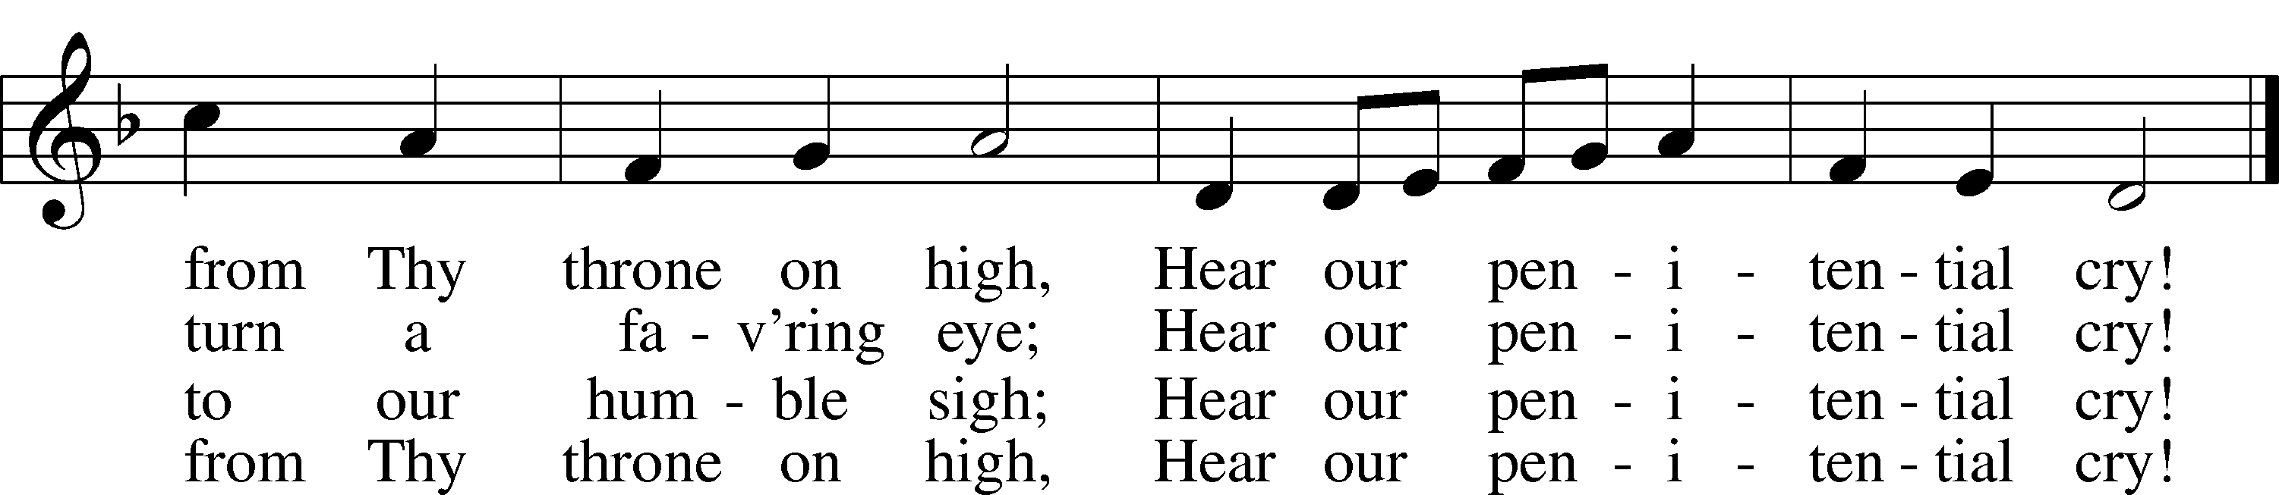
Text: Robert Grant, 1779–1838, alt.
Tune: Joseph Parry, 1841–1903
Text and tune: Public domain

The sign of the cross may be made by all in remembrance of their Baptism.

Invocation
P In the name of the Father and of the T Son and of the Holy Spirit.
C Amen.

Exhortation LSB 184
P Beloved in the Lord! Let us draw near with a true heart and confess our sins unto God our Father, beseeching Him in the name of our Lord Jesus Christ to grant us forgiveness.

P Our help is in the name of the Lord,
C who made heaven and earth.
P I said, I will confess my transgressions unto the Lord,
C and You forgave the iniquity of my sin.

Silence for reflection on God’s Word and for self-examination.

Confession of Sins LSB 184
P O almighty God, merciful Father,
C I, a poor, miserable sinner, confess unto You all my sins and iniquities with which I have ever offended You and justly deserved Your temporal and eternal punishment. But I am heartily sorry for them and sincerely repent of them, and I pray You of Your boundless mercy and for the sake of the holy, innocent, bitter sufferings and death of Your beloved Son, Jesus Christ, to be gracious and merciful to me, a poor, sinful being.

Absolution LSB 185
P Upon this your confession, I, by virtue of my office, as a called and ordained servant of the Word, announce the grace of God unto all of you, and in the stead and by the command of my Lord Jesus Christ I forgive you all your sins in the name of the Father and of the T Son and of the Holy Spirit.
C Amen.

SERVICE OF THE WORD

Psalm Psalm 51:1–4, 10–12
P Have mercy on me, O God, according to Your steadfast love;
C according to Your abundant mercy blot out my transgressions.
P Wash me thoroughly from my iniquity, and cleanse me from my sin!
C For I know my transgressions, and my sin is ever before me.
P Against You, You only, have I sinned and done what is evil in Your sight,
C so that You may be justified in Your words and blameless in Your judgment.
P Create in me a clean heart, O God,
C and renew a right spirit within me.
P Cast me not away from Your presence,
C and take not Your Holy Spirit from me.
P Restore to me the joy of Your salvation,
C and uphold me with a willing spirit.
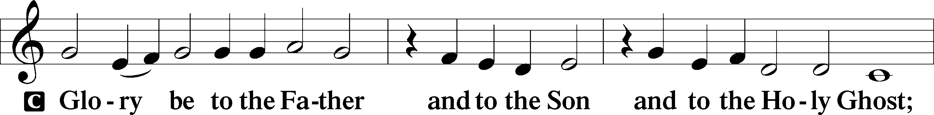
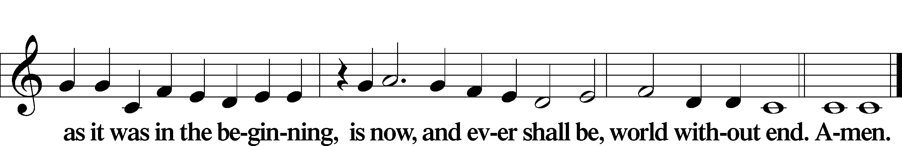

Kyrie LSB 186
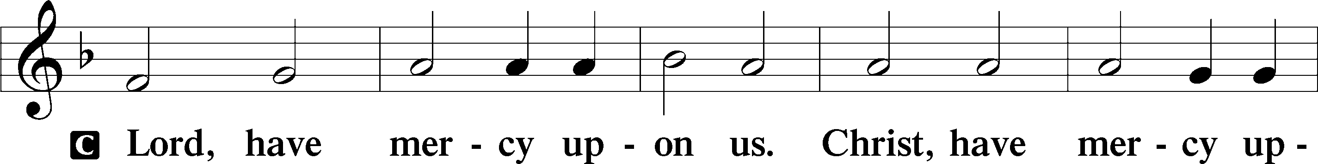
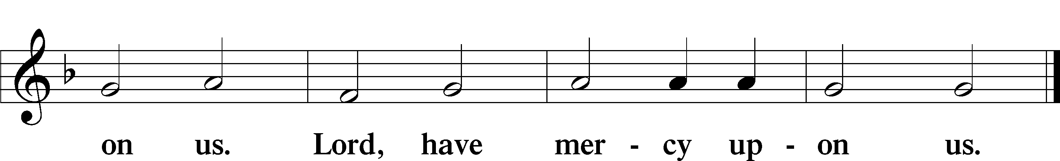
Salutation and Collect of the Day
P The Lord be with you.
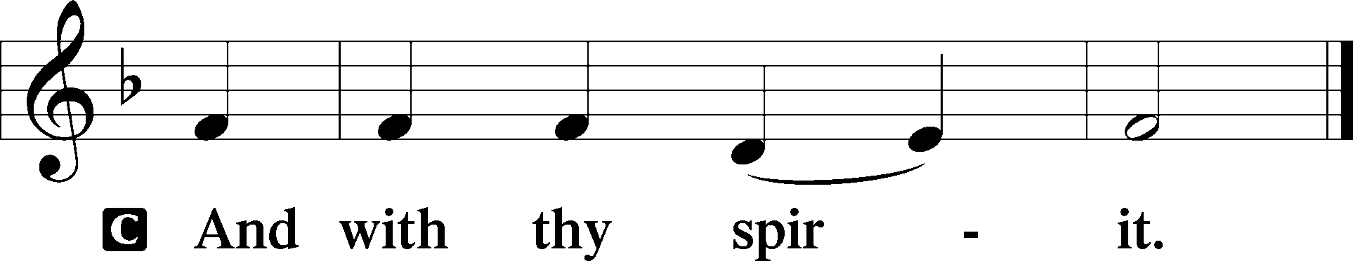

P Let us pray.
Almighty and everlasting God, You despise nothing You have made and forgive the sins of all who are penitent. Create in us new and contrite hearts that lamenting our sins and acknowledging our wretchedness we may receive from You full pardon and forgiveness; through Jesus Christ, Your Son, our Lord, who lives and reigns with You and the Holy Spirit, one God, now and forever.
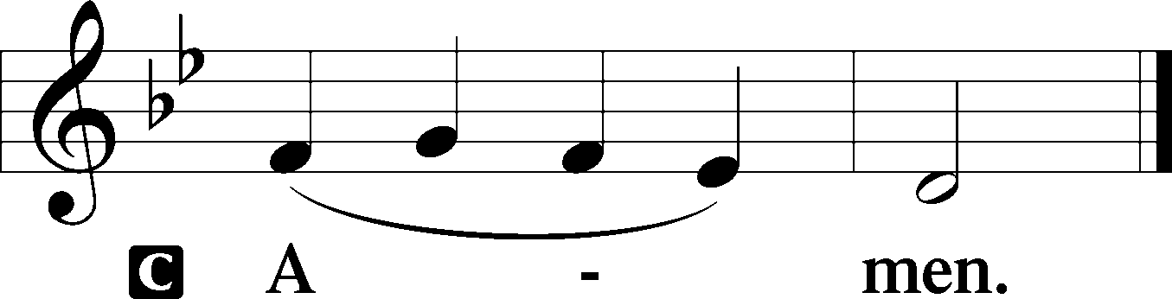

Old Testament Reading Job 30:11–19
P The Old Testament Reading is from Job, the thirtieth chapter.

11Because God has loosed my cord and humbled me,
they have cast off restraint in my presence.
12On my right hand the rabble rise;
they push away my feet;
they cast up against me their ways of destruction.
13They break up my path;
they promote my calamity;
they need no one to help them.
14As through a wide breach they come;
amid the crash they roll on.
15Terrors are turned upon me;
my honor is pursued as by the wind,
and my prosperity has passed away like a cloud.
16“And now my soul is poured out within me;
days of affliction have taken hold of me.
17The night racks my bones,
and the pain that gnaws me takes no rest.
18With great force my garment is disfigured;
it binds me about like the collar of my tunic.
19God has cast me into the mire,
and I have become like dust and ashes.

P This is the Word of the Lord.
C Thanks be to God.

Gradual Hebrews 12:2
[O come, let us fix our eyes on] | Jesus,*
the founder and perfecter | of our faith,
who for the joy that was set before him endured the cross, despis- | ing the shame,*
and is seated at the right hand of the | throne of God.

Epistle 2 Corinthians 5:16—6:2
P The Epistle is from Second Corinthians, the fifth and sixth chapters.

16From now on, therefore, we regard no one according to the flesh. Even though we once regarded Christ according to the flesh, we regard him thus no longer. 17Therefore, if anyone is in Christ, he is a new creation. The old has passed away; behold, the new has come. 18All this is from God, who through Christ reconciled us to himself and gave us the ministry of reconciliation; 19that is, in Christ God was reconciling the world to himself, not counting their trespasses against them, and entrusting to us the message of reconciliation. 20Therefore, we are ambassadors for Christ, God making his appeal through us. We implore you on behalf of Christ, be reconciled to God. 21For our sake he made him to be sin who knew no sin, so that in him we might become the righteousness of God.
1Working together with him, then, we appeal to you not to receive the grace of God in vain. 2For he says,
“In a favorable time I listened to you,
and in a day of salvation I have helped you.”
Behold, now is the favorable time; behold, now is the day of salvation.

P This is the Word of the Lord.
C Thanks be to God.

Lenten Verse LSB 157
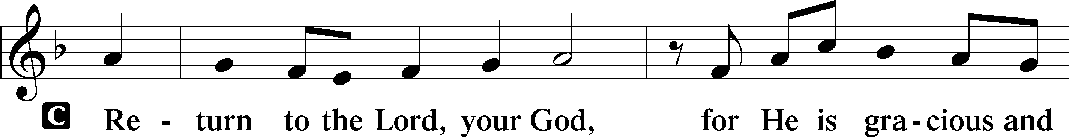
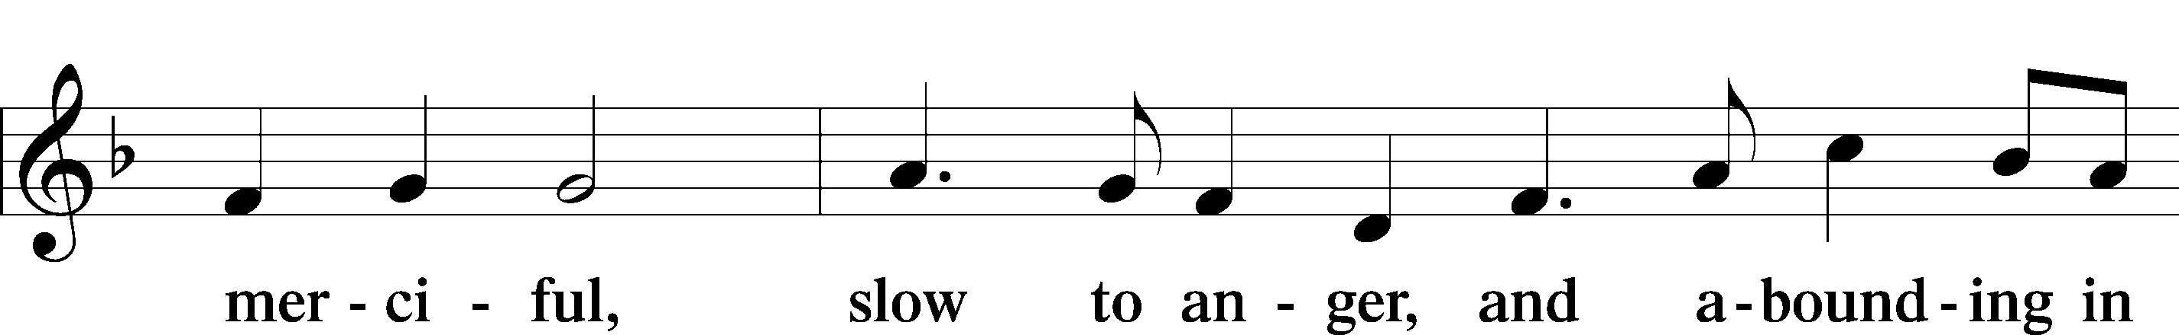
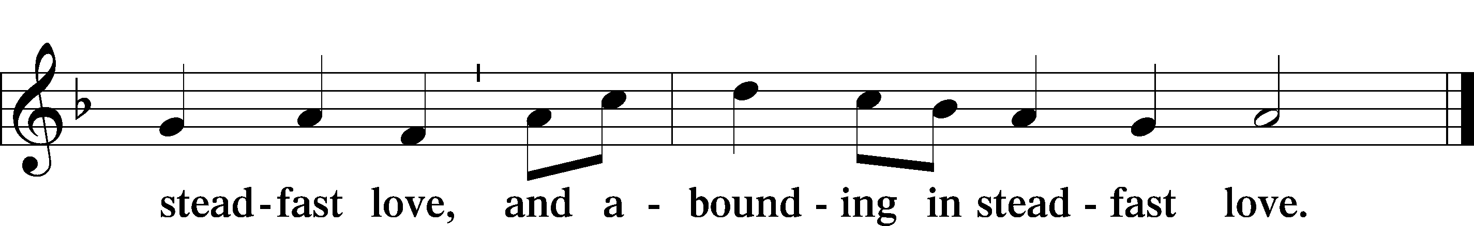

Holy Gospel Matthew 11:20–30
P The Holy Gospel according to St. Matthew, the eleventh chapter.
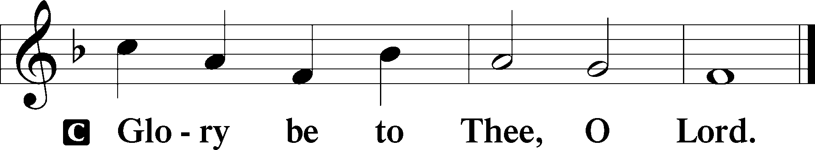

20Then he began to denounce the cities where most of his mighty works had been done, because they did not repent. 21“Woe to you, Chorazin! Woe to you, Bethsaida! For if the mighty works done in you had been done in Tyre and Sidon, they would have repented long ago in sackcloth and ashes. 22But I tell you, it will be more bearable on the day of judgment for Tyre and Sidon than for you. 23And you, Capernaum, will you be exalted to heaven? You will be brought down to Hades. For if the mighty works done in you had been done in Sodom, it would have remained until this day. 24But I tell you that it will be more tolerable on the day of judgment for the land of Sodom than for you.”
25At that time Jesus declared, “I thank you, Father, Lord of heaven and earth, that you have hidden these things from the wise and understanding and revealed them to little children; 26yes, Father, for such was your gracious will. 27All things have been handed over to me by my Father, and no one knows the Son except the Father, and no one knows the Father except the Son and anyone to whom the Son chooses to reveal him. 28Come to me, all who labor and are heavy laden, and I will give you rest. 29Take my yoke upon you, and learn from me, for I am gentle and lowly in heart, and you will find rest for your souls. 30For my yoke is easy, and my burden is light.”

P This is the Gospel of the Lord.
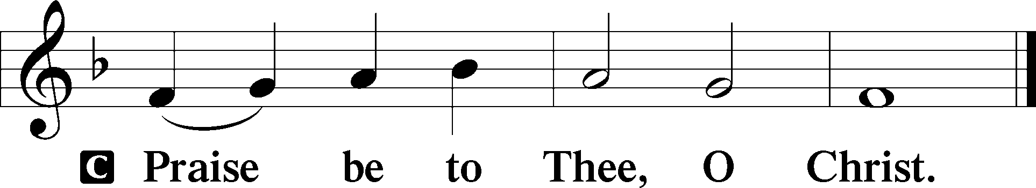

Nicene Creed
C I believe in one God,
the Father Almighty,
maker of heaven and earth
and of all things visible and invisible.

And in one Lord Jesus Christ,
the only-begotten Son of God,
begotten of His Father before all worlds,
God of God, Light of Light,
very God of very God,
begotten, not made,
being of one substance with the Father,
by whom all things were made;
who for us men and for our salvation came down from heaven
and was incarnate by the Holy Spirit of the virgin Mary
and was made man;
and was crucified also for us under Pontius Pilate.
He suffered and was buried.
And the third day He rose again according to the Scriptures
and ascended into heaven
and sits at the right hand of the Father.
And He will come again with glory to judge both the living and the dead,
whose kingdom will have no end.

And I believe in the Holy Spirit,
the Lord and giver of life,
who proceeds from the Father and the Son,
who with the Father and the Son together is worshiped and glorified,
who spoke by the prophets.
And I believe in one holy Christian and apostolic Church,
I acknowledge one Baptism for the remission of sins,
and I look for the resurrection of the dead
and the life T of the world to come. Amen.

One House Abides Unending See Insert

Sermon

Offertory LSB 192
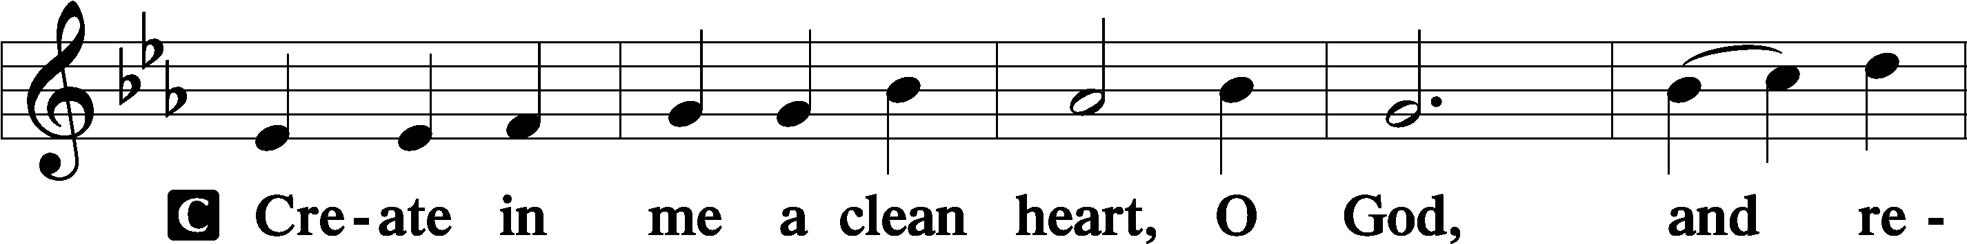
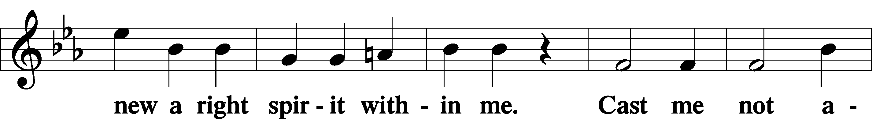
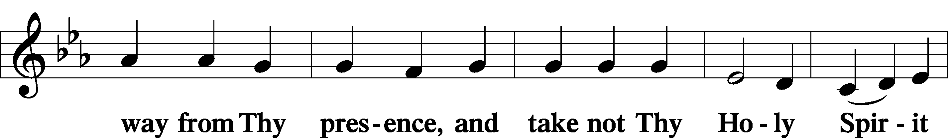
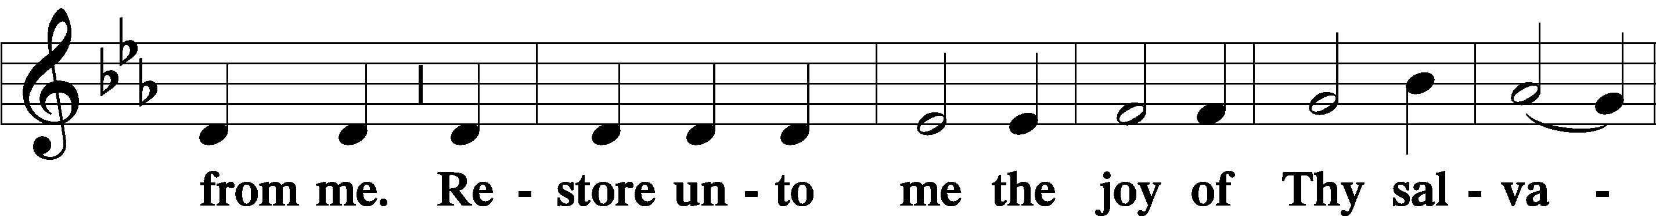
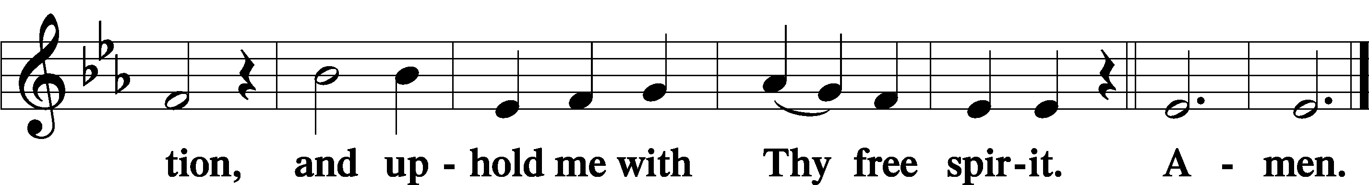

Sit

Offering

Prayer of the Church
P Gracious God, Father of our Lord Jesus Christ, we thank You for blessing us with the opportunity to meditate again on the cross of Christ and receive Your promised treasures.
C Grant that the message of the Lamb of God slain for our salvation bring us the riches of Your pardon and peace.
P Lead us to see that our sins caused Jesus’ great agony in the garden, that our sins nailed Him to the cross of Calvary,
C that He was forsaken by His Father so that we might never be forsaken, and that He died so that we may live.
P Almighty and everlasting God, You despise nothing You have made and forgive the sins of all who come to You in repentance and faith.
C Create in us clean hearts to receive from You the promised treasures of Your mercy and forgiveness.
P Holy Spirit, lift up troubled souls everywhere. Grant wholeness to those hurting in heart, body, and mind. Work Your healing power in the lives of those in need, [especially . . .], and in the lives of all we name before You in our hearts.
C All glory, honor, and praise be to You, with the Father and the Son, one God, now and forever. Amen.

SERVICE OF THE SACRAMENT

Preface LSB 194
P The Lord be with you.
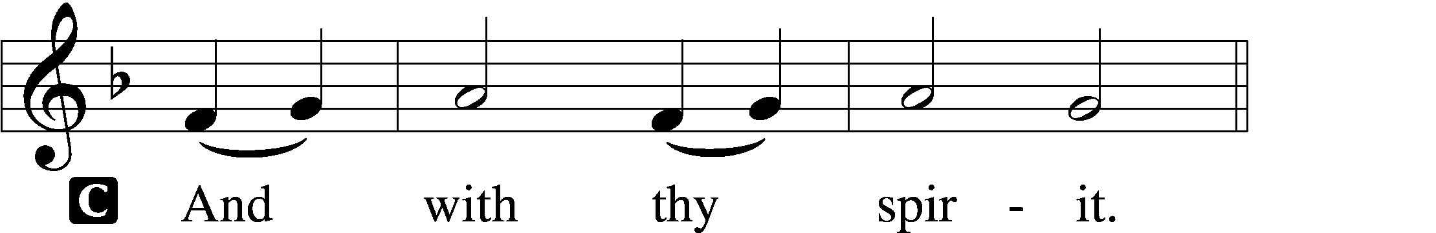

P Lift up your hearts.
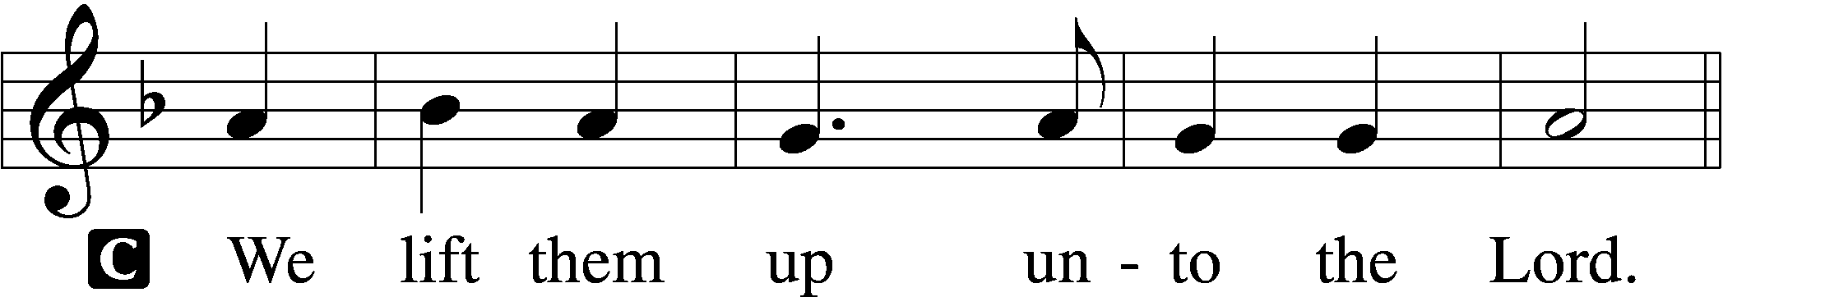

P Let us give thanks unto the Lord, our God.
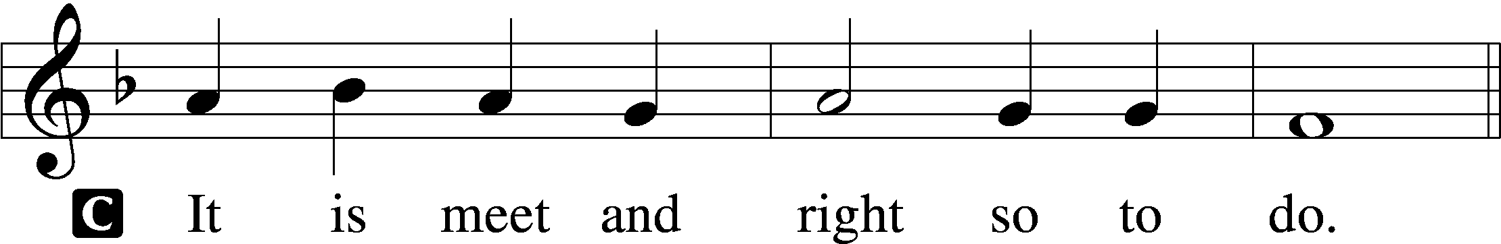

Proper Preface
P It is truly good, right, and salutary that we should at all times and in all places give thanks to You, holy Lord, almighty Father, everlasting God, through Jesus Christ, our Lord, who overcame the assaults of the devil and gave His life as a ransom for many that with cleansed hearts we might be prepared joyfully to celebrate the paschal feast in sincerity and truth. Therefore with angels and archangels and with all the company of heaven we laud and magnify Your glorious name, evermore praising You and saying:

Sanctus LSB 195
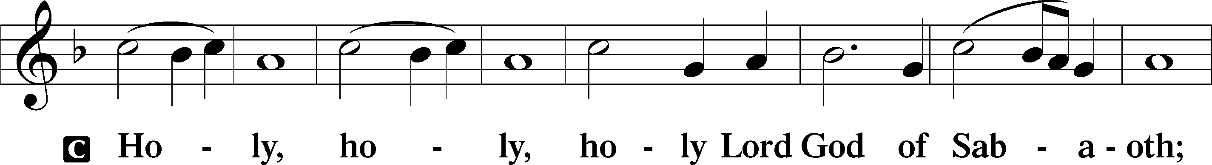
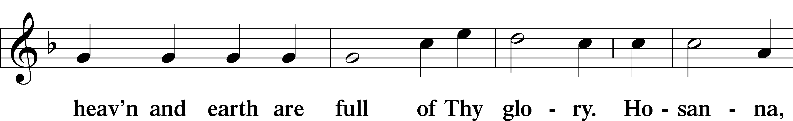
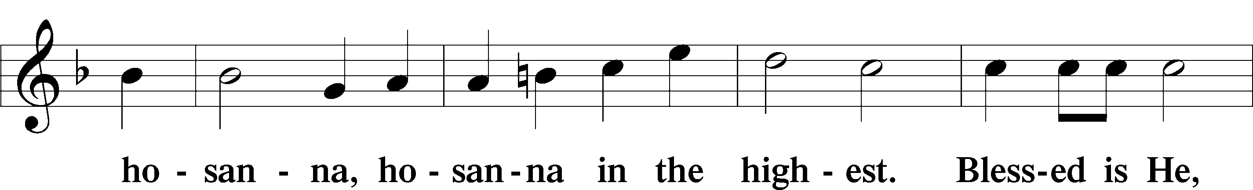
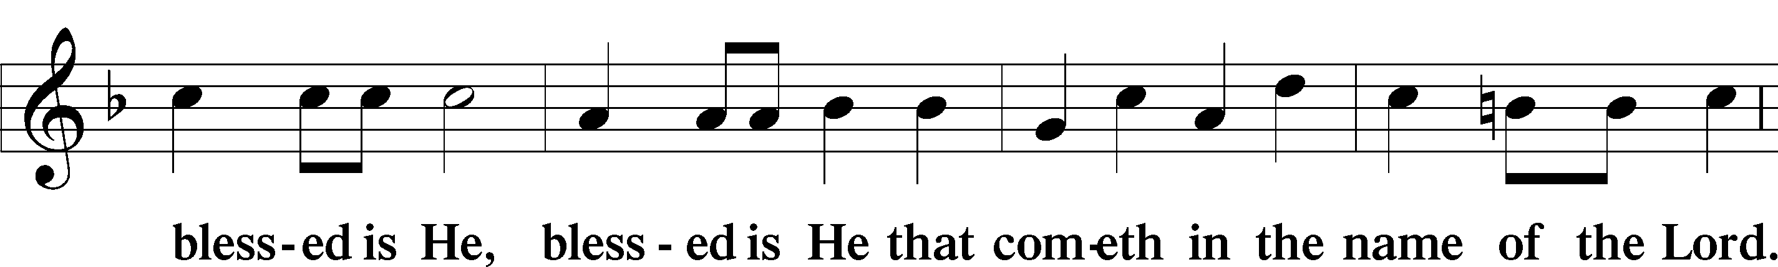
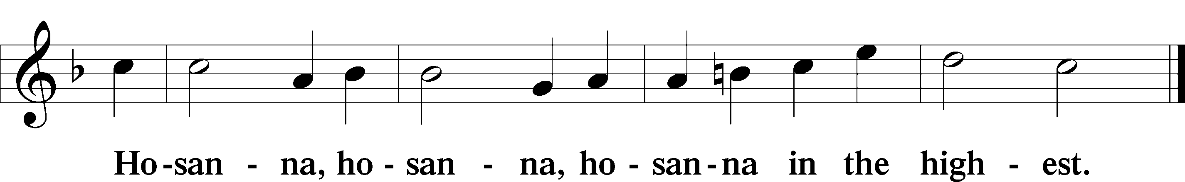

Lord’s Prayer
P Lord, remember us in Your kingdom and teach us to pray:
C Our Father who art in heaven,
hallowed be Thy name,
Thy kingdom come,
Thy will be done on earth
as it is in heaven;
give us this day our daily bread;
and forgive us our trespasses
as we forgive those
who trespass against us;
and lead us not into temptation,
but deliver us from evil.
For Thine is the kingdom
and the power and the glory
forever and ever. Amen.

The Words of Our Lord
P Our Lord Jesus Christ, on the night when He was betrayed, took bread, and when He had given thanks, He broke it and gave it to the disciples and said: “Take, eat; this is My T body, which is given for you. This do in remembrance of Me.”

In the same way also He took the cup after supper, and when He had given thanks, He gave it to them, saying: “Drink of it, all of you; this cup is the new testament in My T blood, which is shed for you for the forgiveness of sins. This do, as often as you drink it, in remembrance of Me.”

Pax Domini LSB 197
P The peace of the Lord be with you always.

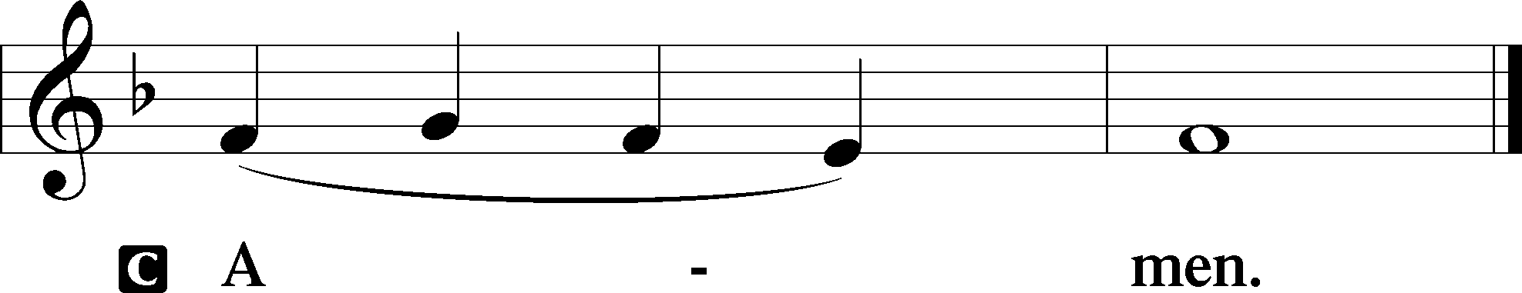

Agnus Dei LSB 198
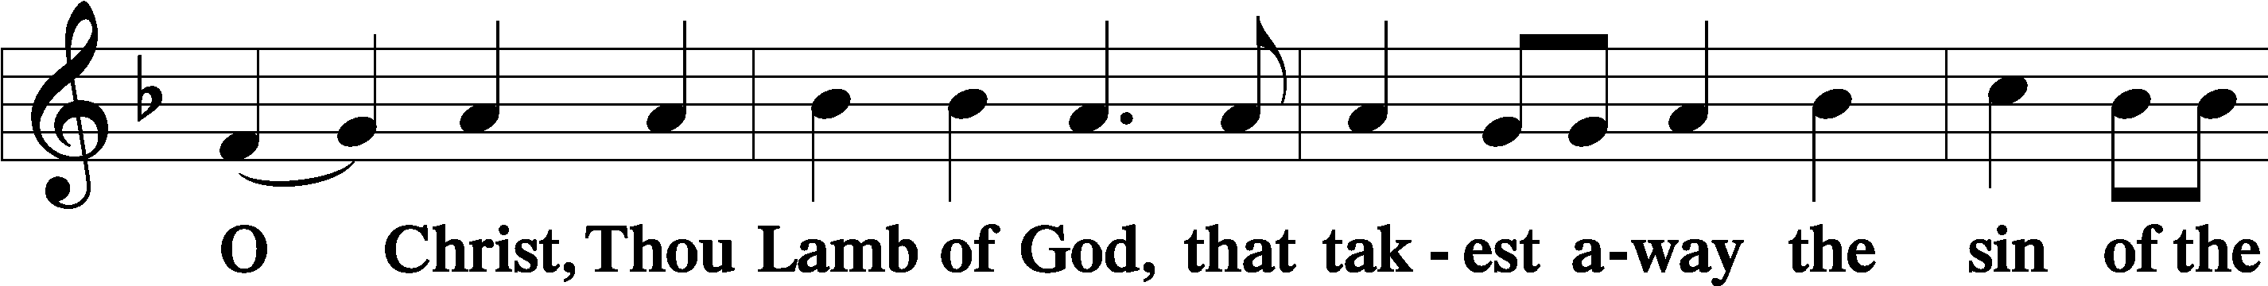
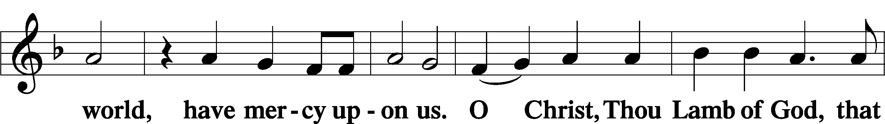
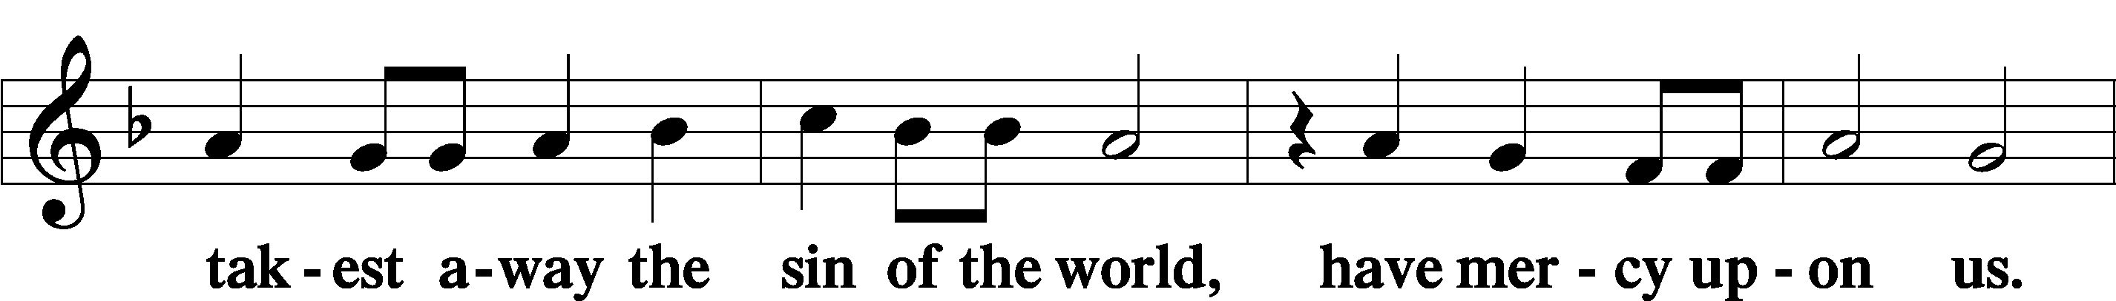
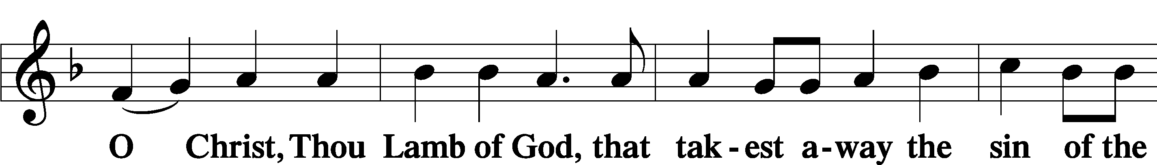
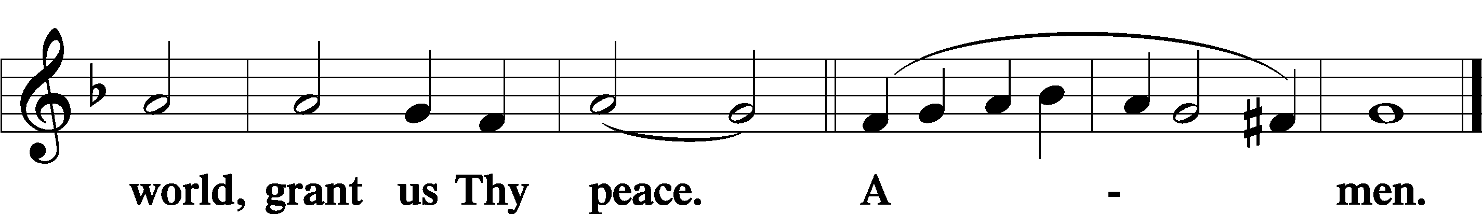

Distribution

Distribution Hymns

Hymn: Just As I Am, Without One Plea LSB 570
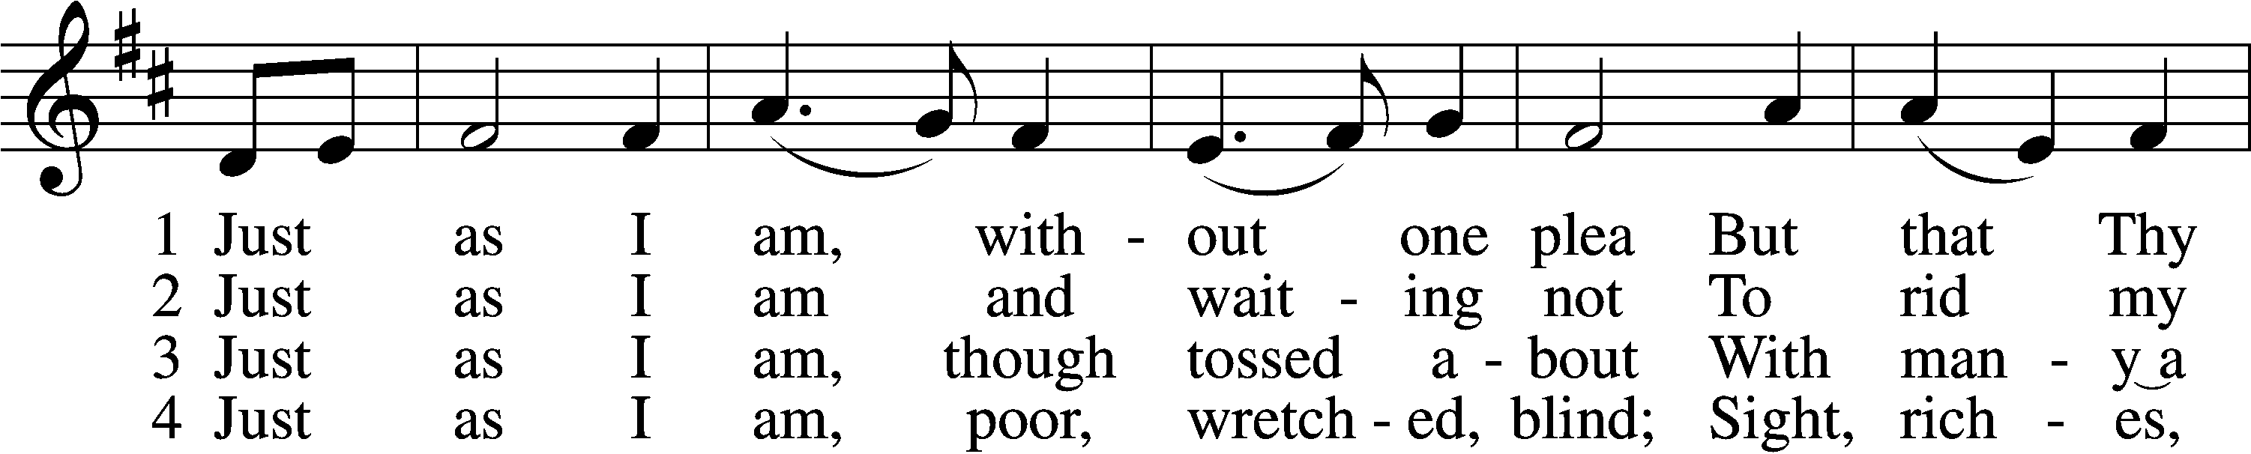
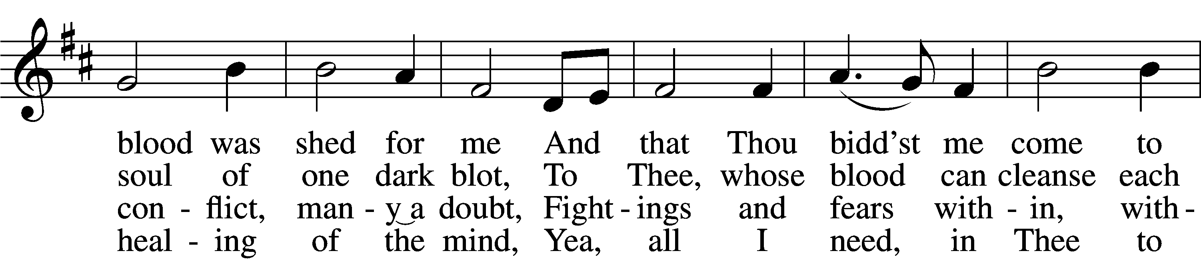
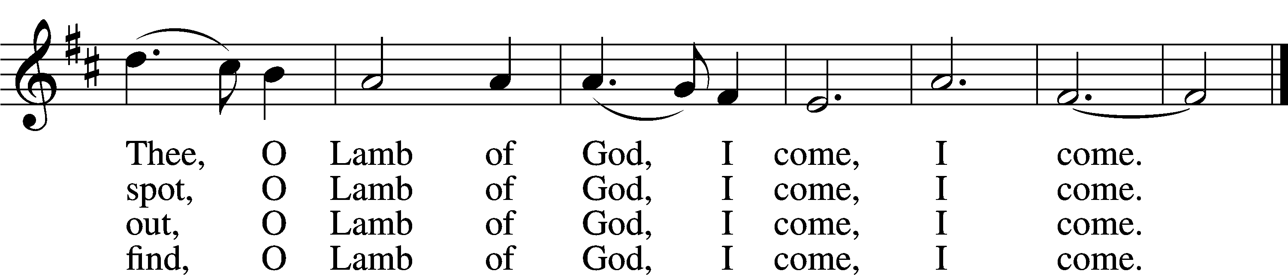

5 Just as I am, Thou wilt receive,
Wilt welcome, pardon, cleanse, relieve;
Because Thy promise I believe,
O Lamb of God, I come, I come.

6 Just as I am; Thy love unknown
Has broken ev’ry barrier down;
Now to be Thine, yea, Thine alone,
O Lamb of God, I come, I come.
Text: Charlotte Elliott, 1789–1871
Tune: William B. Bradbury, 1816–68
Text and tune: Public domain

Hymn: On My Heart Imprint Your Image LSB 422
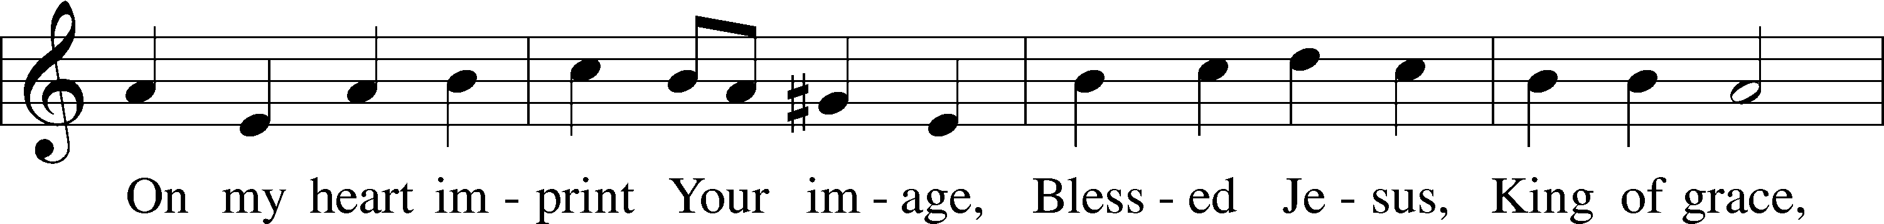
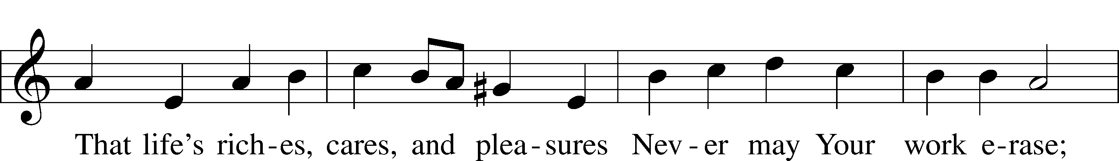
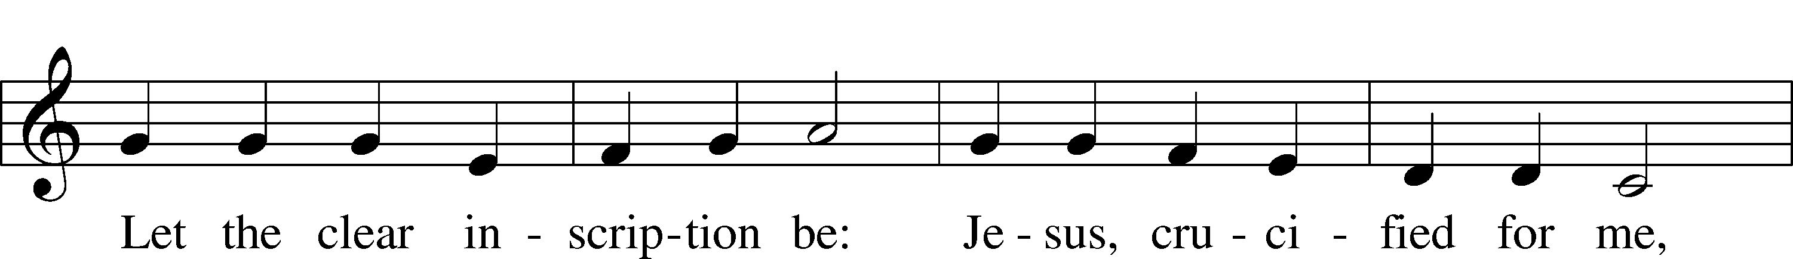
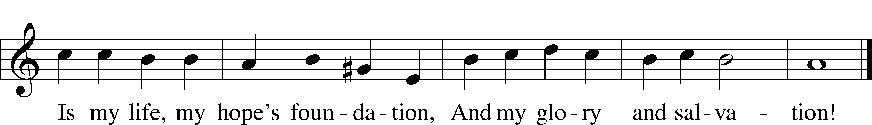
Text: Thomas Hansen Kingo, 1634–1703; tr. Peer O. Strömme, 1856–1921, alt.
Tune: Johann Balthasar König, 1691–1758
Text and tune: Public domain

Nunc Dimittis LSB 199
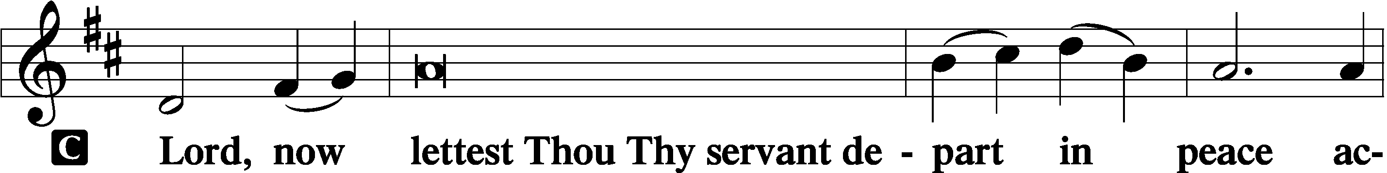

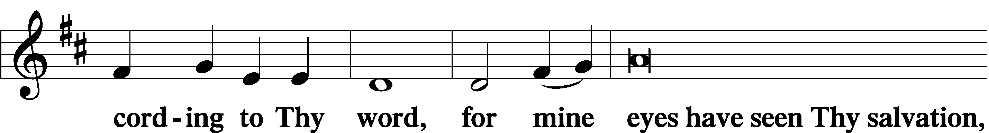

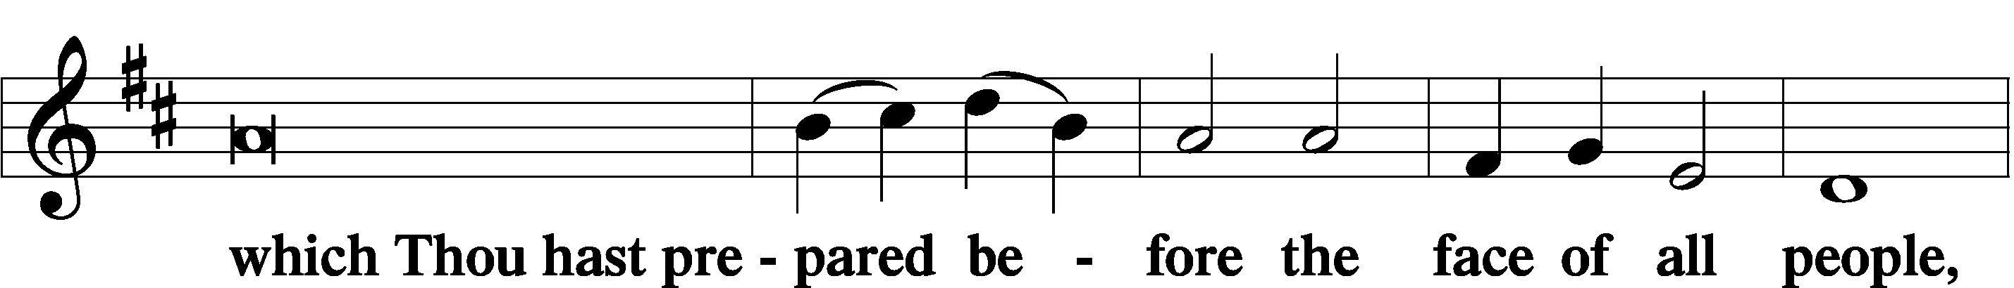

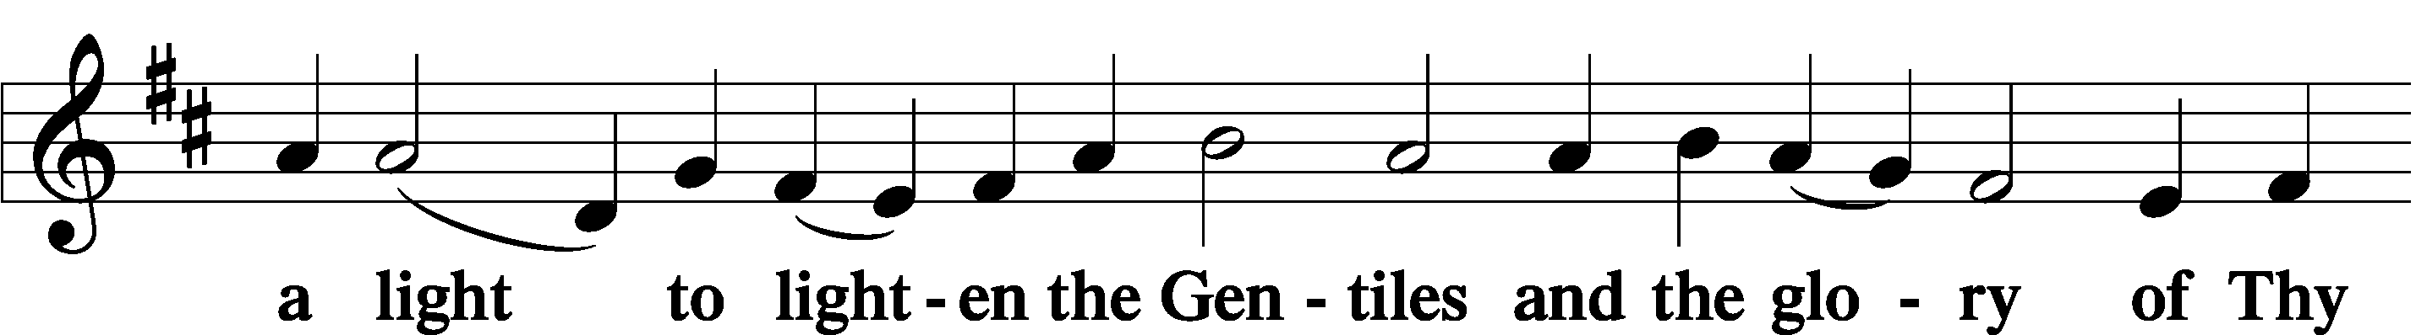

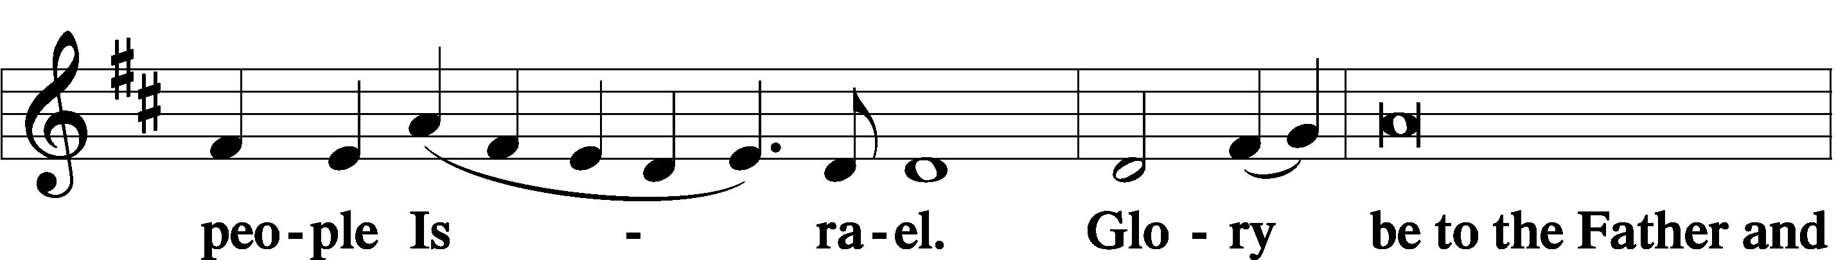

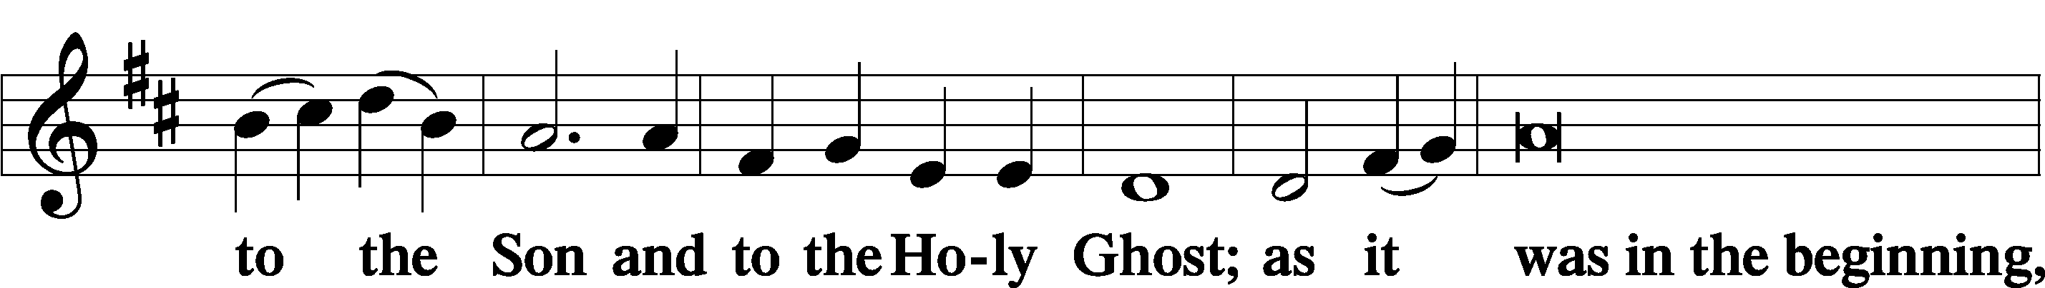

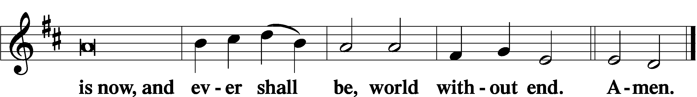

Thanksgiving LSB 200
A O give thanks unto the Lord, for He is good,

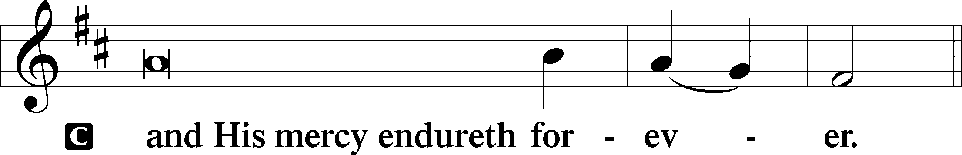

A Let us pray.
We give thanks to You, almighty God, that You have refreshed us through this salutary gift, and we implore You that of Your mercy You would strengthen us through the same in faith toward You and in fervent love toward one another; through Jesus Christ, Your Son, our Lord, who lives and reigns with You and the Holy Spirit, one God, now and forever.

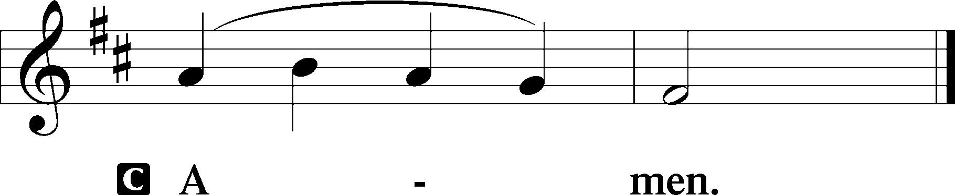

P The Lord be with you.

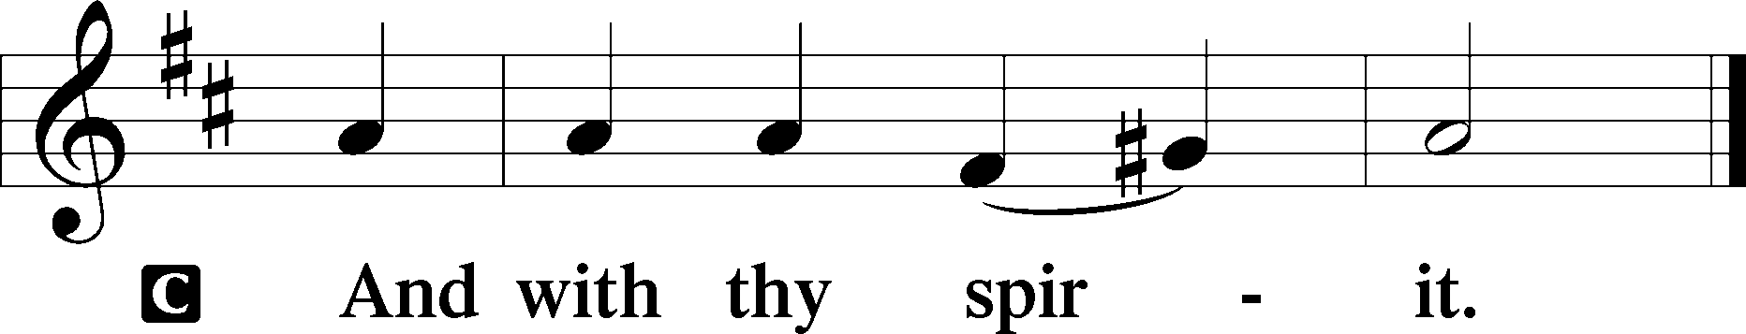

Benedicamus LSB 202
A Bless we the Lord.

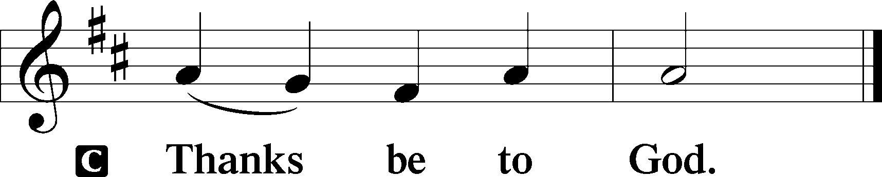

Benediction LSB 202
P The Lord bless you and keep you.
The Lord make His face shine upon you and be gracious unto you.
The Lord lift up His countenance upon you and T give you peace.
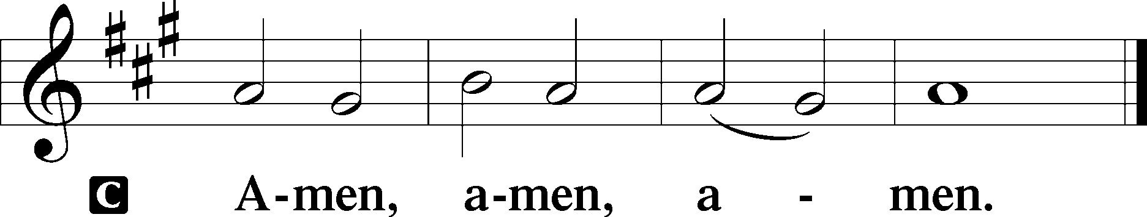

Hymn: Christ the Life of All the Living LSB 420
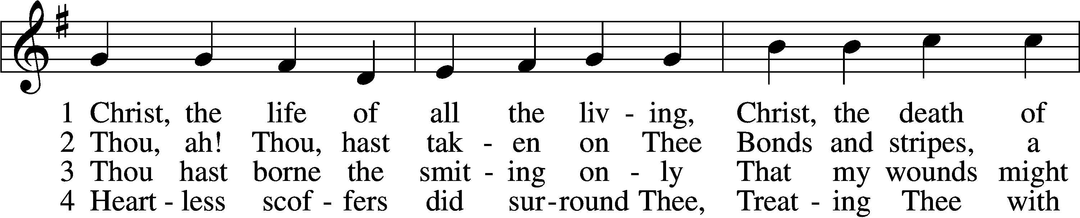
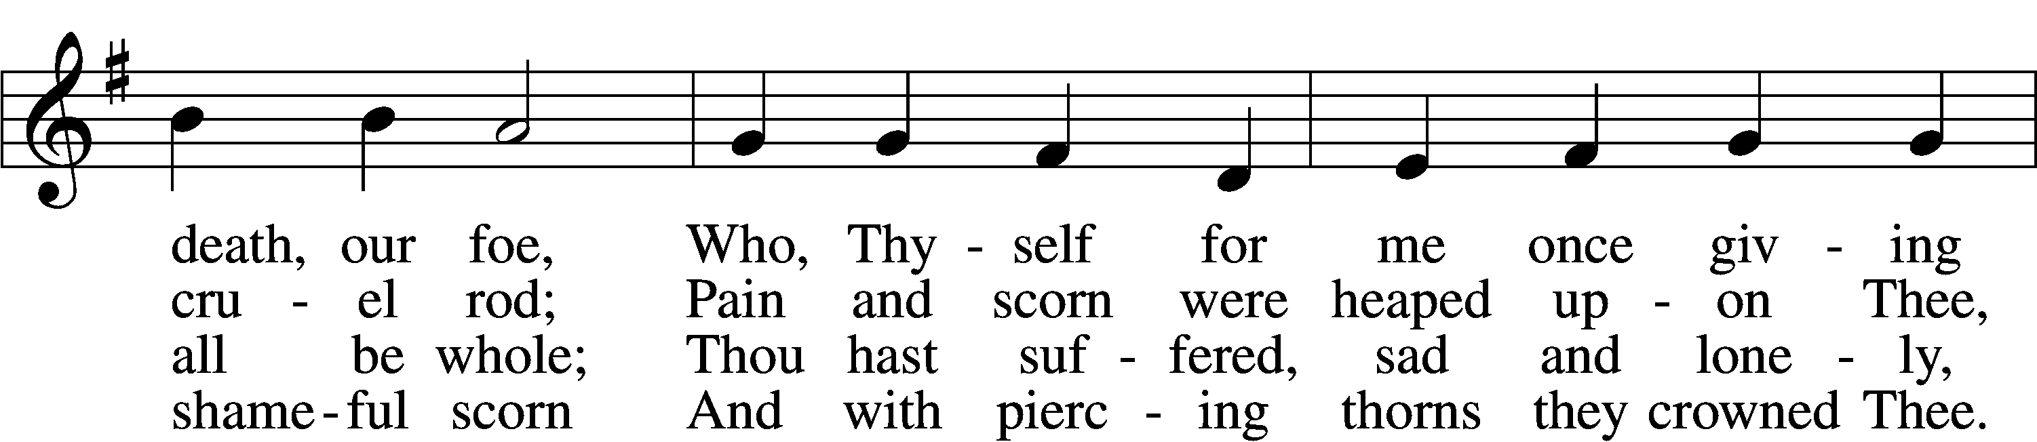
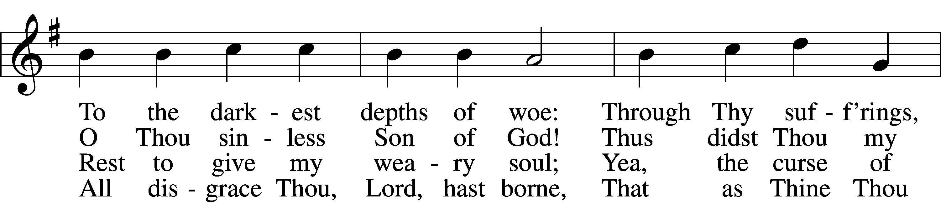
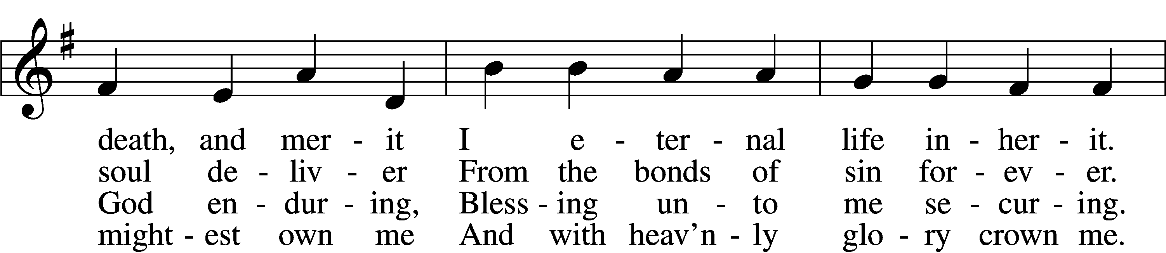
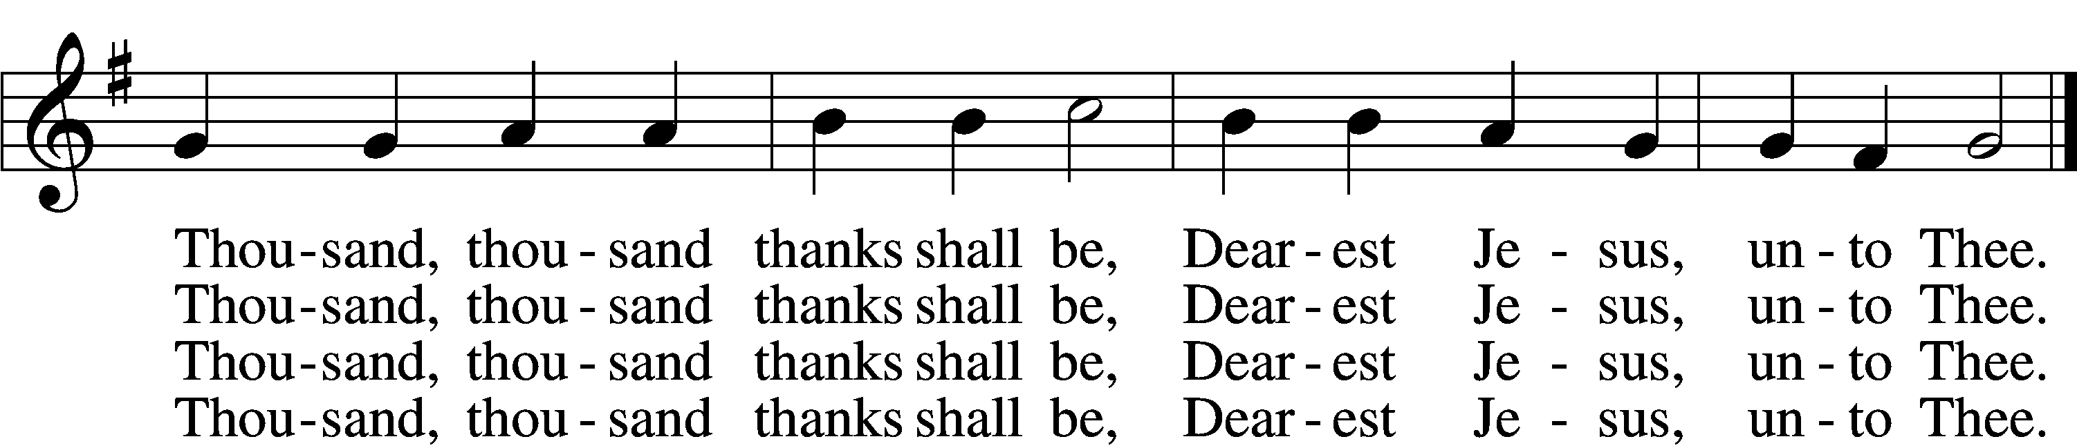

5 Thou hast suffered men to bruise Thee,
That from pain I might be free;
Falsely did Thy foes accuse Thee:
Thence I gain security;
Comfortless Thy soul did languish
Me to comfort in my anguish.
Thousand, thousand thanks shall be,
Dearest Jesus, unto Thee.

6 Thou hast suffered great affliction
And hast borne it patiently,
Even death by crucifixion,
Fully to atone for me;
Thou didst choose to be tormented
That my doom should be prevented.
Thousand, thousand thanks shall be,
Dearest Jesus, unto Thee.

7 Then, for all that wrought my pardon,
For Thy sorrows deep and sore,
For Thine anguish in the Garden,
I will thank Thee evermore,
Thank Thee for Thy groaning, sighing,
For Thy bleeding and Thy dying,
For that last triumphant cry,
And shall praise Thee, Lord, on high.
Text: Ernst Christoph Homburg, 1605–81; (sts. 1–2, 5, 7): tr. Catherine Winkworth, 1827–78, alt.; (sts. 3–4, 6): tr. Evangelical Lutheran Hymn-Book, 1912, St. Louis
Tune: Das grosse Cantional, 1687, Darmstadt
Text and tune: Public domain

Acknowledgments
Unless otherwise indicated, Scripture quotations are from the ESV® Bible (The Holy Bible, English Standard Version®), copyright © 2001 by Crossway, a publishing ministry of Good News Publishers. Used by permission. All rights reserved.
Created by Lutheran Service Builder © 2023 Concordia Publishing House.

