First Sunday in Advent
November 27, 2022
9:00 AM

Salem Lutheran Church
1-715-537-3011
http://www.salembarron.com
rev.mike.nielsen@gmail.com

The Lord Comes in Meekness and Humility to Save Us Now

The Lord Jesus enters Jerusalem “humble, and mounted on a donkey,” riding on “a beast of burden” (Matt. 21:5), as He Himself bears the sins of the world in His body. Now He comes by the ministry of the Gospel to save us from sin, death, the devil and hell. Therefore, we sing, “Blessed is he who comes in the name of the Lord!” (Matt. 21:9). For we are called “to the mountain of the Lord, to the house of the God of Jacob,” His Holy Church, “that he may teach us his ways and that we may walk in his paths” (Is. 2:3). By His Word, we “walk in the light of the Lord” (Is. 2:5). That is to live in love, which “does no wrong to a neighbor” (Rom. 13:10). We “cast off the works of darkness and put on the armor of light,” for “salvation is nearer to us now than when we first believed” (Rom. 13:11, 12). Hence, the entire Christian life is a time to wake and watch, “for you do not know on what day your Lord is coming” (Matt. 24:42).

Hymn: The Advent of Our King LSB 331
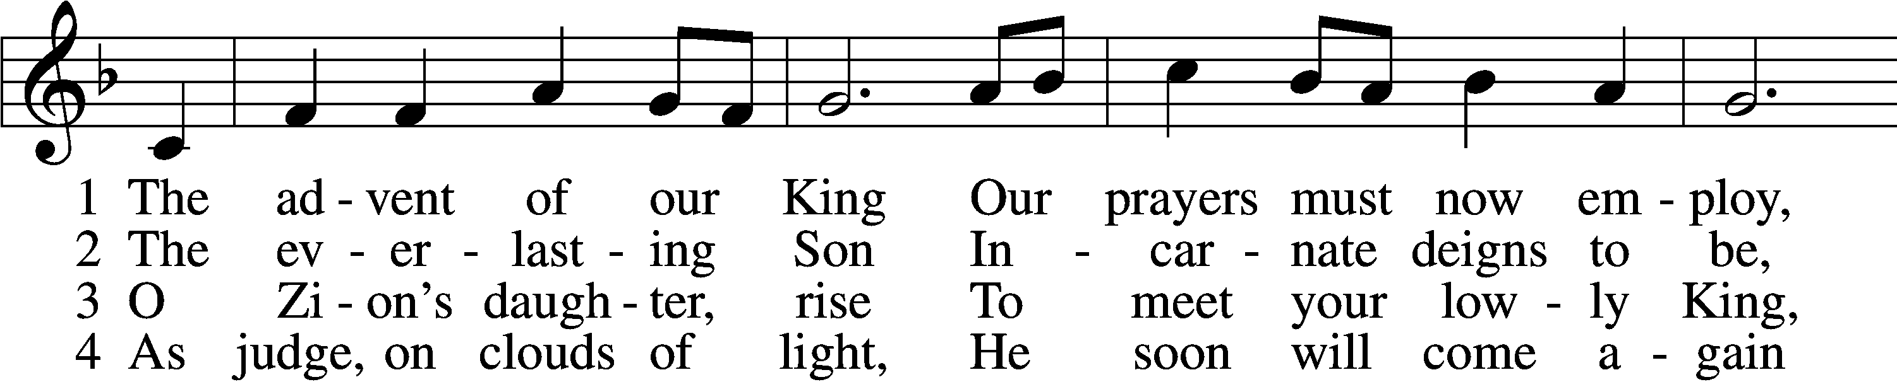
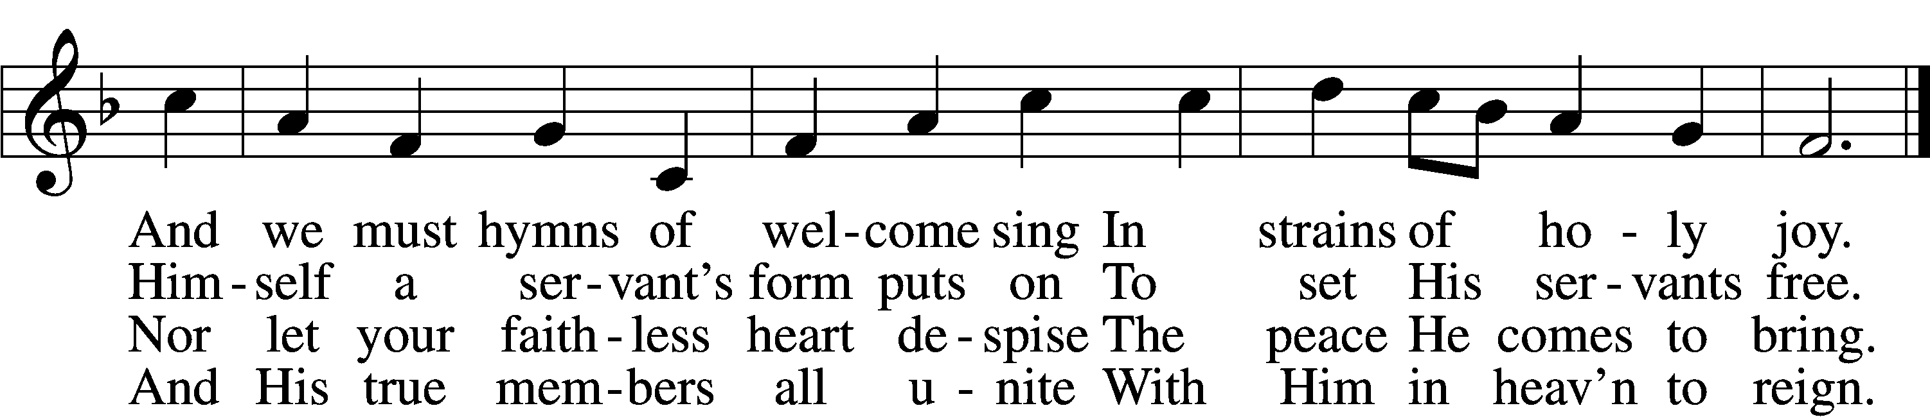

5 Before the dawning day
Let sin’s dark deeds be gone,
The sinful self be put away,
The new self now put on.
D 6 All glory to the Son,
Who comes to set us free,
With Father, Spirit, ever one
Through all eternity.

Text: Charles Coffin, 1676–1749; tr. John Chandler, 1806–76, alt.
Tune: Aaron Williams, 1731–76
Text and tune: Public domain

Stand

Advent Versicles LSB 219
L O Lord, open my lips,
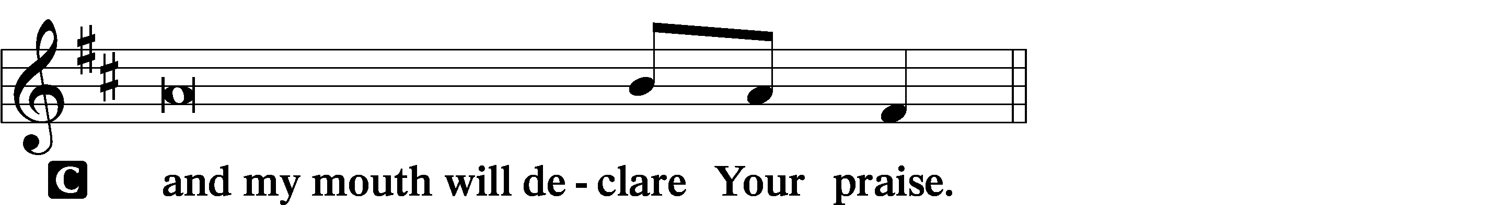

L Make haste, O God, to deliver me;
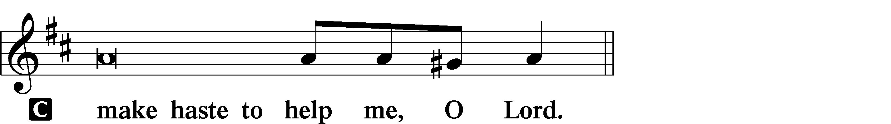
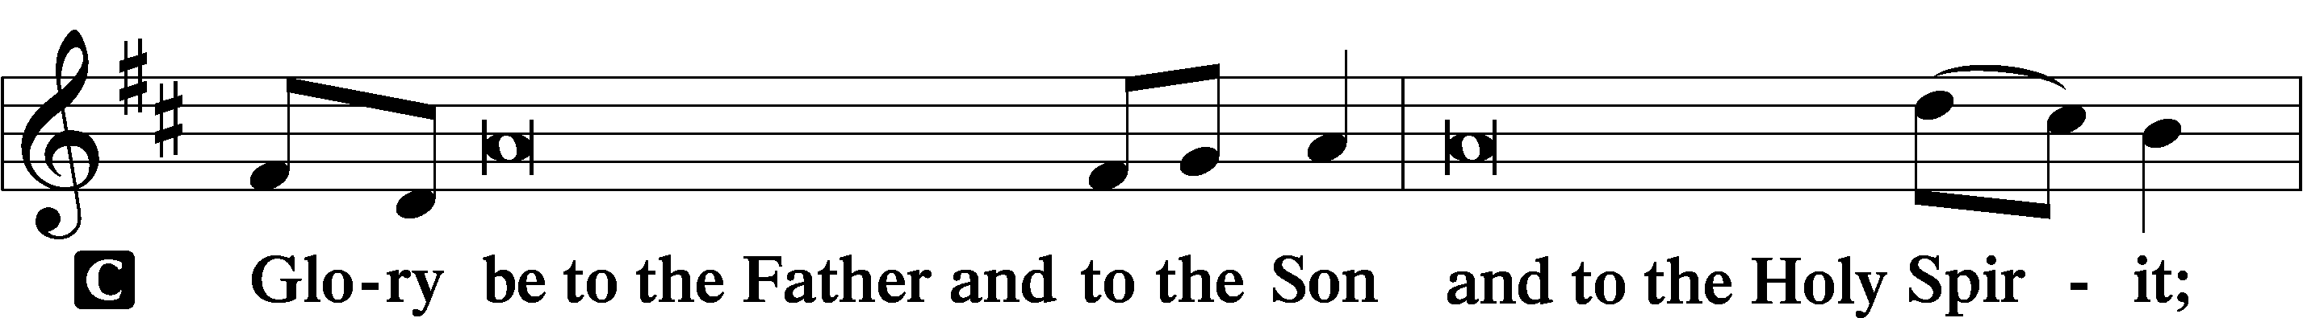
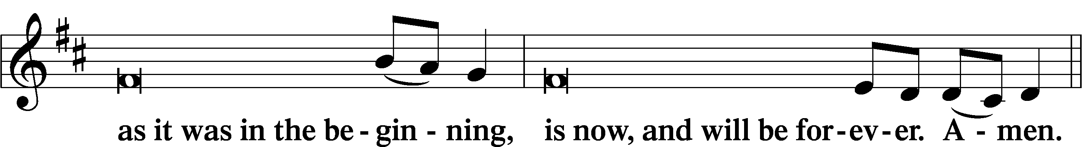
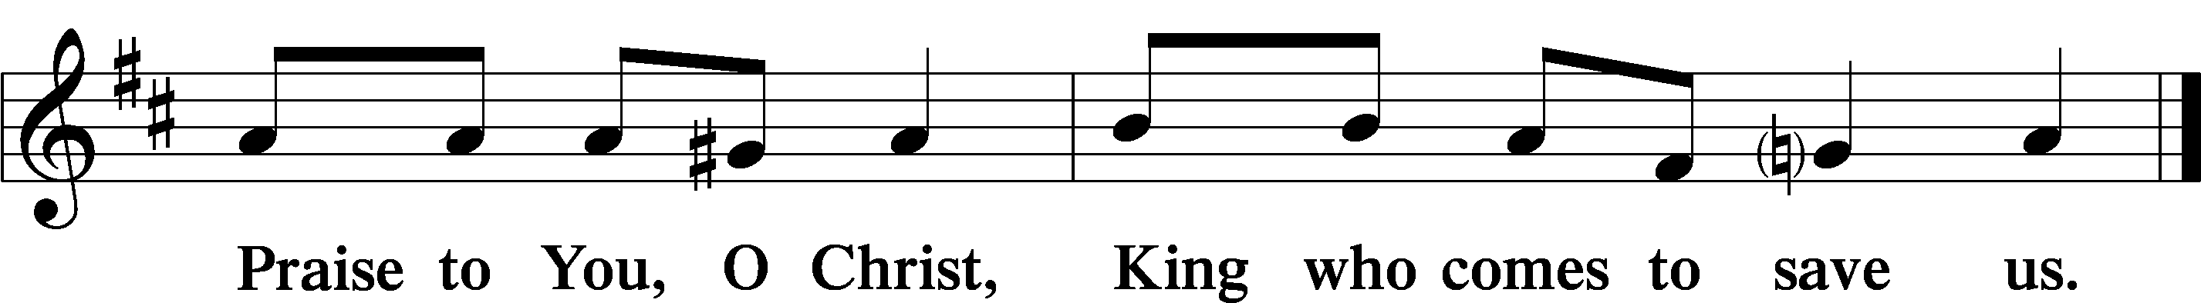

Psalmody

L Behold, the Lord comes to save us.
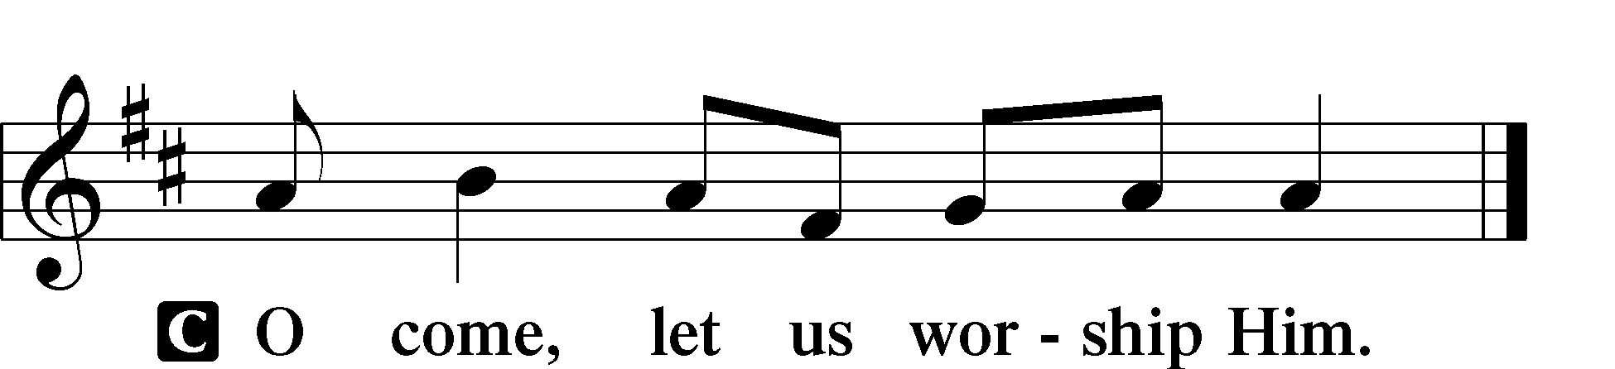

Venite LSB 220
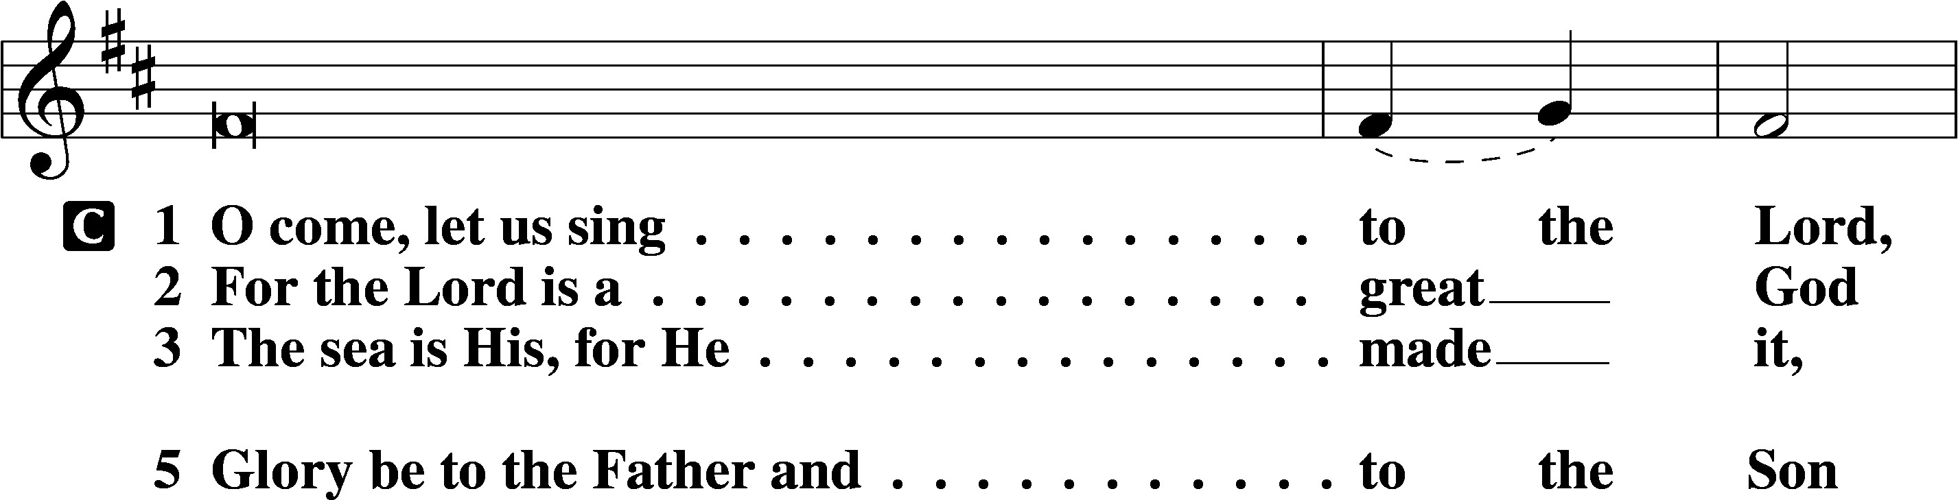
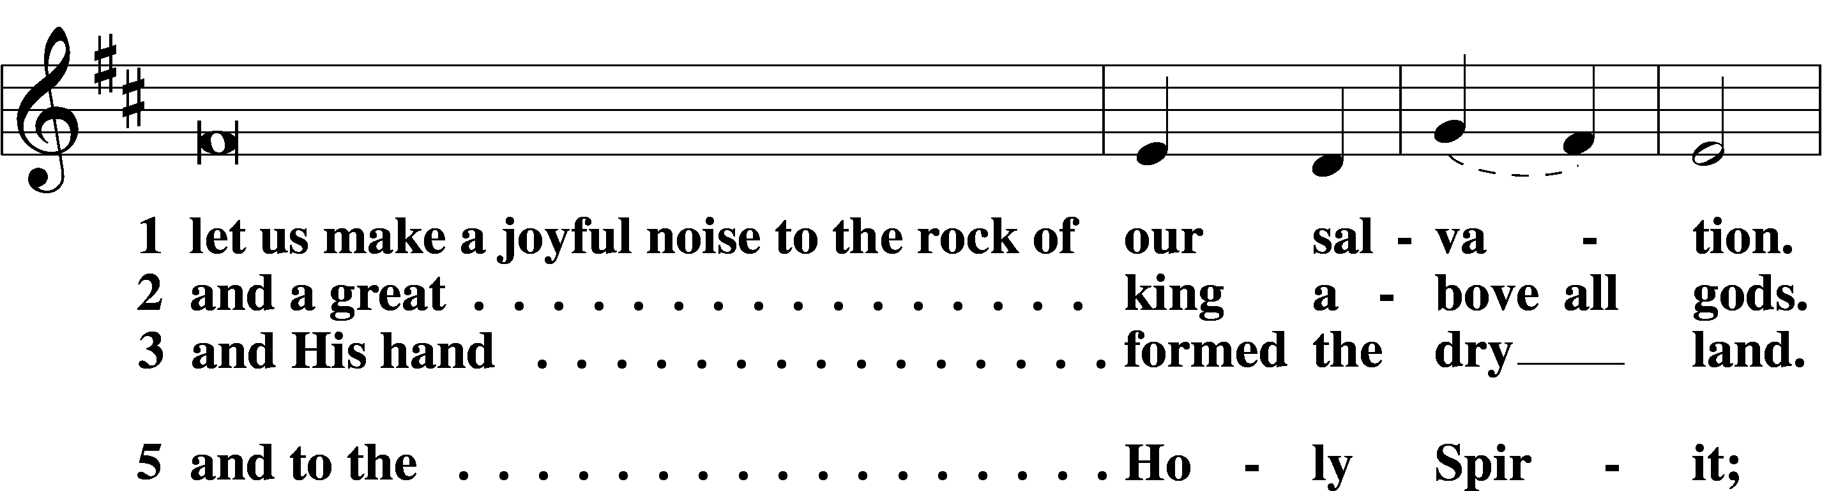
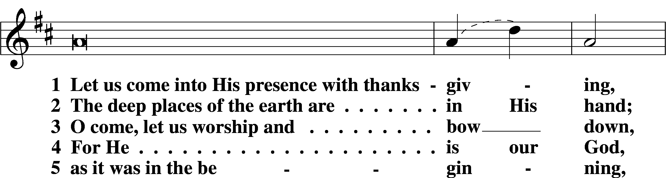
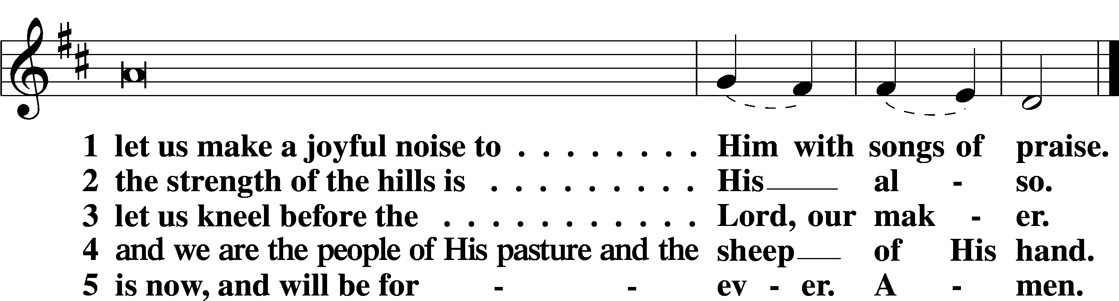

L Behold, the Lord comes to save us.

Additional Psalms Psalm 122; antiphon: v. 6
1I was glad when they said to me,
“Let us go to the house of the Lord!”
2Our feet have been standing
within your gates, O Jerusalem!
3Jerusalem—built as a city
that is bound firmly together,
4to which the tribes go up,
the tribes of the Lord,
as was decreed for Israel,
to give thanks to the name of the Lord.
5There thrones for judgment were set,
the thrones of the house of David.
6Pray for the peace of Jerusalem!
“May they be secure who love you!
7Peace be within your walls
and security within your towers!”
8For my brothers and companions’ sake
I will say, “Peace be within you!”
9For the sake of the house of the Lord our God,
I will seek your good.

Sit

Office Hymn: Savior of the Nations Come LSB 332
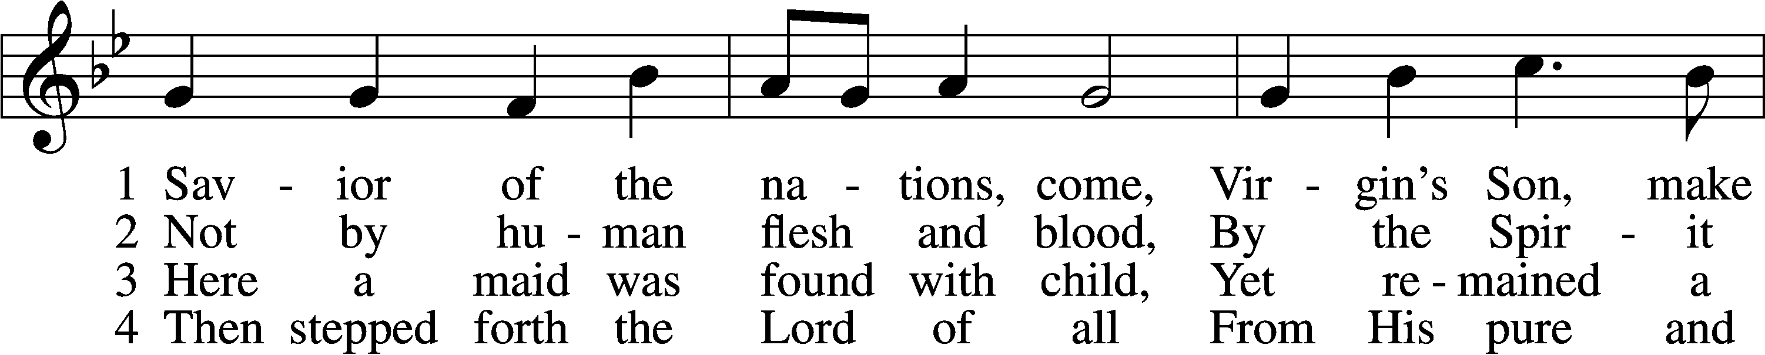
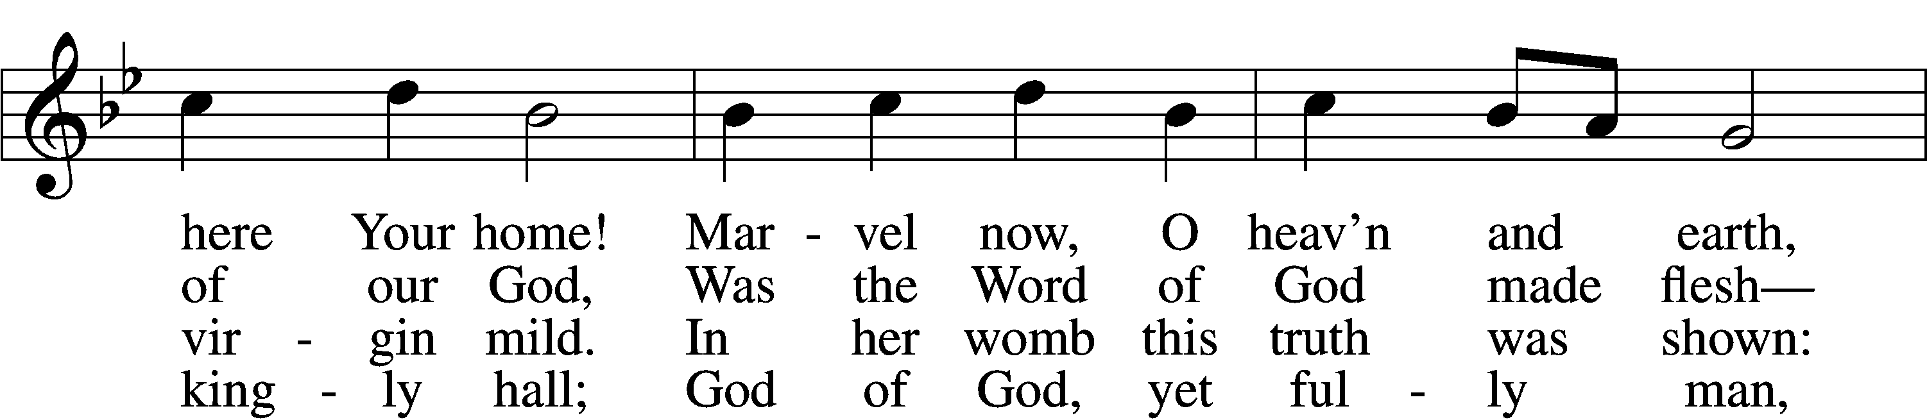
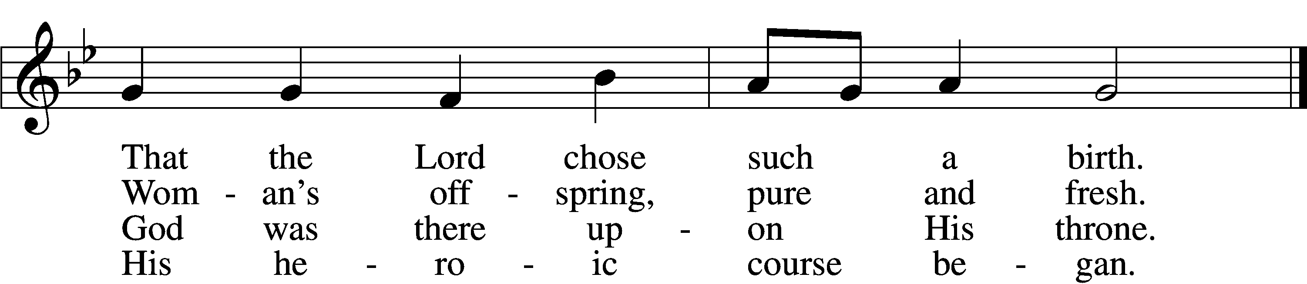

5 God the Father was His source,
Back to God He ran His course.
Into hell His road went down,
Back then to His throne and crown.
7 From the manger newborn light
Shines in glory through the night.
Darkness there no more resides;
In this light faith now abides.

D 8 Glory to the Father sing,
Glory to the Son, our king,
Glory to the Spirit be
Now and through eternity.

6 For You are the Father’s Son
Who in flesh the vict’ry won.
By Your mighty pow’r make whole
All our ills of flesh and soul.

Text: attr. Ambrose of Milan, 340–397; German version, Martin Luther, 1483–1546; (sts. 1–2): tr. William M. Reynolds, 1812–76; (sts. 3, 6): tr. Lutheran Service Book, 2006; (sts. 4–5, 8): tr. F. Samuel Janzow, 1913–2001; (st. 7): tr. Gifford A. Grobien, 1973
Tune: Geystliche gesangk Buchleyn, 1524, Wittenberg, ed. Johann Walter
Text (sts. 3, 6–7): © 2006 Concordia Publishing House; (sts. 4–5, 8): © 1978 Concordia Publishing House. Used by permission: LSB Hymn License no. 110005504
Text (sts. 1–2) and tune: Public domain

Readings

Reading Isaiah 2:1–5
L A reading from Isaiah, chapter 2.

1The word that Isaiah the son of Amoz saw concerning Judah and Jerusalem.
2It shall come to pass in the latter days
that the mountain of the house of the Lord
shall be established as the highest of the mountains,
and shall be lifted up above the hills;
and all the nations shall flow to it,
3and many peoples shall come, and say:
“Come, let us go up to the mountain of the Lord,
to the house of the God of Jacob,
that he may teach us his ways
and that we may walk in his paths.”
For out of Zion shall go the law,
and the word of the Lord from Jerusalem.
4He shall judge between the nations,
and shall decide disputes for many peoples;
and they shall beat their swords into plowshares,
and their spears into pruning hooks;
nation shall not lift up sword against nation,
neither shall they learn war anymore.
5O house of Jacob,
come, let us walk
in the light of the Lord.

L O Lord, have mercy on us.
C Thanks be to God.

Reading Romans 13:8–14
L A reading from Romans, chapter 13.

8Owe no one anything, except to love each other, for the one who loves another has fulfilled the law. 9The commandments, “You shall not commit adultery, You shall not murder, You shall not steal, You shall not covet,” and any other commandment, are summed up in this word: “You shall love your neighbor as yourself.” 10Love does no wrong to a neighbor; therefore love is the fulfilling of the law.
11Besides this you know the time, that the hour has come for you to wake from sleep. For salvation is nearer to us now than when we first believed. 12The night is far gone; the day is at hand. So then let us cast off the works of darkness and put on the armor of light. 13Let us walk properly as in the daytime, not in orgies and drunkenness, not in sexual immorality and sensuality, not in quarreling and jealousy. 14But put on the Lord Jesus Christ, and make no provision for the flesh, to gratify its desires.

L O Lord, have mercy on us.
C Thanks be to God.

Reading Matthew 21:1–11
L A reading from Matthew, chapter 21.

1Now when they drew near to Jerusalem and came to Bethphage, to the Mount of Olives, then Jesus sent two disciples, 2saying to them, “Go into the village in front of you, and immediately you will find a donkey tied, and a colt with her. Untie them and bring them to me. 3If anyone says anything to you, you shall say, ‘The Lord needs them,’ and he will send them at once.” 4This took place to fulfill what was spoken by the prophet, saying,
5“Say to the daughter of Zion,
‘Behold, your king is coming to you,
humble, and mounted on a donkey,
and on a colt, the foal of a beast of burden.’”
6The disciples went and did as Jesus had directed them. 7They brought the donkey and the colt and put on them their cloaks, and he sat on them. 8Most of the crowd spread their cloaks on the road, and others cut branches from the trees and spread them on the road. 9And the crowds that went before him and that followed him were shouting, “Hosanna to the Son of David! Blessed is he who comes in the name of the Lord! Hosanna in the highest!” 10And when he entered Jerusalem, the whole city was stirred up, saying, “Who is this?” 11And the crowds said, “This is the prophet Jesus, from Nazareth of Galilee.”

L O Lord, have mercy on us.
C Thanks be to God.

Responsory LSB 221
L Forever, O Lord, Your Word is firmly set in the heavens.
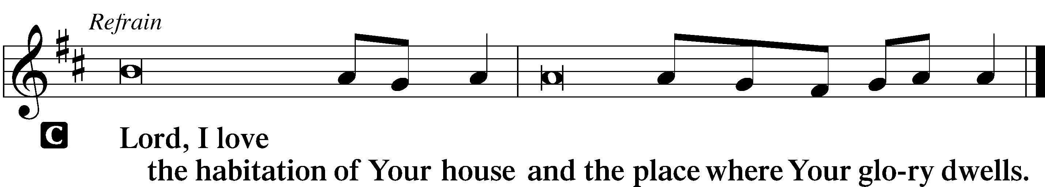

L Blessed are those who hear the Word of God and keep it.

L Glory be to the Father and to the Son and to the Holy Spirit.

Sermon

Canticle

Stand

Te Deum LSB 223
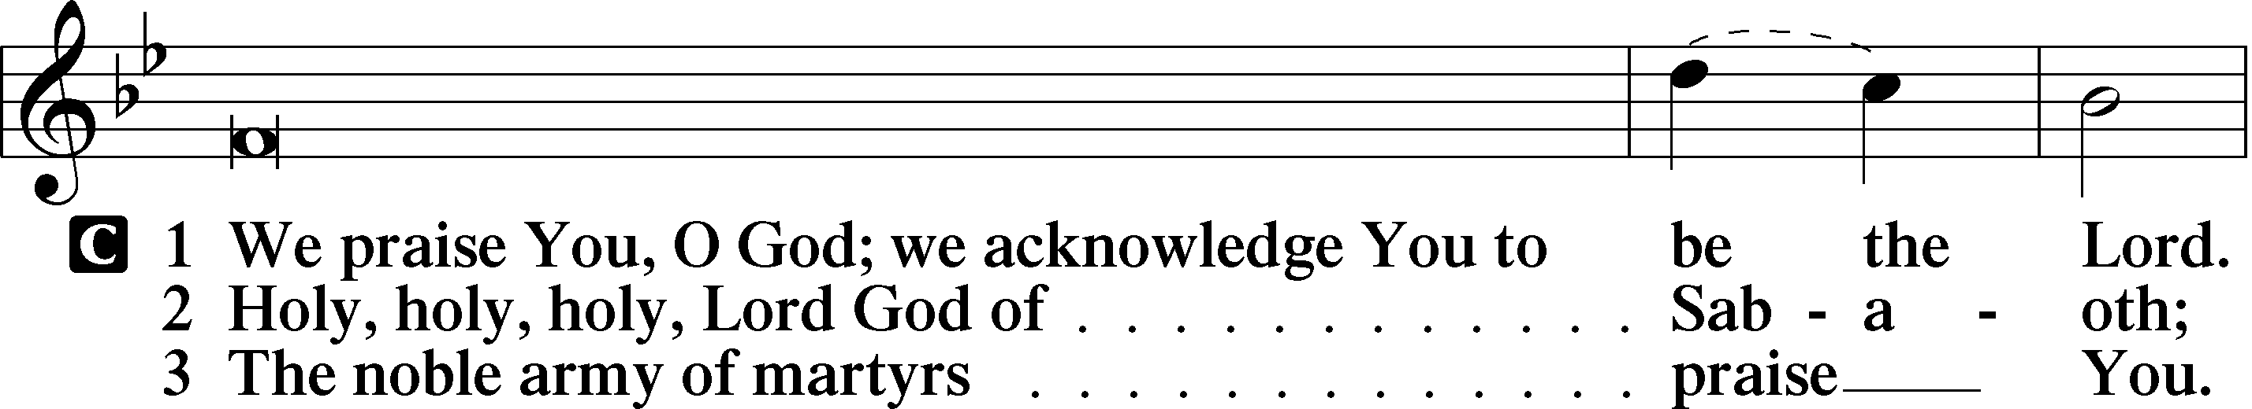
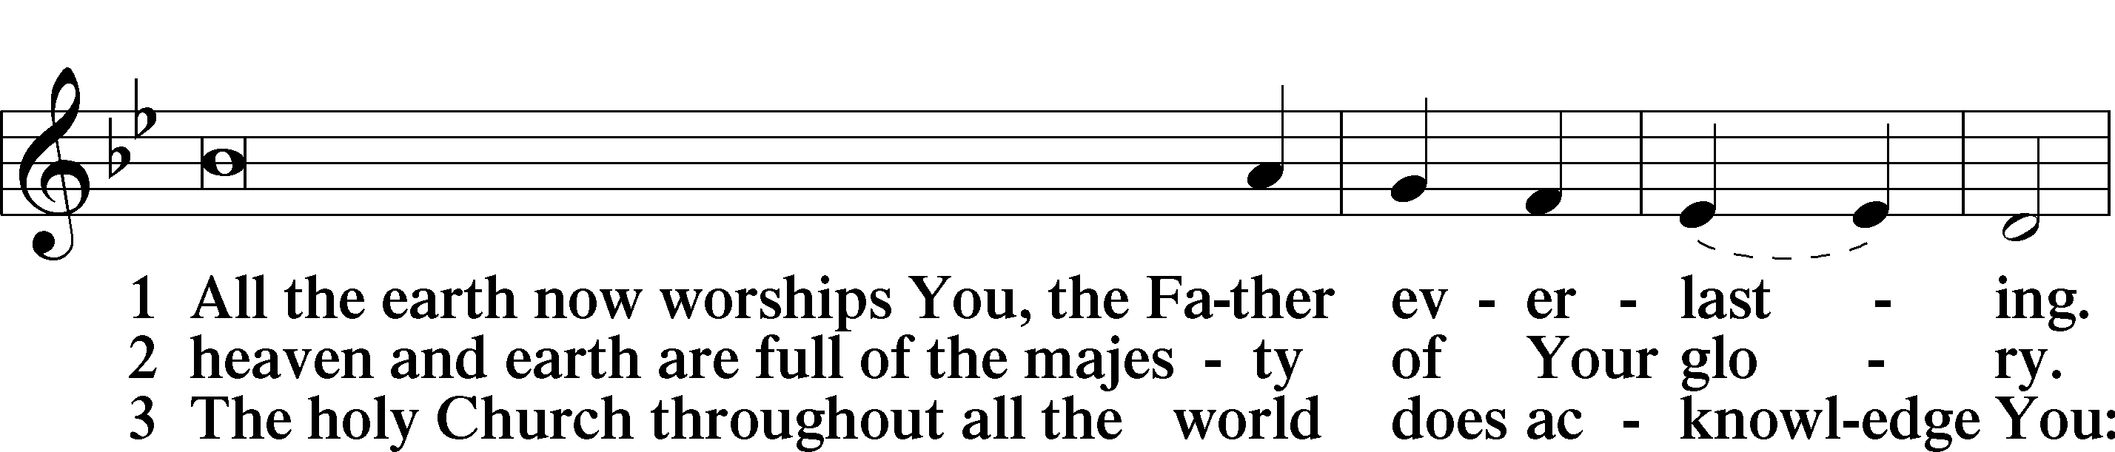
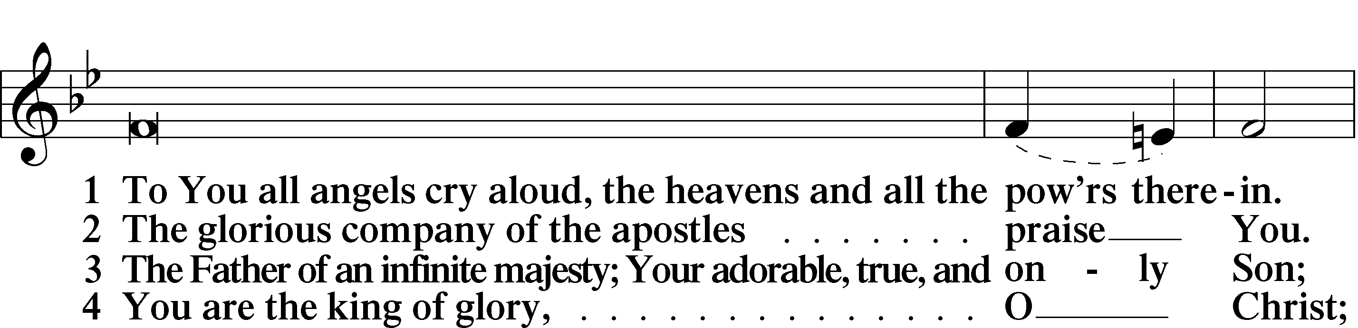
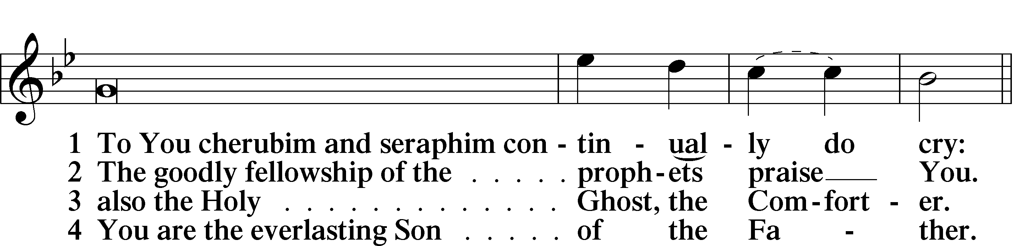
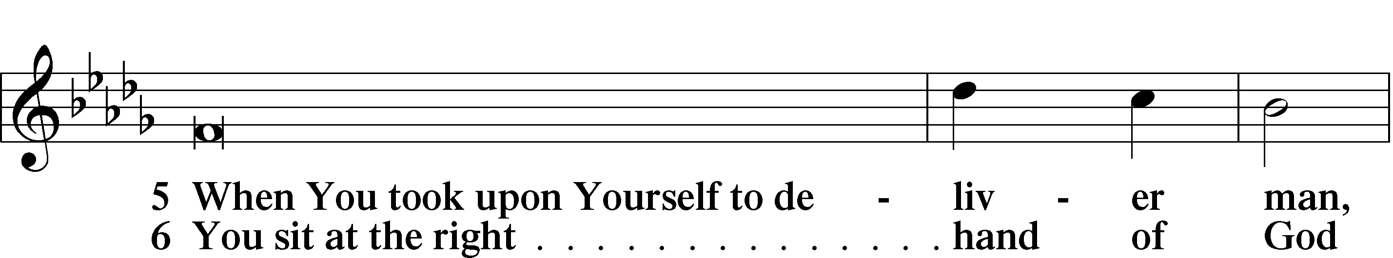
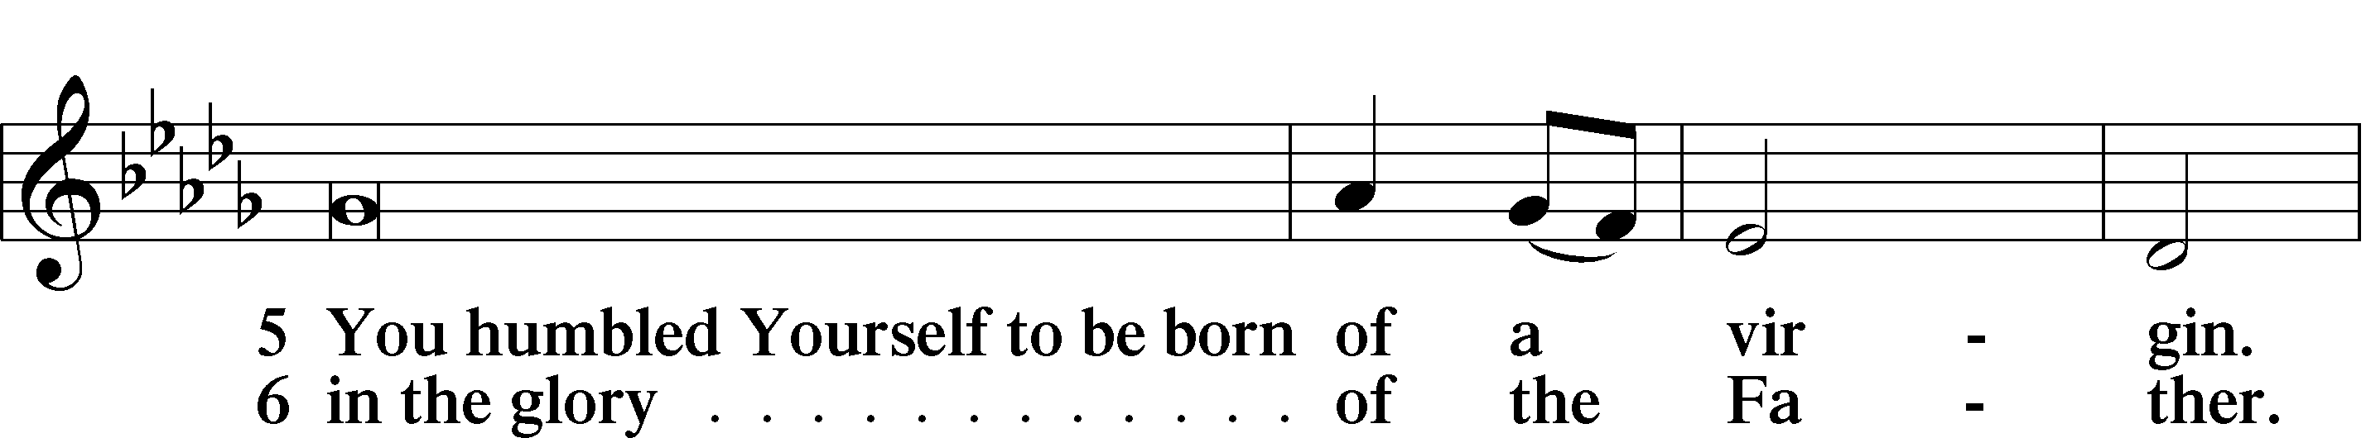
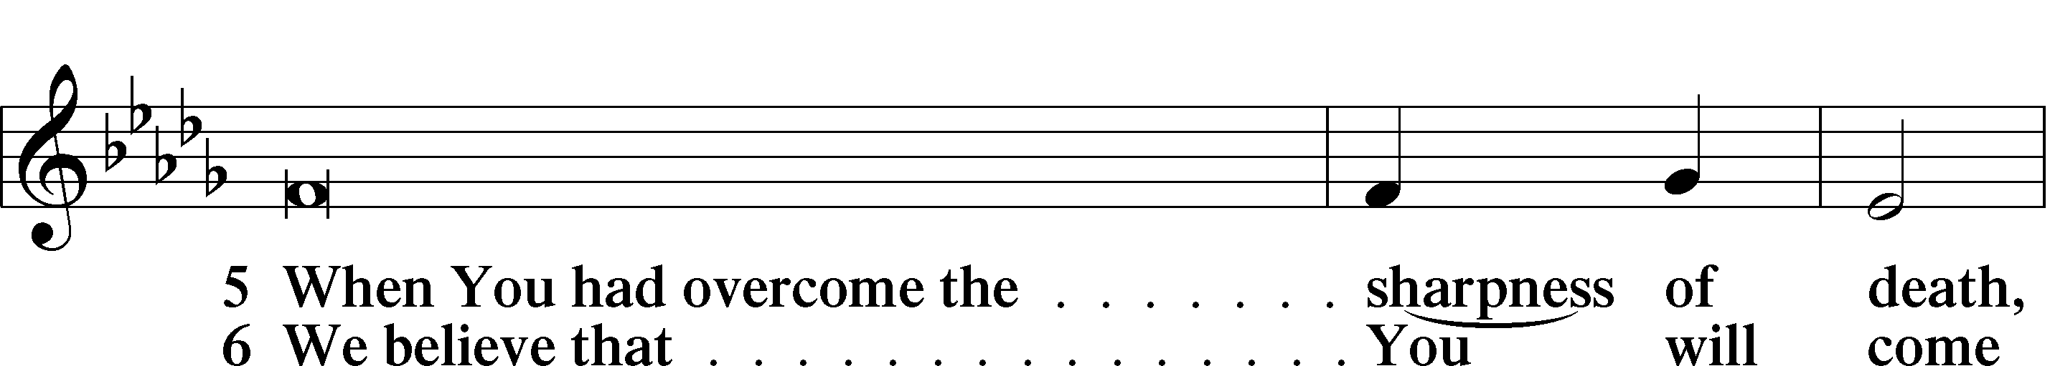
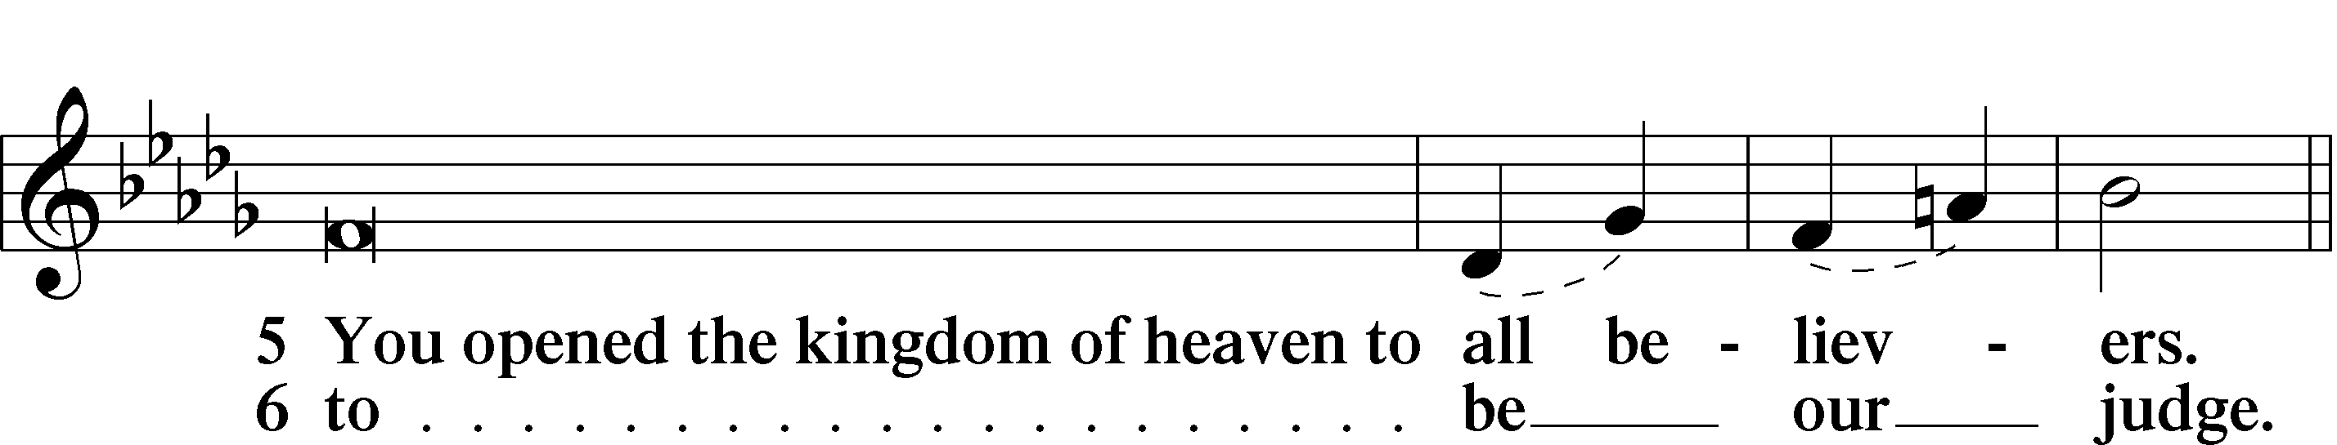
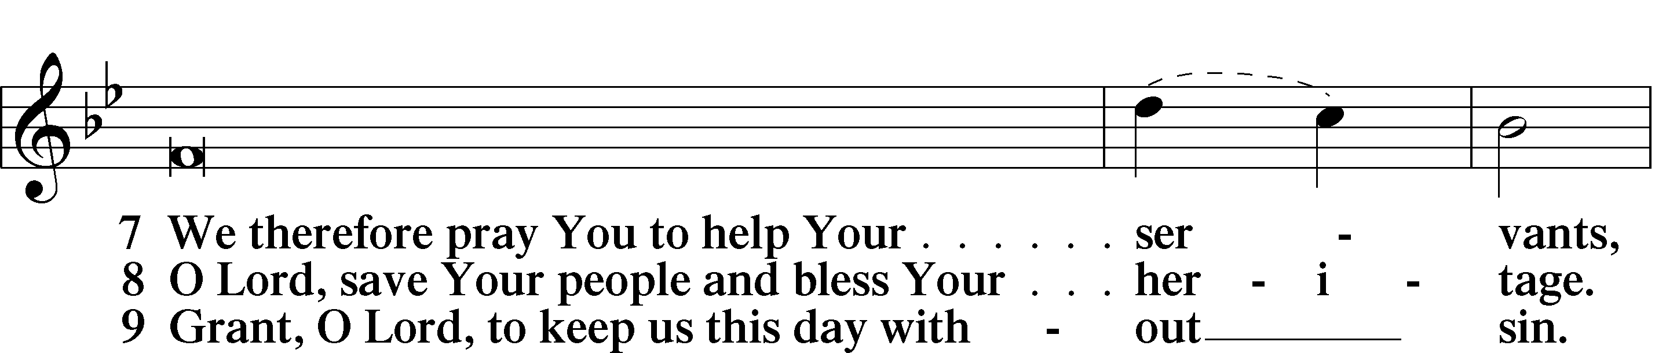
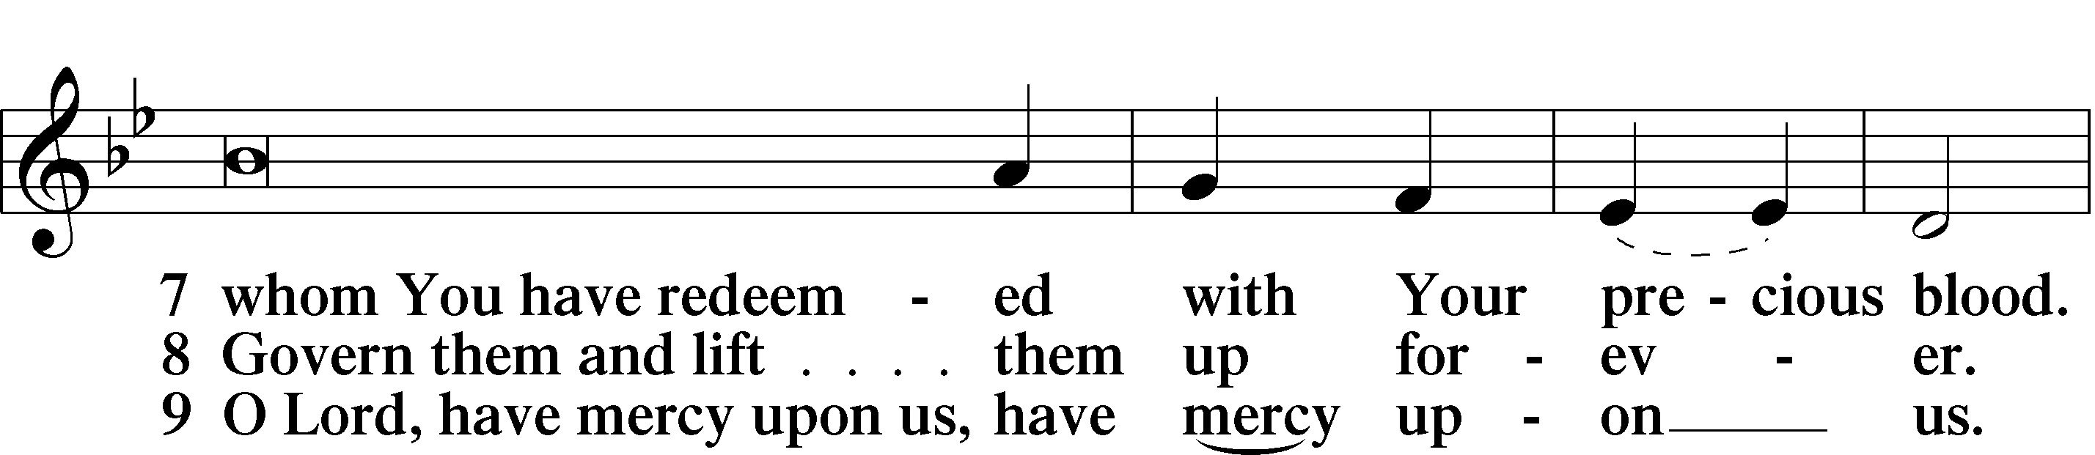
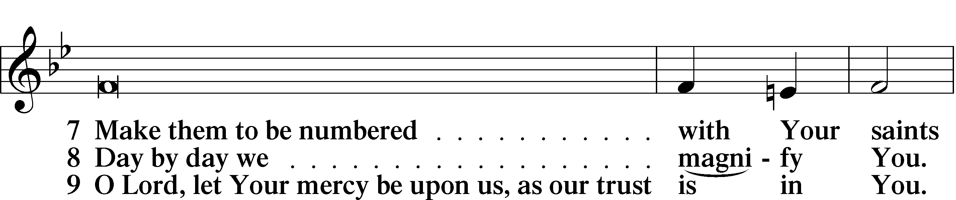
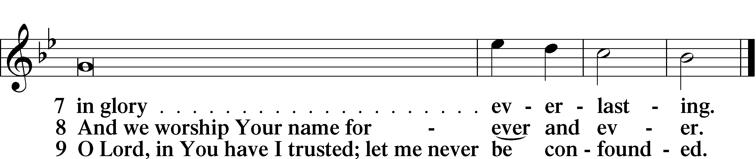

Sit

Offering

Prayer

Kneel/Stand

Kyrie LSB 227
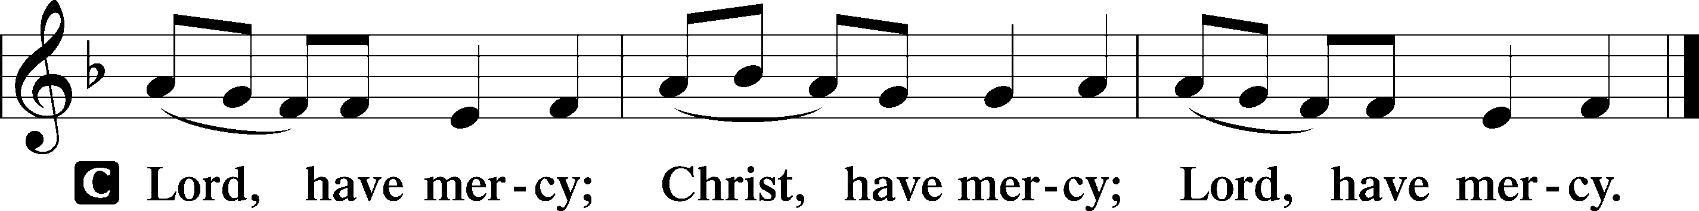

Lord’s Prayer
C Our Father who art in heaven,
hallowed be Thy name,
Thy kingdom come,
Thy will be done on earth
as it is in heaven;
give us this day our daily bread;
and forgive us our trespasses
as we forgive those
who trespass against us;
and lead us not into temptation,
but deliver us from evil.
For Thine is the kingdom
and the power and the glory
forever and ever. Amen.

Collects

Introduction to Collects LSB 227
L O Lord, hear my prayer.
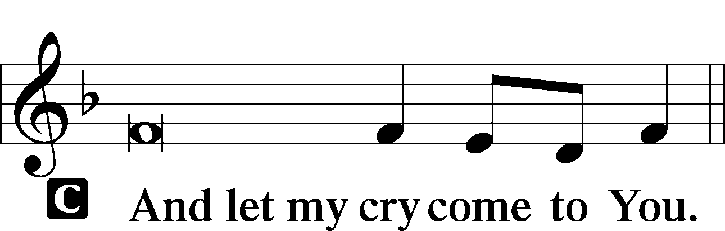

Collect of the Day
Stir up Your power, O Lord, and come, that by Your protection we may be rescued from the threatening perils of our sins and saved by Your mighty deliverance; for You live and reign with the Father and the Holy Spirit, one God, now and forever.
C Amen.

Collect for Grace
L O Lord, our heavenly Father, almighty and everlasting God, You have safely brought us to the beginning of this day. Defend us in the same with Your mighty power and grant that this day we fall into no sin, neither run into any kind of danger, but that all our doings, being ordered by Your governance, may be righteous in Your sight; through Jesus Christ, Your Son, our Lord, who lives and reigns with You and the Holy Spirit, one God, now and forever.
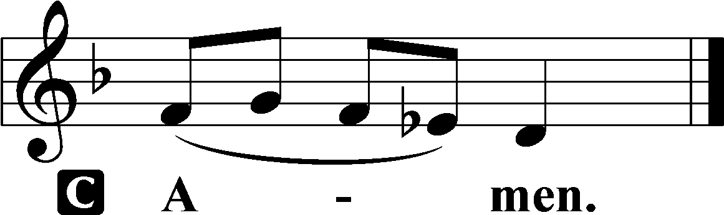

Stand

Benedicamus LSB 228
L Let us bless the Lord.
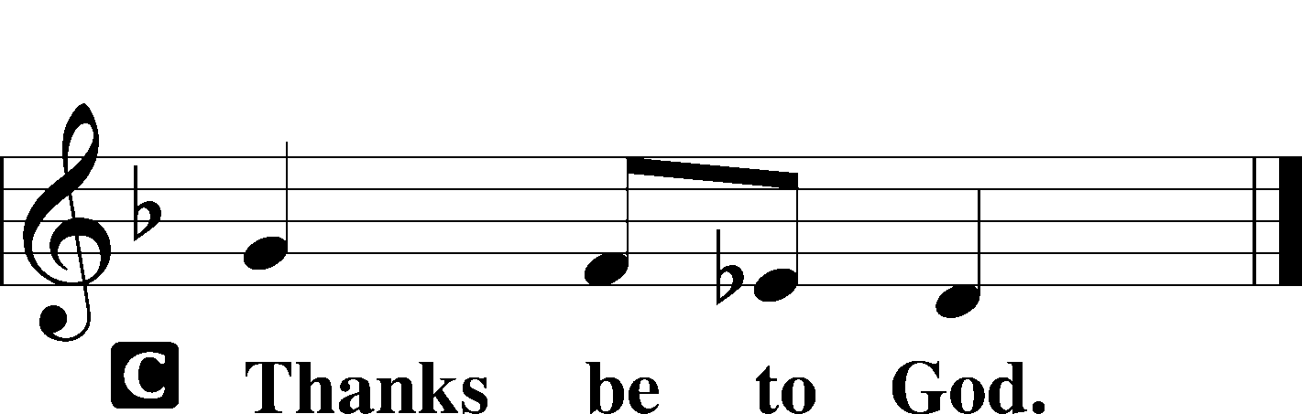

Benediction LSB 228
P The grace of our Lord T Jesus Christ and the love of God and the communion of the Holy Spirit be with you all.

Hymn to Depart: O Savior, Rend the Heavens Wide LSB 355
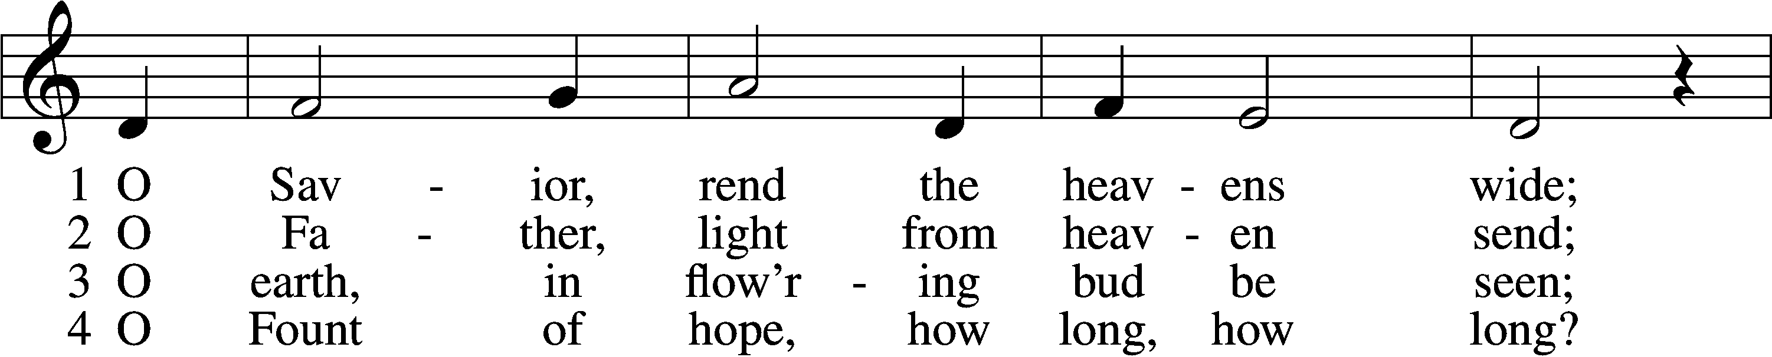
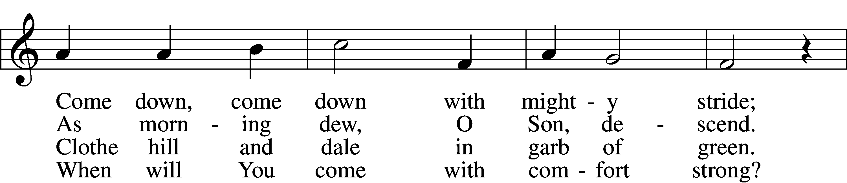
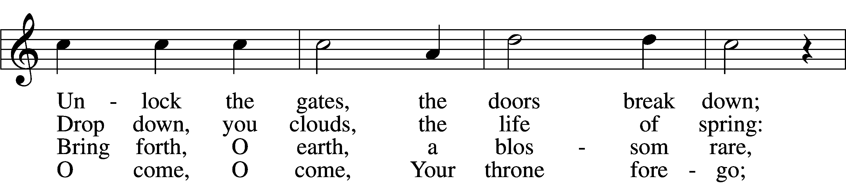
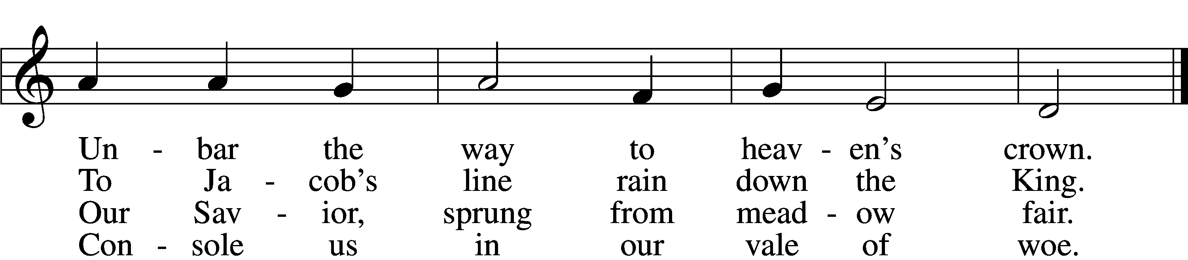

5 O Morning Star, O radiant Sun,
When will our hearts behold Your dawn?
O Sun, arise; without Your light
We grope in gloom and dark of night.

7 There shall we all our praises bring
And sing to You, our Savior King;
There shall we laud You and adore
Forever and forevermore.

6 Sin’s dreadful doom upon us lies;
Grim death looms fierce before our eyes.
O come, lead us with mighty hand
From exile to our promised land.

Text: Friedrich von Spee, 1591–1635; tr. Martin L. Seltz, 1909–67, alt.
Tune: Rheinfelssisch Deutsches Catholisches Gesangbuch, 1666, Augsburg
Text: © 1969 Concordia Publishing House. Used by permission: LSB Hymn License no. 110005504
Tune: Public domain

Acknowledgments
Matins from Lutheran Service Book
Unless otherwise indicated, Scripture quotations are from the ESV® Bible (The Holy Bible, English Standard Version®), copyright © 2001 by Crossway, a publishing ministry of Good News Publishers. Used by permission. All rights reserved.
Created by Lutheran Service Builder © 2022 Concordia Publishing House.

Announcements:
Church Service Phone: 888-505-1870/715-438-4200
(Stay on the line for recorded service to start)
Live Stream audio services: http://salem.listentochurch.com
Salem’s Web Page: https://www.salembarron.com/

Pastor Michael Nielsen: Cell phone: 218-280-0999
Email: rev.mike.nielsen@gmail.com
Pastor’s Office Hours: Monday-Wednesday 9-12

Attendance:
Call-in line:11/20– 9 In-person: 11/20- 70

Weekly Needs: $2823.92
11/13/22 – General: $ Missions: $Bldg: $Childcare: $ SS: $ AC: $ Schutz Oil: $

Coffee and Snacks: Jim and Lori Crawford.
Elder Today: Don Duncan
Altar Guild: Denise Stabenow

Link to Salem’s Facebook page is:
https://www.facebook.com/SalemEvangelicalLutheranChurchAndPreschool/

Schedule for the upcoming week:
Tuesday: 7:30 AM Bible Study
Wednesday: 12 Noon – Advent Service
4:00 PM – Catechism Class
5:30 PM – Advent Dinner
6:30 PM – Advent Service
Thursday: 11:00 AM Basics of Biblical Interpretation.

Midweek Advent Services begin November 30, 2022

December 4th – annual meeting after service (children’s Christmas Practice 10:15 -11:45 AM)

December 6th: Big Buck Contest – 7:00pm, Starts with lunch and deer stories. Prizes awarded to anyone who shoots a deer gun or bow. Deer harvested in Wisconsin. Come in enjoy the evening and see who got the Biggest Buck!

December 10th – Children’s Christmas Service Practice 9-11:45 AM
December 11th – Children’s Christmas Service
Prayer requests:

Those in the nursing home: Caroly, Lois, Wilma, Loretta

Those Shut-in at home: Char, Gail and Roxanne, Joan, Joyce

Those recovering from accident: Rusty Weise
Those recovering from surgery: Marilynn Amundson
Those with ongoing health issues: Harrison, Jeanne, Wyatt, Owen, Joyce, Kathy, Jeff, Daria, Bob, Pastor Jody Walter, Janee, Larry, Pastor Brent Berkesch, Pastor Quinten Buechner, Darlene, Mona, Timothy, Titus

Those who lead our nation:
Joe Biden, Kamala Harris, Tony Evers, Rod Nordby

Those who serve in our military:
Ryan Graf and Ethan Kobernick, Chaplain Pon Chanthaphon (Our Adopt-a-Chaplain)

Our Childcare Staff: Melissa Weinert, Jasmine Ferguson, Denise Stabenow, Katelyn Hendren, Holly Wilhelmi, Janica Skjerly

Families of the Week:

Other: Holy Trinity Lutheran Church, Bristol, TN – Building issues

Those who are struggling with Covid and the doctors and nurses caring for their patients.

Mission Statement
The Mission of Salem Lutheran Church is to be what God called us to be through faith in Jesus Christ, a body of believers engaged in building the Kingdom of God by discipling the Barron area with His Word and Sacrament ministry.

