Third Sunday in Lent
March 12, 2023
9:00 AM

Salem Lutheran Church
1-715-537-3011
http://www.salembarron.com
rev.mike.nielsen@gmail.com
We Worship the Father of Our Lord Jesus Christ in the Spirit and Truth of His Gospel

Though the Lord had brought them out of Egypt, “all the congregation of the people of Israel” grumbled against Him because “there was no water for the people to drink” (Ex. 17:1). Despite their quarreling, the Lord graciously provided for them. He did not strike the people for their sins, but by the hand of Moses He struck the rock instead and brought forth water for the people. In the same way, living water flows from the pierced side of Christ at “about the sixth hour” (John 4:6; 19:14), when He is lifted up on the cross for the sins of the world. He is “the gift of God” (John 4:10), the well from which the Holy Spirit is poured out and becomes in His people “a spring of water welling up to eternal life” (John 4:14). By this grace in which we stand, being at peace with God through our Lord Jesus Christ, we “worship the Father in spirit and truth” (John 4:23). “We rejoice in hope of the glory of God” because “God’s love has been poured into our hearts through the Holy Spirit who has been given to us” (Rom. 5:2, 5).
Hymn: Rock of Ages, Cleft for Me LSB 761
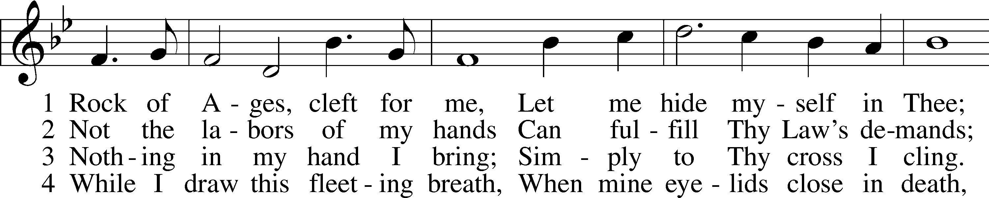
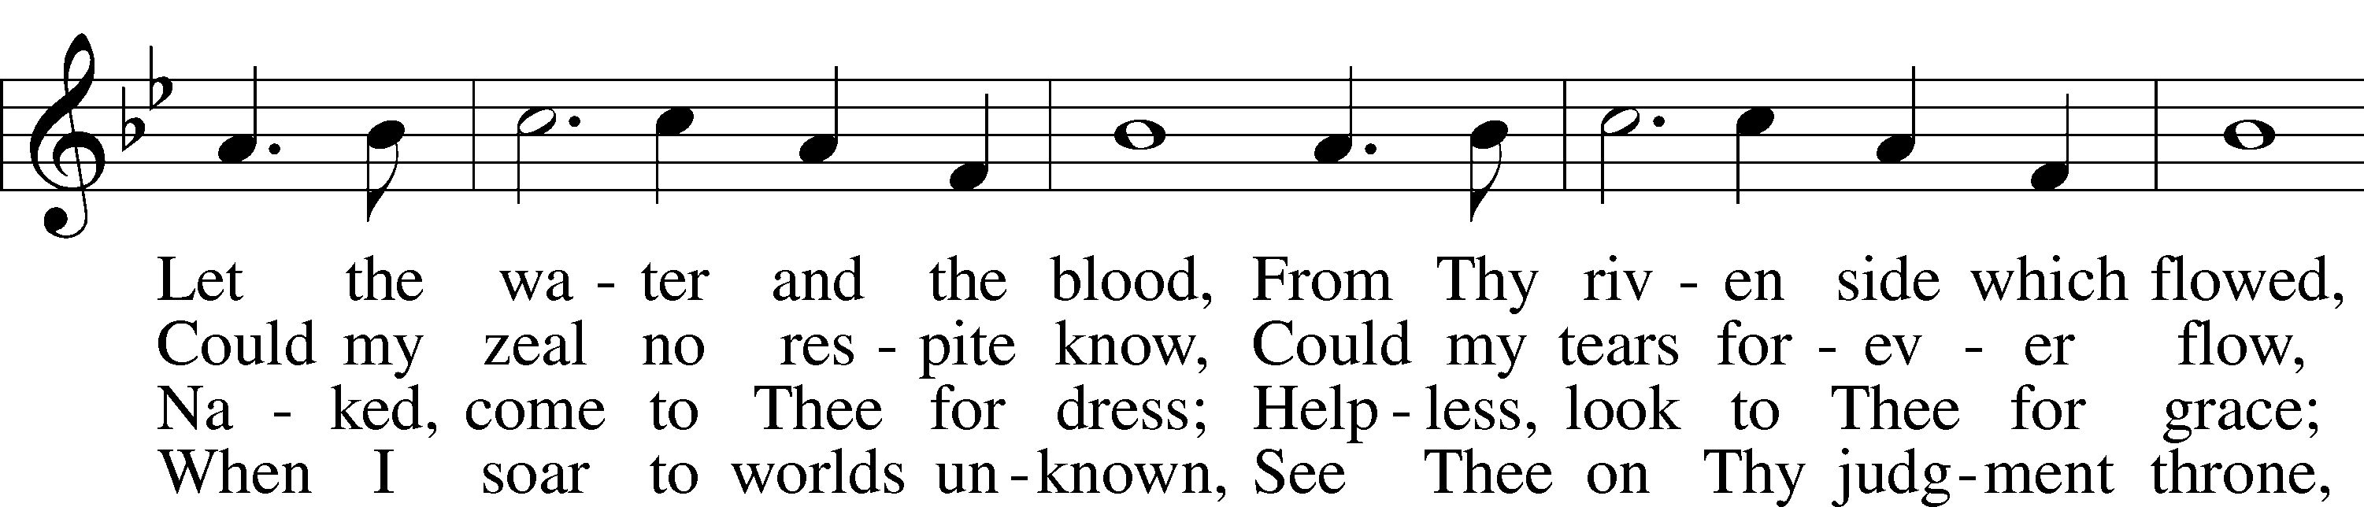
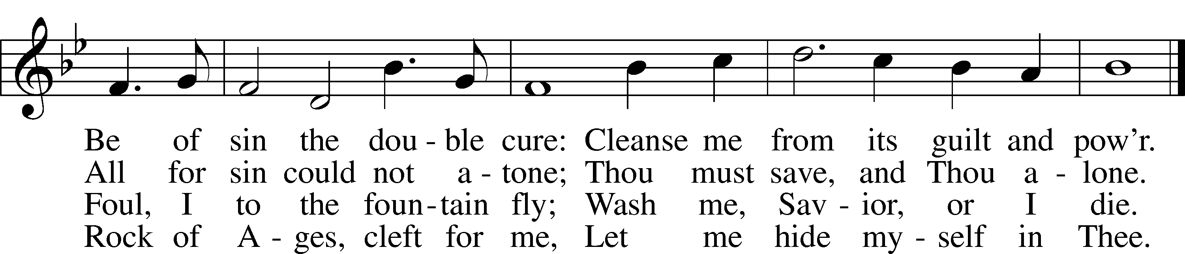
Text: Augustus M. Toplady, 1740–78
Tune: Thomas Hastings, 1784–1872
Text and tune: Public domain

Stand

Opening Versicles

L This is the day which the Lord has made;
C let us rejoice and be glad in it.
L From the rising of the sun to its setting,
C the name of the Lord is to be praised.

L Return to the Lord, your God, for He is gracious and merciful,
C slow to anger, and abounding in steadfast love, and repents of evil.
L Jesus said: If any man would come after Me,
C let him deny himself and take up his cross and follow Me.
L Christ was wounded for our transgressions.
C He was bruised for our iniquities.

L From the rising of the sun to its setting,
C the name of the Lord is to be praised.

C Glory be to the Father and to the Son and to the Holy Spirit;
as it was in the beginning, is now, and will be forever. Amen.

Old Testament Canticle LSB 261
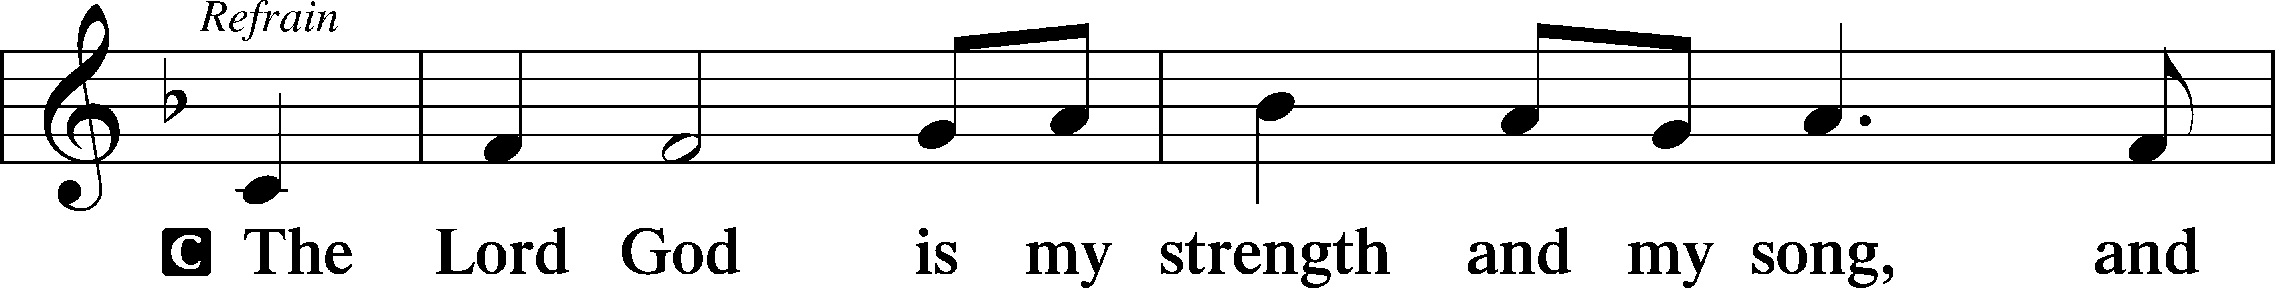
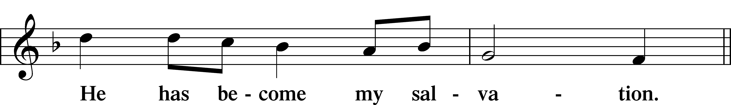
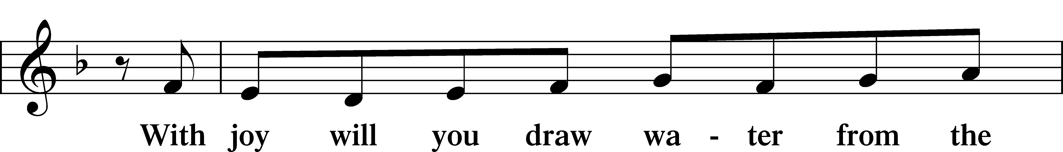
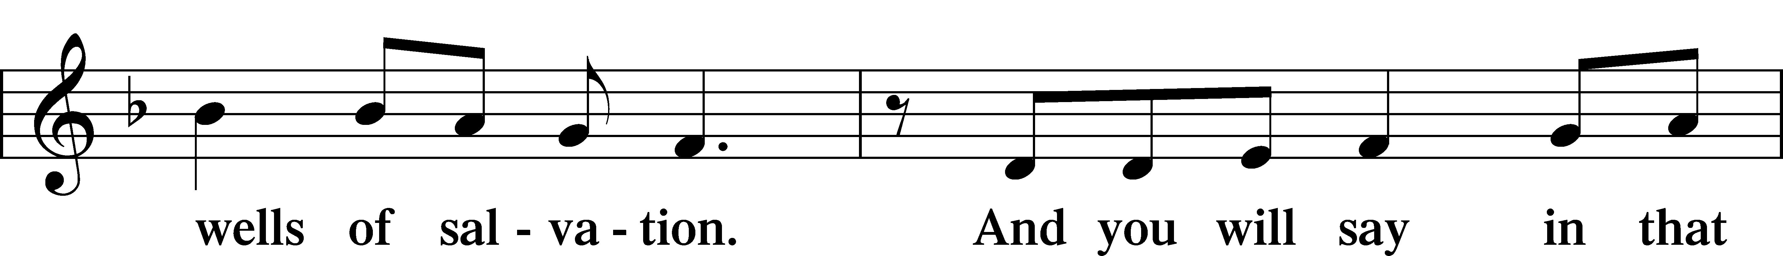
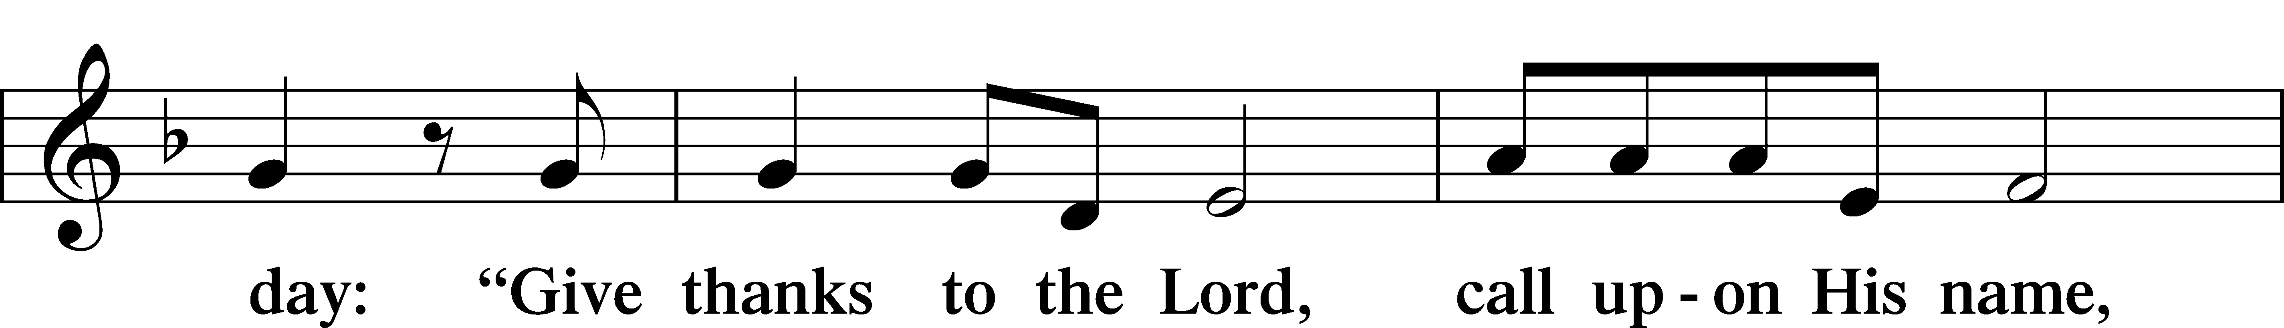
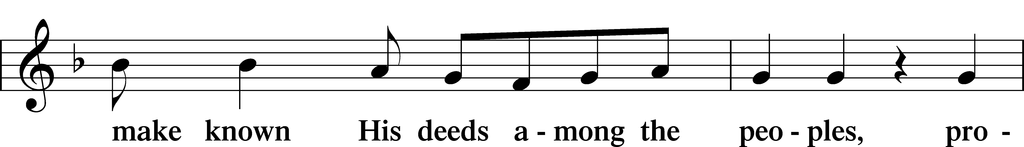
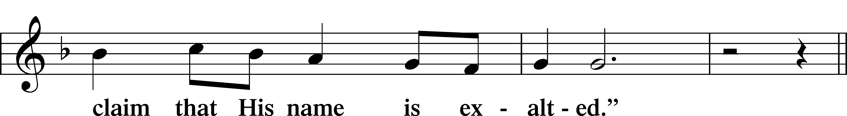
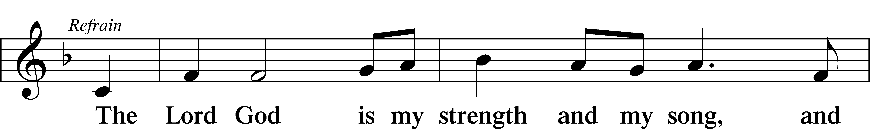
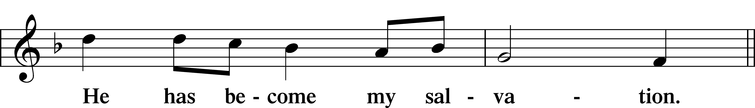
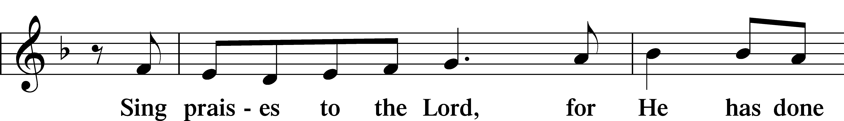
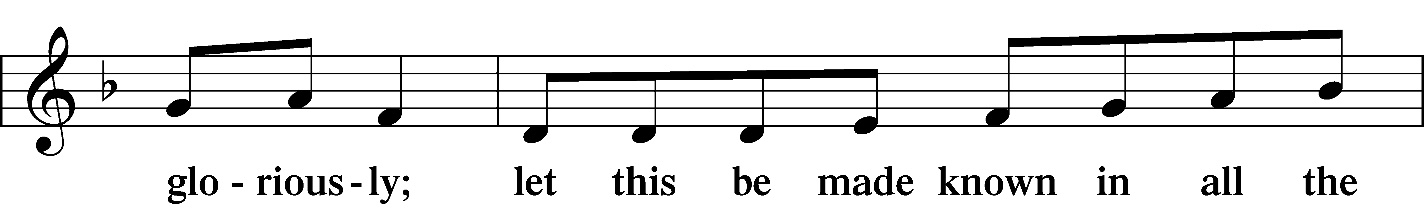
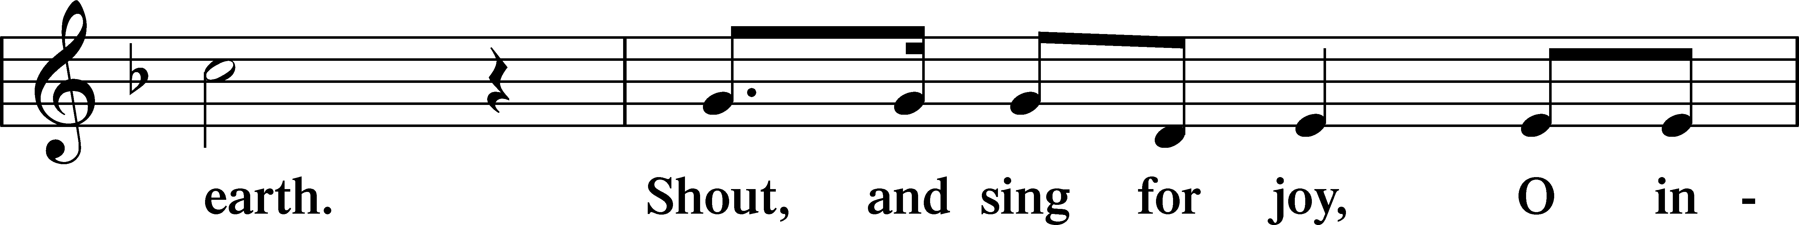
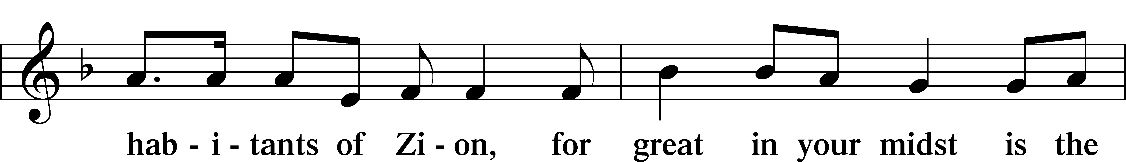
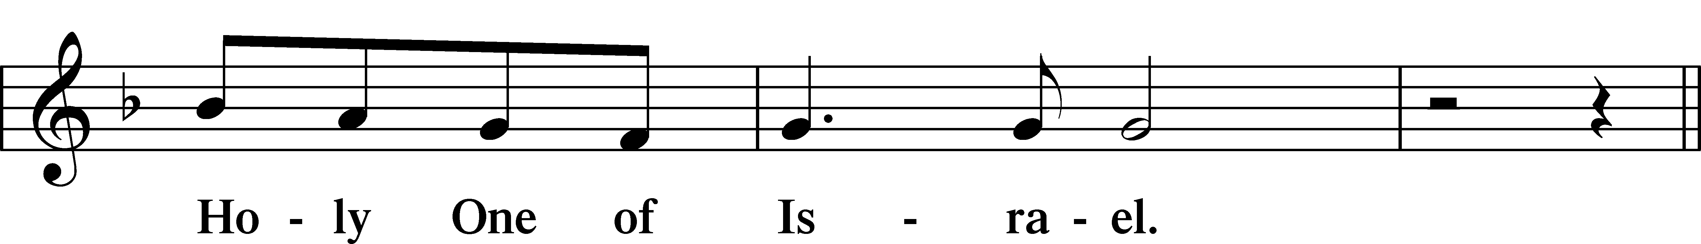
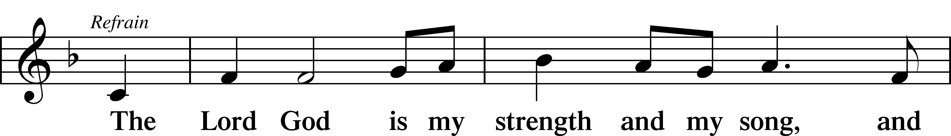
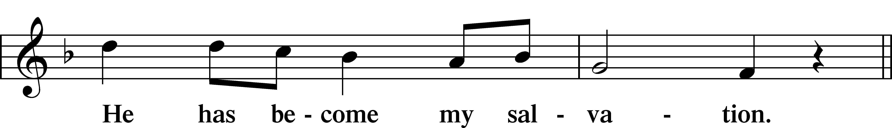
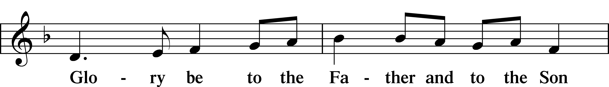
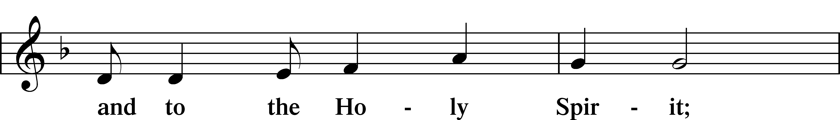
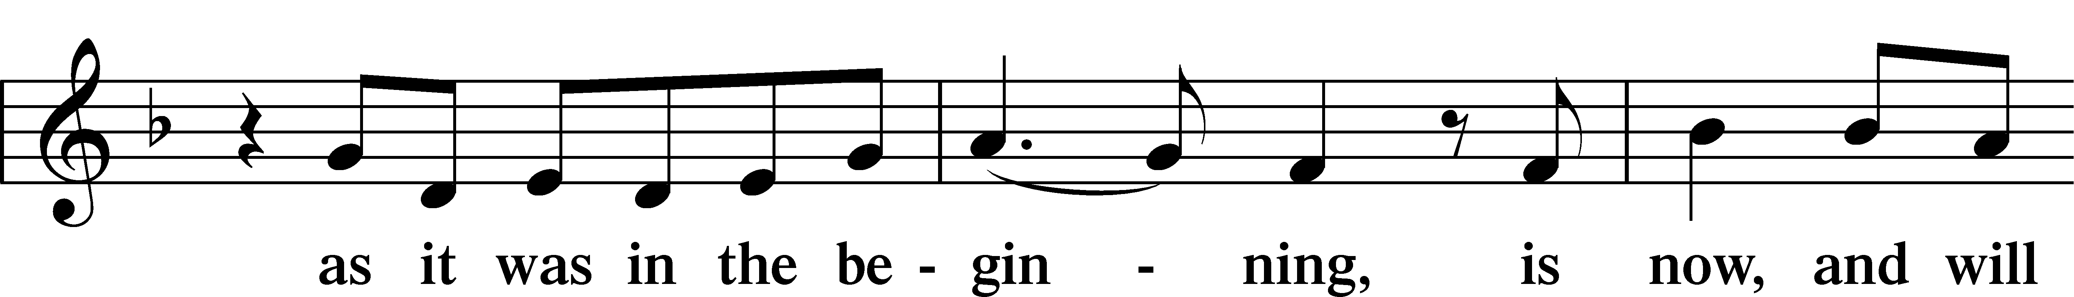
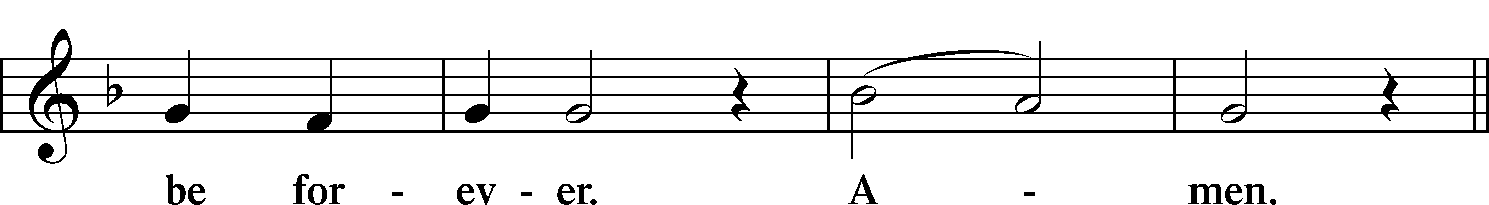
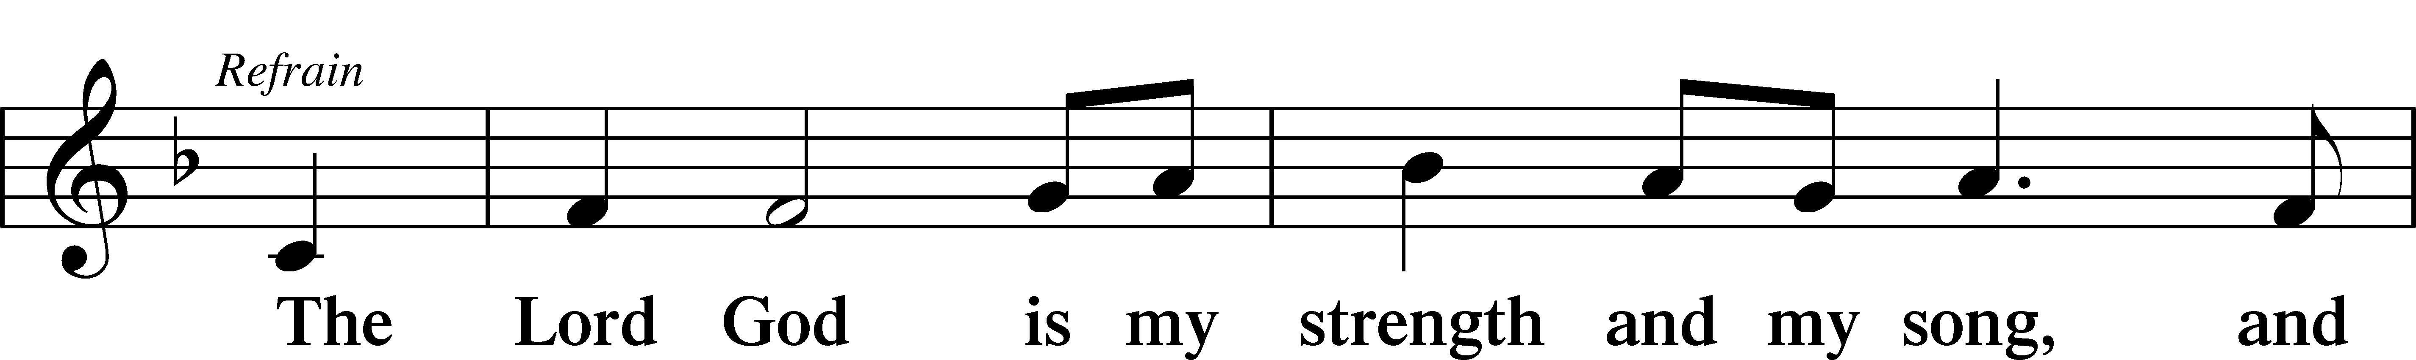
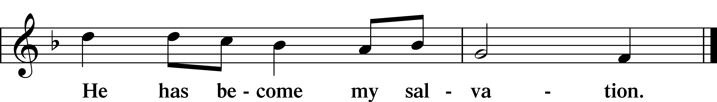

Sit

Readings From Holy Scripture

Reading Exodus 17:1–7
L A reading from Exodus, the seventeenth chapter.

Water from the Rock
1All the congregation of the people of Israel moved on from the wilderness of Sin by stages, according to the commandment of the Lord, and camped at Rephidim, but there was no water for the people to drink. 2Therefore the people quarreled with Moses and said, “Give us water to drink.” And Moses said to them, “Why do you quarrel with me? Why do you test the Lord?” 3But the people thirsted there for water, and the people grumbled against Moses and said, “Why did you bring us up out of Egypt, to kill us and our children and our livestock with thirst?” 4So Moses cried to the Lord, “What shall I do with this people? They are almost ready to stone me.” 5And the Lord said to Moses, “Pass on before the people, taking with you some of the elders of Israel, and take in your hand the staff with which you struck the Nile, and go. 6Behold, I will stand before you there on the rock at Horeb, and you shall strike the rock, and water shall come out of it, and the people will drink.” And Moses did so, in the sight of the elders of Israel. 7And he called the name of the place Massah and Meribah, because of the quarreling of the people of Israel, and because they tested the Lord by saying, “Is the Lord among us or not?”

L This is the Word of the Lord.
C Thanks be to God.

Reading Psalm 95:1–9
Let Us Sing Songs of Praise
1Oh come, let us sing to the Lord;
let us make a joyful noise to the rock of our salvation!
2Let us come into his presence with thanksgiving;
let us make a joyful noise to him with songs of praise!
3For the Lord is a great God,
and a great King above all gods.
4In his hand are the depths of the earth;
the heights of the mountains are his also.
5The sea is his, for he made it,
and his hands formed the dry land.
6Oh come, let us worship and bow down;
let us kneel before the Lord, our Maker!
7For he is our God,
and we are the people of his pasture,
and the sheep of his hand.
Today, if you hear his voice,
8do not harden your hearts, as at Meribah,
as on the day at Massah in the wilderness,
9when your fathers put me to the test
and put me to the proof, though they had seen my work.

Reading Romans 5:1–8
Peace with God Through Faith
1Therefore, since we have been justified by faith, we have peace with God through our Lord Jesus Christ. 2Through him we have also obtained access by faith into this grace in which we stand, and we rejoice in hope of the glory of God. 3More than that, we rejoice in our sufferings, knowing that suffering produces endurance, 4and endurance produces character, and character produces hope, 5and hope does not put us to shame, because God’s love has been poured into our hearts through the Holy Spirit who has been given to us.
6For while we were still weak, at the right time Christ died for the ungodly. 7For one will scarcely die for a righteous person—though perhaps for a good person one would dare even to die— 8but God shows his love for us in that while we were still sinners, Christ died for us.

Reading John 4:5–26
5[Jesus] came to a town of Samaria called Sychar, near the field that Jacob had given to his son Joseph. 6Jacob’s well was there; so Jesus, wearied as he was from his journey, was sitting beside the well. It was about the sixth hour.
7There came a woman of Samaria to draw water. Jesus said to her, “Give me a drink.” 8(For his disciples had gone away into the city to buy food.) 9The Samaritan woman said to him, “How is it that you, a Jew, ask for a drink from me, a woman of Samaria?” (For Jews have no dealings with Samaritans.) 10Jesus answered her, “If you knew the gift of God, and who it is that is saying to you, ‘Give me a drink,’ you would have asked him, and he would have given you living water.” 11The woman said to him, “Sir, you have nothing to draw water with, and the well is deep. Where do you get that living water? 12Are you greater than our father Jacob? He gave us the well and drank from it himself, as did his sons and his livestock.” 13Jesus said to her, “Everyone who drinks of this water will be thirsty again, 14but whoever drinks of the water that I will give him will never be thirsty forever. The water that I will give him will become in him a spring of water welling up to eternal life.” 15The woman said to him, “Sir, give me this water, so that I will not be thirsty or have to come here to draw water.”
16Jesus said to her, “Go, call your husband, and come here.” 17The woman answered him, “I have no husband.” Jesus said to her, “You are right in saying, ‘I have no husband’; 18for you have had five husbands, and the one you now have is not your husband. What you have said is true.” 19The woman said to him, “Sir, I perceive that you are a prophet. 20Our fathers worshiped on this mountain, but you say that in Jerusalem is the place where people ought to worship.” 21Jesus said to her, “Woman, believe me, the hour is coming when neither on this mountain nor in Jerusalem will you worship the Father. 22You worship what you do not know; we worship what we know, for salvation is from the Jews. 23But the hour is coming, and is now here, when the true worshipers will worship the Father in spirit and truth, for the Father is seeking such people to worship him. 24God is spirit, and those who worship him must worship in spirit and truth.” 25The woman said to him, “I know that Messiah is coming (he who is called Christ). When he comes, he will tell us all things.” 26Jesus said to her, “I who speak to you am he.”

Psalms, hymns, or choral music may be sung between the readings.

Lent Responsory LSB 263
L We have an advocate with the Father: Jesus Christ, the Righteous One.
C He was delivered up to death; He was delivered for the sins of the people.
L Blessed is the one whose transgression is forgiven, whose sin is covered.
C He was delivered up to death; He was delivered for the sins of the people.
L We have an advocate with the Father; Jesus Christ, the Righteous One.
C He was delivered up to death; He was delivered for the sins of the people.

Stand

Ten Commandments
C You shall have no other gods.
You shall not misuse the name of the Lord your God.
Remember the Sabbath day by keeping it holy.
Honor your father and your mother.
You shall not murder.
You shall not commit adultery.
You shall not steal.
You shall not give false testimony against your neighbor.
You shall not covet your neighbor’s house.
You shall not covet your neighbor’s wife, or his manservant or maidservant, his ox or donkey, or anything that belongs to your neighbor.

Apostles’ Creed
C I believe in God, the Father Almighty,
maker of heaven and earth.

And in Jesus Christ, His only Son, our Lord,
who was conceived by the Holy Spirit,
born of the virgin Mary,
suffered under Pontius Pilate,
was crucified, died and was buried.
He descended into hell.
The third day He rose again from the dead.
He ascended into heaven
and sits at the right hand of God the Father Almighty.
From thence He will come to judge the living and the dead.

I believe in the Holy Spirit,
the holy Christian Church,
the communion of saints,
the forgiveness of sins,
the resurrection of the body,
and the life T everlasting. Amen.

Lord’s Prayer
C Our Father who art in heaven,
hallowed be Thy name,
Thy kingdom come,
Thy will be done on earth
as it is in heaven;
give us this day our daily bread;
and forgive us our trespasses
as we forgive those
who trespass against us;
and lead us not into temptation,
but deliver us from evil.
For Thine is the kingdom
and the power and the glory
forever and ever. Amen.

Sit

Children’s Message

Hymn: May God Bestow On His Grace LSB 824
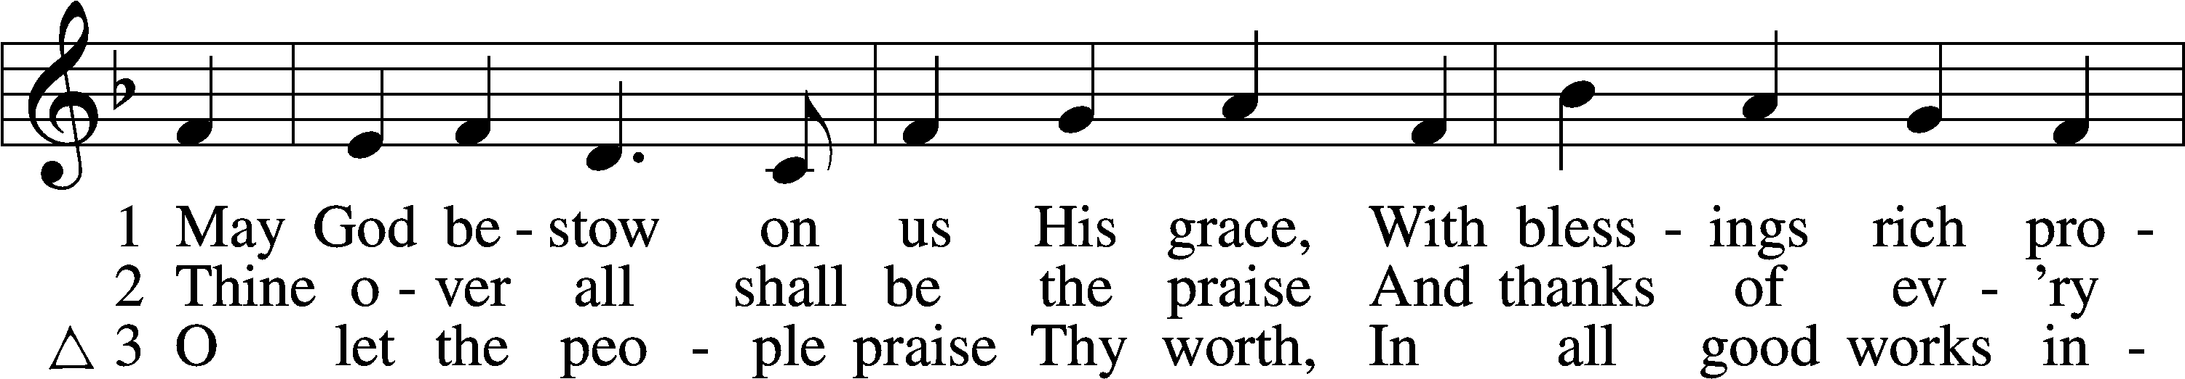
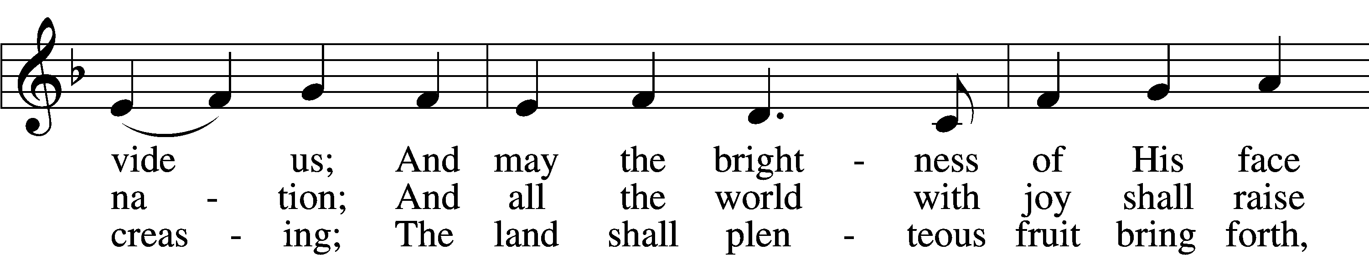
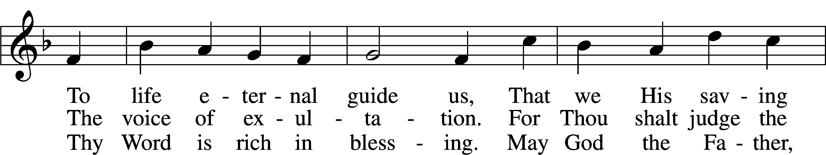
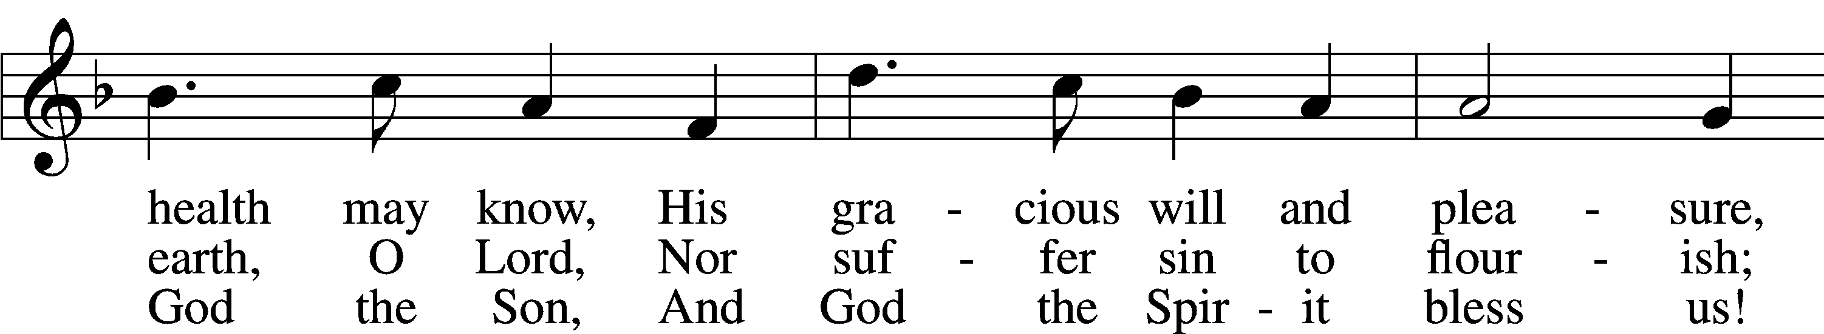
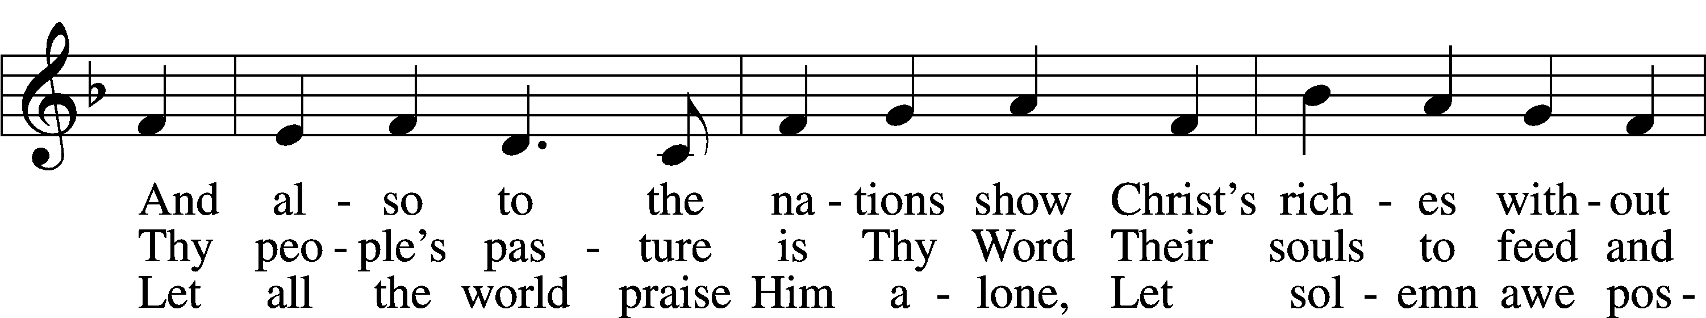
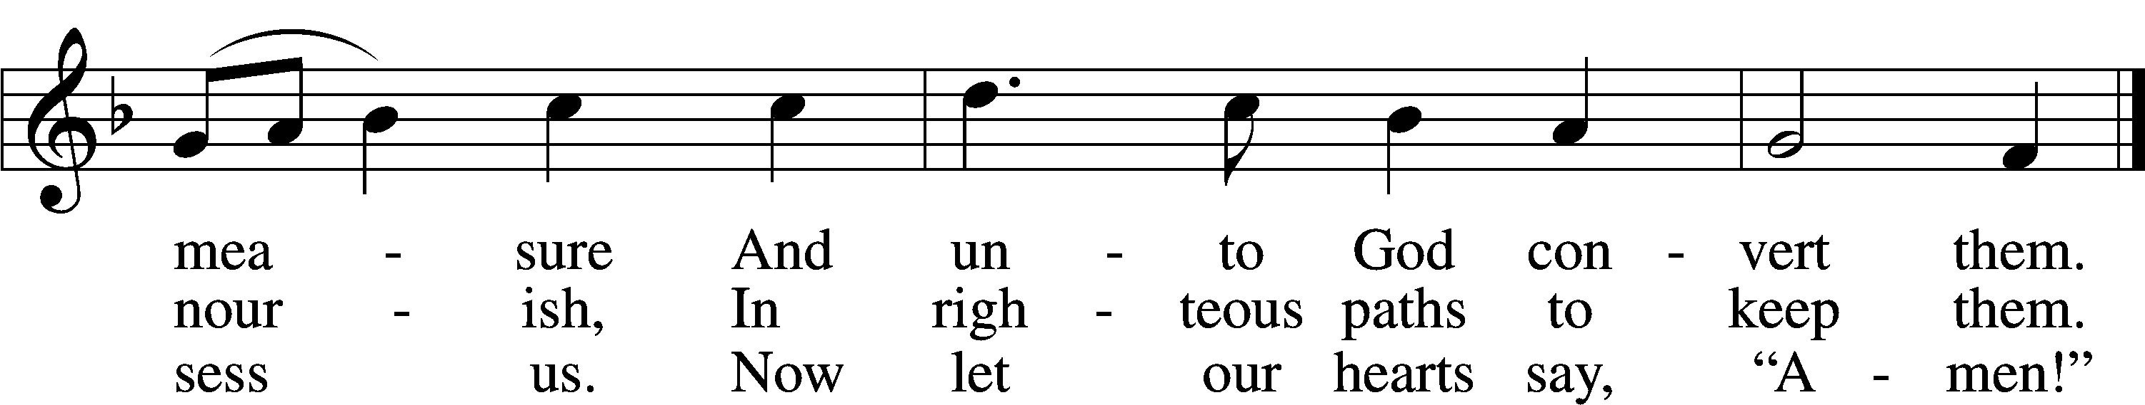
Text: Martin Luther, 1483–1546; tr. Richard Massie, 1800–87, alt.
Tune: David Lee, 1956
Text: Public domain
Tune: © 2004 David Lee. Used by permission: LSB Hymn License no. 110005504

Sermon

Offering

Stand

Prayer

Collect of the Day
L O God, whose glory it is always to have mercy, be gracious to all who have gone astray from Your ways and bring them again with penitent hearts and steadfast faith to embrace and hold fast the unchangeable truth of Your Word; through Jesus Christ, Your Son, our Lord, who lives and reigns with You and the Holy Spirit, one God, now and forever.
C Amen.

Collect for the Word
L Blessed Lord, You have caused all Holy Scriptures to be written for our learning. Grant that we may so hear them, read, mark, learn, and take them to heart that, by the patience and comfort of Your holy Word, we may embrace and ever hold fast the blessed hope of everlasting life; through Jesus Christ, Your Son, our Lord, who lives and reigns with You and the Holy Spirit, one God, now and forever.
C Amen.

Morning Prayer
C I thank You, my heavenly Father, through Jesus Christ, Your dear Son, that You have kept me this night from all harm and danger; and I pray that You would keep me this day also from sin and every evil, that all my doings and life may please You. For into Your hands I commend myself, my body and soul, and all things. Let Your holy angel be with me, that the evil foe may have no power over me.

NT Canticle: My Soul Rejoices LSB 933
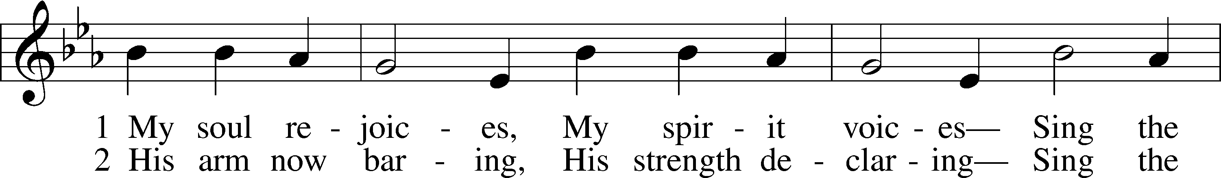
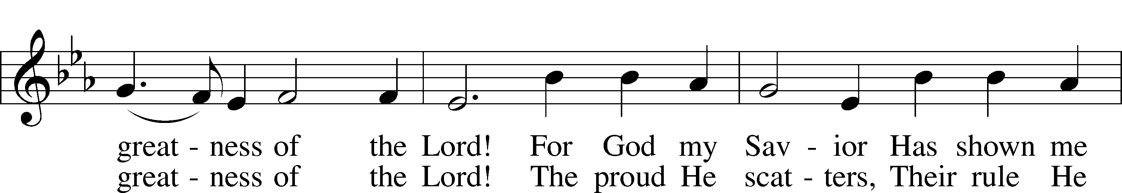
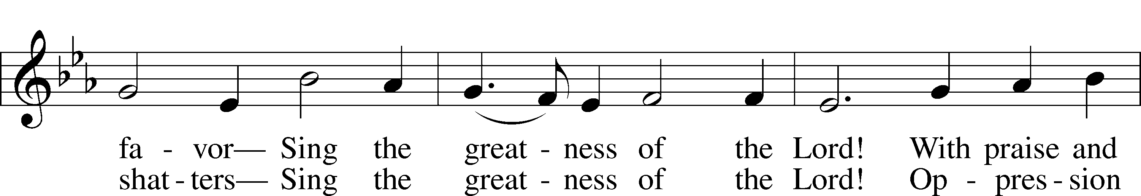
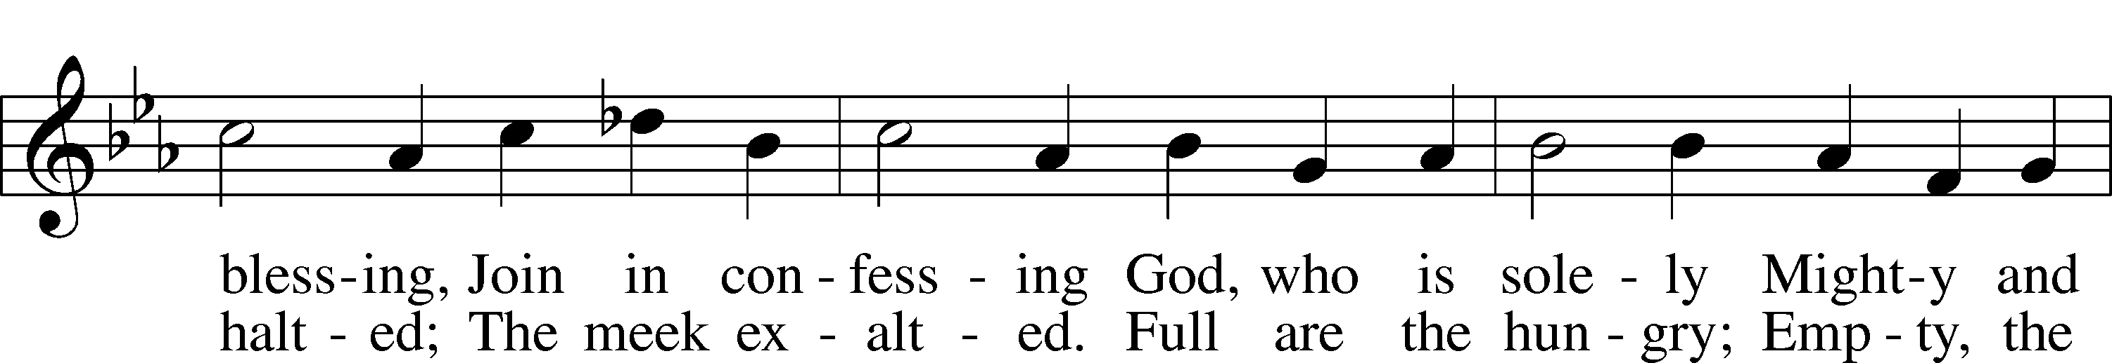
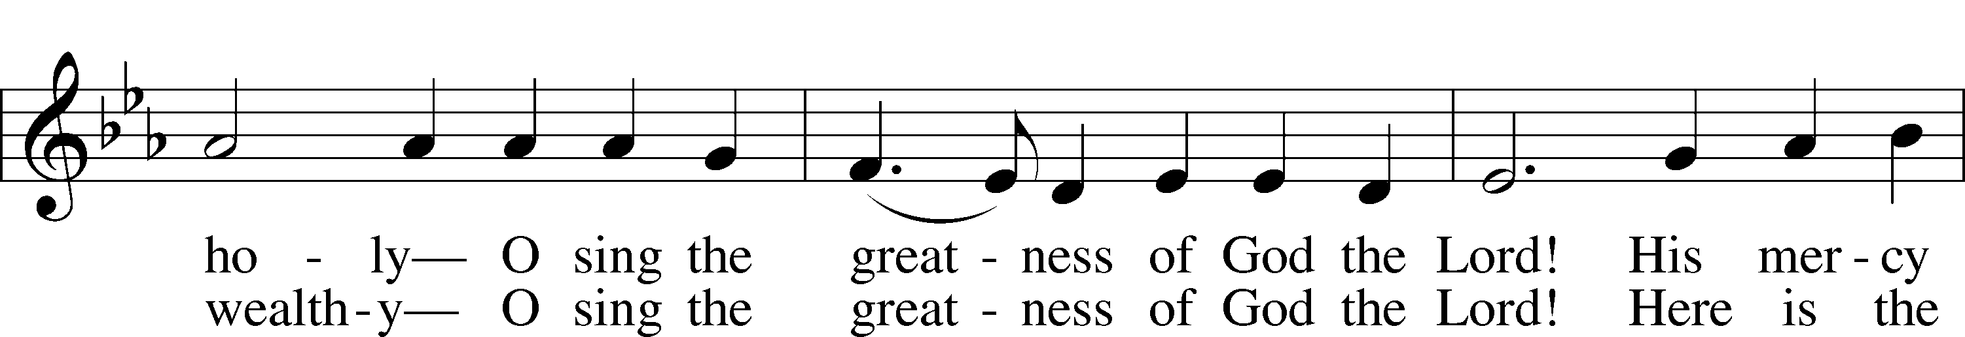
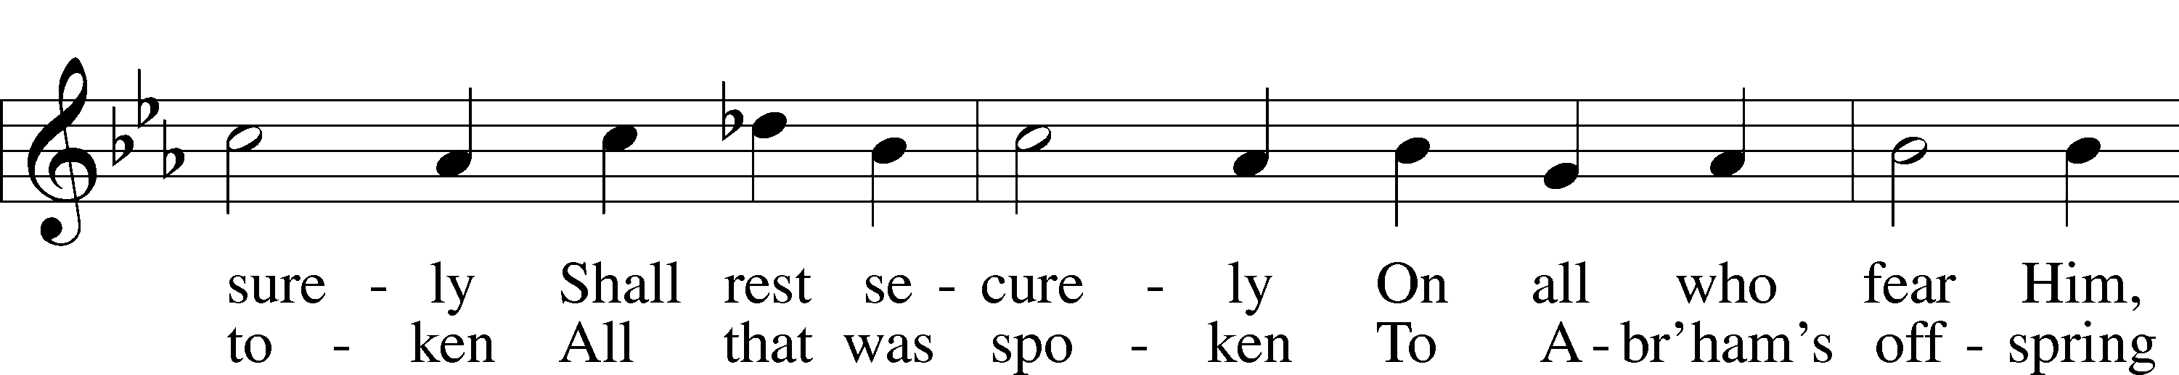
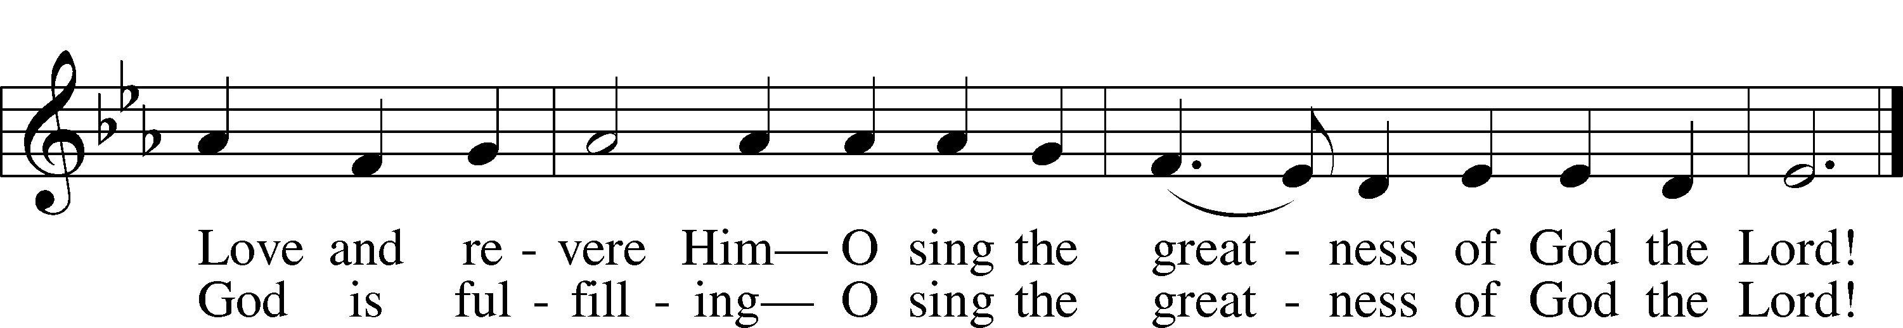
Text: Stephen P. Starke, 1955
Tune: Giovanni Giacomo Gastoldi, c. 1556–c. 1622
Text: © 1991 Stephen P. Starke, admin. Concordia Publishing House. Used by permission: LSB Hymn License no. 110005504
Tune: Public domain

Benedicamus LSB 267
L Let us bless the Lord.
C Thanks be to God.

Benediction LSB 267
L The almighty and merciful Lord, the Father, the T Son, and the Holy Spirit, bless and preserve us.
C Amen.

Hymn: Jesus, Lead Thou On LSB 718
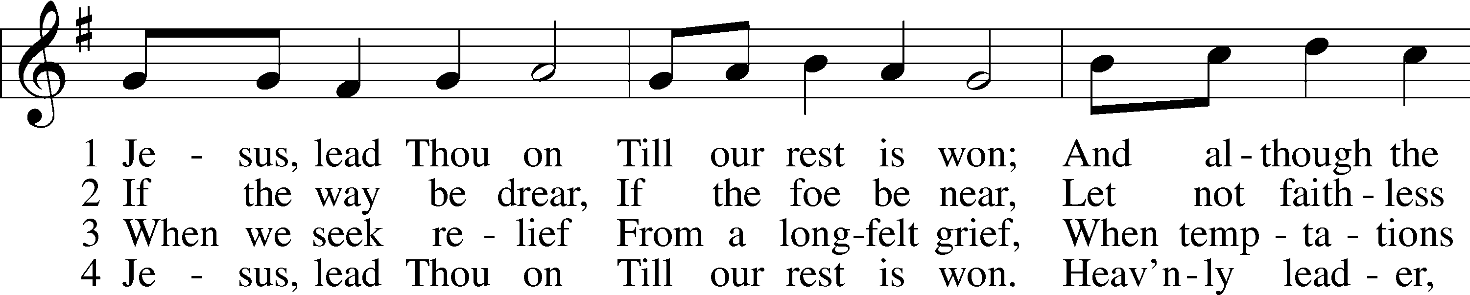
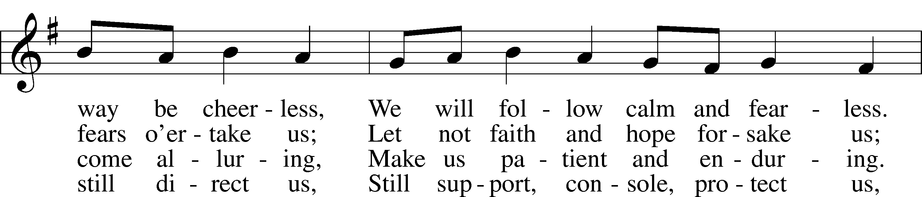
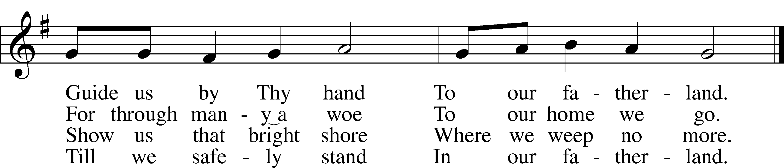
Text: Nicolaus Ludwig von Zinzendorf, 1700–60; tr. Jane L. Borthwick, 1813–97, alt.
Tune: Adam Drese, 1620–1701
Text and tune: Public domain

Acknowledgments
Service of Prayer and Preaching from Lutheran Service Book
Unless otherwise indicated, Scripture quotations are from the ESV® Bible (The Holy Bible, English Standard Version®), copyright © 2001 by Crossway, a publishing ministry of Good News Publishers. Used by permission. All rights reserved.
Created by Lutheran Service Builder © 2023 Concordia Publishing House.

Announcements:
Church Service Phone: 888-505-1870/715-438-4200
(Stay on the line for recorded service to start)
Live Stream audio services: http://salem.listentochurch.com
Salem’s Web Page: https://www.salembarron.com/

Pastor Michael Nielsen: Cell phone: 218-280-0999
Email: rev.mike.nielsen@gmail.com
Pastor’s Office Hours: Monday-Wednesday 9-12
Attendance:
Call-in line:3/1 – 3, 3/5 – 4 In-person: 3/1 – 13/20, 3/5 - 68

Weekly Needs: $2823.92

2/19/23 – General: $1846 Missions: $42 Bldg: $67 Childcare: $105 Hymnals: $50
2/26/23 – General: $2086 Missions: $52 Bldg: $47 Childcare: $40 SS: $7.40

Coffee and Snacks: YFM
Elder Today: Trevor Duncan
Altar Guild: MaryAnn Thompson and Kari Longmire

Link to Salem’s Facebook page is:
https://www.facebook.com/SalemEvangelicalLutheranChurchAndPreschool/

Schedule for the upcoming week:
Tuesday: 7:30 AM Men‘s Bible Study
7:00 PM Church Council
Wednesday: 12:00 PM Lent Service
4:00 PM Catechism Class
5:30 Lenten Supper
6:30 PM Lent Service
Thursday: 11:00 AM Bible Class

Save the date: March 22, April, May – 10% nights at DQ for Salem’s Childcare from 4-9 PM

Today: March 12, 2023 – Chili and Pie Cook off
Save the date: March 26, 2023 – Soup Sunday
Save the date: April 8, 2023 – Easter Egg Hunt
Save the date: April 13-15, 2023 – Church Garage Sale. There will be guys to help on Tuesday mornings and Sunday mornings after church.
Save the Date: April 30, 2023 – Confirmation Questioning
Save the Date: May 7, 2023 – Confirmation Sunday

Please bring your salad jars back.

Prayer requests:

Those in the nursing home: Caroly, Wilma, Loretta, Diane

Those Shut-in at home: Char, Gail and Roxanne, Joan, Joyce

Those recovering from surgery: Randy Church, Mona Duncan, Carol Shearer
Those recovering from accident: Rusty Weise
Those with ongoing health issues: Harrison, Jeanne, Wyatt, Owen, Joyce, Kathy N, Jeff, Daria, Bob, Pastor Jody Walter, Janee, Larry, Jessica,

Those who lead our nation:
Joe Biden, Kamala Harris, Tony Evers, Rod Nordby

Those who serve in our military:
Ryan Graf and Ethan Kobernick, Chaplain Pon Chanthaphon (Our Adopt-a-Chaplain)

Our Childcare Staff: Melissa Weinert, Jasmine Ferguson, Denise Stabenow, Katelyn Hendren, Holly Wilhelmi, Janica Skjerly

Families of the Week: Holly Johnson (Hunter Nelson), Joyce (and David) Kaseno, Ione Kern, Nathan and Alicia Kirkman (Krew and Vivian), Terry and Marlene Kirkman

Barron Area Businesses: Swant Graber Auto/Motors, Church Barn, Erickson Insurance Agency, Hometown Pharmacy

Mission Statement
The Mission of Salem Lutheran Church is to be what God called us to be through faith in Jesus Christ, a body of believers engaged in building the Kingdom of God by discipling the Barron area with His Word and Sacrament ministry.

