Reformation Sunday
October 31, 2021
9:00 AM

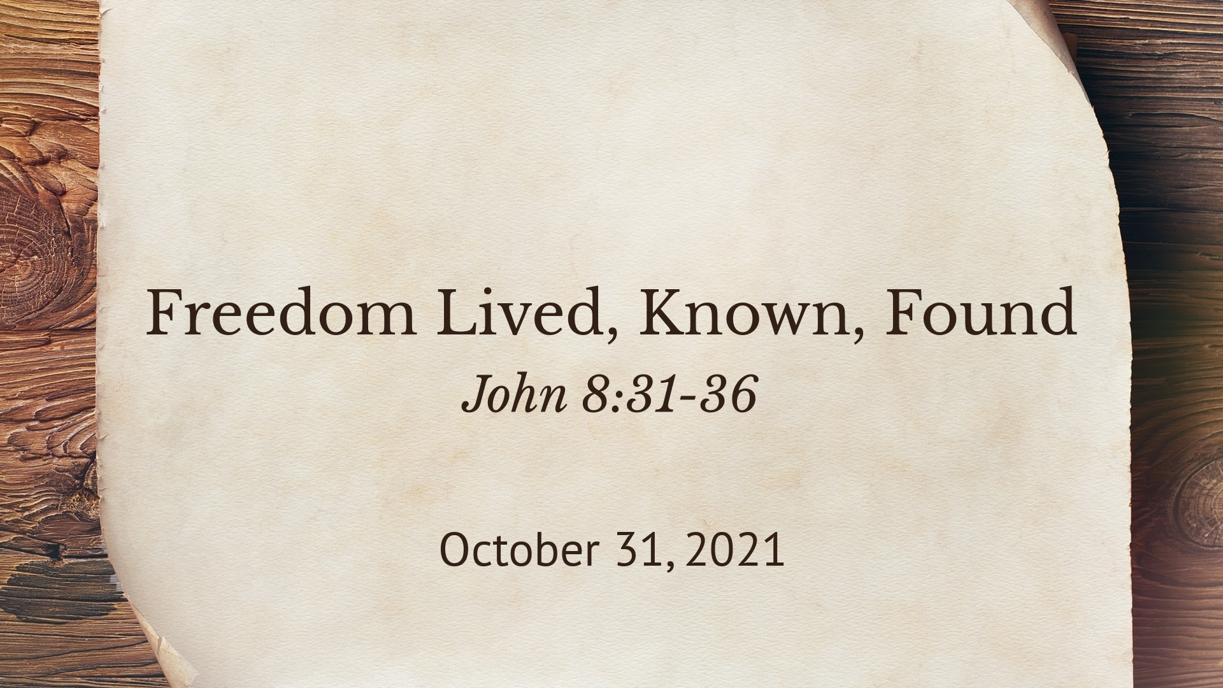

Salem Lutheran Church
1-715-537-3011
http://www.salembarron.com
rev.mike.nielsen@gmail.com

The Son of God Has Set Us Free from Sin and Death by His Grace

“Wisdom is justified by her deeds” (Matt. 11:19), and the true Wisdom of God, Christ Jesus, the incarnate Son, has justified us by His deeds. He prepares His way by the preaching of repentance, but He has suffered the violence of the Law and voluntarily handed Himself over to violent men, that we might eat and drink with Him in His kingdom and “remain in the house forever” (John 8:35). He is “a friend of tax collectors and sinners” (Matt. 11:18–19), and He has rescued us by His grace from the slavery of sin and death. By the proclamation of His eternal Gospel “to those who dwell on earth, to every nation and tribe and language and people” (Rev. 14:6), “the righteousness of God has been manifested apart from the law” (Rom. 3:21), “that he might be just and the justifier of the one who has faith in Jesus” (Rom. 3:26). And by the hearing of that Gospel of Christ Jesus, “whom God put forward as a propitiation by his blood, to be received by faith” (Rom. 3:25), “you will know the truth, and the truth will set you free” (John 8:31–32).
Confession and Absolution

Hymn of Invocation: A Mighty Fortress Is Our God LSB 656
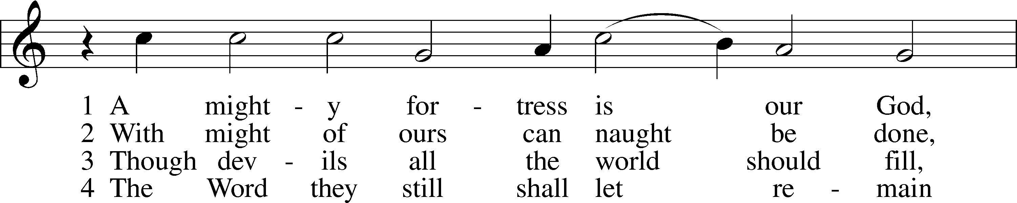
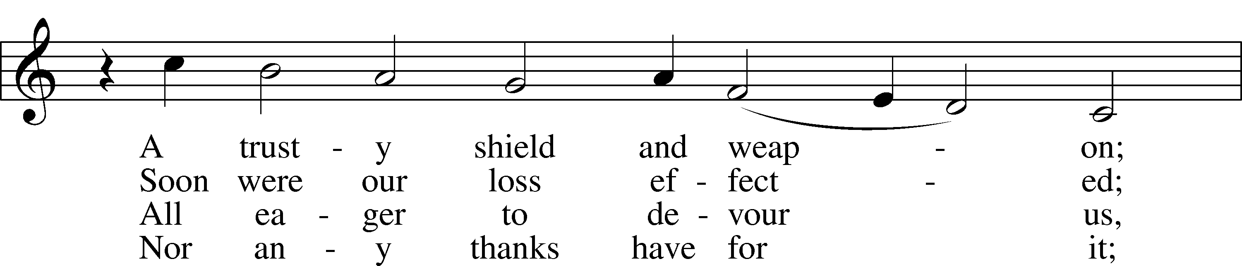
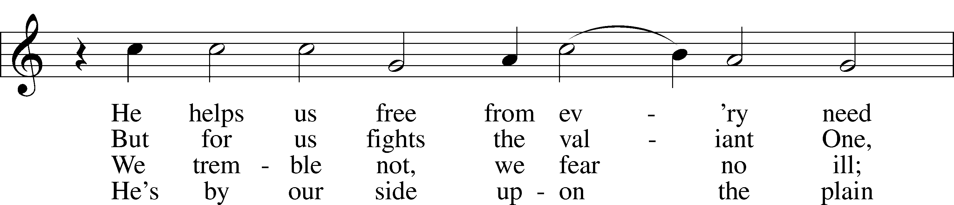
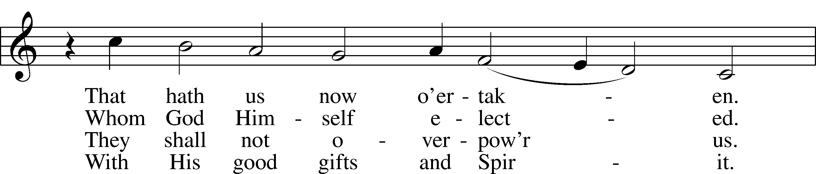
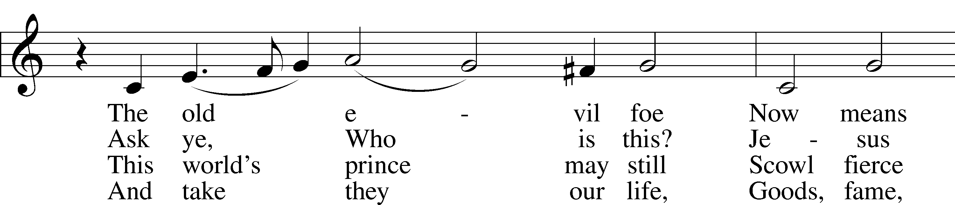
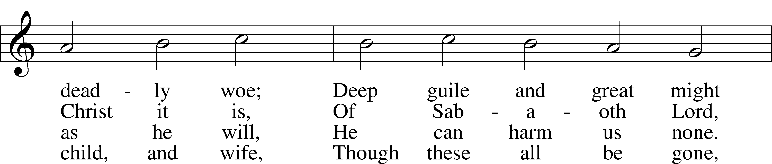
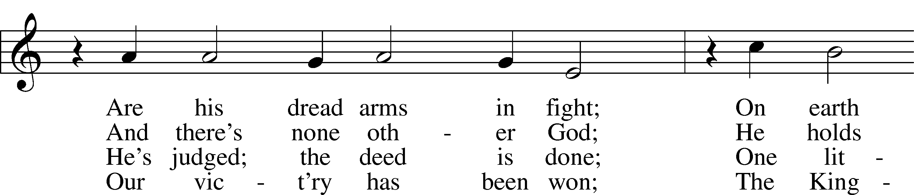
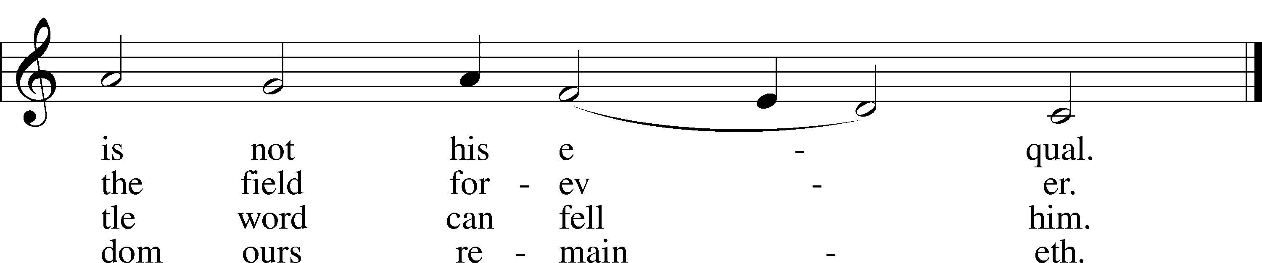
Tune and text: Public domain

Stand

The sign of the cross may be made by all in remembrance of their Baptism.

Invocation
P In the name of the Father and of the T Son and of the Holy Spirit.
C Amen.

Exhortation LSB 213
P Beloved in the Lord! Let us draw near with a true heart and confess our sins unto God our Father, beseeching Him in the name of our Lord Jesus Christ to grant us forgiveness.

P Our help is in the name of the Lord,
C who made heaven and earth.
P I said, I will confess my transgressions unto the Lord,
C and You forgave the iniquity of my sin.

Silence for reflection on God’s Word and for self-examination.

Confession of Sins LSB 213
P O almighty God, merciful Father,
C I, a poor, miserable sinner, confess unto You all my sins and iniquities with which I have ever offended You and justly deserved Your temporal and eternal punishment. But I am heartily sorry for them and sincerely repent of them, and I pray You of Your boundless mercy and for the sake of the holy, innocent, bitter sufferings and death of Your beloved Son, Jesus Christ, to be gracious and merciful to me, a poor, sinful being.

Absolution LSB 213
P Upon this your confession, I, by virtue of my office, as a called and ordained servant of the Word, announce the grace of God unto all of you, and in the stead and by the command of my Lord Jesus Christ I forgive you all your sins in the name of the Father and of the T Son and of the Holy Spirit.
C Amen.
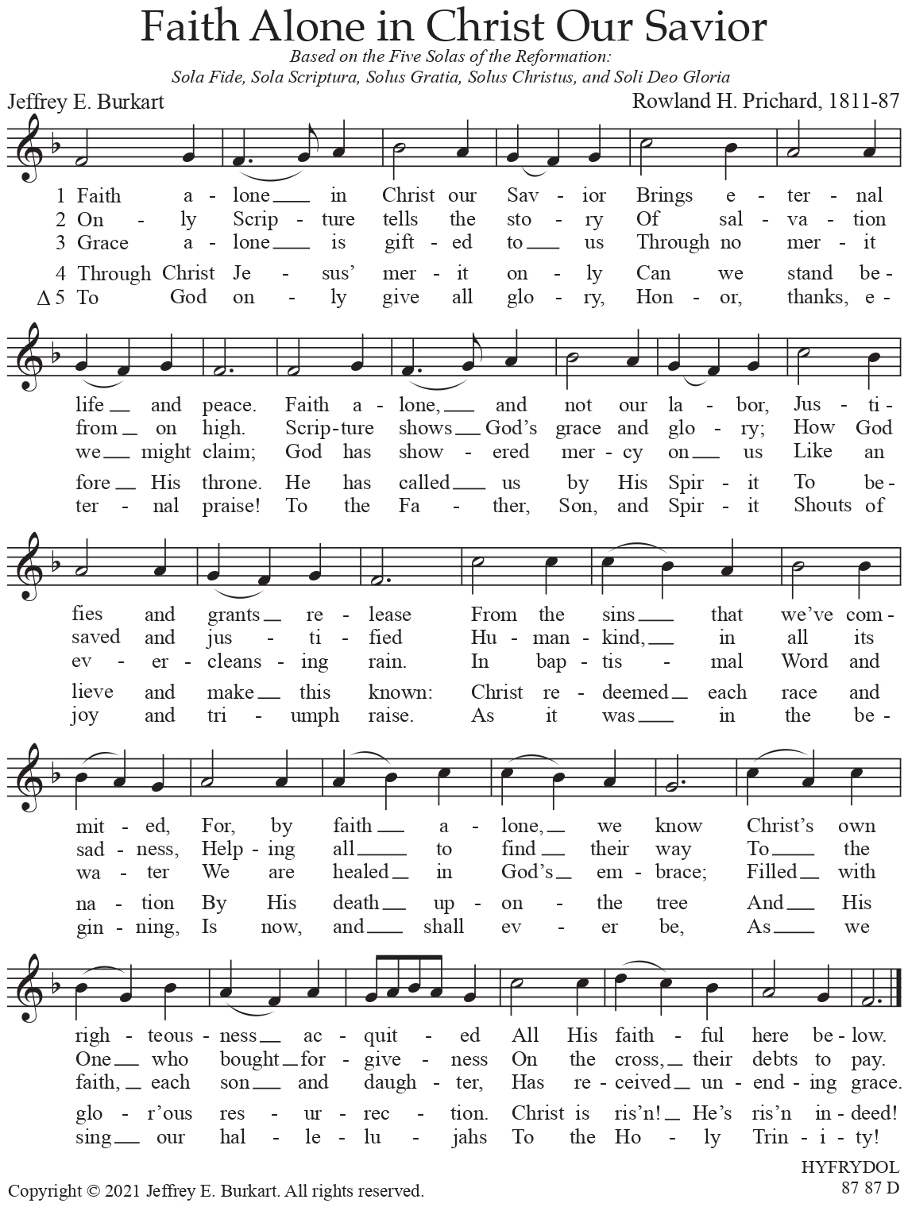
Used by Permission of the Author: Dr. Jeffrey E. Burkart

Stand

Service of the Word

Introit Psalm 34:1–2, 11, 22; antiphon: Psalm 119:46
I will speak of your testimonies before kings, | [O Lord,]*
and shall not be | put to shame.
I will bless the Lord at | all times;*
his praise shall continually be | in my mouth.
My soul makes its boast | in the Lord;*
let the humble hear | and be glad.
Come, O children, lis- | ten to me;*
I will teach you the fear | of the Lord.
The Lord redeems the life of his | servants;*
none of those who take refuge in him will | be condemned.
Glory be to the Father and | to the Son*
and to the Holy | Spirit;
as it was in the be- | ginning,*
is now, and will be forever. | Amen.
I will speak of your testimonies before kings, | [O Lord,]*
and shall not be | put to shame.

942 Kyrie! God, Father
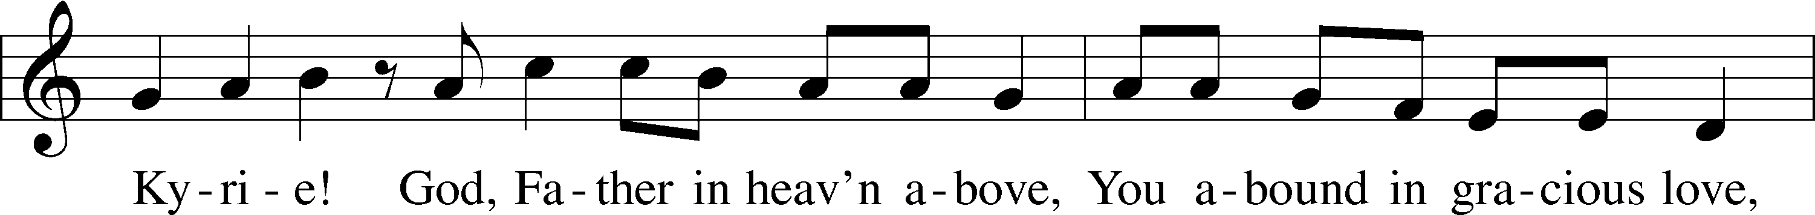
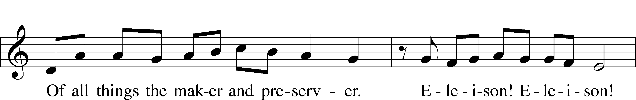
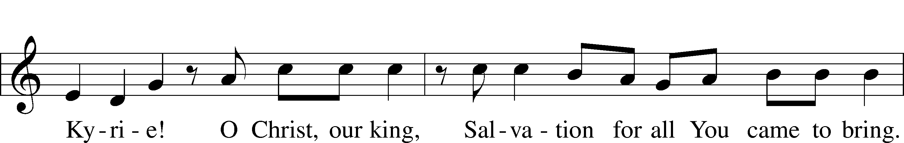
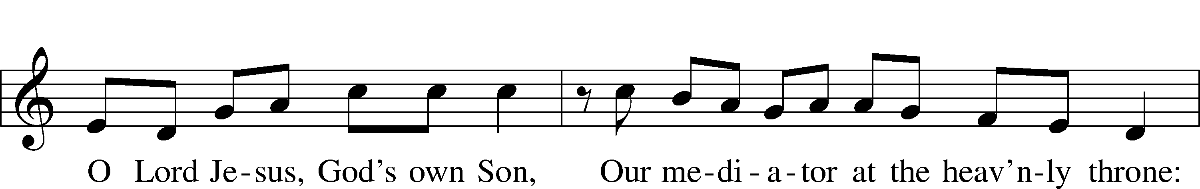
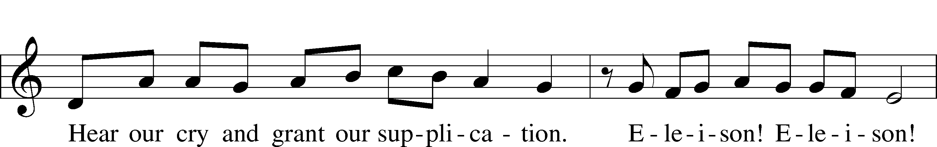
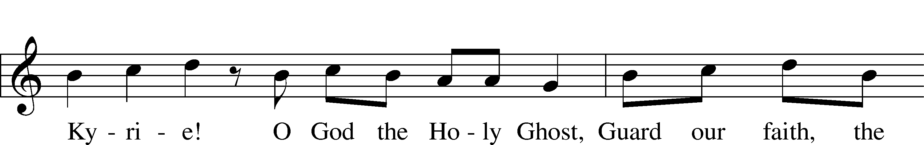
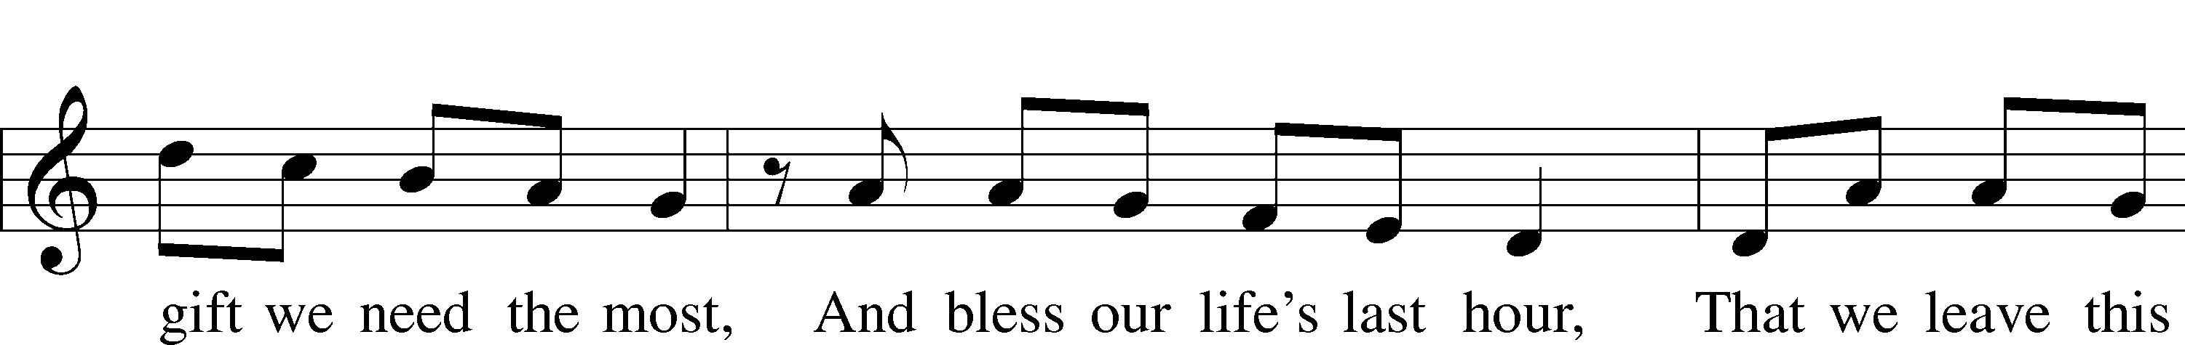
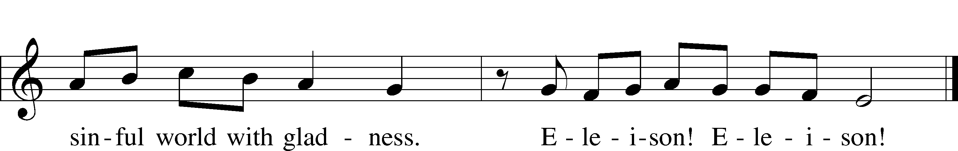
Tune: Public domain
Text: © 1941 Concordia Publishing House. Used by permission: LSB Hymn License no. 110005504

947 All Glory Be to God on High
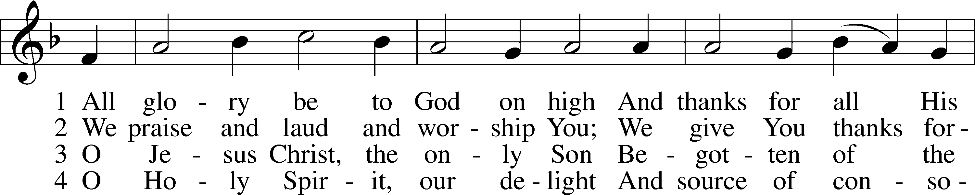
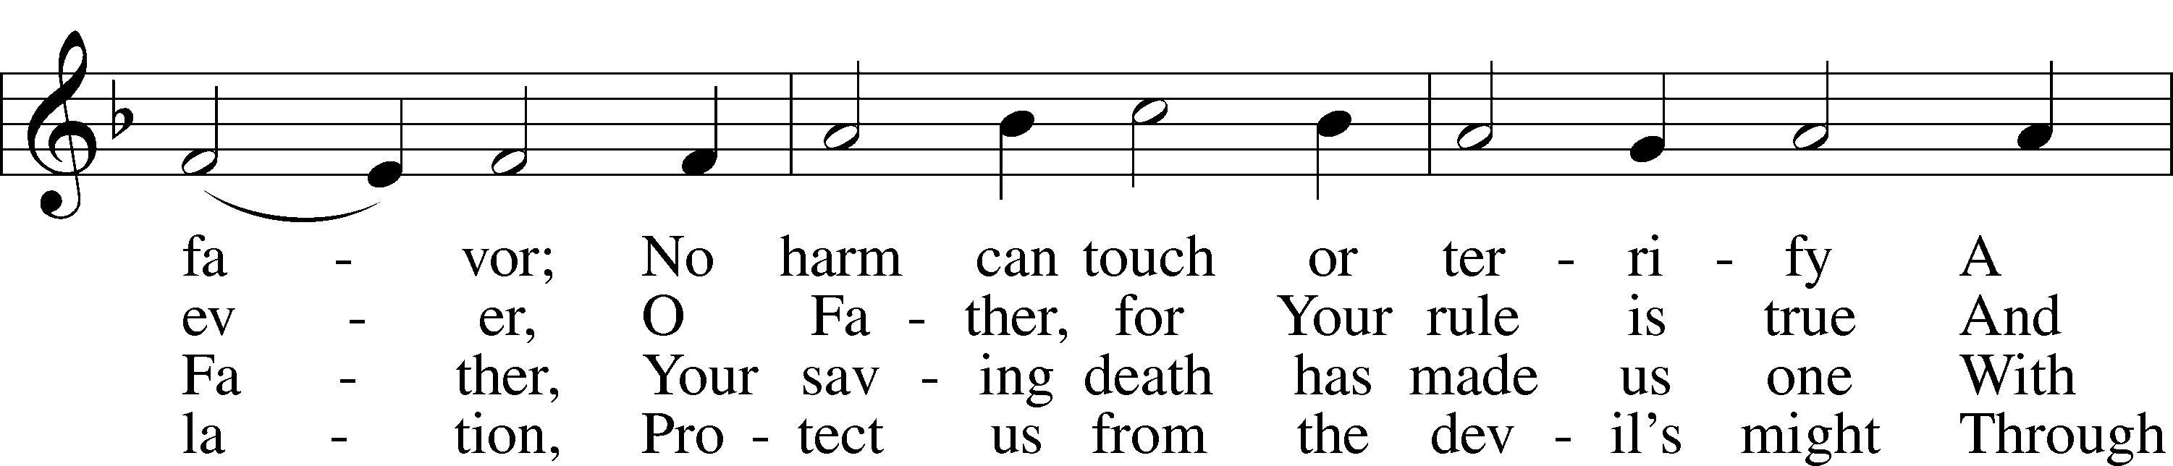
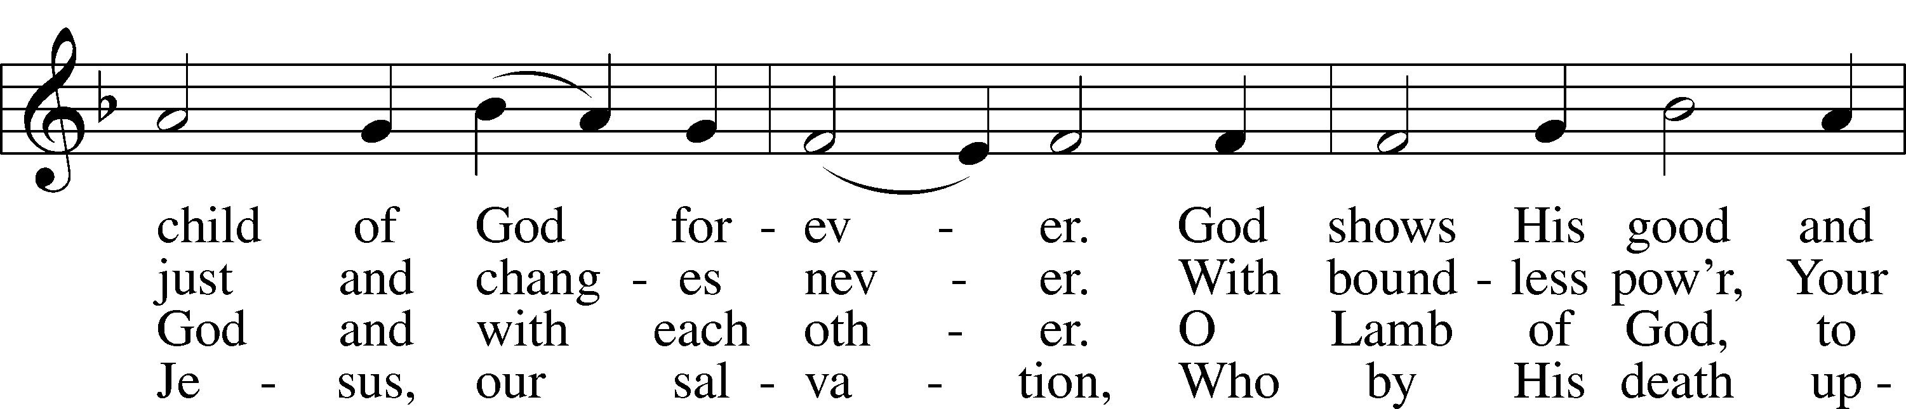
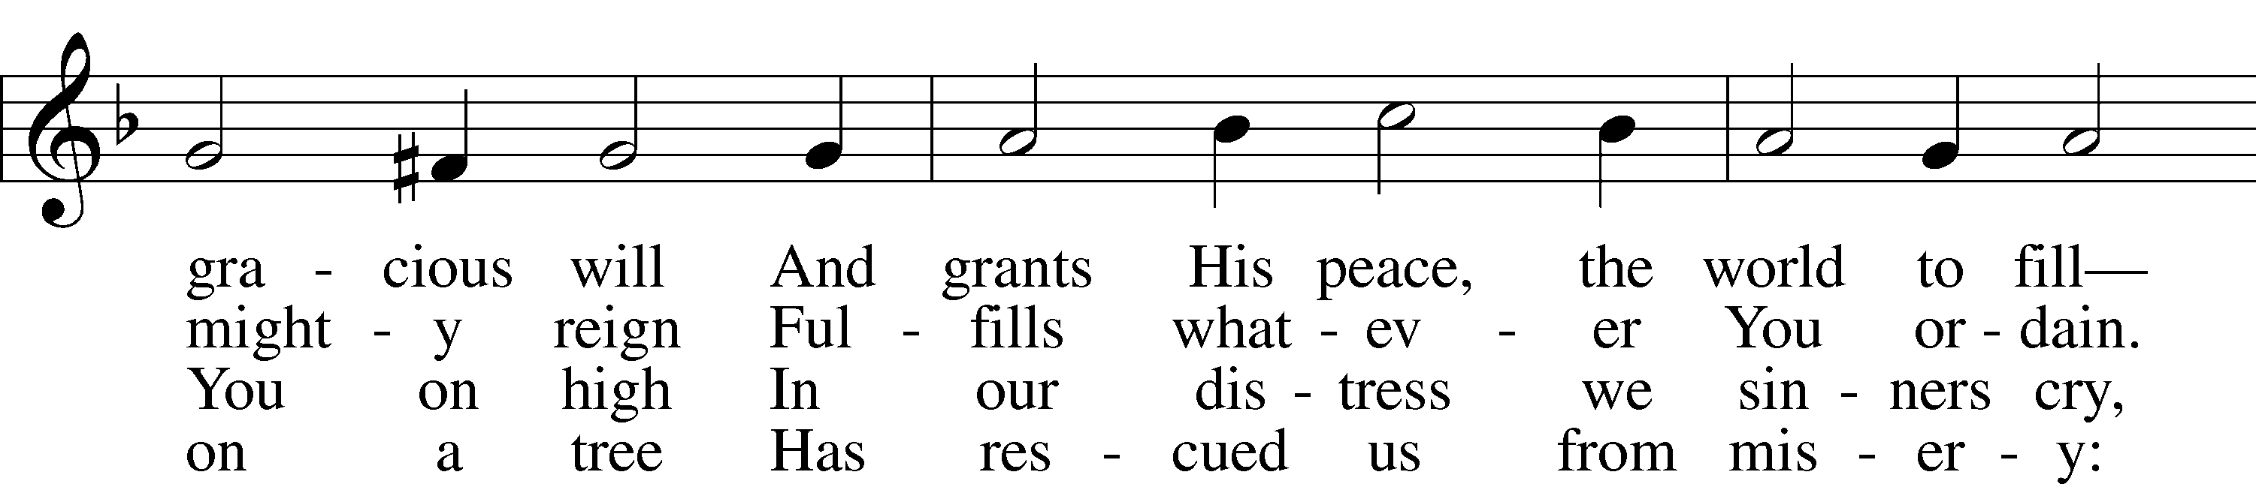
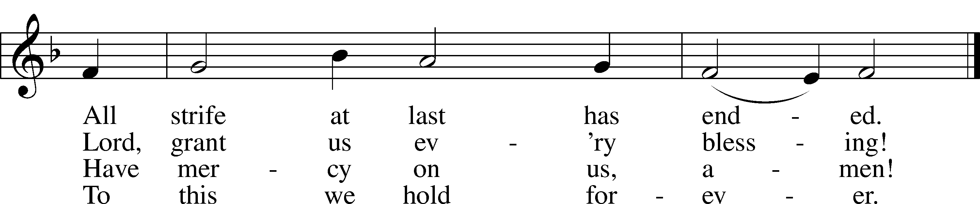
Text: © 2006 Concordia Publishing House. Used by permission: LSB Hymn License no. 110005504
Tune: Public domain

Salutation and Collect of the Day
P The Lord be with you.
C And also with you.

P Let us pray.
Almighty and gracious Lord, pour out Your Holy Spirit on Your faithful people. Keep us steadfast in Your grace and truth, protect and deliver us in times of temptation, defend us against all enemies, and grant to Your Church Your saving peace; through Jesus Christ, Your Son, our Lord, who lives and reigns with You and the Holy Spirit, one God, now and forever.

C Amen.

Sit

First Reading Revelation 14:6–7
6Then I saw another angel flying directly overhead, with an eternal gospel to proclaim to those who dwell on earth, to every nation and tribe and language and people. 7And he said with a loud voice, “Fear God and give him glory, because the hour of his judgment has come, and worship him who made heaven and earth, the sea and the springs of water.”

A This is the Word of the Lord.
C Thanks be to God.

Psalm Psalm 46; antiphon: v. 7
1God is our ref- | uge and strength,*
a very present help in | trouble.
2Therefore we will not fear though the | earth gives way,*
though the mountains be moved into the heart | of the sea,
3though its waters | roar and foam,*
though the mountains tremble at its | swelling.
4There is a river whose streams make glad the cit- | y of God,*
the holy habitation of the | Most High.
5God is in the midst of her; she shall | not be moved;*
God will help her when | morning dawns.
6The nations rage, the kingdoms | totter;*
he utters his voice, the | earth melts.
7The Lord of hosts is | with us;*
the God of Jacob is our | fortress.
8Come, behold the works | of the Lord,*
how he has brought desolations | on the earth.
9He makes wars cease to the end | of the earth;*
he breaks the bow and shatters the spear;
he burns the chariots | with fire.
10“Be still, and know that | I am God.*
I will be exalted among the nations,
I will be exalted | in the earth!”
11The Lord of hosts is | with us;*
the God of Jacob is our | fortress.

Creed: We All Believe in One True God LSB 953
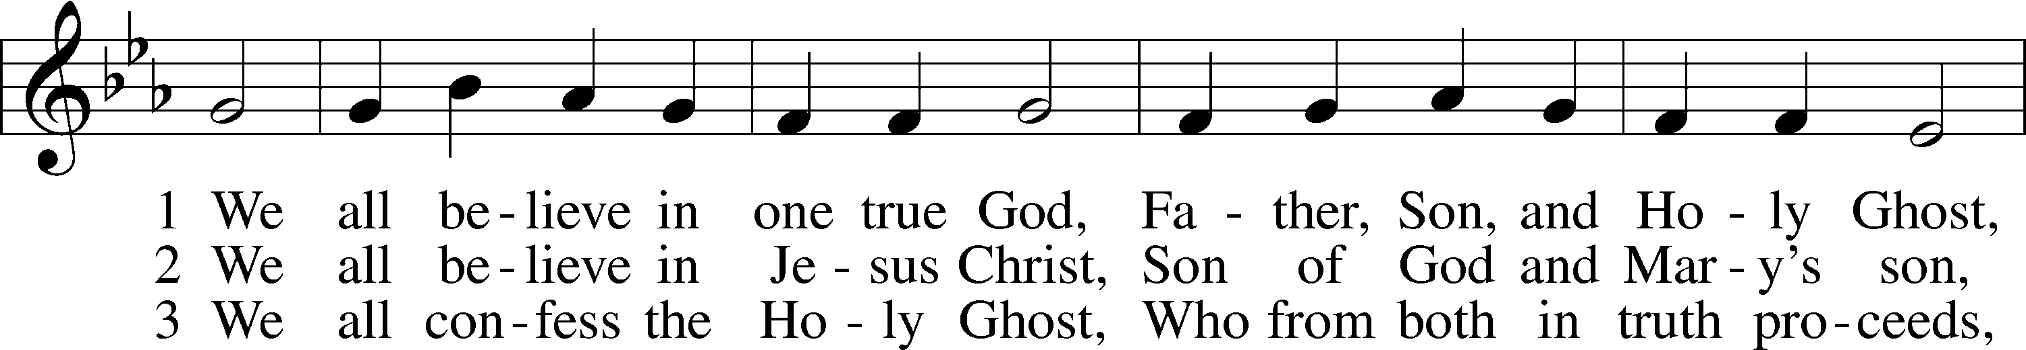
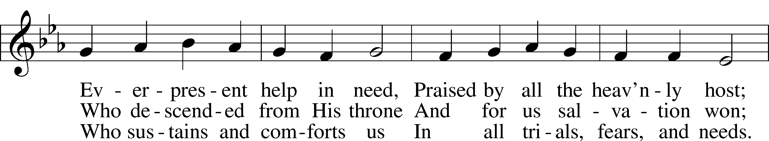
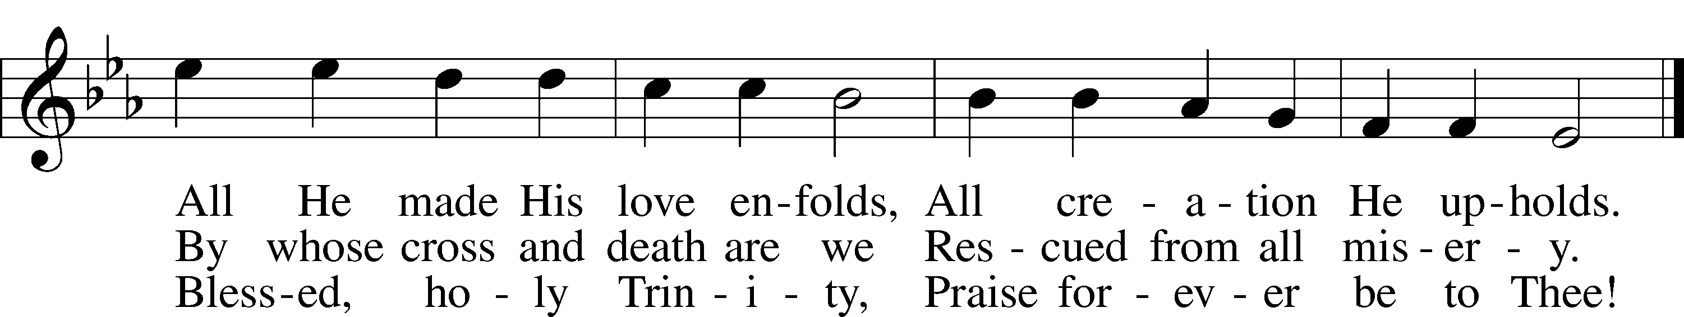
Text and tune: Public domain

Epistle Romans 3:19–28
19Now we know that whatever the law says it speaks to those who are under the law, so that every mouth may be stopped, and the whole world may be held accountable to God. 20For by works of the law no human being will be justified in his sight, since through the law comes knowledge of sin.
21But now the righteousness of God has been manifested apart from the law, although the Law and the Prophets bear witness to it— 22the righteousness of God through faith in Jesus Christ for all who believe. For there is no distinction: 23for all have sinned and fall short of the glory of God, 24and are justified by his grace as a gift, through the redemption that is in Christ Jesus, 25whom God put forward as a propitiation by his blood, to be received by faith. This was to show God’s righteousness, because in his divine forbearance he had passed over former sins. 26It was to show his righteousness at the present time, so that he might be just and the justifier of the one who has faith in Jesus.
27Then what becomes of our boasting? It is excluded. By what kind of law? By a law of works? No, but by the law of faith. 28For we hold that one is justified by faith apart from works of the law.

A This is the Word of the Lord.
C Thanks be to God.

Hymn of the Day: Salvation Unto Us Has Come LSB 555 stz 1-4
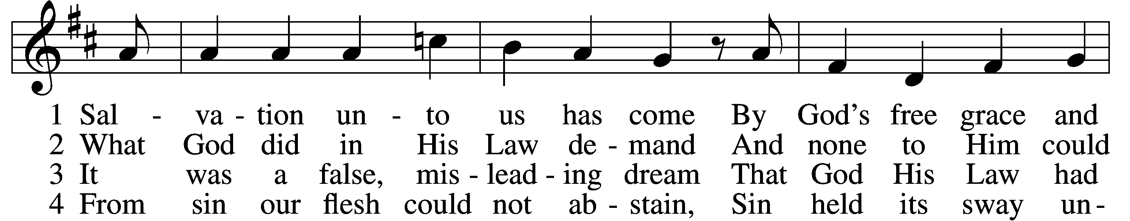
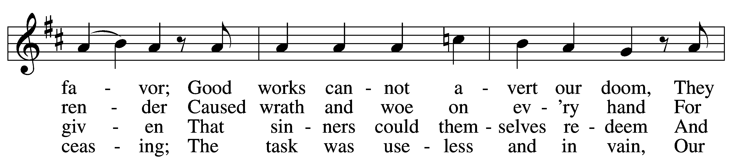
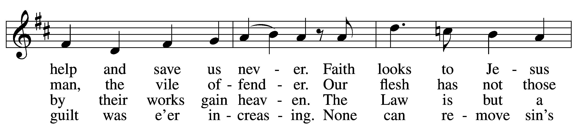
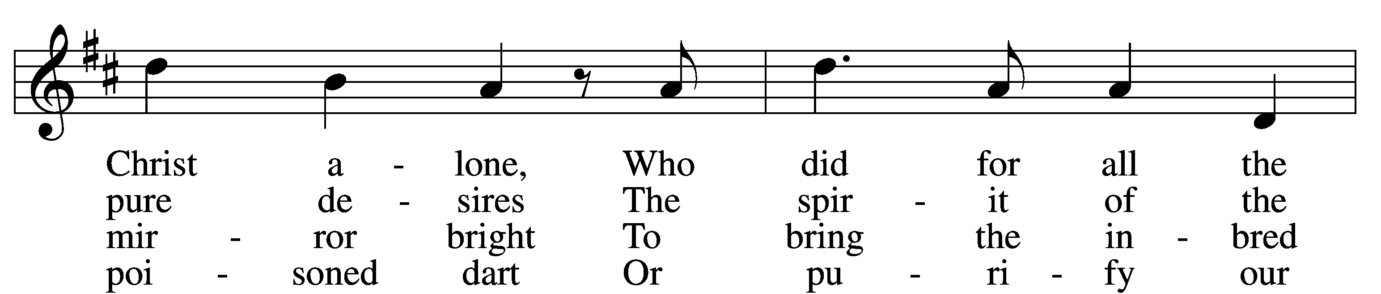
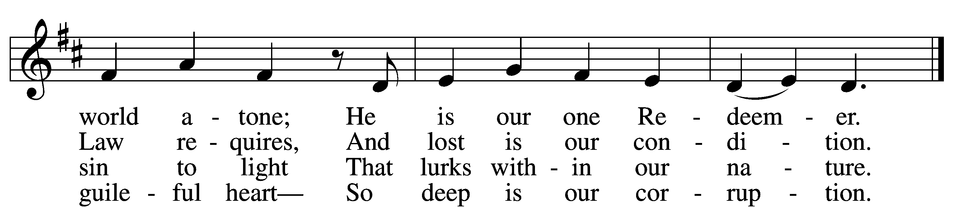
Tune and text: Public domain

Stand

Holy Gospel John 8:31–36
P The Holy Gospel according to St. John, the eighth chapter.
C Glory to You, O Lord.

31So Jesus said to the Jews who had believed in him, “If you abide in my word, you are truly my disciples, 32and you will know the truth, and the truth will set you free.” 33They answered him, “We are offspring of Abraham and have never been enslaved to anyone. How is it that you say, ‘You will become free’?”
34Jesus answered them, “Truly, truly, I say to you, everyone who commits sin is a slave to sin. 35The slave does not remain in the house forever; the son remains forever. 36So if the Son sets you free, you will be free indeed.”

P This is the Gospel of the Lord.
C Praise to You, O Christ.

Sit

Hymn: Salvation Unto Us Has Come LSB 555 sts. 5–10
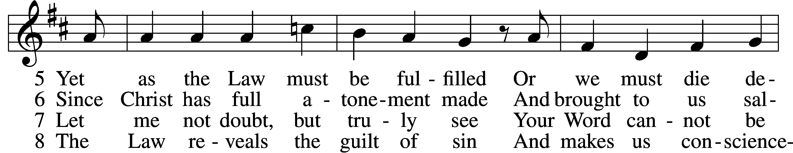
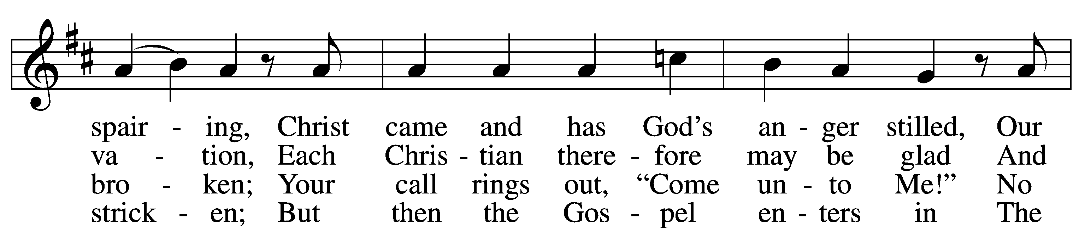
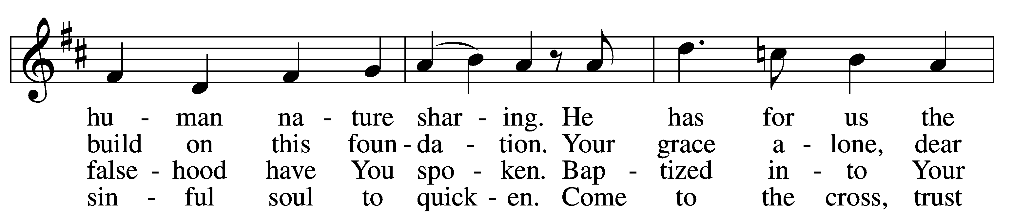
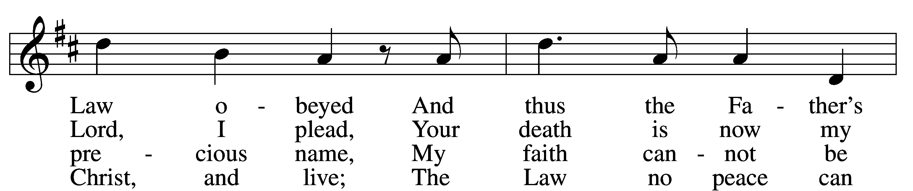
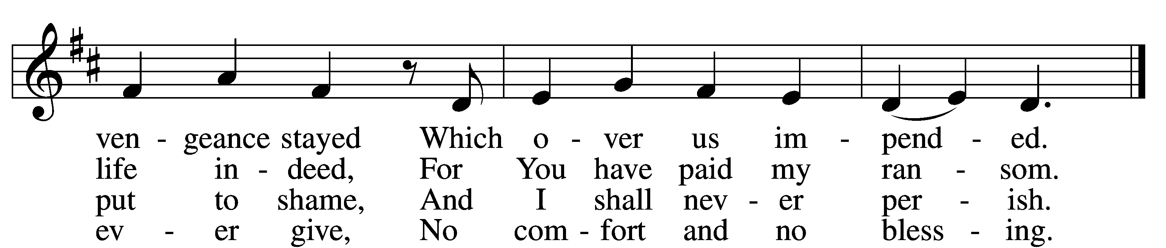

9 Faith clings to Jesus’ cross alone
And rests in Him unceasing;
And by its fruits true faith is known,
With love and hope increasing.
For faith alone can justify;
Works serve our neighbor and supply
The proof that faith is living.
D 10 All blessing, honor, thanks, and praise
To Father, Son, and Spirit,
The God who saved us by His grace;
All glory to His merit.
O triune God in heav’n above,
You have revealed Your saving love;
Your blessèd name we hallow.

Tune and text: Public domain

Sermon

Offering

Offering Hymn: Rise Up, O Believer (Sunday School sings verse 1, Congregation sings 2-4) One And All Rejoice 265
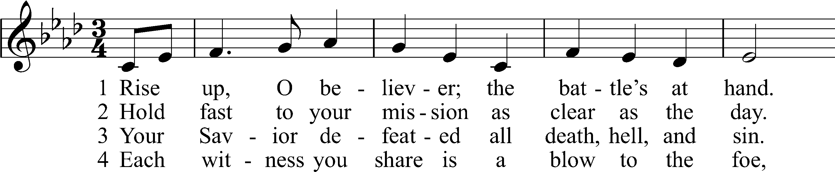
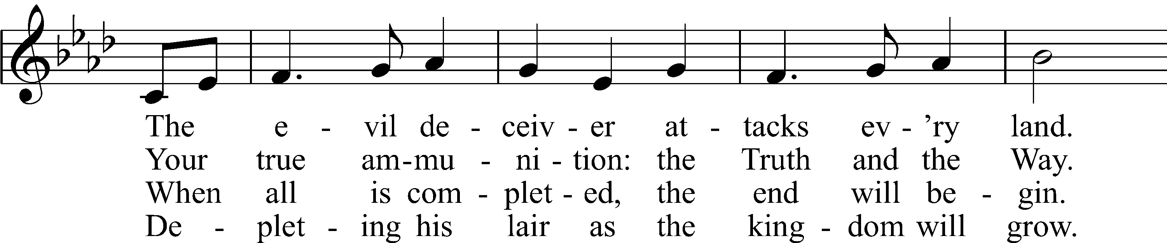
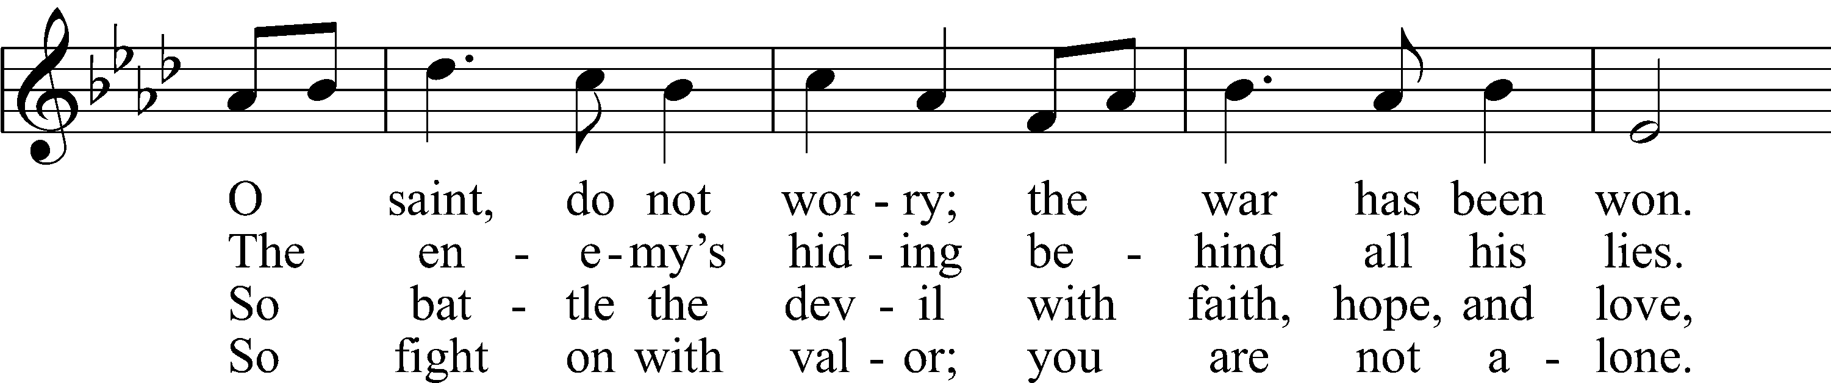
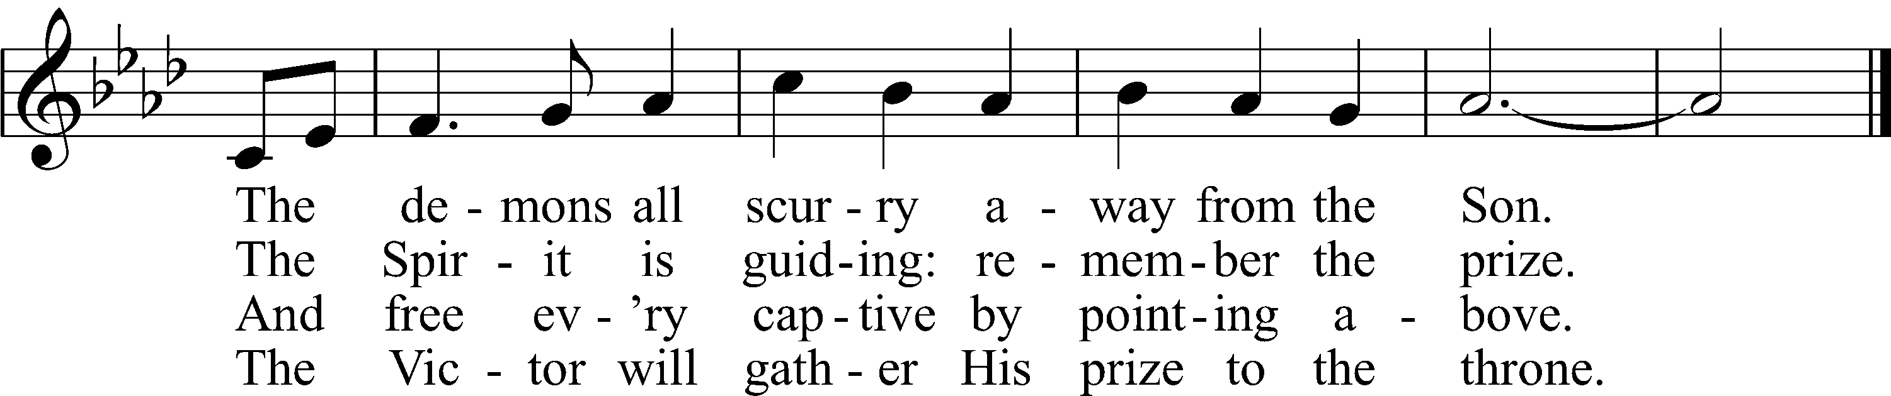
Tune: © 2020 Benjamin M. Culli. Used by permission: OAR Hymn License no. 110005504
Text: © 2020 Concordia Publishing House. Used by permission: OAR Hymn License no. 110005504

Prayer of the Church
P Friends in Christ, I urge you all to lift up your hearts to God and pray with me as Christ our Lord has taught us and freely promised to hear us.
Gracious heavenly Father, we thank You for the comfort of the Gospel restored to Your Church on earth through the work of Martin Luther and other faithful pastors and leaders during the Reformation. We praise You that by Your rich grace we have come to the sure knowledge that we stand justified before You, not by what we have done, but rather by faith in what Your Son, Jesus Christ, our Lord, has done on our behalf. We implore You, defend Your Church from all enemies of Your saving Word. Cause Your eternal Gospel to be proclaimed in our time to every nation, tribe, language and people on earth, and graciously preserve Your truth for generations to come. Lord, in Your mercy, hear our prayer.

Lord, make us truly Your disciples. Keep us in Your Word, free us from all errors, and make our homes and families peaceful. Preserve all fathers and encourage them for their godly task, that children would be brought up in the fear and instruction of the Lord. Lord, in Your mercy, hear our prayer.

Be with our catechumens. Teach us also to hear and learn Your Word anew as disciples with them. Lord, in Your mercy, hear our prayer.

Have mercy on our nation. Give us good and faithful rulers who will govern after Your good pleasure. Give us comfort and a right understanding of Your rule in this world, that we would not be deceived to think earthly powers will last forever, but have confidence in You alone. Your kingdom come! Lord, in Your mercy, hear our prayer.

Hear our prayers for the sick, the joyful and those in any need [especially _____________]. Answer their prayers, preserve them by Your promises and bring them safely through this world to everlasting life. Lord, in Your mercy, hear our prayer.

You have given us the certainty of sins forgiven in Your Son, set forth as the propitiation for our sins by His blood to be received by faith. So lead us to eat and drink Your holy body and precious blood in repentance and faith, now and always. Lord, in Your mercy, hear our prayer.

Lord God, heavenly Father, we thank You that You have brought us by Your Word out of the darkness of error and into the light of Your grace. Mercifully help us to walk in that light. Guard us from error and false doctrine, and grant that we do not become ungrateful and despise Your Word, but receive it with all our heart, conduct our lives according to it and put our trust in Your grace; through the merits of Jesus Christ, Your Son, our Lord, who lives and reigns with You and the Holy Spirit, one God, now and forever. Amen.

Service of the Sacrament
Please complete a communion card for our records; they are in the pew in front of you, or request one from an usher. Salem’s communion practice is that of close communion. We invite to our rail those who are members in good standing of sister Missouri Synod parishes. Visitors, please contact the pastor prior to communing. For those who prefer to use the Common Cup, we ask your assistance by holding the cup’s base as you commune.

Stand

Preface LSB 216
P The Lord be with you.
C And also with you.

P Lift up your hearts.
C We lift them to the Lord.

P Let us give thanks to the Lord our God.
C It is right to give Him thanks and praise.

P It is truly good, right, and salutary that we should at all times and in all places give thanks to You, O Lord our God, king of all creation, for You have had mercy on us and given Your only-begotten Son that whoever believes in Him should not perish but have eternal life. Grant us Your Spirit, gracious Father, that we may give heed to the testament of Your Son in true faith and, above all, firmly take to heart the words with which Christ gives to us His body and blood for our forgiveness. By Your grace, lead us to remember and give thanks for the boundless love which He manifested to us when, by pouring out His precious blood, He saved us from Your righteous wrath and from sin, death, and hell. Grant that we may receive the bread and wine, that is, His body and blood, as a gift, guarantee, and pledge of His salvation. Graciously receive our prayers; deliver and preserve us. To You alone, O Father, be all glory, honor, and worship, with the Son and the Holy Spirit, one God, now and forever.
C Amen.

Lord’s Prayer
C Our Father who art in heaven,
hallowed be Thy name,
Thy kingdom come,
Thy will be done on earth
as it is in heaven;
give us this day our daily bread;
and forgive us our trespasses
as we forgive those
who trespass against us;
and lead us not into temptation,
but deliver us from evil.
For Thine is the kingdom
and the power and the glory
forever and ever. Amen.

P In the name of our Lord and Savior Jesus Christ, at His command, and with His own words, we receive His testament:

The Words of Our Lord LSB 217
P Our Lord Jesus Christ, on the night when He was betrayed, took bread, and when He had given thanks, He broke it and gave it to the disciples and said: “Take, eat; this is My T body, which is given for you. This do in remembrance of Me.”

In the same way also He took the cup after supper, and when He had given thanks, He gave it to them, saying: “Drink of it, all of you; this cup is the new testament in My T blood, which is shed for you for the forgiveness of sins. This do, as often as you drink it, in remembrance of Me.”

Sanctus: Isaiah, Mighty Seer in Days of Old LSB 960
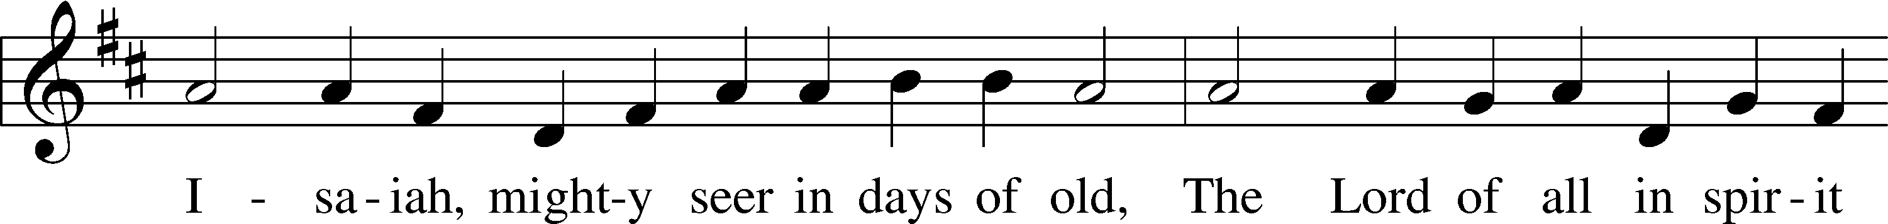
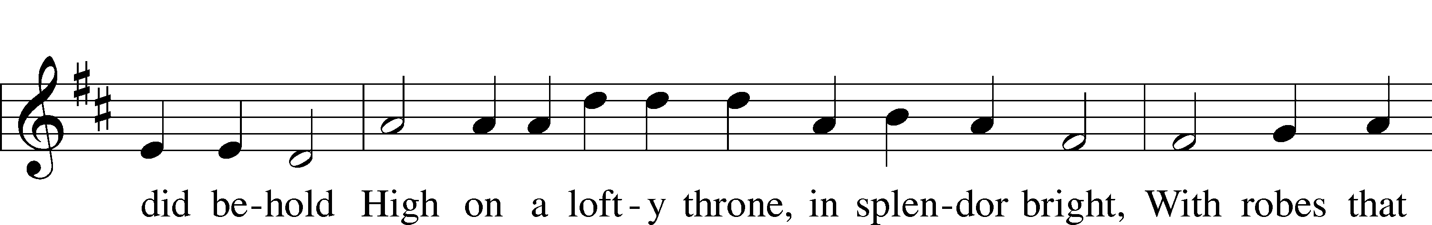
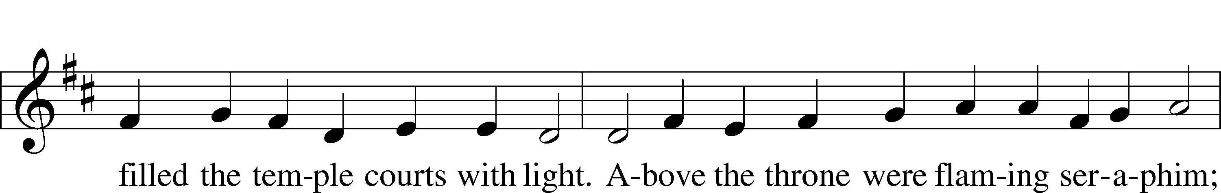
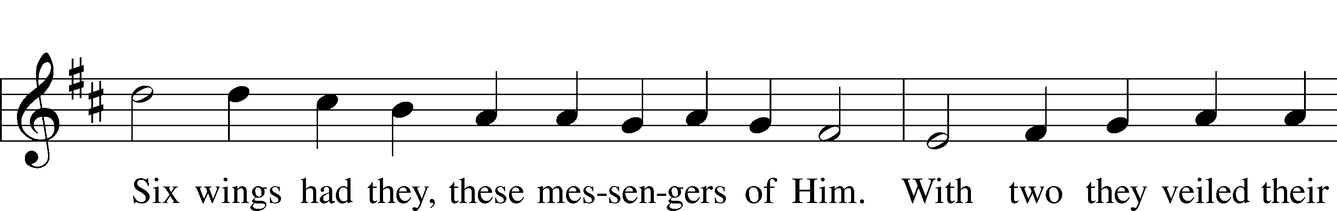
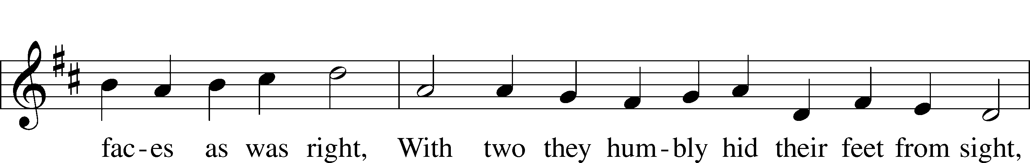
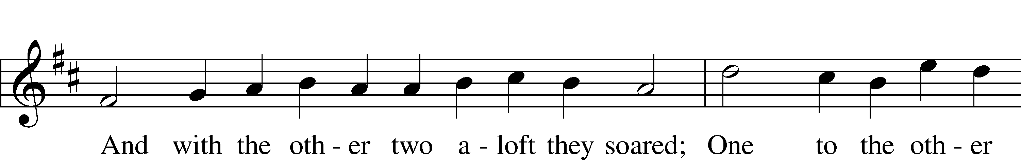
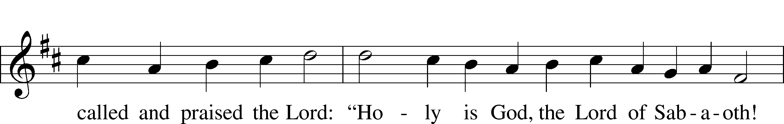
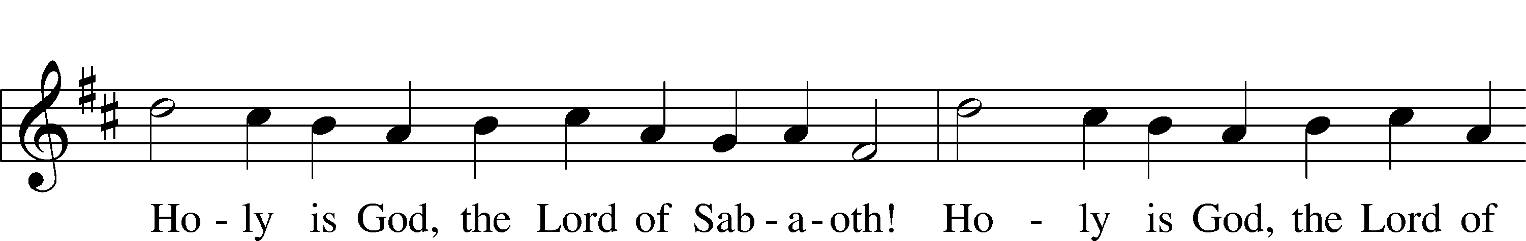
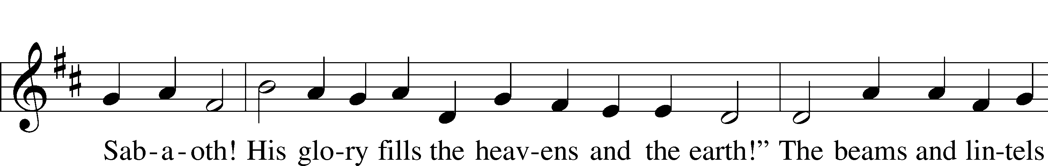
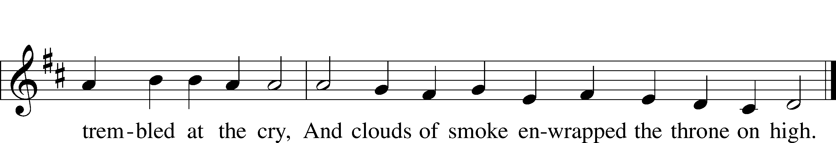
Text: © 1941 Concordia Publishing House. Used by permission: LSB Hymn License no. 110005504
Tune: Public domain

Pax Domini
P The peace of the Lord be with you always.
C Amen.

Agnus Dei: Lamb of God, Pure and Holy LSB 434
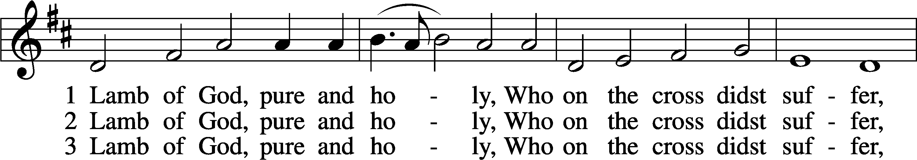
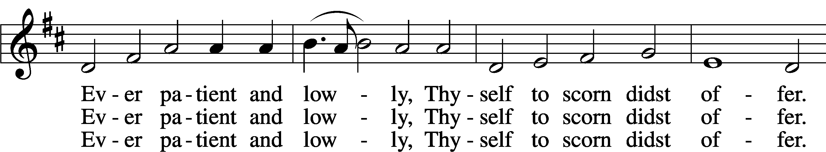
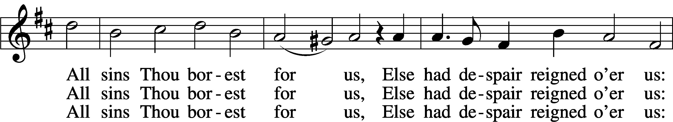
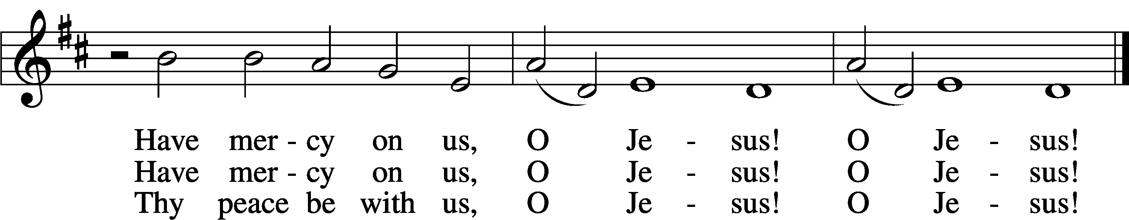
Tune and text: Public domain

Sit

Distribution

Distribution Hymn: Lord, Keep Us Steadfast in Your Word LSB 655
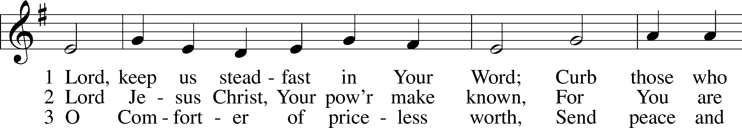
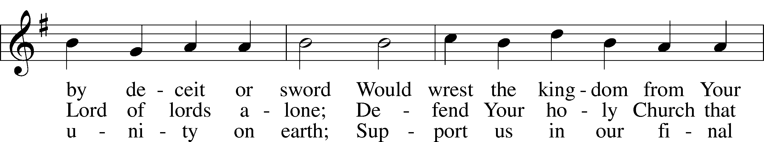
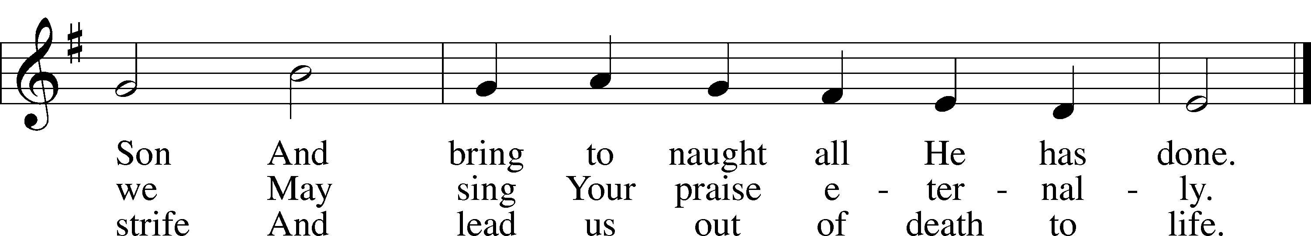
Text and tune: Public domain

Distribution Hymn: What is this Bread? LSB 629
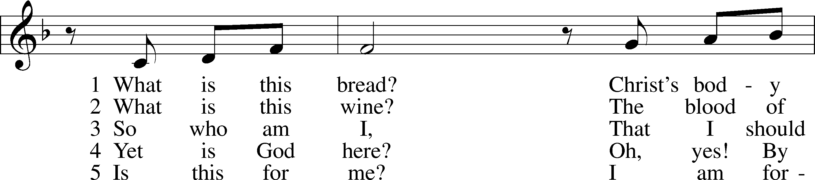
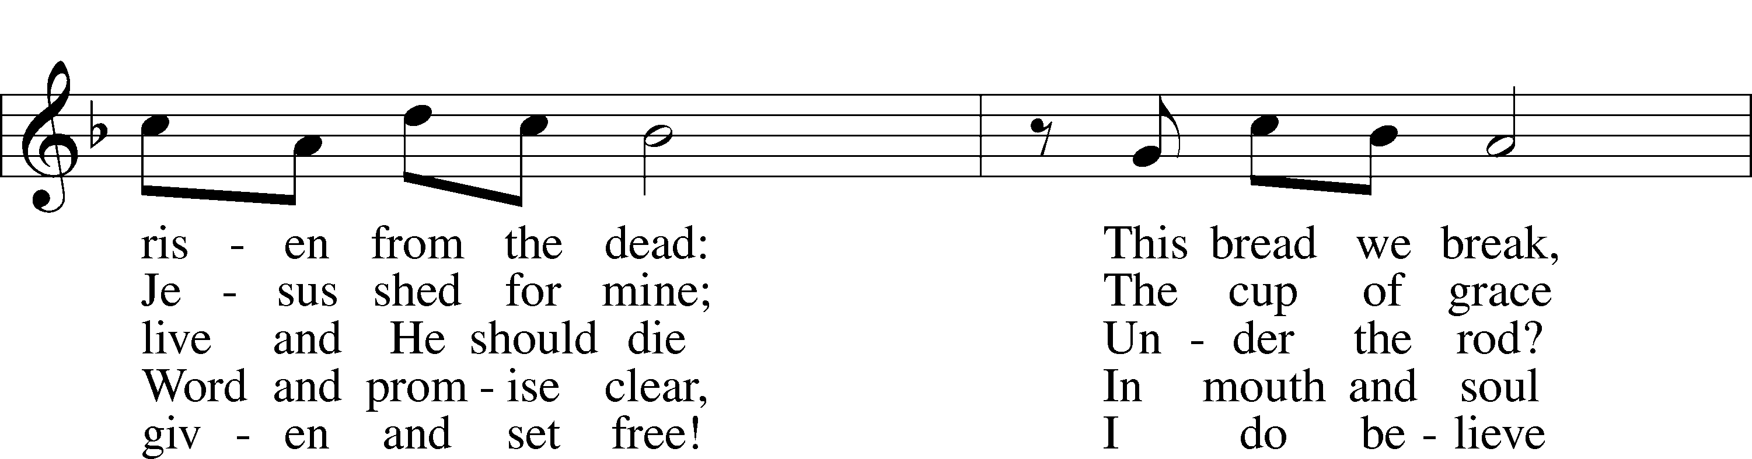
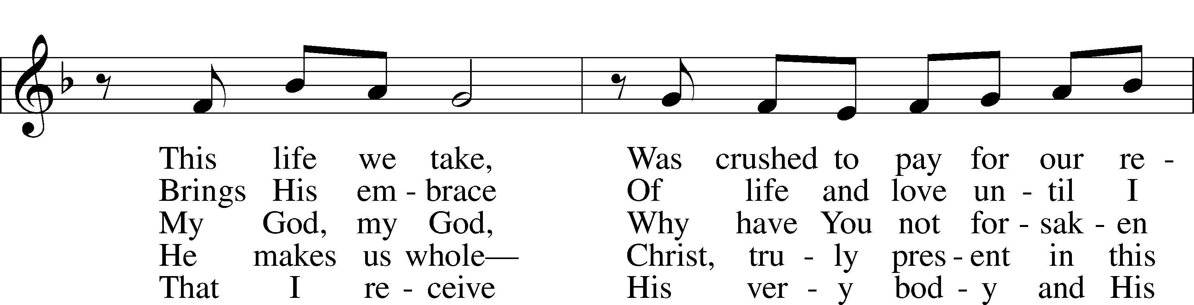
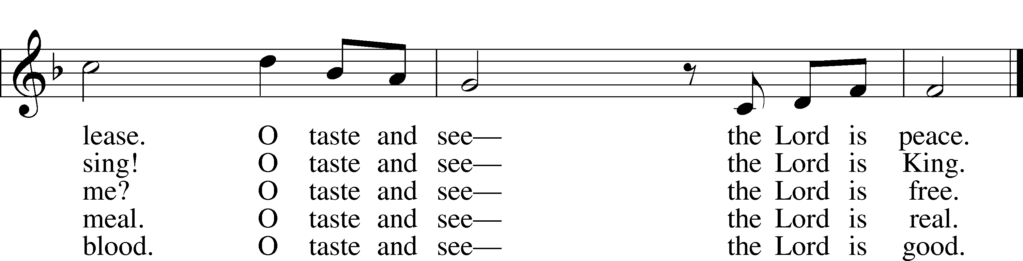
Tune and text: © 1991 Fred and Jean Baue. Used by permission: LSB Hymn License no. 110005504

Stand

Post-Communion Hymn: O Lord, We Praise Thee LSB 617
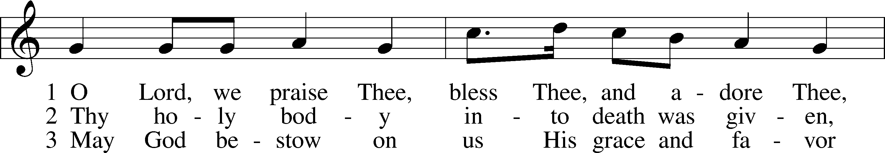
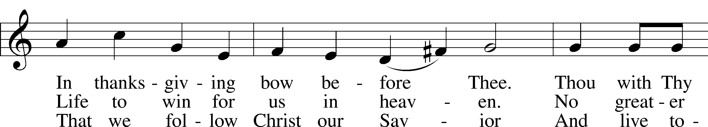
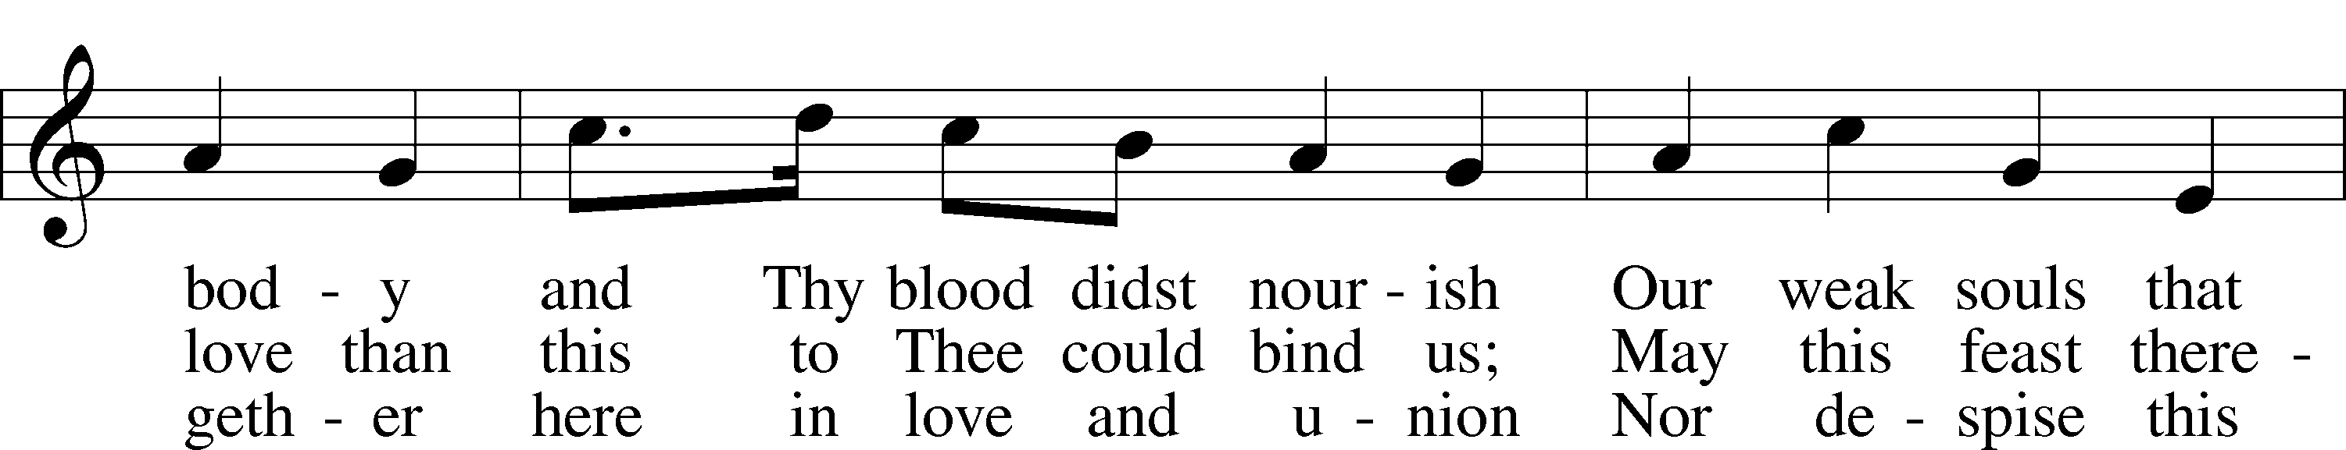
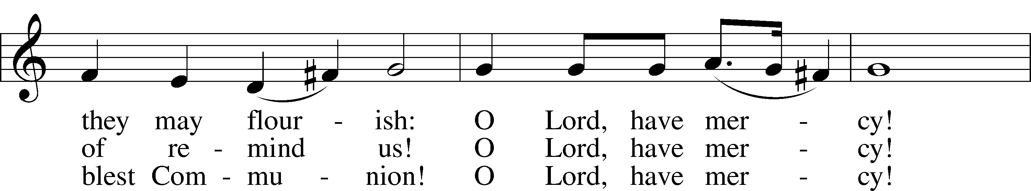
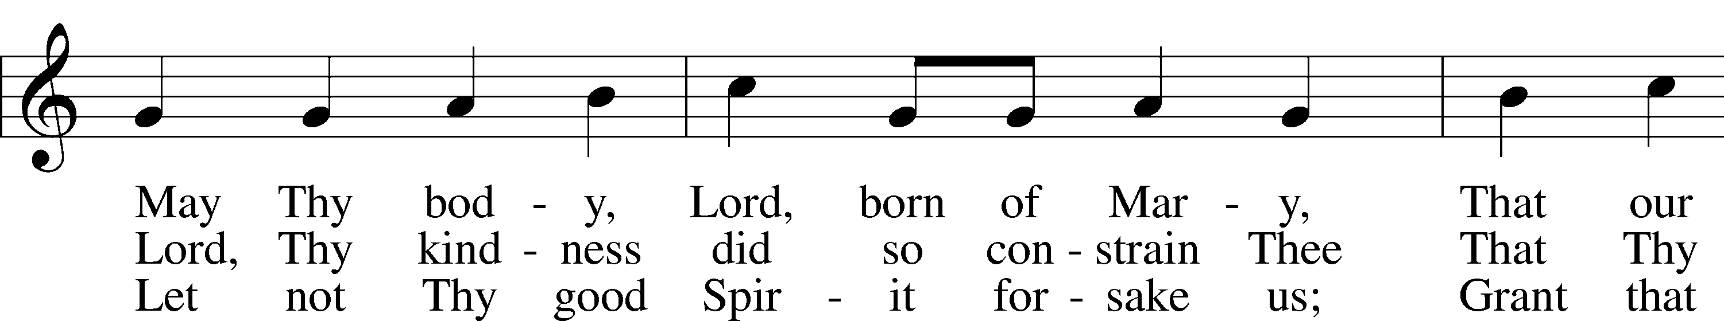
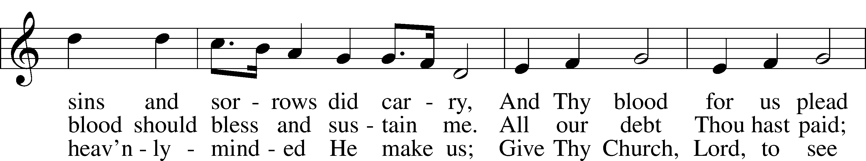
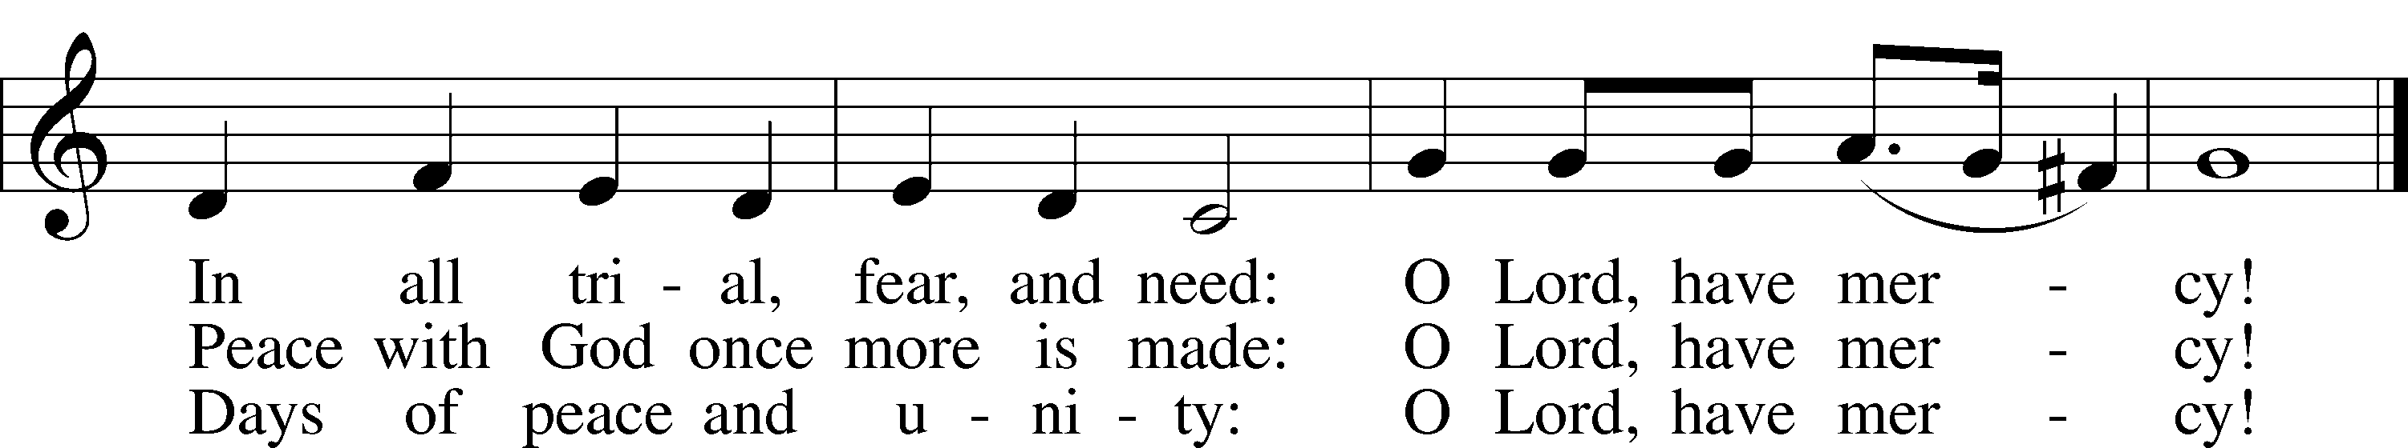
Tune: Public domain
Text: © 1941 Concordia Publishing House. Used by permission: LSB Hymn License no. 110005504

Post-Communion Collect
A Let us pray.
We give thanks to You, almighty God, that You have refreshed us through this salutary gift, and we implore You that of Your mercy You would strengthen us through the same in faith toward You and in fervent love toward one another; through Jesus Christ, Your Son, our Lord, who lives and reigns with You and the Holy Spirit, one God, now and forever.
C Amen.

Benedicamus LSB 218
A Let us bless the Lord.
C Thanks be to God.

Benediction
P The Lord bless you and keep you.
The Lord make His face shine on you and be gracious to you.
The Lord look upon you with favor and T give you peace.
C Amen.

Hymn to Depart: Faith and Truth and Life Bestowing LSB 584
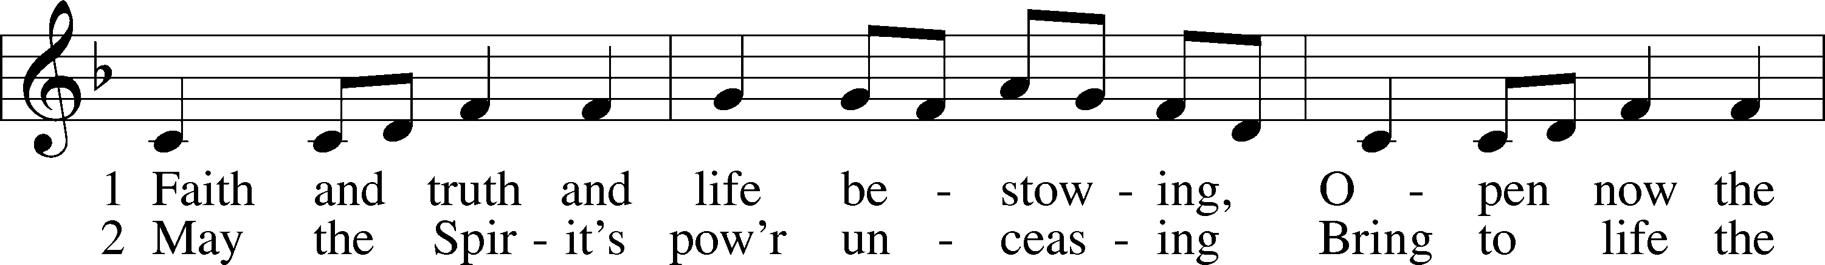
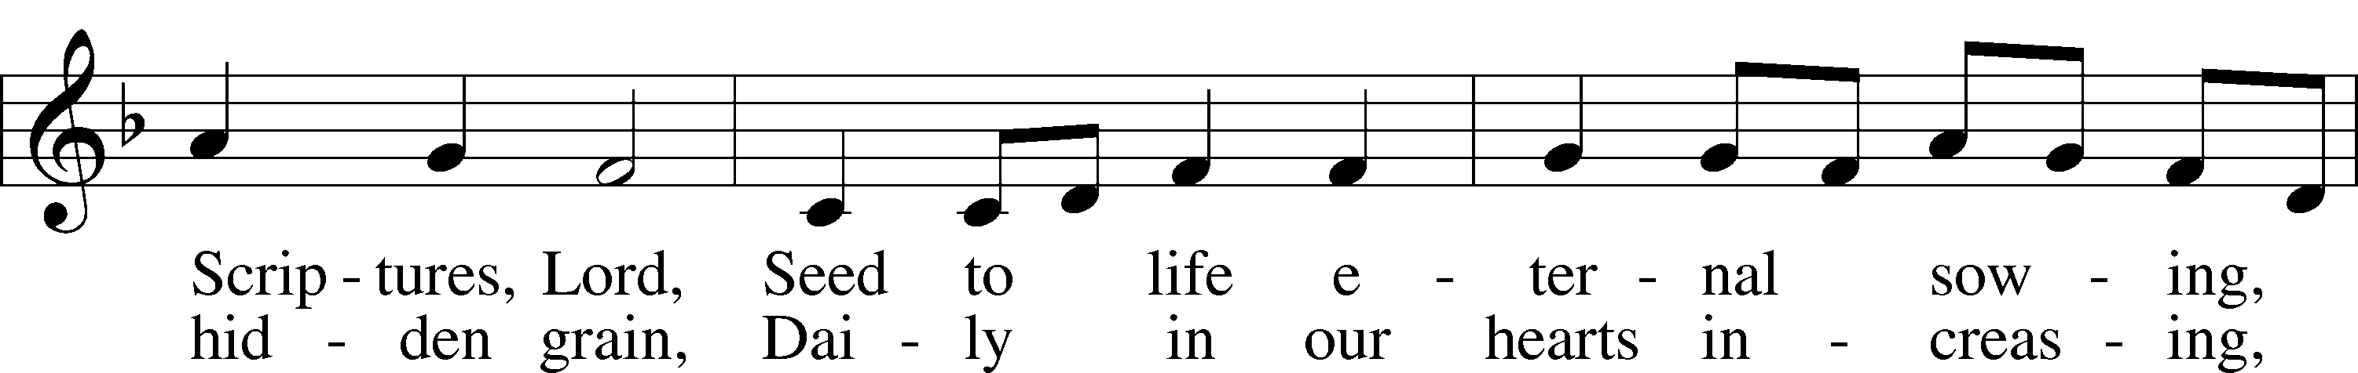
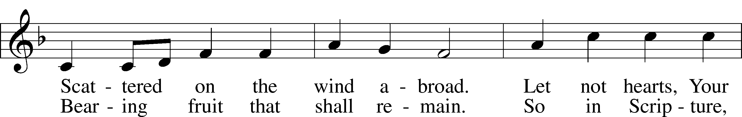
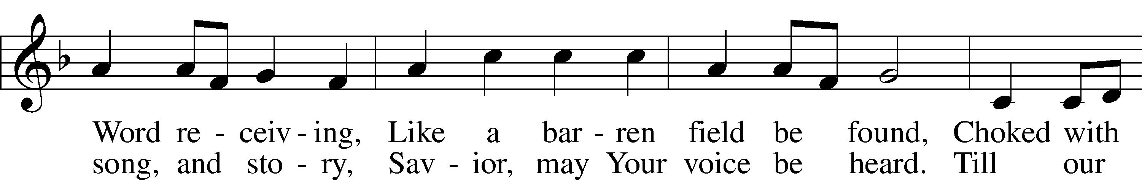
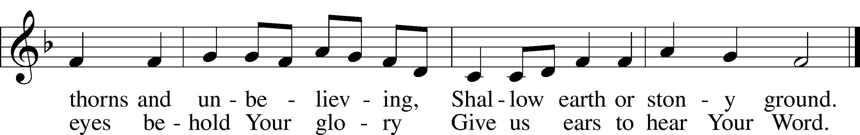
Tune: Public domain
Text: © 1997 Hope Publishing Co. Used by permission: LSB Hymn License no. 110005504

Acknowledgments
Divine Service, Setting Five from Lutheran Service Book
Unless otherwise indicated, Scripture quotations are from the ESV® Bible (The Holy Bible, English Standard Version®), copyright © 2001 by Crossway, a publishing ministry of Good News Publishers. Used by permission. All rights reserved.
Created by Lutheran Service Builder © 2021 Concordia Publishing House.

Announcements:
Church Service Phone: 888-505-1870/715-438-4200
(Stay on the line for recorded service to start)
Live Stream audio services: http://salem.listentochurch.com
Salem’s Web Page: https://www.salembarron.com/

Pastor Michael Nielsen: Cell phone: 218-280-0999
Email: rev.mike.nielsen@gmail.com
Pastor’s Office Hours: Monday-Wednesday 9-12

Attendance:
Call-in line: 10/24– 5
Facebook live: 10/24– 8
In-person: 10/24 – 70

Weekly Needs: $2823.92
10/17/21– General: $ Missions: $ Bldg: $ Childcare: $ SS: $

Coffee and Snacks: Men’s Club
Elder Today: Paul Millerman
Altar Guild: Kathy Schuettpelz

Link to Salem’s Facebook page is:
https://www.facebook.com/SalemEvangelicalLutheranChurchAndPreschool/

Schedule for the upcoming week:
Monday: 7:00 PM - Elders
Tuesday: 7:30 AM – Men’s Bible Study, 7:00 PM Men’s Club
Wednesday: 4:00 PM Confirmation
Thursday: 11:00 AM Christian Difference

Save the Date: December 5 – Annual Meeting. Potluck preceding. Dec. 7 – Big Buck Contest

We need 1st and 2nd grade, and 7th and 8th grade Sunday School teachers.

The Nativity Scene needs some painting. Anyone can be of assistance, please let Pastor, Don Duncan, or Tom Lipke know.

Childcare Amazon Needs List: https://a.co/75FLsBE

Thank you to the Wiese family for their musical talents today!

Thank you Amelia Weise for playing flute for our Sunday School students.

If you are interested in being part of the Church Pictorial Directory Committee, please see MaryAnn Thompson

That time of year when we are looking for your college/military loved ones addresses so we can send them a care package. Please get addresses to the office for Sue by November 1st. Thank you.
Prayer requests:

Those in the nursing home:
Caroly, Etta, Leonard, Lois, Vi, Wilma

Those Shut-in at home:
Char, Gail and Roxanne, Joan, Joyce, Loretta

Those recovering from accident: Rusty Weise, Lois, Hunter Nelson, Grant Stabenow

Those with ongoing health issues: Harrison, Jeanne, Kim, Marlene, Wyatt, Owen, Pete, Joyce, Daria, Marilyn, Bernie, Michelle, Sarah, Kathy, Mary, Chris, Sue.

Those who lead our nation:
Joe Biden, Kamala Harris, Tony Evers, Ron Fladten

Those who serve in our military:
Ryan Graf and Ethan Kobernick

Our Childcare Staff: Amanda Ritchie, Mary Zook, Kristin Loback

Families of the Week:
Wendy (Starck) Noha, Jeff Nyhus, Mary Oscarson, Marilyn Otto, Esten and Bernadine Pedersen

Those who are struggling with Covid and the doctors and nurses caring for their patients.

Mission Statement
The Mission of Salem Lutheran Church is to be what God called us to be through faith in Jesus Christ, a body of believers engaged in building the Kingdom of God by discipling the Barron area with His Word and Sacrament ministry.

