Last Sunday of the Church Year
November 20, 2022
9:00 AM

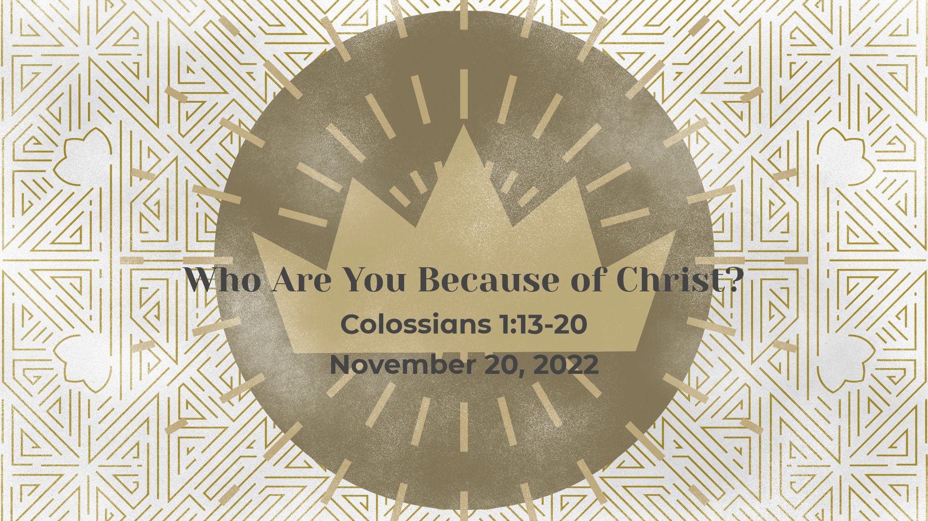

Salem Lutheran Church
1-715-537-3011
http://www.salembarron.com
rev.mike.nielsen@gmail.com

Jesus Christ Reigns, Enduring the Cross — Its Scorn and Shame

The Lord Jesus reigns in love among those who are baptized in His name. “They shall be mine,” He says, “and I will spare them as a man spares his son who serves him” (Mal. 3:17). Jesus’ service through crucifixion for sinful men anchors us in new life. In the proclamation of His Son, God makes His justice clear, defining “the distinction between the righteous and the wicked” (Mal. 3:18). He truly is “the King of the Jews” (Luke 23:38), who governs His Church with all authority in heaven and on earth. He has come into His kingdom by His cross, and He graciously remembers us in paradise. Therefore, do not weep for Him, but with repentant faith “weep for yourselves and for your children” (Luke 23:28). Then the mountains and hills of Jerusalem, His holy Church, shall cover you with His righteousness and peace. For He “is the image of the invisible God, the firstborn of all creation” (Col. 1:15). “All things were created through him and for him” (Col. 1:16), and “all the fullness of God was pleased to dwell” bodily in Him, reconciling all things to Himself “by the blood of his cross” (Col. 1:19–20).
Confession and Absolution

Hymn of Invocation: All Hail the Power of Jesus' Name LSB 549
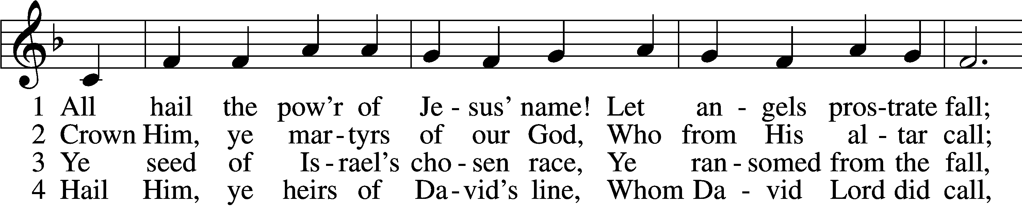
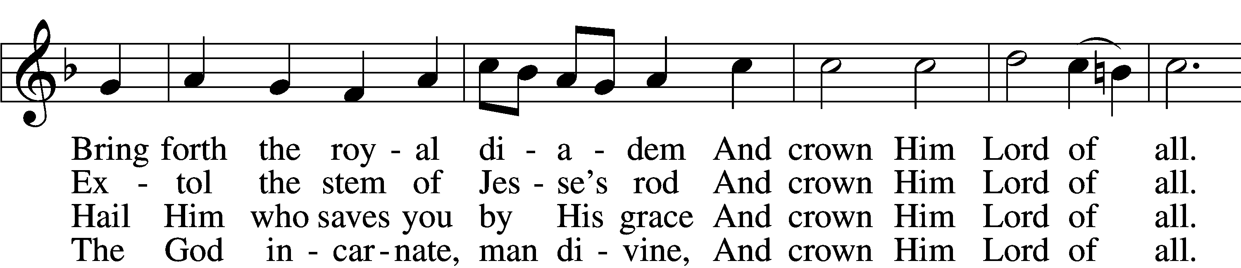
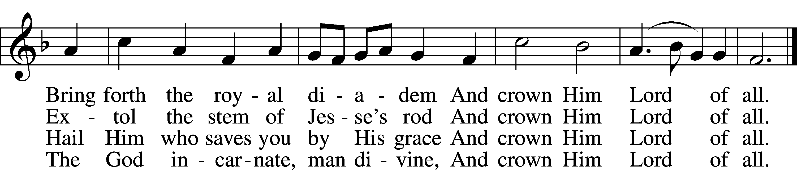

5 Sinners, whose love can ne’er forget
The wormwood and the gall,
Go, spread your trophies at His feet
And crown Him Lord of all.
Go, spread your trophies at His feet
And crown Him Lord of all.
7 Oh, that with yonder sacred throng
We at His feet may fall!
We’ll join the everlasting song
And crown Him Lord of all.
We’ll join the everlasting song
And crown Him Lord of all.

6 Let ev’ry kindred, ev’ry tribe,
On this terrestrial ball
To Him all majesty ascribe
And crown Him Lord of all.
To Him all majesty ascribe
And crown Him Lord of all.
Text (sts. 1–5): Edward Perronet, 1726–92, alt.; (sts. 6–7): A Selection of Hymns, 1787, London, alt.
Tune: Oliver Holden, 1765–1844
Text and tune: Public domain

Stand

The sign of the cross may be made by all in remembrance of their Baptism.

Invocation
P In the name of the Father and of the T Son and of the Holy Spirit.
C Amen.

Exhortation LSB 203
P Our help is in the name of the Lord,
C who made heaven and earth.

P If You, O Lord, kept a record of sins, O Lord, who could stand?
C But with You there is forgiveness; therefore You are feared.

P Since we are gathered to hear God’s Word, call upon Him in prayer and praise, and receive the body and blood of our Lord Jesus Christ in the fellowship of this altar, let us first consider our unworthiness and confess before God and one another that we have sinned in thought, word, and deed, and that we cannot free ourselves from our sinful condition. Together as His people let us take refuge in the infinite mercy of God, our heavenly Father, seeking His grace for the sake of Christ, and saying: God, be merciful to me, a sinner.

Kneel/Stand

Confession of Sins LSB 203
C Almighty God, have mercy upon us, forgive us our sins, and lead us to everlasting life. Amen.

Absolution LSB 203
P Almighty God in His mercy has given His Son to die for you and for His sake forgives you all your sins. As a called and ordained servant of Christ, and by His authority, I therefore forgive you all your sins in the name of the Father and of the T Son and of the Holy Spirit.
C Amen.

Stand

Service of the Word

Introit Psalm 134; antiphon: Psalm 33:8
Let all the earth fear the Lord;
let all the inhabitants of the world stand in awe of him!
Come, bless the Lord, all you servants of the Lord,
who stand by night in the house of the Lord!
Lift up your hands to the holy place
and bless the Lord!
May the Lord bless you from Zion,
he who made heaven and earth!
Glory be to the Father and to the Son
and to the Holy Spirit;
as it was in the beginning,
is now, and will be forever. Amen.
Let all the earth fear the Lord;
let all the inhabitants of the world stand in awe of him!

Kyrie LSB 204
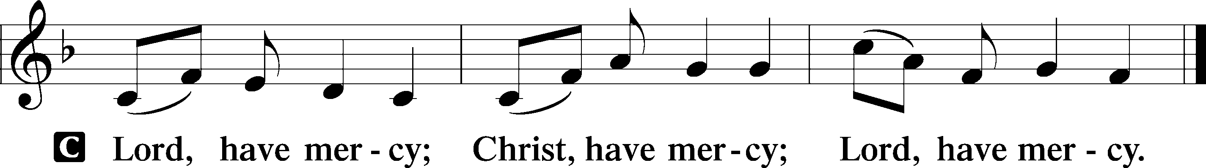

Gloria in Excelsis LSB 204
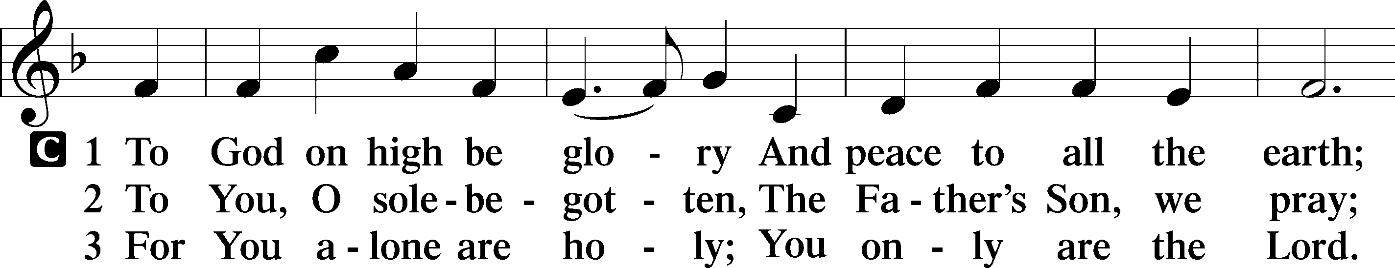
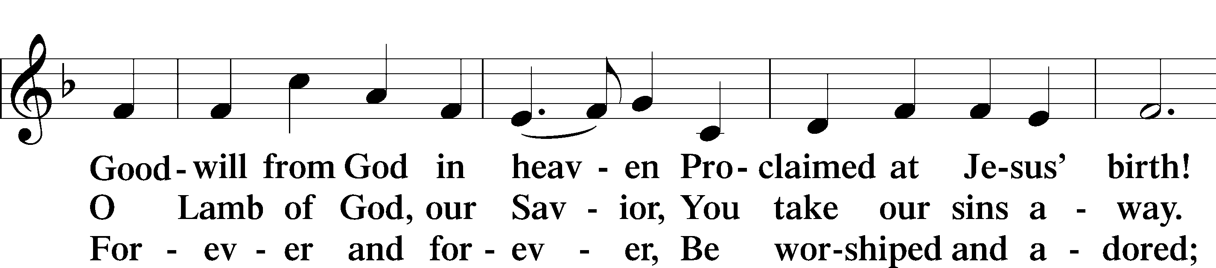
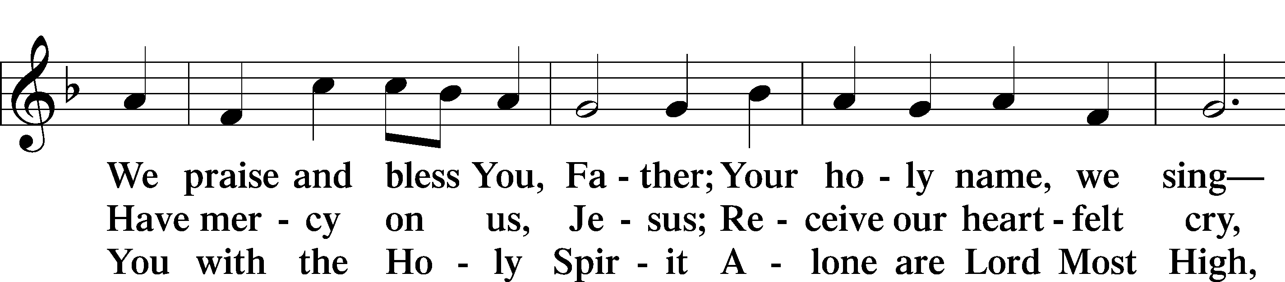
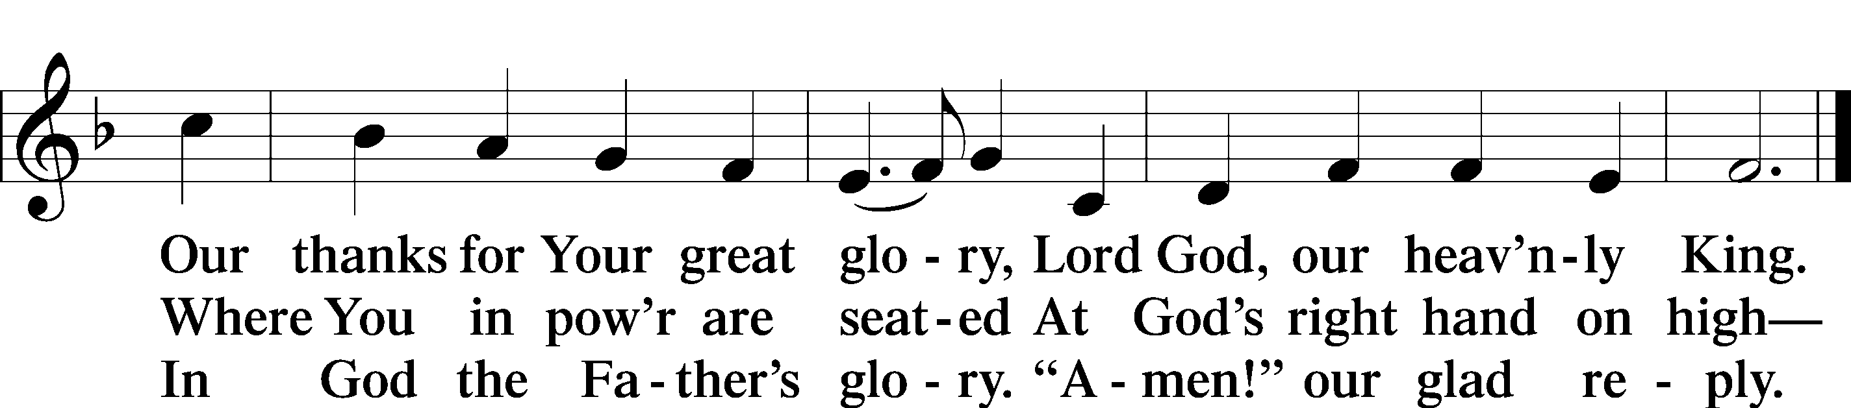
Text: Stephen P. Starke

Salutation and Collect of the Day
P The Lord be with you.
C And also with you.

P Let us pray.
Lord Jesus Christ, You reign among us by the preaching of Your cross. Forgive Your people their offenses that we, being governed by Your bountiful goodness, may enter at last into Your eternal paradise; for You live and reign with the Father and the Holy Spirit, one God, now and forever.

C Amen.

Sit

Old Testament Reading Malachi 3:13–18
13“Your words have been hard against me, says the Lord. But you say, ‘How have we spoken against you?’ 14You have said, ‘It is vain to serve God. What is the profit of our keeping his charge or of walking as in mourning before the Lord of hosts? 15And now we call the arrogant blessed. Evildoers not only prosper but they put God to the test and they escape.’”
16Then those who feared the Lord spoke with one another. The Lord paid attention and heard them, and a book of remembrance was written before him of those who feared the Lord and esteemed his name. 17“They shall be mine, says the Lord of hosts, in the day when I make up my treasured possession, and I will spare them as a man spares his son who serves him. 18Then once more you shall see the distinction between the righteous and the wicked, between one who serves God and one who does not serve him.”

A This is the Word of the Lord.
C Thanks be to God.

Epistle Colossians 1:13–20
13He has delivered us from the domain of darkness and transferred us to the kingdom of his beloved Son, 14in whom we have redemption, the forgiveness of sins.
15He is the image of the invisible God, the firstborn of all creation. 16For by him all things were created, in heaven and on earth, visible and invisible, whether thrones or dominions or rulers or authorities—all things were created through him and for him. 17And he is before all things, and in him all things hold together. 18And he is the head of the body, the church. He is the beginning, the firstborn from the dead, that in everything he might be preeminent. 19For in him all the fullness of God was pleased to dwell, 20and through him to reconcile to himself all things, whether on earth or in heaven, making peace by the blood of his cross.

A This is the Word of the Lord.
C Thanks be to God.

Stand

Alleluia LSB 205
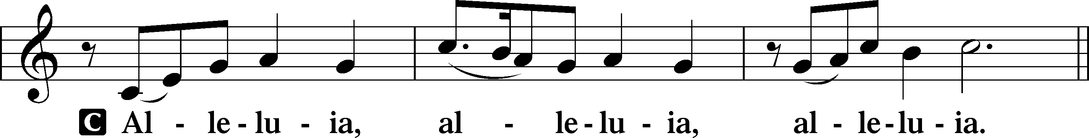

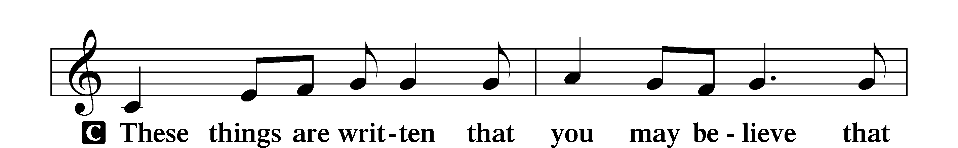
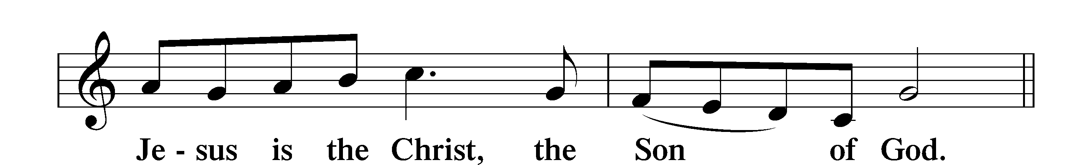

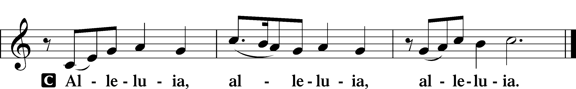

Holy Gospel Luke 23:27–43
P The Holy Gospel according to St. Luke, the twenty-third chapter.
C Glory to You, O Lord.

27And there followed [Jesus] a great multitude of the people and of women who were mourning and lamenting for him. 28But turning to them Jesus said, “Daughters of Jerusalem, do not weep for me, but weep for yourselves and for your children. 29For behold, the days are coming when they will say, ‘Blessed are the barren and the wombs that never bore and the breasts that never nursed!’ 30Then they will begin to say to the mountains, ‘Fall on us,’ and to the hills, ‘Cover us.’ 31For if they do these things when the wood is green, what will happen when it is dry?”
32Two others, who were criminals, were led away to be put to death with him. 33And when they came to the place that is called The Skull, there they crucified him, and the criminals, one on his right and one on his left. 34And Jesus said, “Father, forgive them, for they know not what they do.” And they cast lots to divide his garments. 35And the people stood by, watching, but the rulers scoffed at him, saying, “He saved others; let him save himself, if he is the Christ of God, his Chosen One!” 36The soldiers also mocked him, coming up and offering him sour wine 37and saying, “If you are the King of the Jews, save yourself!” 38There was also an inscription over him, “This is the King of the Jews.”
39One of the criminals who were hanged railed at him, saying, “Are you not the Christ? Save yourself and us!” 40But the other rebuked him, saying, “Do you not fear God, since you are under the same sentence of condemnation? 41And we indeed justly, for we are receiving the due reward of our deeds; but this man has done nothing wrong.” 42And he said, “Jesus, remember me when you come into your kingdom.” 43And he said to him, “Truly, I say to you, today you will be with me in Paradise.”

P This is the Gospel of the Lord.
C Praise to You, O Christ.

Nicene Creed
C I believe in one God,
the Father Almighty,
maker of heaven and earth
and of all things visible and invisible.

And in one Lord Jesus Christ,
the only-begotten Son of God,
begotten of His Father before all worlds,
God of God, Light of Light,
very God of very God,
begotten, not made,
being of one substance with the Father,
by whom all things were made;
who for us men and for our salvation came down from heaven
and was incarnate by the Holy Spirit of the virgin Mary
and was made man;
and was crucified also for us under Pontius Pilate.
He suffered and was buried.
And the third day He rose again according to the Scriptures
and ascended into heaven
and sits at the right hand of the Father.
And He will come again with glory to judge both the living and the dead,
whose kingdom will have no end.

And I believe in the Holy Spirit,
the Lord and giver of life,
who proceeds from the Father and the Son,
who with the Father and the Son together is worshiped and glorified,
who spoke by the prophets.
And I believe in one holy Christian and apostolic Church,
I acknowledge one Baptism for the remission of sins,
and I look for the resurrection of the dead
and the life T of the world to come. Amen.

Sit

Hymn of the Day: Lord Enthroned in Heavenly Splendor LSB 534
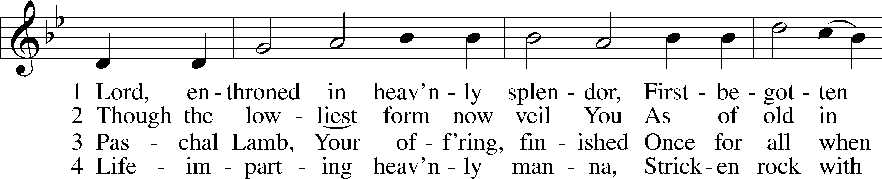
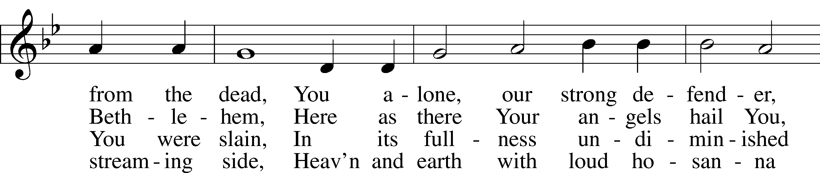
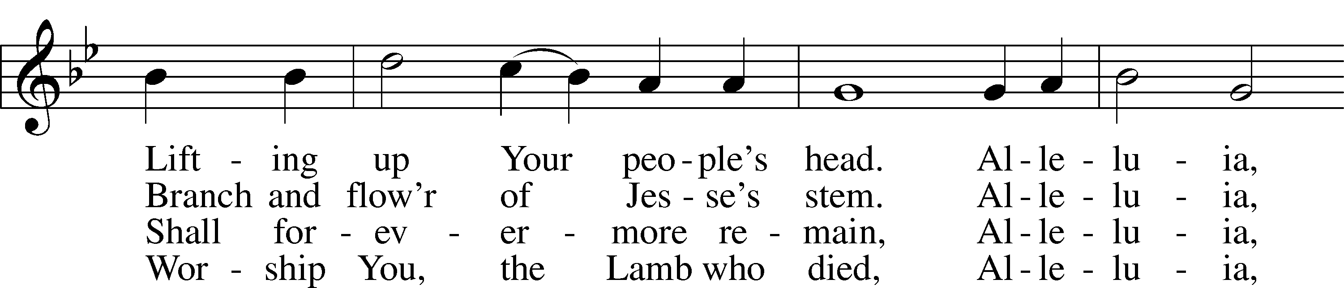
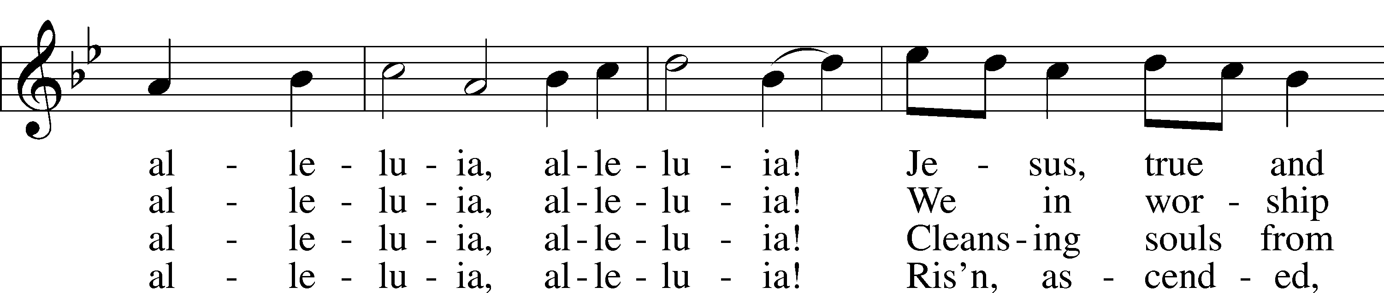
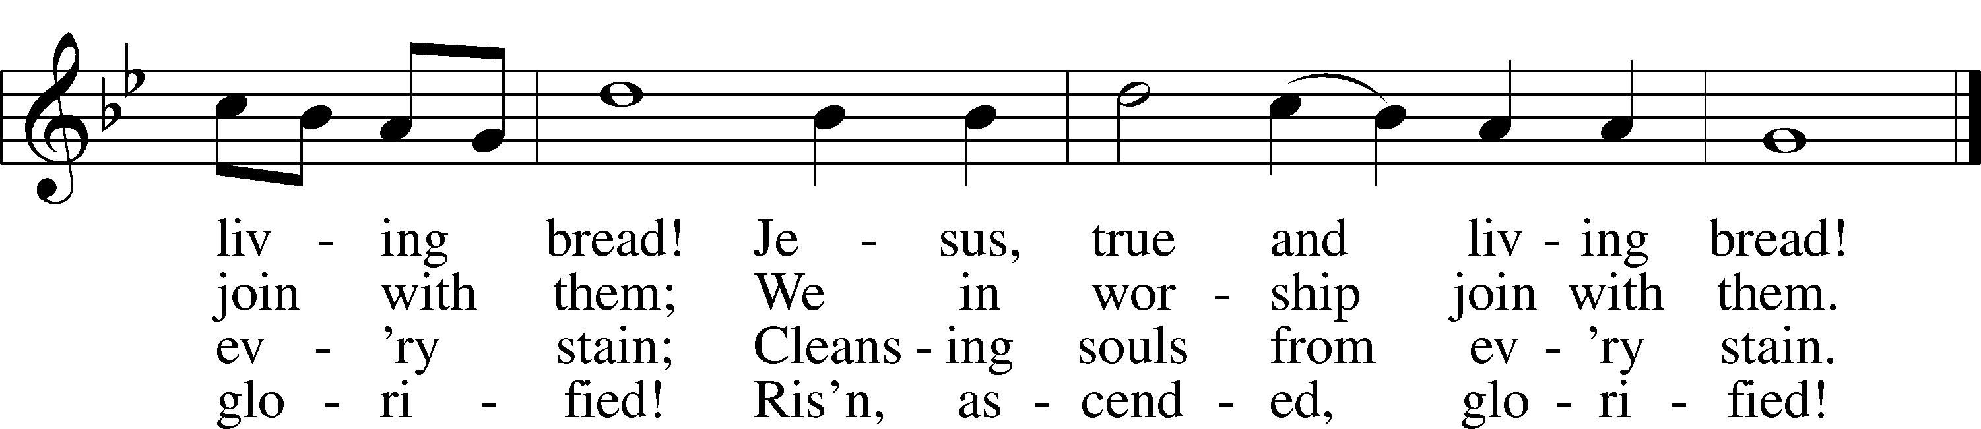
Text: George H. Bourne, 1840–1925, alt.
Tune: William Owen, 1813–93
Text and tune: Public domain

Sermon

Stand

Prayer of the Church

Sit

Offering and Hymn
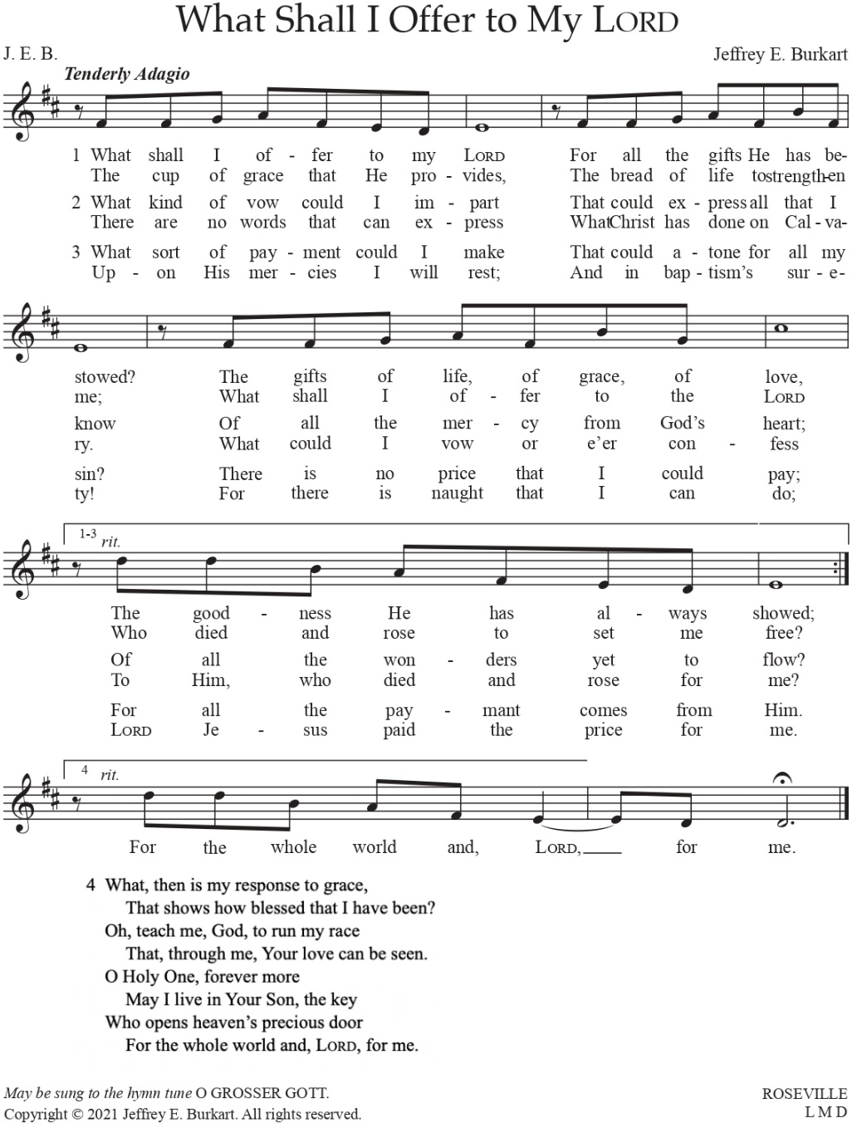
Used by permission of author Dr. Jeffrey E. Burkhart

Service of the Sacrament

Stand

Preface LSB 208
P The Lord be with you.
C And also with you.

P Lift up your hearts.
C We lift them to the Lord.

P Let us give thanks to the Lord our God.
C It is right to give Him thanks and praise.

P It is truly good, right, and salutary that we should at all times and in all places give thanks to You, O Lord, holy Father, almighty and everlasting God, for the countless blessings You so freely bestow on us and all creation. Above all, we give thanks for Your boundless love shown to us when You sent Your only-begotten Son, Jesus Christ, into our flesh and laid on Him our sin, giving Him into death that we might not die eternally. Because He is now risen from the dead and lives and reigns to all eternity, all who believe in Him will overcome sin and death and will rise again to new life. Therefore with angels and archangels and with all the company of heaven we laud and magnify Your glorious name, evermore praising You and saying:

Sanctus LSB 208
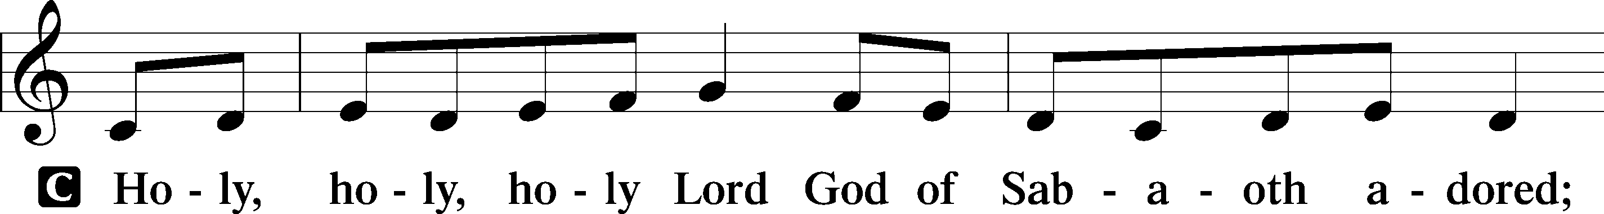
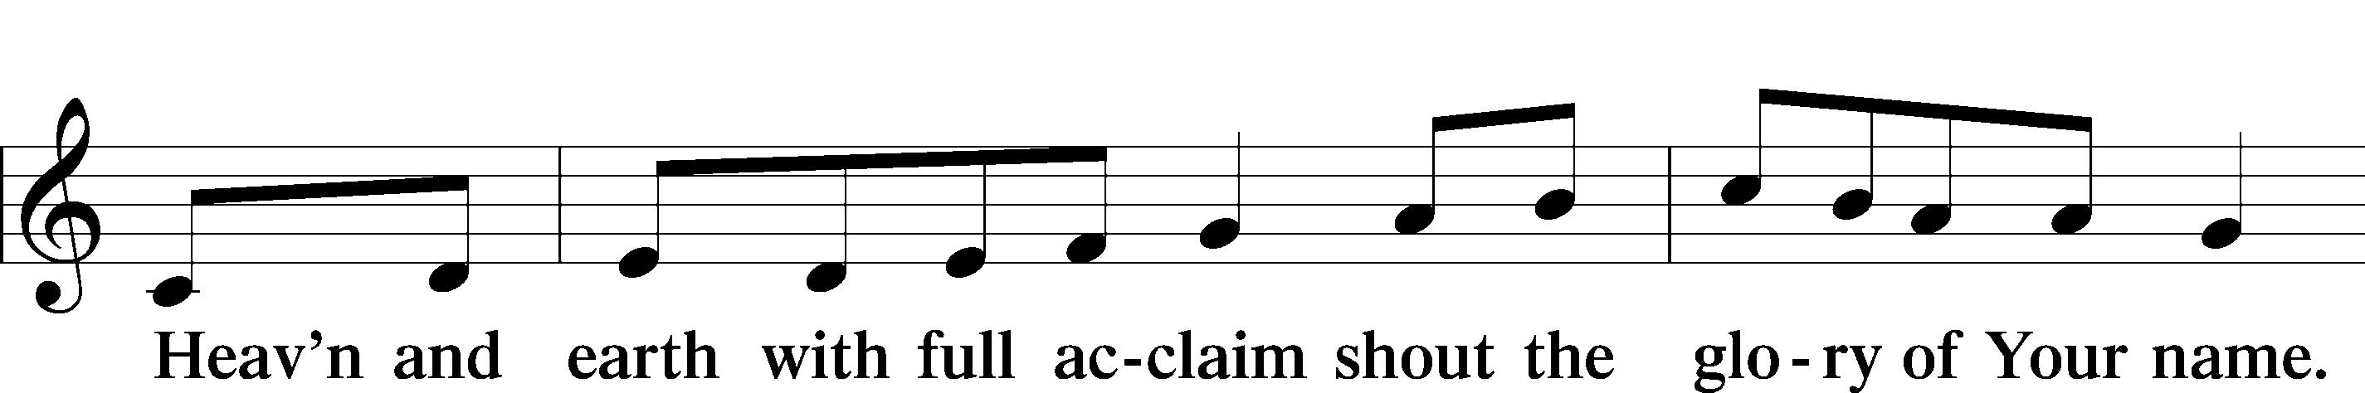
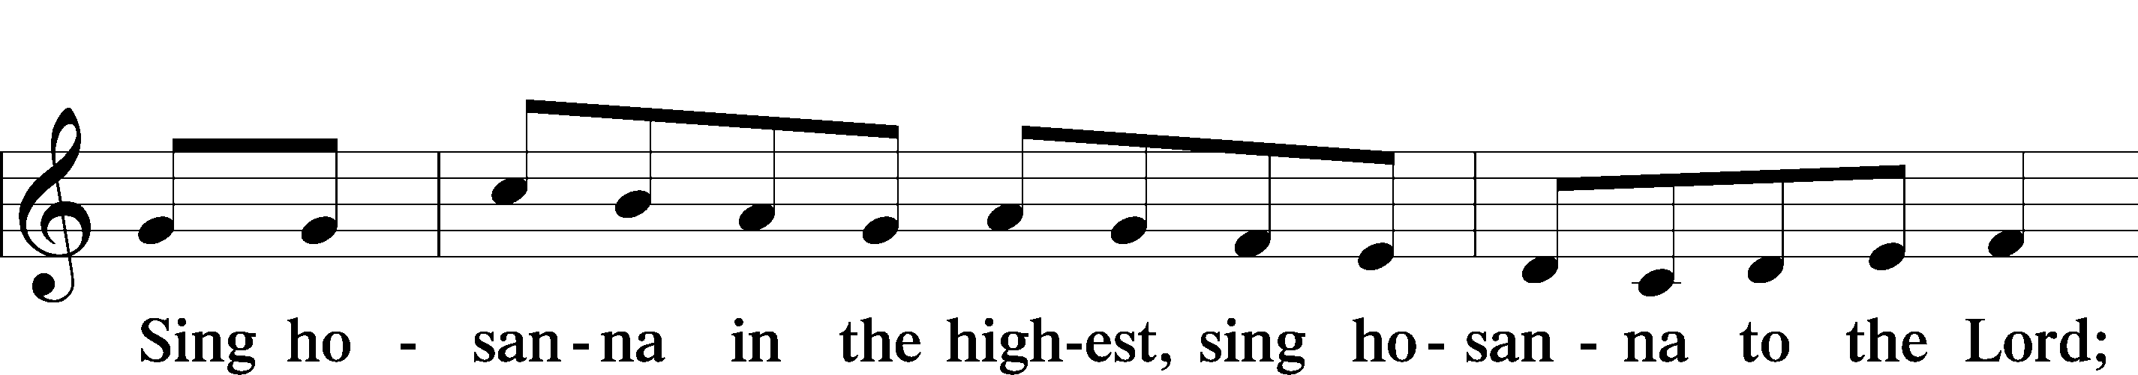
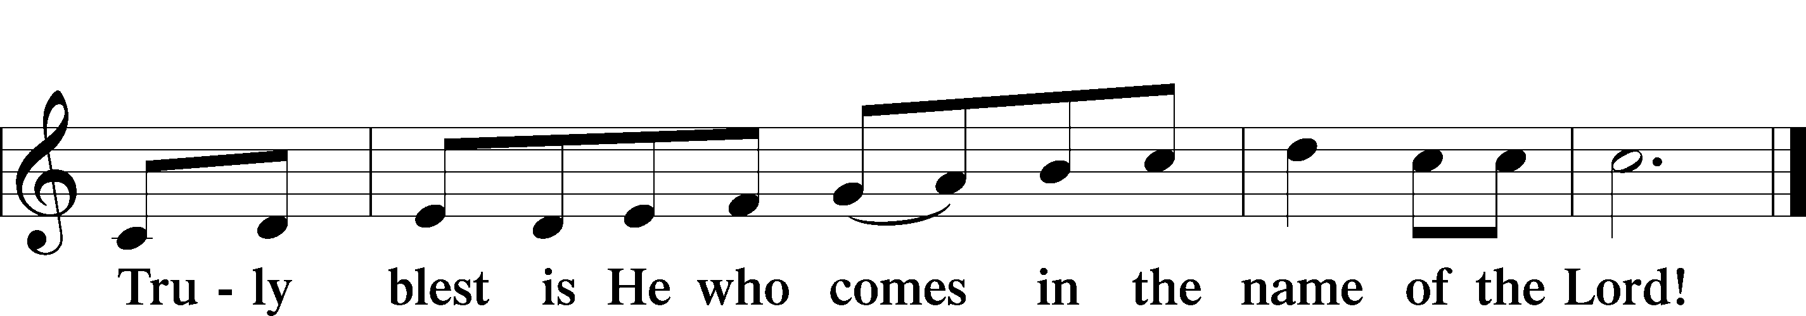
Text: Stephen P. Starke

Prayer of Thanksgiving
P Blessed are You, O Lord our God, king of all creation, for You have had mercy on us and given Your only-begotten Son that whoever believes in Him should not perish but have eternal life.

In Your righteous judgment You condemned the sin of Adam and Eve, who ate the forbidden fruit, and You justly barred them and all their children from the tree of life. Yet, in Your great mercy, You promised salvation by a second Adam, Your Son, Jesus Christ, our Lord, and made His cross a life-giving tree for all who trust in Him.

We give You thanks for the redemption You have prepared for us through Jesus Christ. Grant us Your Holy Spirit that we may faithfully eat and drink of the fruits of His cross and receive the blessings of forgiveness, life, and salvation that come to us in His body and blood.

Hear us as we pray in His name and as He has taught us:

Lord’s Prayer
C Our Father who art in heaven,
hallowed be Thy name,
Thy kingdom come,
Thy will be done on earth
as it is in heaven;
give us this day our daily bread;
and forgive us our trespasses
as we forgive those
who trespass against us;
and lead us not into temptation,
but deliver us from evil.
For Thine is the kingdom
and the power and the glory
forever and ever. Amen.

The Words of Our Lord
P Our Lord Jesus Christ, on the night when He was betrayed, took bread, and when He had given thanks, He broke it and gave it to the disciples and said: “Take, eat; this is My T body, which is given for you. This do in remembrance of Me.”

In the same way also He took the cup after supper, and when He had given thanks, He gave it to them, saying: “Drink of it, all of you; this cup is the new testament in My T blood, which is shed for you for the forgiveness of sins. This do, as often as you drink it, in remembrance of Me.”

Pax Domini
P The peace of the Lord be with you always.
C Amen.

Agnus Dei LSB 210
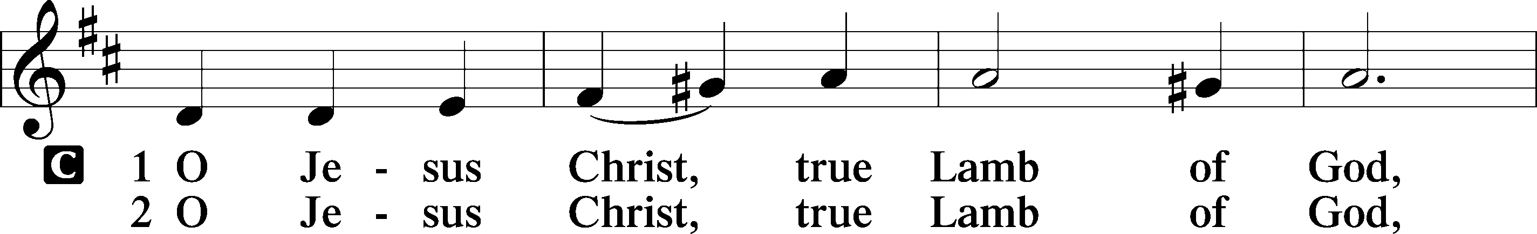
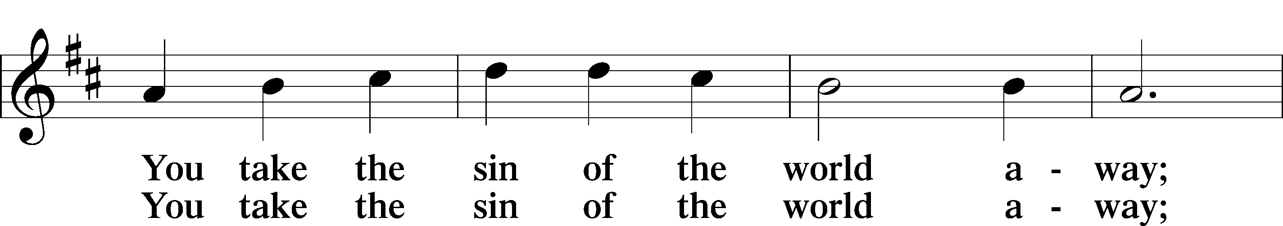
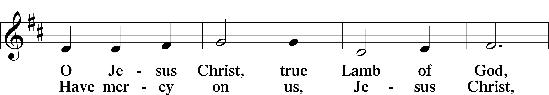
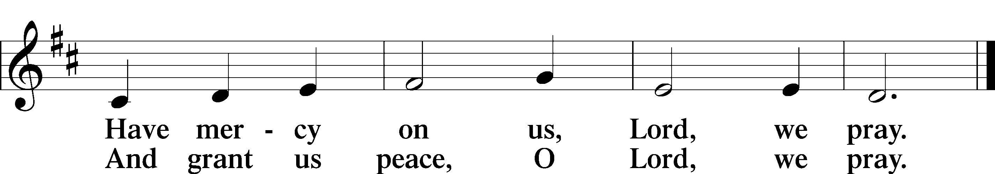
Text: Stephen P. Starke

Sit

Distribution

Distribution Hymn: The Head that Once was Crowned with Thorns LSB 532
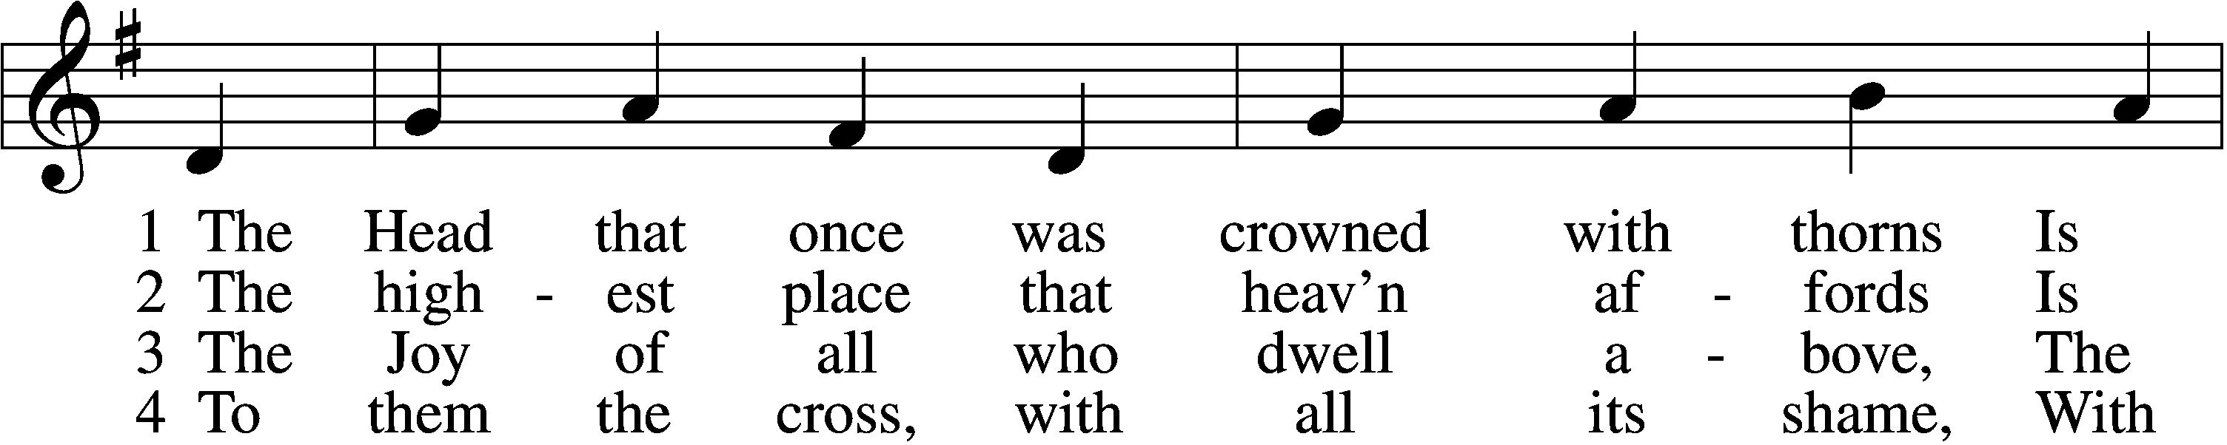
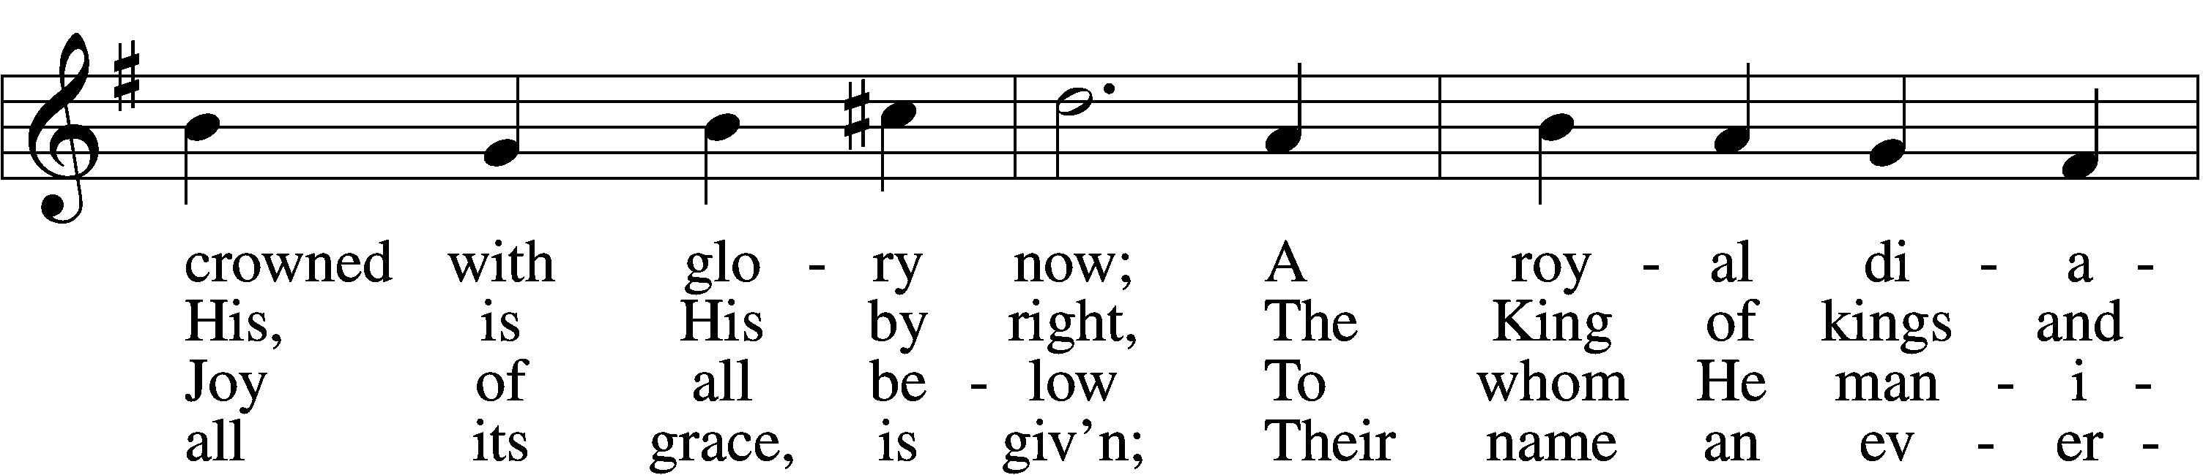
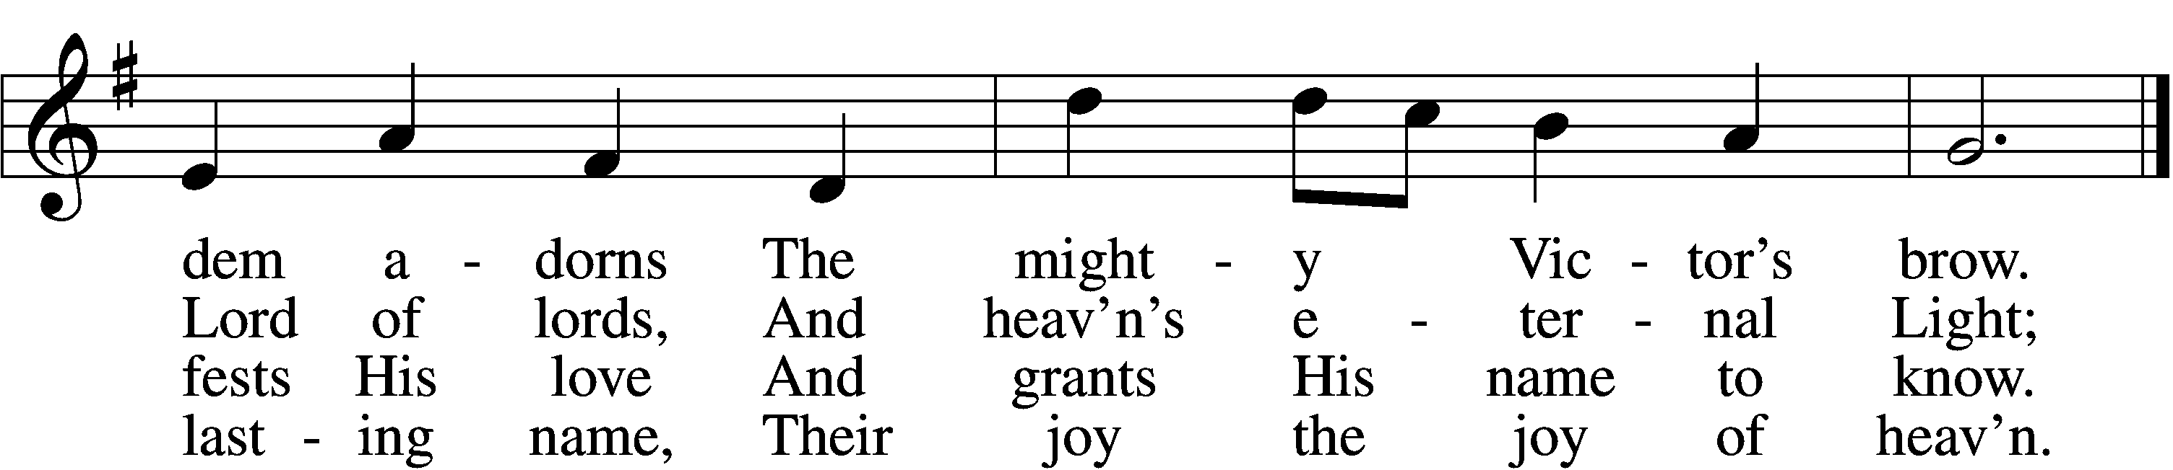

5 They suffer with their Lord below,
They reign with Him above,
Their profit and their joy to know
The myst’ry of His love.

6 The cross He bore is life and health,
Though shame and death to Him:
His people’s hope, His people’s wealth,
Their everlasting theme.
Text: Thomas Kelly, 1769–1855
Tune: Jeremiah Clarke, c. 1674–1707
Text and tune: Public domain

Distribution Hymn: Crown Him With Many Crowns LSB 525
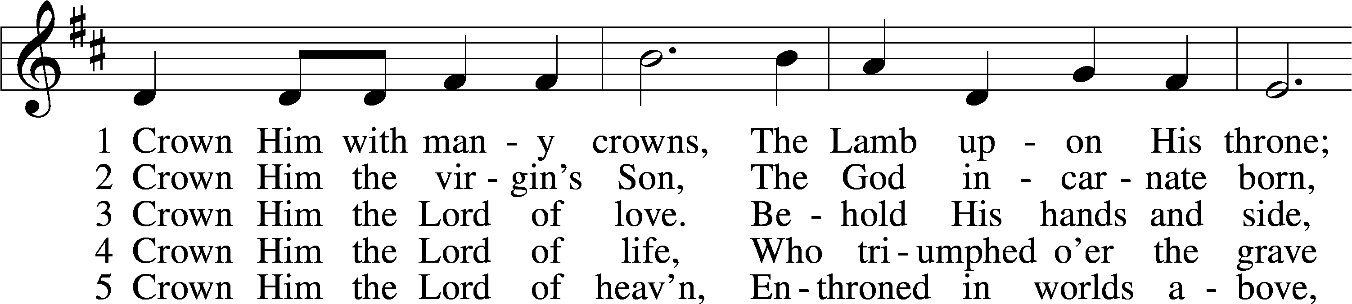
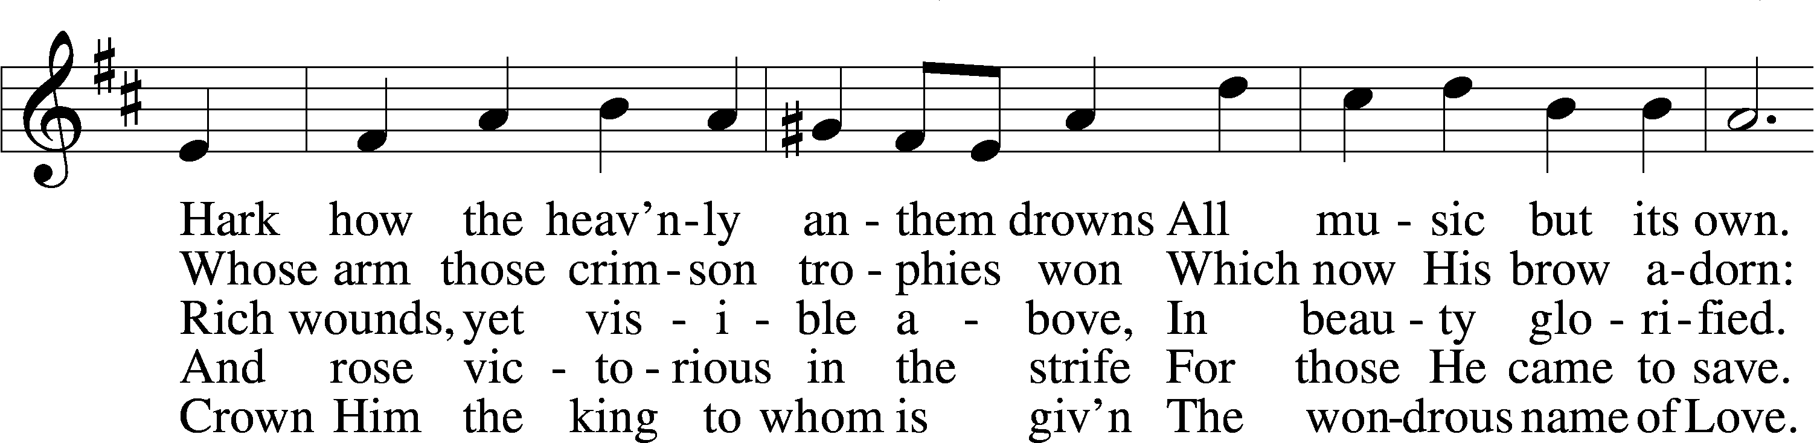
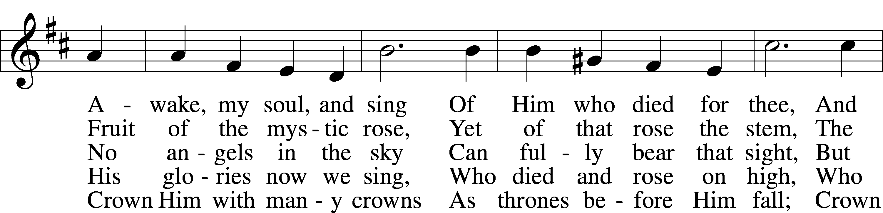
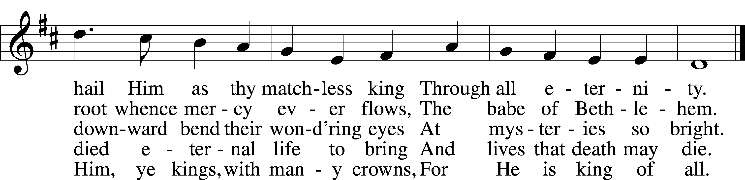
Text (sts. 1–3, 5): Matthew Bridges, 1800–94, alt.; (st. 4): Godfrey Thring, 1823–1903
Tune: George J. Elvey, 1816–93
Text and tune: Public domain

Stand

Nunc Dimittis LSB 211
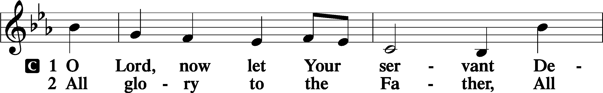
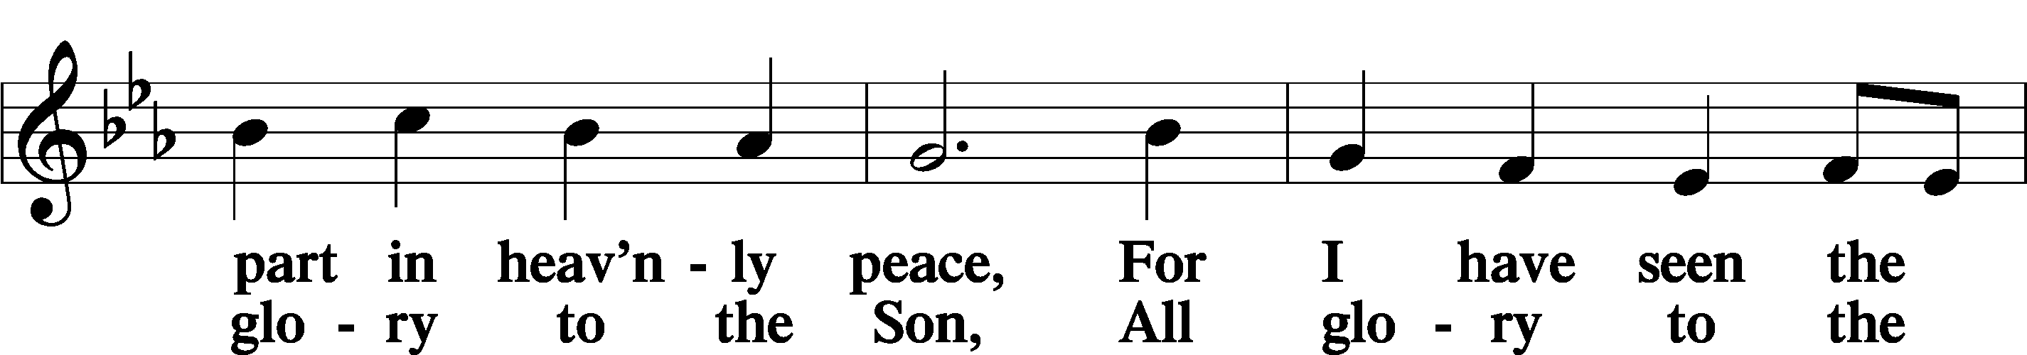
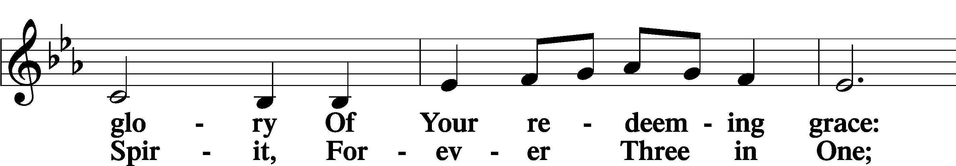
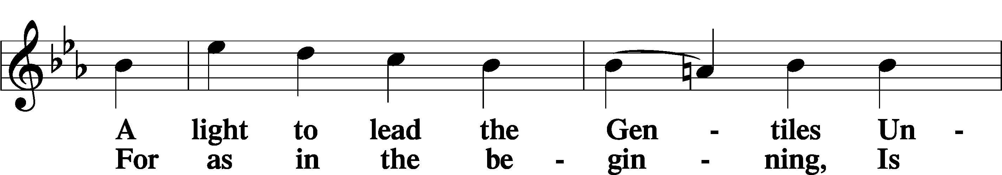
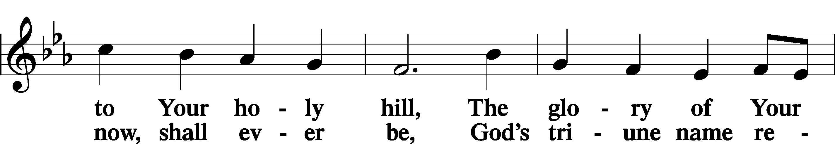
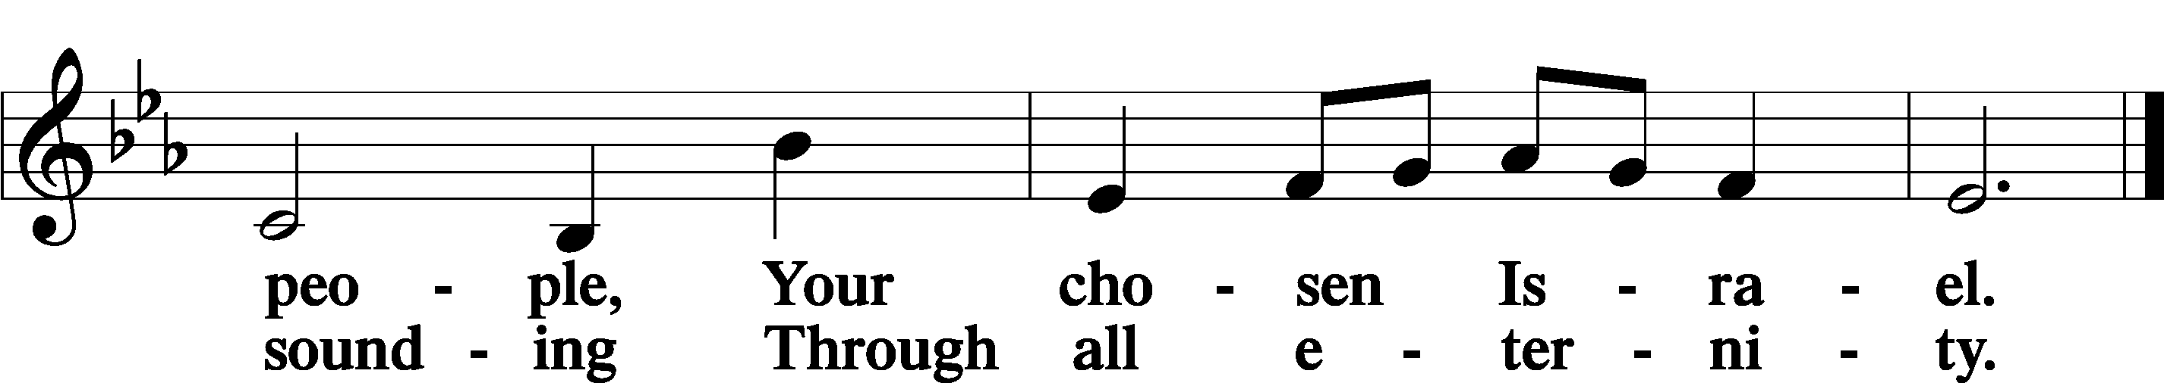

Post-Communion Collect
A Let us pray.
We give thanks to You, almighty God, that You have refreshed us through this salutary gift, and we implore You that of Your mercy You would strengthen us through the same in faith toward You and in fervent love toward one another; through Jesus Christ, Your Son, our Lord, who lives and reigns with You and the Holy Spirit, one God, now and forever.
C Amen.

Benedicamus LSB 212
A Let us bless the Lord.
C Thanks be to God.

Benediction
P The Lord bless you and keep you.
The Lord make His face shine on you and be gracious to you.
The Lord look upon you with favor and T give you peace.
C Amen.

Hymn to Depart: At the Name of Jesus LSB 512
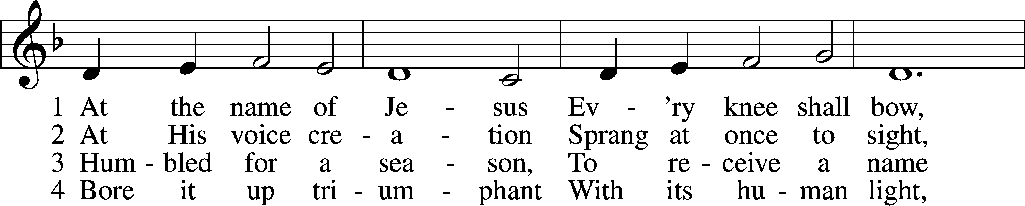
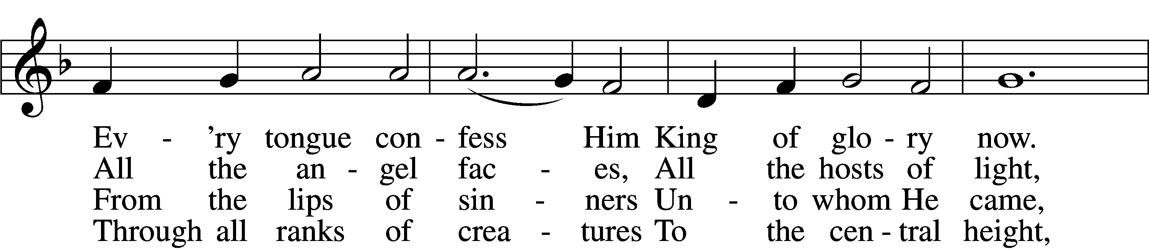
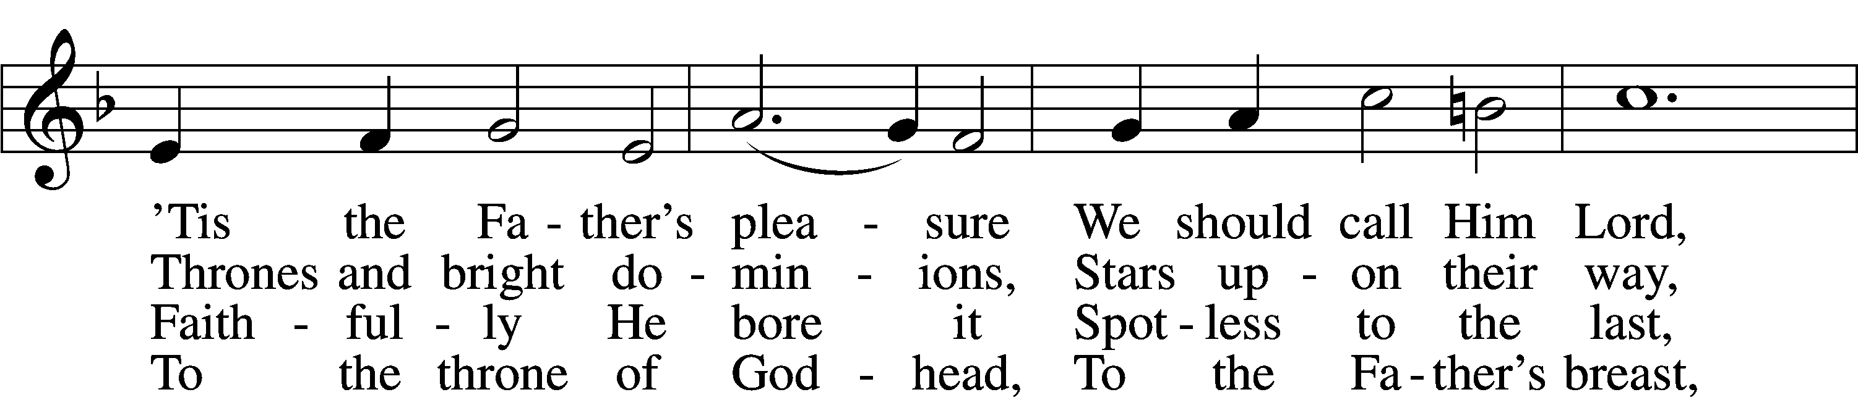
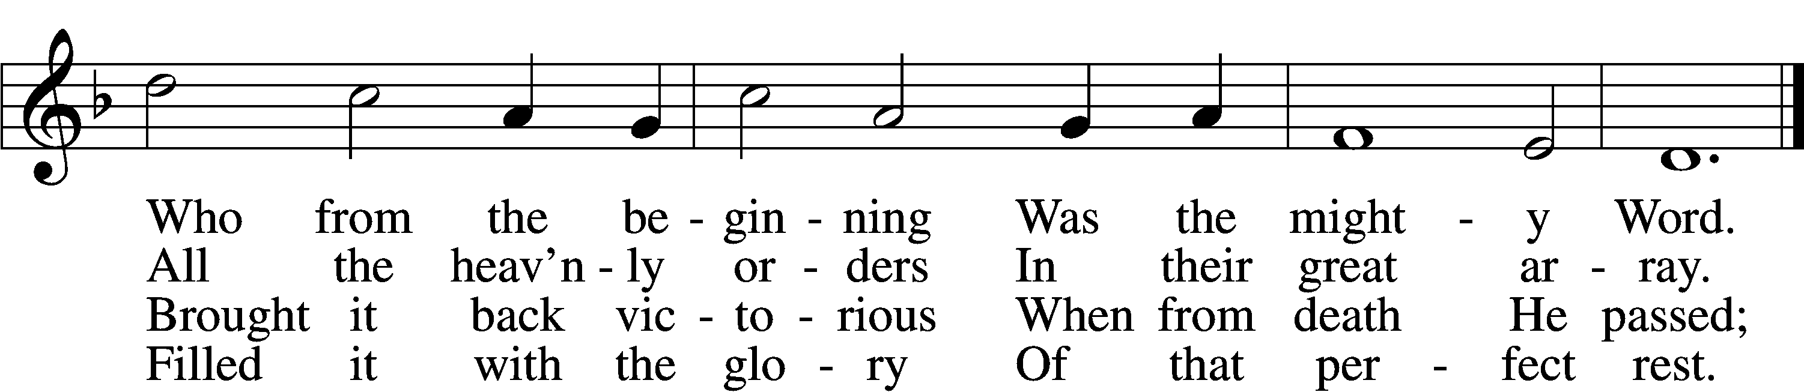

5 In your hearts enthrone Him;
There let Him subdue
All that is not holy,
All that is not true:
Crown Him as your captain
In temptation’s hour;
Let His will enfold you
In its light and pow’r.

6 Christians, this Lord Jesus
Shall return again
In His Father’s glory,
With His angel train;
For all wreaths of empire
Meet upon His brow,
And our hearts confess Him
King of glory now.

D 7 Glory then to Jesus,
Who, the Prince of light,
To a world in darkness
Brought the gift of sight;
Praise to God the Father;
In the Spirit’s love
Praise we all together
Him who reigns above.
Text: Caroline M. Noel, 1817–77, alt.
Tune: Ralph Vaughan Williams, 1872–1958
Text and tune: Public domain

Acknowledgments
Divine Service, Setting Four from Lutheran Service Book
Unless otherwise indicated, Scripture quotations are from the ESV® Bible (The Holy Bible, English Standard Version®), copyright © 2001 by Crossway, a publishing ministry of Good News Publishers. Used by permission. All rights reserved.
Created by Lutheran Service Builder © 2022 Concordia Publishing House.
Announcements:
Church Service Phone: 888-505-1870/715-438-4200
(Stay on the line for recorded service to start)
Live Stream audio services: http://salem.listentochurch.com
Salem’s Web Page: https://www.salembarron.com/

Pastor Michael Nielsen: Cell phone: 218-280-0999
Email: rev.mike.nielsen@gmail.com
Pastor’s Office Hours: Monday-Wednesday 9-12

Attendance:
Call-in line:11/13– 6 In-person: 11/13- 70

Weekly Needs: $2823.92
11/6/22 – General: $2749 Missions: $227 Bldg: $223 Childcare: $107 SS: $4 AC: $100 Schutz Oil: $110.9

Coffee and Snacks: Melissa Weinert
Elder Today: Paul Millerman
Altar Guild: Denise Stabenow

Link to Salem’s Facebook page is:
https://www.facebook.com/SalemEvangelicalLutheranChurchAndPreschool/

Schedule for the upcoming week:
Today: Children’s Christmas Practice – 10:15 -11:45 AM
Tuesday: 7:30 AM Bible Study
Thursday: 9:00 AM Thanksgiving Service

Midweek Advent Services begin November 30, 2022

December 4th – annual meeting after service (children’s Christmas Practice 10:15 -11:45 AM)

December 6th: Big Buck Contest – 7:00pm, Starts with lunch and deer stories. Prizes awarded to anyone who shoots a deer gun or bow. Deer harvested in Wisconsin. Come in enjoy the evening and see who got the Biggest Buck!

December 10th – 9-11:45 AM
December 11th – Children’s Christmas Service

Prayer requests:

Those in the nursing home: Caroly, Lois, Wilma, Loretta

Those Shut-in at home: Char, Gail and Roxanne, Joan, Joyce

Those recovering from accident: Rusty Weise
Those recovering from surgery: Marilynn Amundson
Those with ongoing health issues: Harrison, Jeanne, Wyatt, Owen, Joyce, Kathy, Jeff, Daria, Bob, Pastor Jody Walter, Janee, Larry, Pastor Brent Berkesch, Pastor Quinten Buechner, Darlene, Mona, Timothy, Titus

Those who lead our nation:
Joe Biden, Kamala Harris, Tony Evers, Rod Nordby

Those who serve in our military:
Ryan Graf and Ethan Kobernick, Chaplain Pon Chanthaphon (Our Adopt-a-Chaplain)

Our Childcare Staff: Melissa Weinert, Jasmine Ferguson, Denise Stabenow, Katelyn Hendren, Holly Wilhelmi, Janica Skjerly

Families of the Week: Mike and Mikayla Solie, Austin Stabenow (Mariah Behnke and Bexley), Dwayne and Denise Stabenow (Grant), Albert Starck, Earl and Amee Starck

Other: Holy Trinity Lutheran Church, Bristol, TN – Building issues

Those who are struggling with Covid and the doctors and nurses caring for their patients.

Mission Statement
The Mission of Salem Lutheran Church is to be what God called us to be through faith in Jesus Christ, a body of believers engaged in building the Kingdom of God by discipling the Barron area with His Word and Sacrament ministry.

