Hymn: One House Abides Unending

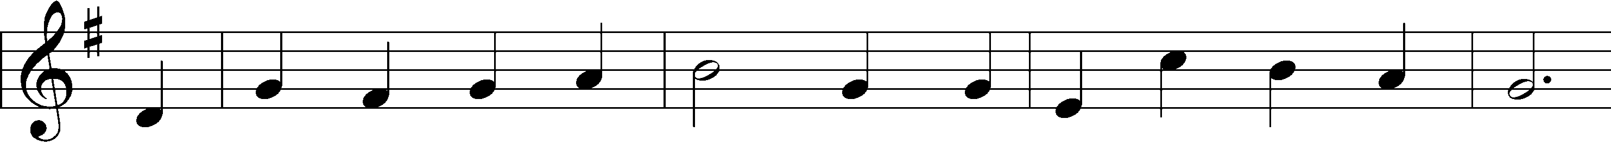
1. One house a - bides un - end - ing, One Mas -ter fears no fall
2. The wealth of all cre - a - tion We squan-dered at our birth
3. With end-less hun - ger dri - ven The grave cried out for more,
4. Ex-change our ash for beau - ty, A – noint our grief with joy;
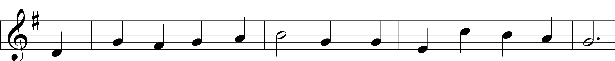
One Lord pro – vides, at – tend- ing The dai - ly want of all
The heirs of con – dem-na- tion sowed tears in blight – ed earth.
But Je - sus Christ has giv - en Safe pas – sage through its door:
Dear Lord, who paid our du - ty, All grace for us em – ploy.
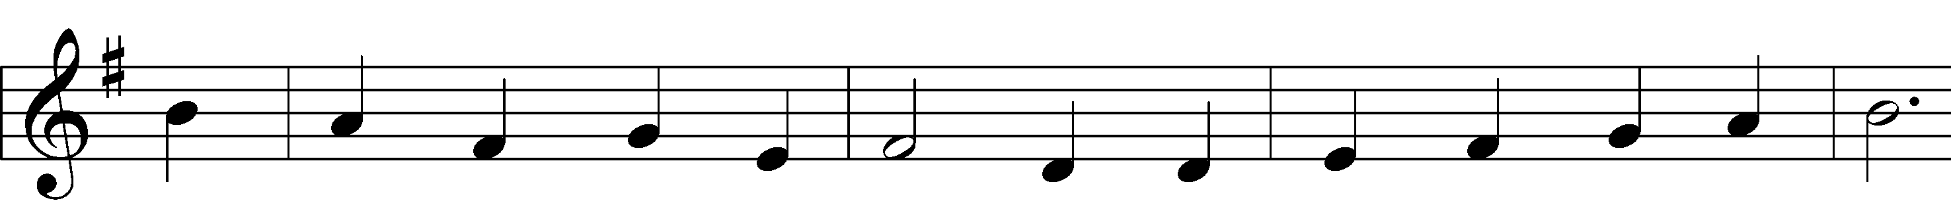
When ru - in would al - lure them Whose one es - tate was need,
But light, the world’s first treas- ure, The Mas - ter worked a - new
His flow - ing blood our rai - ment, The flood to purge our shame;
Feed us the sav - ing man – na Lest on the way we fail
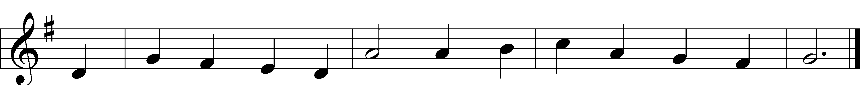
One Fa - ther would se – cure them In will, in trust, in deed.
In prom-ise, and in mea- sure No mor-tal eye could view.
The liv - ing God the pay – ment That buys for us His name.
And sweet – en our Ho – san - na To Ho - ly Eas - ter’s hail.

Tune: Friedrich K. Anthes, 1812–after 1857 (public opinion)
Text: Rachel Crane, 2022, Copyright, CPH. All rights reservd

Please return for use throughout Lent

