25th Sunday After Pentecost
November 14, 2021
9:00 AM

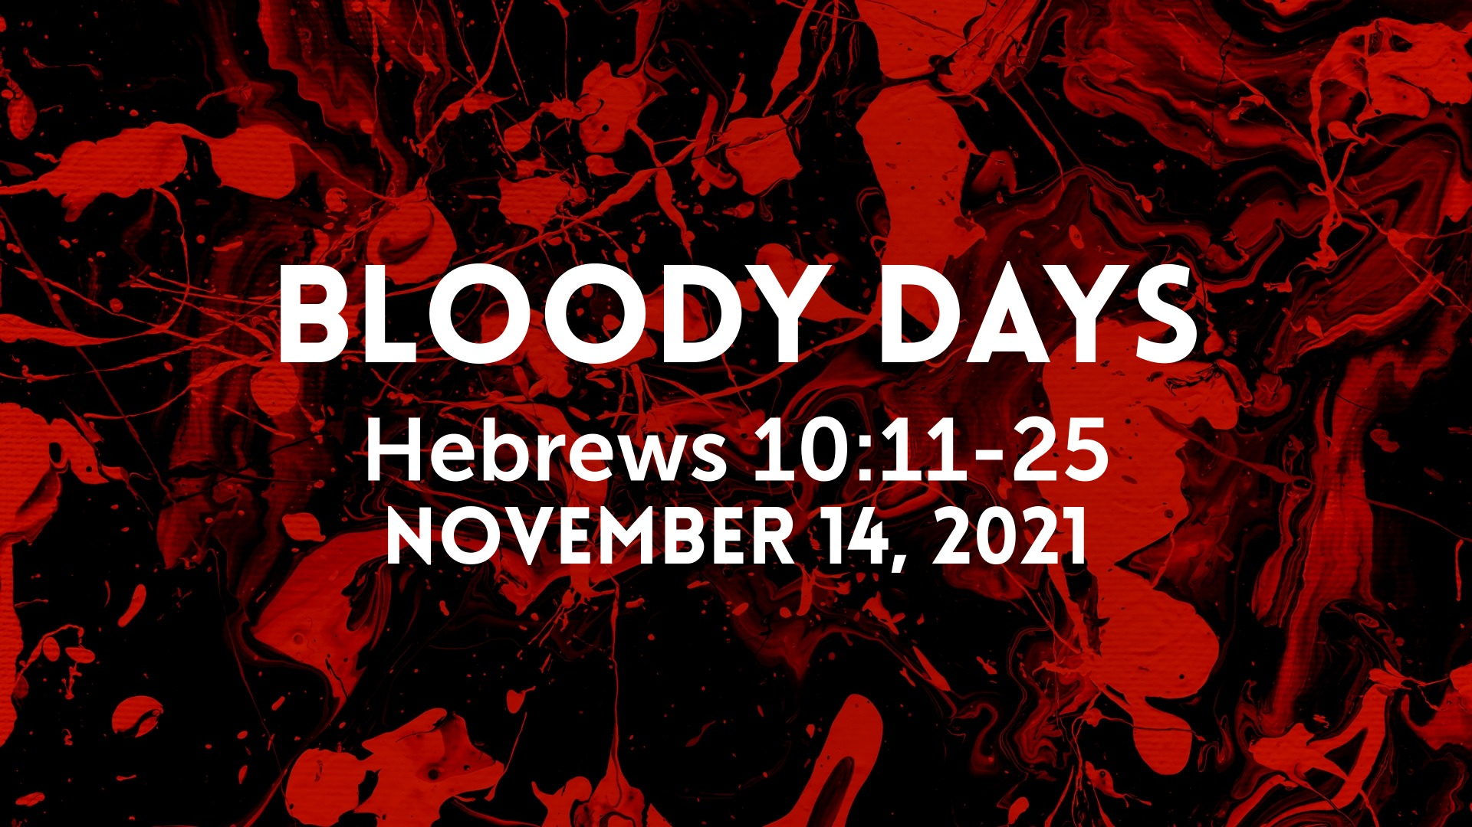

Salem Lutheran Church
1-715-537-3011
http://www.salembarron.com
rev.mike.nielsen@gmail.com
The Crucified and Risen Body of Christ Jesus Is the True Temple of God

Despite its “wonderful stones” and “great buildings,” the Jerusalem temple would be torn down, with not one stone left upon another, just as this present world and its kingdoms will come to an end (Mark 13:1–8). But that temple pointed beyond itself to Christ, to His sacrifice upon the cross and to the resurrection of His body as the true Temple of God. In the midst of sin and death, by the proclamation of the Gospel, He now gathers disciples into His body, wherein “the one who endures to the end will be saved” (Mark 13:10–13). For He is “a great priest over the house of God,” who “will remember their sins and their lawless deeds no more.” By the pure water of His Baptism, they “draw near with a true heart in full assurance of faith,” and by His flesh and blood, they enter the Holy of Holies (Heb. 10:17–22). Thus are His people delivered, “everyone whose name shall be found written in the book.” For by the wisdom of His Gospel, He turns “many to righteousness,” so that “many of those who sleep in the dust of the earth shall awake” to everlasting life (Dan. 12:1–3).
Hymn: No Temple Now, No Gift of Price LSB 530
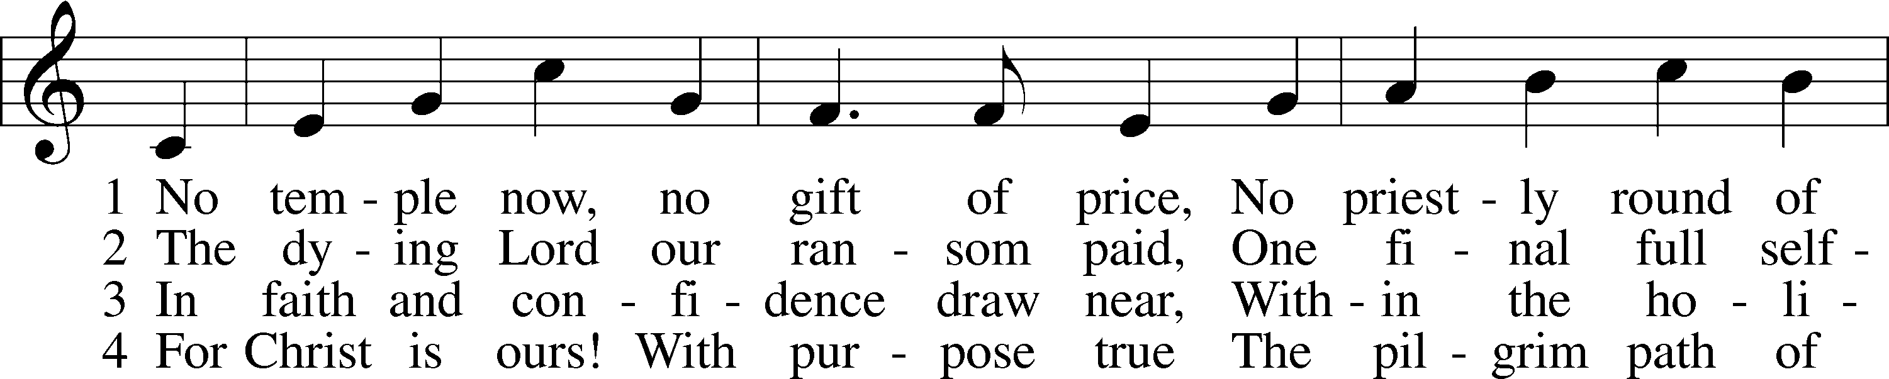
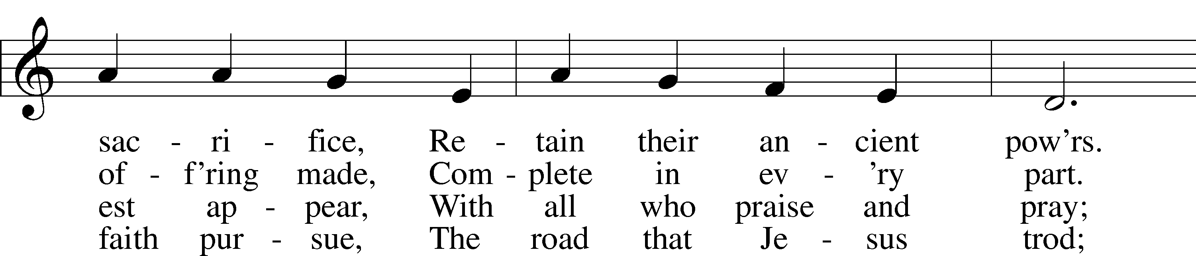
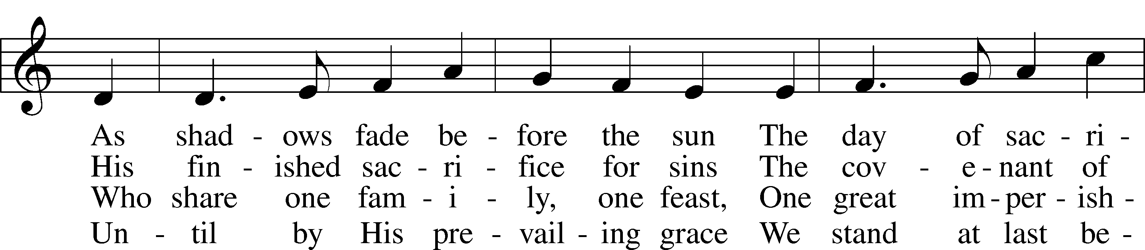
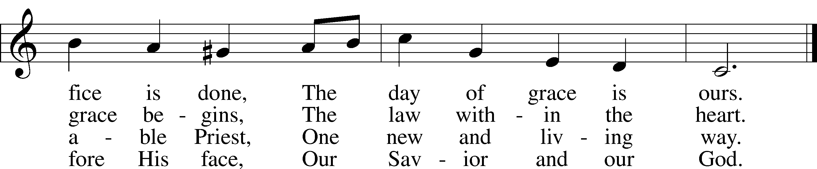
Text: © 1984 Hope Publishing Co. Used by permission: LSB Hymn License no. 110005504
Tune: © 1998 Joseph Herl. Used by permission: LSB Hymn License no. 110005504

Stand

Common Versicles LSB 260
L This is the day which the Lord has made;
C let us rejoice and be glad in it.
L From the rising of the sun to its setting,
C the name of the Lord is to be praised.

L Better is one day in Your courts than a thousand elsewhere;
C I would rather be a doorkeeper in the house of my God than dwell in the tents of the wicked.
L Make me to know Your ways, O Lord.
C Teach me Your paths.
L Sanctify us in Your truth.
C Your Word is truth.

L From the rising of the sun to its setting,
C the name of the Lord is to be praised.

C Glory be to the Father and to the Son and to the Holy Spirit;
as it was in the beginning, is now, and will be forever. Amen.

Old Testament Canticle LSB 261
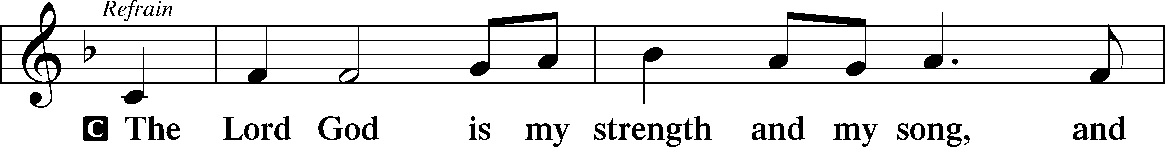
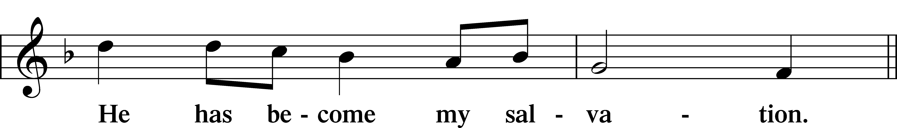
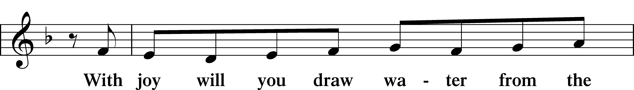
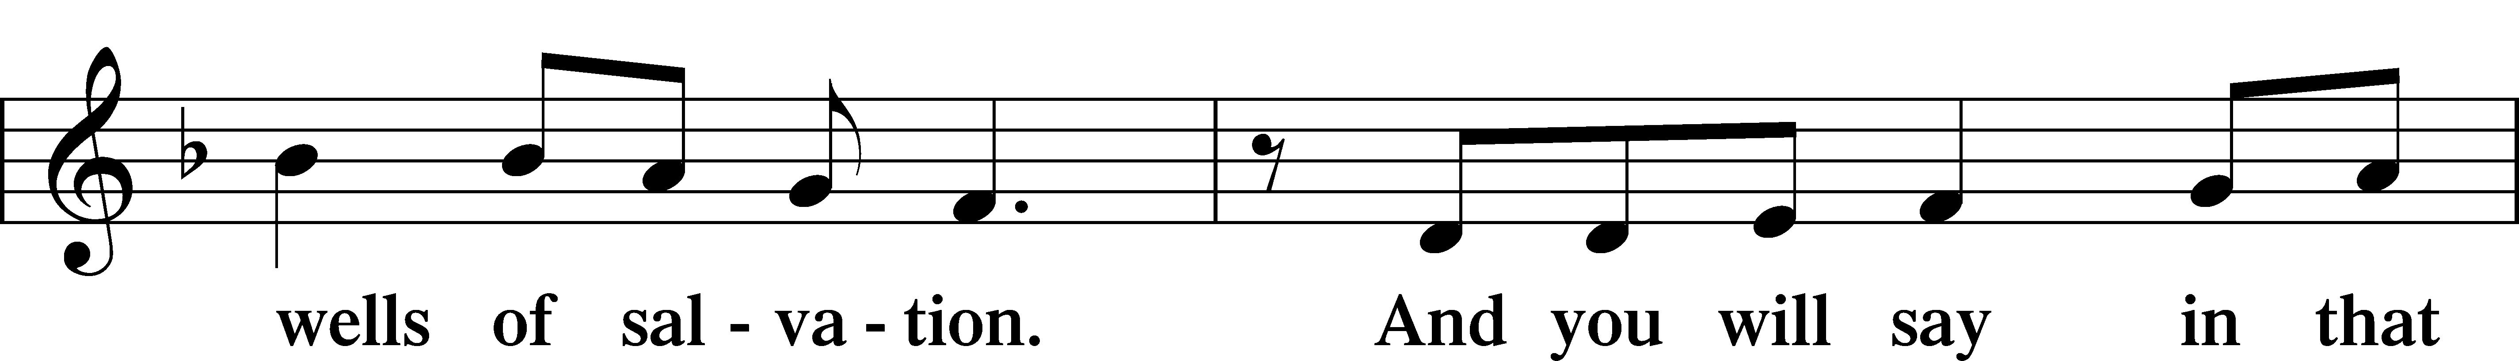
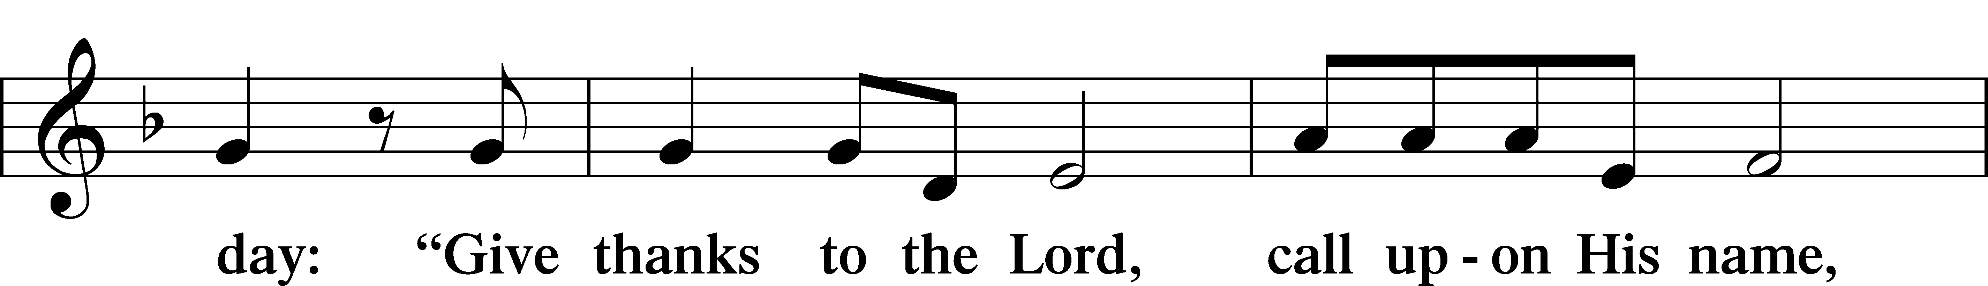
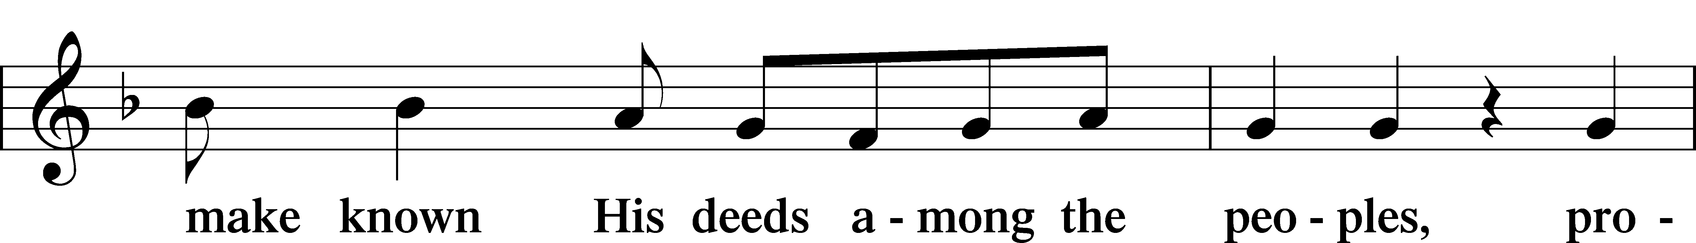
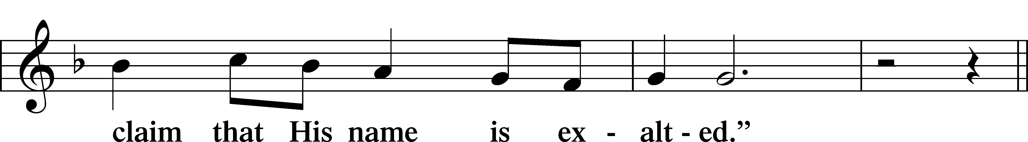
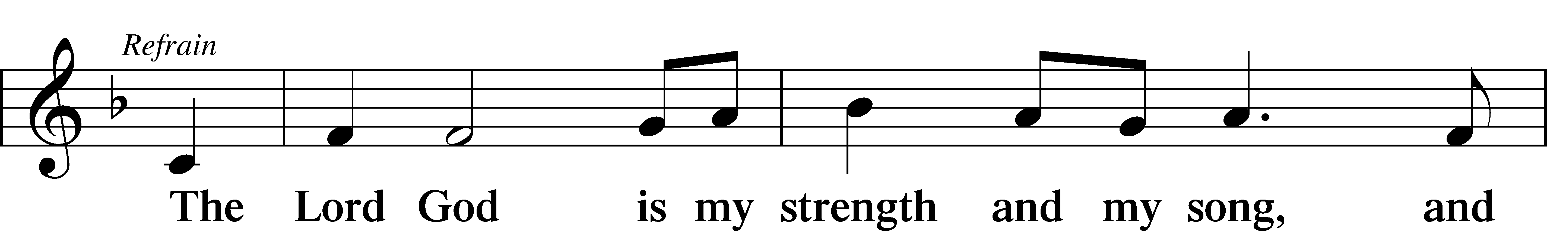
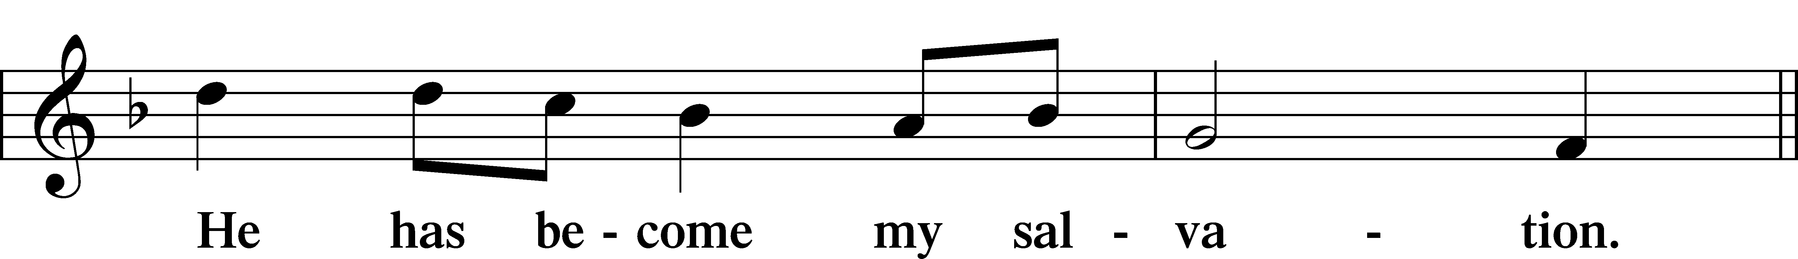
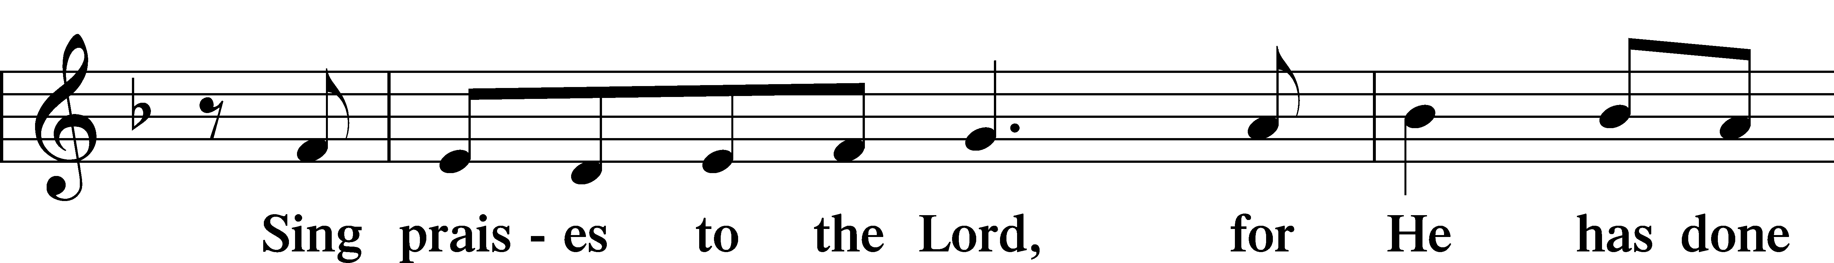
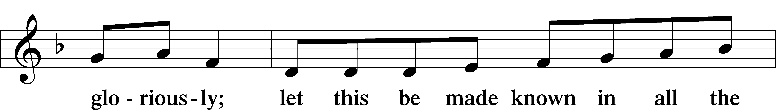
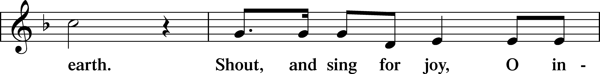
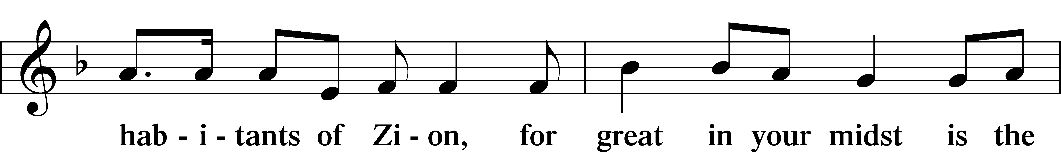
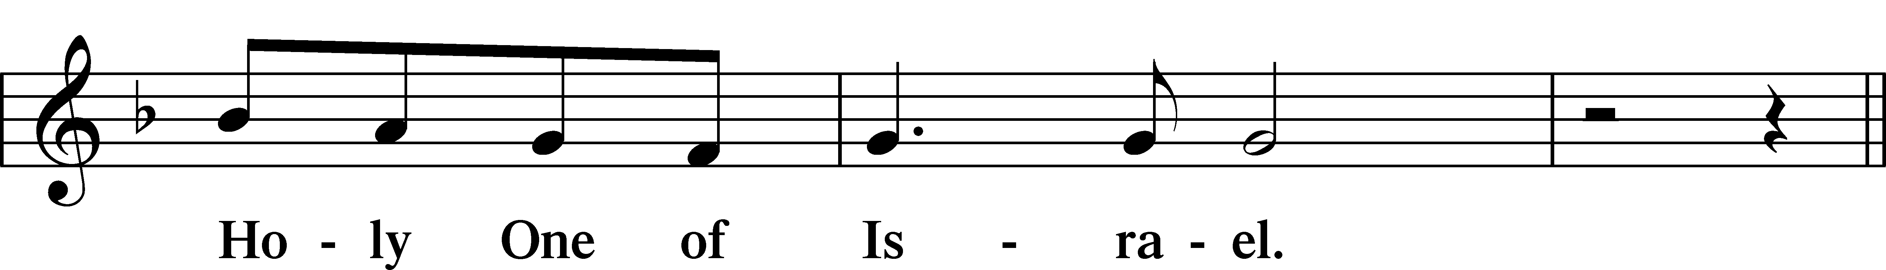
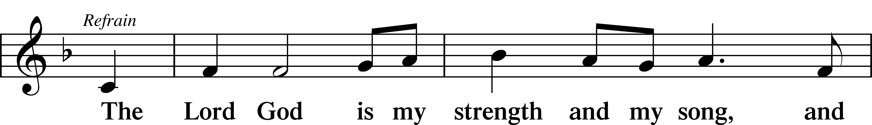
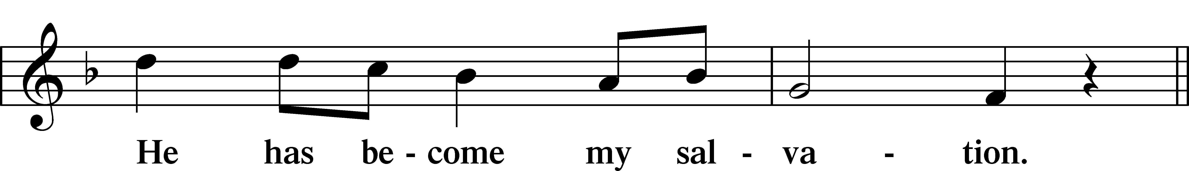
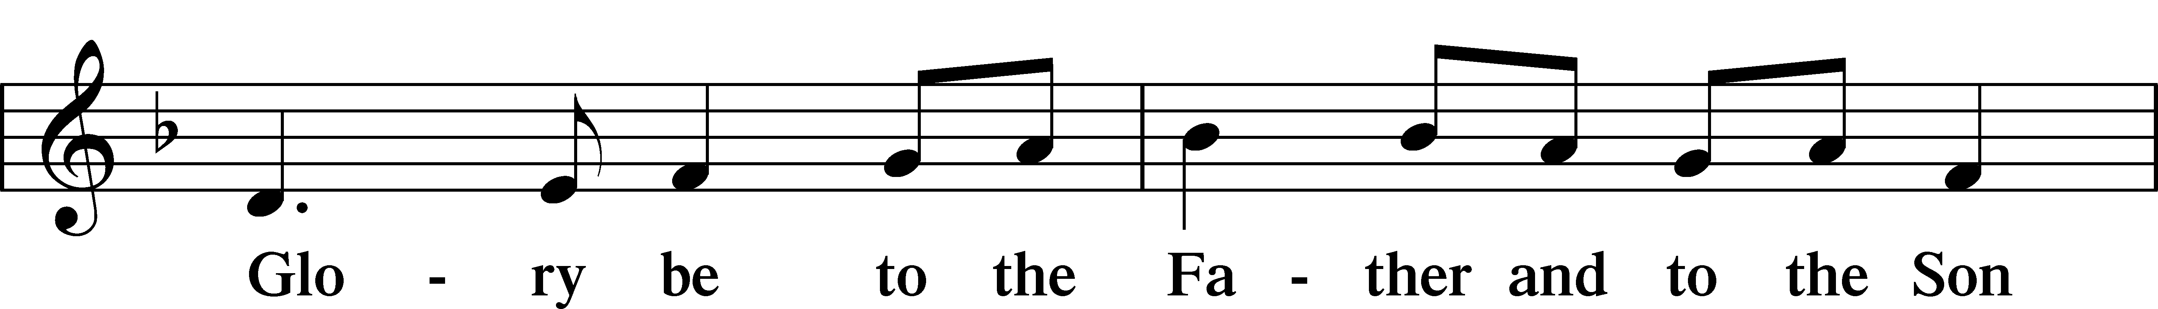
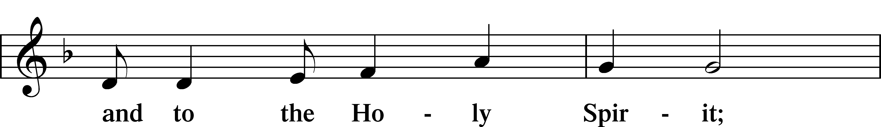
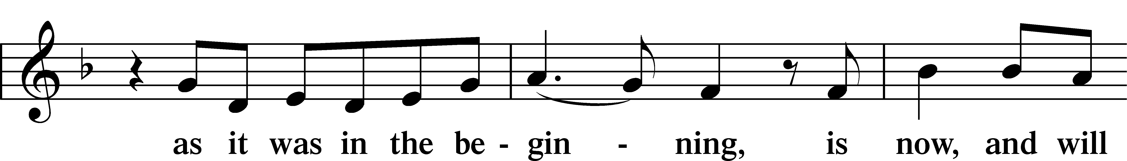
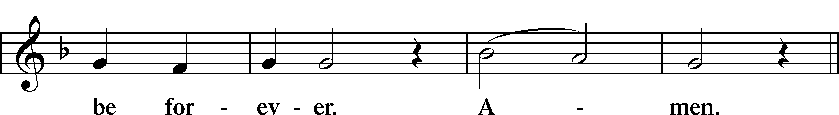
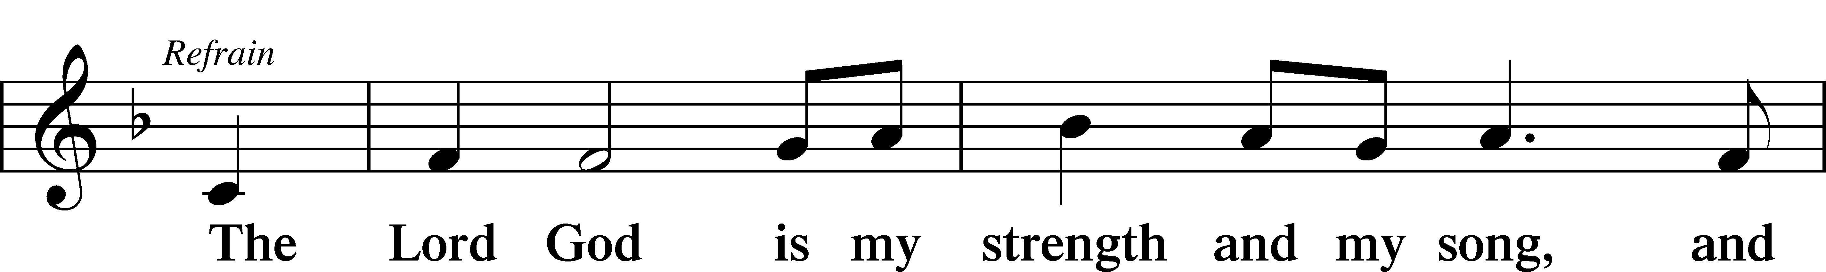
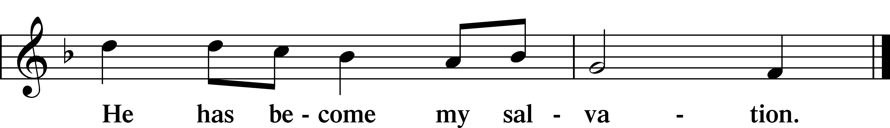

Sit

Readings From Holy Scripture

Reading Daniel 12:1–3
L A reading from Daniel, the twelfth chapter.

The Time of the End
1“At that time shall arise Michael, the great prince who has charge of your people. And there shall be a time of trouble, such as never has been since there was a nation till that time. But at that time your people shall be delivered, everyone whose name shall be found written in the book. 2And many of those who sleep in the dust of the earth shall awake, some to everlasting life, and some to shame and everlasting contempt. 3And those who are wise shall shine like the brightness of the sky above; and those who turn many to righteousness, like the stars forever and ever.”

L This is the Word of the Lord.
C Thanks be to God.

Reading Psalm 16
You Will Not Abandon My Soul
1Preserve me, O God,
for in you I take refuge.
2I say to the Lord, “You are my Lord;
I have no good apart from you.”
3As for the saints in the land,
they are the excellent ones,
in whom is all my delight.
4The sorrows of those who run after another god shall multiply;
their drink offerings of blood I will not pour out
or take their names on my lips.
5The Lord is my chosen portion and my cup;
you hold my lot.
6The lines have fallen for me in pleasant places;
indeed, I have a beautiful inheritance.
7I bless the Lord who gives me counsel;
in the night also my heart instructs me.
8I have set the Lord always before me;
because he is at my right hand, I shall not be shaken.
9Therefore my heart is glad, and my whole being rejoices;
my flesh also dwells secure.
10For you will not abandon my soul to Sheol,
or let your holy one see corruption.
11You make known to me the path of life;
in your presence there is fullness of joy;
at your right hand are pleasures forevermore.

Reading Hebrews 10:11–25
11Every priest stands daily at his service, offering repeatedly the same sacrifices, which can never take away sins. 12But when Christ had offered for all time a single sacrifice for sins, he sat down at the right hand of God, 13waiting from that time until his enemies should be made a footstool for his feet. 14For by a single offering he has perfected for all time those who are being sanctified.
15And the Holy Spirit also bears witness to us; for after saying,
16“This is the covenant that I will make with them
after those days, declares the Lord:
I will put my laws on their hearts,
and write them on their minds,”
17then he adds,
“I will remember their sins and their lawless deeds no more.”
18Where there is forgiveness of these, there is no longer any offering for sin.
The Full Assurance of Faith
19Therefore, brothers, since we have confidence to enter the holy places by the blood of Jesus, 20by the new and living way that he opened for us through the curtain, that is, through his flesh, 21and since we have a great priest over the house of God, 22let us draw near with a true heart in full assurance of faith, with our hearts sprinkled clean from an evil conscience and our bodies washed with pure water. 23Let us hold fast the confession of our hope without wavering, for he who promised is faithful. 24And let us consider how to stir up one another to love and good works, 25not neglecting to meet together, as is the habit of some, but encouraging one another, and all the more as you see the Day drawing near.

A This is the Word of the Lord.
C Thanks be to God.

Reading Mark 13:1–13
Jesus Foretells Destruction of the Temple
1As [Jesus] came out of the temple, one of his disciples said to him, “Look, Teacher, what wonderful stones and what wonderful buildings!” 2And Jesus said to him, “Do you see these great buildings? There will not be left here one stone upon another that will not be thrown down.”
Signs of the Close of the Age
3And as he sat on the Mount of Olives opposite the temple, Peter and James and John and Andrew asked him privately, 4“Tell us, when will these things be, and what will be the sign when all these things are about to be accomplished?” 5And Jesus began to say to them, “See that no one leads you astray. 6Many will come in my name, saying, ‘I am he!’ and they will lead many astray. 7And when you hear of wars and rumors of wars, do not be alarmed. This must take place, but the end is not yet. 8For nation will rise against nation, and kingdom against kingdom. There will be earthquakes in various places; there will be famines. These are but the beginning of the birth pains.
9“But be on your guard. For they will deliver you over to councils, and you will be beaten in synagogues, and you will stand before governors and kings for my sake, to bear witness before them. 10And the gospel must first be proclaimed to all nations. 11And when they bring you to trial and deliver you over, do not be anxious beforehand what you are to say, but say whatever is given you in that hour, for it is not you who speak, but the Holy Spirit. 12And brother will deliver brother over to death, and the father his child, and children will rise against parents and have them put to death. 13And you will be hated by all for my name’s sake. But the one who endures to the end will be saved.”

A This is the Word of the Lord.
C Thanks be to God.

Common Responsory LSB 263
L Forever, O Lord, Your Word is firmly set in the heavens.
C Lord, I love the habitation of Your house and the place where Your glory dwells.
L Blessed are those who hear the Word of God and keep it.
C Lord, I love the habitation of Your house and the place where Your glory dwells.
L Glory be to the Father and to the Son and to the Holy Spirit.
C Lord, I love the habitation of Your house and the place where Your glory dwells.

Stand

Ten Commandments
C You shall have no other gods. You shall not misuse the name of the Lord your God. Remember the Sabbath day by keeping it holy. Honor your father and your mother. You shall not murder. You shall not commit adultery. You shall not steal. You shall not give false testimony against your neighbor. You shall not covet your neighbor’s house. You shall not covet your neighbor’s wife, or his manservant or maidservant, his ox or donkey, or anything that belongs to your neighbor.

Apostles’ Creed
C I believe in God, the Father Almighty, maker of heaven and earth.

And in Jesus Christ, His only Son, our Lord, who was conceived by the Holy Spirit, born of the virgin Mary, suffered under Pontius Pilate, was crucified, died and was buried. He descended into hell. The third day He rose again from the dead. He ascended into heaven and sits at the right hand of God the Father Almighty. From thence He will come to judge the living and the dead.
I believe in the Holy Spirit, the holy Christian Church, the communion of saints, the forgiveness of sins, the resurrection of the body, and the life T everlasting. Amen.

Lord’s Prayer
C Our Father who art in heaven, hallowed be Thy name, Thy kingdom come, Thy will be done on earth as it is in heaven; give us this day our daily bread; and forgive us our trespasses as we forgive those who trespass against us; and lead us not into temptation, but deliver us from evil. For Thine is the kingdom and the power and the glory forever and ever. Amen.

Sit

Children's Message

Hymn: The Day is Surely Drawing Near LSB 508
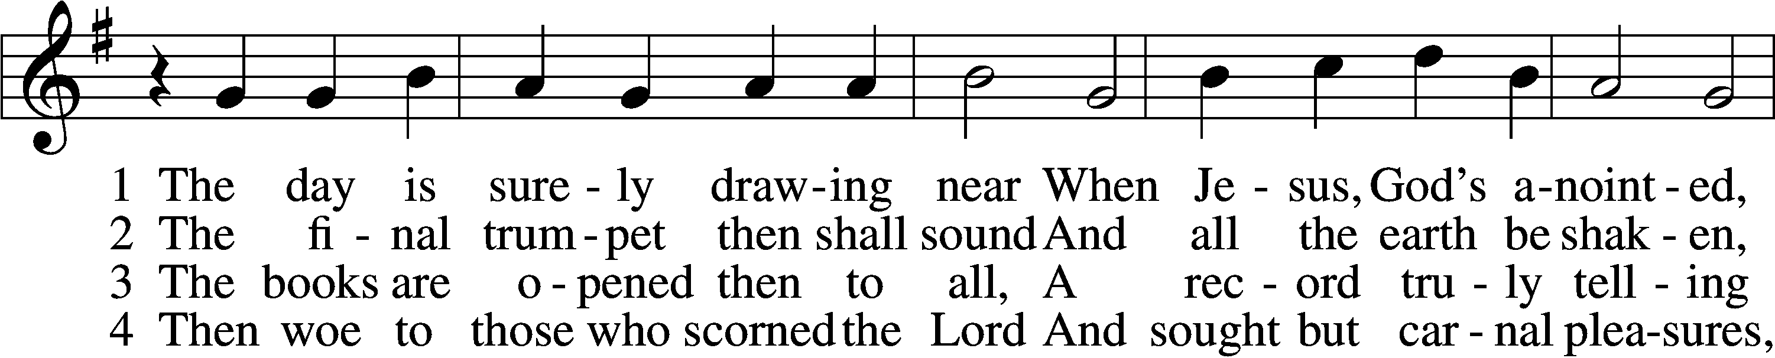
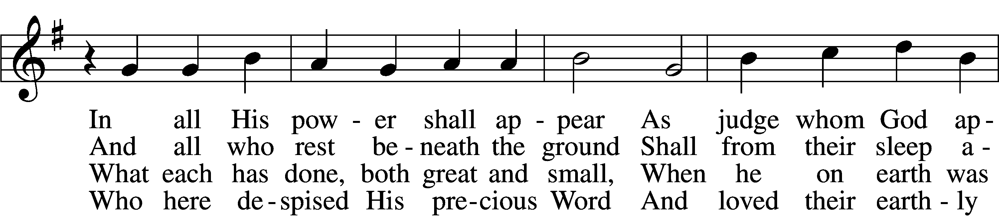
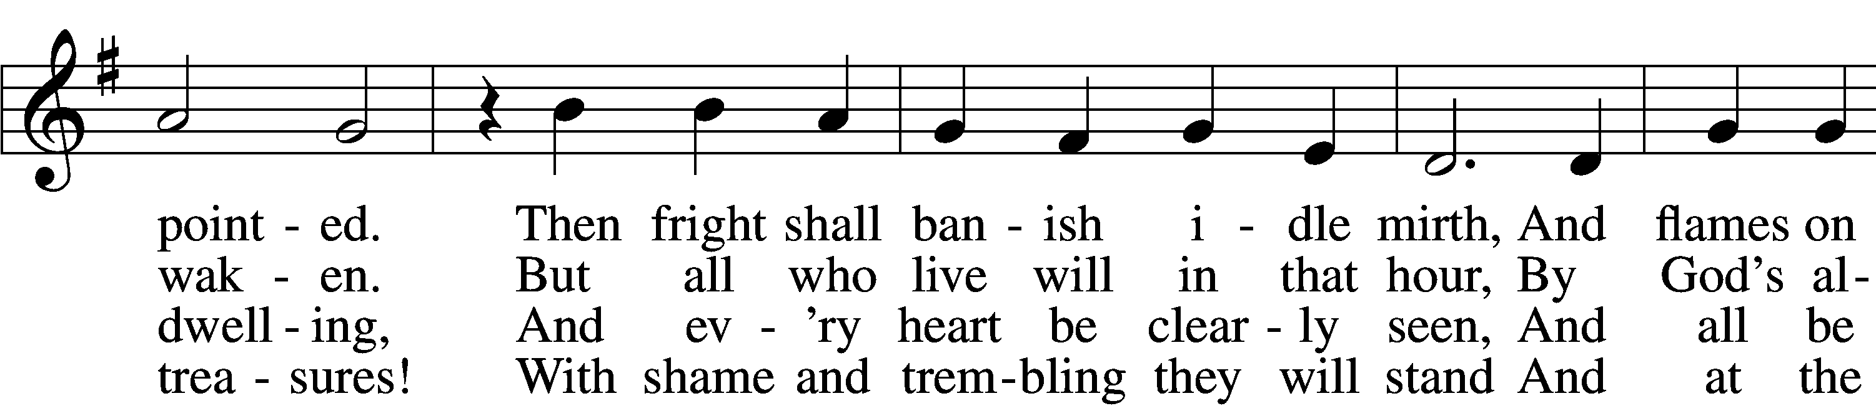
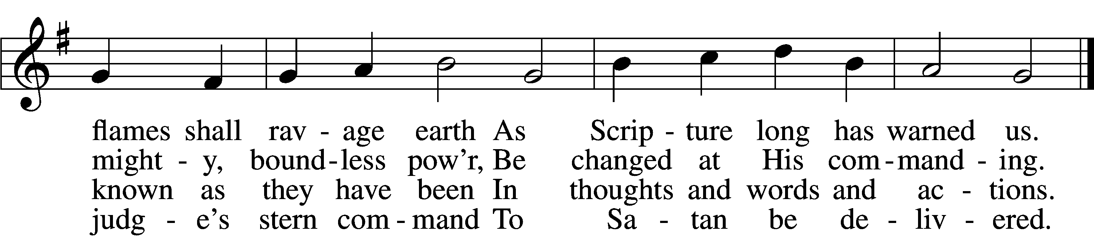

5 My Savior paid the debt I owe
And for my sin was smitten;
Within the Book of Life I know
My name has now been written.
I will not doubt, for I am free,
And Satan cannot threaten me;
There is no condemnation!
7 O Jesus Christ, do not delay,
But hasten our salvation;
We often tremble on our way
In fear and tribulation.
O hear and grant our fervent plea:
Come, mighty judge, and set us free
From death and ev’ry evil.

6 May Christ our intercessor be
And through His blood and merit
Read from His book that we are free
With all who life inherit.
Then we shall see Him face to face,
With all His saints in that blest place
Which He has purchased for us.

Text and tune: Public domain

Sermon

Offering

Stand

Prayer

Collect of the Day
L O Lord, by Your bountiful goodness release us from the bonds of our sins, which by reason of our weakness we have brought upon ourselves, that we may stand firm until the day of our Lord Jesus Christ, who lives and reigns with You and the Holy Spirit, one God, now and forever.
C Amen.

Collect for the Word
L Blessed Lord, You have caused all Holy Scriptures to be written for our learning. Grant that we may so hear them, read, mark, learn, and take them to heart that, by the patience and comfort of Your holy Word, we may embrace and ever hold fast the blessed hope of everlasting life; through Jesus Christ, Your Son, our Lord, who lives and reigns with You and the Holy Spirit, one God, now and forever.
C Amen.

Morning Prayer
C I thank You, my heavenly Father, through Jesus Christ, Your dear Son, that You have kept me this night from all harm and danger; and I pray that You would keep me this day also from sin and every evil, that all my doings and life may please You. For into Your hands I commend myself, my body and soul, and all things. Let Your holy angel be with me, that the evil foe may have no power over me.

New Testament Canticle LSB 266
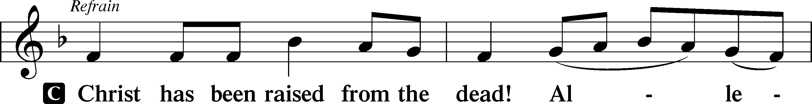
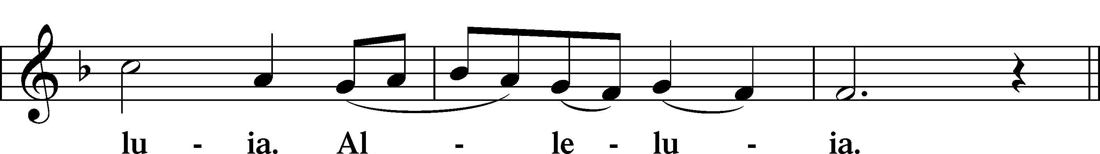
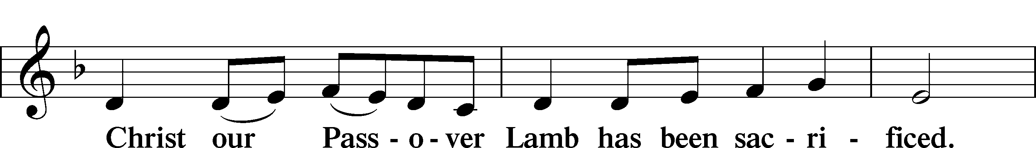
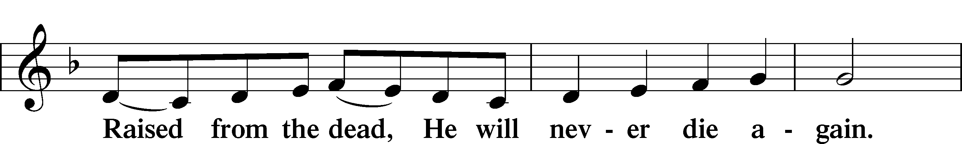
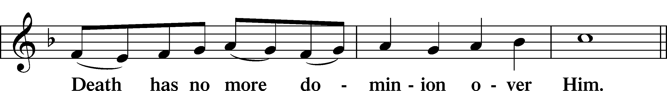
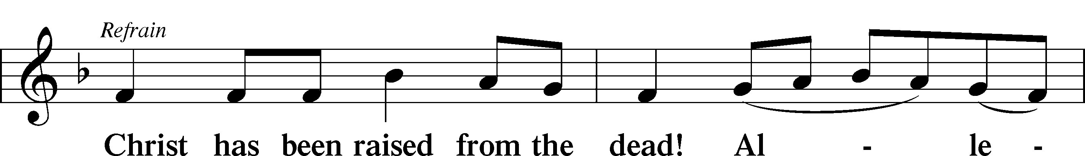
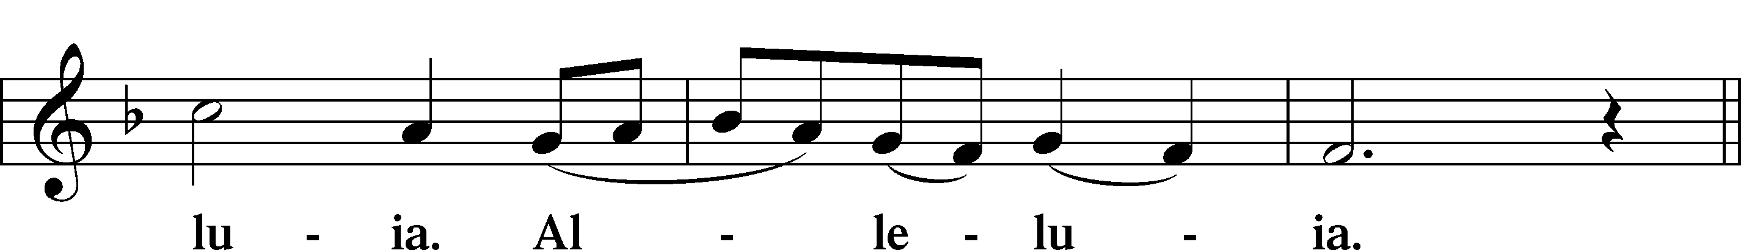
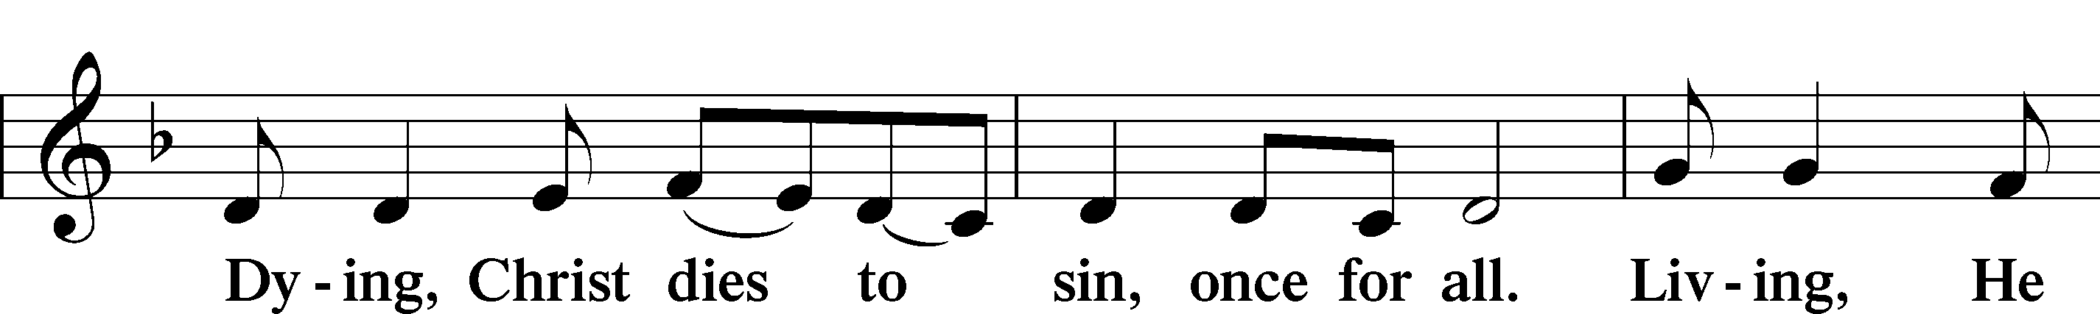
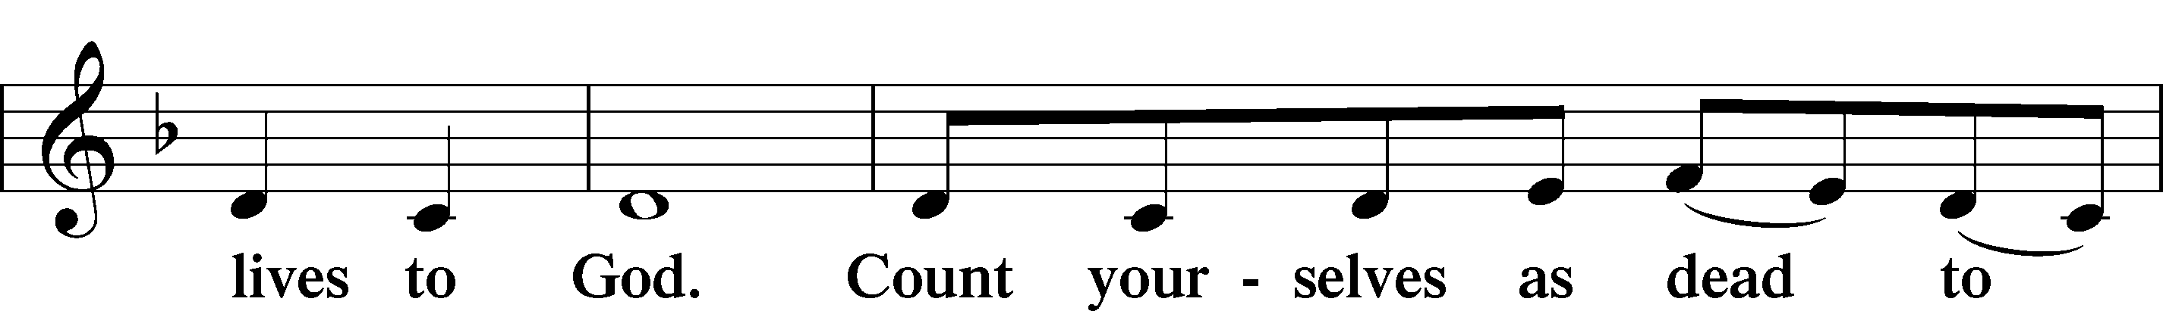
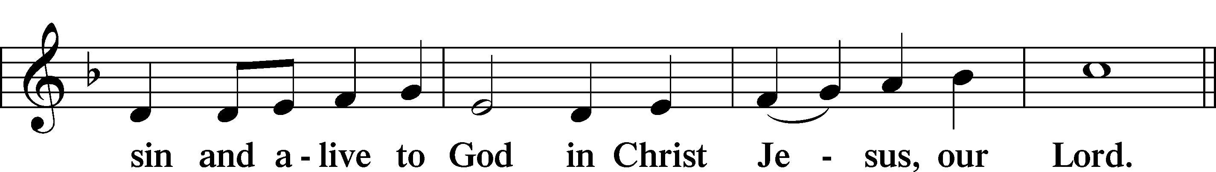
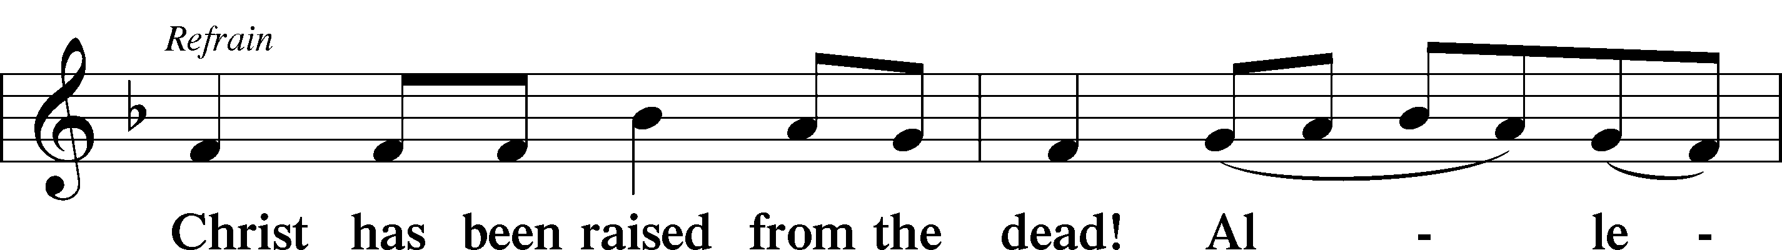
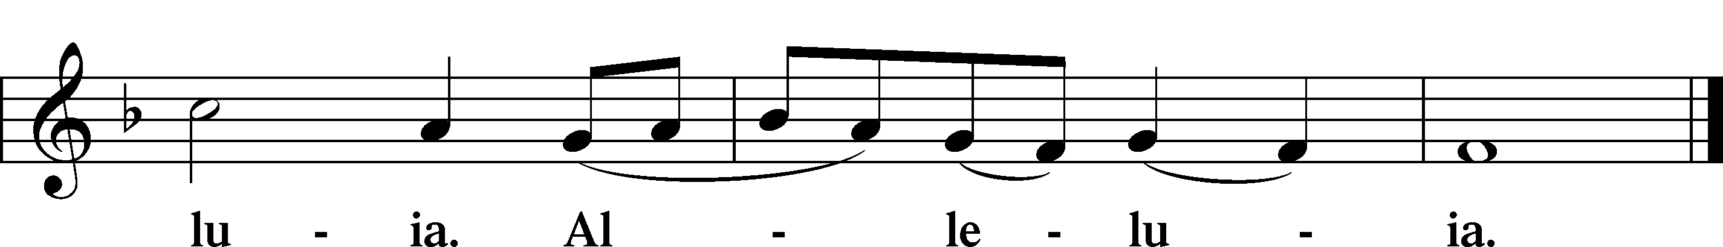

Blessing

L Let us bless the Lord.
C Thanks be to God.

L The almighty and merciful Lord, the Father, the T Son, and the Holy Spirit, bless and preserve us.
C Amen.

Hymn: My Hope is Built on Nothing Less LSB 575
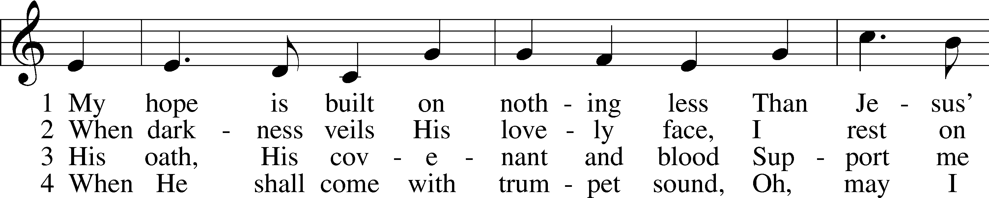
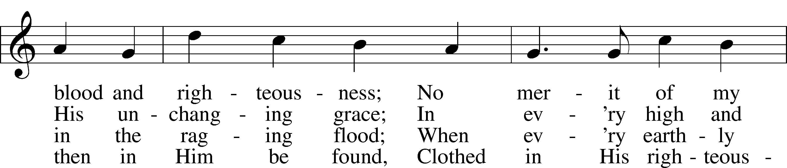
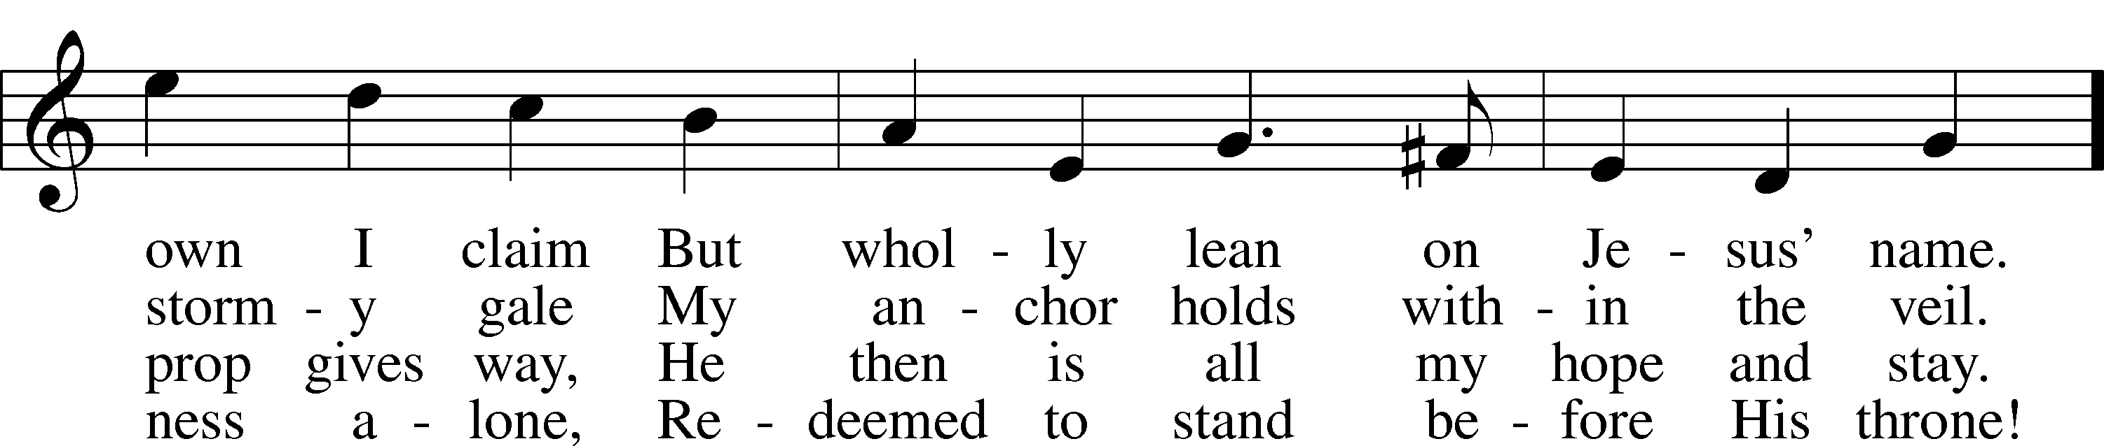
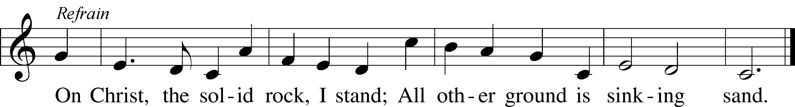
Tune and text: Public domain

Acknowledgments
Service of Prayer and Preaching from Lutheran Service Book
Unless otherwise indicated, Scripture quotations are from the ESV® Bible (The Holy Bible, English Standard Version®), copyright © 2001 by Crossway, a publishing ministry of Good News Publishers. Used by permission. All rights reserved.
Created by Lutheran Service Builder © 2021 Concordia Publishing House.

Announcements:
Church Service Phone: 888-505-1870/715-438-4200
(Stay on the line for recorded service to start)
Live Stream audio services: http://salem.listentochurch.com
Salem’s Web Page: https://www.salembarron.com/

Pastor Michael Nielsen: Cell phone: 218-280-0999
Email: rev.mike.nielsen@gmail.com
Pastor’s Office Hours: Monday-Wednesday 9-12

Attendance:
Call-in line: 11/7– 9
Facebook live: 11/7– 10
In-person: 11/7 – 72

Weekly Needs: $2823.92
10/31/21 - General: $1554 Missions: $22 Bldg: $33 Childcare: $45 Cemetery: $20 Oil Well: $166.11

Coffee and Snacks: Stan and Nancy Koenig
Elder Today: Trevor Duncan
Altar Guild: Denise Stabenow

Link to Salem’s Facebook page is:
https://www.facebook.com/SalemEvangelicalLutheranChurchAndPreschool/

Schedule for the upcoming week:
Tuesday: 7:30 AM – Men’s Bible Study; 4:15 PM - YFM
Wednesday: 4:00 PM Confirmation
Thursday: 11:00 AM Christian Difference

Save the Date: Christmas Program Practices
November 28: 11-12:15 PM
December 4: 9-11:30 AM
December 5 – Annual Meeting and Potluck.
December 7 – Big Buck Contest
December 18: 10-11:30 AM
December 19: Children’s Christmas Service

The Nativity Scene needs some painting. Anyone can be of assistance, please let Pastor, Don Duncan, or Tom Lipke know.

Childcare Amazon Needs List: https://a.co/75FLsBE

Prayer requests:

Those in the nursing home:
Caroly, Etta, Leonard, Lois, Vi, Wilma

Those Shut-in at home:
Char, Gail and Roxanne, Joan, Joyce, Loretta

Those recovering from accident: Rusty Weise, Hunter Nelson, Grant Stabenow

Those with ongoing health issues: Harrison, Jeanne, Kim, Marlene, Wyatt, Owen, Joyce, Marilyn, Bernie, Michelle, Sarah, Kathy, Mary, Chris, Sue, Carol.

Those who grieve: The Families of Pete Pedersen and Gary Zabel

Those who lead our nation:
Joe Biden, Kamala Harris, Tony Evers, Ron Fladten

Those who serve in our military:
Ryan Graf and Ethan Kobernick

Our Childcare Staff: Amanda Ritchie, Mary Zook, Kristin Loback, Mariah Behnke

Families of the Week: Marty Schipull, Andrew Schuettpelz, Will and Kathy Schuettpelz, Dr. Chris and Jolene Severt (Logan, Taylor, Maddie, Payten), Carol Shearer, Dustin Slayton (Ava and Bentley)

Those who are struggling with Covid and the doctors and nurses caring for their patients.

Mission Statement
The Mission of Salem Lutheran Church is to be what God called us to be through faith in Jesus Christ, a body of believers engaged in building the Kingdom of God by discipling the Barron area with His Word and Sacrament ministry.

