First Sunday in Lent
February 26, 2023
9:00 AM

Salem Lutheran Church
1-715-537-3011
http://www.salembarron.com
rev.mike.nielsen@gmail.com
Following His Baptism, Jesus is “led up by the Spirit into the wilderness to be tempted by the devil” (Matt. 4:1). As He takes upon Himself the curse of our sin and sets Himself against our enemy, He trusts His Father’s voice and waits upon His Father’s hand for all things. The devil questions His sonship, but the beloved and well-pleasing Son remains faithful and lives “by every word that comes from the mouth of God” (Matt. 4:4). Jesus patiently suffers hunger in His mortal flesh and returns to the dust whence man was taken, and by His pain He brings forth food for all the children of men (Gen. 3:18–19). By the sweat of His brow, we eat the fruit of His cross, even as our nakedness is covered by His righteousness. Although all people live in bondage to death through the trespass of the first man, Adam, all the more “have the grace of God and the free gift by the grace of that one man Jesus Christ abounded for many” (Rom. 5:15). His righteous obedience “leads to justification and life for all men” (Rom. 5:18).
Hymn: In Adam We Have All Been One LSB 569
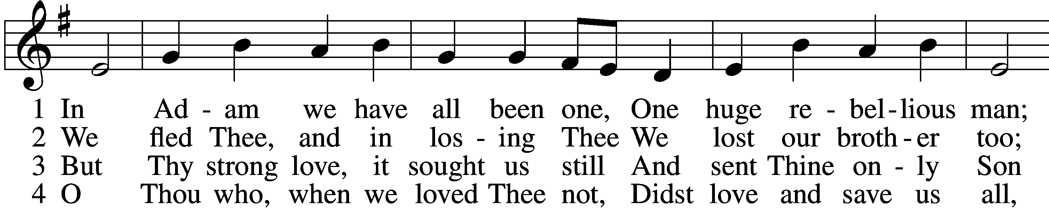
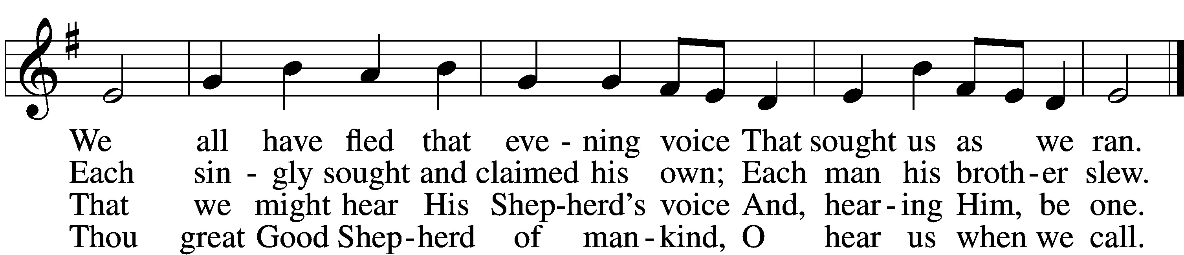

5 Send us Thy Spirit, teach us truth;
Thou Son, O set us free
From fancied wisdom, self-sought ways,
To make us one in Thee.
D 6 Then shall our song united rise
To Thine eternal throne,
Where with the Father evermore
And Spirit Thou art one.

Text: Martin H. Franzmann, 1907–76
Tune: Southern Harmony, 1835, New Haven
Text: © 1969 Concordia Publishing House. Used by permission: LSB Hymn License no. 110005504
Tune: Public domain

Stand

Lent Versicles LSB 219
L O Lord, open my lips,

L Make haste, O God, to deliver me;
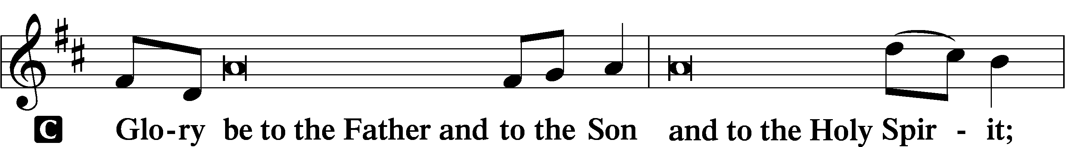
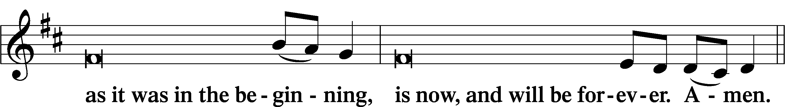
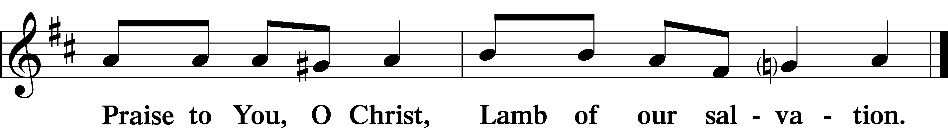

Psalmody

L The Lord has redeemed His people.
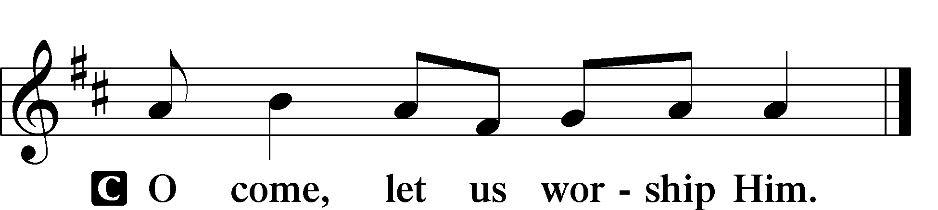

Venite LSB 220
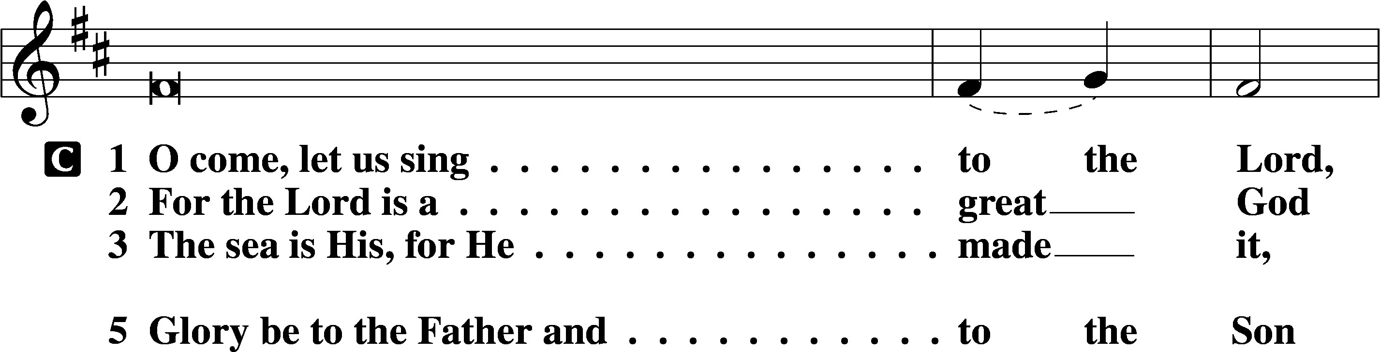
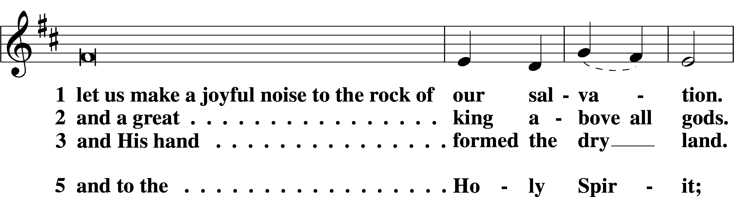
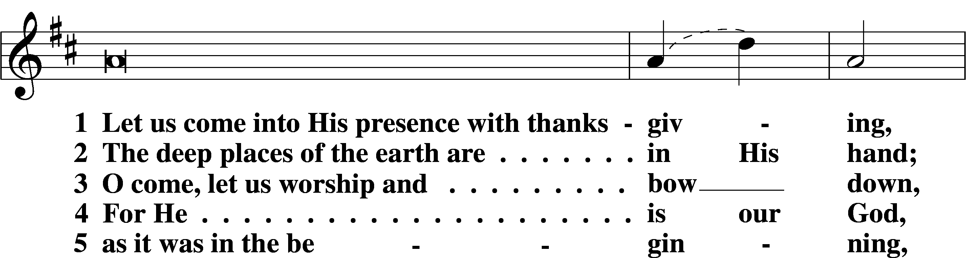
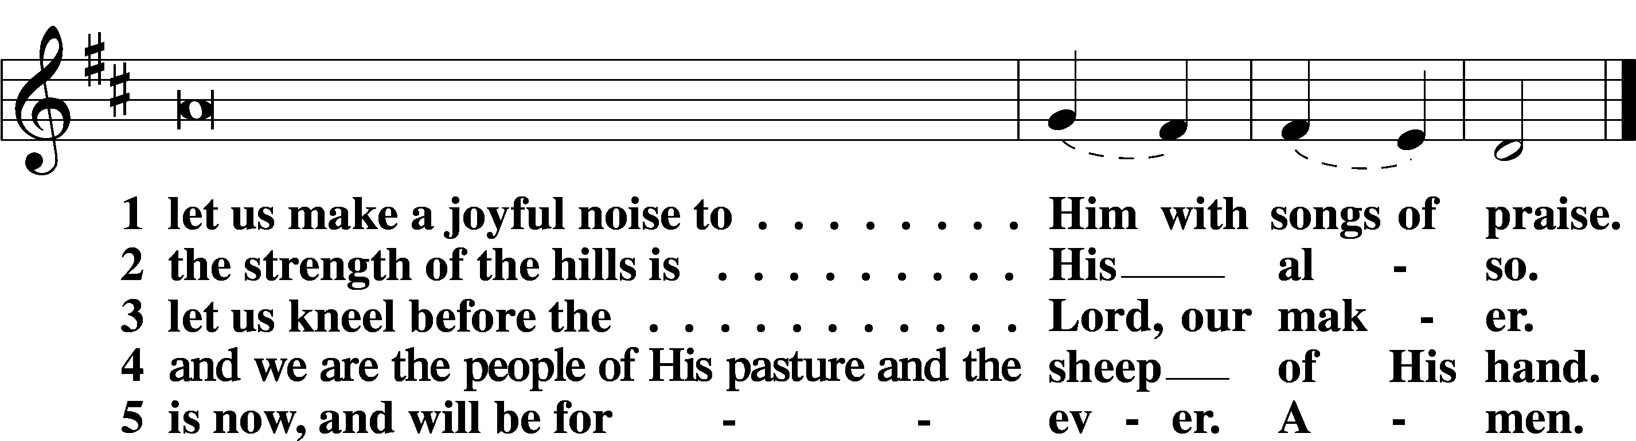

L The Lord has redeemed His people.

Additional Psalms Psalm 32:1–7; antiphon: v. 7a
Blessed Are the Forgiven
1Blessèd is the one whose transgression is forgiven,
whose sin is covered.
2Blessèd is the man against whom the Lord counts no iniquity,
and in whose spirit there is no deceit.
3For when I kept silent, my bones wasted away
through my groaning all day long.
4For day and night your hand was heavy upon me;
my strength was dried up as by the heat of summer.
5I acknowledged my sin to you,
and I did not cover my iniquity;
I said, “I will confess my transgressions to the Lord,”
and you forgave the iniquity of my sin.
6Therefore let everyone who is godly
offer prayer to you at a time when you may be found;
surely in the rush of great waters,
they shall not reach him.
7You are a hiding place for me;
you preserve me from trouble;
you surround me with shouts of deliverance.

Sit

Office Hymn: A Mighty Fortress is Our Good LSB 656
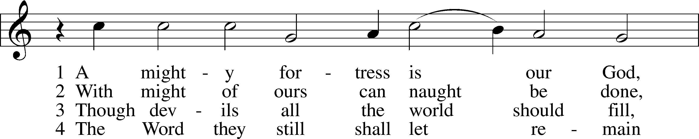
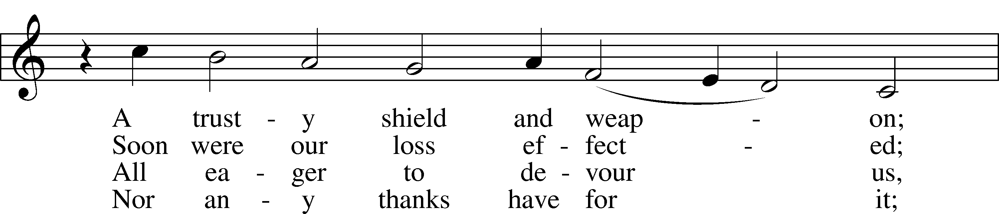
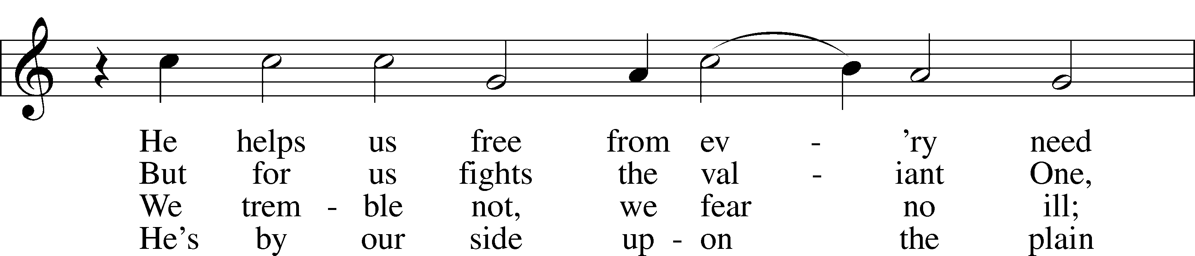
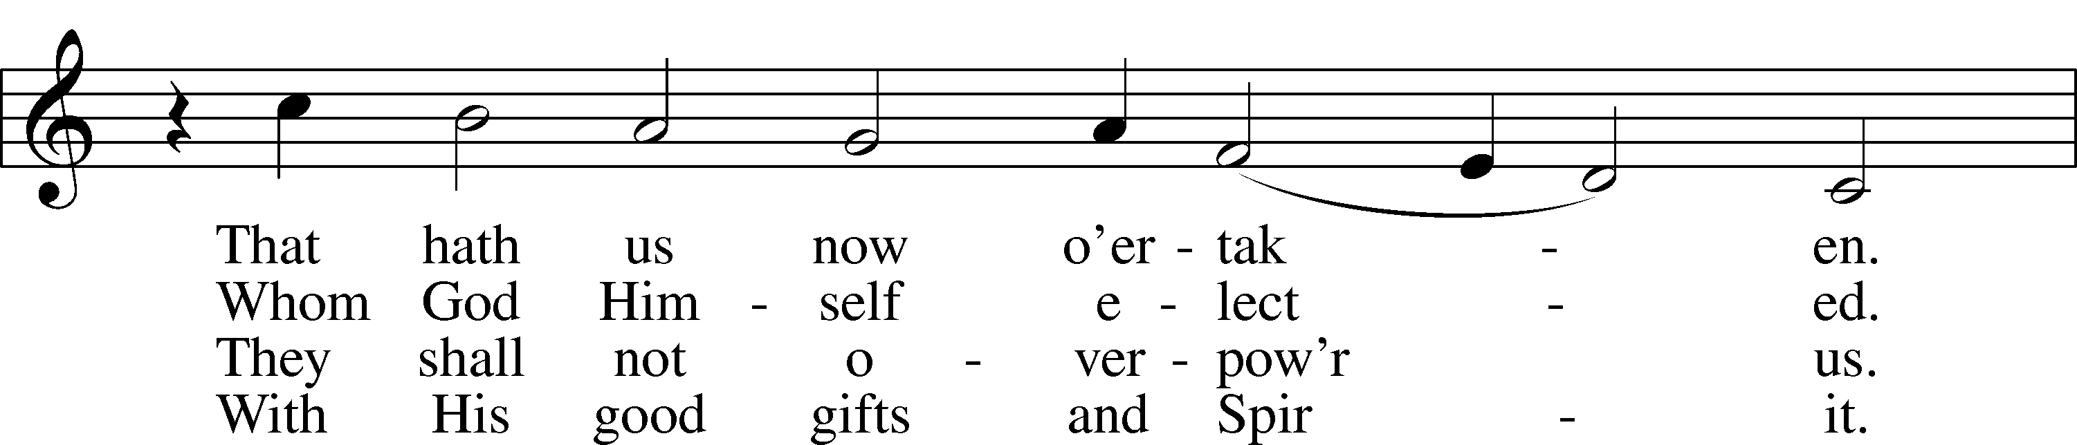
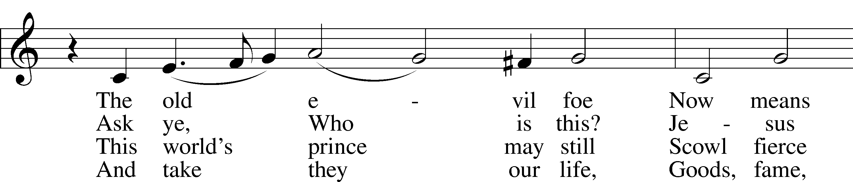
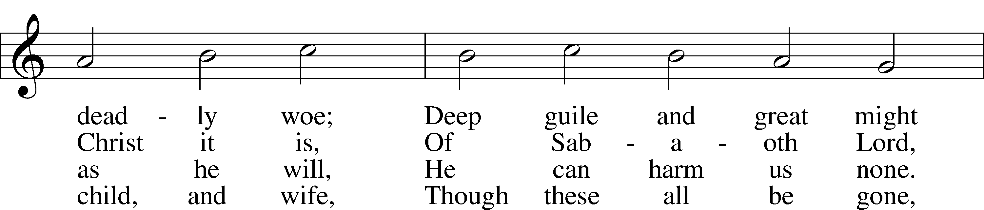
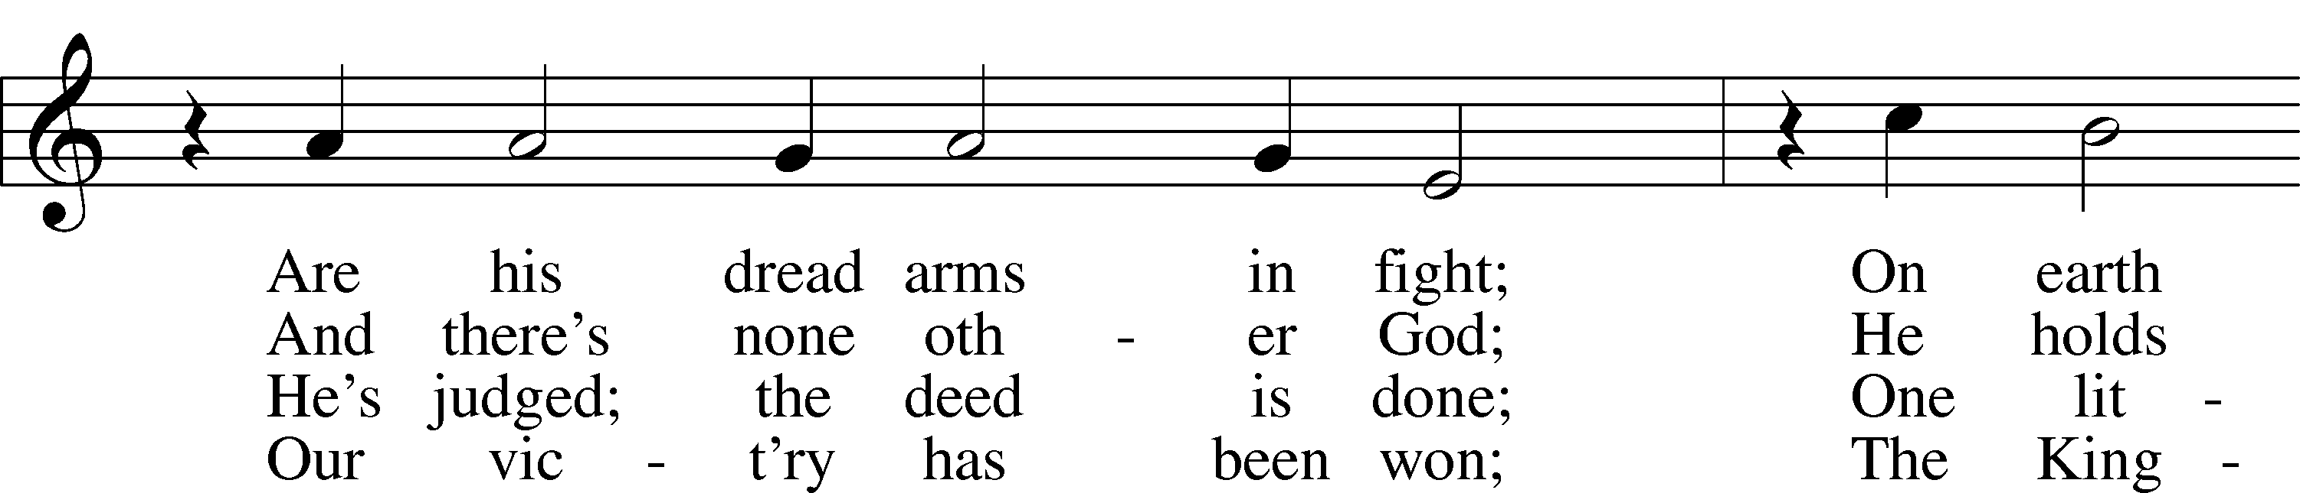
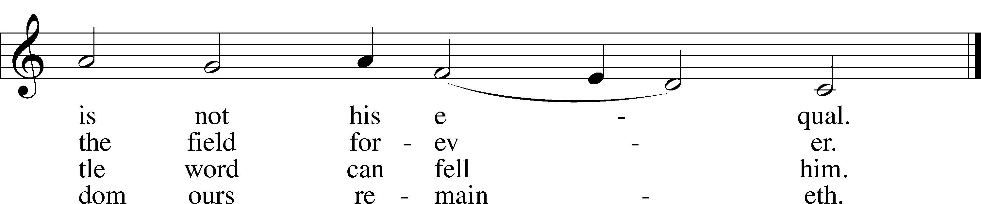
Text: tr. composite
Text and tune: Martin Luther, 1483–1546
Text and tune: Public domain

Readings

Reading Genesis 3:1–21
L A reading from Genesis, chapter 3.

1Now the serpent was more crafty than any other beast of the field that the Lord God had made.
He said to the woman, “Did God actually say, ‘You shall not eat of any tree in the garden’?” 2And the woman said to the serpent, “We may eat of the fruit of the trees in the garden, 3but God said, ‘You shall not eat of the fruit of the tree that is in the midst of the garden, neither shall you touch it, lest you die.’” 4But the serpent said to the woman, “You will not surely die. 5For God knows that when you eat of it your eyes will be opened, and you will be like God, knowing good and evil.” 6So when the woman saw that the tree was good for food, and that it was a delight to the eyes, and that the tree was to be desired to make one wise, she took of its fruit and ate, and she also gave some to her husband who was with her, and he ate. 7Then the eyes of both were opened, and they knew that they were naked. And they sewed fig leaves together and made themselves loincloths.
8And they heard the sound of the Lord God walking in the garden in the cool of the day, and the man and his wife hid themselves from the presence of the Lord God among the trees of the garden. 9But the Lord God called to the man and said to him, “Where are you?” 10And he said, “I heard the sound of you in the garden, and I was afraid, because I was naked, and I hid myself.” 11He said, “Who told you that you were naked? Have you eaten of the tree of which I commanded you not to eat?” 12The man said, “The woman whom you gave to be with me, she gave me fruit of the tree, and I ate.” 13Then the Lord God said to the woman, “What is this that you have done?” The woman said, “The serpent deceived me, and I ate.”
14The Lord God said to the serpent,
“Because you have done this, cursed are you above all livestock and above all beasts of the field; on your belly you shall go, and dust you shall eat all the days of your life.
15I will put enmity between you and the woman, and between your offspring and her offspring; he shall bruise your head, and you shall bruise his heel.”
16To the woman he said,
“I will surely multiply your pain in childbearing; in pain you shall bring forth children. Your desire shall be for your husband, and he shall rule over you.”
17And to Adam he said,
“Because you have listened to the voice of your wife and have eaten of the tree
of which I commanded you, ‘You shall not eat of it,’ cursed is the ground because of you; in pain you shall eat of it all the days of your life; 18thorns and thistles it shall bring forth for you; and you shall eat the plants of the field. 19By the sweat of your face you shall eat bread, till you return to the ground, for out of it you were taken; for you are dust, and to dust you shall return.”
20The man called his wife’s name Eve, because she was the mother of all living. 21And the Lord God made for Adam and for his wife garments of skins and clothed them.

L O Lord, have mercy on us.
C Thanks be to God.

Reading Romans 5:12–19
L A reading from Romans, chapter 5.

12Therefore, just as sin came into the world through one man, and death through sin, and so death spread to all men because all sinned— 13for sin indeed was in the world before the law was given, but sin is not counted where there is no law. 14Yet death reigned from Adam to Moses, even over those whose sinning was not like the transgression of Adam, who was a type of the one who was to come.
15But the free gift is not like the trespass. For if many died through one man’s trespass, much more have the grace of God and the free gift by the grace of that one man Jesus Christ abounded for many. 16And the free gift is not like the result of that one man’s sin. For the judgment following one trespass brought condemnation, but the free gift following many trespasses brought justification. 17If, because of one man’s trespass, death reigned through that one man, much more will those who receive the abundance of grace and the free gift of righteousness reign in life through the one man Jesus Christ.
18Therefore, as one trespass led to condemnation for all men, so one act of righteousness leads to justification and life for all men. 19For as by the one man’s disobedience the many were made sinners, so by the one man’s obedience the many will be made righteous.

L O Lord, have mercy on us.
C Thanks be to God.

Reading Matthew 4:1–11
L A reading from Matthew, chapter 4.

1Then Jesus was led up by the Spirit into the wilderness to be tempted by the devil. 2And after fasting forty days and forty nights, he was hungry. 3And the tempter came and said to him, “If you are the Son of God, command these stones to become loaves of bread.” 4But he answered, “It is written,
“‘Man shall not live by bread alone,
but by every word that comes from the mouth of God.’”
5Then the devil took him to the holy city and set him on the pinnacle of the temple 6and said to him, “If you are the Son of God, throw yourself down, for it is written,
“‘He will command his angels concerning you,’
and
“‘On their hands they will bear you up,
lest you strike your foot against a stone.’”
7Jesus said to him, “Again it is written, ‘You shall not put the Lord your God to the test.’” 8Again, the devil took him to a very high mountain and showed him all the kingdoms of the world and their glory. 9And he said to him, “All these I will give you, if you will fall down and worship me.” 10Then Jesus said to him, “Be gone, Satan! For it is written,
“‘You shall worship the Lord your God
and him only shall you serve.’”
11Then the devil left him, and behold, angels came and were ministering to him.

L O Lord, have mercy on us.
C Thanks be to God.

Children’s Message

Responsory (Lent) LSB 222
L We have an advocate with the Father; Jesus is the propitiation for our sins.
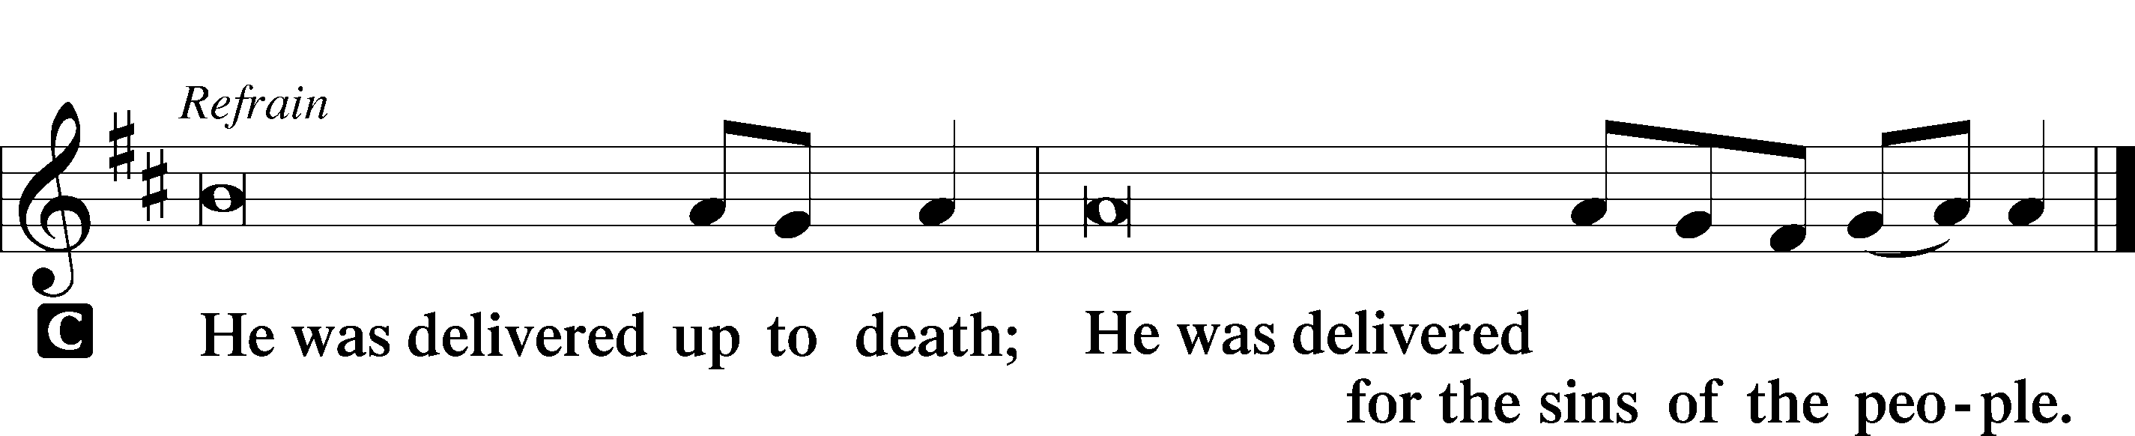

L Blessed is he whose transgression is forgiven and whose sin is put away.

L We have an advocate with the Father; Jesus is the propitiation for our sins.

Sermon

Canticle

Stand

Te Deum LSB 223
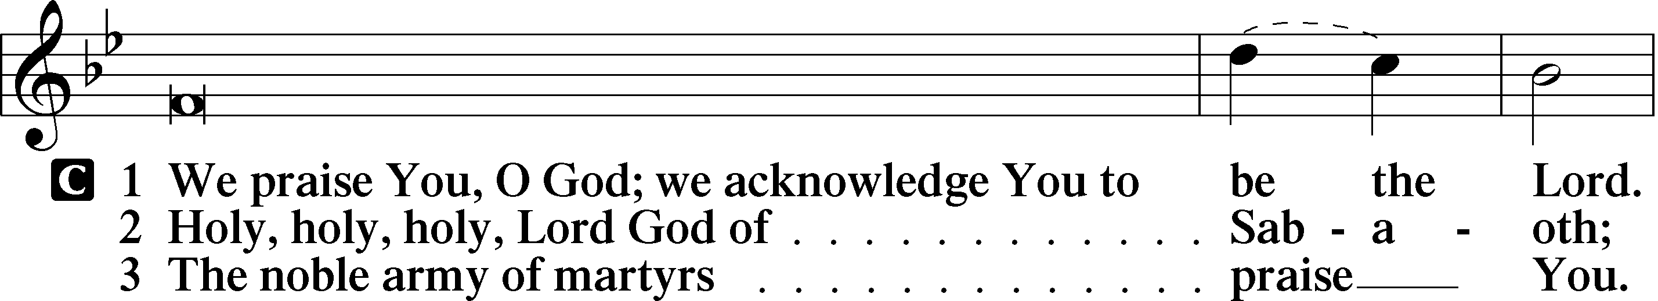
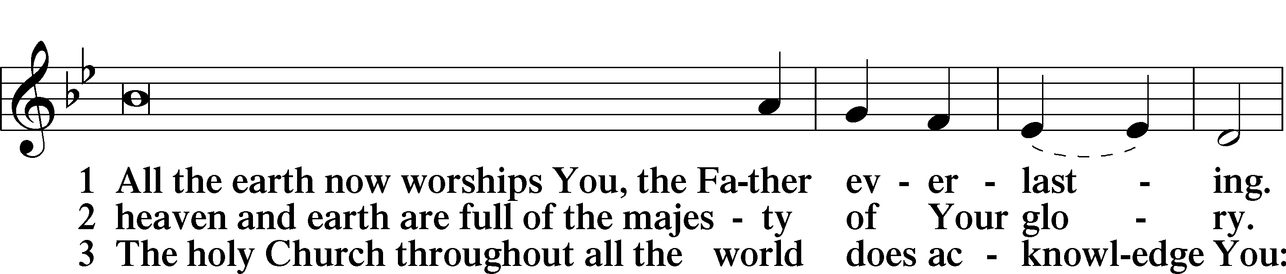
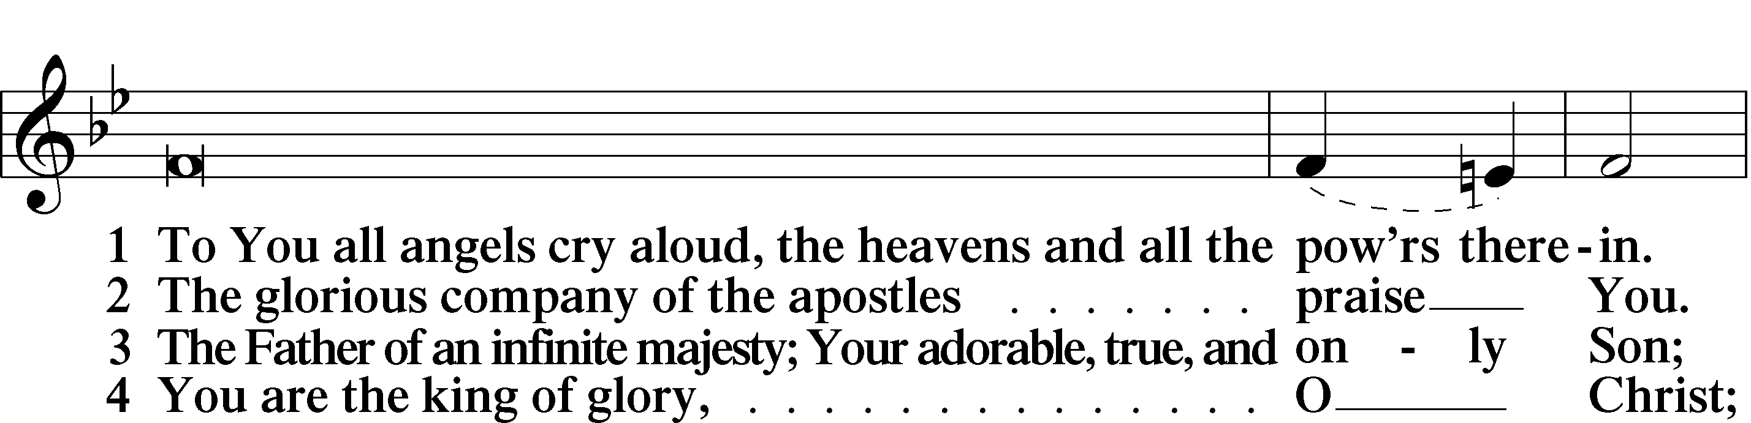
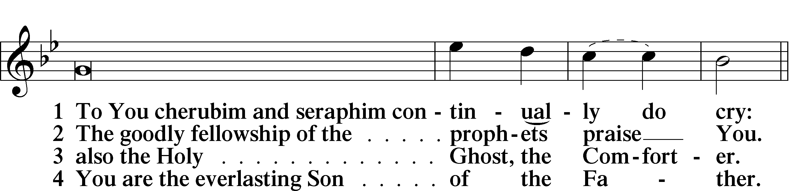
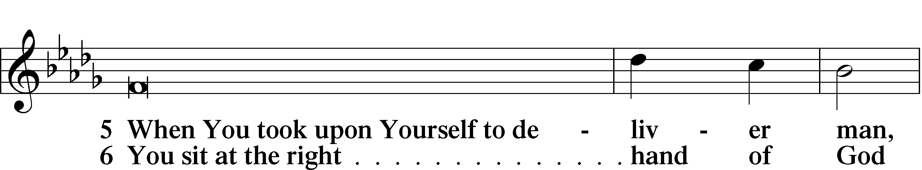
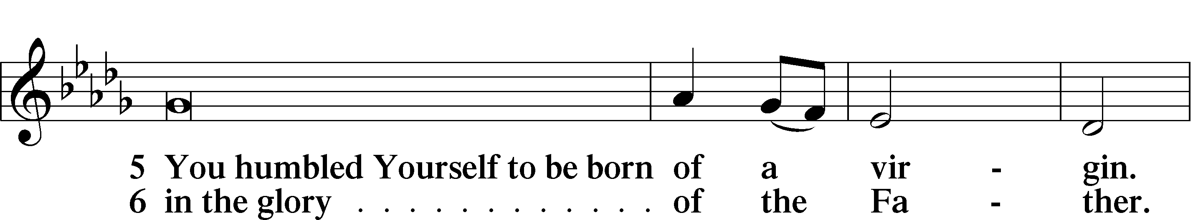
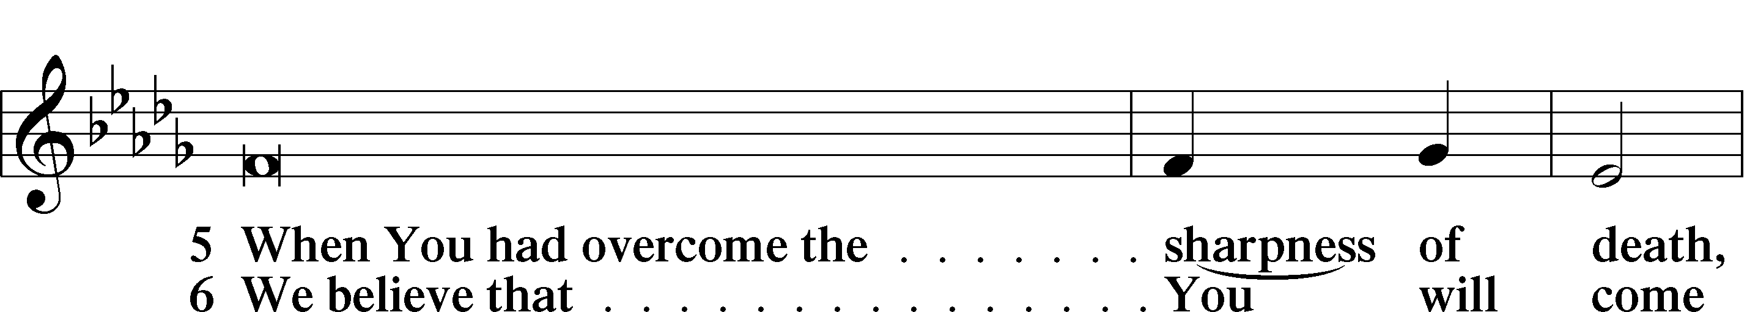
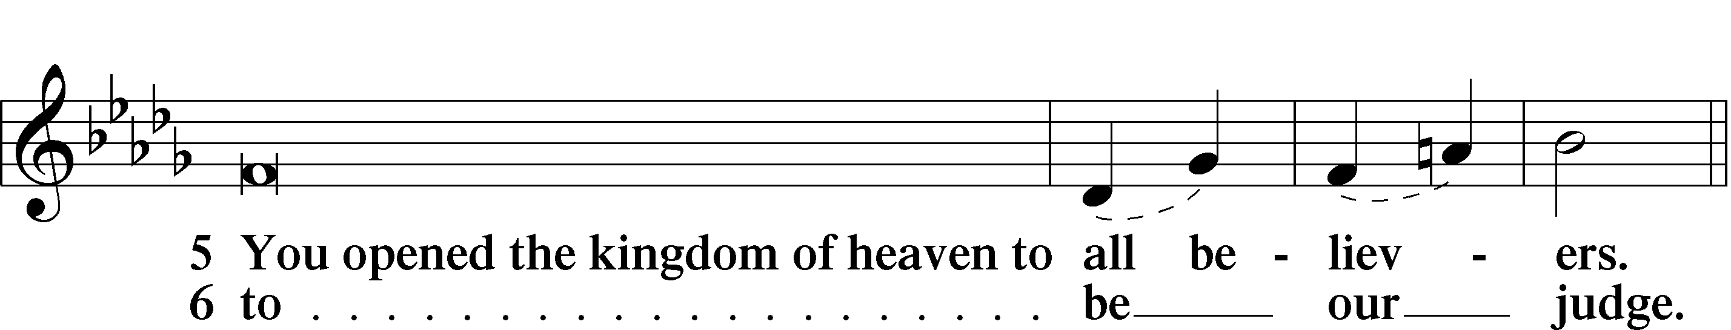
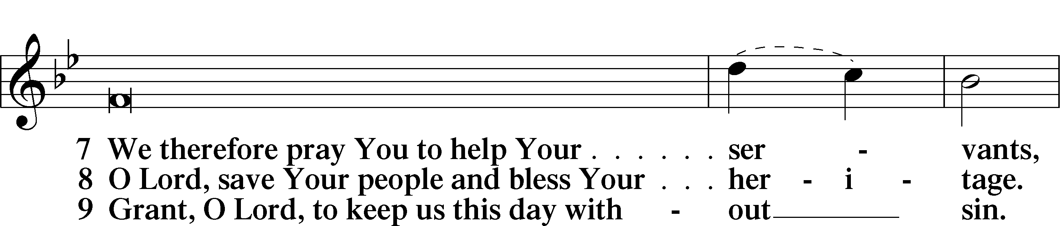
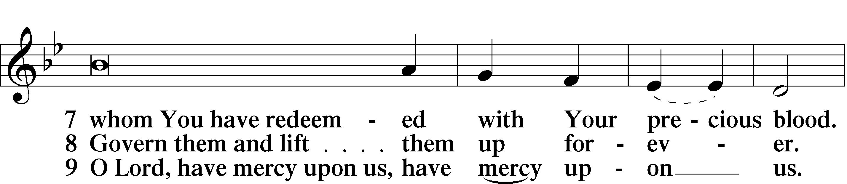
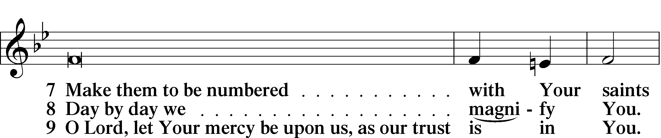
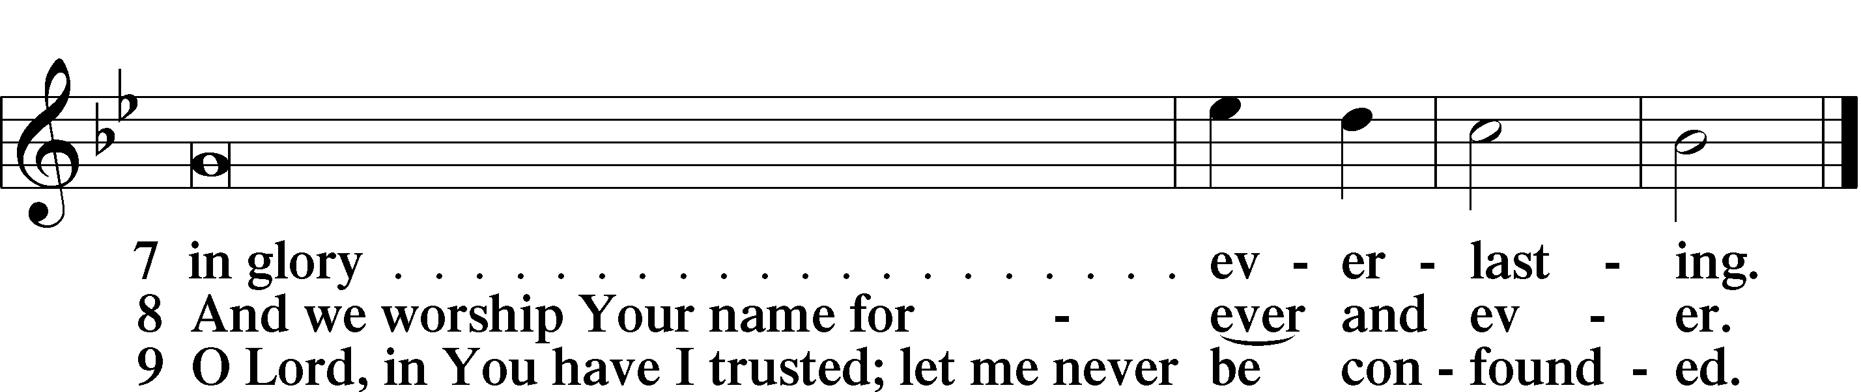

Sit

Offering

Prayer

Kneel/Stand

Kyrie LSB 227
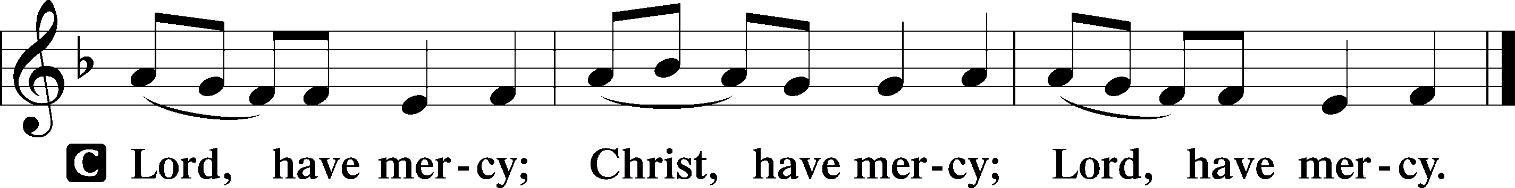

Lord’s Prayer
C Our Father who art in heaven, hallowed be Thy name, Thy kingdom come, Thy will be done on earth as it is in heaven; give us this day our daily bread; and forgive us our trespasses as we forgive those who trespass against us; and lead us not into temptation, but deliver us from evil. For Thine is the kingdom and the power and the glory forever and ever. Amen.

Introduction to Collects LSB 227
Introduction to Collects LSB 227
L O Lord, hear my prayer.
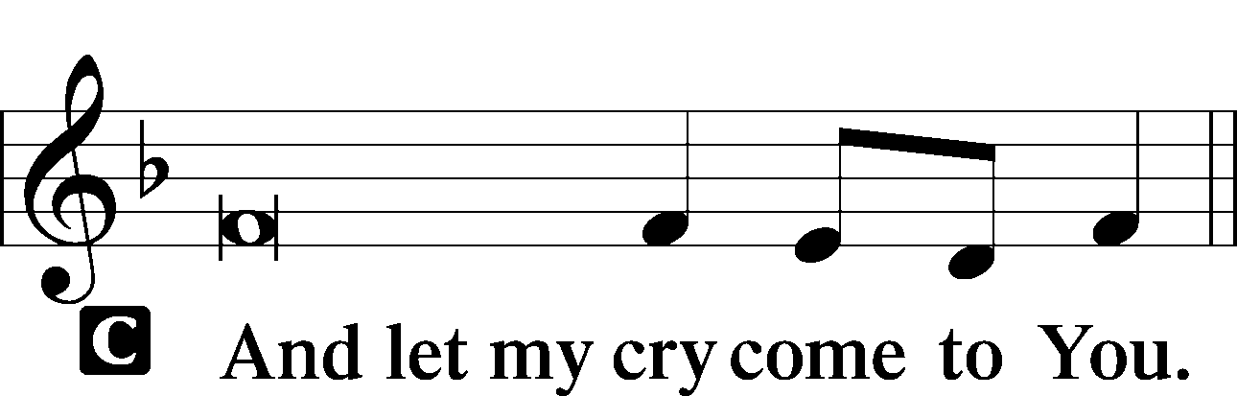

Collect of the Day
O Lord God, You led Your ancient people through the wilderness and brought them to the promised land. Guide the people of Your Church that following our Savior we may walk through the wilderness of this world toward the glory of the world to come; through Jesus Christ, Your Son, our Lord, who lives and reigns with You and the Holy Spirit, one God, now and forever.
C Amen.

Collect for Grace
L O Lord, our heavenly Father, almighty and everlasting God, You have safely brought us to the beginning of this day. Defend us in the same with Your mighty power and grant that this day we fall into no sin, neither run into any kind of danger, but that all our doings, being ordered by Your governance, may be righteous in Your sight; through Jesus Christ, Your Son, our Lord, who lives and reigns with You and the Holy Spirit, one God, now and forever.

Stand

Benedicamus LSB 228
L Let us bless the Lord.
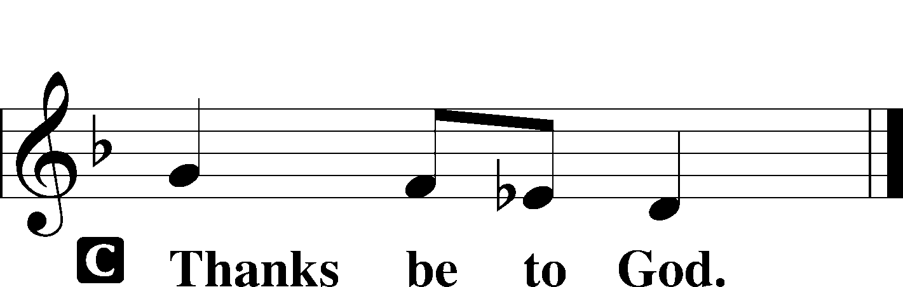

Benediction LSB 228
P The grace of our Lord T Jesus Christ and the love of God and the communion of the Holy Spirit be with you all.

Hymn to Depart: O Christ, You Walked the Road LSB 424
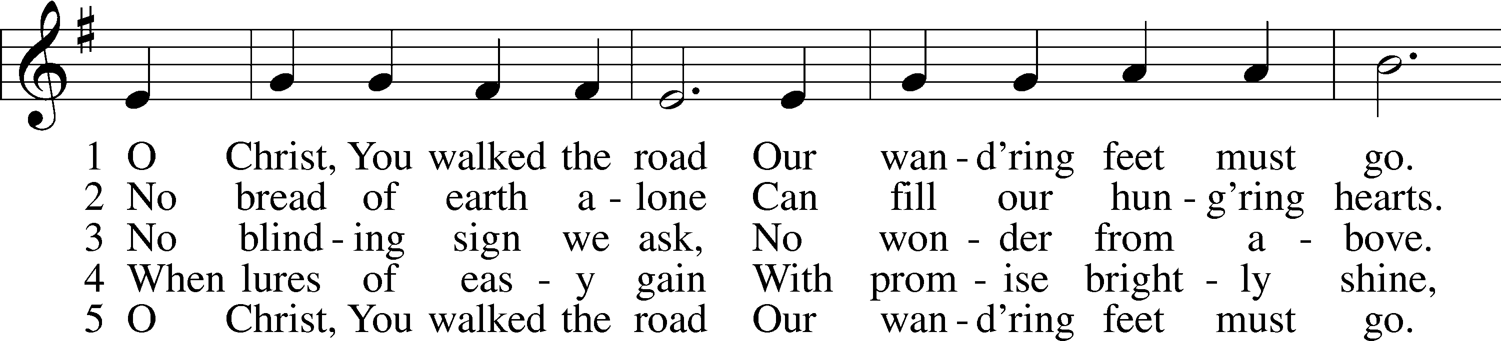
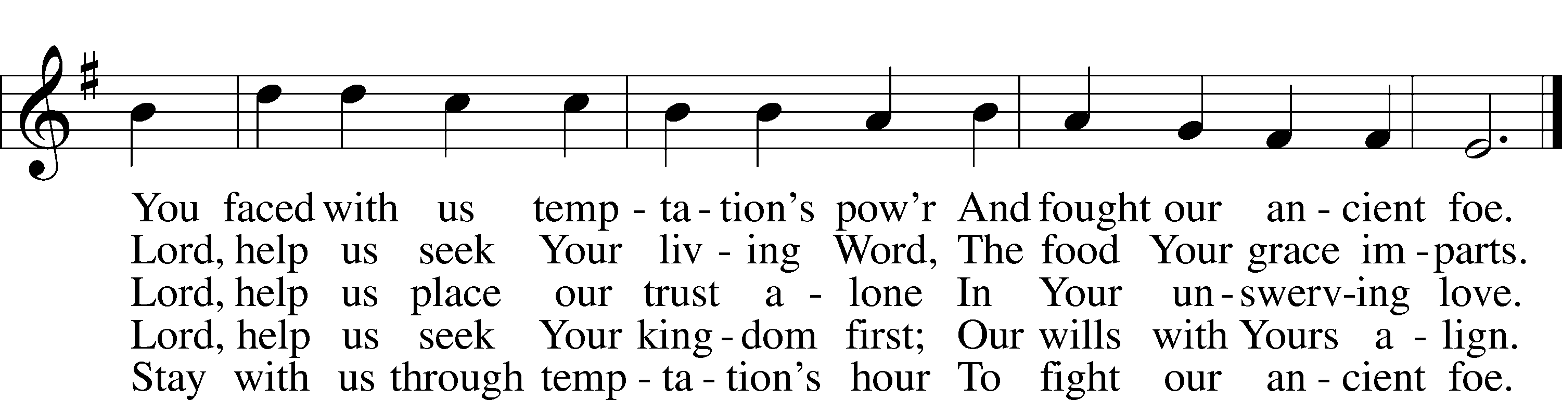
Text: Herman G. Stuempfle, Jr., 1923–2007
Tune: William Daman, c. 1540–1591
Text: © 1997 GIA Publications, Inc. Used by permission: LSB Hymn License no. 110005504
Tune: Public domain

Acknowledgments
Matins from Lutheran Service Book
Unless otherwise indicated, Scripture quotations are from the ESV® Bible (The Holy Bible, English Standard Version®), copyright © 2001 by Crossway, a publishing ministry of Good News Publishers. Used by permission. All rights reserved.
Created by Lutheran Service Builder © 2023 Concordia Publishing House.

Announcements:
Church Service Phone: 888-505-1870/715-438-4200
(Stay on the line for recorded service to start)
Live Stream audio services: http://salem.listentochurch.com
Salem’s Web Page: https://www.salembarron.com/

Pastor Michael Nielsen: Cell phone: 218-280-0999
Email: rev.mike.nielsen@gmail.com
Pastor’s Office Hours: Monday-Wednesday 9-12
Attendance:
Call-in line: 2/19- 4, In-person: 2/19 - 61

Weekly Needs: $2823.92
2/5/23 – General: $1991 Missions: $127 Bldg: $62 Childcare: $70 SS: $5.86 Cemetary: $10 AC: $100 VBS: $78 Hymnals: $100 Memorial Cemetary: $525 Memorial VBS: $350 Memorial – Funeral Fund: $200

2/12/23 – General: $3532 Missions: $150 Bldg: $145 Childcare: $35 SS: $4.60 Shutz Oil Well: $98.25 Hymnals: $150

Coffee and Snacks: Paul and Sue Millerman
Elder Today: Paul Millerman
Altar Guild: Kathy Schuettpelz

Link to Salem’s Facebook page is:
https://www.facebook.com/SalemEvangelicalLutheranChurchAndPreschool/

Schedule for the upcoming week:
Tuesday: 7:30 AM Men‘s Bible Study
Wednesday: 12:00 PM Lent Service
4:00 PM Catechism Class
5:30 Lenten Supper
6:30 PM Lent Service
Thursday: 11:00 AM Bible Class

Save the date: March 22, April, May – 10% nights at DQ for Salem’s Childcare from 4-9 PM

Save the date: March 12, 2023 – Chili and Pie Cook off
Save the date: April 13-15, 2023 – Church Garage Sale. There will be guys to help on Tuesday mornings and Sunday mornings after church.

Please bring your salad jars back.

Prayer requests:

Those in the nursing home: Caroly, Wilma, Loretta, Diane

Those Shut-in at home: Char, Gail and Roxanne, Joan, Joyce

Those recovering from surgery: Randy Church, Mona Duncan, Carol Shearer
Those recovering from accident: Rusty Weise
Those with ongoing health issues: Harrison, Jeanne, Wyatt, Owen, Joyce, Kathy N, Jeff, Daria, Bob, Pastor Jody Walter, Janee, Larry, Jessica,

Those who lead our nation:
Joe Biden, Kamala Harris, Tony Evers, Rod Nordby

Those who serve in our military:
Ryan Graf and Ethan Kobernick, Chaplain Pon Chanthaphon (Our Adopt-a-Chaplain)

Our Childcare Staff: Melissa Weinert, Jasmine Ferguson, Denise Stabenow, Katelyn Hendren, Holly Wilhelmi, Janica Skjerly

Families of the Week: Sharon Hammann, Scot and Becky Hammann (Brooke, Summer, Brody, Shyanne), Dean and Kim Hanson (Rachel, Ryan and Ryley), Robert Harbaugh, Shirley Hehl

Barron Area Businesses: Barron Area Community Center, Barron Chiropractic Center, Barron Massage Works, Barron News Shield

Mission Statement
The Mission of Salem Lutheran Church is to be what God called us to be through faith in Jesus Christ, a body of believers engaged in building the Kingdom of God by discipling the Barron area with His Word and Sacrament ministry.

