All Saints Day (observed)
November 7, 2021
9:00 AM

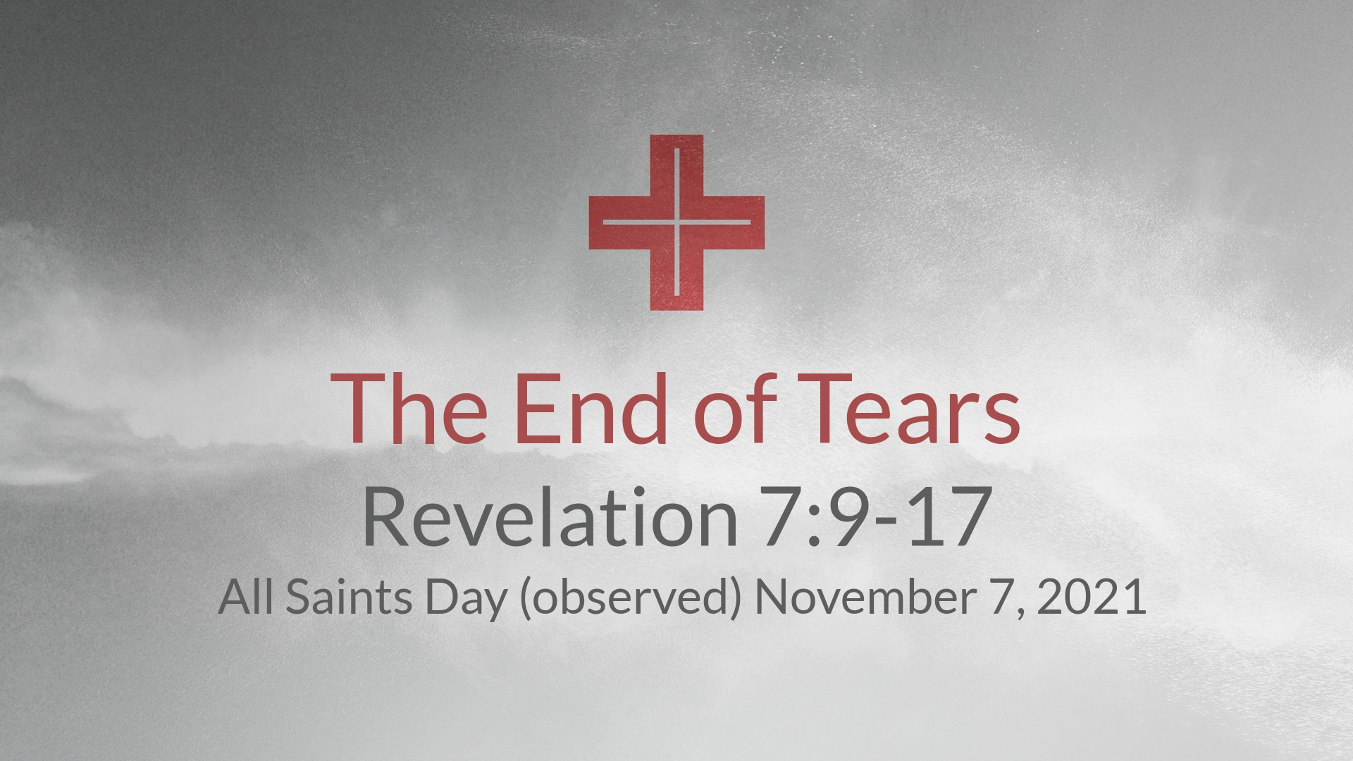

Salem Lutheran Church
1-715-537-3011
http://www.salembarron.com
rev.mike.nielsen@gmail.com
Saints Are Blessed in the Eternal Presence of Christ

“A great multitude … from every nation, from all tribes and peoples and languages,” cry out, “Salvation belongs to our God who sits on the throne” (Rev. 7:9–17). Faith-filled saints from every place and time, with unified voices, eternally magnify the Lamb of God. As His beloved children, we, too, “shall see him as he is” (1 John 3:1–3). Joined with the throng of angels and myriad saints, we shall “serve him day and night in his temple” (Rev. 7:9–17). In our earthly tension vacillating between saint and sinner, faith and doubt, sacred and profane, we earnestly seek Jesus to calm our fears, comfort our spirits and forgive our sins. The Holy Spirit through faith in Christ propels us forward, fortifying us in Word and Sacrament, to our eternal home. In the midst of our constant struggle as believers, we need to be blessed. And so we are. The poor in spirit, the meek, the hungry, the thirsty, the merciful, the pure and the persecuted are all blessed, and we will most certainly inherit the kingdom of heaven (Matt. 5:1–12).
Confession and Absolution

Hymn of Invocation: Behold a Host, Arrayed in White LSB 676
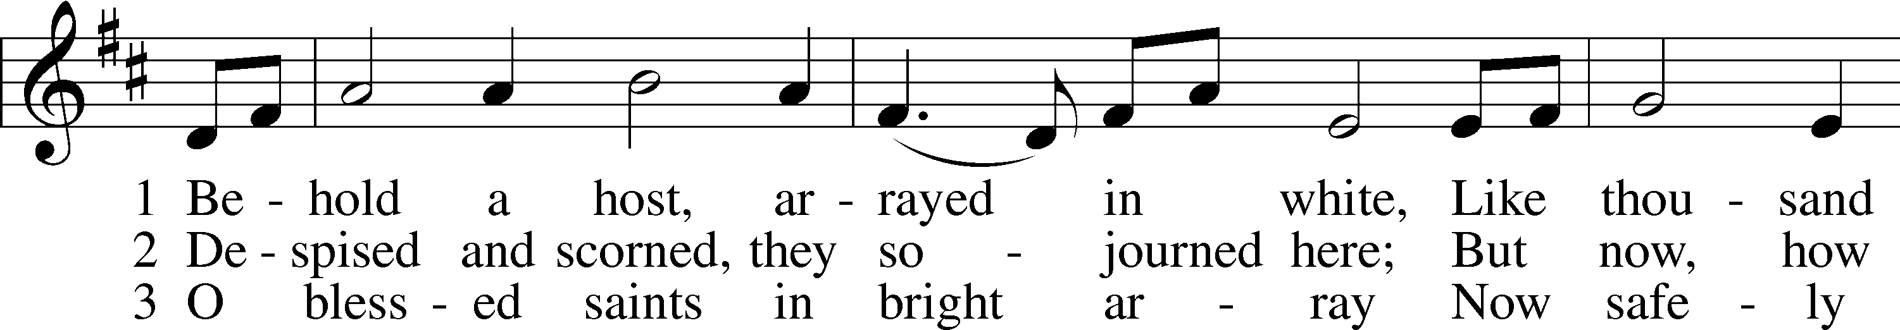
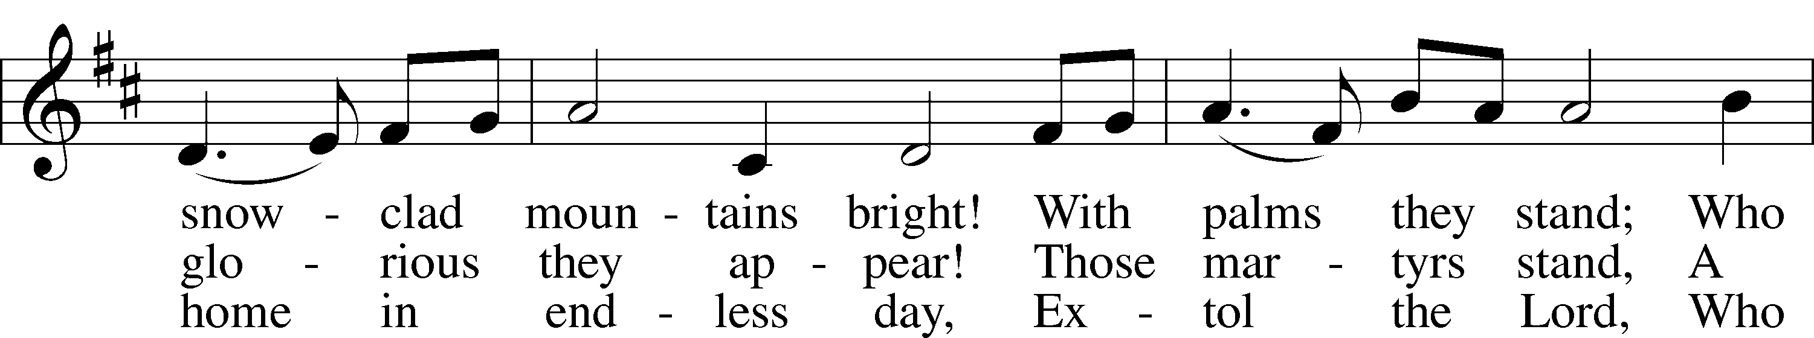
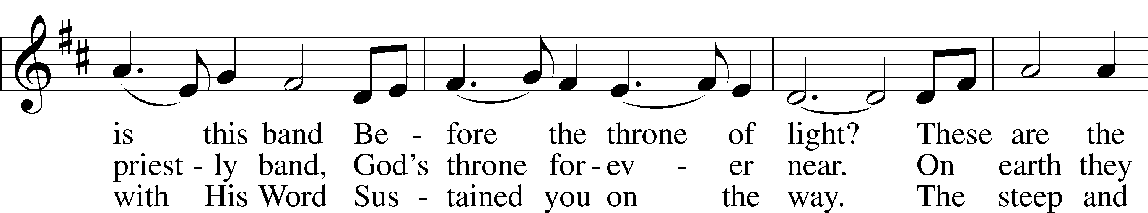
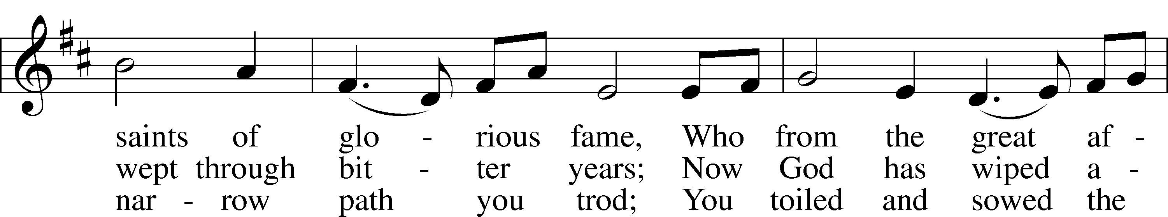
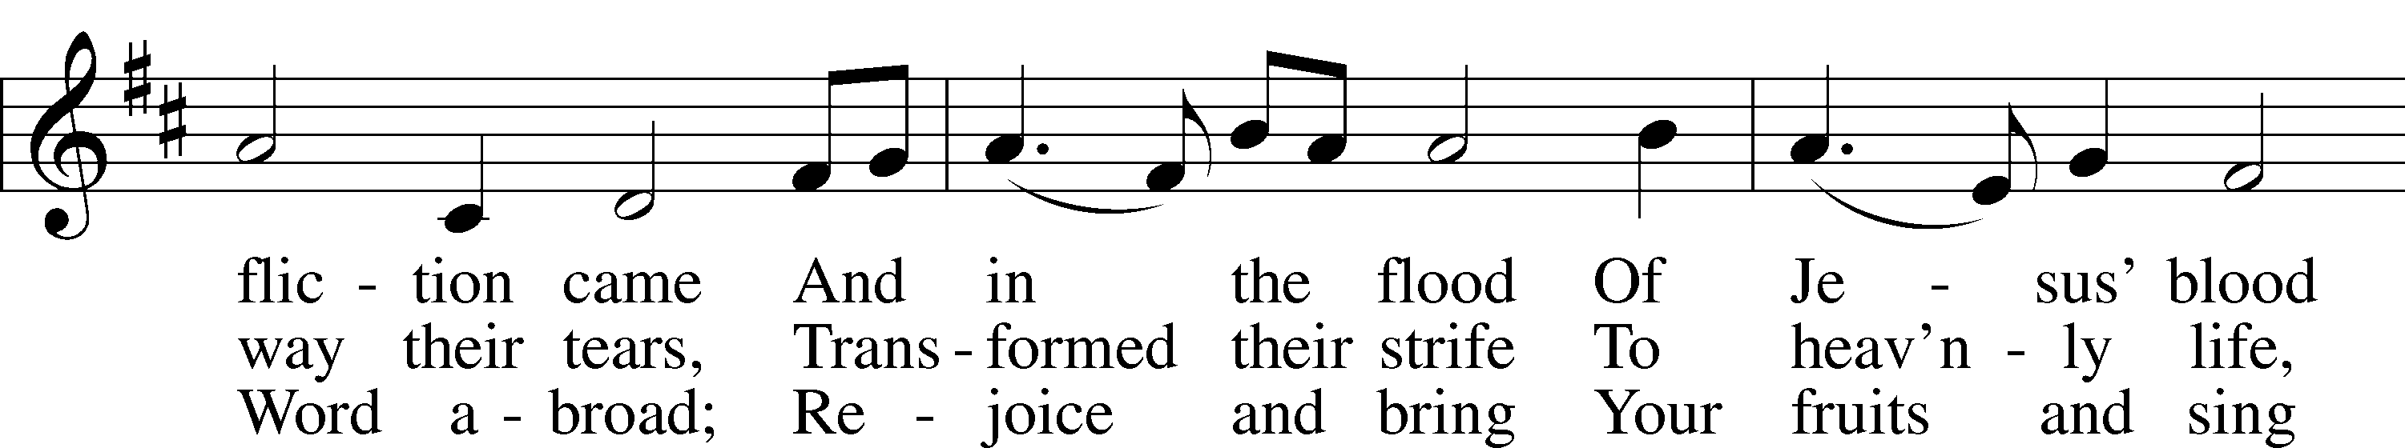
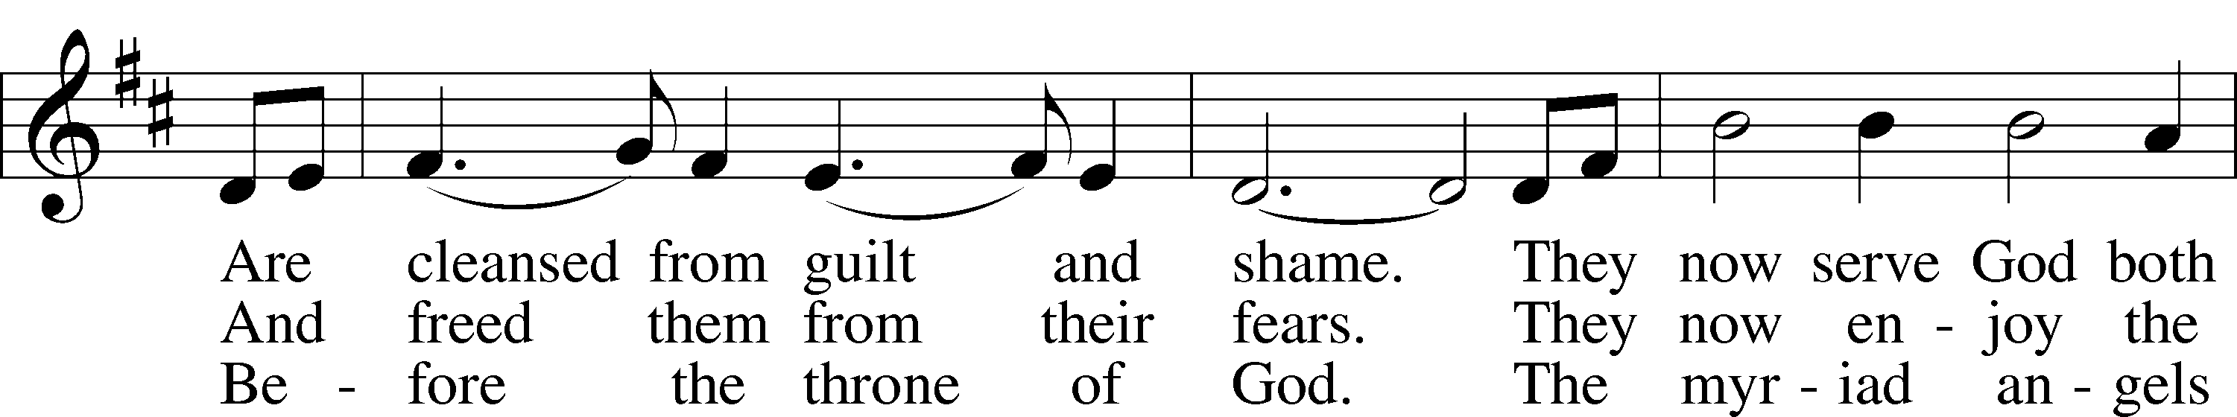
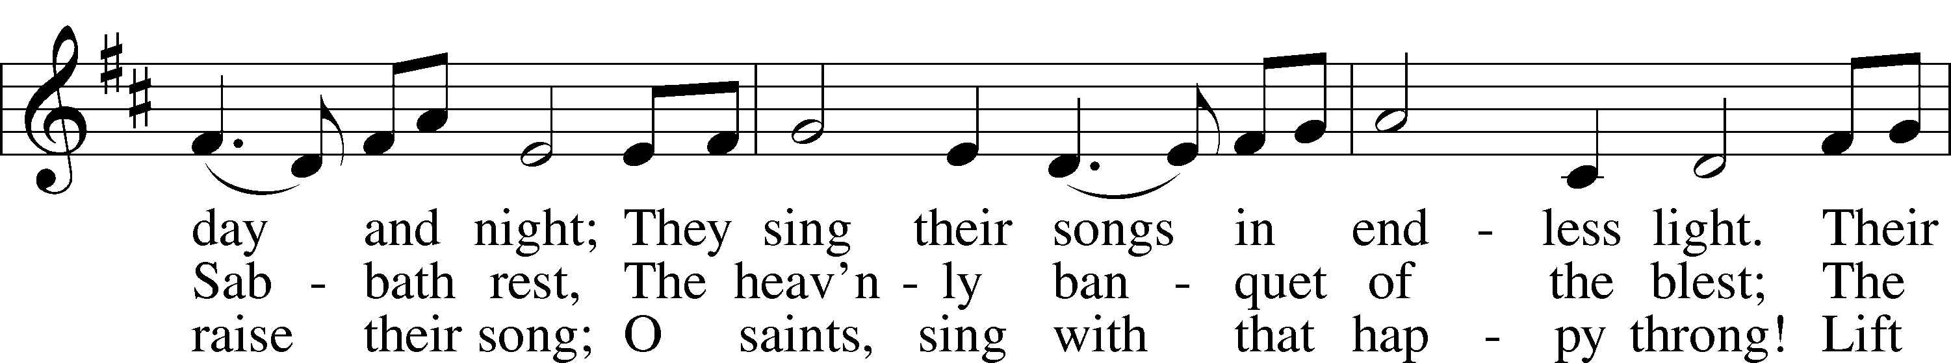
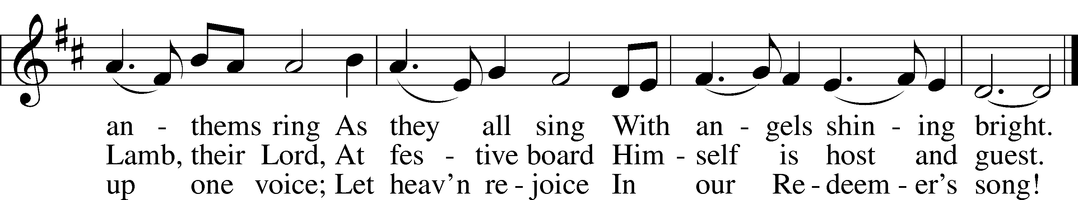
Tune and text: Public domain

Stand

The sign of the cross may be made by all in remembrance of their Baptism.

Invocation
P In the name of the Father and of the T Son and of the Holy Spirit.
C Amen.

Exhortation LSB 151
P If we say we have no sin, we deceive ourselves, and the truth is not in us.
C But if we confess our sins, God, who is faithful and just, will forgive our sins and cleanse us from all unrighteousness.

Silence for reflection on God’s Word and for self-examination.

Confession of Sins LSB 151
P Let us then confess our sins to God our Father.
C Most merciful God, we confess that we are by nature sinful and unclean. We have sinned against You in thought, word, and deed, by what we have done and by what we have left undone. We have not loved You with our whole heart; we have not loved our neighbors as ourselves. We justly deserve Your present and eternal punishment. For the sake of Your Son, Jesus Christ, have mercy on us. Forgive us, renew us, and lead us, so that we may delight in Your will and walk in Your ways to the glory of Your holy name. Amen.

Absolution LSB 151
P Almighty God in His mercy has given His Son to die for you and for His sake forgives you all your sins. As a called and ordained servant of Christ, and by His authority, I therefore forgive you all your sins in the name of the Father and of the T Son and of the Holy Spirit.
C Amen.

Service of the Word
Entrance Hymn: Saints of God Your Voices Raise – See Insert

Kyrie LSB 152
A In peace let us pray to the Lord.
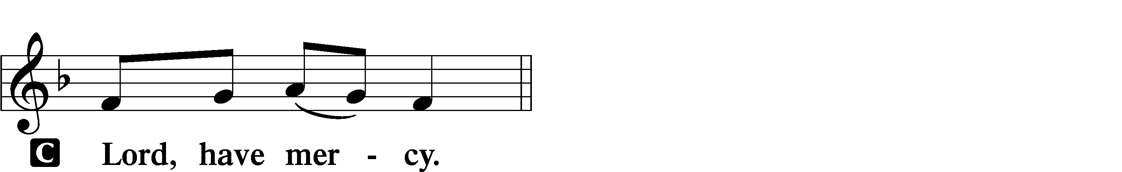

A For the peace from above and for our salvation let us pray to the Lord.
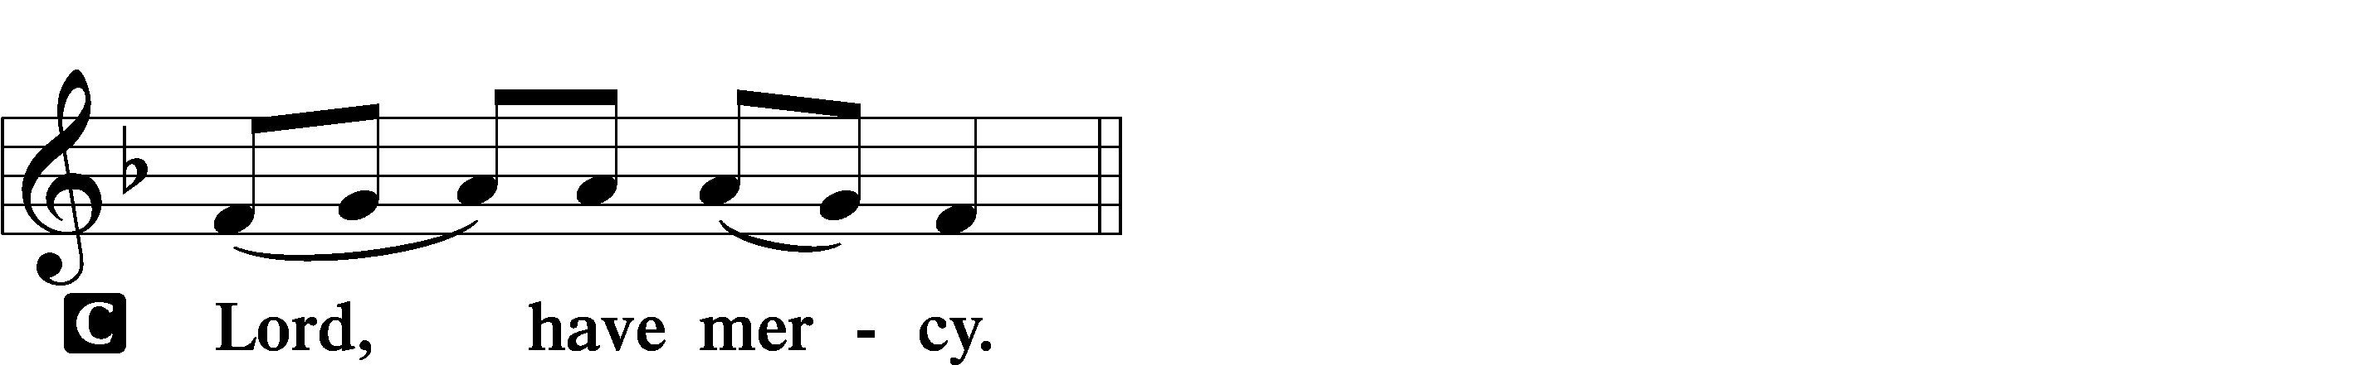

A For the peace of the whole world, for the well-being of the Church of God, and for the unity of all let us pray to the Lord.
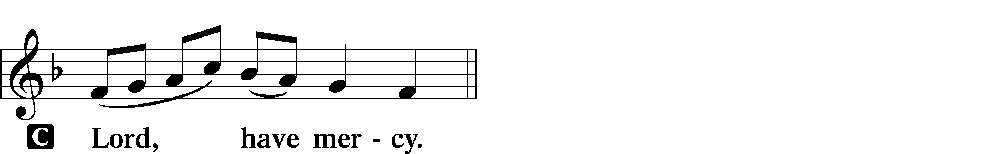

A For this holy house and for all who offer here their worship and praise let us pray to the Lord.
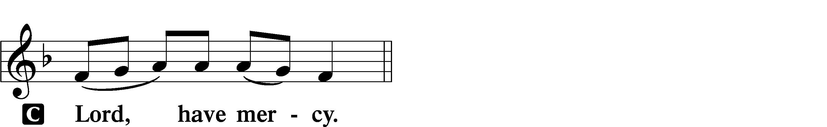

A Help, save, comfort, and defend us, gracious Lord.

This Is the Feast LSB 155
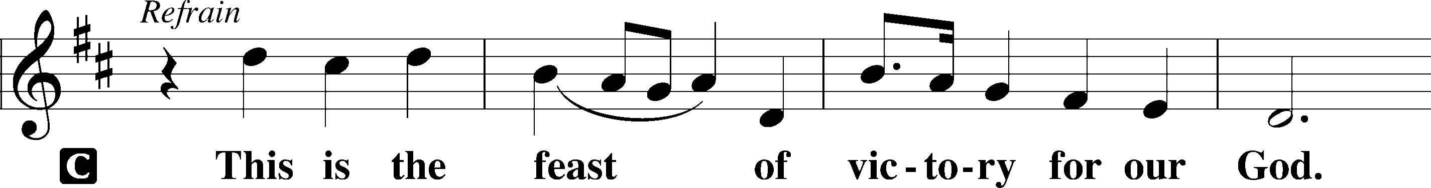
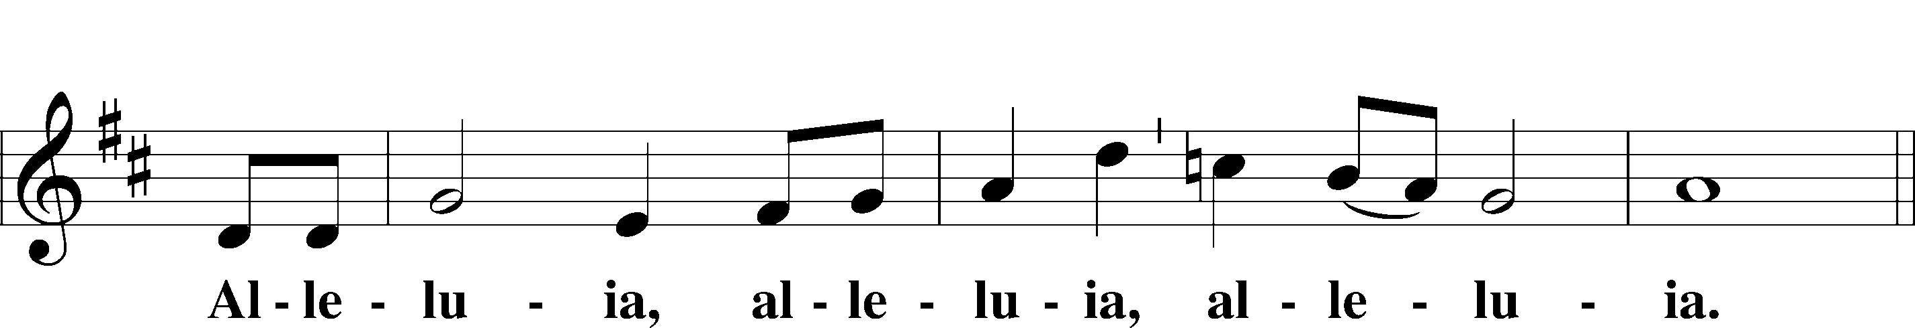
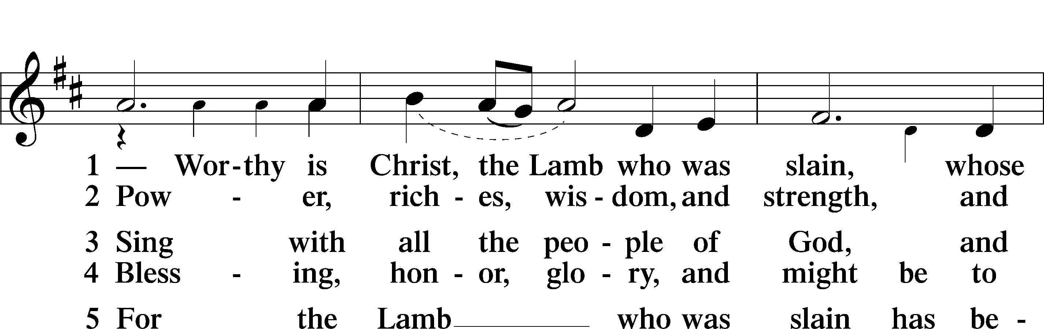
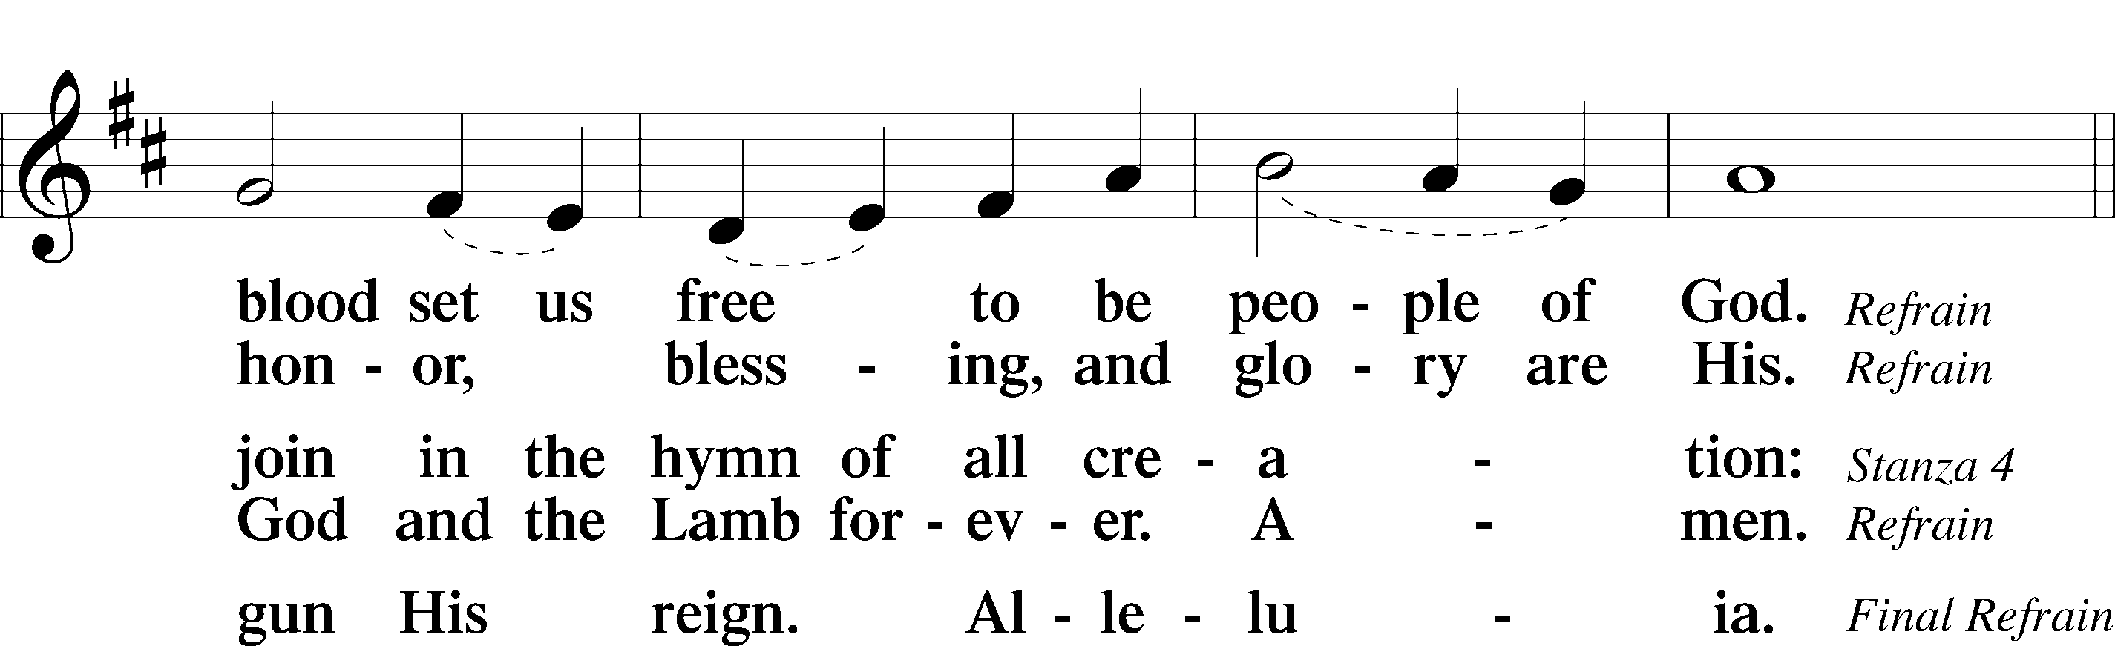
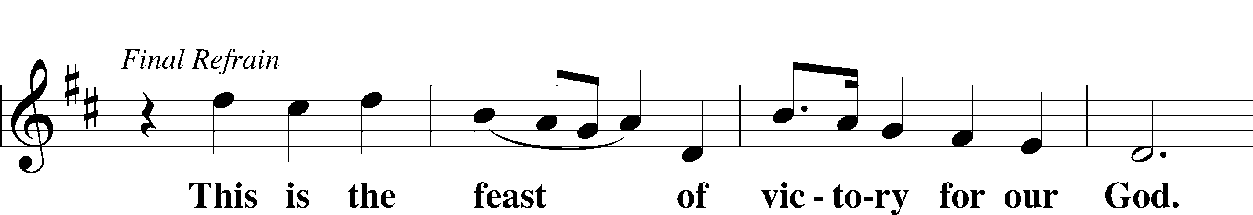
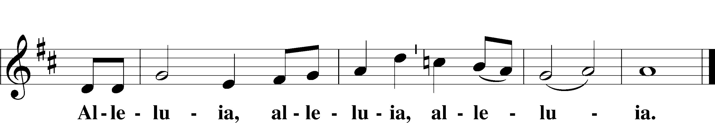

Salutation and Collect of the Day
P The Lord be with you.
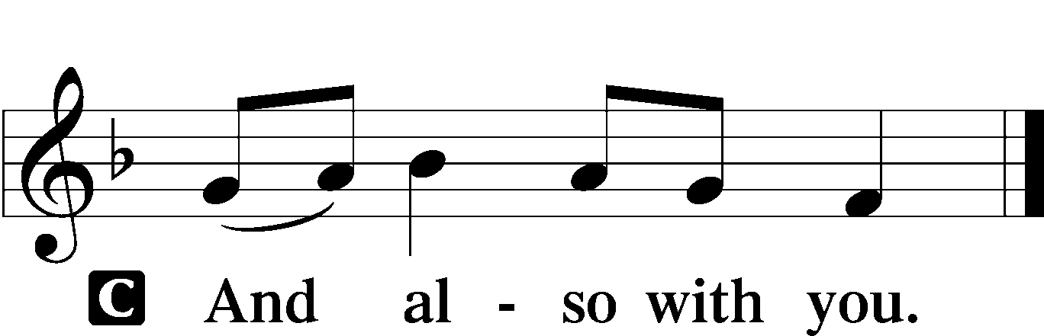

P Let us pray.
Almighty and everlasting God, You knit together Your faithful people of all times and places into one holy communion, the mystical body of Your Son, Jesus Christ. Grant us so to follow Your blessed saints in all virtuous and godly living that, together with them, we may come to the unspeakable joys You have prepared for those who love You; through Jesus Christ, our Lord, who lives and reigns with You and the Holy Spirit, one God, now and forever.

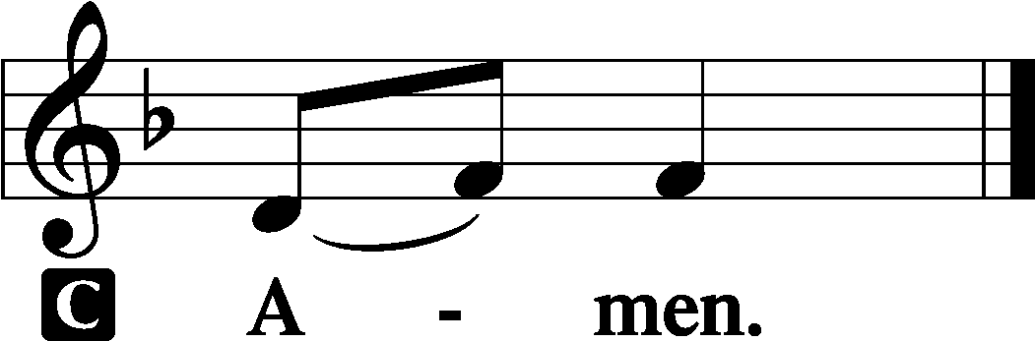

Sit

All Saints Litany See Insert

First Reading Revelation 7:9–17
A Great Multitude from Every Nation
9After this I looked, and behold, a great multitude that no one could number, from every nation, from all tribes and peoples and languages, standing before the throne and before the Lamb, clothed in white robes, with palm branches in their hands, 10and crying out with a loud voice, “Salvation belongs to our God who sits on the throne, and to the Lamb!” 11And all the angels were standing around the throne and around the elders and the four living creatures, and they fell on their faces before the throne and worshiped God, 12saying, “Amen! Blessing and glory and wisdom and thanksgiving and honor and power and might be to our God forever and ever! Amen.”
13Then one of the elders addressed me, saying, “Who are these, clothed in white robes, and from where have they come?” 14I said to him, “Sir, you know.” And he said to me, “These are the ones coming out of the great tribulation. They have washed their robes and made them white in the blood of the Lamb.
15“Therefore they are before the throne of God,
and serve him day and night in his temple;
and he who sits on the throne will shelter them with his presence.
16They shall hunger no more, neither thirst anymore;
the sun shall not strike them,
nor any scorching heat.
17For the Lamb in the midst of the throne will be their shepherd,
and he will guide them to springs of living water,
and God will wipe away every tear from their eyes.”

A This is the Word of the Lord.
C Thanks be to God.

Psalm Psalm 149; antiphon: v. 4
Sing to the Lord a New Song
1Praise the Lord!
Sing to the Lord a new song,
his praise in the assembly of the godly!
2Let Israel be glad in his Maker;
let the children of Zion rejoice in their King!
3Let them praise his name with dancing,
making melody to him with tambourine and lyre!
4For the Lord takes pleasure in his people;
he adorns the humble with salvation.
5Let the godly exult in glory;
let them sing for joy on their beds.
6Let the high praises of God be in their throats
and two-edged swords in their hands,
7to execute vengeance on the nations
and punishments on the peoples,
8to bind their kings with chains
and their nobles with fetters of iron,
9to execute on them the judgment written!
This is honor for all his godly ones. Praise the Lord!

Epistle 1 John 3:1–3
1See what kind of love the Father has given to us, that we should be called children of God; and so we are. The reason why the world does not know us is that it did not know him. 2Beloved, we are God’s children now, and what we will be has not yet appeared; but we know that when he appears we shall be like him, because we shall see him as he is. 3And everyone who thus hopes in him purifies himself as he is pure.

A This is the Word of the Lord.
C Thanks be to God.

Stand

Alleluia and Verse LSB 156
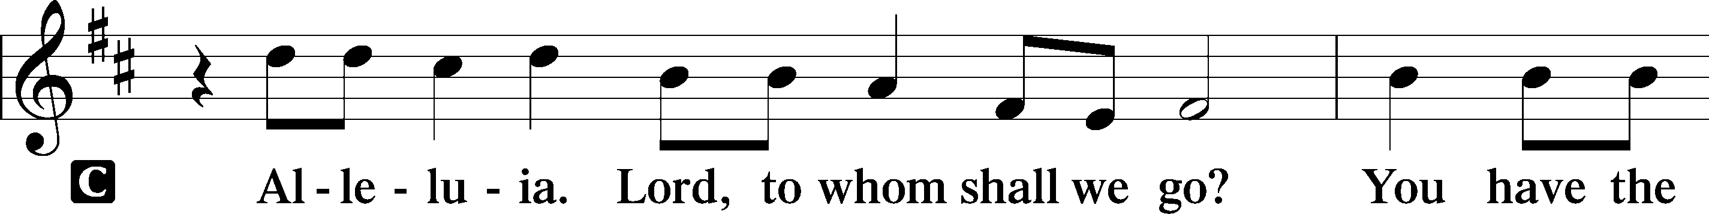
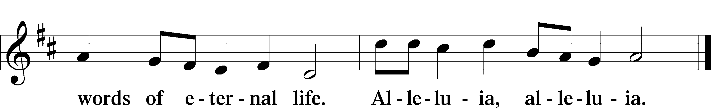

Holy Gospel Matthew 5:1–12
P The Holy Gospel according to St. Matthew, the fifth chapter.

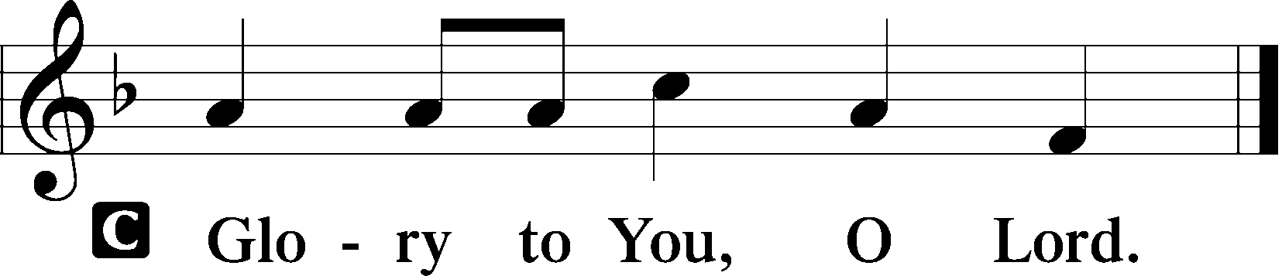

The Sermon on the Mount
1Seeing the crowds, [Jesus] went up on the mountain, and when he sat down, his disciples came to him.
The Beatitudes
2And he opened his mouth and taught them, saying:
3“Blessed are the poor in spirit, for theirs is the kingdom of heaven.
4“Blessed are those who mourn, for they shall be comforted.
5“Blessed are the meek, for they shall inherit the earth.
6“Blessed are those who hunger and thirst for righteousness, for they shall be satisfied.
7“Blessed are the merciful, for they shall receive mercy.
8“Blessed are the pure in heart, for they shall see God.
9“Blessed are the peacemakers, for they shall be called sons of God.
10“Blessed are those who are persecuted for righteousness’ sake, for theirs is the kingdom of heaven.
11“Blessed are you when others revile you and persecute you and utter all kinds of evil against you falsely on my account. 12Rejoice and be glad, for your reward is great in heaven, for so they persecuted the prophets who were before you.”

P This is the Gospel of the Lord.

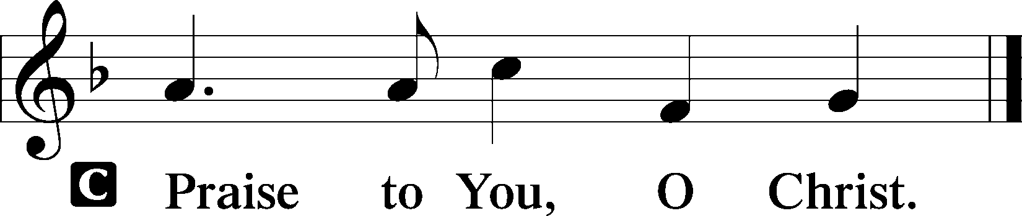

Sit

Hymn of the Day: For All the Saints LSB 677
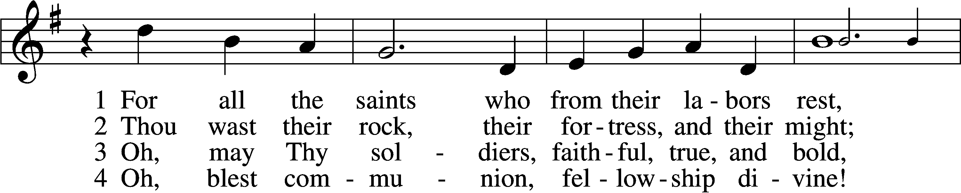
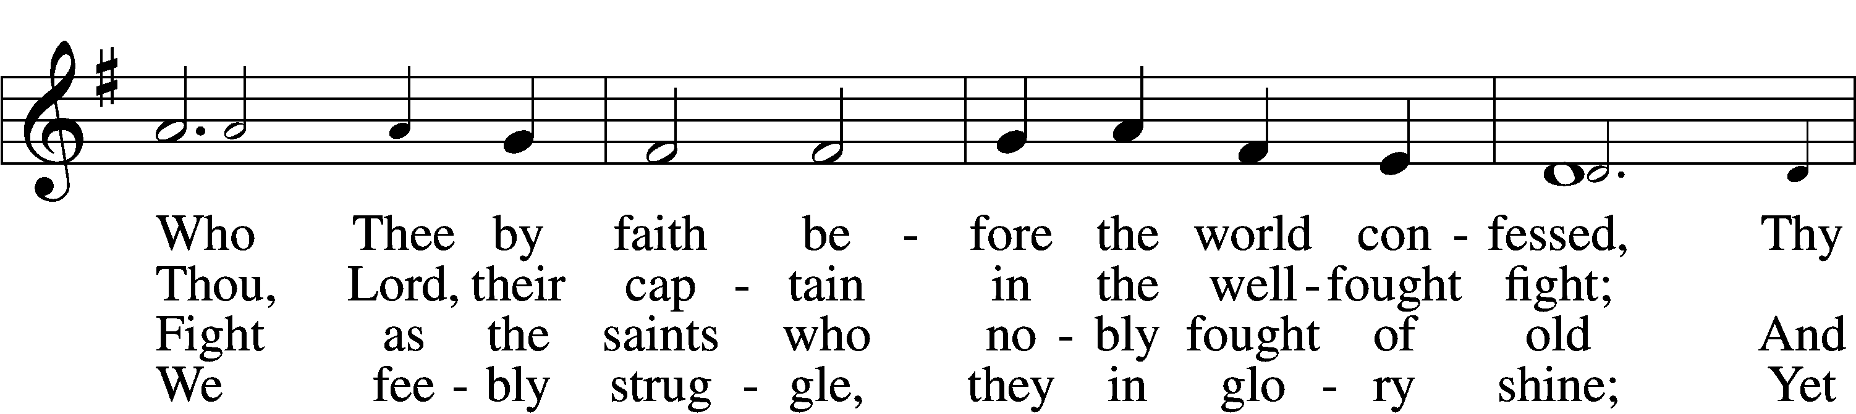
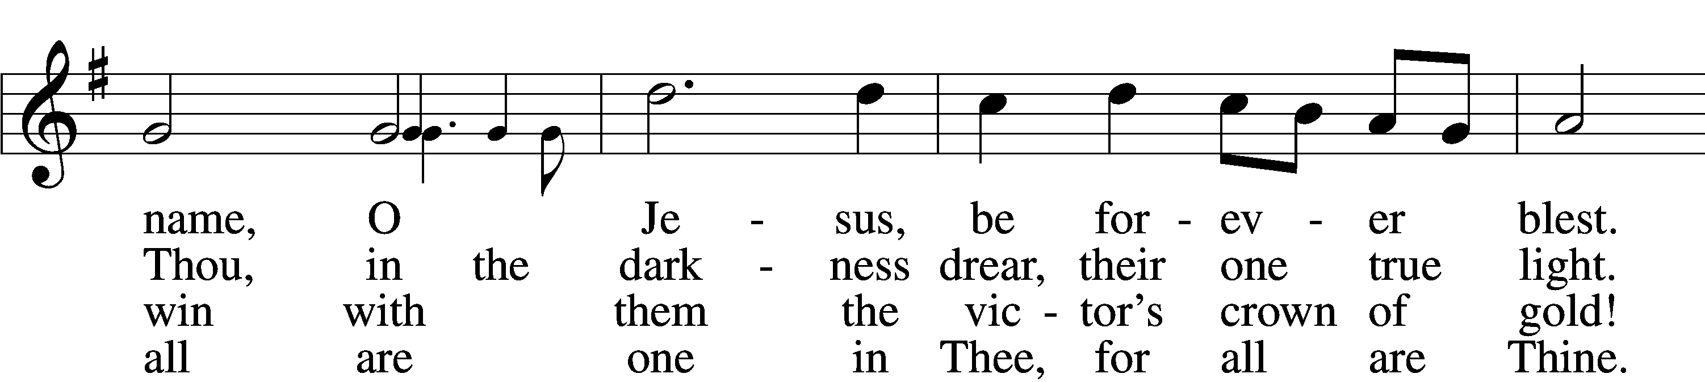
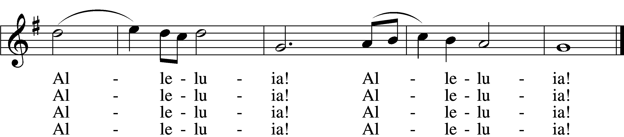

5 And when the fight is fierce, the warfare long,
Steals on the ear the distant triumph song,
And hearts are brave again, and arms are strong.
Alleluia! Alleluia!

6 The golden evening brightens in the west;
Soon, soon to faithful warriors cometh rest;
Sweet is the calm of paradise the blest.
Alleluia! Alleluia!

7 But, lo, there breaks a yet more glorious day:
The saints triumphant rise in bright array;
The King of Glory passes on His way.
Alleluia! Alleluia!

D 8 From earth’s wide bounds, from ocean’s farthest coast,
Through gates of pearl streams in the countless host,
Singing to Father, Son, and Holy Ghost:
Alleluia! Alleluia!
Tune and text: Public domain

Sermon

Stand

Nicene Creed
C I believe in one God, the Father Almighty, maker of heaven and earth and of all things visible and invisible.

And in one Lord Jesus Christ, the only-begotten Son of God, begotten of His Father before all worlds, God of God, Light of Light, very God of very God, begotten, not made, being of one substance with the Father, by whom all things were made; who for us men and for our salvation came down from heaven and was incarnate by the Holy Spirit of the virgin Mary and was made man; and was crucified also for us under Pontius Pilate. He suffered and was buried. And the third day He rose again according to the Scriptures and ascended into heaven and sits at the right hand of the Father. And He will come again with glory to judge both the living and the dead, whose kingdom will have no end.

And I believe in the Holy Spirit, the Lord and giver of life, who proceeds from the Father and the Son, who with the Father and the Son together is worshiped and glorified, who spoke by the prophets. And I believe in one holy Christian and apostolic Church, I acknowledge one Baptism for the remission of sins, and I look for the resurrection of the dead and the life T of the world to come. Amen.

Prayer of the Church

Sit

Offering

Stand

Offertory LSB 159
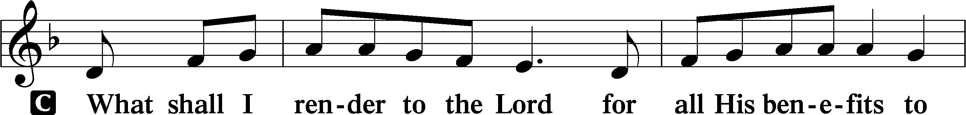
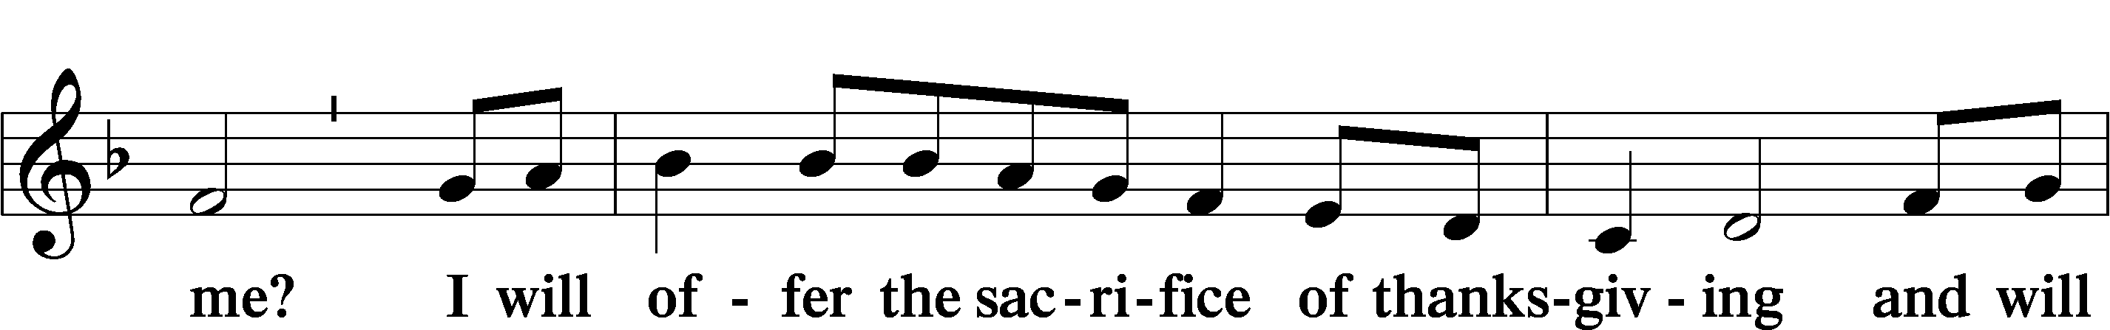
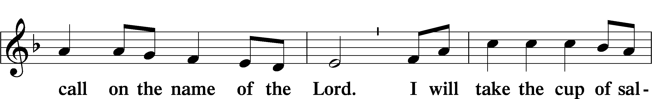
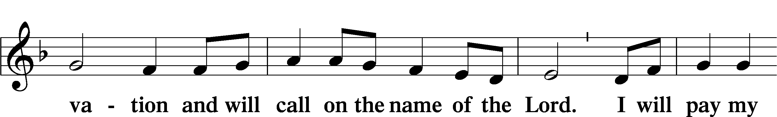
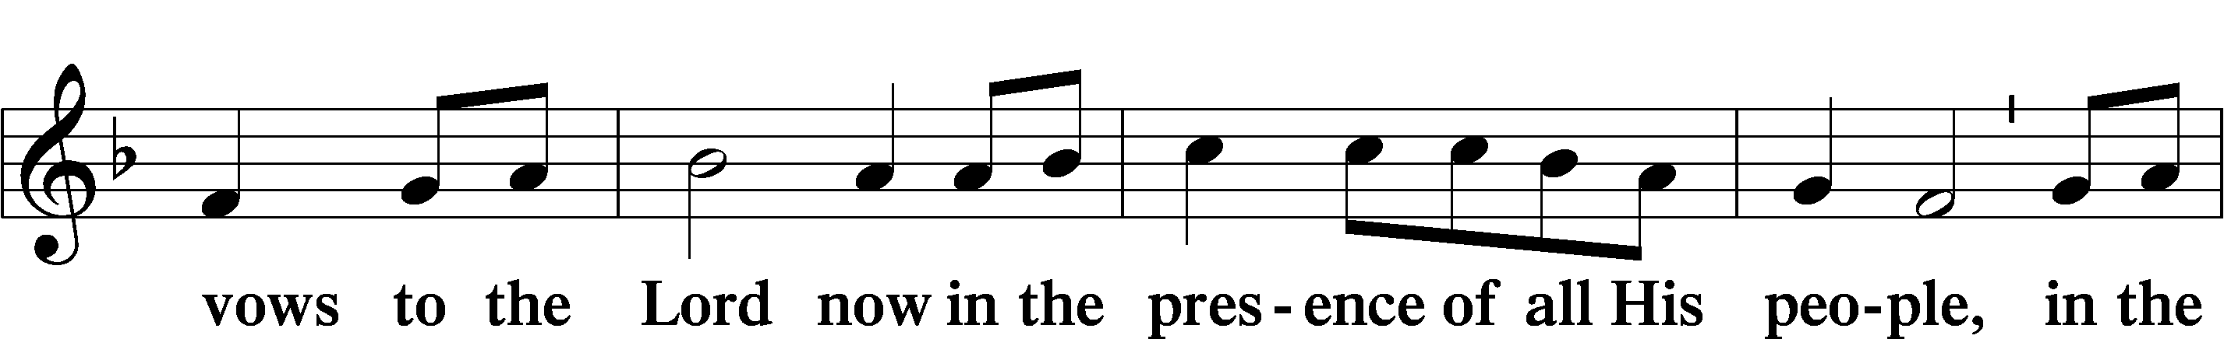
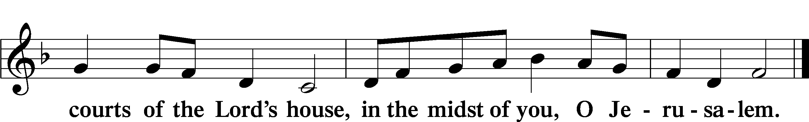

Service of the Sacrament

Preface LSB 160
P The Lord be with you.
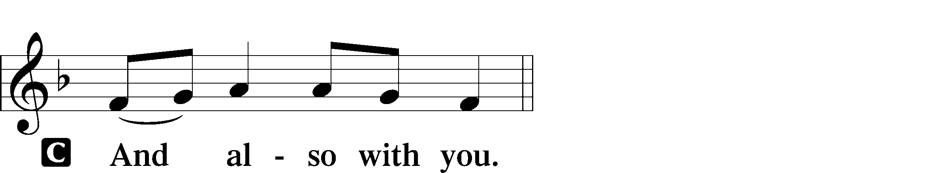

P Lift up your hearts.

P Let us give thanks to the Lord our God.
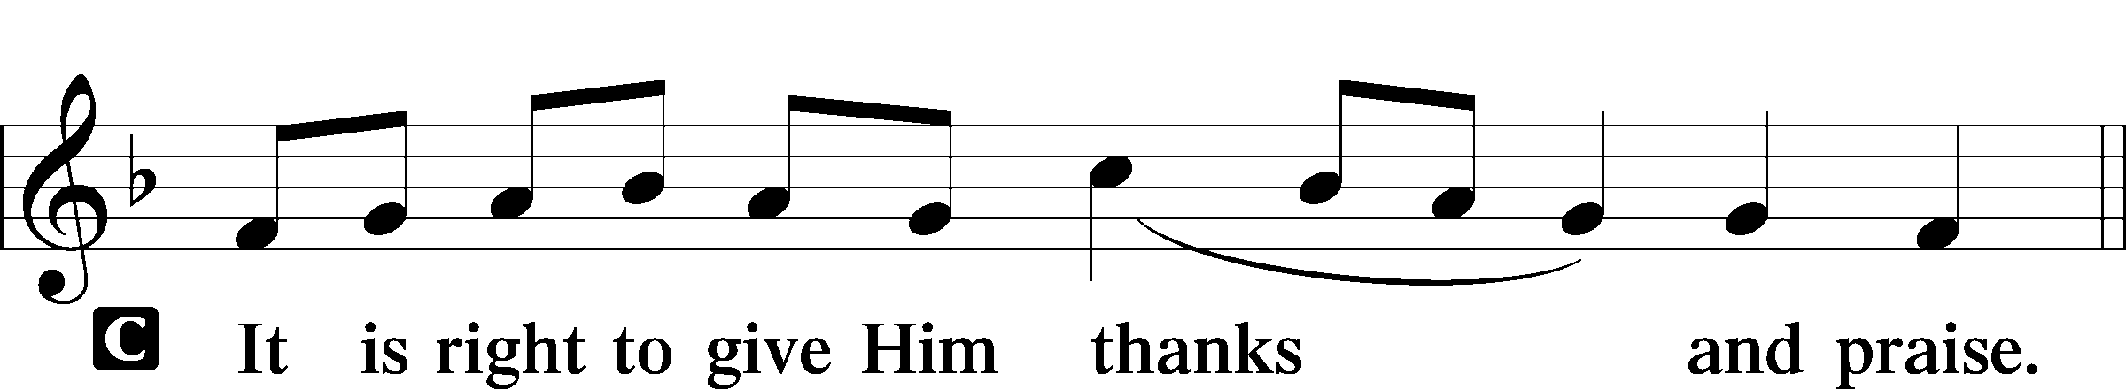

P It is truly good, right, and salutary that we should at all times and in all places give thanks to You, holy Lord, almighty Father, everlasting God… Therefore with angels and archangels and with all the company of heaven we laud and magnify Your glorious name, evermore praising You and saying:

Sanctus LSB 161
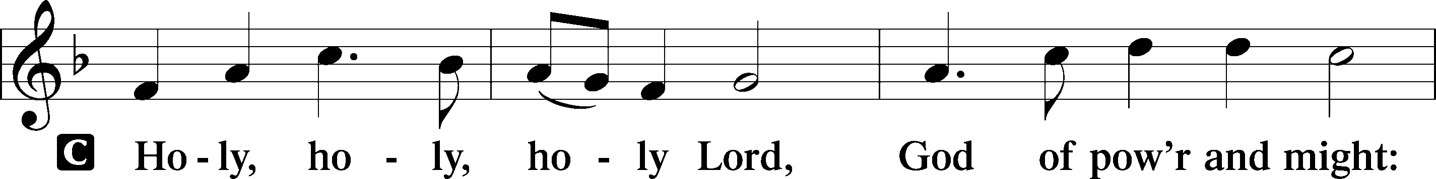
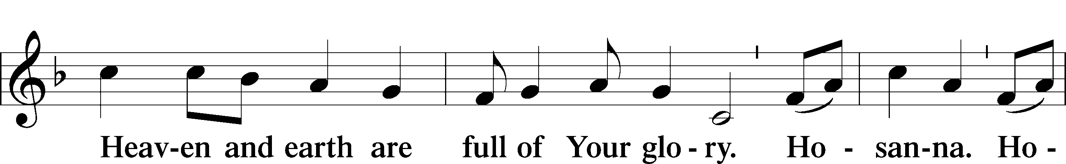
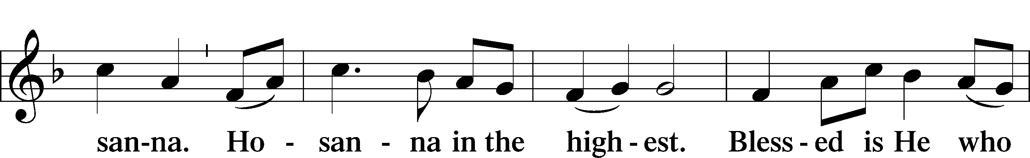
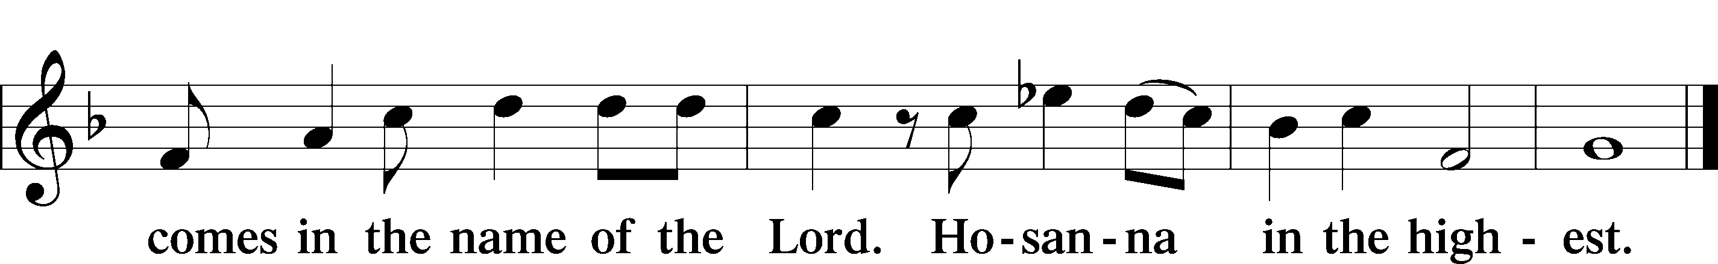

Prayer of Thanksgiving LSB 161
P Blessed are You, Lord of heaven and earth, for You have had mercy on those whom You created and sent Your only-begotten Son into our flesh to bear our sin and be our Savior. With repentant joy we receive the salvation accomplished for us by the all-availing sacrifice of His body and His blood on the cross.

Gathered in the name and the remembrance of Jesus, we beg You, O Lord, to forgive, renew, and strengthen us with Your Word and Spirit. Grant us faithfully to eat His body and drink His blood as He bids us do in His own testament. Gather us together, we pray, from the ends of the earth to celebrate with all the faithful the marriage feast of the Lamb in His kingdom, which has no end. Graciously receive our prayers; deliver and preserve us. To You alone, O Father, be all glory, honor, and worship, with the Son and the Holy Spirit, one God, now and forever.
C Amen.

Lord’s Prayer LSB 162
P Lord, remember us in Your kingdom and teach us to pray:
C Our Father who art in heaven, hallowed be Thy name, Thy kingdom come, Thy will be done on earth as it is in heaven; give us this day our daily bread; and forgive us our trespasses as we forgive those who trespass against us; and lead us not into temptation, but deliver us from evil. For Thine is the kingdom and the power and the glory forever and ever. Amen.

The Words of Our Lord
P Our Lord Jesus Christ, on the night when He was betrayed, took bread, and when He had given thanks, He broke it and gave it to the disciples and said: “Take, eat; this is My T body, which is given for you. This do in remembrance of Me.”

In the same way also He took the cup after supper, and when He had given thanks, He gave it to them, saying: “Drink of it, all of you; this cup is the new testament in My T blood, which is shed for you for the forgiveness of sins. This do, as often as you drink it, in remembrance of Me.”

Pax Domini LSB 163
P The peace of the Lord be with you always.

Agnus Dei LSB 163
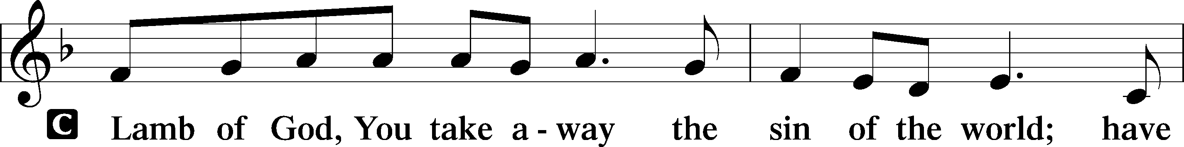
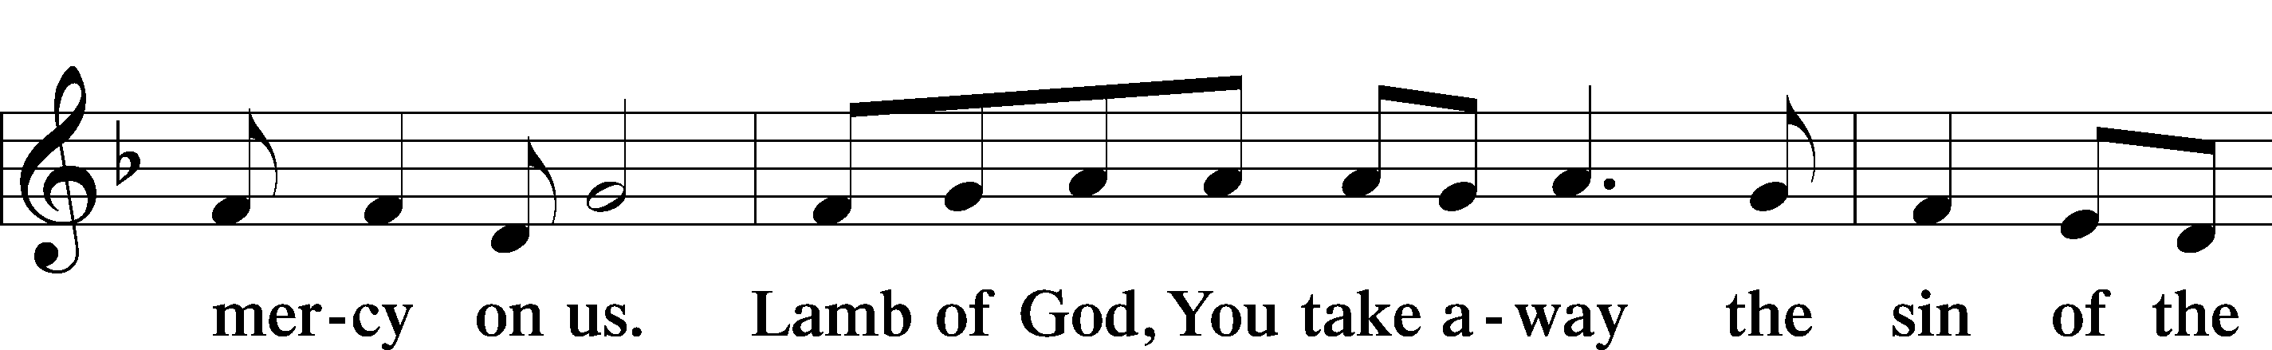
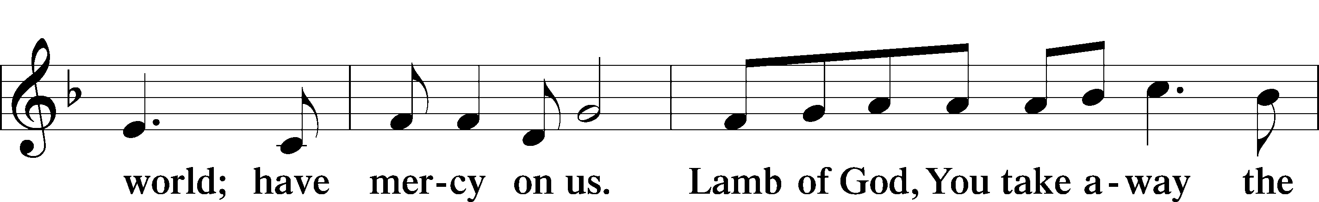
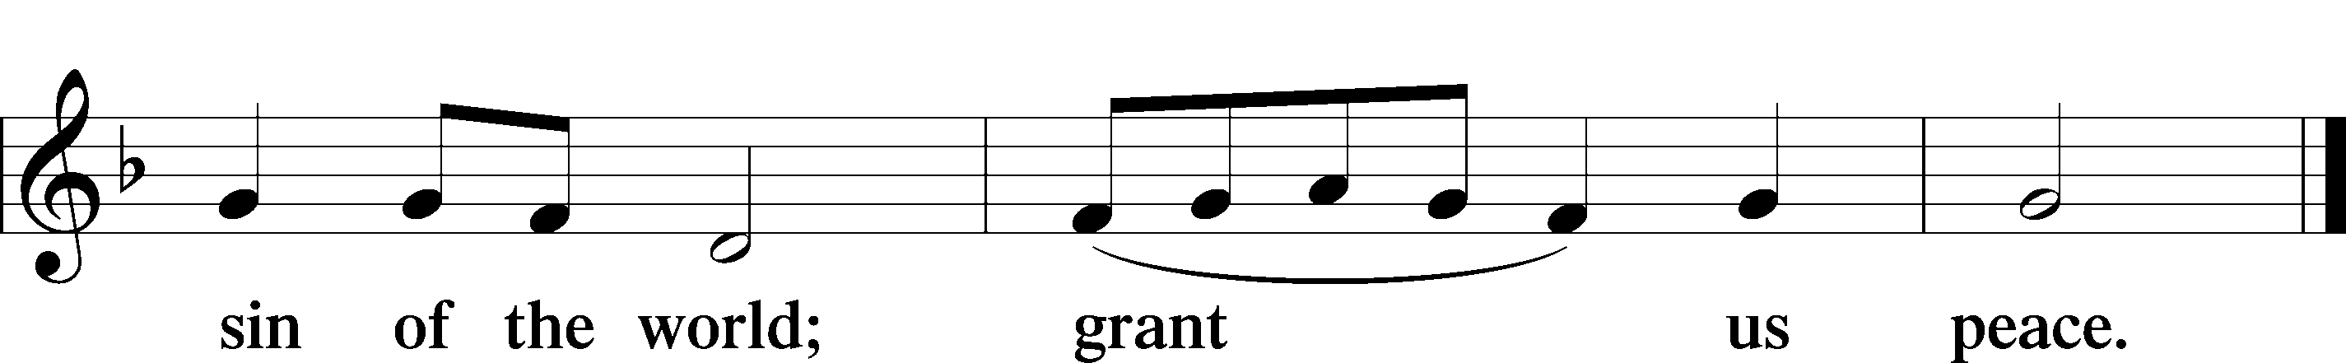

Sit

Distribution
Distribution Hymn: Ye Watchers and Ye Holy Ones LSB 671
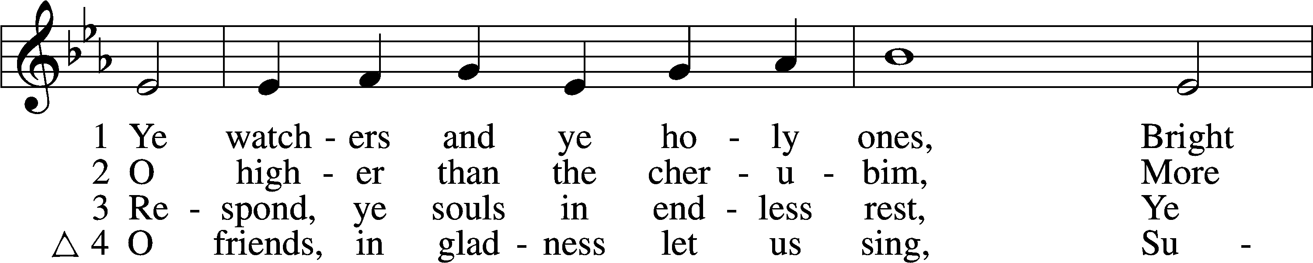
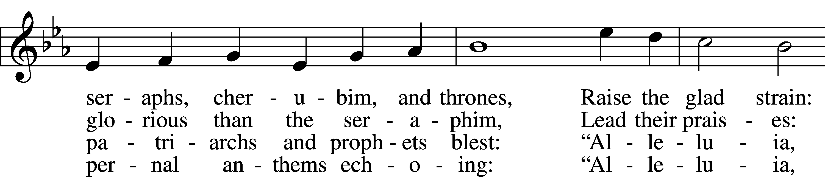
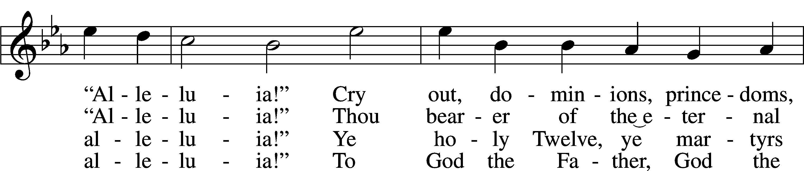
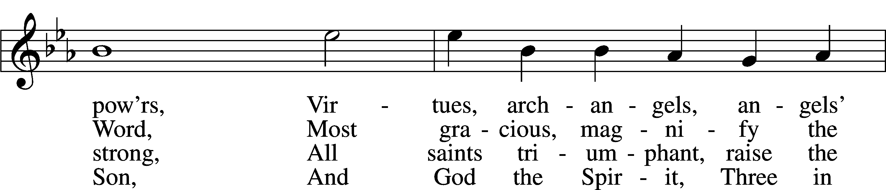
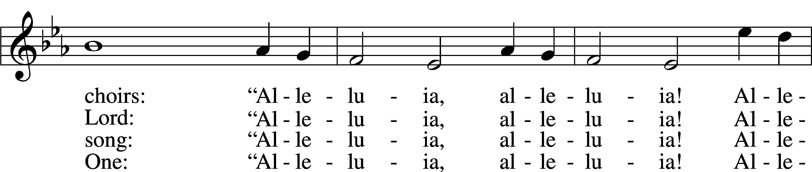
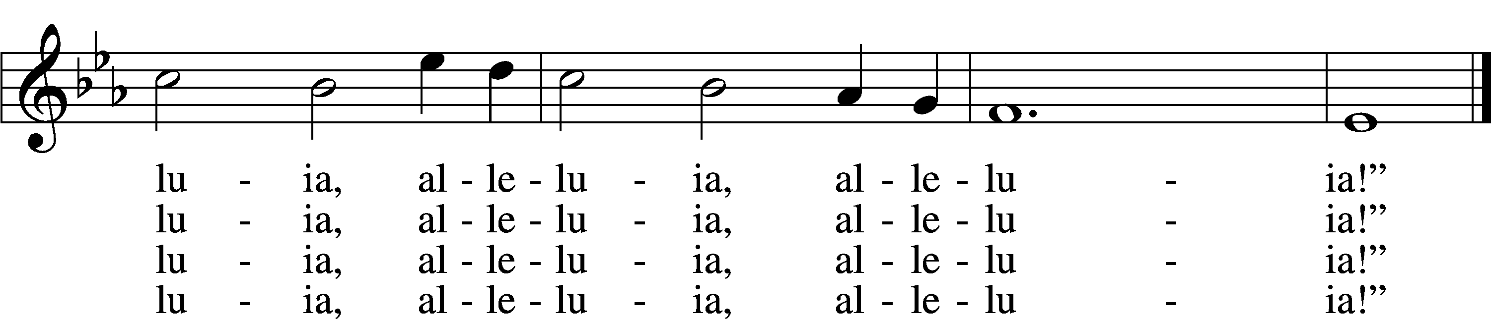
Tune and text: Public domain

Distribution Hymn: Sing with All the Saints in Glory LSB 671
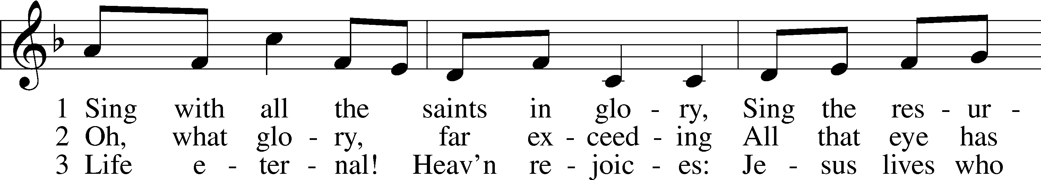
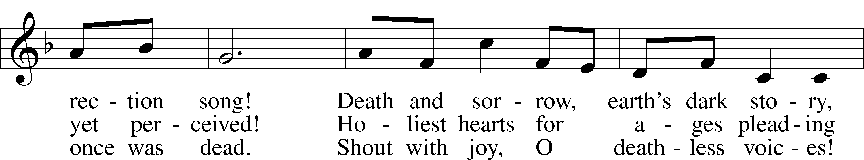
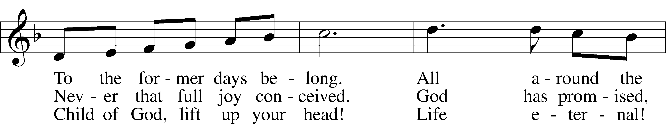
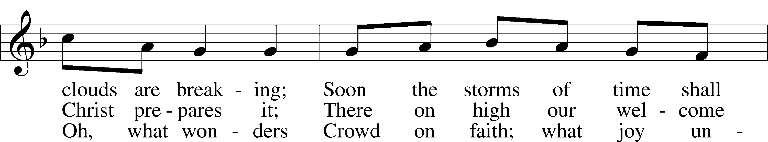
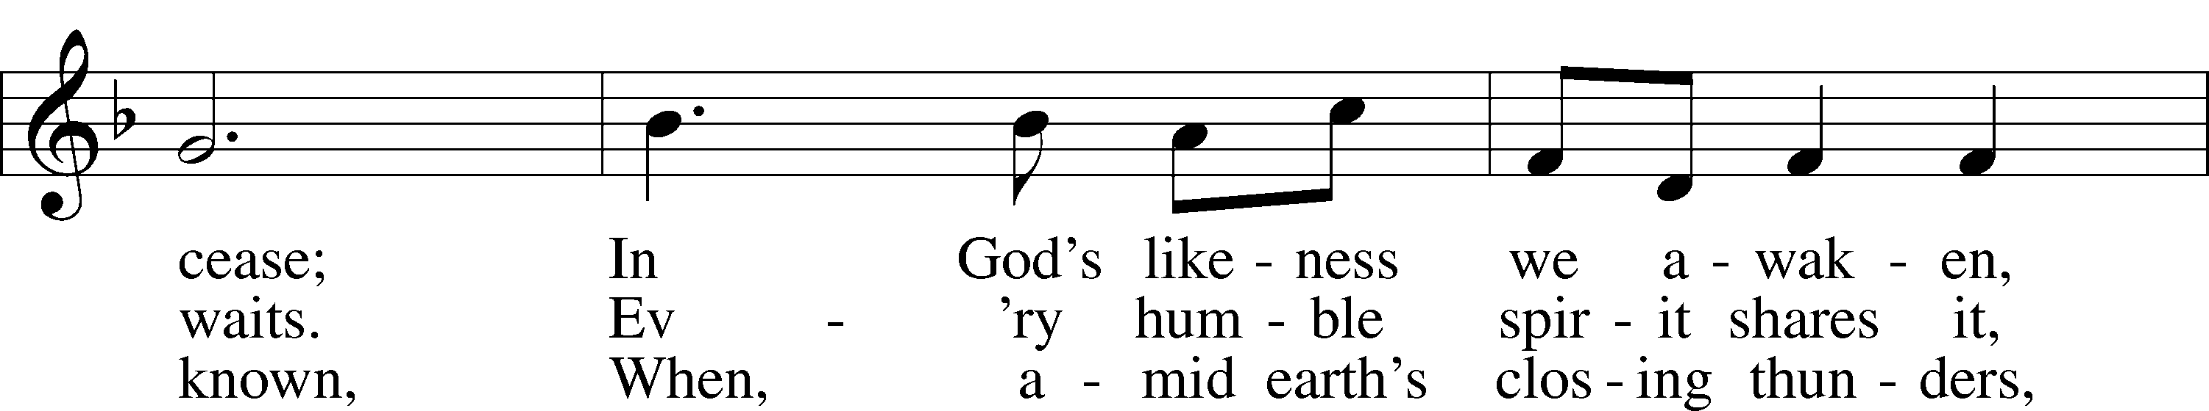
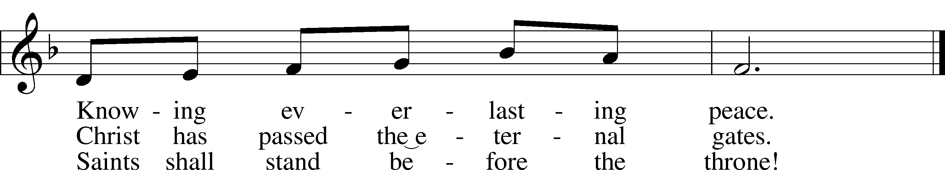
Text: Public domain
Tune: © 1995 Augsburg Fortress. Used by permission: LSB Hymn License no. 110005504

Stand

Thank the Lord LSB 164
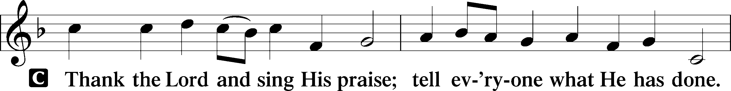
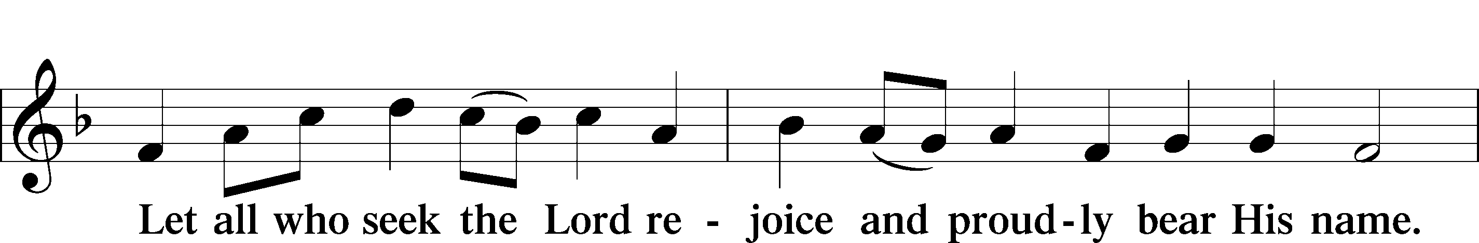
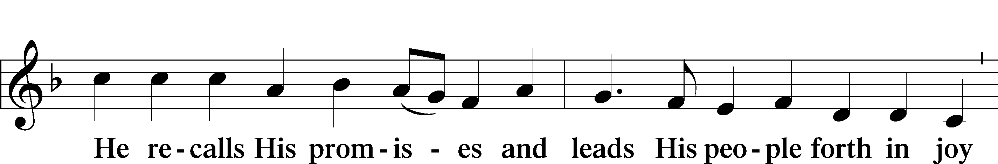
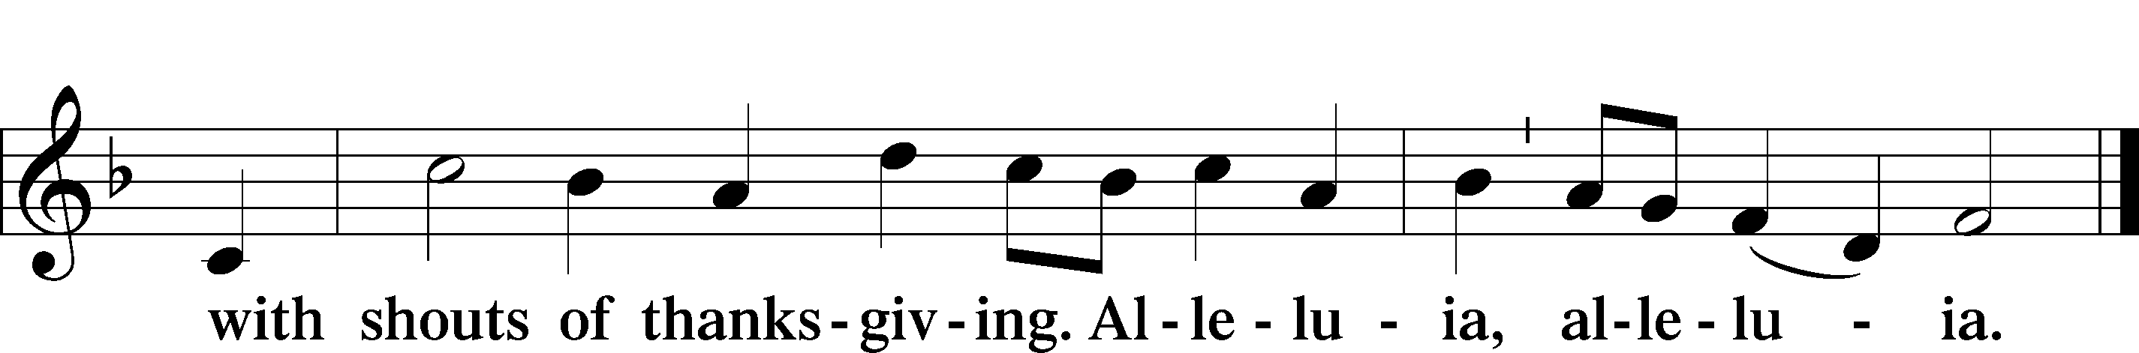

Post-Communion Collect
A Let us pray.
We give thanks to You, almighty God, that You have refreshed us through this salutary gift, and we implore You that of Your mercy You would strengthen us through the same in faith toward You and in fervent love toward one another; through Jesus Christ, Your Son, our Lord, who lives and reigns with You and the Holy Spirit, one God, now and forever.

Benediction LSB 166
P The Lord bless you and keep you.
The Lord make His face shine on you and be gracious to you.
The Lord look upon you with favor and T give you peace.

Hymn to Depart: Oh, How Blest Are They LSB 679
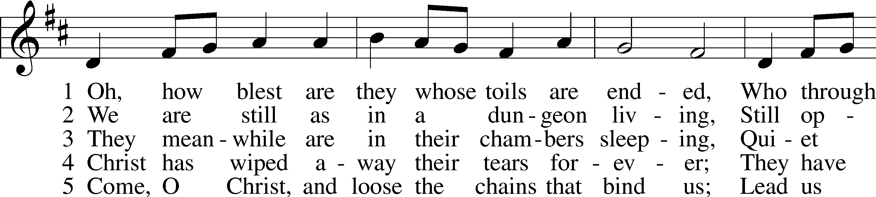
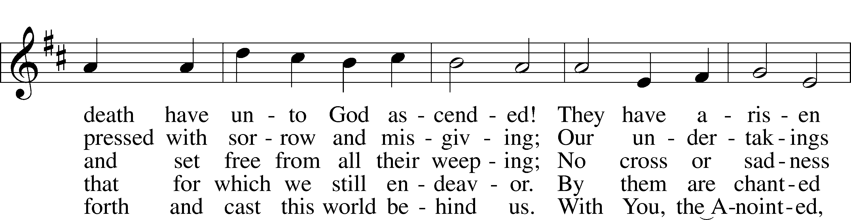
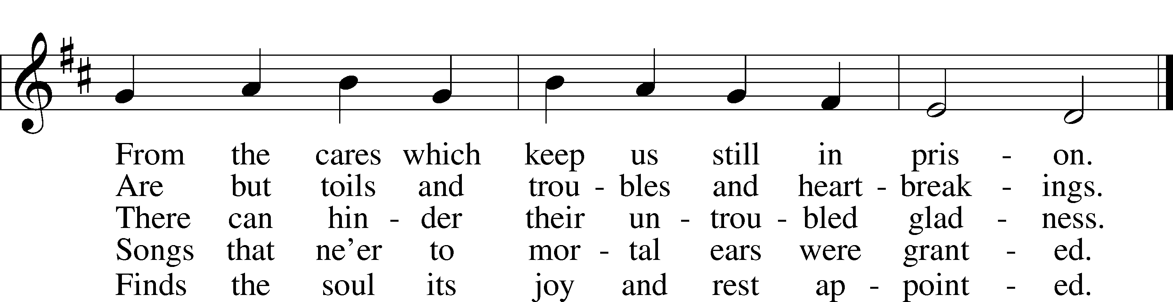
Tune and text: Public domain

Acknowledgments
Divine Service, Setting One from Lutheran Service Book
Unless otherwise indicated, Scripture quotations are from the ESV® Bible (The Holy Bible, English Standard Version®), copyright © 2001 by Crossway, a publishing ministry of Good News Publishers. Used by permission. All rights reserved.
Created by Lutheran Service Builder © 2021 Concordia Publishing House.

Announcements:
Church Service Phone: 888-505-1870/715-438-4200
(Stay on the line for recorded service to start)
Live Stream audio services: http://salem.listentochurch.com
Salem’s Web Page: https://www.salembarron.com/

Pastor Michael Nielsen: Cell phone: 218-280-0999
Email: rev.mike.nielsen@gmail.com
Pastor’s Office Hours: Monday-Wednesday 9-12

Attendance:
Call-in line: 10/31– 9
Facebook live: 10/31– 12
In-person: 10/31 – 70

Weekly Needs: $2823.92
10/17/21– General: $2006 Missions: $127 Bldg: $110 Childcare: $ SS: $52 SS Memorial – Kenny Harbaugh: $300 AC Memorial – Kenny Harbaugh: $200 Picture Frames: $20
10/24/21 - General: $2524.44 Missions: $47 Bldg: $23 Childcare: $112 SS: $6.40 SS Memorial – Sandy Germanson: $200 AC: $100 Vacuum: $30

Coffee and Snacks: Rusty and Missy Weise
Elder Today: Stan Koenig
Altar Guild: Denise Stabenow

Link to Salem’s Facebook page is:
https://www.facebook.com/SalemEvangelicalLutheranChurchAndPreschool/

Schedule for the upcoming week:
Tuesday: 7:30 AM – Men’s Bible Study; 7:00 PM Church Council
Wednesday: 4:00 PM Confirmation
Thursday: 11:00 AM Christian Difference

Save the Date: December 5 – Annual Meeting and Potluck. December 7 – Big Buck Contest

We need 1st and 2nd grade, and 7th and 8th grade Sunday School teachers.

The Nativity Scene needs some painting. Anyone can be of assistance, please let Pastor, Don Duncan, or Tom Lipke know.

Childcare Amazon Needs List: https://a.co/75FLsBE

Thank you to the Wiese family for their musical talents today!

If you are interested in being part of the Church Pictorial Directory Committee, please see MaryAnn Thompson

Prayer requests:

Those in the nursing home:
Caroly, Etta, Leonard, Lois, Vi, Wilma

Those Shut-in at home:
Char, Gail and Roxanne, Joan, Joyce, Loretta

Those recovering from accident: Rusty Weise, Lois, Hunter Nelson, Grant Stabenow

Those with ongoing health issues: Harrison, Jeanne, Kim, Marlene, Wyatt, Owen, Pete, Joyce, Daria, Marilyn, Bernie, Michelle, Sarah, Kathy, Mary, Chris, Sue.

Those who lead our nation:
Joe Biden, Kamala Harris, Tony Evers, Ron Fladten

Those who serve in our military:
Ryan Graf and Ethan Kobernick

Our Childcare Staff: Jennifer Kazekewicz, Amanda Ritchie, Mary Zook, Kristin Loback

Families of the Week: Jeanne Perala, Christopher and Amber Queiser (Emmitt, Delilah, Jordan), Scott Queiser (Amanda), Fred and Linda Riebe, Kassie (and Aaron) Rivard

Those who are struggling with Covid and the doctors and nurses caring for their patients.

Mission Statement
The Mission of Salem Lutheran Church is to be what God called us to be through faith in Jesus Christ, a body of believers engaged in building the Kingdom of God by discipling the Barron area with His Word and Sacrament ministry.

