First Sunday in Advent
November 28, 2021
9:00 AM

Salem Lutheran Church
1-715-537-3011
http://www.salembarron.com
rev.mike.nielsen@gmail.com
The Lord Jesus Comes in Humility to Redeem Us

The season of Advent focuses on the coming of our Lord Jesus Christ, and this first Sunday establishes this theme for the rest of the season. The Son of God came long ago to be our Savior, “a righteous Branch” descended from David (Jer. 33:15). As He then came into Jerusalem, riding on a lowly donkey to sacrifice Himself for the sins of the world (Luke 19:28–40), so does He come to His Church today in the humility of Word and Sacrament to deliver the fruits of His Passion: the forgiveness of sins and eternal life. He absolves us and establishes our hearts “blameless in holiness before our God and Father” (1 Thess. 3:13). The same Lord Jesus, who came to Jerusalem then and who comes to us now in peace, will come again with power and great glory on the Last Day. Then there will be “distress of nations in perplexity,” with “people fainting with fear.” Yet, as we anticipate that great and terrible day, He bids us to rest securely in Him: “Raise your heads, because your redemption is drawing near” (Luke 21:25, 26, 28).
Hymn: Rejoice, Rejoice, Believers LSB 515
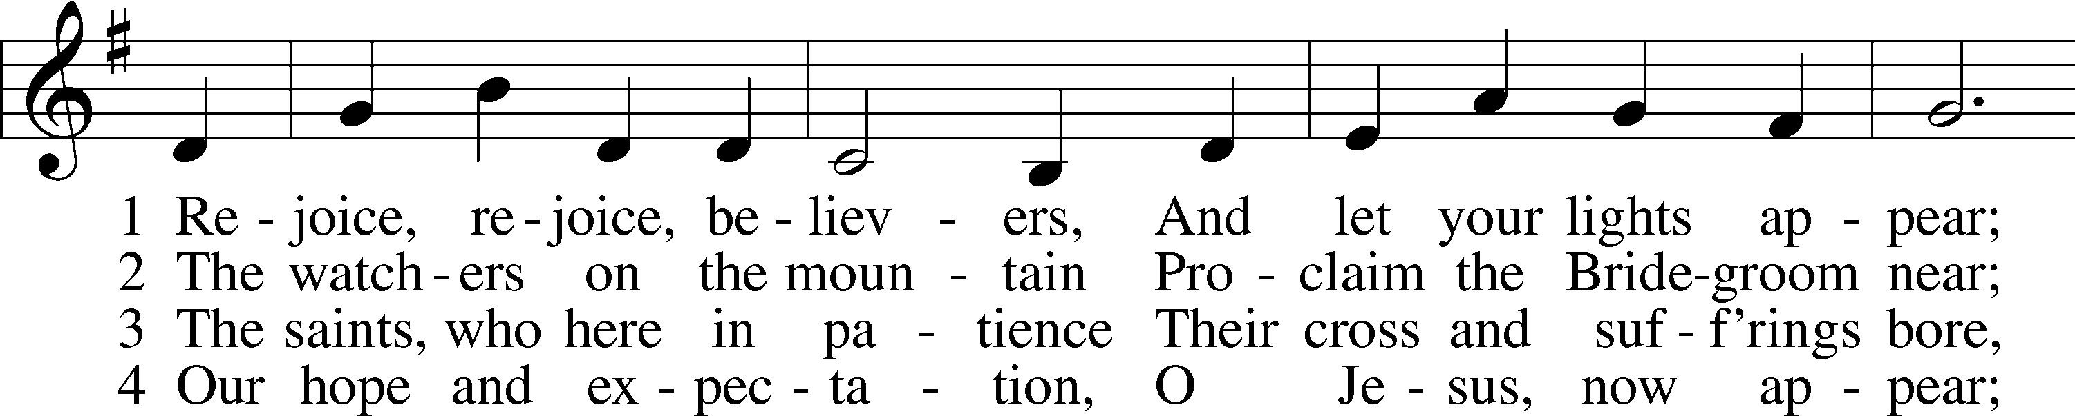
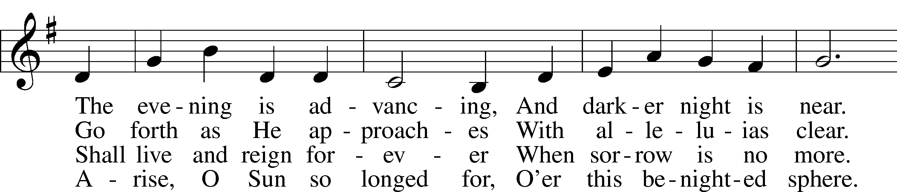
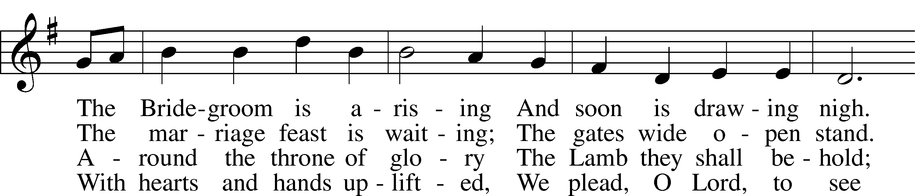
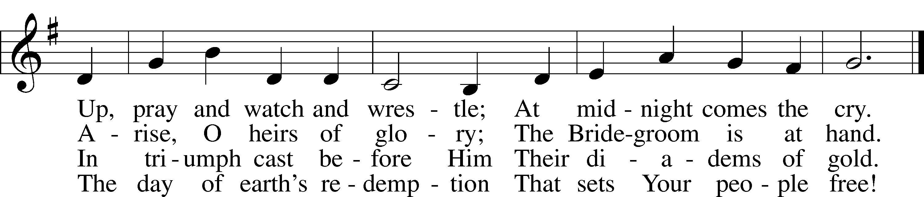
Text and tune: Public domain

Stand

Advent Versicles LSB 219
L O Lord, open my lips,

L Make haste, O God, to deliver me;
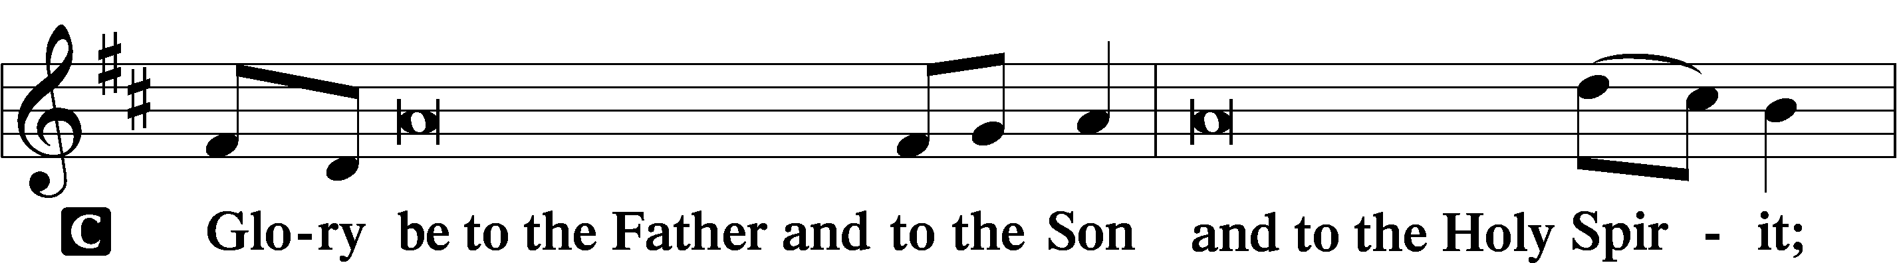
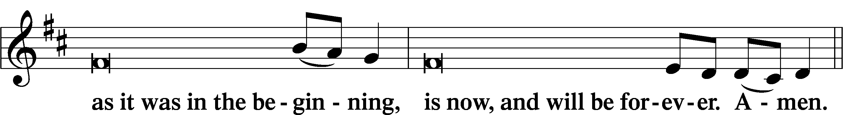
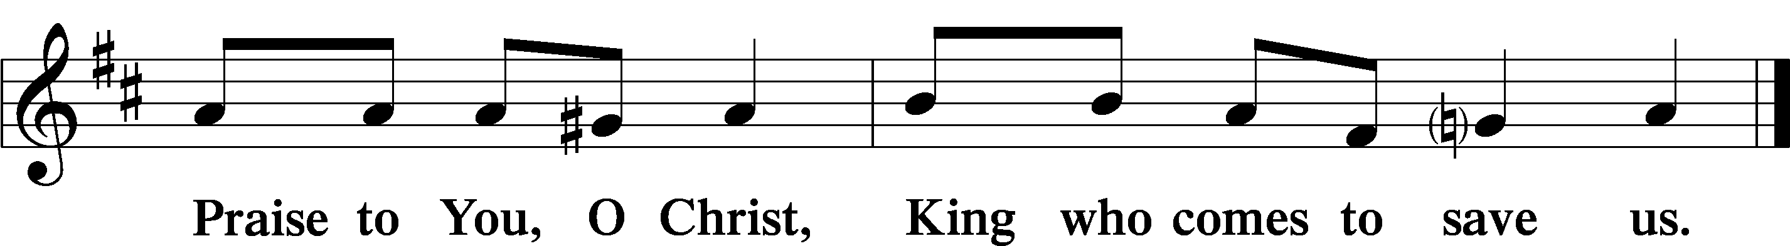

Psalmody

L Behold, the Lord comes to save us.
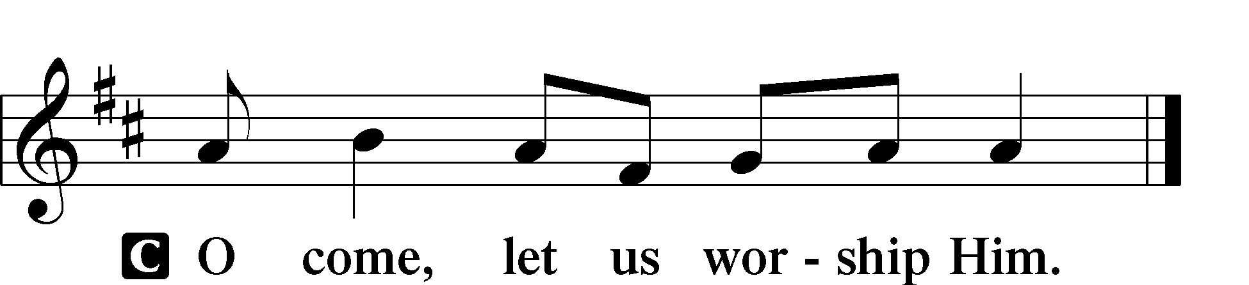

Venite LSB 220
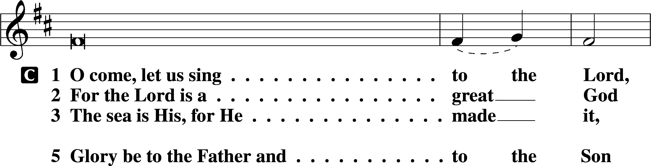
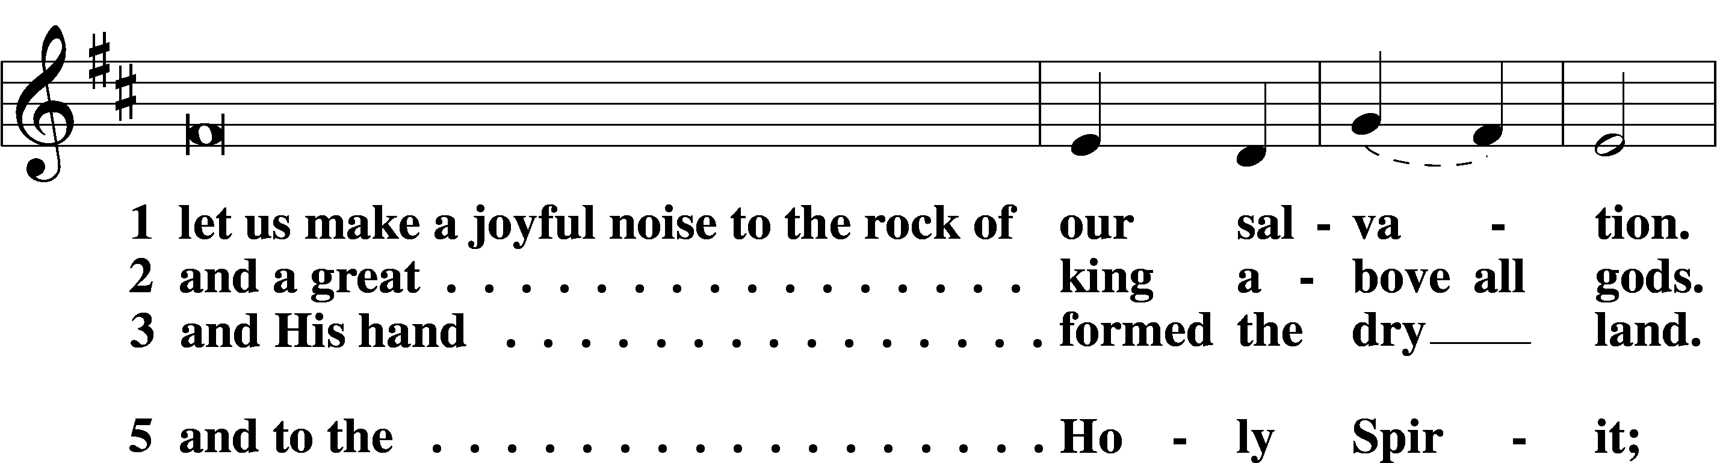
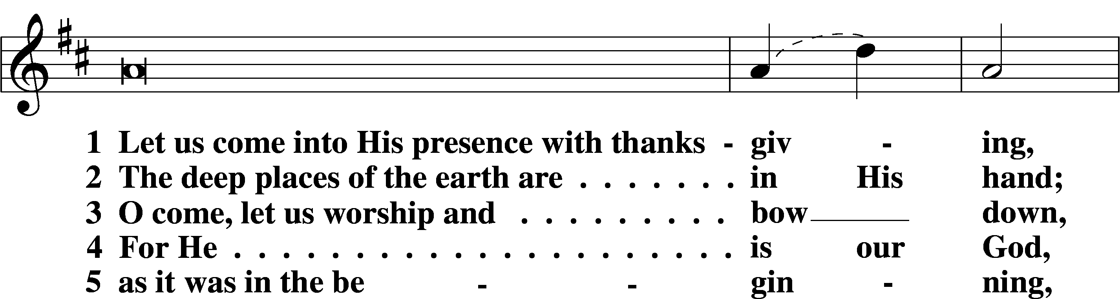
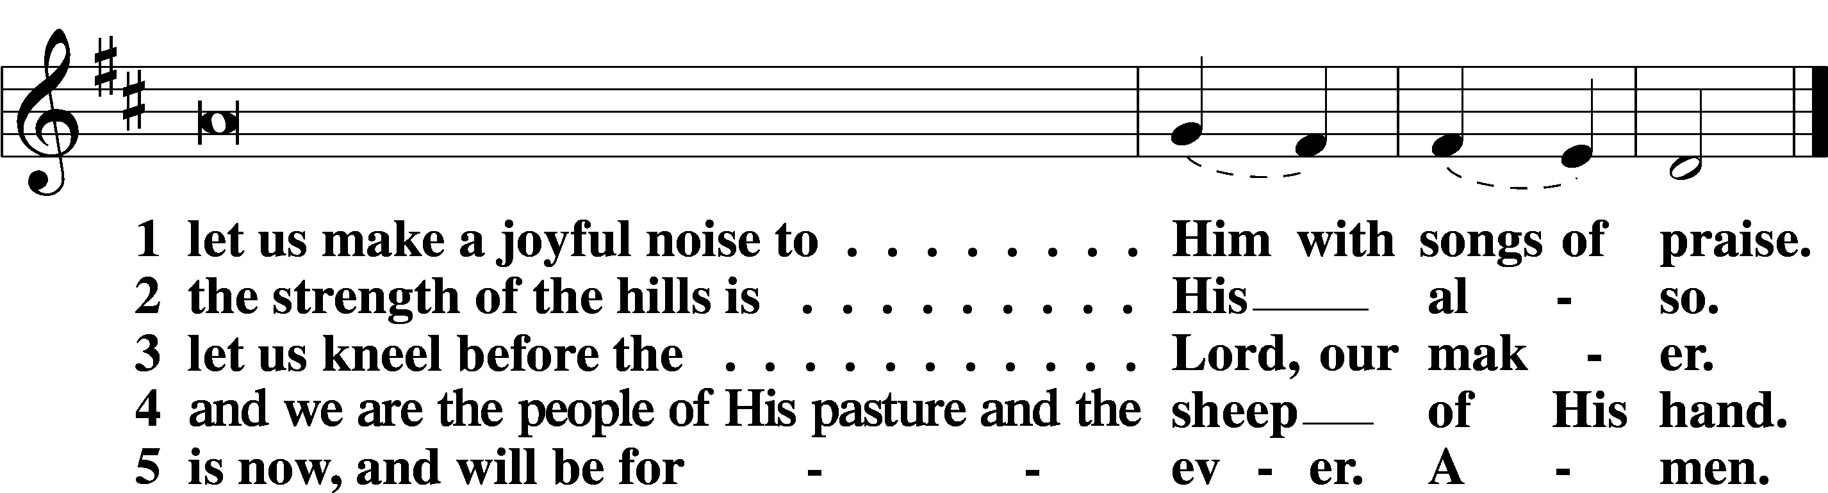

L Behold, the Lord comes to save us.

Additional Psalms Psalm 25:1–10; antiphon: v. 6
Teach Me Your Paths
1To you, O Lord,
I lift up my soul.
2O my God, in you I trust;
let me not be put to shame;
let not my enemies exult over me.
3Indeed, none who wait for you shall be put to shame;
they shall be ashamed who are wantonly treacherous.
4Make me to know your ways, O Lord;
teach me your paths.
5Lead me in your truth and teach me,
for you are the God of my salvation;
for you I wait all the day long.
6Remember your mercy, O Lord, and your steadfast love,
for they have been from of old.
7Remember not the sins of my youth or my transgressions;
according to your steadfast love remember me,
for the sake of your goodness, O Lord!
8Good and upright is the Lord;
therefore he instructs sinners in the way.
9He leads the humble in what is right,
and teaches the humble his way.
10All the paths of the Lord are steadfast love and faithfulness,
for those who keep his covenant and his testimonies.

Sit

Office Hymn: Savior of the Nations, Come LSB 332
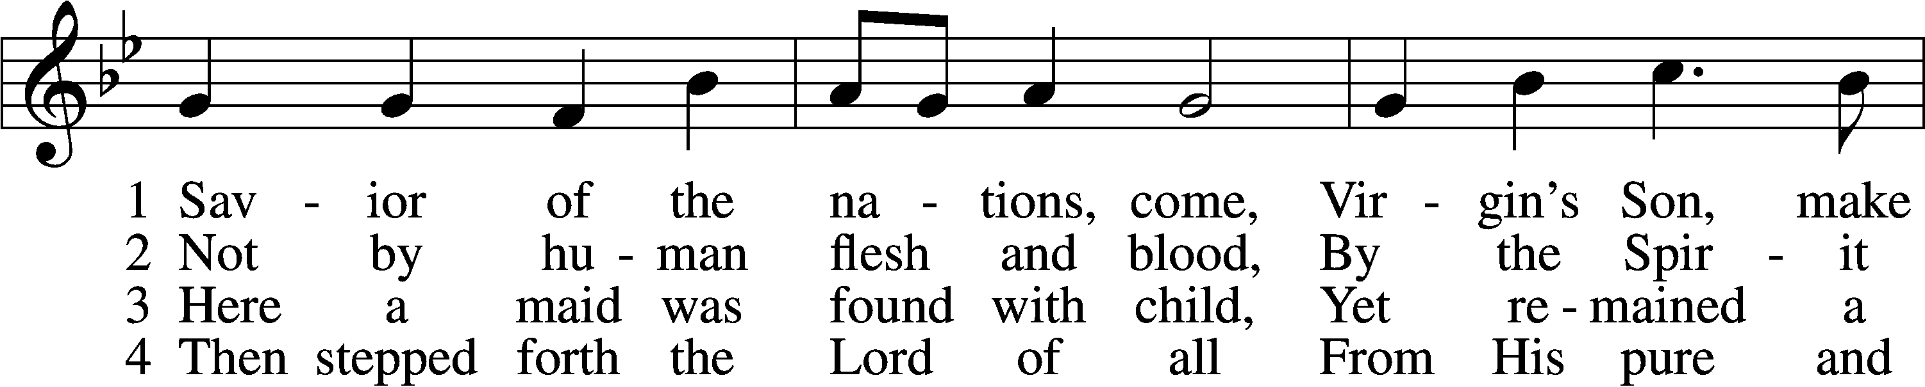
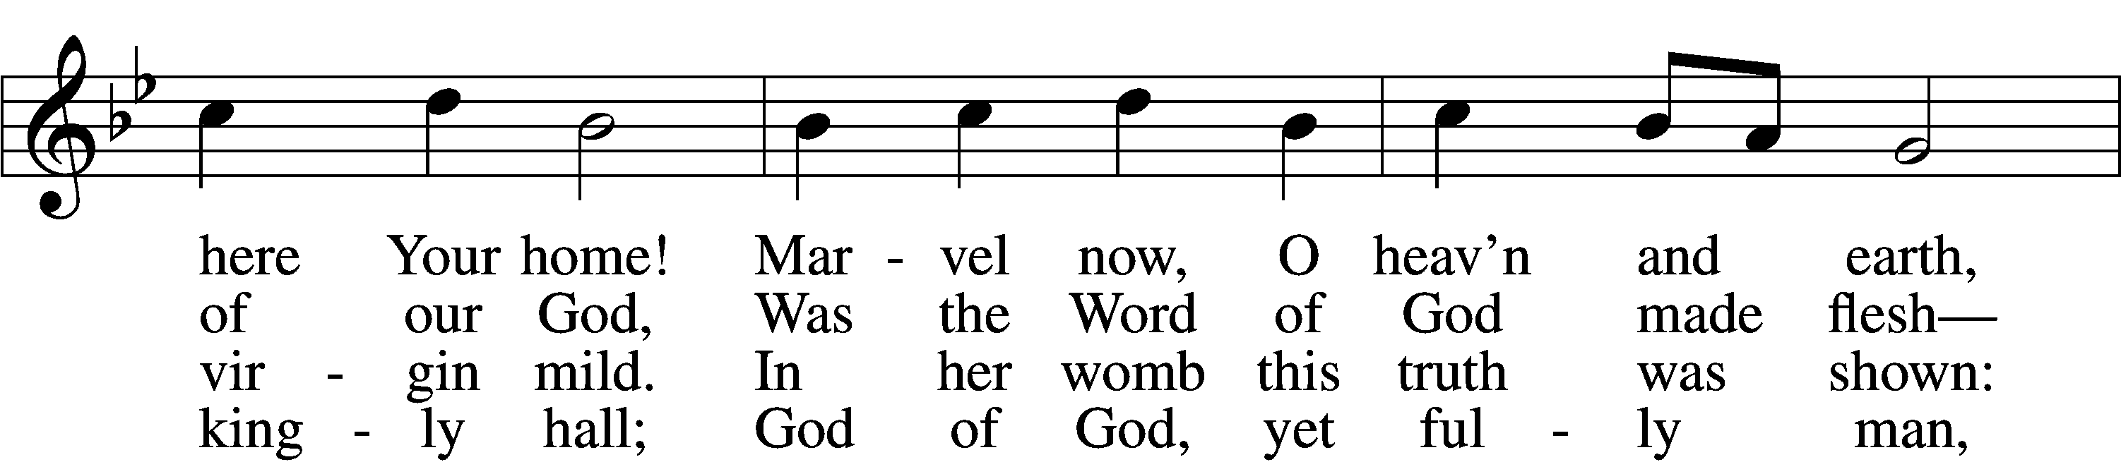
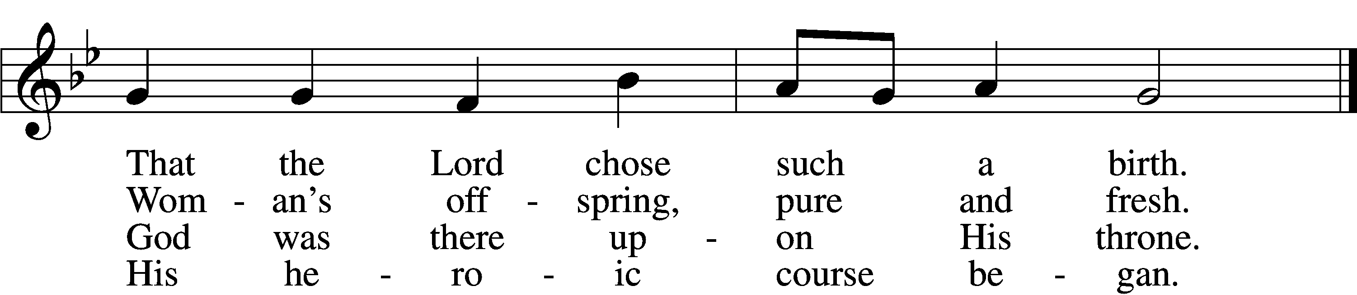

5 God the Father was His source,
Back to God He ran His course.
Into hell His road went down,
Back then to His throne and crown.

6 For You are the Father’s Son
Who in flesh the vict’ry won.
By Your mighty pow’r make whole
All our ills of flesh and soul.

7 From the manger newborn light
Shines in glory through the night.
Darkness there no more resides;
In this light faith now abides.

D 8 Glory to the Father sing,
Glory to the Son, our king,
Glory to the Spirit be
Now and through eternity.
Text (sts. 3, 6–7): © 2006 Concordia Publishing House; (sts. 4–5, 8): © 1978 Concordia Publishing House. Used by permission: LSB Hymn License no. 110005504
Text (sts. 1–2) and tune: Public domain

Readings

Reading Jeremiah 33:14–16
The Lord’s Eternal Covenant with David
14“Behold, the days are coming, declares the Lord, when I will fulfill the promise I made to the house of Israel and the house of Judah. 15In those days and at that time I will cause a righteous Branch to spring up for David, and he shall execute justice and righteousness in the land. 16In those days Judah will be saved and Jerusalem will dwell securely. And this is the name by which it will be called: ‘The Lord is our righteousness.’”

L O Lord, have mercy on us.
C Thanks be to God.

Reading 1 Thessalonians 3:9–13
9What thanksgiving can we return to God for you, for all the joy that we feel for your sake before our God, 10as we pray most earnestly night and day that we may see you face to face and supply what is lacking in your faith?
11Now may our God and Father himself, and our Lord Jesus, direct our way to you, 12and may the Lord make you increase and abound in love for one another and for all, as we do for you, 13so that he may establish your hearts blameless in holiness before our God and Father, at the coming of our Lord Jesus with all his saints.

L O Lord, have mercy on us.
C Thanks be to God.

Reading Luke 19:28–40
The Triumphal Entry
28When [Jesus] had said these things, he went on ahead, going up to Jerusalem. 29When he drew near to Bethphage and Bethany, at the mount that is called Olivet, he sent two of the disciples, 30saying, “Go into the village in front of you, where on entering you will find a colt tied, on which no one has ever yet sat. Untie it and bring it here. 31If anyone asks you, ‘Why are you untying it?’ you shall say this: ‘The Lord has need of it.’” 32So those who were sent went away and found it just as he had told them. 33And as they were untying the colt, its owners said to them, “Why are you untying the colt?” 34And they said, “The Lord has need of it.” 35And they brought it to Jesus, and throwing their cloaks on the colt, they set Jesus on it. 36And as he rode along, they spread their cloaks on the road. 37As he was drawing near—already on the way down the Mount of Olives—the whole multitude of his disciples began to rejoice and praise God with a loud voice for all the mighty works that they had seen, 38saying, “Blessed is the King who comes in the name of the Lord! Peace in heaven and glory in the highest!” 39And some of the Pharisees in the crowd said to him, “Teacher, rebuke your disciples.” 40He answered, “I tell you, if these were silent, the very stones would cry out.”

L O Lord, have mercy on us.
C Thanks be to God.

Children’s Message

Common Responsory LSB 221
Sermon

Canticle

Stand

Te Deum LSB 223
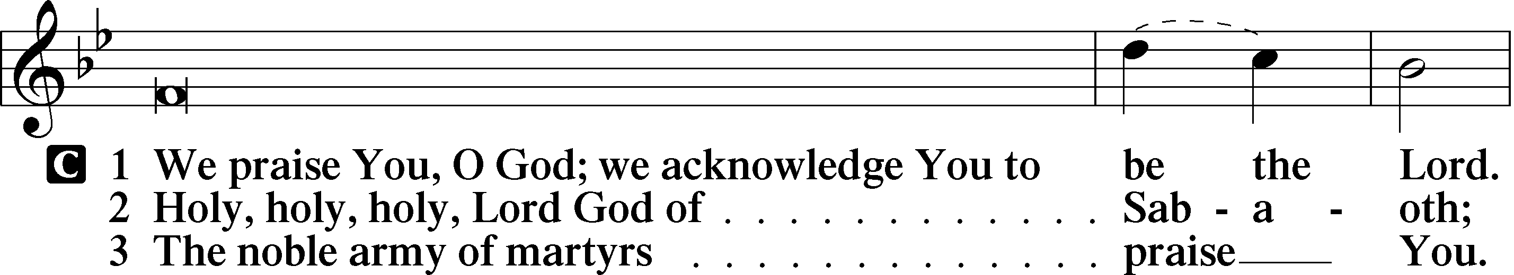
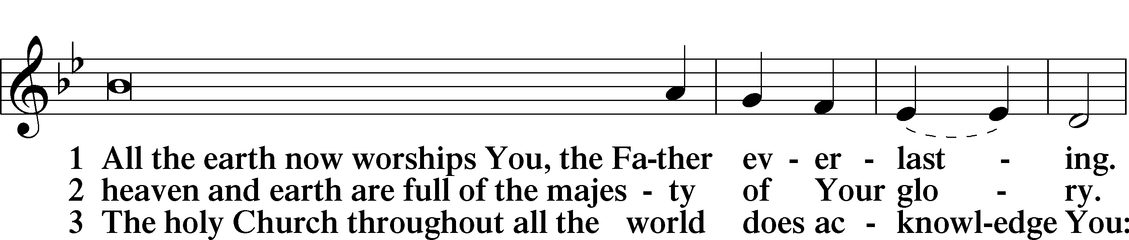
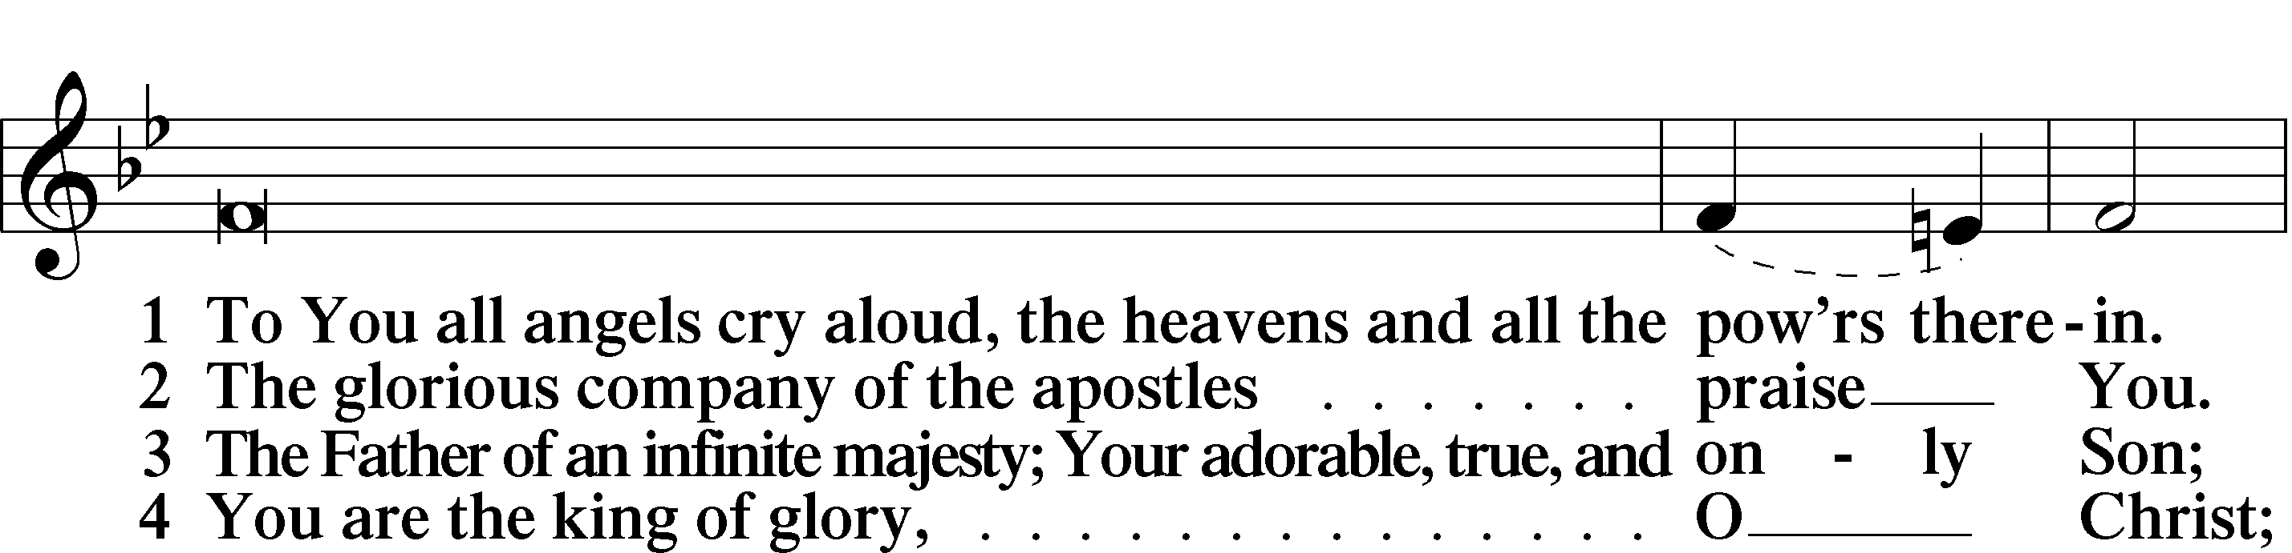
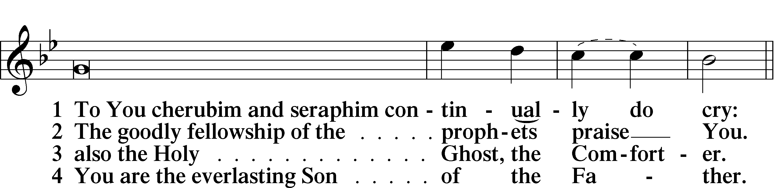
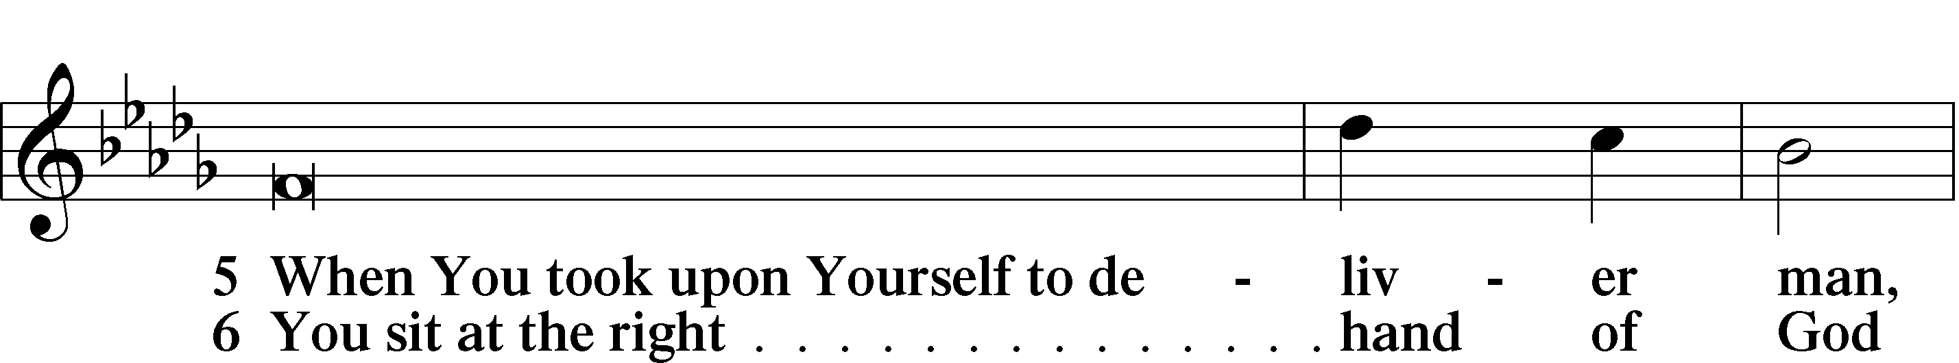
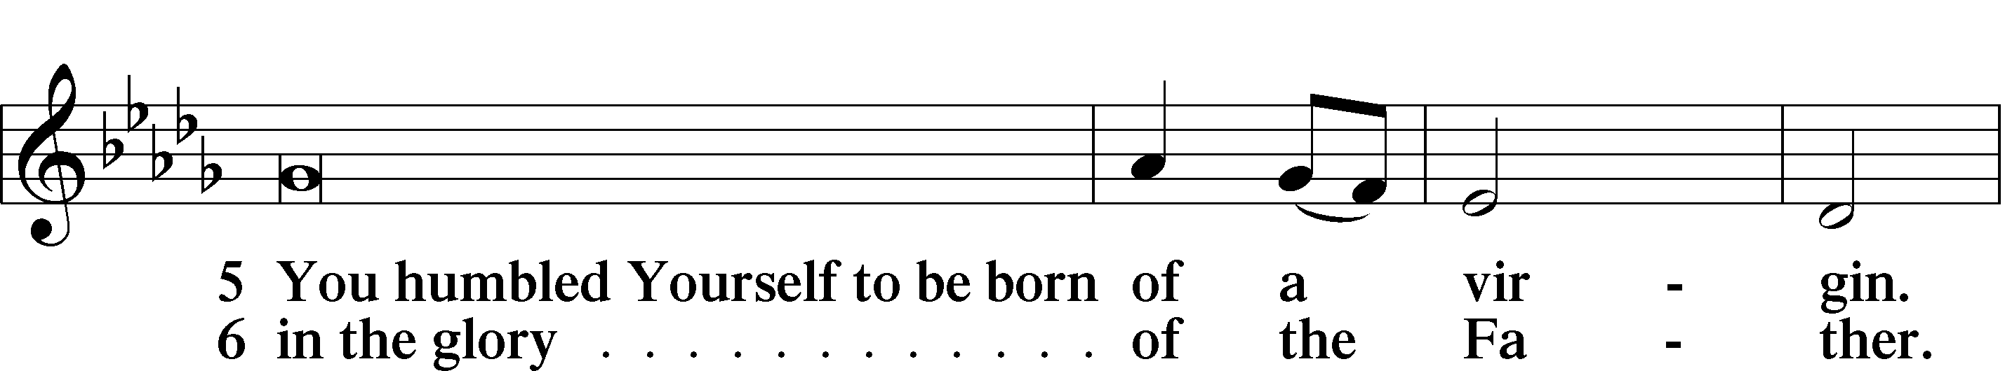
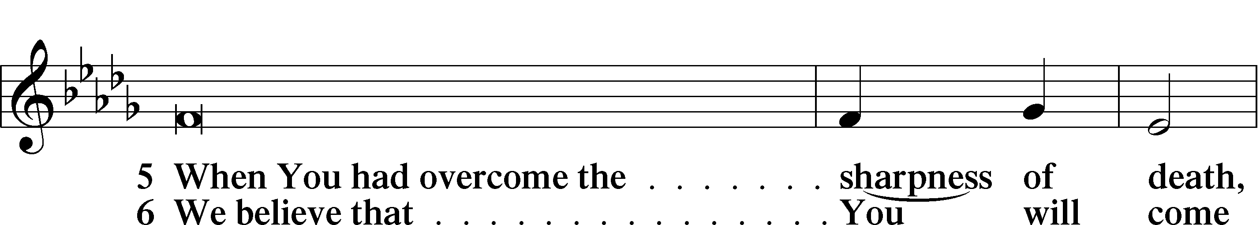
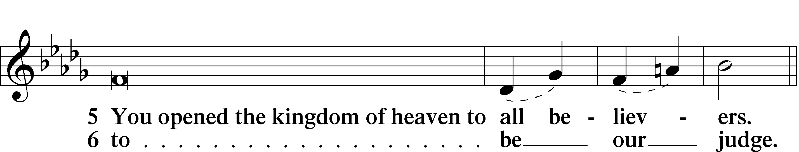
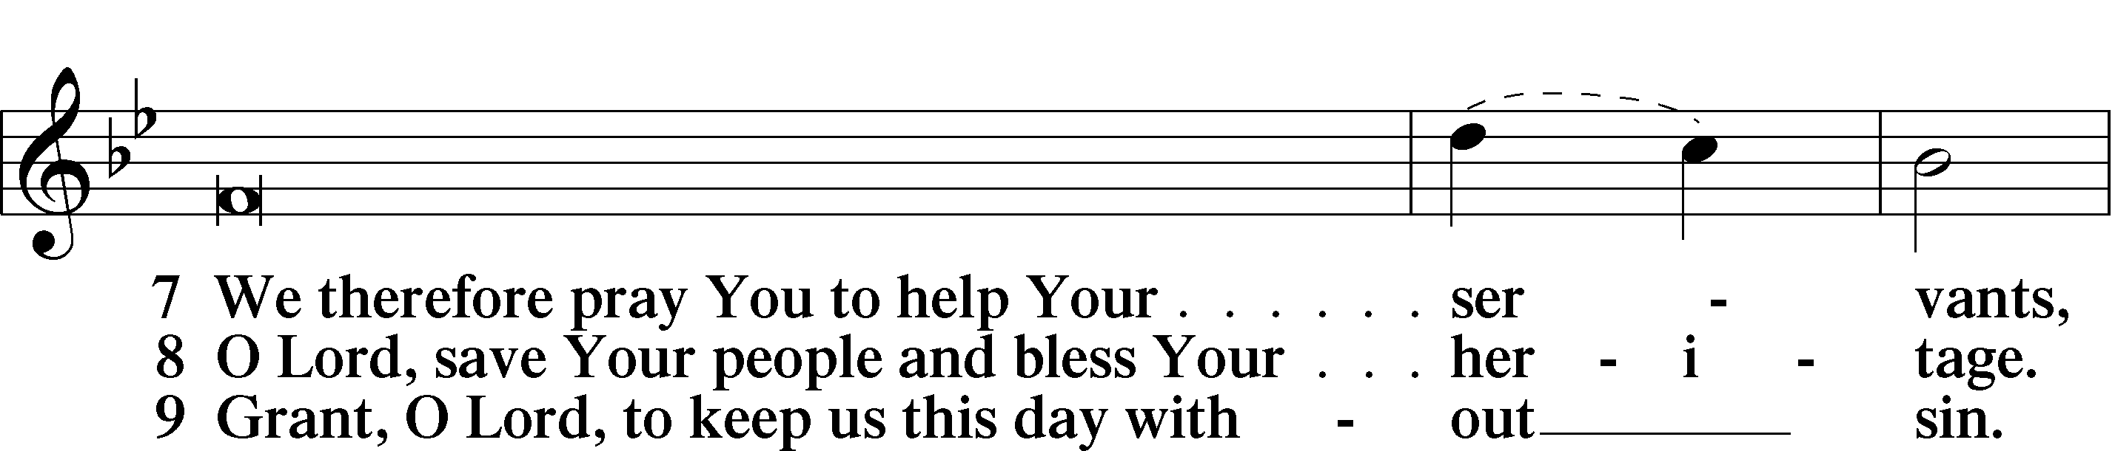
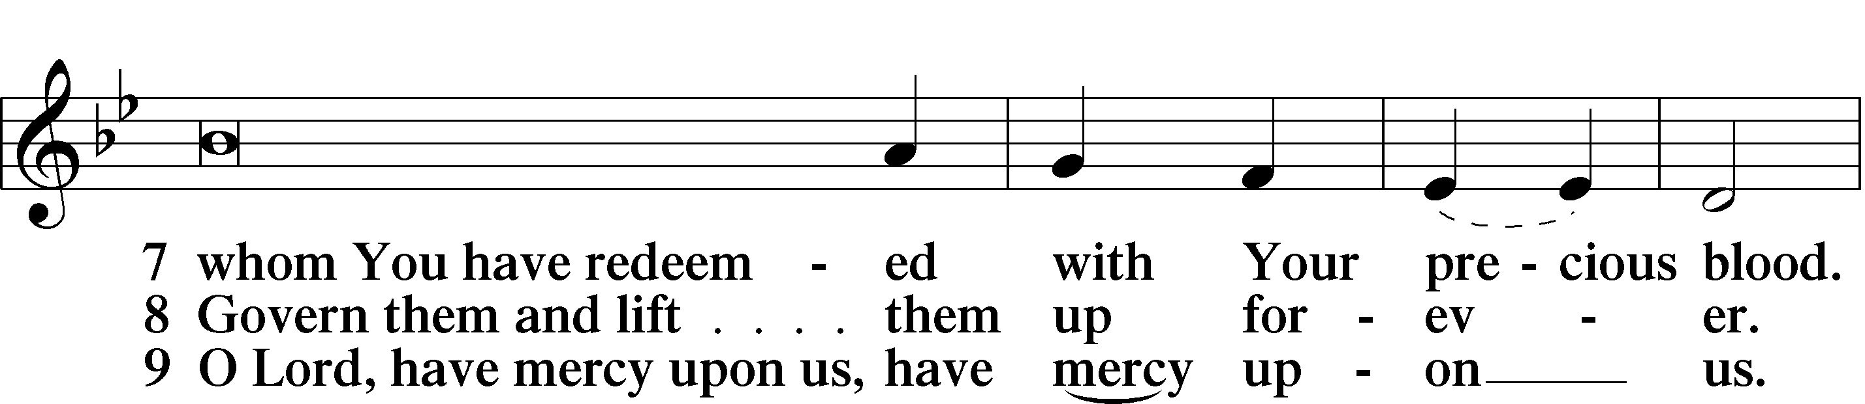
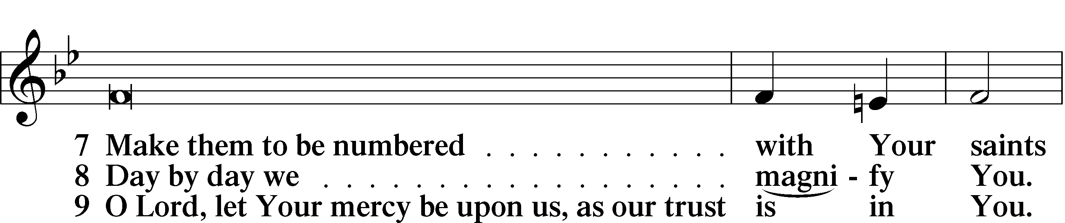
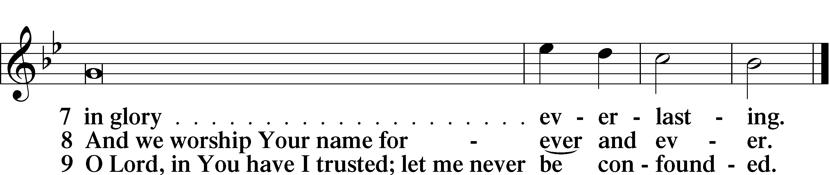

Sit

Offering

Prayer

Kneel/Stand

Kyrie LSB 227
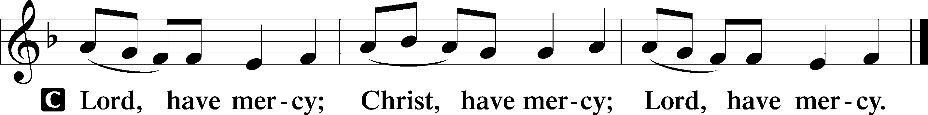

Lord’s Prayer
C Our Father who art in heaven,
hallowed be Thy name,
Thy kingdom come,
Thy will be done on earth
as it is in heaven;
give us this day our daily bread;
and forgive us our trespasses
as we forgive those
who trespass against us;
and lead us not into temptation,
but deliver us from evil.
For Thine is the kingdom
and the power and the glory
forever and ever. Amen.

Collects

L O Lord, hear my prayer.
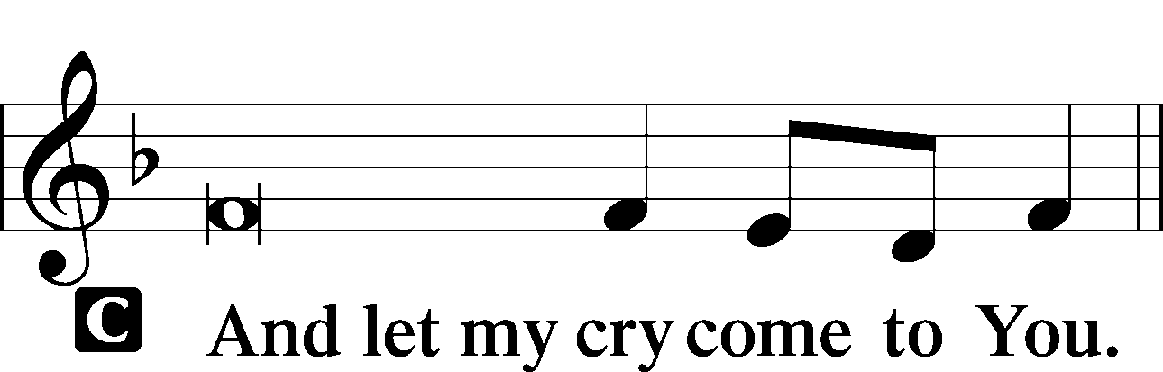

Collect of the Day
Stir up Your power, O Lord, and come, that by Your protection we may be rescued from the threatening perils of our sins and saved by Your mighty deliverance; for You live and reign with the Father and the Holy Spirit, one God, now and forever.
C Amen.

Collect for Grace
L O Lord, our heavenly Father, almighty and everlasting God, You have safely brought us to the beginning of this day. Defend us in the same with Your mighty power and grant that this day we fall into no sin, neither run into any kind of danger, but that all our doings, being ordered by Your governance, may be righteous in Your sight; through Jesus Christ, Your Son, our Lord, who lives and reigns with You and the Holy Spirit, one God, now and forever.

Stand

Benedicamus LSB 228
L Let us bless the Lord.
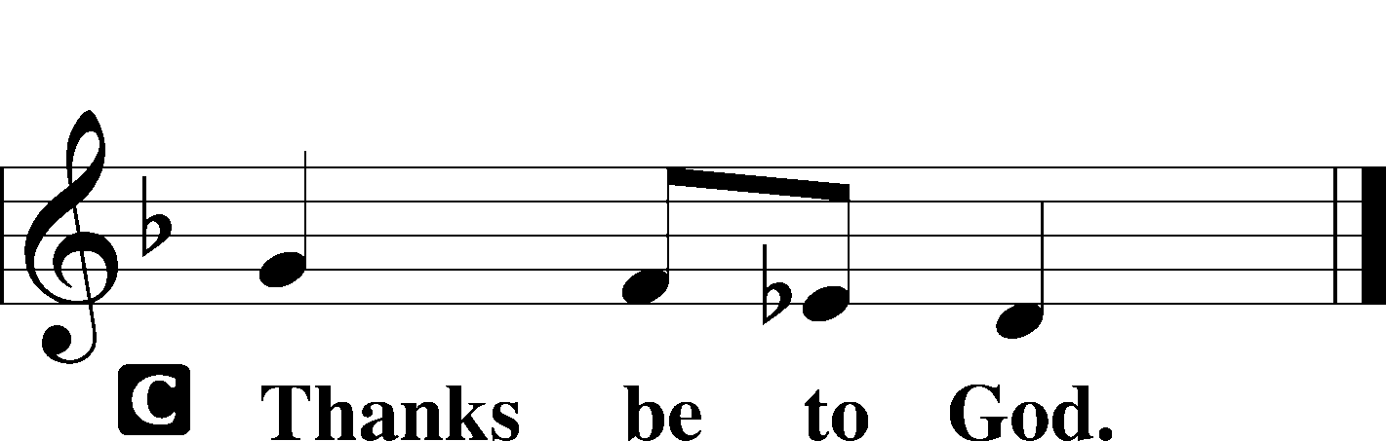

Benediction LSB 228
P The grace of our Lord T Jesus Christ and the love of God and the communion of the Holy Spirit be with you all.

Hymn to Depart: Lift Up Your Heads, Ye Mighty Gates LSB 341
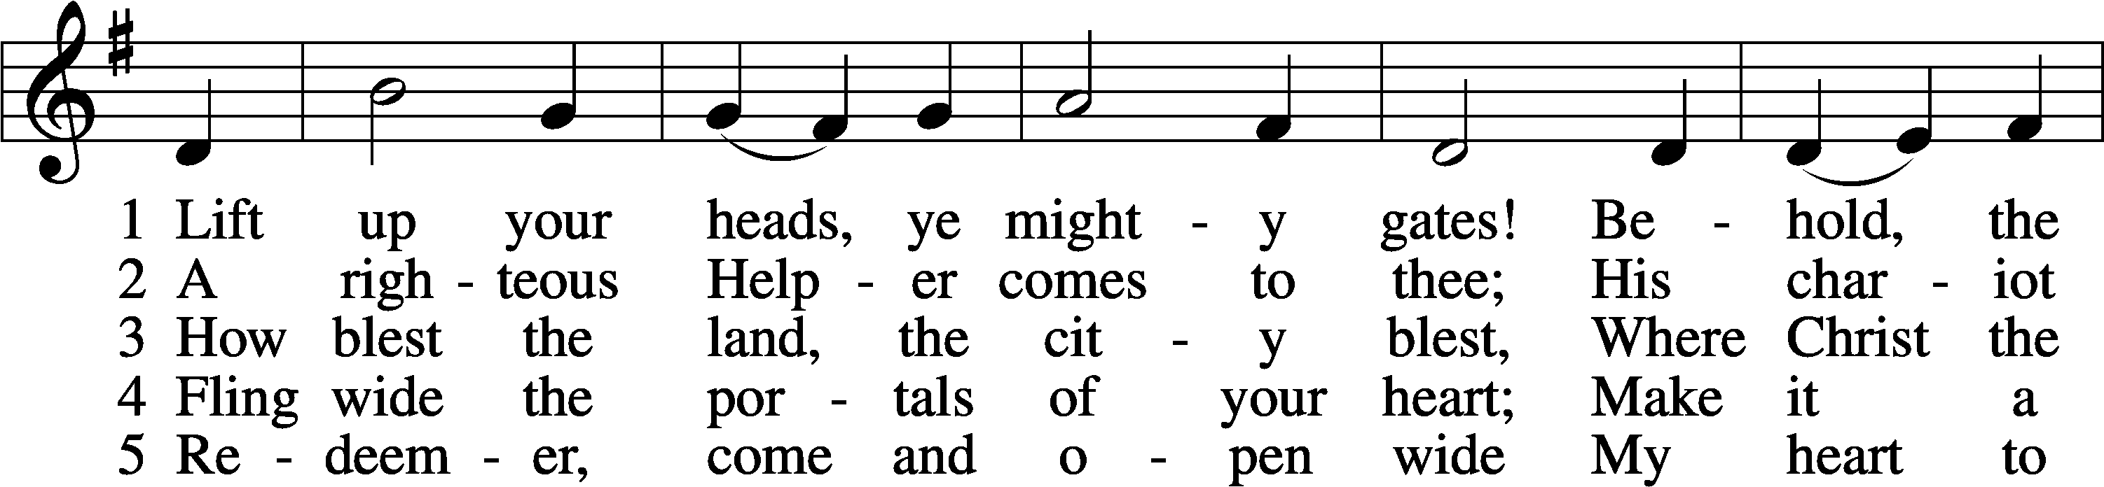
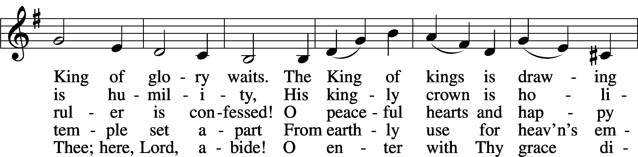
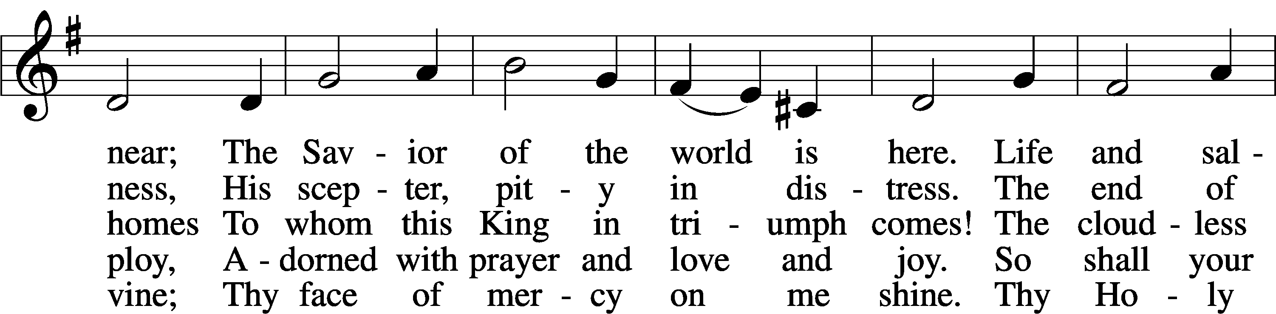
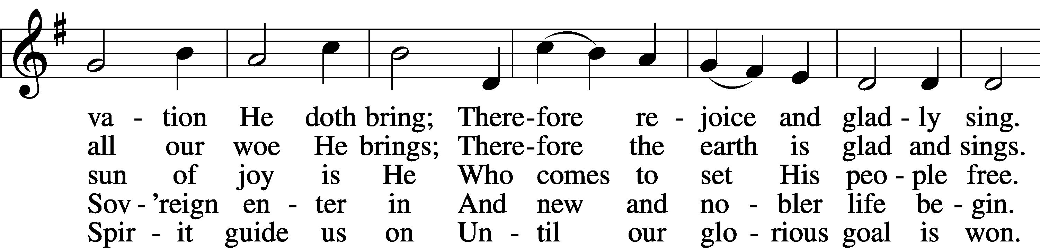
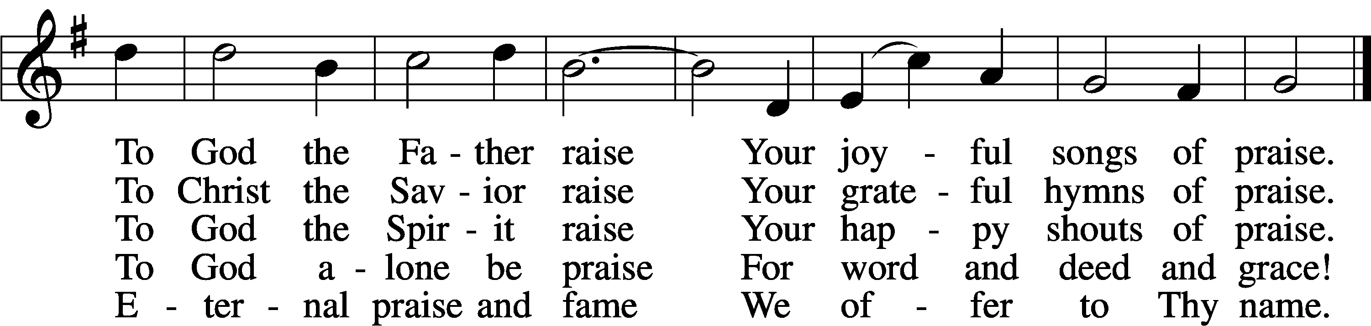
Tune and text: Public domain

Acknowledgments
Matins from Lutheran Service Book
Unless otherwise indicated, Scripture quotations are from the ESV® Bible (The Holy Bible, English Standard Version®), copyright © 2001 by Crossway, a publishing ministry of Good News Publishers. Used by permission. All rights reserved.
Created by Lutheran Service Builder © 2021 Concordia Publishing House.

Announcements:
Church Service Phone: 888-505-1870/715-438-4200
(Stay on the line for recorded service to start)
Live Stream audio services: http://salem.listentochurch.com
Salem’s Web Page: https://www.salembarron.com/

Pastor Michael Nielsen: Cell phone: 218-280-0999
Email: rev.mike.nielsen@gmail.com
Pastor’s Office Hours: Monday-Wednesday 9-12

Attendance:
Call-in line: 11/21– 8
Facebook live: 11/21– 10
In-person: 11/21 – 55

Weekly Needs: $2823.92
11/14/21 - General: $ Missions: $ Bldg: $ Childcare: $ SS: $

Coffee and Snacks: Chris and Kelly Mueller
Elder Today: Josh Millerman
Altar Guild: Denise Stabenow

Link to Salem’s Facebook page is:
https://www.facebook.com/SalemEvangelicalLutheranChurchAndPreschool/

Schedule for the upcoming week:
Tuesday: 7:30 AM – Men’s Bible Study
Wednesday: Noon and 6:30 PM Midweek Advent Service
4:00 PM Catechism Class
5:30 PM Advent Dinner
Thursday: 11:00 AM Christian Difference

Save the Date: Christmas Program Practices
November 28: 11-12:15 PM
December 4 – Parent’s Night Out (4-8:30 PM) Practice (4-5:30 PM)
December 5 – Annual Meeting and Potluck.
December 7 – Big Buck Contest
December 12 – 11-12:15 PM December 18: 10-11:30 AM
December 19: Children’s Christmas Service

If you are interested in renewing your Lutheran Witness subscription or becoming a new subscriber, please let the Church Office known by December 29. Cost is $15.96.

This Saturday is a Parent’s Night Out from 4:30 – 8:00 PM. Please contact Jen Millerman if you have any question.

Flowers on the Altar this week and next are in honor of the 60th anniversary of Duffy and Janee Andersson

Childcare Amazon Needs List: https://a.co/75FLsBE

Prayer requests:

Those in the nursing home:
Caroly, Etta, Leonard, Lois, Vi, Wilma

Those Shut-in at home:
Char, Gail and Roxanne, Joan, Joyce, Loretta

Those recovering from accident: Rusty Weise, Hunter Nelson, Grant Stabenow

Those with ongoing health issues: Harrison, Jeanne, Wyatt, Owen, Joyce, Marilyn, Bernie, Michelle, Sarah, Kathy, Chris, Sue, Carol

Those who grieve: The Family of Marlene Amdall

Those who lead our nation:
Joe Biden, Kamala Harris, Tony Evers, Ron Fladten

Those who serve in our military:
Ryan Graf and Ethan Kobernick

Our Childcare Staff: Amanda Ritchie, Mary Zook, Kristin Loback, Mariah Behnke

Families of the Week: Albert Starck, Earl and Amee Starck, James Starck, David and Cindy Steel (Zack, Brady, and Isaac Mickelson), John and Emily Steele (Garrett, Adam, Waylon, Matthew), Robert and MaryAnn Thompson (Matthew)

Those who are struggling with Covid and the doctors and nurses caring for their patients.

Mission Statement
The Mission of Salem Lutheran Church is to be what God called us to be through faith in Jesus Christ, a body of believers engaged in building the Kingdom of God by discipling the Barron area with His Word and Sacrament ministry.

