Good Friday – Tre Ore
April 15, 2022
12:00 PM

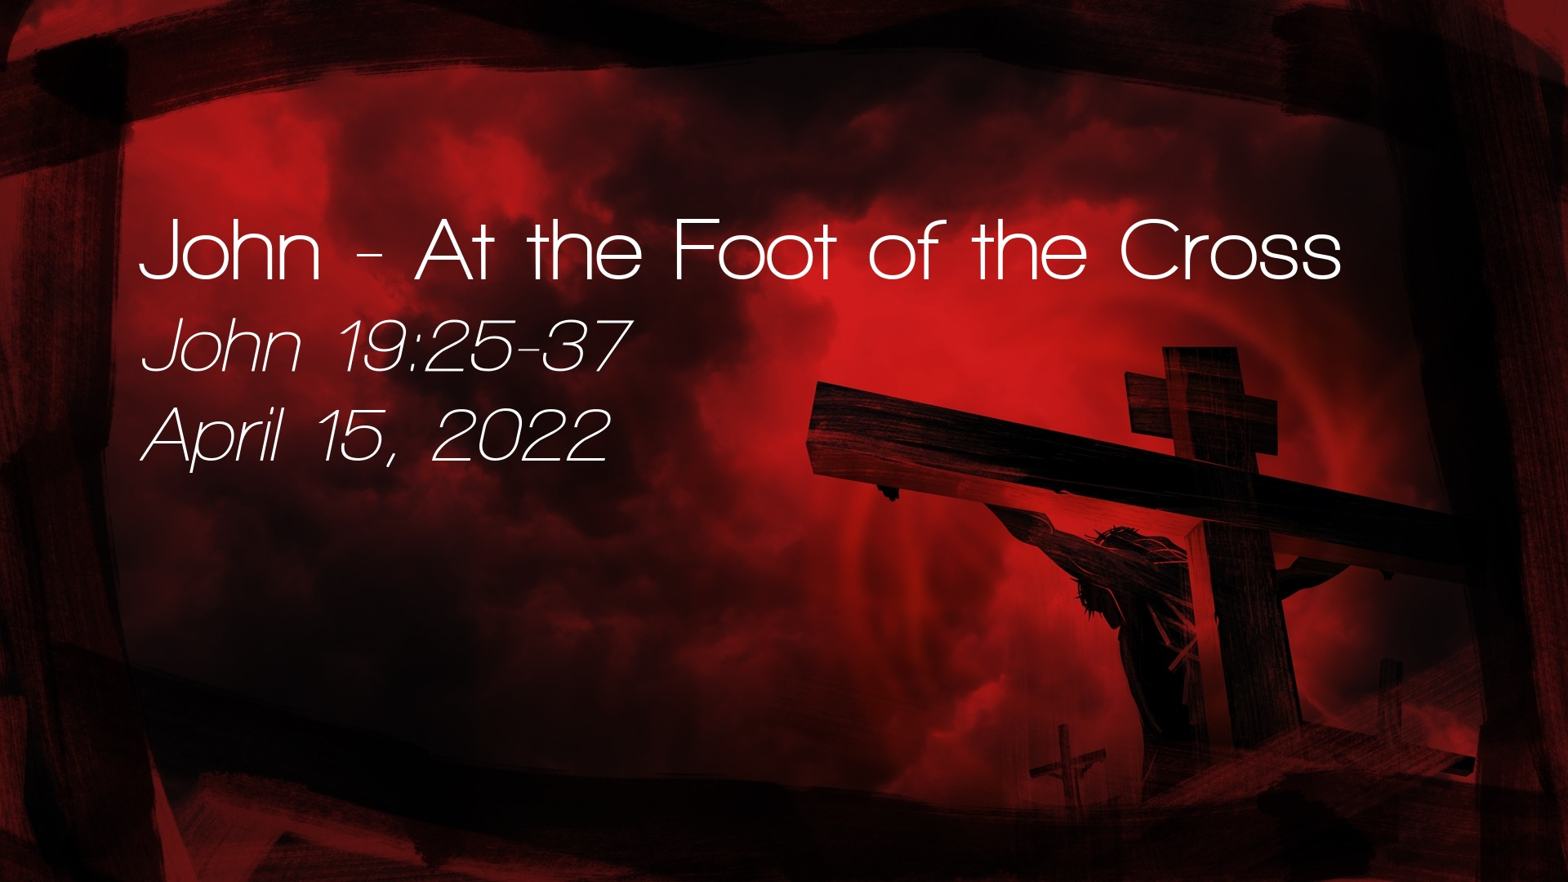

Salem Lutheran Church
1-715-537-3011
http://www.salembarron.com
rev.mike.nielsen@gmail.com
John, the Gospel Writer
Our journey to follow Christ through witnesses to Christ arrives now at the cross. Tonight, we view Christ on the cross through the author’s eyes—John, Apostle and Evangelist, the beloved disciple, the son of Zebedee, and the brother of James. By John’s witness, we view Jesus beaten and bloodied. We hear His words of forgiveness and fulfillment. We see Him shedding His blood for the life of the world. As we sing and pray and sit in silence this evening, we ponder Christ’s love for us. We marvel at His gifts of forgiveness and salvation, for we have been clothed with the blood of Christ.
The First Word from the Cross
“Father, forgive them, for they know not what they do.” (Luke 23:34)

Stand

Opening Sentences Psalm 69:20; Lamentations 1:12; Isaiah 53:5
L Reproaches have broken my heart, so that I am in despair. I looked for pity, but there was none, and for comforters, but I found none. Is it nothing to you, all you who pass by? Look and see if there is any sorrow like my sorrow, which was brought upon me, which the Lord inflicted on the day of His fierce anger.
C He was wounded for our transgressions; He was crushed for our iniquities: upon Him was the chastisement that brought us peace, and with His stripes we are healed.

Prayer
L O Lord Jesus Christ, Son of the Father and Savior of the world, hear us as with humble and adoring hearts we remember Your seven words of love spoken on this day from the cross. Draw us into closer communion with Your Spirit, that the mind that was in You may also be found in us. We remember that, as they crucified You, You said, “Father, forgive them, for they know not what they do.” If You, Lord, should mark iniquities, O Lord who shall stand? But there is forgiveness with You that You may be feared. You Yourself bore our sins in Your own body on the tree that we, being dead to sin, should live to Your righteousness. In thanksgiving for this word, we worship and adore Your holy name.
C Amen.

Sit
Hymn: Jesus, I Will Ponder Now LSB 440
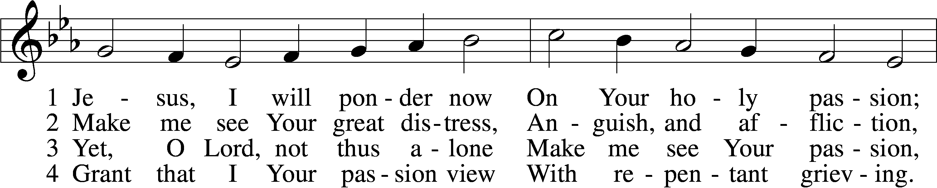
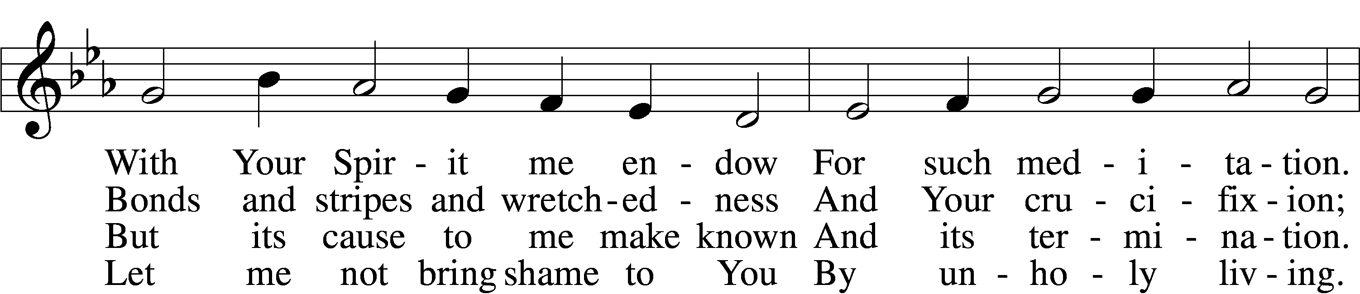
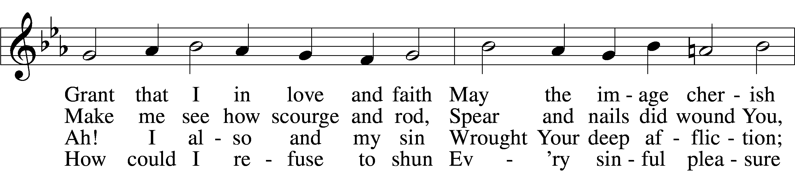
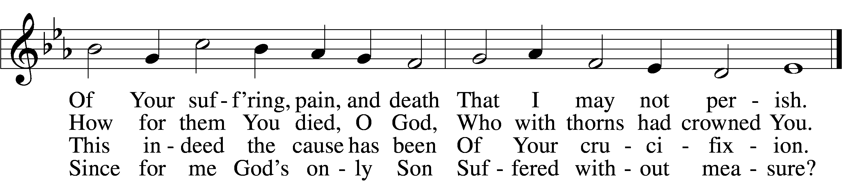

5 If my sins give me alarm
And my conscience grieve me,
Let Your cross my fear disarm;
Peace of conscience give me.
Help me see forgiveness won
By Your holy passion.
If for me He slays His Son,
God must have compassion!
6 Graciously my faith renew;
Help me bear my crosses,
Learning humbleness from You,
Peace mid pain and losses.
May I give You love for love!
Hear me, O my Savior,
That I may in heav’n above
Sing Your praise forever.

Tune and text: Public domain

Lesson Luke 23:32–34
32Two others, who were criminals, were led away to be put to death with him. 33And when they came to the place that is called The Skull, there they crucified him, and the criminals, one on his right and one on his left. 34And Jesus said, “Father, forgive them, for they know not what they do.” And they cast lots to divide his garments.

Stand

Prayer
L O Good Shepherd, who laid down Your life for the sheep.
C Remember us and have mercy upon us.

L O everlasting Power and Wisdom of the Most High God, Word of the Father.
C Remember us and have mercy upon us.

L O Maker of the world, the Life of all, the Lord of angels.
C Remember us and have mercy upon us.

L You were seized, though guiltless, buffeted, and given over to robbers.
C Remember us and have mercy upon us.

L You alone by Your death overcame the death of our guilt.
C Remember us and have mercy upon us.

Collect on the First Word from the Cross
L Lord Jesus Christ, our only Mediator and Advocate, by the determinate counsel and foreknowledge of God, You were taken and crucified and slain by the hand of wicked people, and then You made intercession for the transgressors: we pray, grant unto us the blessed assurance that there is now no condemnation for those who are in You; and we pray that, if anyone sin, we have an Advocate with the Father in You, the Righteous, whose blood speaks better things than Abel’s blood; for You live and reign with the Father and the Holy Spirit, one God, now and forever.
C Amen.
The Second Word from the Cross

“Truly I say to you, today you will be with Me in Paradise.” (Luke 23:43)

Stand

Opening Sentences Hebrews 9:11–12
L When Christ appeared as a high priest of the good things that have come, then through the greater and more perfect tent (not made with hands, that is, not of this creation) He entered once for all into the holy places, . . . securing an eternal redemption.
C Thanks be to God.

Prayer
L O Lord Jesus Christ, Son of the Father and Savior of the world, hear us as with humble and adoring hearts we remember Your seven words of love spoken on this day from the cross. Draw us into closer communion with Your Spirit, that the mind that was in You may also be found in us. We remember Your promise to the penitent thief, “Truly I say to you, today you will be with Me in Paradise.” With You, O Lord, is the fountain of life, and in Your light shall we see light. O Shepherd of the flock of God, who guides those who know Your voice in green pastures and beside the waters of comfort, when we awake we shall be satisfied with Your likeness. In thanksgiving for this word, we worship and adore Your holy name.
C Amen.

Sit

450 O Sacred Head, Now Wounded sts. 1–4
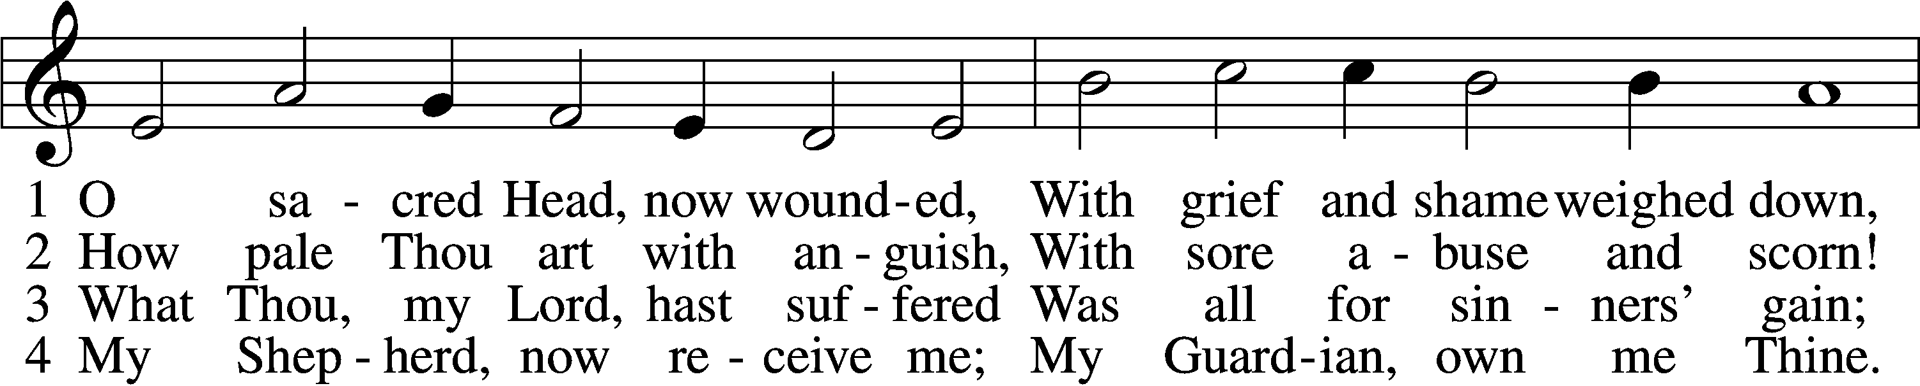
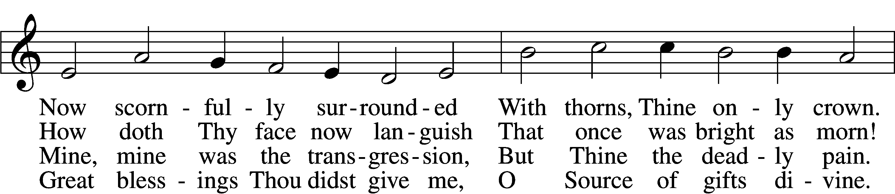
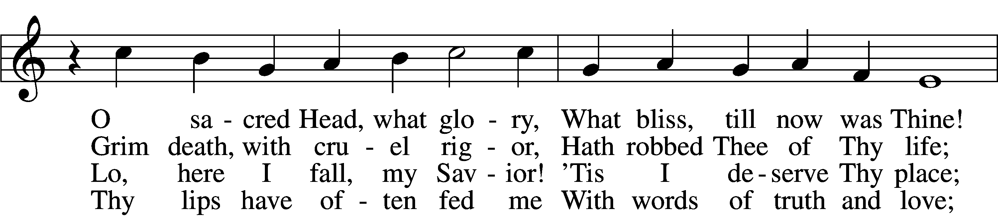
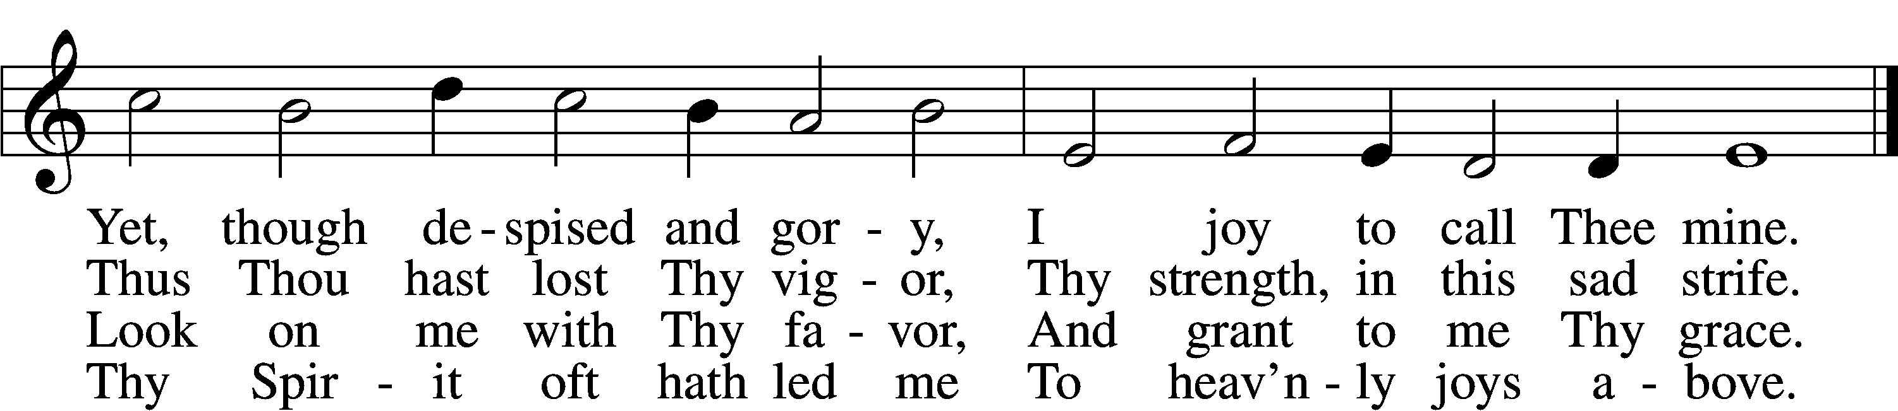
Text: © 1941 Concordia Publishing House. Used by permission: LSB Hymn License no. 110005504
Tune: Public domain

Lesson Luke 23:35–43
35And the people stood by, watching, but the rulers scoffed at him, saying, “He saved others; let him save himself, if he is the Christ of God, his Chosen One!” 36The soldiers also mocked him, coming up and offering him sour wine 37and saying, “If you are the King of the Jews, save yourself!” 38There was also an inscription over him, “This is the King of the Jews.”
39One of the criminals who were hanged railed at him, saying, “Are you not the Christ? Save yourself and us!” 40But the other rebuked him, saying, “Do you not fear God, since you are under the same sentence of condemnation? 41And we indeed justly, for we are receiving the due reward of our deeds; but this man has done nothing wrong.” 42And he said, “Jesus, remember me when you come into your kingdom.” 43And he said to him, “Truly, I say to you, today you will be with me in Paradise.”

Stand

Collect on the Second Word from the Cross
L Lord Jesus Christ, You are our merciful King and Prince of Peace. You veiled Your divine glory and robed Yourself in humility, crowned with thorns, nailed upon the tree of shame, and numbered with the transgressors. We thank You that You have remembered us in our condemnation and have brought us into Your kingdom of grace. We pray that You would rule in our hearts and lives with Your Word, and when life’s brief day is ended, take us with You into Paradise; for You live and reign with the Father and the Holy Spirit, one God, now and forever.
C Amen.

Collect for Good Friday
L O Lord Jesus, You carried our sins in Your own body on the tree so that we might have life. May we and all who remember this day find new life in You now and in the world to come, where You live and reign with the Father and the Holy Spirit, now and forever.
C Amen.

The Third Word from the Cross

“Woman, behold, your son! . . . Behold, your mother!” (John 19:26–27)

Stand

Psalm Psalm 130:1–8
1Out | of the depths*
I cry to you, | O Lord!
2O Lord, | hear my voice!*
Let your ears be attentive
to the voice of my pleas for | mercy!
3If you, O Lord, should mark in- | iquities,*
O Lord, | who could stand?
4But with you there is for- | giveness,*
that you | may be feared.
5I wait for the Lord, my | soul waits,*
and in his | word I hope;
6my soul waits for the Lord
more than watchmen for the | morning,*
more than watchmen for the | morning.
7O Israel, hope in the Lord!
For with the Lord there is | steadfast love,*
and with him is plentiful re- | demption.
8And he will redeem | Israel*
from all his in- | iquities.
Prayer
L O Lord Jesus Christ, Son of the Father and Savior of the world, hear us as with humble and adoring hearts we remember Your seven words of love spoken on this day from the cross. Draw us into closer communion with Your Spirit, that the mind that was in You may also be found in us. We remember Your word to Your mother and the disciple, “Woman, behold, your son! Behold, your mother!” O Son of Man, who came to revive the spirit of the humble and to bind up the broken in heart, Your loving-kindness is better than life; therefore my lips shall praise You. My soul proclaims Your greatness, O Lord, and my spirit rejoices in God my Savior. In thanksgiving for Your love shown to Mary, we worship and adore Your holy name.
C Amen.

Sit

447 Jesus, in Your Dying Woes sts. 7–9
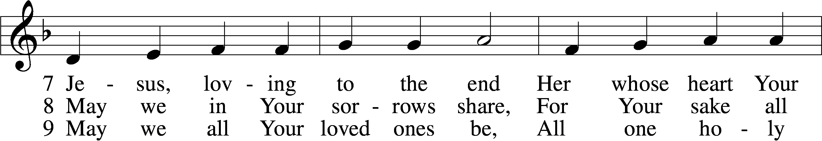
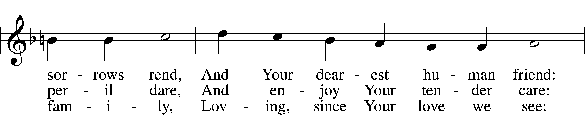
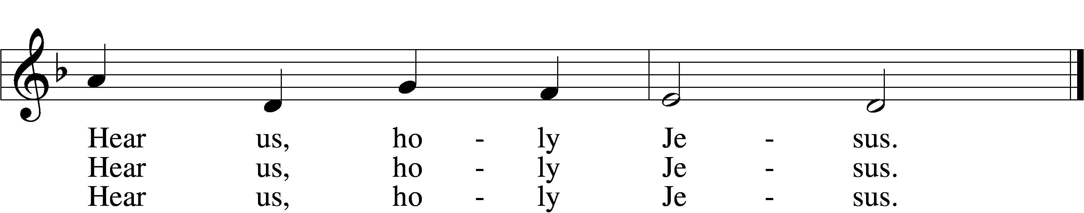
Tune: © 1941 Concordia Publishing House. Used by permission: LSB Hymn License no. 110005504
Text: Public domain

Lesson John 19:25–27
25but standing by the cross of Jesus were his mother and his mother’s sister, Mary the wife of Clopas, and Mary Magdalene. 26When Jesus saw his mother and the disciple whom he loved standing nearby, he said to his mother, “Woman, behold, your son!” 27Then he said to the disciple, “Behold, your mother!” And from that hour the disciple took her to his own home.

Responsory Jeremiah 17:14; Psalm 41:4b; 27:9
L Heal me, O Lord, and I shall be healed; save me, and I shall be saved, for You are my praise.
C Heal me, for I have sinned against You!

L You have been my help. Cast me not off; forsake me not, O God of my salvation!
C Heal me, for I have sinned against You!

855 For All the Faithful Women st. 8
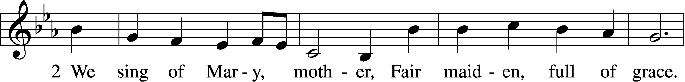
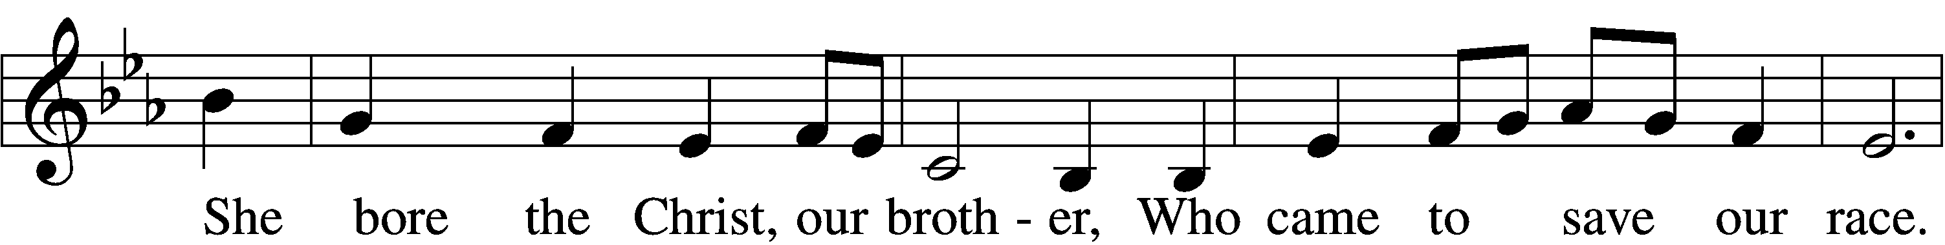
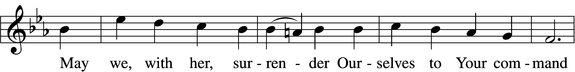
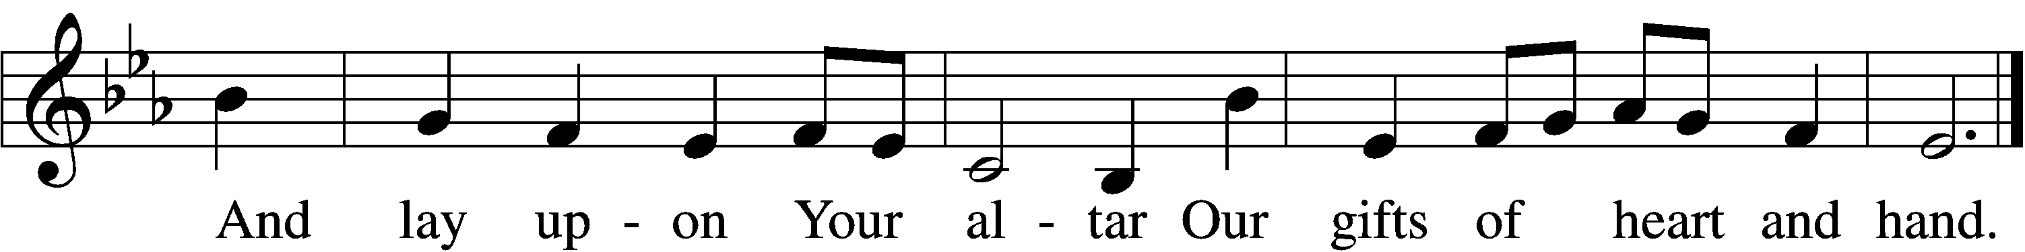
Text: © 1993, 1997, 2003 GIA Publications, Inc. Used by permission: LSB Hymn License no. 110005504
Tune: Public domain

Collect on the Third Word from the Cross
L O compassionate Lord Jesus Christ, we thank You for Your perfect obedience, which You rendered for us even to death on the cross. Grant us Your Holy Spirit, we pray, that He may write Your holy Law upon our hearts, so that, following Your example of love and obedience, we may honor and serve our parents, and, from the least to the greatest, may learn obedience and walk in Your footsteps. Let Your strength to be made perfect in our weakness; for You live and reign with the Father and the Holy Spirit, one God, now and forever.
C Amen.

Sit
The Fourth Word from the Cross

“My God, My God, why have You forsaken Me?” (Mark 15:34)

439 O Dearest Jesus, What Law Hast Thou Broken sts. 1–5
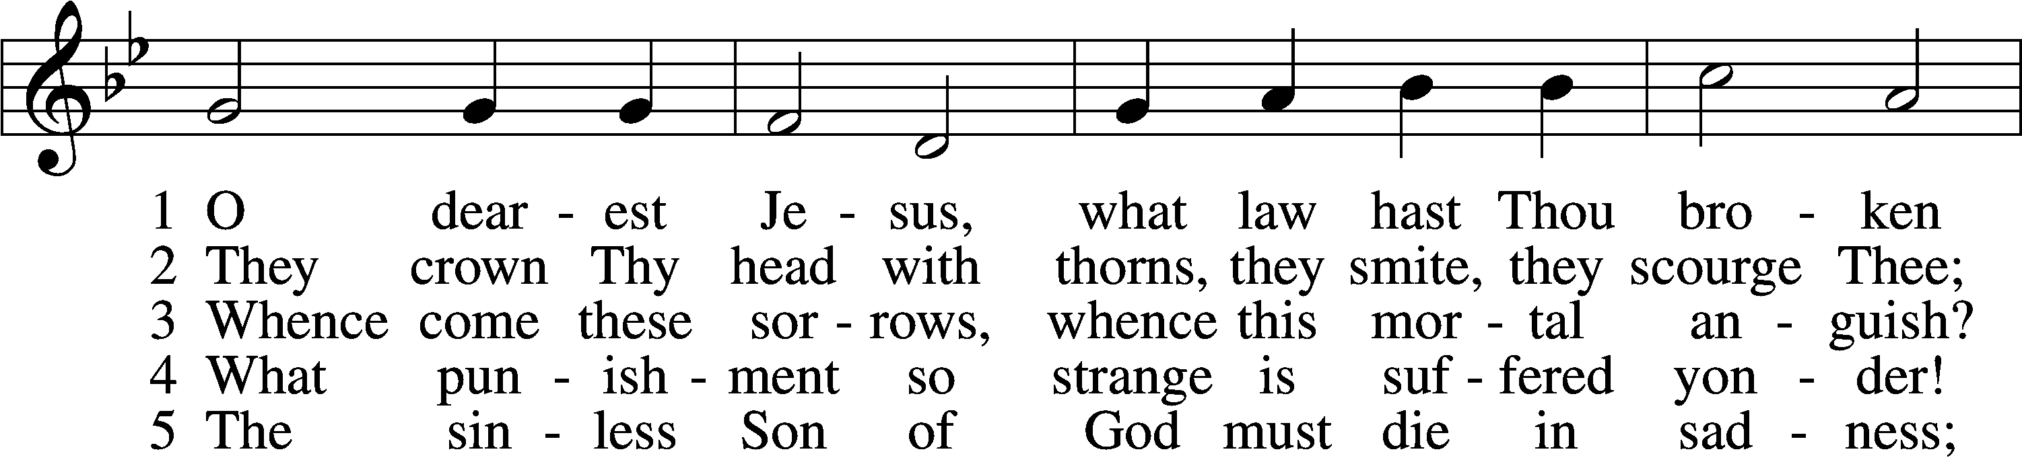
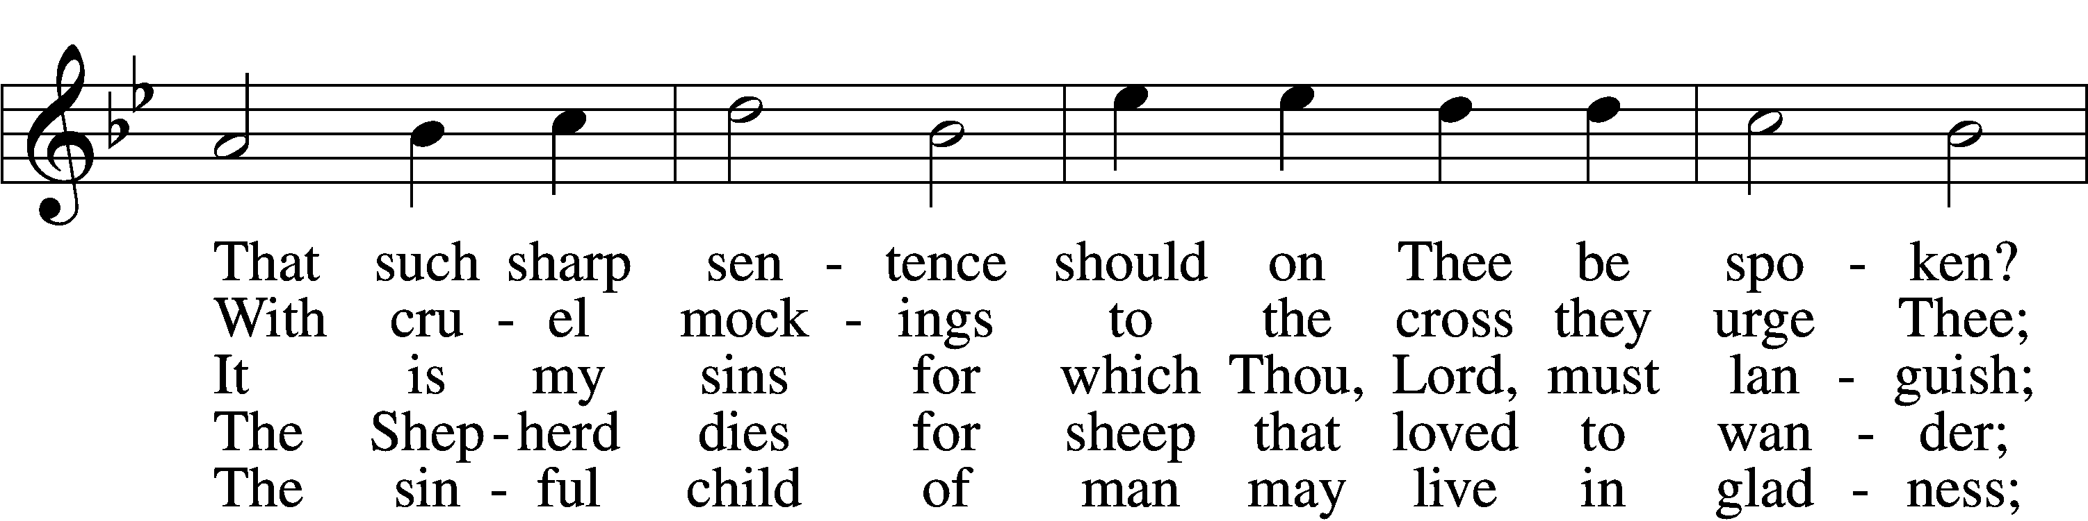
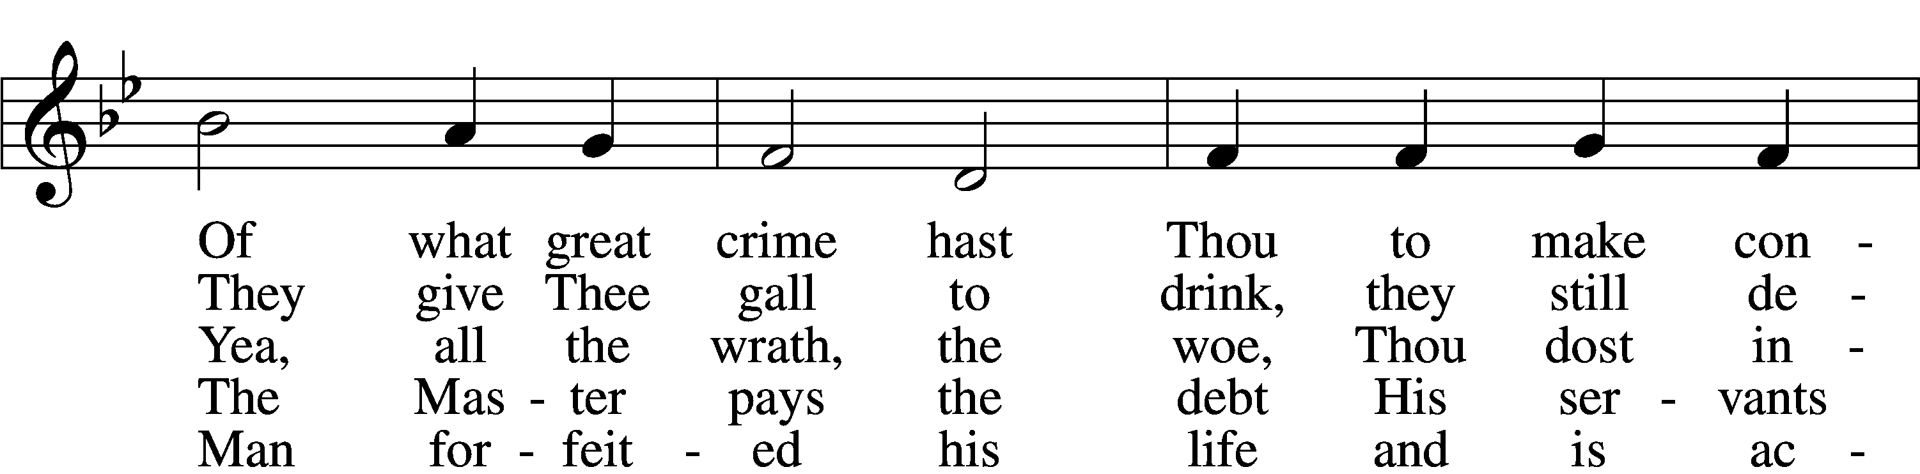
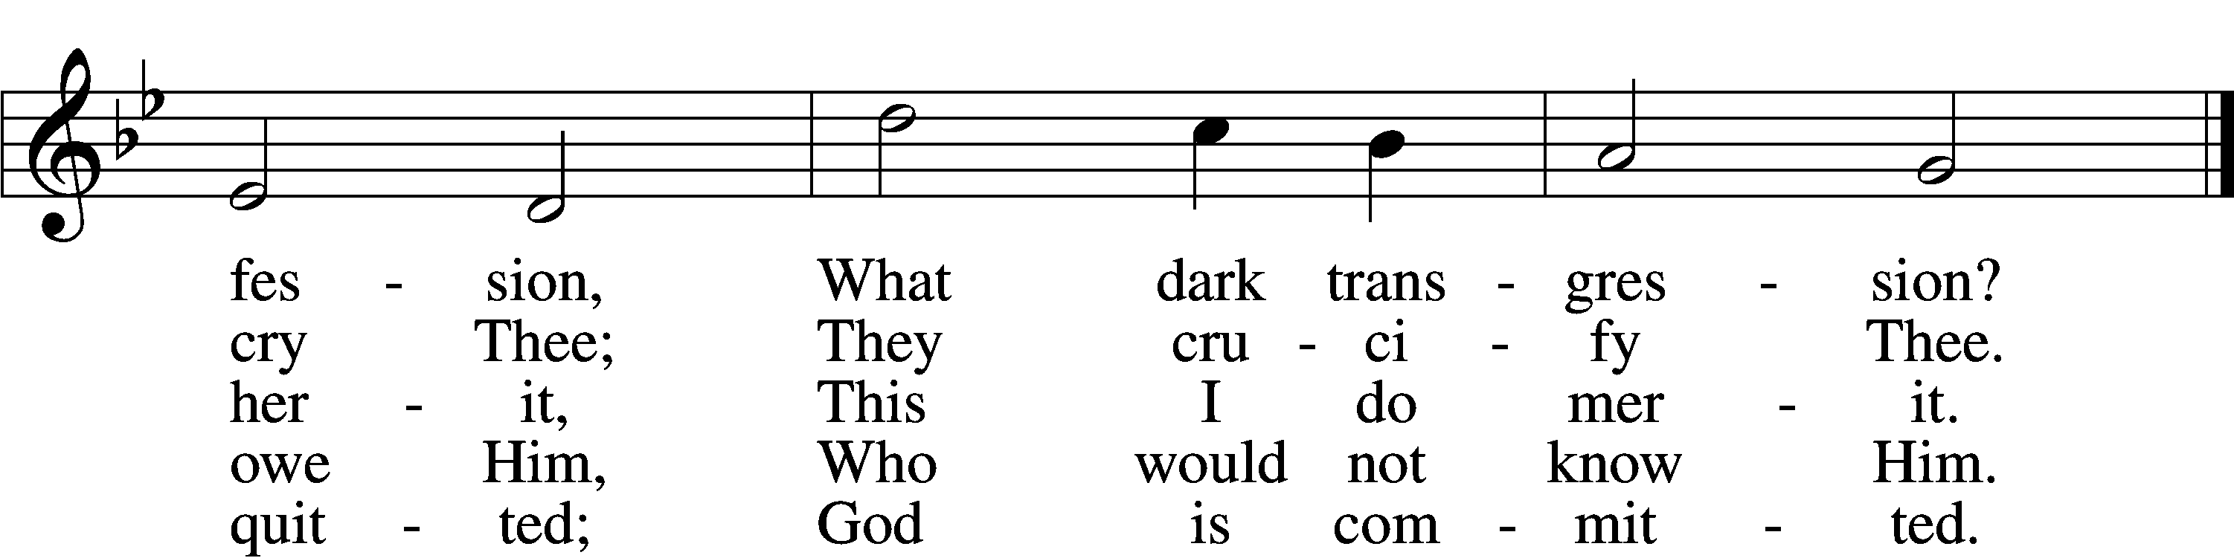
Text and tune: Public domain

Stand

Prayer
L O Lord Jesus Christ, Son of the Father and Savior of the world, hear us as with humble and adoring hearts we remember Your seven words of love spoken on this day from the cross. Draw us into closer communion with Your Spirit, that the mind that was in You may also be found in us. We remember the loneliness of that loud cry, which burst from Your overburdened heart, while the dread darkness lay upon the land: “My God, My God, why have You forsaken Me?” O Son of God, beloved of the Father, was ever sorrow like Your sorrow? You were despised and rejected by men, a man of sorrows and acquainted with grief. For our transgressions, You were wounded; for our iniquities, You were bruised; the chastisement of our peace was upon You, and with Your stripes we are healed. All we, like sheep, had gone astray. We had turned, every one to his own way, and God the Father laid on You the iniquity of us all. In thanksgiving for the depth and breadth of Your love for us, we worship and adore Your holy name.
C Amen.

Sit

Lesson Mark 15:29–34
29And those who passed by derided him, wagging their heads and saying, “Aha! You who would destroy the temple and rebuild it in three days, 30save yourself, and come down from the cross!” 31So also the chief priests with the scribes mocked him to one another, saying, “He saved others; he cannot save himself. 32Let the Christ, the King of Israel, come down now from the cross that we may see and believe.” Those who were crucified with him also reviled him.
33And when the sixth hour had come, there was darkness over the whole land until the ninth hour. 34And at the ninth hour Jesus cried with a loud voice, “Eloi, Eloi, lema sabachthani?” which means, “My God, my God, why have you forsaken me?”

422 On My Heart Imprint Your Image
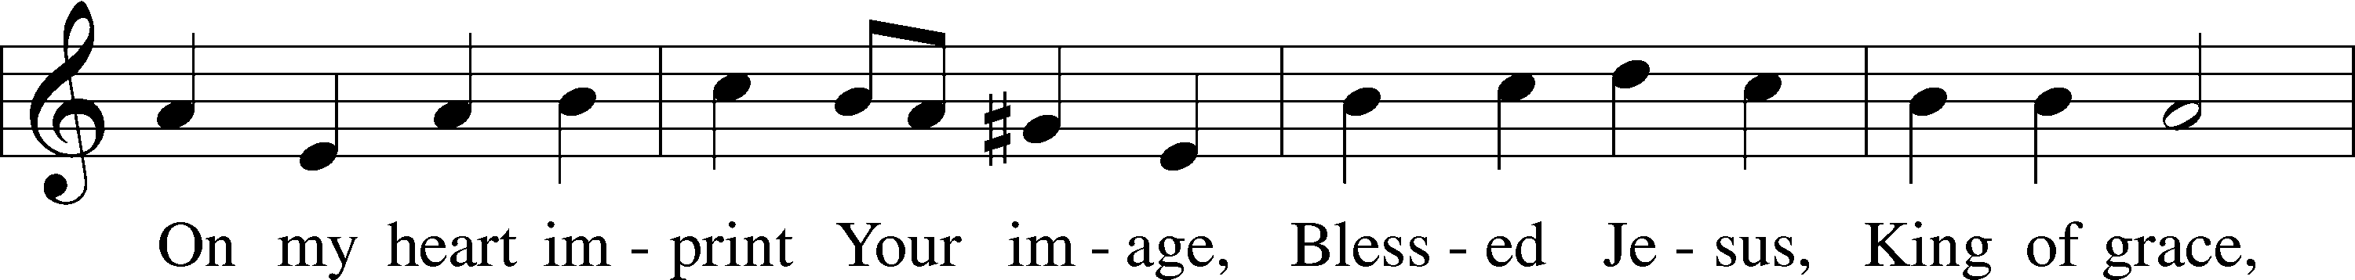
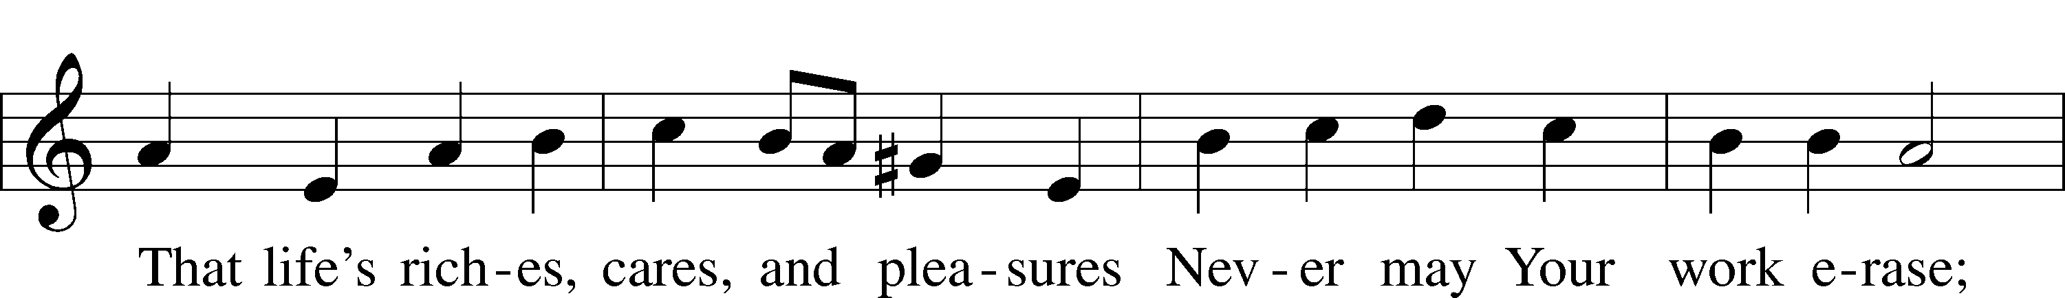
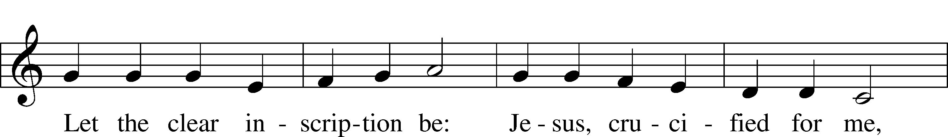
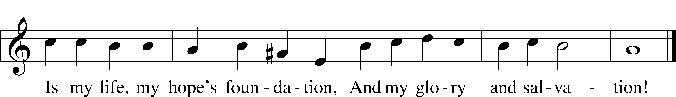
Text and tune: Public domain

Stand

Prayer
L Show us Your mercy, O Lord; grant us pardon and the remission of our sins:
C Have mercy on us.

L You came to save the world but were brought to judgment; when You come again to judge the living and the dead, do not deliver us up with the ungodly:
C Have mercy on us.

L You hung on the cross, bearing the death due to our guilt:
C Have mercy on us.

L You suffered once for the ungodly and die no more; put to death our sins and heal us by the wounds of the cross:
C Have mercy on us.

L Do not turn Your face from us, but remember us with pardon:
C Have mercy on us.

Collect on the Fourth Word from the Cross
L Lord Jesus Christ, Author and Finisher of our faith: You tread the winepress of God’s wrath alone and You were made a curse for us on the accursed tree, forsaken of God. Grant that our faith in You may never know doubt or change. Strengthen us in the sure knowledge and confidence that nothing shall separate us from the love of God in You and that, though Your Father hide His face from us in a little moment of wrath, we may never despair of His loving-kindness, for the sake of Your bitter agony; for You live and reign with the Father and the Holy Spirit, one God, now and forever.
C Amen.

Sit
The Fifth Word from the Cross

“I thirst.” (John 19:28)

435 Come to Calvary’s Holy Mountain
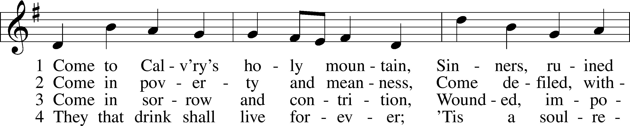
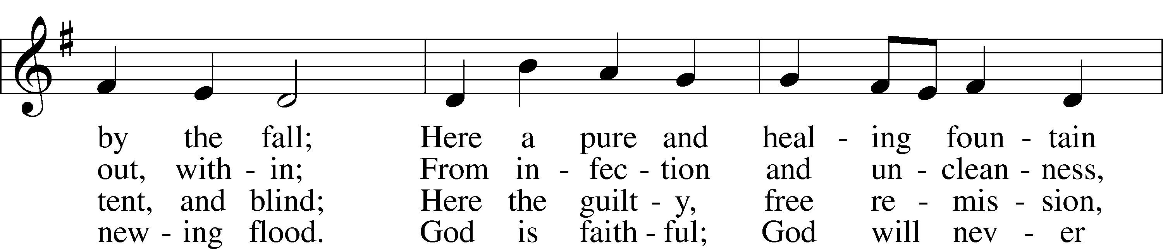
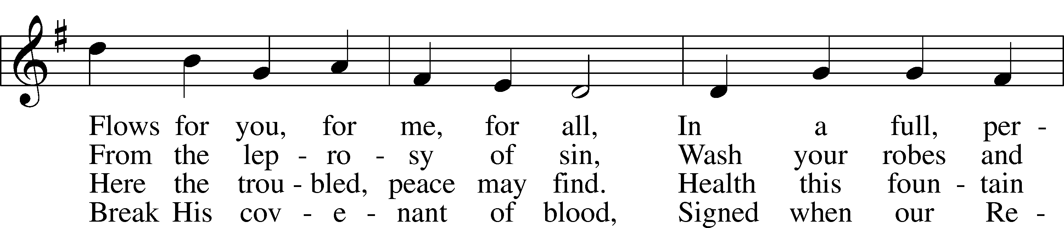
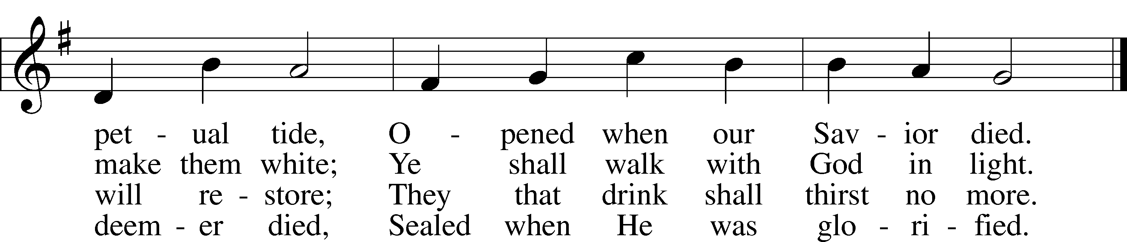
Text and tune: Public domain

Stand

Prayer
L O Lord Jesus Christ, Son of the Father and Savior of the world, hear us as with humble and adoring hearts we remember Your seven words of love spoken on this day from the cross. Draw us into closer communion with Your Spirit, that the mind that was in You may also be found in us. We remember how, in fulfillment of the Scriptures, You said, “I thirst.” Was it not written of You, “My strength is dried up like a potsherd, and My tongue sticks to my jaws; You lay Me in the dust of death” (Psalm 22:15)? Yet Your word endures. If anyone thirsts, let him come to Me and drink. O fount of life, who thirsts for the souls of all, my soul thirsts for You in a dry and thirsty land, where there is no water. In thanksgiving for the thirst that brings us to You, we worship You and adore Your holy name.
C Amen.

Sit

Lesson John 19:28
28After this, Jesus, knowing that all was now finished, said (to fulfill the Scripture), “I thirst.”

Responsory
L Heal me, O Lord, and I shall be healed; save me, and I shall be saved, for You are my praise.
C Heal my soul, for I have sinned against You.

L You have been my help. Cast me not off; forsake me not, O God of my salvation!
C Heal my soul, for I have sinned against You.

447 Jesus, in Your Dying Woes sts. 13–15
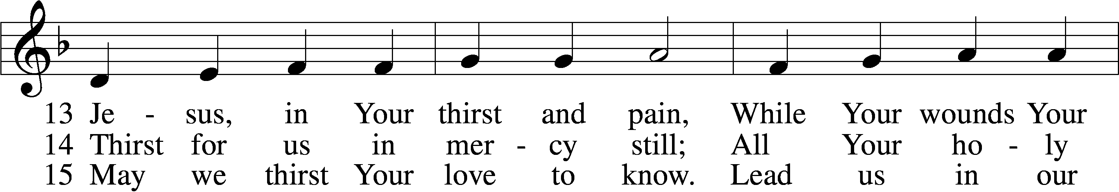
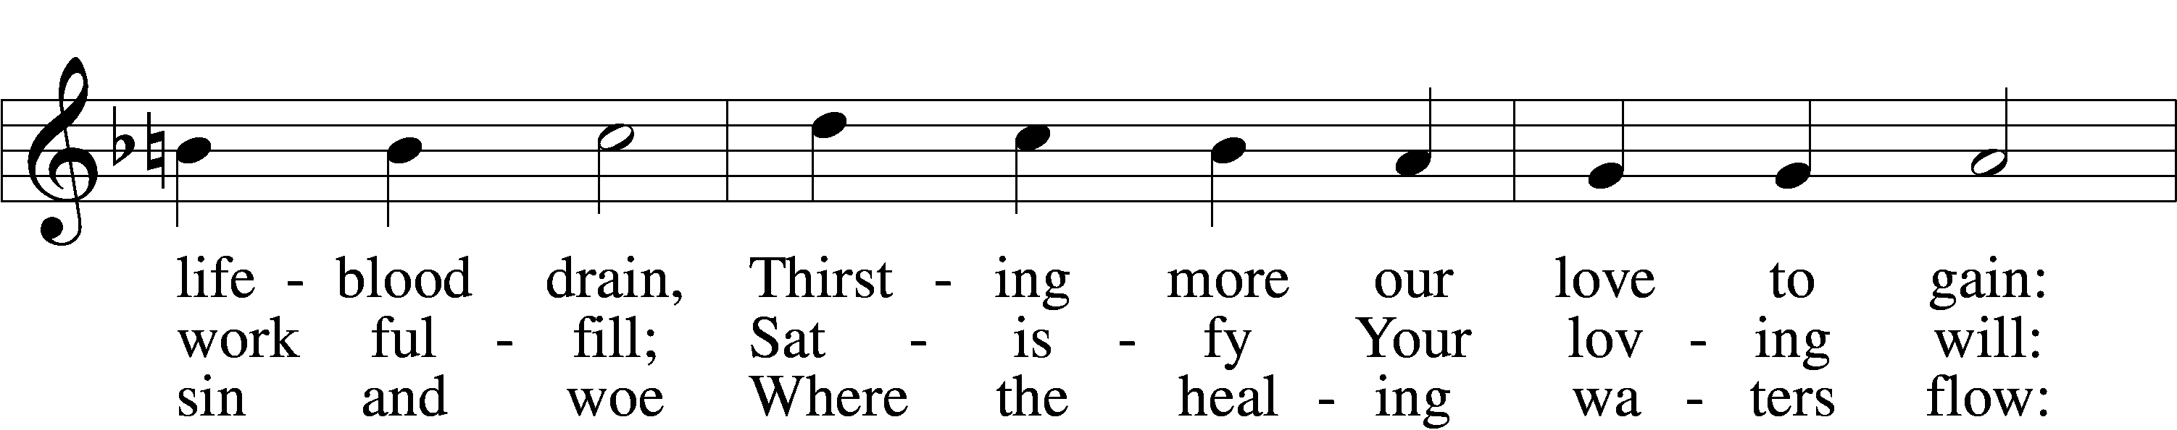
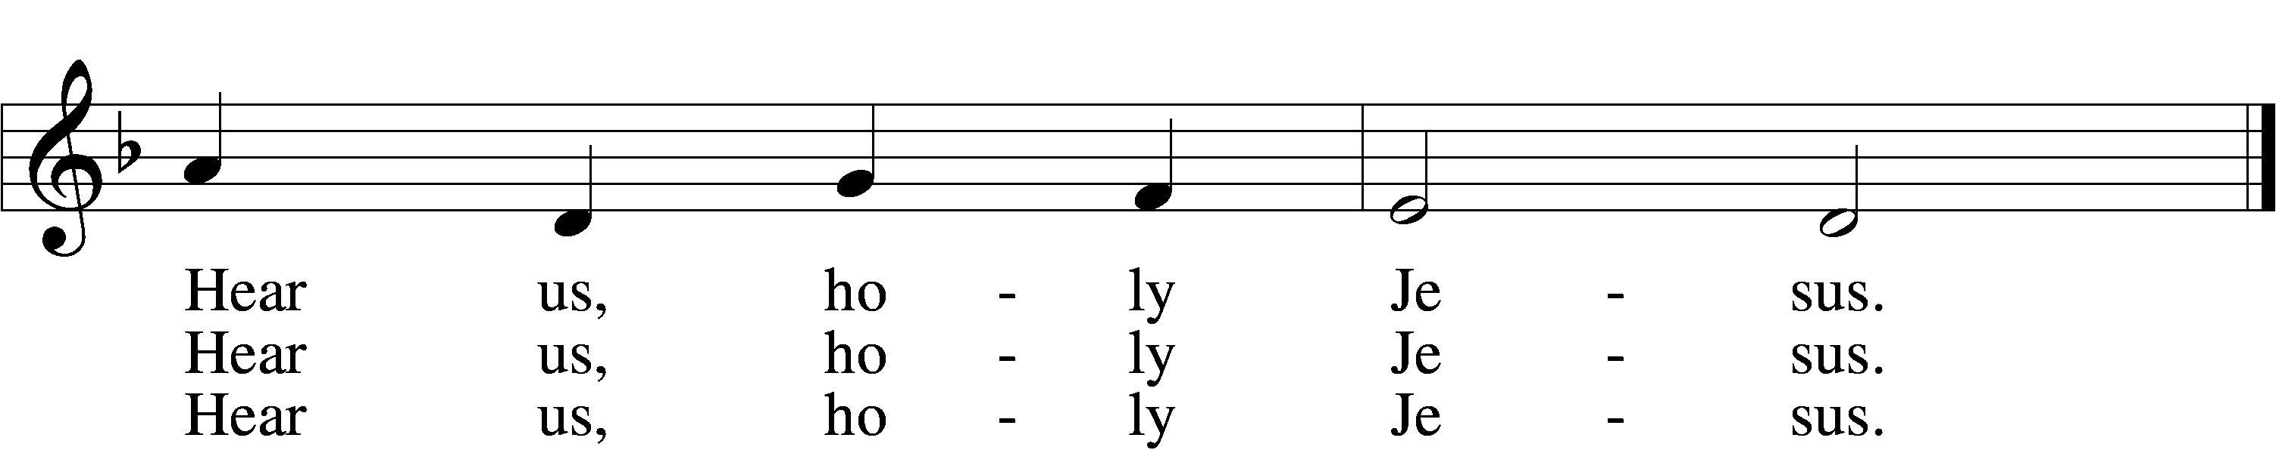
Tune: © 1941 Concordia Publishing House. Used by permission: LSB Hymn License no. 110005504
Text: Public domain

Prayer
L Turn away, O Lord, the fierceness of Your wrath, and in pity spare Your people.
C Have mercy on us.

L Grant a favorable and speedy answer to the prayers of all.
C Have mercy on us.

L O Christ, look on our groanings, loose the bands of death, and grant us life.
C Have mercy on us.

L Behold our tears, consider our sighs, and now at length in pity forgive our sins.
C Have mercy on us.

L Though none of us is worthy to be heard, O Christ, for Your own sake, help us.
C Have mercy on us.

The Sixth Word from the Cross

“It is finished.” (John 19:30)

Stand

Prayer
L O Lord Jesus Christ, Son of the Father and Savior of the world, hear us as with humble and adoring hearts we remember Your seven words of love spoken on this day from the cross. Draw us into closer communion with Your Spirit, that the mind that was in You may also be found in us. We remember the word that from Your lips alone was very truth: “It is finished.” O Alpha and Omega, the beginning and the end, the author and finisher of the faith, for the joy that was set before You, You endured the cross, despising the shame, and now are seated at the right hand of the throne of God. In thanksgiving for Your accomplishment of all that is needed for our salvation, we worship and adore Your holy name.
C Amen.
Sit

425 When I Survey the Wondrous Cross
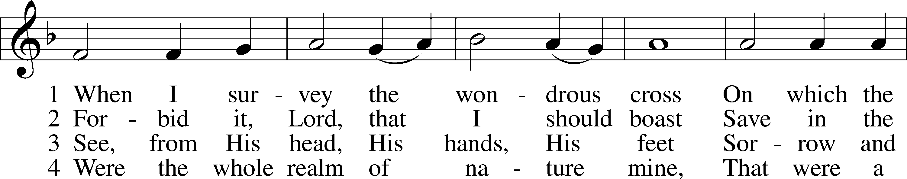
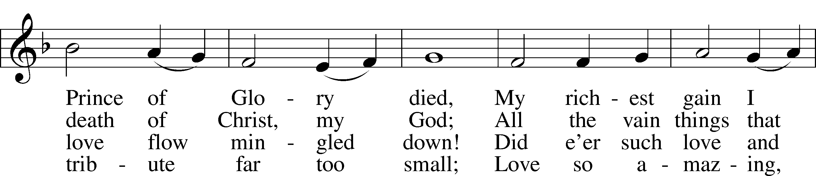
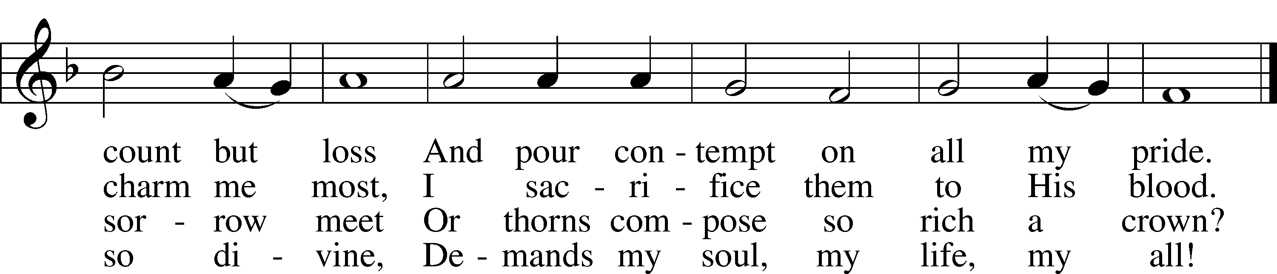
Text and tune: Public domain

Lesson John 19:29–30
29A jar full of sour wine stood there, so they put a sponge full of the sour wine on a hyssop branch and held it to his mouth. 30When Jesus had received the sour wine, he said, “It is finished,” and he bowed his head and gave up his spirit.

Responsory Isaiah 53:7; Psalm 76:2
L He was brought as a lamb to the slaughter. He was oppressed and He was afflicted, yet He opened not His mouth.
C He was delivered up to death that He might give life to His people.

L His abode has been established in Salem, His dwelling place in Zion.
C He was delivered up to death that He might give life to His people.

453 Upon the Cross Extended sts. 1–2, 5–7
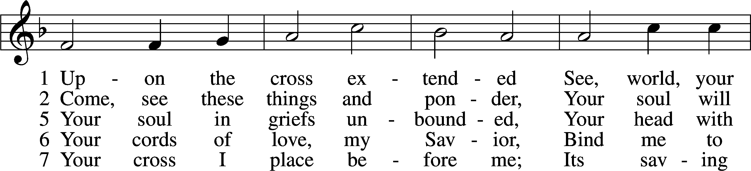
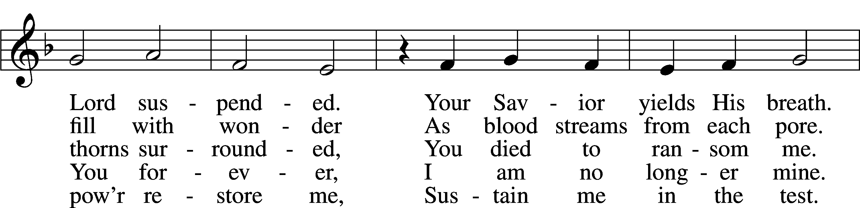
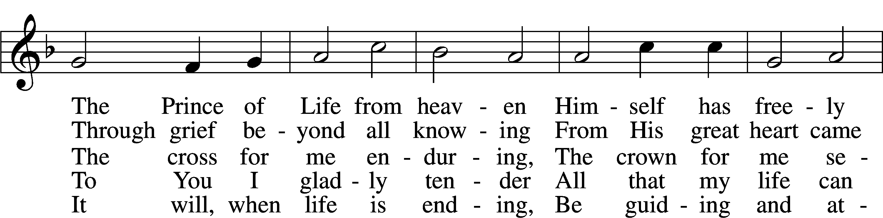
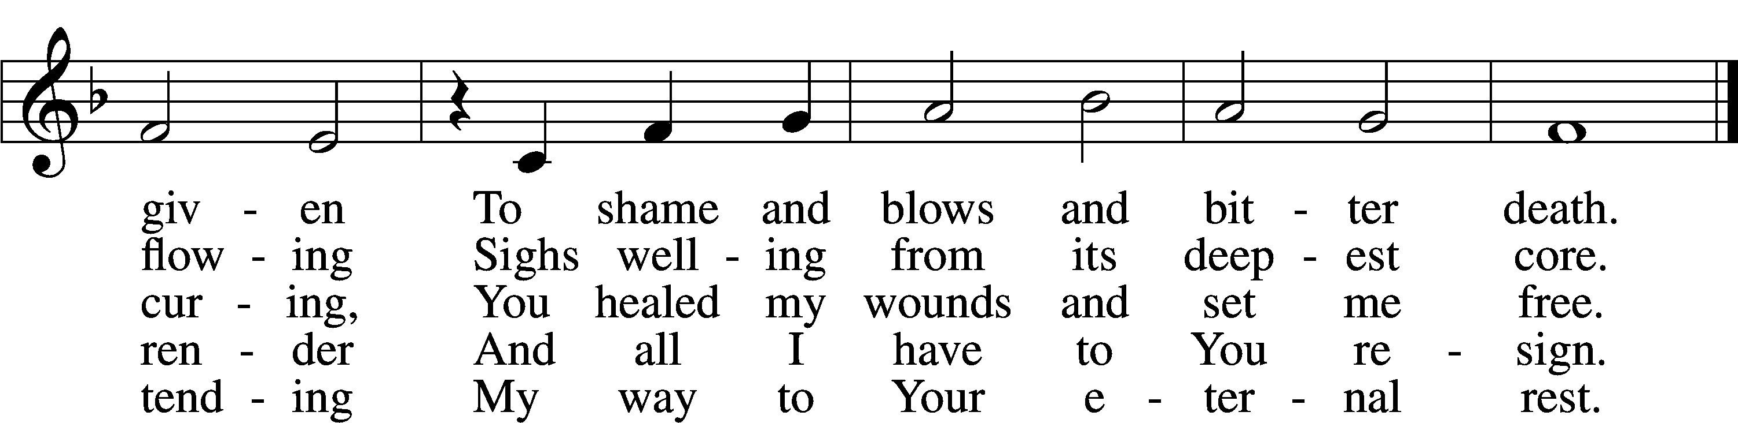
Text and tune: Public domain

Collect on the Sixth Word from the Cross
L Lord Jesus, on the cross You cried out, “It is finished.” We thank You that You completed the work Your Father gave You to do. You fulfilled the Law of God for us. You bore the curse of the Law in our place. You reconciled all people to God. Grant that we may with our whole heart believe this and may never rely on any merit of our own, but always trust in Your finished work on Calvary; for You live and reign with the Father and the Holy Spirit, one God, now and forever.
C Amen.
The Seventh Word from the Cross

“Father, into Your hands I commit My spirit!” (Luke 23:46)

Kneel/Stand

Repoaches Based on Micah 6:3–4; Jeremiah 2:6–7; Isaiah 5:2–4
L Thus says the Lord: What have I done to you, O My people, and wherein have I offended you? Answer Me. For I have raised you up out of the prison house of sin and death, and you have delivered up your Redeemer to be scourged. For I have redeemed you from the house of bondage, and you have nailed your Savior to the cross. O My people.
A Holy Lord God, holy and mighty God, holy and most merciful Redeemer; God eternal, leave us not to bitter death. O Lord, have mercy.

434 Lamb of God, Pure and Holy st. 1
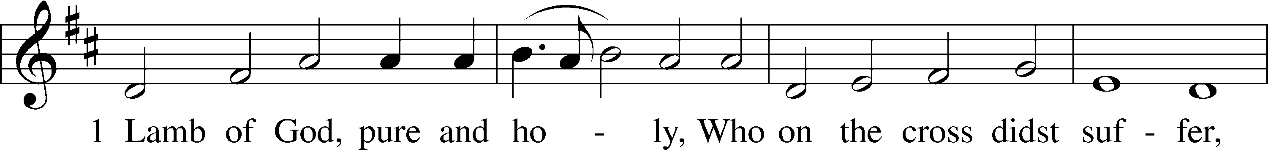
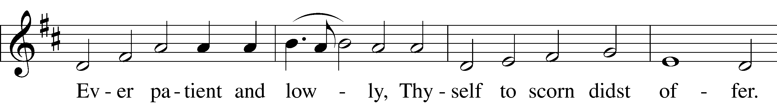
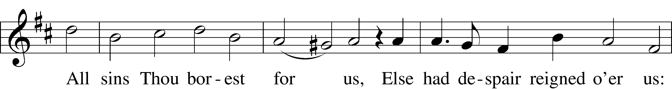
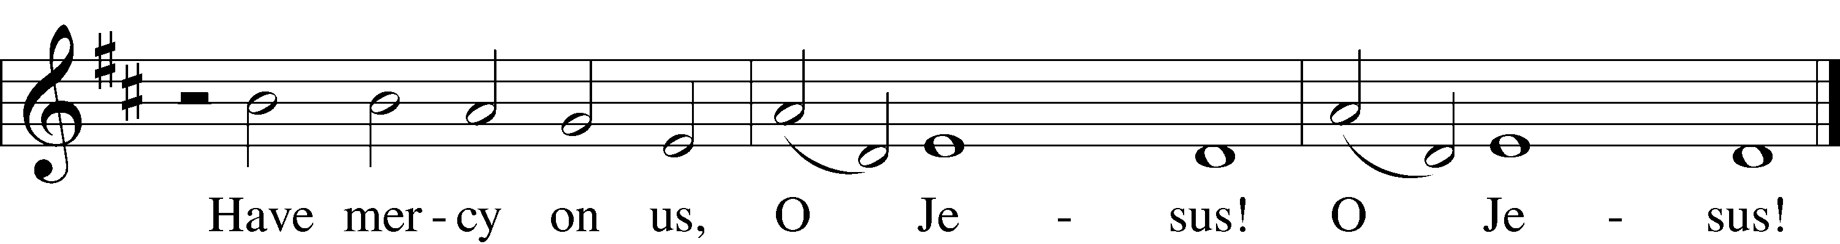
Tune and text: Public domain

L Thus says the Lord: What have I done to you, O My people, and wherein have I offended you? Answer Me. For I have conquered all your foes, and you have given Me over and delivered Me to those who persecute Me. For I have fed you with My Word and refreshed you with living water, and you have given Me gall and vinegar to drink. O My people.
A Holy Lord God, holy and mighty God, holy and most merciful Redeemer; God eternal, allow us not to lose hope in the face of death and hell. O Lord, have mercy.

434 Lamb of God, Pure and Holy st. 2
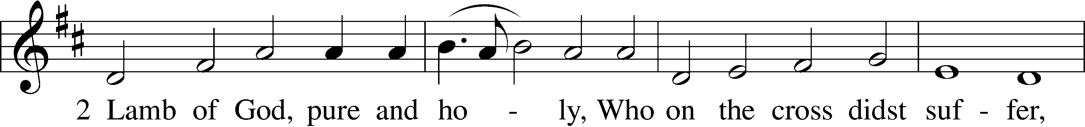
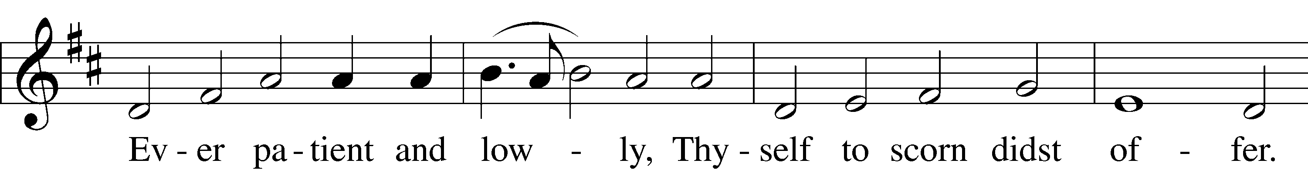
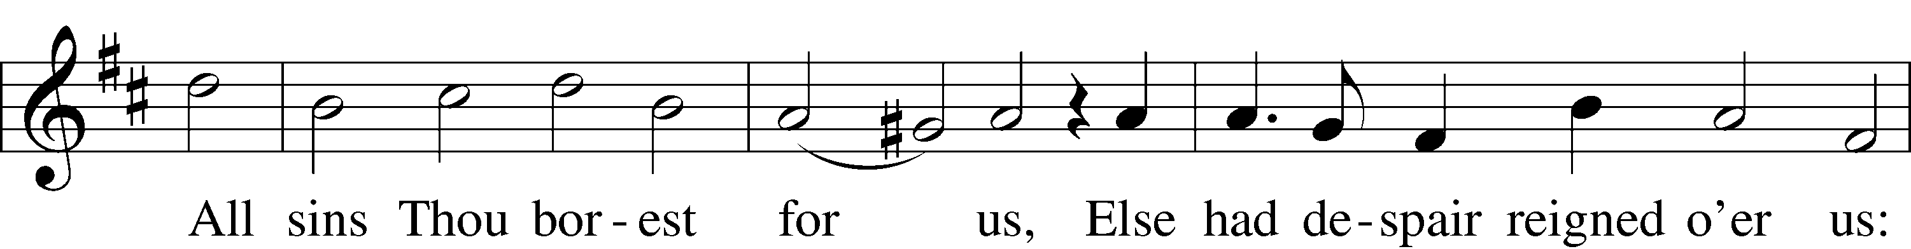
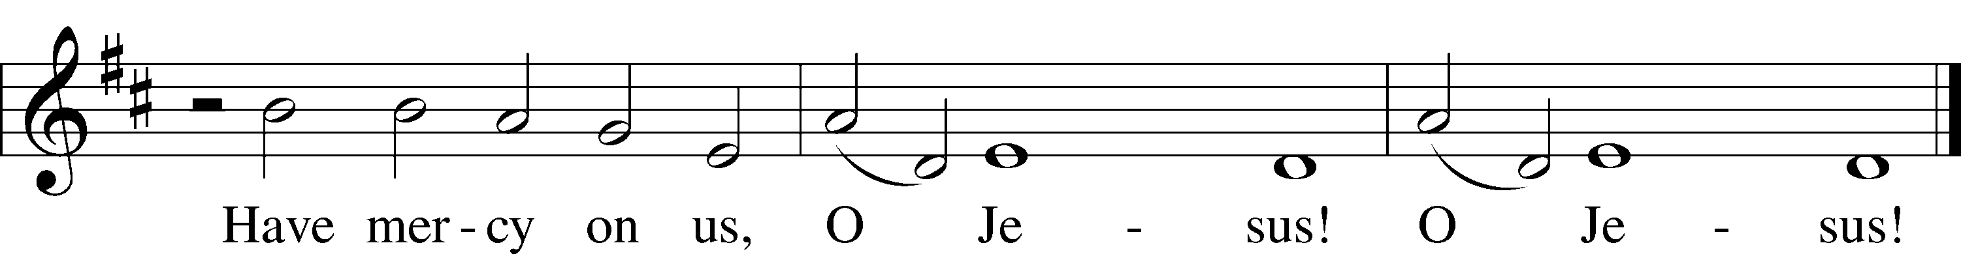
Tune and text: Public domain

L Thus says the Lord: What have I done to you, O My people, and wherein have I offended you? Answer Me. What more could have been done for My vineyard than I have done for it? When I looked for good grapes, why did it yield only bad? My people, is this how you thank your God? O My people.
A Holy Lord God, holy and mighty God, holy and most merciful Redeemer; God eternal, keep us steadfast in the true faith. O Lord, have mercy.

434 Lamb of God, Pure and Holy st. 3
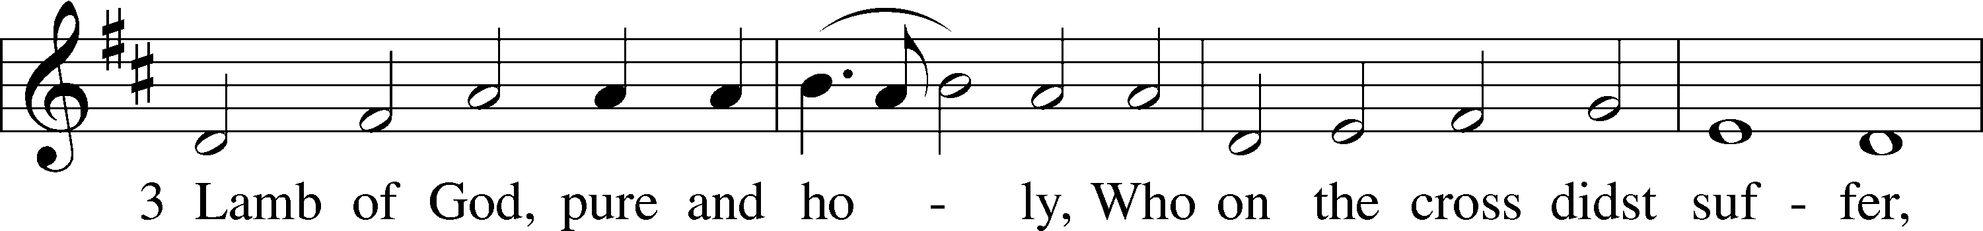
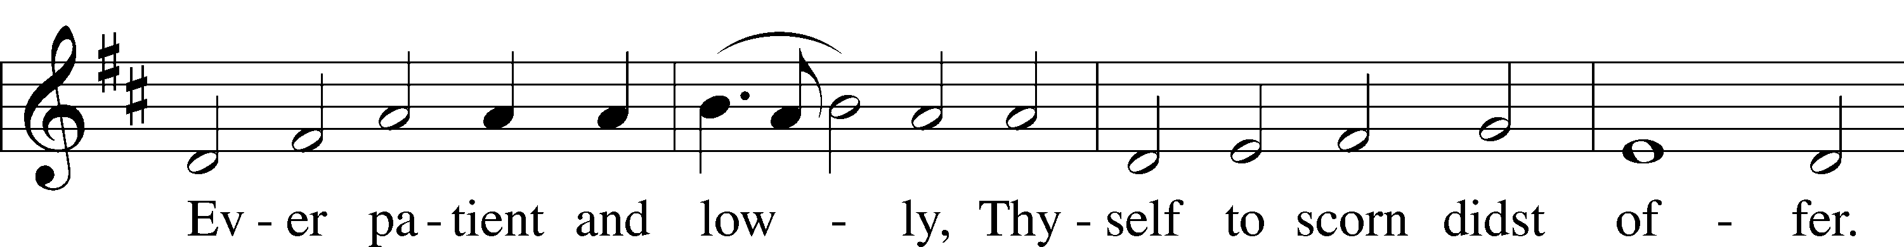
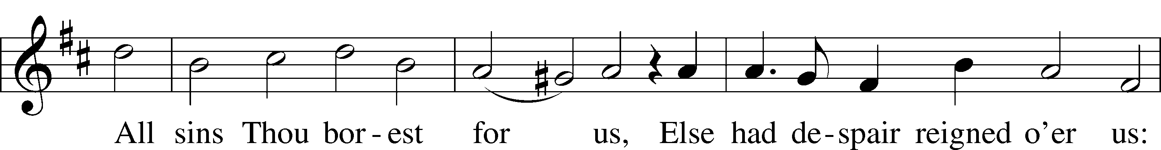
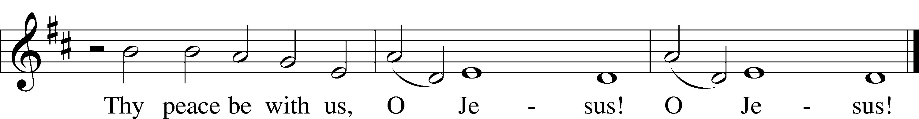
Tune and text: Public domain

Prayer
L Lord Jesus Christ, Son of the Father and Savior of the world, hear us as with humble and adoring hearts we remember Your seven words of love spoken on this day from the cross. Draw us into closer communion with Your Spirit, that the mind that was in You may also be found in us. We remember that when You had cried with a loud voice, You said, “Father, into Your hands I commit My spirit!” Then, bowing Your head, You breathed Your last. O Savior of the world, whom have I in heaven but You? And there is nothing upon earth that I desire besides You. My flesh and my heart may fail, but God is the strength of my heart and my portion forever. Into Your hands I commit my spirit; You have redeemed me, O Lord, faithful God. In thanksgiving for Your life, given on the cross for our redemption, we worship and adore Your holy name.
C Amen.

Sit

Lesson Luke 23:44–46
44It was now about the sixth hour, and there was darkness over the whole land until the ninth hour, 45while the sun’s light failed. And the curtain of the temple was torn in two. 46Then Jesus, calling out with a loud voice, said, “Father, into your hands I commit my spirit!” And having said this he breathed his last.

Series Hymn: “Behold! The Lamb of God,” John Said
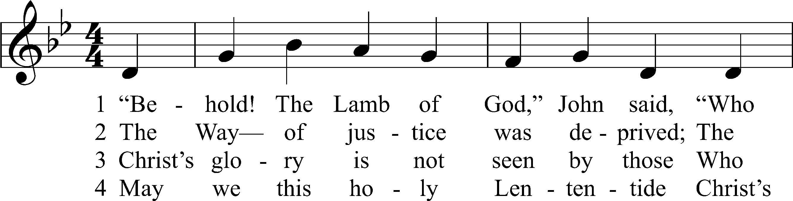
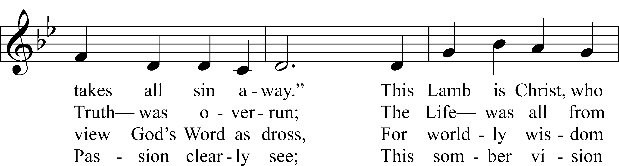
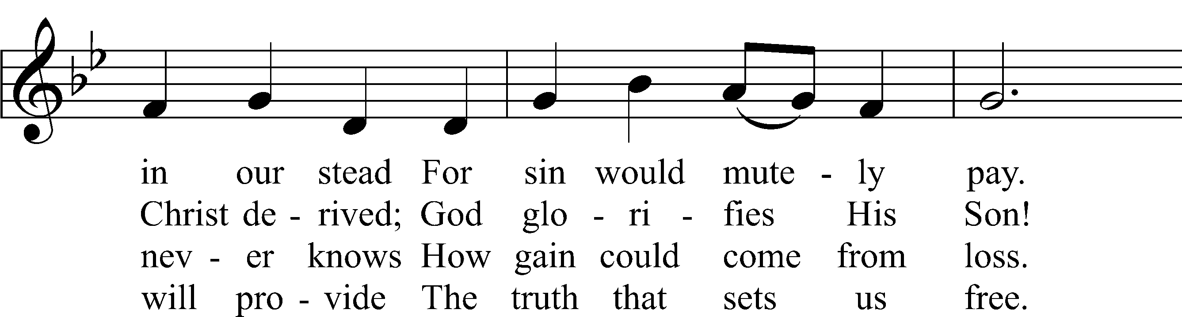
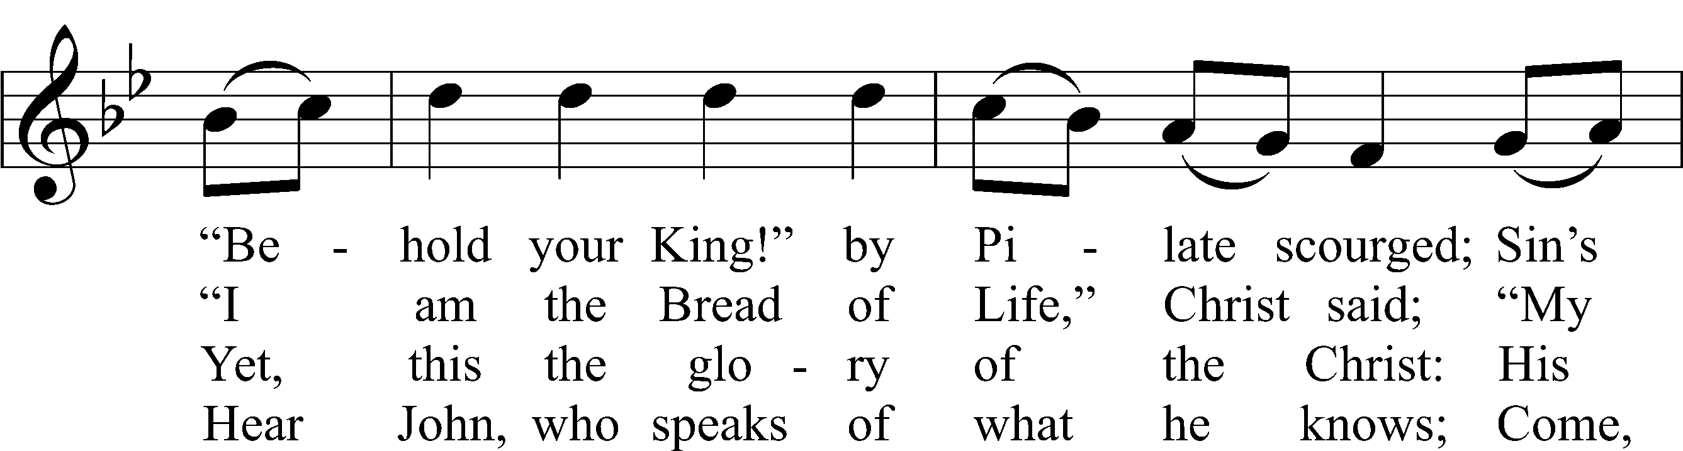
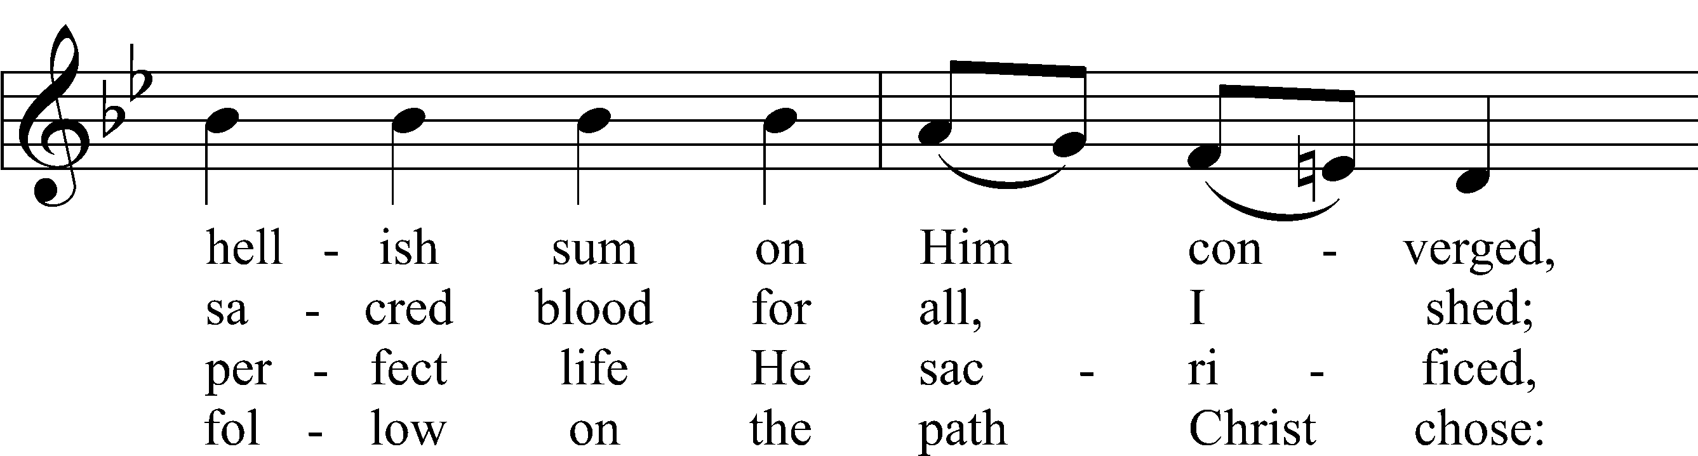
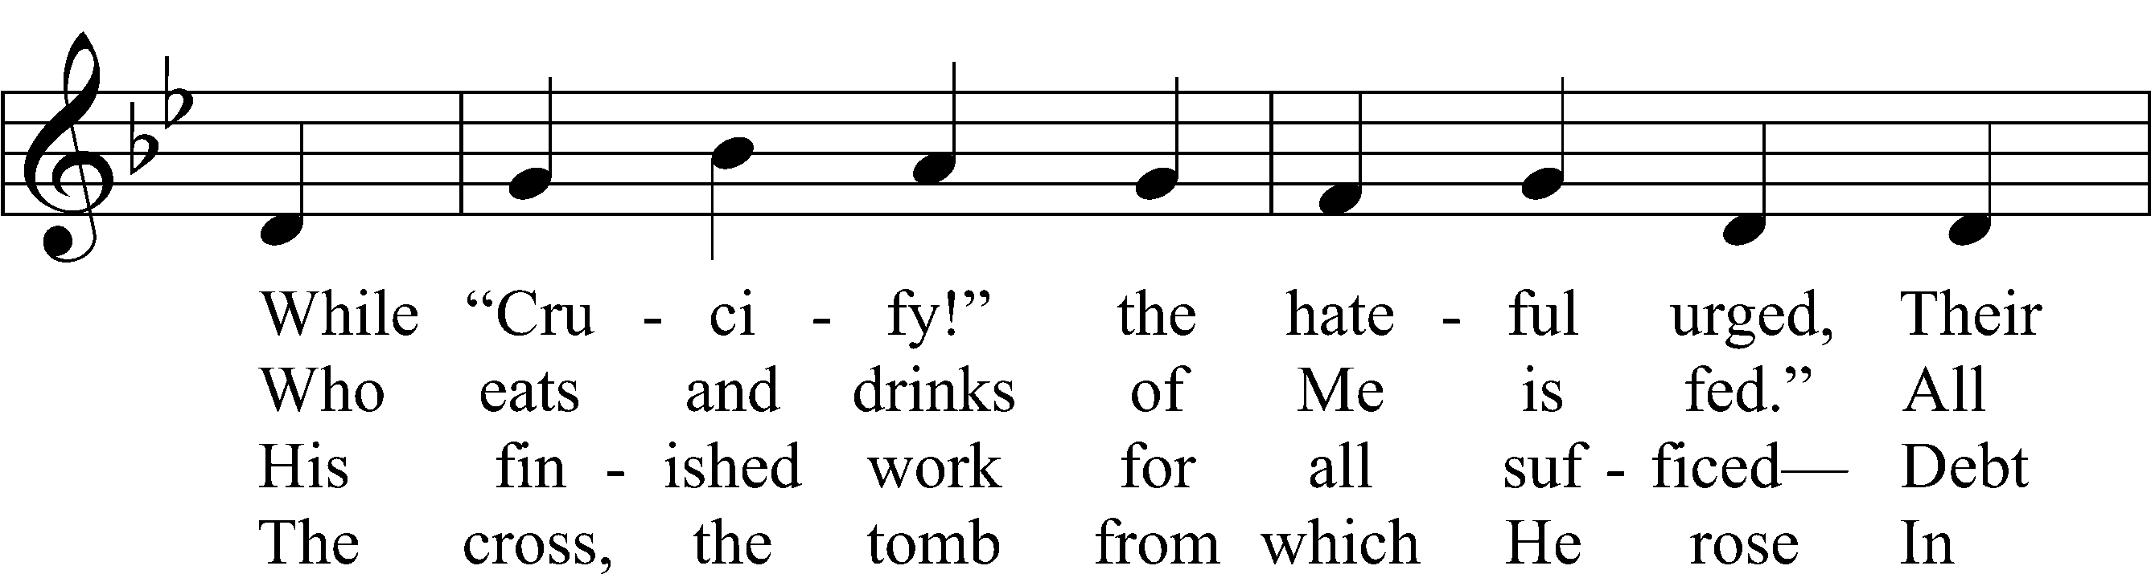
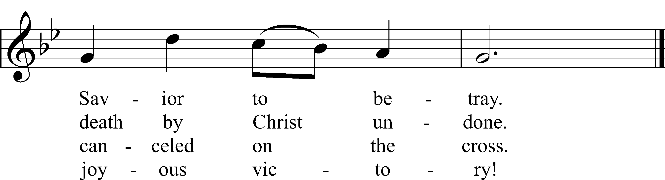
Text and text and text and text and text and text and text and text and text: Stephen P. Starke
Tune and tune and tune and tune and tune and tune and tune and tune and tune: John L. Bell
Text: © 2021 Stephen P. Starke, admin. Concordia Publishing House. Used by permission: CPH Lent License no. 110005504
Tune: © 1988, 1997 Wild Goose Resource Group, Iona Community, Scotland, admin. GIA Publications, Inc. Used by permission: CPH Lent License no. 110005504

Sermon

Kneel/Stand

Kyrie
L Lord, have mercy.
C Christ, have mercy.
L Lord, have mercy.

Lord’s Prayer
C Our Father who art in heaven,
hallowed be Thy name,
Thy kingdom come,
Thy will be done on earth
as it is in heaven;
give us this day our daily bread;
and forgive us our trespasses
as we forgive those
who trespass against us;
and lead us not into temptation,
but deliver us from evil.
For Thine is the kingdom
and the power and the glory
forever and ever. Amen.

Collect for Good Friday
L Almighty God, we ask You to look with mercy on Your family, for whom our Lord Jesus Christ was willing to be betrayed and to be given over to the hands of sinners and to suffer death on the cross; who lives and reigns with You and the Holy Spirit, one God, forever and ever.
C Amen.

454 Sing, My Tongue, the Glorious Battle
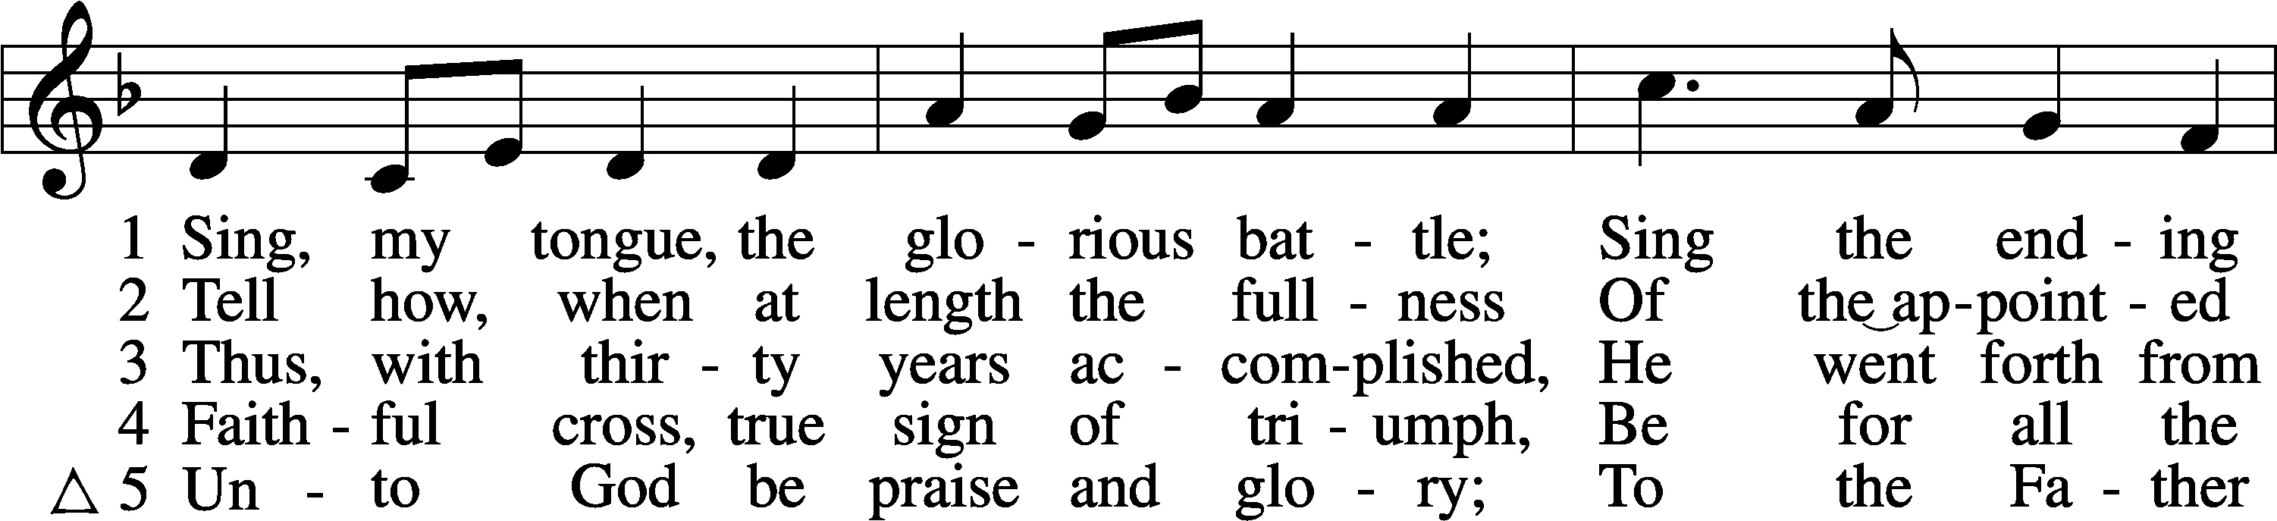
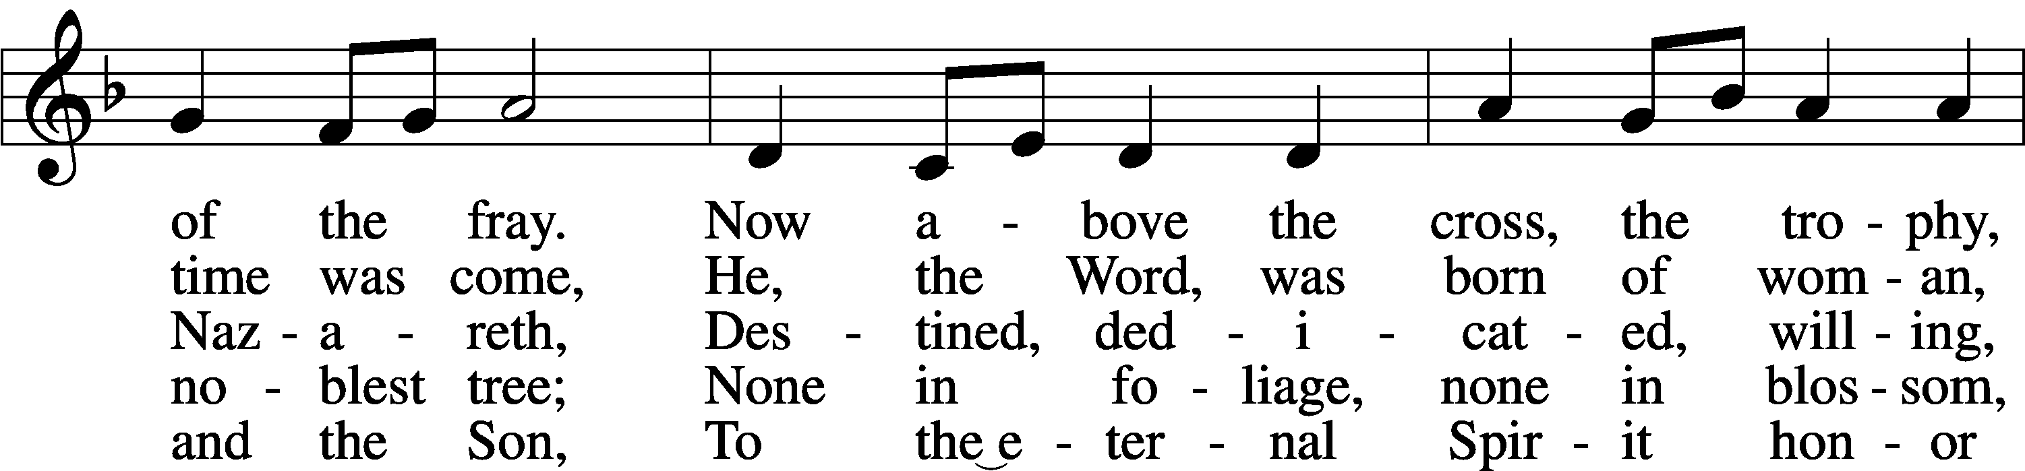
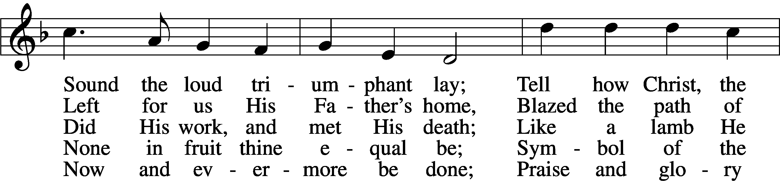
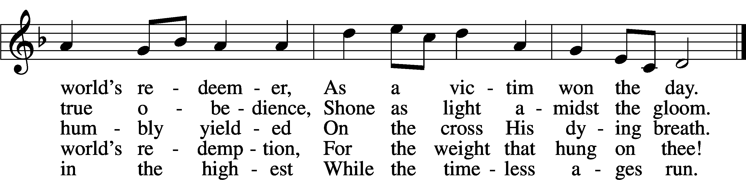
Text: Public domain
Tune: © 1967 Concordia Publishing House. Used by permission: LSB Hymn License no. 110005504

You are invited to remain in silent prayer after the service. Please leave the church in silence.

Acknowledgments
Unless otherwise indicated, Scripture quotations are from the ESV® Bible (The Holy Bible, English Standard Version®), copyright © 2001 by Crossway, a publishing ministry of Good News Publishers. Used by permission. All rights reserved.
Created by Lutheran Service Builder © 2021 Concordia Publishing House.

