Thanksgiving Day Worship
Salem Lutheran Church
9:00 AM
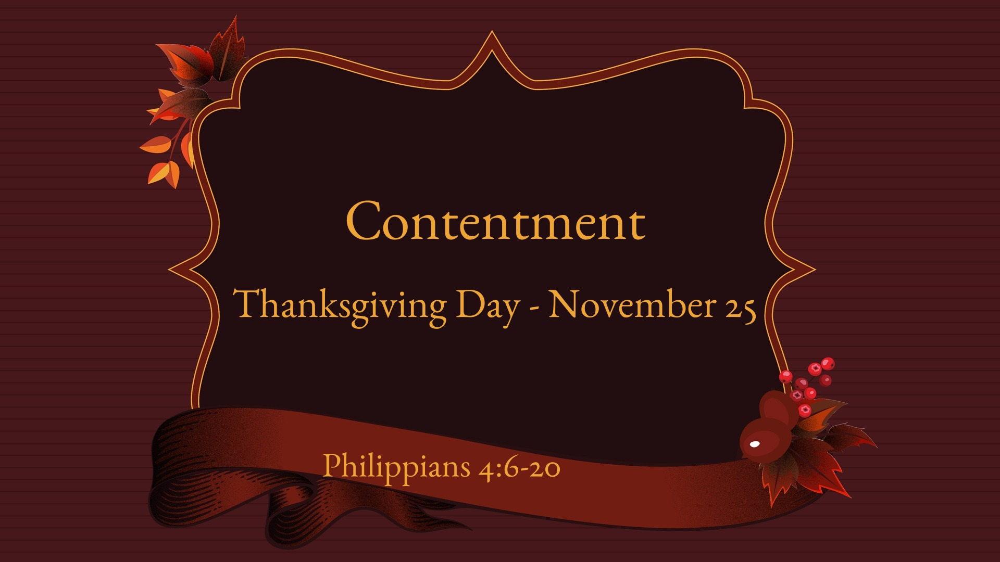

Hymn: Come, Ye Thankful People, Come LSB 892
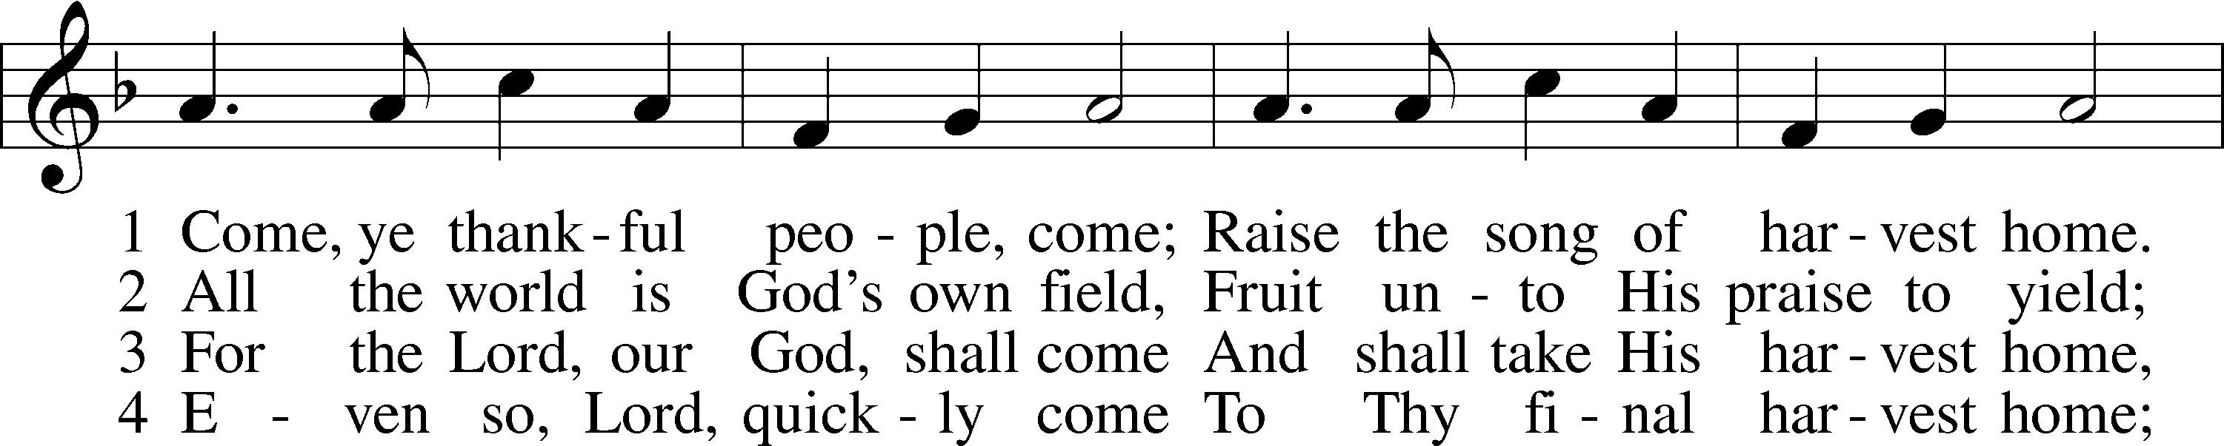
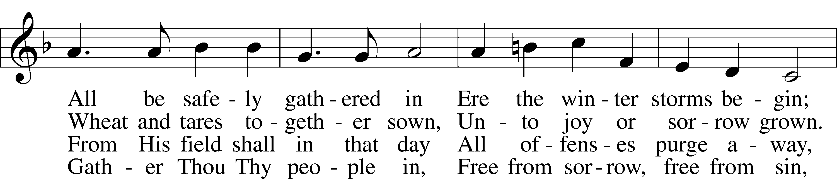
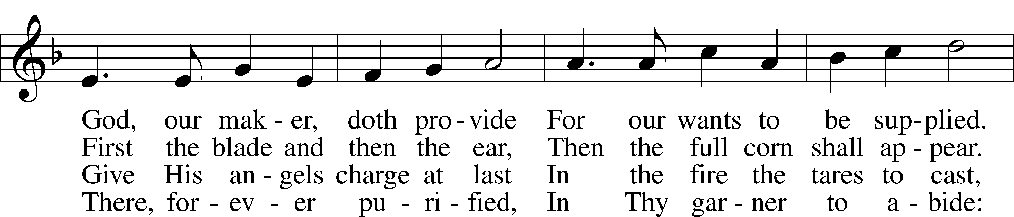
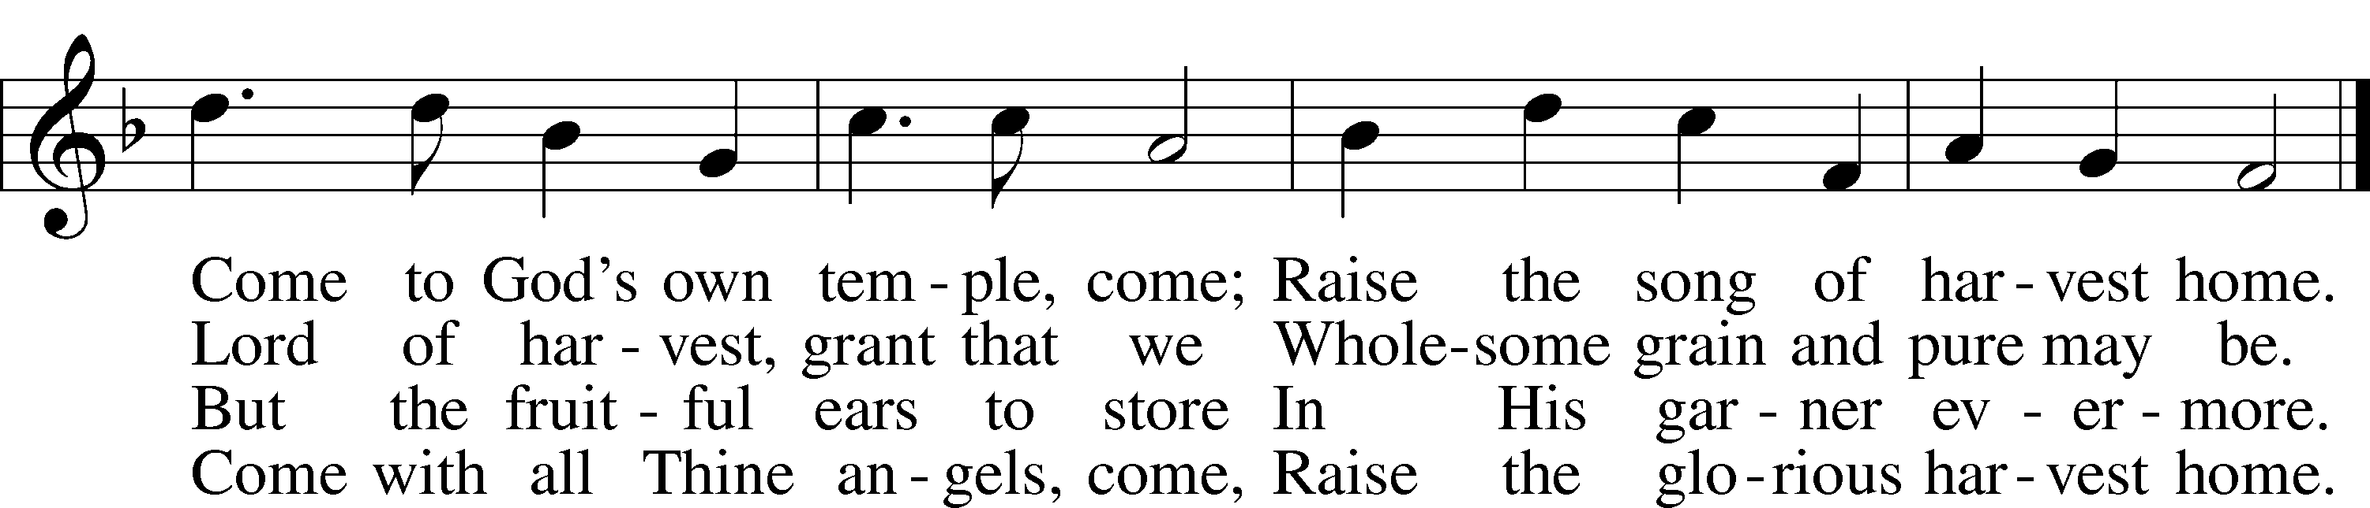
Tune and text: Public domain

Invocation
L In the name of the Father and of the T Son and of the Holy Spirit.
C Amen.

L Oh give thanks to the Lord, for He is good,
C His steadfast love endures forever!

L He forgives all your sins.
C His steadfast love endures forever!

L He redeems your life from the pit.
C His steadfast love endures forever!

L Every good and perfect gift comes from the Lord.
C His steadfast love endures forever!

Psalmody Psalm 67
Make Your Face Shine upon Us
1May God be gracious to us and bless us
and make his face to shine upon us,
2that your way may be known on earth,
your saving power among all nations.
3Let the peoples praise you, O God;
let all the peoples praise you!
4Let the nations be glad and sing for joy,
for you judge the peoples with equity
and guide the nations upon earth.
5Let the peoples praise you, O God;
let all the peoples praise you!
6The earth has yielded its increase;
God, our God, shall bless us.
7God shall bless us;
let all the ends of the earth fear him!

Gloria Patri LSB 186
C Glory be to the Father and to the Son and to the Holy Ghost;
as it was in the beginning, is now, and ever shall be, world without end. Amen.

Hymn: For the Fruits of His Creation LSB 894
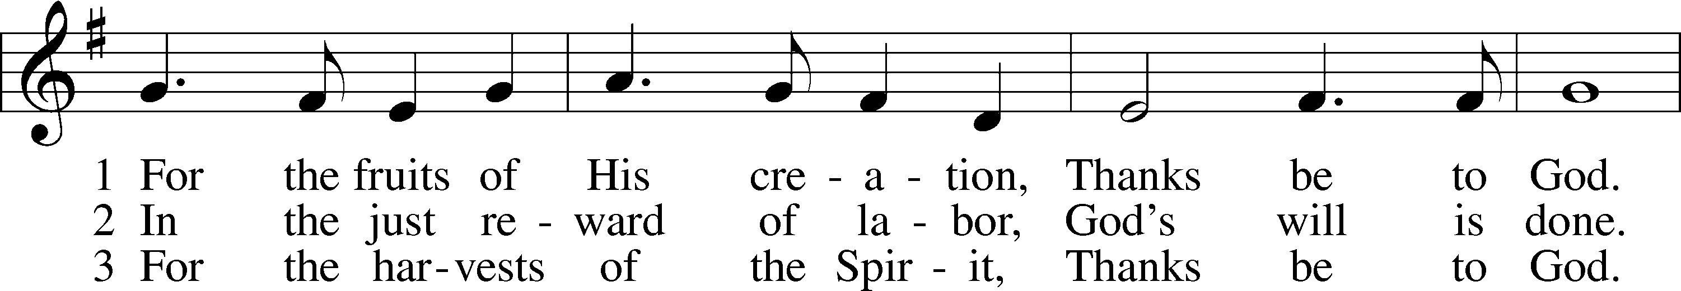
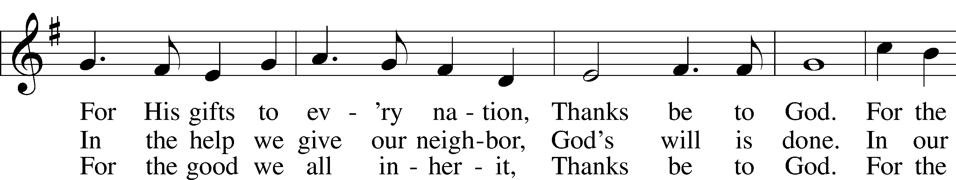
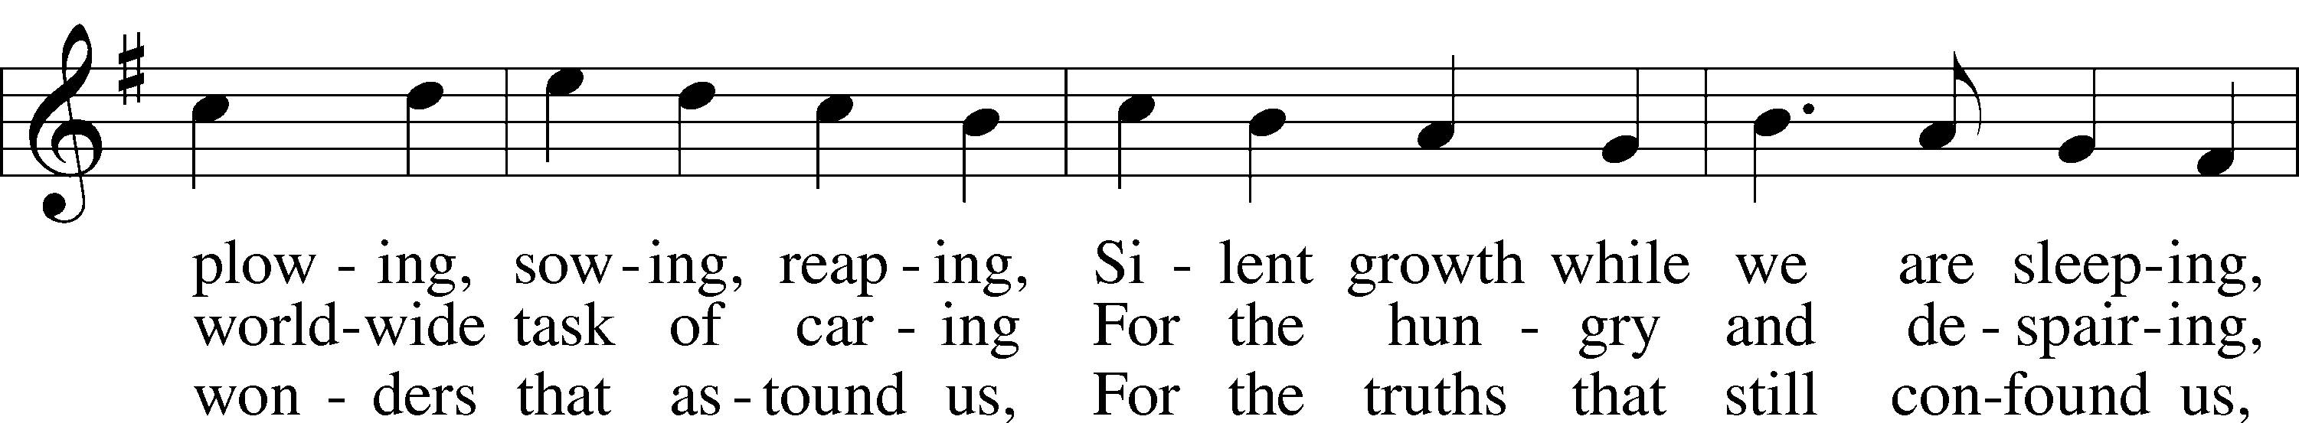
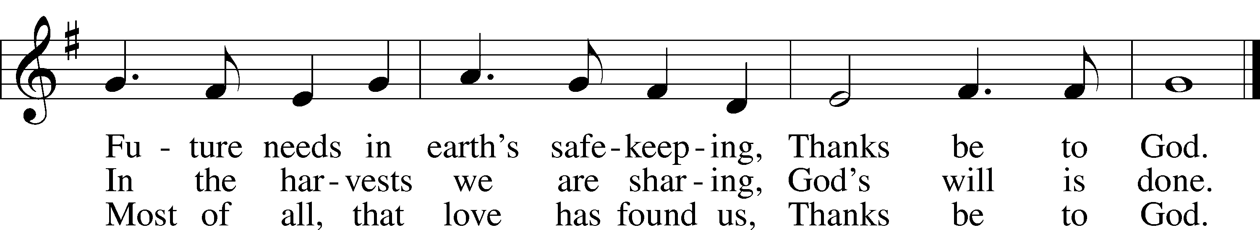
Text: © 1970 Hope Publishing Co. Used by permission: LSB Hymn License no. 110005504
Tune: Public domain

Scripture Reading Deuteronomy 8:1–10
Remember the Lord Your God
1“The whole commandment that I command you today you shall be careful to do, that you may live and multiply, and go in and possess the land that the Lord swore to give to your fathers. 2And you shall remember the whole way that the Lord your God has led you these forty years in the wilderness, that he might humble you, testing you to know what was in your heart, whether you would keep his commandments or not. 3And he humbled you and let you hunger and fed you with manna, which you did not know, nor did your fathers know, that he might make you know that man does not live by bread alone, but man lives by every word that comes from the mouth of the Lord. 4Your clothing did not wear out on you and your foot did not swell these forty years. 5Know then in your heart that, as a man disciplines his son, the Lord your God disciplines you. 6So you shall keep the commandments of the Lord your God by walking in his ways and by fearing him. 7For the Lord your God is bringing you into a good land, a land of brooks of water, of fountains and springs, flowing out in the valleys and hills, 8a land of wheat and barley, of vines and fig trees and pomegranates, a land of olive trees and honey, 9a land in which you will eat bread without scarcity, in which you will lack nothing, a land whose stones are iron, and out of whose hills you can dig copper. 10And you shall eat and be full, and you shall bless the Lord your God for the good land he has given you.”

A This is the Word of the Lord.
C Thanks be to God.

Reading Philippians 4:6–20
6Do not be anxious about anything, but in everything by prayer and supplication with thanksgiving let your requests be made known to God. 7And the peace of God, which surpasses all understanding, will guard your hearts and your minds in Christ Jesus.
8Finally, brothers, whatever is true, whatever is honorable, whatever is just, whatever is pure, whatever is lovely, whatever is commendable, if there is any excellence, if there is anything worthy of praise, think about these things. 9What you have learned and received and heard and seen in me—practice these things, and the God of peace will be with you.
God’s Provision
10I rejoiced in the Lord greatly that now at length you have revived your concern for me. You were indeed concerned for me, but you had no opportunity. 11Not that I am speaking of being in need, for I have learned in whatever situation I am to be content. 12I know how to be brought low, and I know how to abound. In any and every circumstance, I have learned the secret of facing plenty and hunger, abundance and need. 13I can do all things through him who strengthens me.
14Yet it was kind of you to share my trouble. 15And you Philippians yourselves know that in the beginning of the gospel, when I left Macedonia, no church entered into partnership with me in giving and receiving, except you only. 16Even in Thessalonica you sent me help for my needs once and again. 17Not that I seek the gift, but I seek the fruit that increases to your credit. 18I have received full payment, and more. I am well supplied, having received from Epaphroditus the gifts you sent, a fragrant offering, a sacrifice acceptable and pleasing to God. 19And my God will supply every need of yours according to his riches in glory in Christ Jesus. 20To our God and Father be glory forever and ever. Amen.

A This is the Word of the Lord.
C Thanks be to God.

Reading Luke 17:11–19
Jesus Cleanses Ten Lepers
11On the way to Jerusalem [Jesus] was passing along between Samaria and Galilee. 12And as he entered a village, he was met by ten lepers, who stood at a distance 13and lifted up their voices, saying, “Jesus, Master, have mercy on us.” 14When he saw them he said to them, “Go and show yourselves to the priests.” And as they went they were cleansed. 15Then one of them, when he saw that he was healed, turned back, praising God with a loud voice; 16and he fell on his face at Jesus’ feet, giving him thanks. Now he was a Samaritan. 17Then Jesus answered, “Were not ten cleansed? Where are the nine? 18Was no one found to return and give praise to God except this foreigner?” 19And he said to him, “Rise and go your way; your faith has made you well.”

A This is the Word of the Lord.
C Thanks be to God.

Hymn: Now Thank We All Our God LSB 895
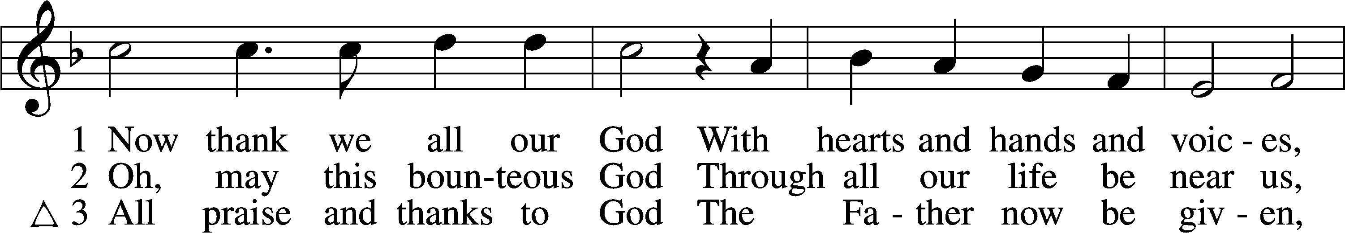
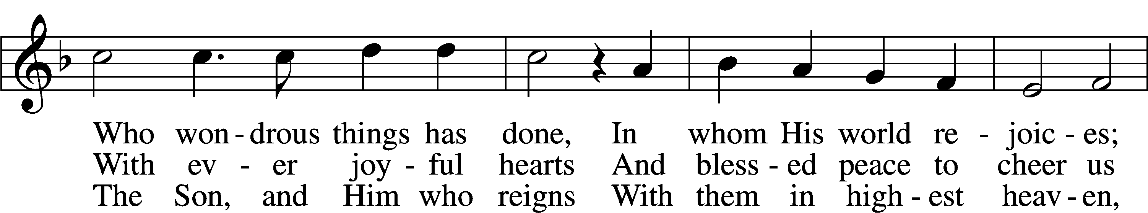
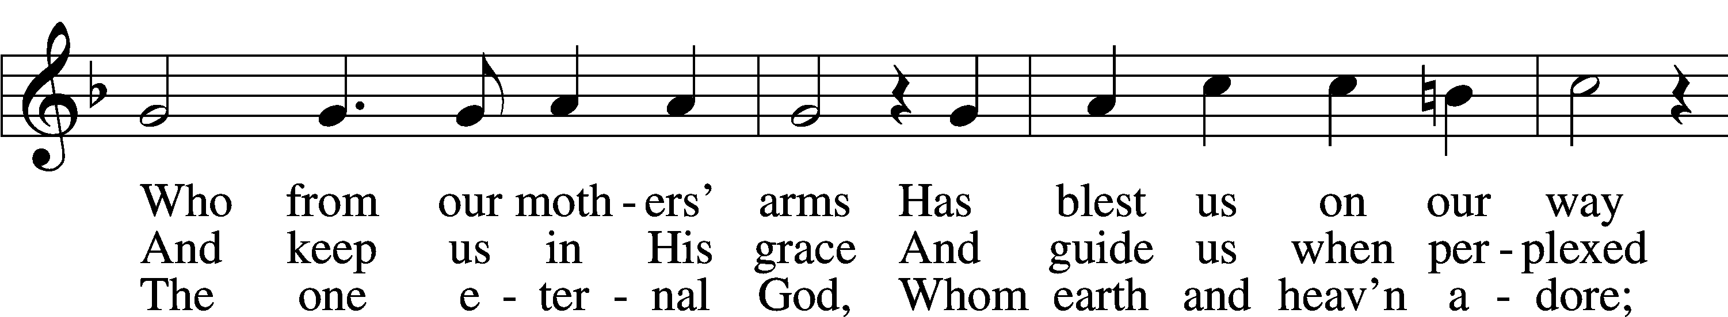
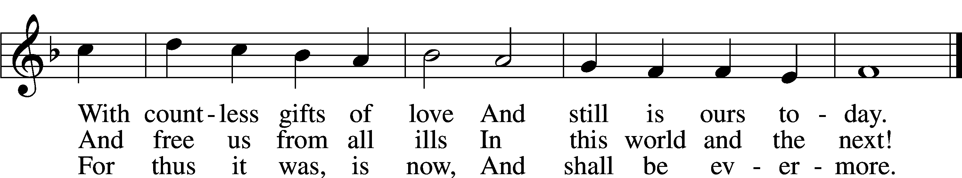
Text and tune: Public domain

Message

Apostles’ Creed
C I believe in God, the Father Almighty, maker of heaven and earth.

And in Jesus Christ, His only Son, our Lord, who was conceived by the Holy Spirit, born of the virgin Mary, suffered under Pontius Pilate, was crucified, died and was buried. He descended into hell. The third day He rose again from the dead. He ascended into heaven and sits at the right hand of God the Father Almighty. From thence He will come to judge the living and the dead.

I believe in the Holy Spirit, the holy Christian Church, the communion of saints, the forgiveness of sins, the resurrection of the body, and the life T everlasting. Amen.

Offering

Hymn: We Give Thee But Thine Own LSB 781
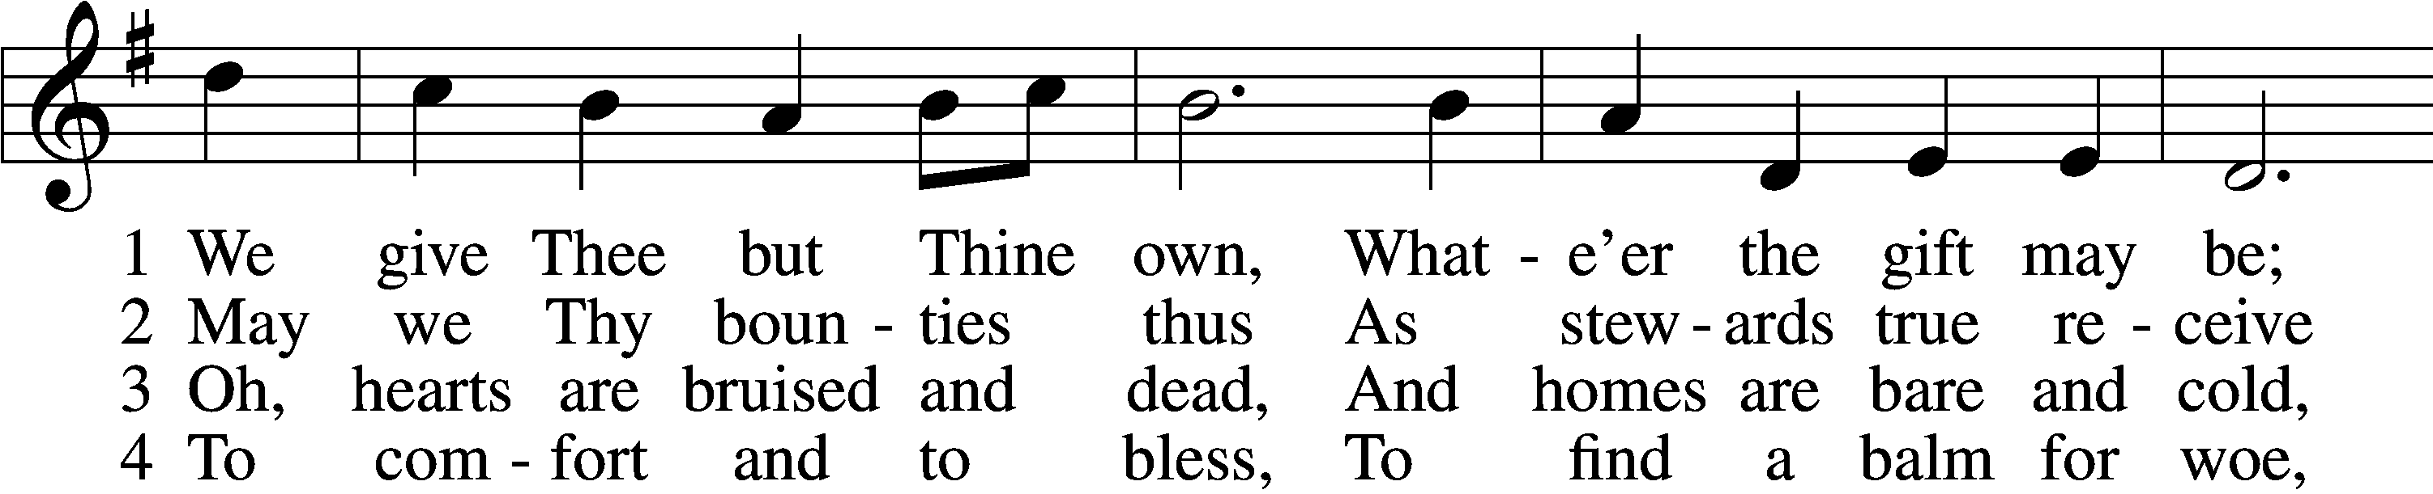
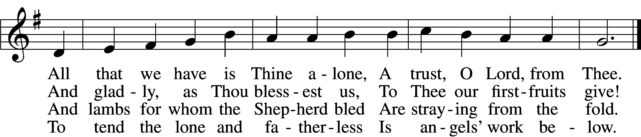

5 The captive to release,
To God the lost to bring,
To teach the way of life and peace,
It is a Christ-like thing.
6 And we believe Thy Word,
Though dim our faith may be:
Whate’er for Thine we do, O Lord,
We do it unto Thee.

Tune and text: Public domain

Prayers

Lord’s Prayer
C Our Father who art in heaven,
hallowed be Thy name,
Thy kingdom come,
Thy will be done on earth
as it is in heaven;
give us this day our daily bread;
and forgive us our trespasses
as we forgive those
who trespass against us;
and lead us not into temptation,
but deliver us from evil.
For Thine is the kingdom
and the power and the glory
forever and ever. Amen.

Prayer
Almighty God, Your mercies are new every morning and You graciously provide for all our needs of body and soul. Grant us Your Holy Spirit that we may acknowledge Your goodness, give thanks for Your benefits, and serve You in willing obedience all our days; through Jesus Christ, our Lord, who lives and reigns with You and the Holy Spirit, one God, now and forever.

Prayer
Almighty God, You crown the fields with Your blessing and permit us to gather in the fruits of the earth. As stewards of Your creation, may we receive Your gifts in humble thankfulness and share Your bounty with those in need; through Jesus Christ, our Lord, who lives and reigns with You and the Holy Spirit, one God, now and forever.

L For all the gifts that God has given,
C thanks be to God.

L For all the sins Christ has forgiven,
C thanks be to God.

L For all the Spirit’s faithful guiding,
C thanks be to God.

L For faith and hope and love abiding,
C thanks be to God.

L For all our triune God’s providing,
C thanks be to God.

Benedicamus LSB 234
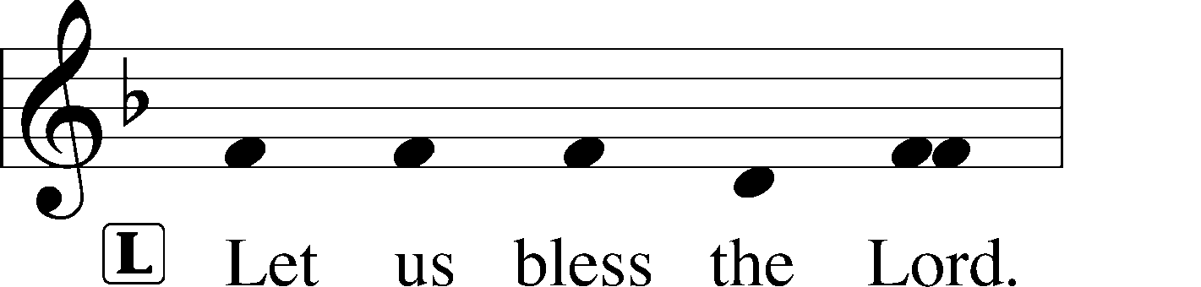
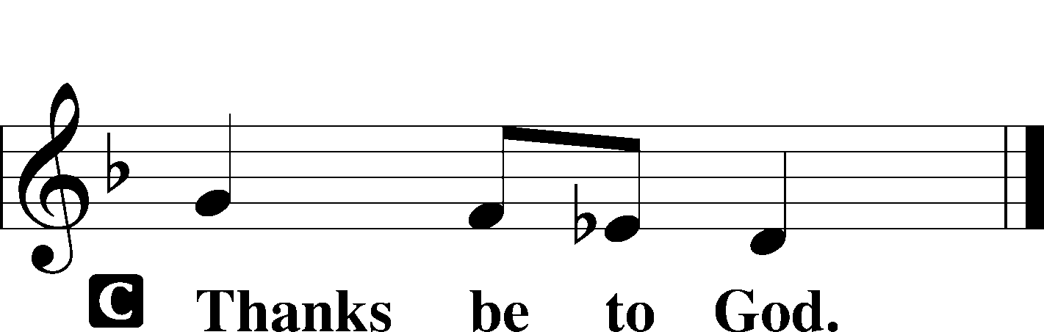

Benediction (Pauline)
P The grace of our Lord T Jesus Christ and the love of God and the communion of the Holy Spirit be with you all.
C Amen.

Hymn: We Plow the Fields and Scatter OAR 337
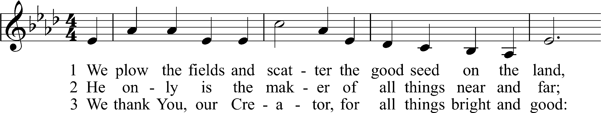
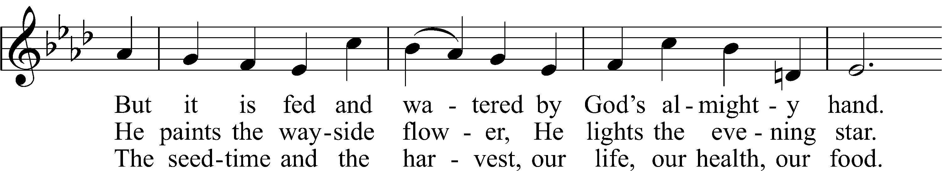
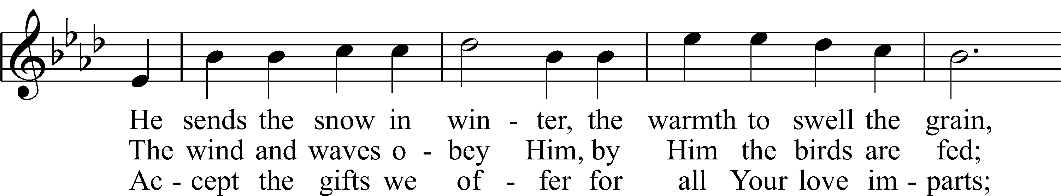
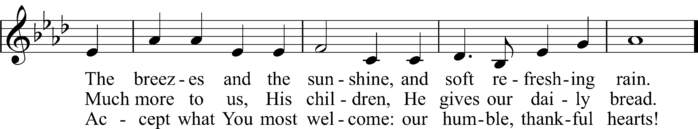
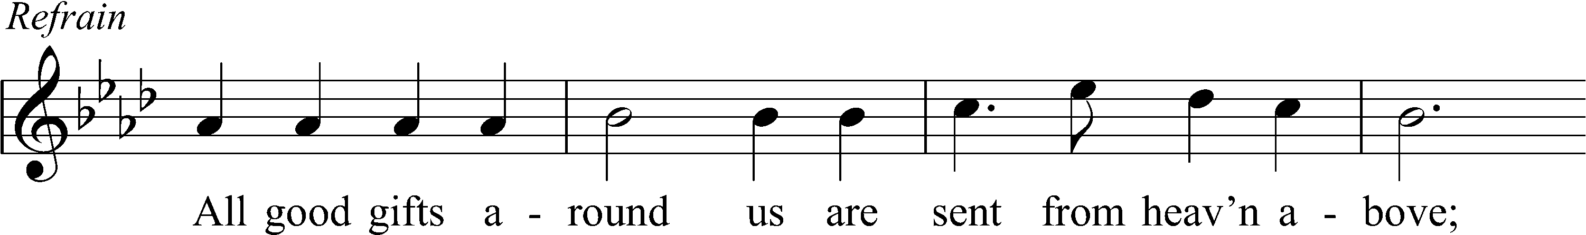
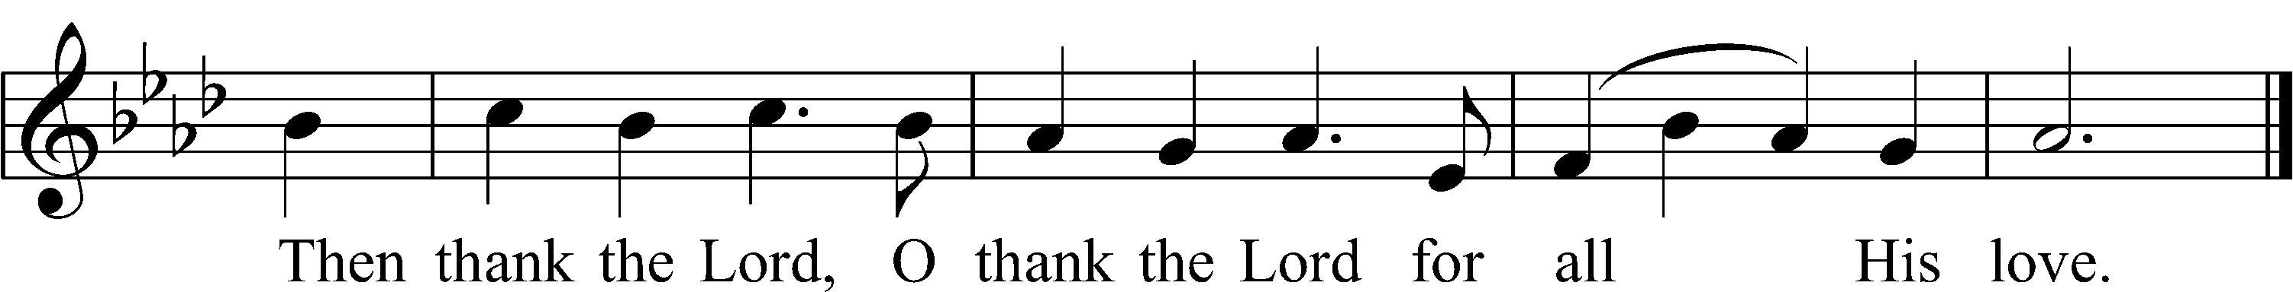
Text and tune: Public domain

Acknowledgments
Unless otherwise indicated, Scripture quotations are from the ESV® Bible (The Holy Bible, English Standard Version®), copyright © 2001 by Crossway, a publishing ministry of Good News Publishers. Used by permission. All rights reserved.
Created by Lutheran Service Builder © 2021 Concordia Publishing House.
Salem Lutheran Church Advent/Christmas Schedule
Theme: Symbols of Salvation

December 1 – Old Testament Christmas
December 8 – The Lord Sets His Tent Among Us
December 15 – You Shall Defeat Them As One Man
December 22 – Advent Readings and Carols

Services will be at 12:00 Noon and 6:30 PM

December 24 – 6:30 PM
December 25 – Jesus, the Living Nativity 9:00 AM

November and December Children’s Worship Practices
November 28: 11-12:15 PM
December 4: 9-11:30 AM
December 12 – 11-12:15 PM
December 18: 10-11:30 AM
December 19: Children’s Christmas Service

